**Appendix B3. Intervention Assessment Materials**

**This page has been left blank for double-sided copying.**

**Connecticut**

OMB Control Number: 0584-XXXX

Expiration Date: XX/XX/XXXX

***Motivation-driven assessment***

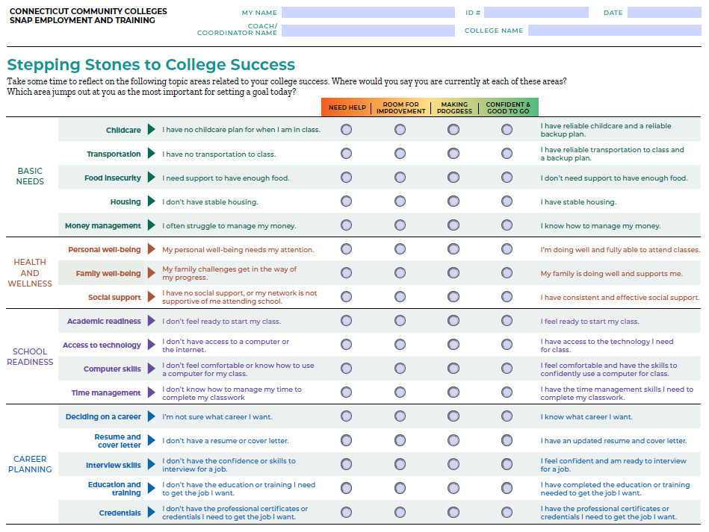

**Public Burden Statement**

This information is being collected to assist the Food and Nutrition Service in evaluating operational improvements in Supplemental Nutrition Assistance Program (SNAP) Employment and Training (E&T) programs that aim to improve delivery of services and program outcomes. This is a voluntary collection and FNS will use the information to assess the effectiveness of changes made to the SNAP E&T program. This collection does request any personally identifiable information under the Privacy Act of 1974. According to the Paperwork Reduction Act of 1995, an agency may not conduct or sponsor, and a person is not required to respond to, a collection of information unless it displays a valid OMB control number. The valid OMB control number for this information collection is 0584-[xxxx]. The time required to complete this information collection is estimated to average 30 minutes (0.5 hours) per response, including the time for reviewing instructions, searching existing data sources, gathering and maintaining the data needed, and completing and reviewing the collection of information. Send comments regarding this burden estimate or any other aspect of this collection of information, including suggestions for reducing this burden, to: U.S. Department of Agriculture, Food and Nutrition Service, Office of Policy Support, 1320 Braddock Place, 5th Floor, Alexandria, VA 22306 ATTN: PRA (0584-xxxx). Do not return the completed form to this address.

**District of Columbia**

OMB Control Number: 0584-XXXX

Expiration Date: XX/XX/XXXX

**Planning for Career Success**

|  |  |  |  |  |  |  |  |
| --- | --- | --- | --- | --- | --- | --- | --- |
|  |  |  | Need help | Ready to explore | Making progress | Confident and good to go |  |
| Deciding on a career | **Career Awareness** | I don’t know what career I want. | O | O | O | O | I know what career I want. |
| **Career Opportunities** | I don’t know where to go to find “good jobs” that interest me. | O | O | O | O | I know where to find “good jobs” that interest me. |
| **Career Decision** | I don’t know which careers are in demand in our region. | O | O | O | O | I know which careers are in demand in our region. |
| **Wages and salary** | I don’t know what I need to earn to meet my current expenses. | O | O | O | O | I know what I need to earn to meet my current expenses. |
| I don’t know what I should expect to be paid in my career. | O | O | O | O | I know what I am likely to be paid in my career. |
| Preparing for a career | **Credentials** | The career I want may require a license, diploma, or certificate but I don’t know. | O | O | O | O | I have a license, diploma, or certificate for the job I want. |
| I am not sure how to pick a high-quality school. | O | O | O | O | I know how to pick a high-quality school. |
| **High school diploma/GED** | I don’t have a high school diploma or GED. | O | O | O | O | I have a high school diploma or GED. |
| Getting the job | **Job search** | I don’t have a resume, cover letter, or experience applying to jobs. | O | O | O | O | I have a resume, cover letter, and experience applying to jobs. |
| **Job interviewing** | Interviewing for a job makes me uncomfortable and I’m not sure how to get better. | O | O | O | O | I am comfortable interviewing for a job. |
| Growing your career | **Starting a job** | I’m not sure how to succeed or what to expect starting a new job. | O | O | O | O | I feel confident starting a new job. |
| I don’t have what I need to start work (proper attire, etc.). | O | O | O | O | I have what I need to start work (proper attire, etc.). |
| I don’t have the skills I need to be successful in my workplace. | O | O | O | O | I have the skills I need to be successful in my workplace. |
| I don’t understand what is expected from me at my new job. | O | O | O | O | I understand what is expected from me at my new job. |
| **Career growth** | I don’t have a plan for advancing my career. | O | O | O | O | I have a plan for advancing my career. |
| Tech | **Access to Technology** | I don’t have access to a computer or internet. | O | O | O | O | I have access to a computer and/or internet. |
| I don’t feel comfortable or know how to use a computer. | O | O | O | O | I feel confident using a computer. |
| Supports | **Housing** | I don’t have housing. | O | O | O | O  N/A | I have stable and safe housing. |
| **Childcare** | I have no childcare. | O | O | O | O | I have reliable childcare and a backup plan. |
| **Transportation** | I have no transportation. | O | O | O | O | I have reliable transportation and a backup plan. |
| **Personal well-being** | My personal well-being or mental health needs attention. | O | O | O | O | I’m doing well and fully able to work. |

**Public Burden Statement**

This information is being collected to assist the Food and Nutrition Service in evaluating operational improvements in Supplemental Nutrition Assistance Program (SNAP) Employment and Training (E&T) programs that aim to improve delivery of services and program outcomes. This is a voluntary collection and FNS will use the information to assess the effectiveness of changes made to the SNAP E&T program. This collection does request any personally identifiable information under the Privacy Act of 1974. According to the Paperwork Reduction Act of 1995, an agency may not conduct or sponsor, and a person is not required to respond to, a collection of information unless it displays a valid OMB control number. The valid OMB control number for this information collection is 0584-[xxxx]. The time required to complete this information collection is estimated to average 30 minutes (0.5 hours) per response, including the time for reviewing instructions, searching existing data sources, gathering and maintaining the data needed, and completing and reviewing the collection of information. Send comments regarding this burden estimate or any other aspect of this collection of information, including suggestions for reducing this burden, to: U.S. Department of Agriculture, Food and Nutrition Service, Office of Policy Support, 1320 Braddock Place, 5th Floor, Alexandria, VA 22306 ATTN: PRA (0584-xxxx). Do not return the completed form to this address.

**Massachusetts**

OMB Control Number: 0584-XXXX

Expiration Date: XX/XX/XXXX

***Screener***

Thank you for your interest in learning more about Massachusetts DTA’s free employment and training services! Please answer the following questions so we can learn how to best support you. The questions should take less than 5 minutes to answer. Questions marked with an asterisk (*) are required.

* *Client application ID or a unique study ID number [Open response]
* *Are you interested in services to help you find a good-paying job? These services could be training or education, career planning, or help looking for jobs. [Yes, No]

[If “No,” participant does not pass the screener and is sent to the end with guidance on next steps]

* *When would you like to talk to someone about these kinds of services? [Immediately, Within the next month, Within the next 3 months, 6-12 months from now, Not sure, I’m not interested in career services]

[If “Within the next 3 months,” “6-12 months from now,” or “Not sure,” participant does not pass the screener and is sent to the end with guidance on next steps]

* What services are you most interested in exploring? Select all that apply. [Support services, such as housing, transportation, child care, or health care; Deciding on a career; Preparing for a career with credentials, education, or experience; Getting the job through job searching and interviewing; Growing your career; Technology needs, such as computer and internet access]
* What best describes your work experience for the last 6 months? [Employed full-time, Employed part-time, At-home childcare or caregiving, Full-time job seeking, Student, Unemployed, Not working due to disability]
* *What is the best phone number to reach you to talk about these services? [Open response]
* *What is the best email to reach you to talk about these services? [Open response]
* When is the best time to call you? [Morning, Afternoon]
* What language would you like to be contacted in, if different than English? [Open response]

**Public Burden Statement**

This information is being collected to assist the Food and Nutrition Service in evaluating operational improvements in Supplemental Nutrition Assistance Program (SNAP) Employment and Training (E&T) programs that aim to improve delivery of services and program outcomes. This is a voluntary collection and FNS will use the information to assess the effectiveness of changes made to the SNAP E&T program. This collection does request any personally identifiable information under the Privacy Act of 1974. According to the Paperwork Reduction Act of 1995, an agency may not conduct or sponsor, and a person is not required to respond to, a collection of information unless it displays a valid OMB control number. The valid OMB control number for this information collection is 0584-[xxxx]. The time required to complete this information collection is estimated to average 30 minutes (0.5 hours) per response, including the time for reviewing instructions, searching existing data sources, gathering and maintaining the data needed, and completing and reviewing the collection of information. Send comments regarding this burden estimate or any other aspect of this collection of information, including suggestions for reducing this burden, to: U.S. Department of Agriculture, Food and Nutrition Service, Office of Policy Support, 1320 Braddock Place, 5th Floor, Alexandria, VA 22306 ATTN: PRA (0584-xxxx). Do not return the completed form to this address.

***Assessment:* Stepping Stones to Success**

1. **Please take some time to think about the following things that can affect your career success. This tool is for your use and will help guide the conversation when you talk with DTA so we can learn how to best support you. Where would you say you currently are in each of these areas?**

|  |  |  |  |  |  |  |  |
| --- | --- | --- | --- | --- | --- | --- | --- |
|  |  |  | Need help | Ready to explore | Making progress | Confident and good to go |  |
| Support | **Basic needs** | I don’t have a stable place to live, transportation, and child care [if a parent or guardian]. | O | O | O | O | I have a stable place to live, transportation, and child care [if a parent or guardian]. |
| **Health** | My health and well-being keep me from looking for and having a job or going to school or training. | O | O | O | O | My health and well-being do not keep me from working or going to school or training. |
| Deciding on a career | **Career awareness** | I don’t know which career I want. | O | O | O | O | I know what career I want, or I already have the career I want. |
| I don’t know which jobs are in demand where I live. | O | O | O | O | I know the jobs that are in demand where I live. |
| **Wages and salary** | I don’t know how much money I need to make to pay my bills, or what I should expect to be paid in my career. | O | O | O | O | I know how much money I have to make to pay my bills, and I know how much my career will pay. |
| Preparing for a career | **Credentials** | The career I want requires or might require a license or certificate, but I don’t have one. | O | O | O | O | I have a license or certificate for the career I want; or the career I want doesn’t require special credentials. |
| **Education** | I need more education and training to get the career I want. | O | O | O | O | I have the education and training I need to get the career I want. |
| **Experience** | I need more work experience to get the career I want. | O | O | O | O | I have the work experience I need to get the career I want. |
| Getting the job | **Job search** | I don’t have a resume, cover letter, or experience applying to jobs. | O | O | O | O | I have a resume, cover letter, and experience applying to jobs. |
| **Interviewing** | I’m uncomfortable in job interviews, and I’m not sure how to get better at them. | O | O | O | O | I am comfortable interviewing for a job. |
| Growing your career | **Starting a job** | I don’t know what to expect when I start a new job or how to succeed at it. | O | O | O | O | I feel confident starting a new job. |
| I don’t have the clothes or supplies I need to work. | O | O | O | O | I have what I need to start work. |
| I don’t have the “soft” skills (like balancing my work and family responsibilities, managing my time, or communicating in the work place) that I need to succeed in my career. | O | O | O | O | I have the soft skills I need to succeed in my career. |
| **Career growth** | I don’t have a plan for getting ahead in my career. | O | O | O | O | I have a plan for getting ahead in my job. |
| Technol-ogy | **Access to computer and internet** | I don’t have access to a computer or the internet, and/or I don’t know how to use them. | O | O | O | O | I have access to a computer and the internet, and I know how to use them. |

1. **What goal(s) do you want to set today after having this conversation? When should we follow up with you on your goal(s)?**
2. **Is there anything else you feel is important for us to know so we can best support you?**

**PSI has been signed.**

**RHODE ISLAND DEPARTMENT OF HUMAN SERVICES**

OMB Control Number: 0584-XXXX

Expiration Date: XX/XX/XXXX

New SNAP E&T Assessment Form

Date_________________________________

Background information

Case Name____________________________ Participant’s Name_____________________ D.O.B.________________________________ Individual ID#_________________________ (RIBridges) SSN (last 4 digits) _______________________ Address/City/Town____________________ Gender_______________________________ Preferred Pronouns____________________

Cell Number___________________________ Email address_______________________

Primary Spoken Language________________ Primary Written Language_______________

Are you receiving TANF/RI Works? ☐ Yes ☐ No

Are you employed? ☐ Yes, 30 or more hours per week ☐ Yes, less than 30 hours per week ☐ No

**I am agreeing to voluntarily participate in the SNAP E&T program: (if yes complete rest of form)**

**Yes** ☐ **No** ☐

*************************************************************************************

FOR RI DHS ONLY:

Case#: ______________________________________ Agency Representative ___________________

SNAP Office: _________________________________ Preferred Program_______________________

☐ Mandatory Work Regist rant ☐ Voluntary Work Registrant ☐ ABAWD

*************************************************************************************

**Public Burden Statement**

This information is being collected to assist the Food and Nutrition Service in evaluating operational improvements in Supplemental Nutrition Assistance Program (SNAP) Employment and Training (E&T) programs that aim to improve delivery of services and program outcomes. This is a voluntary collection and FNS will use the information to assess the effectiveness of changes made to the SNAP E&T program. This collection does request any personally identifiable information under the Privacy Act of 1974. According to the Paperwork Reduction Act of 1995, an agency may not conduct or sponsor, and a person is not required to respond to, a collection of information unless it displays a valid OMB control number. The valid OMB control number for this information collection is 0584-[xxxx]. The time required to complete this information collection is estimated to average 30 minutes (0.5 hours) per response, including the time for reviewing instructions, searching existing data sources, gathering and maintaining the data needed, and completing and reviewing the collection of information. Send comments regarding this burden estimate or any other aspect of this collection of information, including suggestions for reducing this burden, to: U.S. Department of Agriculture, Food and Nutrition Service, Office of Policy Support, 1320 Braddock Place, 5th Floor, Alexandria, VA 22306 ATTN: PRA (0584-xxxx). Do not return the completed form to this address.

Career interests

Are you interested in staring a job right now? ☐ Yes ☐ No

What type of job are you looking for? ­­­­­­­­­­­­­­­­­­­_________________________________

Would you like some training in a career field before finding a job? ☐ Yes ☐ No

Do any of the following careers sound exciting to you?

☐ Culinary arts ☐ Customer service and management

☐ Construction or building trades ☐ Commercial driving or trucking

☐ Certified nursing assisting or health care ☐ Pharmaceutical technician

☐ Dental assisting ☐ Assisting in a lab

If none, specify other: _______________________________

Career readiness

Do you have a high school diploma or GED? ☐ Yes ☐ No

If “No,” What was the highest grade completed?__________________

Do you think you would have any trouble passing a criminal background check? ☐Yes ☐No

Have you been incarcerated? ☐ Yes ☐ No

How many hours per week could you spend in training or a new job? __________________

***For those interested in starting a job now:*** I’m going to read a few statements to you about your readiness to work, and I would like you to think about if the statement is true and you are confident about doing it on your own, or if you could use some assistance to help you get ready. For each, you can tell me if you could use a lot of help, a little help, or no help at all.

|  |  |  |  |  |  |  |
| --- | --- | --- | --- | --- | --- | --- |
|  |  |  | Need help: | | No help needed |  |
|  |  |  | A lot | A little | **Notes** |
| Deciding on a career | **Job search skills** | I know where to find “good jobs” that interest me. | O | O | O |  |
| **Knowledge of available work** | I know which careers are in demand in my region. | O | O | O |  |
| **Credentials** | I have a license, diploma, or certificate needed for the job I want. | O | O | O |  |
| Getting the job | **Applying for jobs** | I have a resume, cover letter, and experience applying to jobs. | O | O | O |  |
| **Job interviewing** | I am comfortable interviewing for a job. | O | O | O |  |
| Starting the job | **Confidence** | I feel confident starting a new job. | O | O | O |  |
| **Supplies** | I have what I need to start work (proper attire, etc.). | O | O | O |  |

I’m going to read a few statements to you about your skills or items you may need for your career, and I would like you to think about if the statement is true or not. For each, you can tell me if you disagree with the statement or if you disagree.

|  |  |  |  |  |  |  |
| --- | --- | --- | --- | --- | --- | --- |
|  |  |  | No | Yes | N/A | Notes |
| Prepare for a job or training | **Drivers’ license** | I have a valid drivers’ license and a clean driving record. | O | O |  |  |
| **Drug test** | I could consistently pass a drug test. | O | O |  |  |
| **Physical health** | I am physically able to stand for a long time and bend to lift heavy boxes. | O | O |  |  |
| **Language skills** | I speak, write, and read English fluently. | O | O |  |  |
| Technology | **Access/ Use of Technology** | I have reliable access to a computer and/or internet. | O | O |  |  |
| I know how to and frequently use a computer. | O | O |  |  |
| Supports | **Housing** | I have stable and safe housing. | O | O |  |  |
| **Childcare** | I have reliable childcare and a backup plan. | O | O | O |  |
| **Transportation** | I have reliable transportation and a backup plan. | O | O |  |  |
| **Personal well-being** | I’m mentally and emotionally doing well and fully able to work. | O | O |  |  |
| I feel safe in my home and with the people around me. | O | O |  |  |