A. AESDirect Record Formats

Launch Page/Shipment Manager
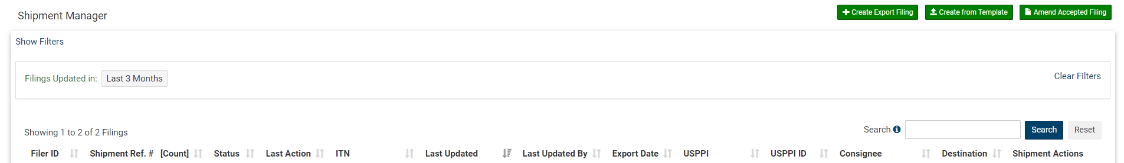

Step 1: Shipment
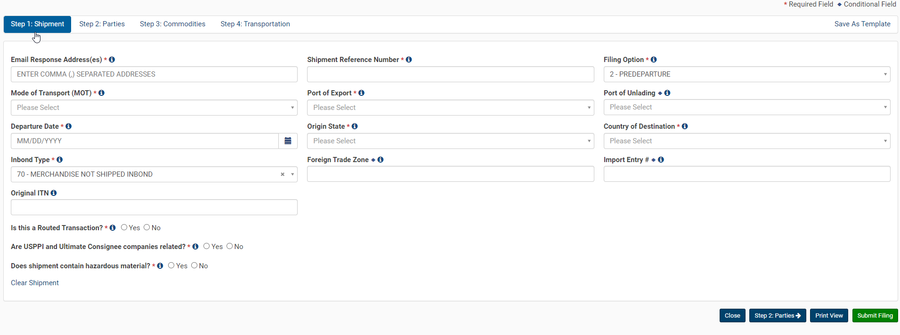

Step 2: Parties
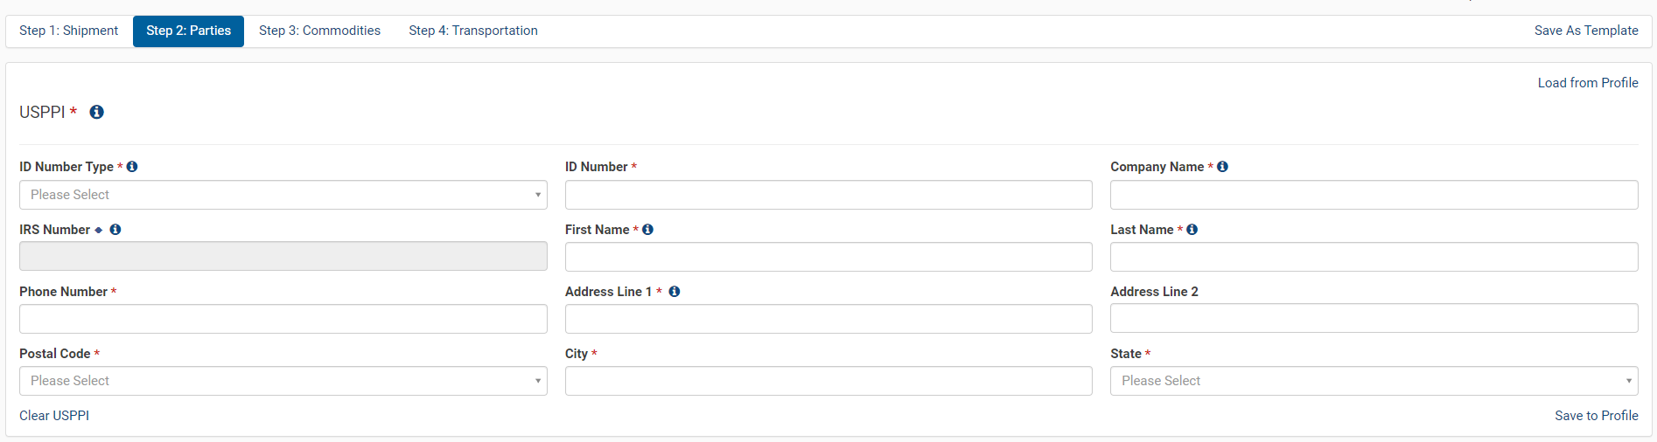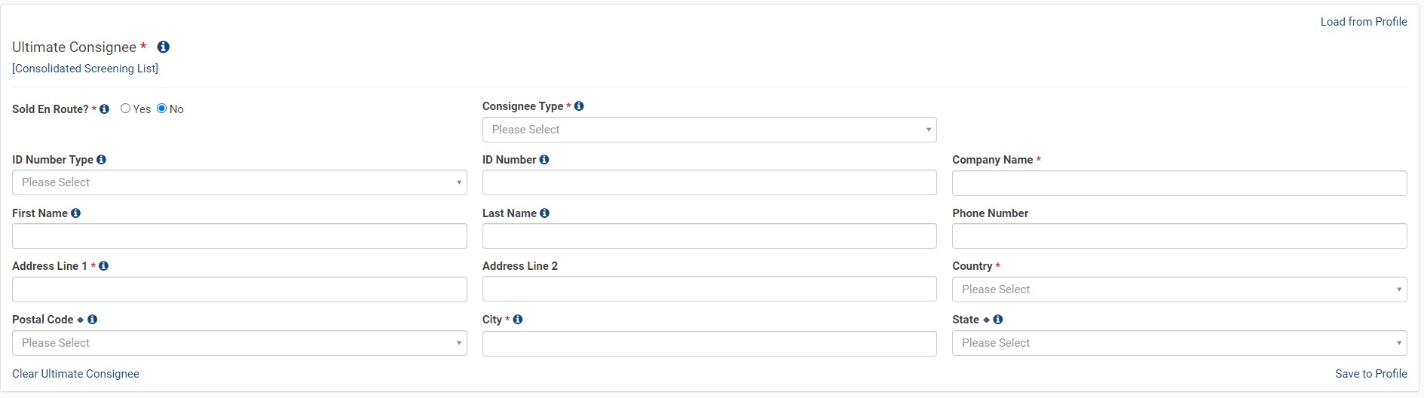
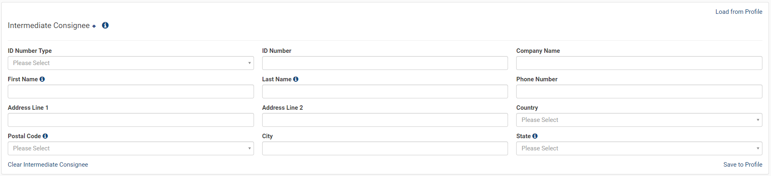
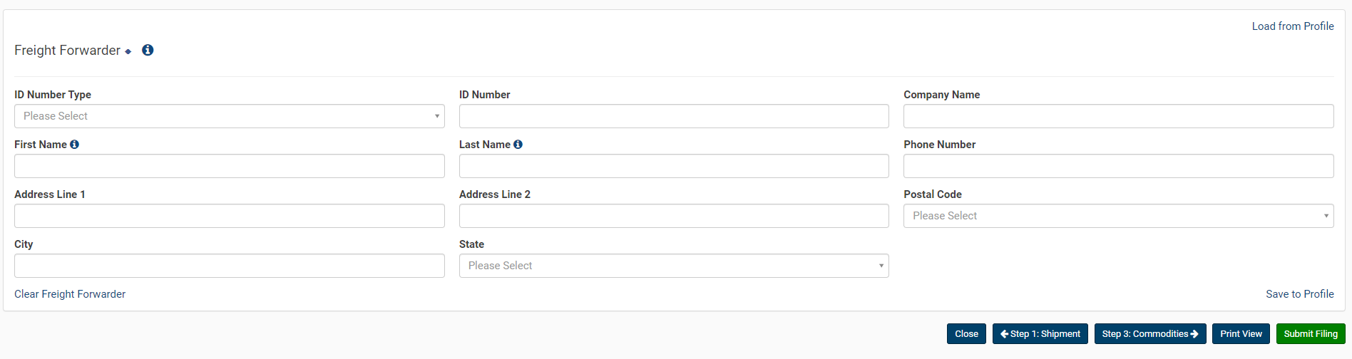

Step 3: Commodities
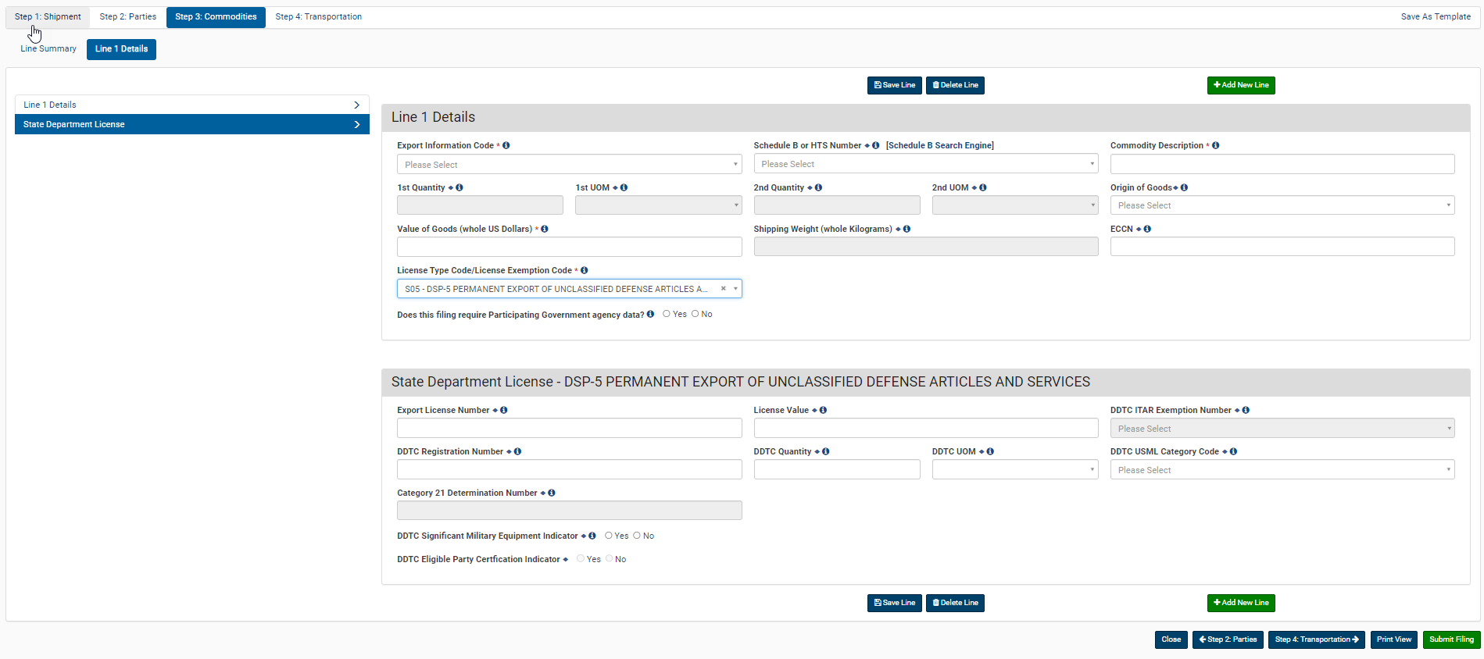
Step 4: Transportation
