AARO Phase II Webpages / Form Images and Text
As of 09/27/2023
Contents
AARO Home Webpage 2
Homepage Image 2
AARO UAP Reporting Information Webpage 3
Reporting Information Page Image 3
Who is eligible to report: 5
What not to report: 5
What to expect after filing a report: 5
I signed an NDA. Can I still report to AARO? 5
Prohibition on Reprisal 6
Do I meet the criteria for submitting a report? 6
AARO UAP Google Form 7
Google Form Images 7
Submission Qualification Criteria 8
If submitter does NOT meet criteria 9
If submitter meets criteria 9
UAP Form Fields 10
Current Contact Information 10
U.S. Government UAP Program / Activity Information 13
Referral Information 15
Prohibition on Reprisal Information 17
Certification and Consent / Submit 18
UAP Report Text and Dropdown Options 21
U.S. Government UAP Programs/Activities Report Form 21
Submission Qualification Criteria 21
UAP Form Fields 22
Current Contact Information 22
U.S. Government UAP Program / Activity Information 25
Referral Information 26
Prohibition on Reprisal Information 26
Certification and Consent / Submit 26
Privacy Act Statement 27
Appendix: List of data fields to be collected from submitters 27

AARO Home Webpage

Homepage Image
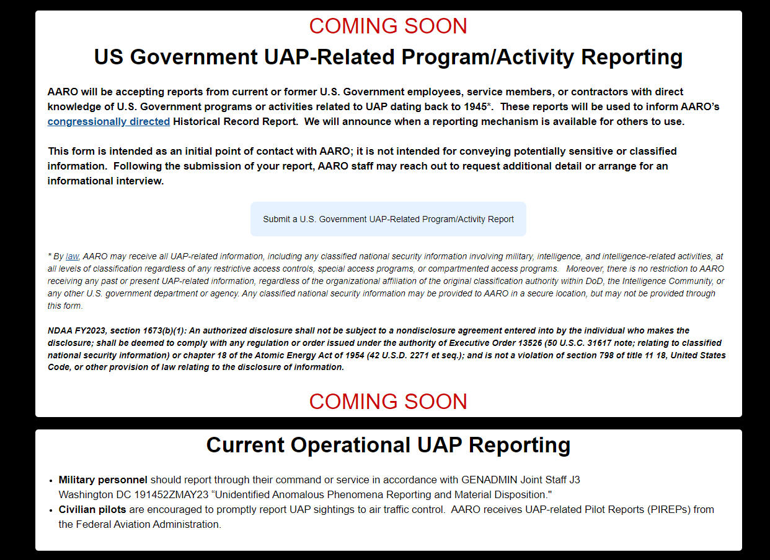
A site visitor will click on the “Submit a U.S. Government UAP-Related Program/Activity Report” button that exists (currently disabled) on the AARO Home page to open the new AARO UAP Repoprting Information webpage shown on the following pages.

AARO UAP Reporting Information Webpage

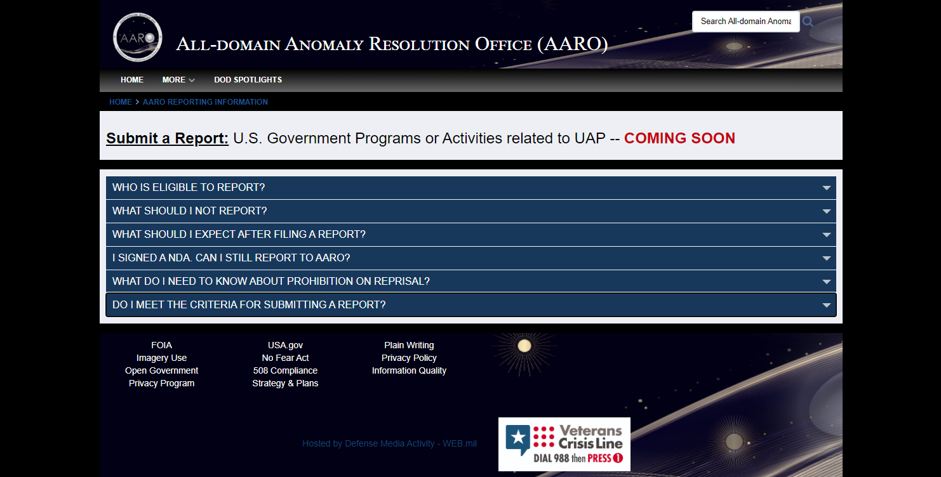
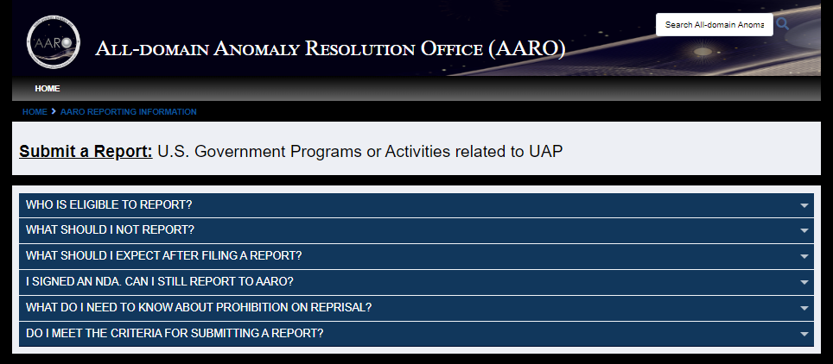
Reporting Information Page Image

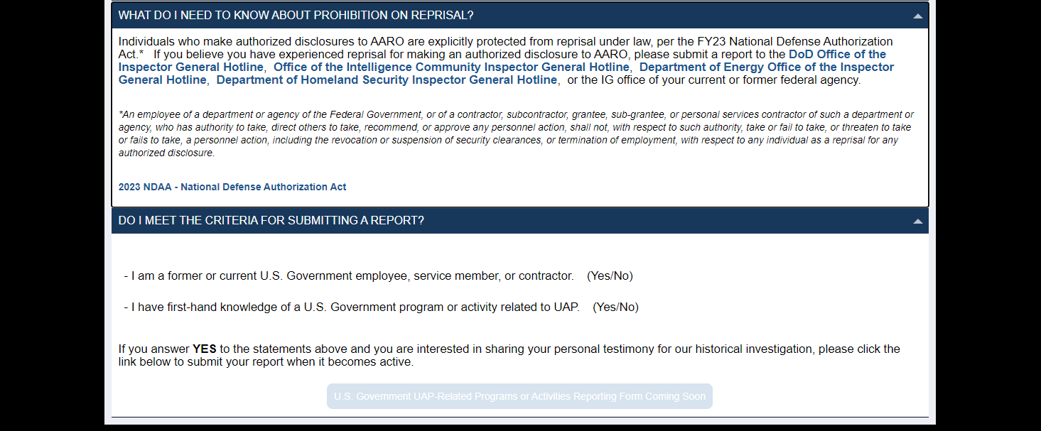
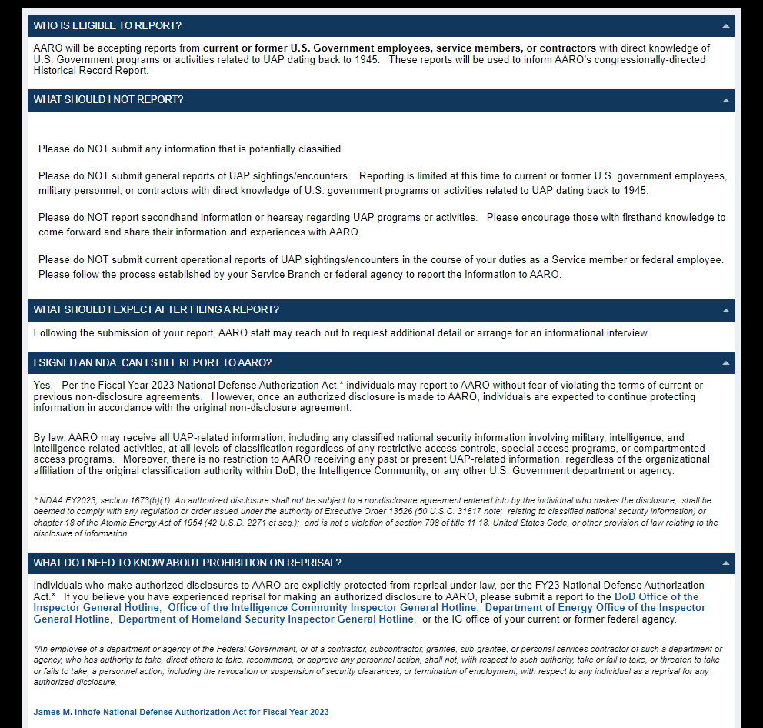

Who is eligible to report:
AARO will be accepting reports from current or former U.S. government employees, service members, or contractors with direct knowledge of USG programs or activities related to UAP dating back to 1945. These reports will be used to inform AARO’s congressionally directed Historical Record Report.

What not to report:
- Please do NOT submit any information that is potentially classified.
- Please do NOT submit general reports of UAP sightings/encounters. Reporting is limited at this time to current or former U.S. government employees, military personnel, or contractors with direct knowledge of USG programs or activities related to UAP dating back to 1945. In the future, reporting eligibility will be expanded to the general public and include reports of any event related to UAP.
- Please do NOT report secondhand information or hearsay regarding UAP programs or activities. Please encourage those with firsthand knowledge to come forward and share their information and experiences with AARO.
- Please do NOT submit current operational reports of UAP sightings/encounters in the course of your duties as a Service member or federal employee. Please follow the process established by your Service Branch or federal agency to report the information to AARO.

What to expect after filing a report:

Following the submission of your report, AARO staff may reach out to request additional detail or arrange for an informational interview.

I signed an NDA. Can I still report to AARO?
Yes. Per the James M. Inhofe National Defense Authorization Act for Fiscal Year 2023,* individuals may report to AARO without fear of violating the terms of current or previous non-disclosure agreements. However, once an authorized disclosure is made to AARO, individuals are expected to continue protecting information in accordance with the original non-disclosure agreement.
By law, AARO may receive all UAP-related information, including any classified national security information involving military, intelligence, and intelligence-related activities, at all levels of classification regardless of any restrictive access controls, special access programs, or compartmented access programs. Moreover, there is no restriction to AARO receiving any past or present UAP-related information, regardless of the organizational affiliation of the original classification authority within DoD, the Intelligence Community, or any other U.S. government department or agency.
* NDAA FY 2023, Section 1673(b)(1): An authorized disclosure shall not be subject to a nondisclosure agreement entered into by the individual who makes the disclosure; shall be deemed to comply with any regulation or order issued under the authority of Executive Order 13526 (50 U.S.C. 31617 note; relating to classified national security information) or chapter 18 of the Atomic Energy Act of 1954 (42 U.S.D. 2271 et seq.); and is not a violation of section 798 of title 11 18, United States Code, or other provision of law relating to the disclosure of information.

Prohibition on Reprisal

Individuals who make authorized disclosures to AARO are explicitly protected from reprisal under law, per the FY23 National Defense Authorization Act.* If you believe you have experienced reprisal for making an authorized disclosure to AARO, please submit a report to the DoD Office of the Inspector General Hotline, Office of the Intelligence Community Inspector General Hotline, Department of Energy Office of the Inspector General Hotline, Department of Homeland Security Inspector General Hotline, or the IG office of your current or former federal agency.

*An employee of a department or agency of the Federal Government, or of a contractor, subcontractor, grantee, sub-grantee, or personal services contractor of such a department or agency, who has authority to take, direct others to take, recommend, or approve any personnel action, shall not, with respect to such authority, take or fail to take, or threaten to take or fails to take, a personnel action, including the revocation or suspension of security clearances, or termination of employment, with respect to any individual as a reprisal for any authorized disclosure.

James M. Inhofe National Defense Authorization Act for Fiscal Year 2023

Do I meet the criteria for submitting a report?
- I am a former or current U.S. Government employee, service member, or contractor. Y/N

- I have first-hand knowledge of a U.S. Government program or activity related to UAP. Y/N

If you answer YES to the statements above and you are interested in sharing your personal testimony for our historical investigation, please follow the link below to submit a report when it becomes active.

(Note: the text on the line below is what appears on a button, which is inactive)
U.S. Government UAP-Related Programs or Activities Reporting Form Coming Soon

AARO UAP Google Form

Google Form Images
The images below reflect the use of Google Forms in AARO’s secure Google Enterprise Plus Workspace account to collect reports associated with UAP-related programs / activities.
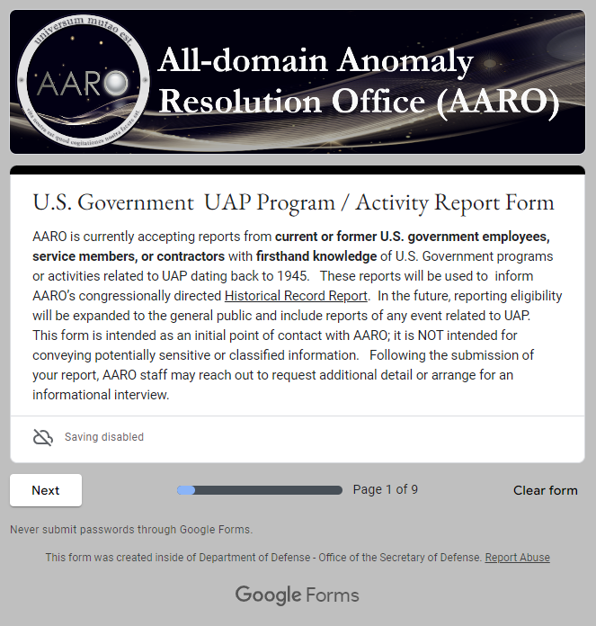

Submission Qualification Criteria
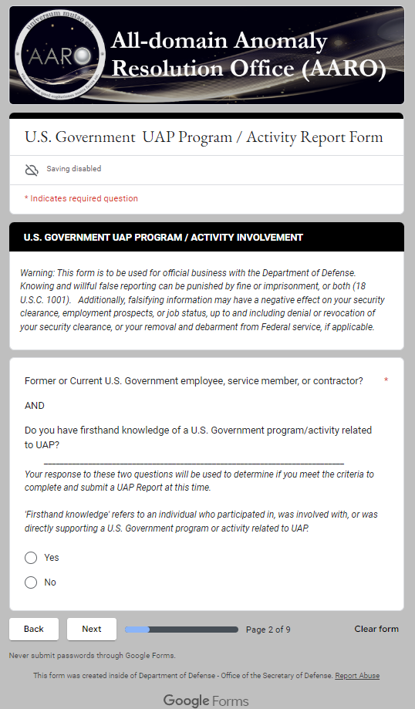

If submitter does NOT meet criteria

If an individual clicks on “No” for the combined response to the first two questions, that individual will not be able to proceed with filling out the Google Form to submit a UAP Report to AARO.
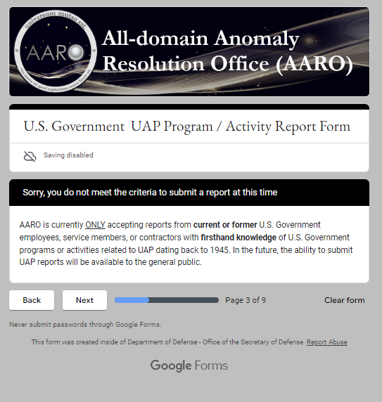

If submitter meets criteria
If an individual clicks on “Yes” for the combined response to the first two questions, that individual will see the multiple form segments in the Google Form, as shown in the following screenshots, to submit a UAP Report to AARO.

UAP Form Fields

Current Contact Information
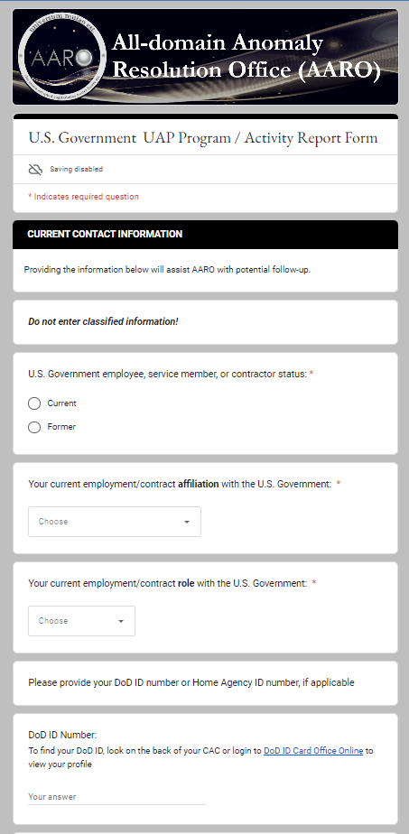

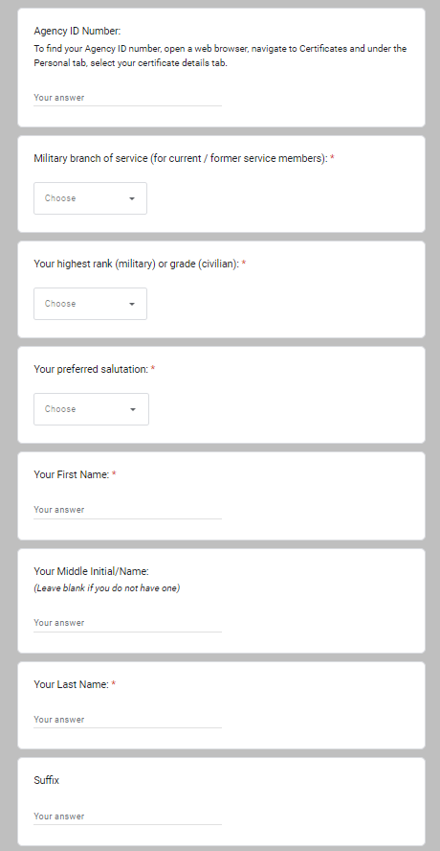
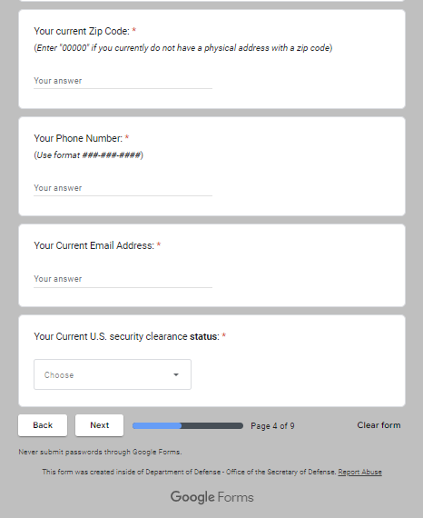

U.S. Government UAP Program / Activity Information
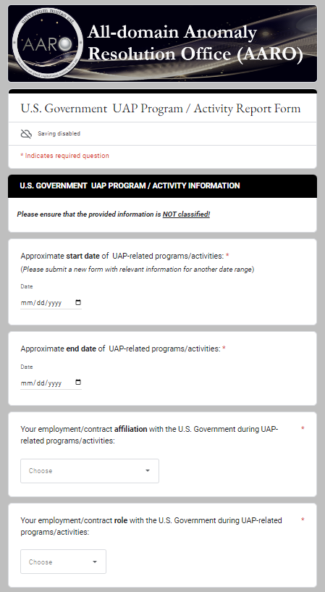

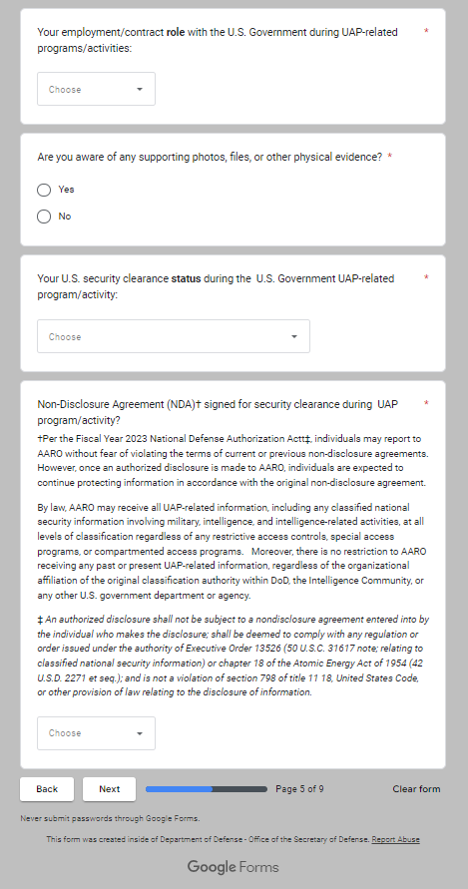

Referral Information

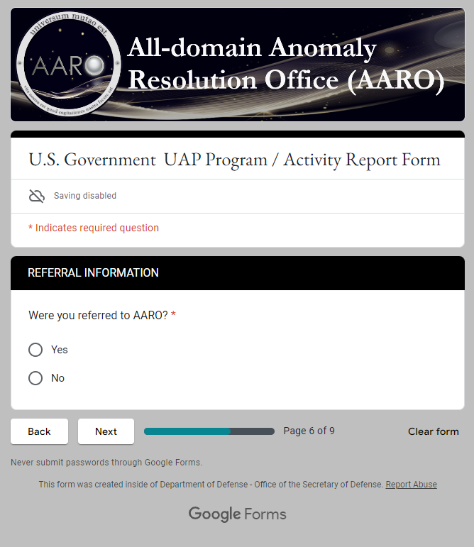

If answer Yes to Referral, these questions will appear
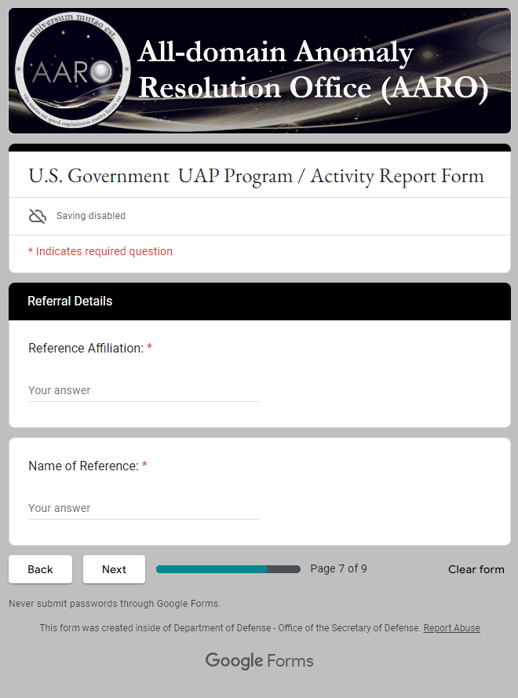

Prohibition on Reprisal Information
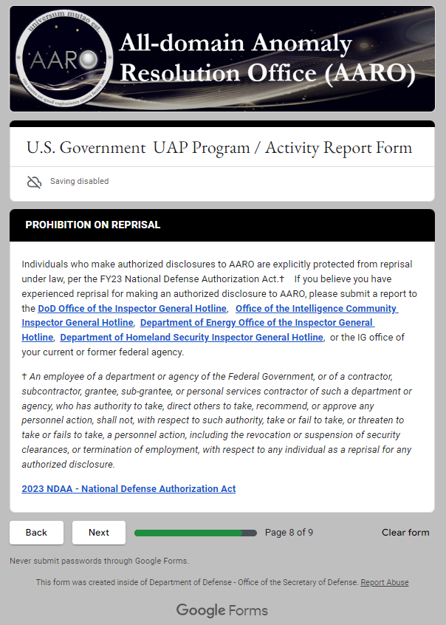

Certification and Consent / Submit
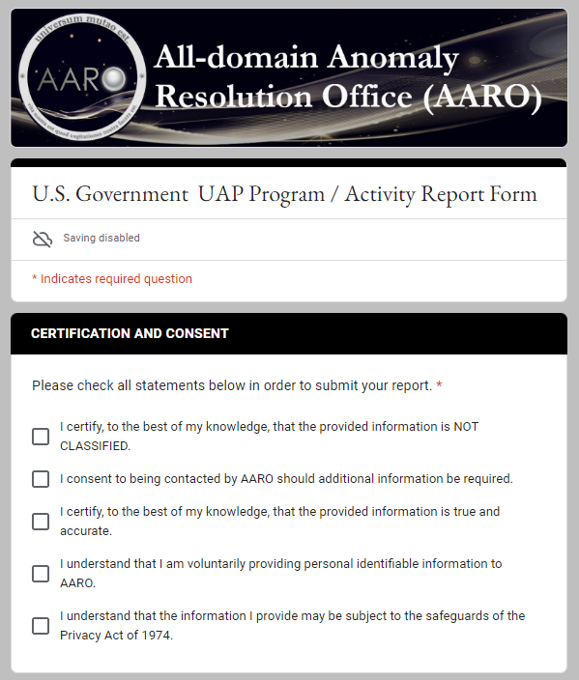
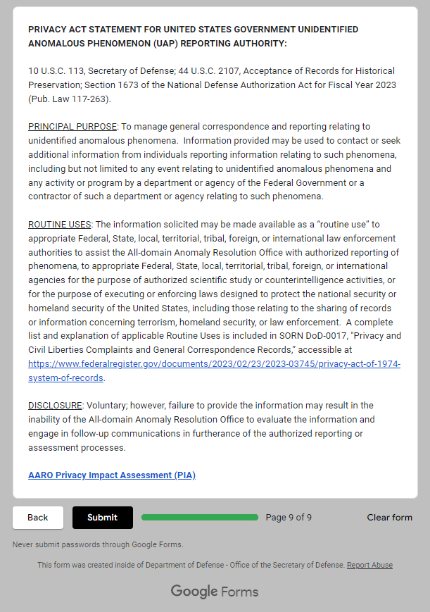
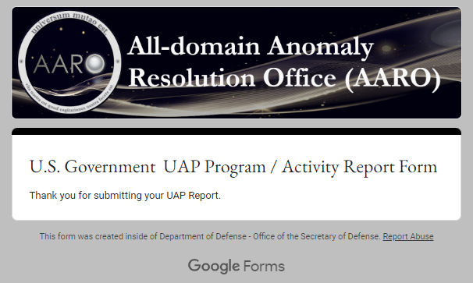

UAP Report Text and Dropdown Options

U.S. Government UAP Programs/Activities Report Form

AARO is currently accepting reports from current or former U.S. government employees, service members, or contractors with firsthand knowledge of U.S. Government programs or activities related to UAP dating back to 1945. These reports will be used to inform AARO’s congressionally directed Historical Record Report. In the future, reporting eligibility will be expanded to the general public and include reports of any event related to UAP. This form is intended as an initial point of contact with AARO; it is NOT intended for conveying potentially sensitive or classified information. Following the submission of your report, AARO staff may reach out to request additional detail or arrange for an informational interview.

Submission Qualification Criteria

U.S. GOVERNMENT UAP PROGRAM / ACTIVITY INVOLVEMENT
Warning: This form is to be used for official business with the Department of Defense. Knowing and willful false reporting can be punished by fine or imprisonment, or both (18 U.S.C. 1001). Additionally, falsifying information may have a negative effect on your security clearance, employment prospects, or job status, up to and including denial or revocation of your security clearance, or your removal and debarment from Federal service, if applicable.
Former or Current U.S. Government employee, service member, or contractor?
AND
Do you have firsthand knowledge of a U.S. Government program/activity related to UAP?
______________________________________________________________
Your response to these two questions will be used to determine if you meet the criteria to complete and submit a UAP Report at this time.
‘Firsthand knowledge' refers to an individual who participated in, was involved with, or was directly supporting a U.S. Government program or activity related to UAP.
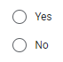

(If answer above is No, only display this text below and ability to enter any more data ceases)
Sorry, you do not meet the criteria to submit a report at this time
AARO is currently ONLY accepting reports from current or former U.S. Government employees, service members, or contractors with firsthand knowledge of U.S. Government programs or activities related to UAP dating back to 1945. In the future, the ability to submit UAP reports will be available to the general public.
(If answer above is Yes, display all of the UAP Reporting Form content that appears below)

UAP Form Fields
* indicates required question

Current Contact Information
Providing the information below will assist AARO with potential follow-up.
Do not enter classified information!
U.S. Government employee, service member, or contractor status:*
Dropdown List Options
- Current
- Former
Your current employment/contract affiliation with the U.S. Government:*
Affiliation Dropdown List Options
- Department of Defense
- Department of Energy
- Department of Homeland Security
- Other Federal Agency
- Non-Federal Agency
- Prefer not to disclose on form

Your current employment/contract role with the U.S. Government:*
Role Dropdown List Options
- Employee
- Service member
- Contractor
Please provide your DoD ID number or Home Agency ID number, if applicable:
DoD ID Number: (text input, up to 15 characters)
To find your DoD ID, look on the back of your CAC or login to DoD ID Card Office Online to view your profile
Agency ID Number: (text input, up to 20 characters)
To find your Agency ID number, open a web browser, navigate to Certificates and under the Personal tab, select your certificate details tab.

Military branch of service (for current/former service members): *
Dropdown List Options
- N/A
- Air Force
- Army
- Coast Guard
- Marine Corps
- Navy
- Space Force
Your highest rank (military) or grade (civilian): *
Dropdown List Options
Military Ranks
- E-1
- E-2
- E-3
- E-4
- E-5
- E-6
- E-7
- E-8
- E-9
- O-1
- O-2
- O-3
- O-4
- O-5
- O-6
- O-7
- O-8
- O-9
- O-10
- W-1
- W-2
- W-3
- W-4
- W-5
Civilian Grades
- GG/GS-1
- GG/GS-2
- GG/GS-3
- GG/GS-4
- GG/GS-5
- GG/GS-6
- GG/GS-7
- GG/GS-8
- GG/GS-9
- GG/GS-10
- GG/GS-11
- GG/GS-12
- GG/GS-13
- GG/GS-14
- GG/GS-15
- SES/DISES/DISL
Other Options
- Other
- N/A

Your preferred salutation: *
Dropdown List Options
- Dr.
- Mr.
- Mrs.
- Ms.
- Miss
- (My military rank)
- N/A
Your First Name: * (text input, up to 20 characters)
Your Middle Initial/Name: (text input, up to 20 characters)
Your Last Name:* (text input, up to 20 characters)
Your Suffix: (text input, up to 5 characters)
Your current Zip Code: * (text, must use this format: #####-####, with last 4 digits optional)
(Enter “00000” if you currently do not have an address with a zip code)
Your Phone number: * (text input, must use this format:###-###-####)
(Use format ###-###-####)
Your Current Email Address: * (text input, must use email format with @)

Your current U.S. security clearance: *
Clearance Status Dropdown List Options
- Currently have
- Previously had
- Never had
- Prefer not to disclose on form

U.S. Government UAP Program / Activity Information
Do not enter classified information!
Approximate start date of UAP-related programs/activities: * (datepicker)
Approximate end date of UAP-related programs/activities: * (datepicker)
Your employment/contract affiliation with the U.S. Government during UAP-related programs/activities: *
Affiliation Dropdown List Options
- Department of Defense
- Department of Energy
- Department of Homeland Security
- Other Federal Agency
- Non-Federal Agency
- Prefer not to disclose on form
Your employment/contract role with the U.S. Government during UAP-related programs/activities:*
Role Dropdown List Options
- Employee
- Service member
- Contractor
Are you aware of any supporting photos, files, or other physical evidence? *
Radio Button Options
- Yes
- No
Your U.S. security clearance during the UAP program/activity: *
Clearance Status Dropdown List Options
- Held a clearance during UAP program/activity
- Did not hold a clearance during UAP program/activity
- Unsure
Non-Disclosure Agreement (NDA)† signed for security clearance during UAP program/activity? *
Dropdown List Options
- Yes
- No
- Unsure
†Per the Fiscal Year 2023 National Defense Authorization Act‡, individuals may report to AARO without fear of violating the terms of current or previous non-disclosure agreements. However, once an authorized disclosure is made to AARO, individuals are expected to continue protecting information in accordance with the original non-disclosure agreement.

By law, AARO may receive all UAP-related information, including any classified national security information involving military, intelligence, and intelligence-related activities, at all levels of classification regardless of any restrictive access controls, special access programs, or compartmented access programs. Moreover, there is no restriction to AARO receiving any past or present UAP-related information, regardless of the organizational affiliation of the original classification authority within DoD, the Intelligence Community, or any other U.S. government department or agency.

‡ An authorized disclosure shall not be subject to a nondisclosure agreement entered into by the individual who makes the disclosure; shall be deemed to comply with any regulation or order issued under the authority of Executive Order 13526 (50 U.S.C. 31617 note; relating to classified national security information) or chapter 18 of the Atomic Energy Act of 1954 (42 U.S.D. 2271 et seq.); and is not a violation of section 798 of title 11 18, United States Code, or other provision of law

Referral Information
Were you referred to AARO? *
Radio Button Options
- Yes
- No
Reference Affiliation: (text input, up to 25 characters)
Name of Reference: (text input, up to 25 characters)

Prohibition on Reprisal Information

Individuals who make authorized disclosures to AARO are explicitly protected from reprisal under law, per the FY23 National Defense Authorization Act.† If you believe you have experienced reprisal for making an authorized disclosure to AARO, please submit a report to the DoD Office of the Inspector General Hotline, Office of the Intelligence Community Inspector General Hotline, Department of Energy Office of the Inspector General Hotline, Department of Homeland Security Inspector General Hotline, or the IG office of your current or former federal agency.
† An employee of a department or agency of the Federal Government, or of a contractor, subcontractor, grantee, sub-grantee, or personal services contractor of such a department or agency, who has authority to take, direct others to take, recommend, or approve any personnel action, shall not, with respect to such authority, take or fail to take, or threaten to take or fails to take, a personnel action, including the revocation or suspension of security clearances, or termination of employment, with respect to any individual as a reprisal for any authorized disclosure.

2023 NDAA - National Defense Authorization Act

Certification and Consent / Submit
I certify, to the best of my knowledge, that the provided information is NOT CLASSIFIED. *
I consent to being contacted by AARO should additional information be required. *
I certify, to the best of my knowledge, that the provided information is true and accurate. *
I understand that I am voluntarily providing personal identifiable information to AARO. *
I understand that the information I provide may be subject to the safeguards of the Privacy Act of 1974. *

Privacy Act Statement

PRIVACY ACT STATEMENT FOR UNITED STATES GOVERNMENT UNIDENTIFIED ANOMALOUS PHENOMENON (UAP) REPORTING AUTHORITY:
PRIVACY ACT STATEMENT FOR UNITED STATES GOVERNMENT UNIDENTIFIED ANOMALOUS PHENOMENON (UAP) REPORTING AUTHORITY:

10 U.S.C. 113, Secretary of Defense; 44 U.S.C. 2107, Acceptance of Records for Historical Preservation; Section 1673 of the National Defense Authorization Act for Fiscal Year 2023 (Pub. Law 117-263).
PRINCIPAL PURPOSE: To manage general correspondence and reporting relating to unidentified anomalous phenomena. Information provided may be used to contact or seek additional information from individuals reporting information relating to such phenomena, including but not limited to any event relating to unidentified anomalous phenomena and any activity or program by a department or agency of the Federal Government or a contractor of such a department or agency relating to such phenomena.
ROUTINE USES: The information solicited may be made available as a “routine use” to appropriate Federal, State, local, territorial, tribal, foreign, or international law enforcement authorities to assist the All-domain Anomaly Resolution Office with authorized reporting of phenomena, to appropriate Federal, State, local, territorial, tribal, foreign, or international agencies for the purpose of authorized scientific study or counterintelligence activities, or for the purpose of executing or enforcing laws designed to protect the national security or homeland security of the United States, including those relating to the sharing of records or information concerning terrorism, homeland security, or law enforcement. A complete list and explanation of applicable Routine Uses is included in SORN DoD-0017, "Privacy and Civil Liberties Complaints and General Correspondence Records,” accessible at
https://www.federalregister.gov/documents/2023/02/23/2023-03745/privacy-act-of-1974-system-of-records.
DISCLOSURE: Voluntary; however, failure to provide the information may result in the inability of the All-domain Anomaly Resolution Office to evaluate the information and engage in follow-up communications in furtherance of the authorized reporting or assessment processes.

AARO Privacy Impact Assessment (PIA)
Submit

Appendix: List of data fields to be collected from submitters

User Input |  | Field Input Type | Required
Qualify | Meet criteria to report for Phase II (yes/ no) | Dropdown List | Yes
Current Information | U.S. Gov. Status (current/former) | Dropdown List | Yes
Current Information | Current Government Affiliation | Dropdown List | Yes
Current Information | Current Gov. Role (employee, service member, contractor) | Dropdown List | Yes
Current Information | DoD ID Number | Text field | No
Current Information | Agency ID Number | Text field | No
Current Information | Military branch of service | Dropdown List | Yes
Current Information | Highest rank (military) / grade(civilian) | Dropdown List | Yes
Current Information | Preferred salutation | Dropdown List | Yes
Current Information | First Name | Text field | Yes
Current Information | Middle Initial / Name | Text field | No
Current Information | Last Name | Text field | Yes
Current Information | Suffix | Text field | No
Current Information | Zip Code | Text field | Yes
Current Information | Phone Number | Text field | Yes
Current Information | Email address | Text field | Yes
Current Information | Current U.S. security clearance status (e.g., have, never had) | Dropdown List | Yes
UAP Related Information | UAP Program / Activity Start Date | Date Picker | Yes
UAP Related Information | UAP Program / Activity End Date | Date Picker | Yes
UAP Related Information | U.S. Government Affiliation | Dropdown List | Yes
UAP Related Information | U.S. Government Role (employee, service member, contractor) | Dropdown List | Yes
UAP Related Information | Knowledge of supporting materials (yes/no) | Dropdown List | Yes
UAP Related Information | U.S. security clearance status (e.g., had, never had) | Dropdown List | Yes
UAP Related Information | NDA signed (yes, no, unsure, N/A) | Dropdown List | Yes
Referral | Referred to AARO (yes / no) | Dropdown List | Yes
Referral | Reference Affiliation | Text field | No
Referral | Name of Reference | Text field | No
Certification Consent | Information provided not classified | Checkbox | Yes
Certification Consent | Contact by AARO consent | Checkbox | Yes
Certification Consent | Information provided true & accurate | Checkbox | Yes
Certification Consent | Voluntarily providing PII to AARO | Checkbox | Yes
Certification Consent | Information provided subject to Privacy Act | Checkbox | Yes

