October 2023 (v.19)
Instructions for Completion of the COVID-19 Long-term Care Facility (LTCF) Resident Impact and Facility Capacity Pathway Form (CDC 57.144)

Data Field | Instructions for Form Completion
NHSN Facility ID # | The NHSN-assigned facility ID will be auto-generated by the system.
CMS Certification Number (CCN)-may be referred to as participation number | Auto-generated by the computer, if applicable, based on the CCN entered during NHSN registration or last updated, if previously edited. Please see NHSN CCN Guidance document for instructions on how to add a new CCN or edit an existing CCN.
Facility Name | Auto-generated by the system based on the facility name previously entered during NHSN registration.
Date for which counts are reported | Required. Select the date on the calendar for which the counts and/or responses in the Resident Impact and Facility Capacity pathway apply. For example, if reporting the number of residents with positive SARS-CoV-2 (COVID-19) viral test results for specimens collected on Monday of the reporting week, Monday should be selected on the calendar as the day for which counts are being reported in the “Resident Impact and Facility Capacity” pathway.
Facility Type | Auto-generated based on the facility type selected during NHSN enrollment. Selections include:  - LTC - ASSIST – Assisted Living Residence  - LTC - ICF/IID – Intermediate Care Facilities for Individuals with Intellectual Disabilities.  - LTC - SKILLNURS – Skilled Nursing Facility +  +Includes both skilled nursing facilities and nursing homes  - LTC - PSYCH – Psychiatric Residential Treatment Facility  - LTC - SVHALF – Assisted Living Facility for State Veteran’s Homes  - LTC - SVHSNF – Skilled Nursing Facility for State Veteran’s Homes  Please see NHSN Guidance document for instructions on How to Correct Your Facility Type if this information is incorrect.
Date Created | Auto-generated based on the first calendar date and time that a user manually enters and saves data or the date the facility first submits a CSV file for a specific pathway. Note: The date and time will automatically generate after the “Save” button is selected and cannot be modified.
Important:
Report only the NEW counts since the last date counts were collected for reporting to NHSN. If the count is zero for any variable, a “0” is to be entered as the response. A blank response is equivalent to missing data.

Data Field | Instructions for Form Completion
Facility Capacity
ALL BEDS | Enter the total number of resident beds in the facility. This number will auto- populate in future sessions and should be updated only if there is a change in the total bed count. For example, if the facility must bring in additional beds to accommodate overflow of residents.  Notes:  - Include the total number of beds for the facility in which the facility is licensed. This number should include private and/or non-private pay beds.
* CURRENT CENSUS  Total number of beds  that are occupied at the time of reporting to NSHN. | Required: Enter the total number of occupied beds for each calendar day in which data are being entered.  Notes:  - Count includes a combination of private and non-private pay occupied beds, when applicable.  - Count includes the total number of residents occupying a bed in the reporting facility, including non-licensed beds. (For example, residents occupying additional non-licensed beds that were brought into the facility in response to increased capacity of residents, or residents being moved to other parts of the facility that are not normally included in the LTCF bed count).
Resident Impact for COVID-19 (SARS-CoV-2)
*POSITIVE TESTS  Number of residents with a newly positive SARS-CoV-2 viral test result.  (numrespostest) | Positive Tests: Defined by NHSN as number of residents newly positive for COVID-19 based on a viral test result. The test result may be from a NAAT/PCR or an antigen test. The definition includes residents with an re-infection. This count ONLY includes current residents of the facility, please do not include COVID-19 admissions in this count.  Notes:  - Exclude residents who have a positive SARS-CoV-2 antigen test, but a negative SARS-CoV-2 NAAT (PCR).  - The PCR will need to be performed within 2 calendar days (date of specimen collection is calendar day 1) of the initial antigen test for this rule to apply.  - This count ONLY includes current residents of the facility. Any tests that are administered by/in the facility will need to be included in this count.  - Serial testing or multiple tests performed on the same resident for the same infection do not need to be counted multiple times. Only include the newly positive test one time for the same infection.  - Re-infection occurs after an initial/previous COVID-19 diagnosis and/or positive viral test result. If the resident has a newly positive SARS-Cov-2 viral test result, and they have fully recovered from any previous COVID-19 infection or diagnosis, please include this individual in the positive test count.  - For further information regarding testing, please visit the CDC’s Overview of Testing for SARS-CoV-2, the virus that causes COVID-19  Important:  - Positive Tests is a surveillance method for capturing positive diagnostic results only, clinical decisions should not be made based on this definition. Instead, diagnostic test results should be used in the context of available clinical, resident/patient, epidemiological, and diagnostic information.  - Report incidence counts only (specifically, residents newly identified in Positive Tests count) to avoid falsely inflated data. For example, if a facility reports counts to NHSN more than once per week, the facility should report new counts since the last date data were reported to NHSN.  - Positive Tests are based on the date of specimen collection.  - The Positive Tests definition, as defined by NHSN, may not represent the definition individual states use to define Confirmed SARS-CoV-2 (COVID-19) cases.  Diagnostic Terms and Definitions:  - NAAT: Nucleic acid amplification testing, a form of molecular testing. Includes but are not limited to Polymerase Chain Reaction (PCR) and Real Time Polymerase Chain Reaction (RT-PCR).  - A viral test is used to detect infection with SARS-CoV-2, the virus that causes COVID-19. Molecular (specifically, NAAT) and antigen tests are types of viral tests. CDC-NHSN recognizes positive results from both molecular and antigen diagnostic tests for diagnosing active COVID-19 infection.  - Exclude antibody test results. They are used to detect previous infection with SARS-CoV-2, the virus that causes COVID-19. This type of test is also called a serological test. Antibody test results are not considered appropriate for diagnosis of active COVID-19 infection.  Example: The following SARS-CoV-2 tests and results were documented this week for residents in a DHQP Skilled Nursing Facility (counts represent newly positive residents only):  - Monday: 3 residents had positive SARS-CoV-2 (COVID-19) viral test results  - Of the 3-positive, all 3 residents had positive point-of-care (POC)  antigen results. 2 of the residents had a follow-up negative NAAT (PCR) test result. 1 of the residents had a follow-up positive NAAT result performed on the same day.  - Tuesday: 3 residents had positive SARS-CoV-2 viral test results.  - Of the 3 positives, all 3 were antigen positive. No other testing  performed on two residents. Only one of the three residents had a follow-up negative PCR, performed 4 days later.  - Wednesday: 1 resident had a positive SARS-CoV-2 NAAT (PCR) viral test result. No other COVID-19 testing performed.  - Thursday: 1 resident had a positive SARS-CoV-2 viral test result.  - Of the 1 positive POC antigen test result, the resident had no other  tests performed. The resident did have a laboratory positive COVID-19 test result over 3 months ago and fully recovered. The resident developed fever and loss of smell today, prompting antigen POC testing.  - Friday: 3 residents had positive SARS-CoV-2 NAAT/PCR viral test results.  - Of the 3 residents, all had positive COVID-19 antigen test results  two weeks ago and were already submitted to NHSN as positive tests  Saturday: 0 newly positive test results.  - Sunday: 1 positive SARS-CoV-2 NAAT/PCR viral test results with no other testing performed.  Based on the above information, the following Positive Tests counts were submitted to NHSN:  If Daily Reporting: Monday: 1 Tuesday: 3; Wednesday: 1; Thursday: 1; Friday: 0; Saturday: 0; Sunday: 1.  If Weekly Reporting Only: Total Positive Tests for the reporting week: 7  Important: If reporting daily Positive Tests counts to NHSN (specifically residents with newly positive viral tests results), do not also report a total weekly count since duplicate reporting will result in falsely inflated counts.
Vaccination Status of Residents with a Newly Confirmed SARS-CoV-2 Viral Test Result
** VACCINATION STATUS  For the newly positive residents, indicate how many received COVID-19 vaccination 14 days or more before the specimen collection date.  The 14-day window ONLY applies for data reported to the RIFC Pathway | Vaccination Status: The occurrence, or lack thereof, receiving a dose(s) of the COVID-19 vaccine. The vaccination status pertains to residents with a newly positive SARS-CoV-2 viral test for the reporting week. The vaccination status is contingent upon if the resident has received the most recent dose of the COVID-19 vaccine 14 days or more before the specimen collection date of the newly positive SARS-CoV-2 Viral test. The date vaccine was received is considered as Day 1. Include residents who received the vaccine while in the LTCF or outside of the LTCF.  Conditional. If the number of reported Positive Tests is greater than “0” for the reporting period, indicate the vaccination status of residents included in the positive test count.  Note:  - The RIFC pathway collects COVID-19 vaccination status ONLY for residents included in the Positive Test count.  - COVID-19 vaccination status is not reported for residents with a positive SARS-CoV-2 antigen test and negative SARS-CoV-2 NAAT (PCR).  To report Vaccination Status:  Indicate the corresponding count of residents with a newly positive SARS-CoV-2 viral test result.  COVID-19 Vaccination options  - Up to Date  - Not Up to Date (auto-populated by the system)  Note: The Not Up to Date category is populated based on the counts entered for Up to date. To edit this category, please update/change the counts entered for Up to Date.  Vaccination Status Definitions:  - Up to Date: include residents who meet the CDC recommendations for up to date with COVID-19 vaccines and the most recent dose was received 14 days or more before the specimen collection of the newly positive SARS-CoV-2 viral test result. (the vaccination status of the resident 14 days before they tested positive).  Note: This data elements requires residents who are considered up to date per the NHSN surveillance definition to have received the most recent COVID-19 vaccine 14 days or more before the specimen collection of the newly positive SARS-CoV-2 viral test result. Because this is a surveillance data element, it is designed to assess vaccine effectiveness in promoting an immune response to SARS-CoV-2 (COVID-19). Therefore, surveillance case reporting requirements may differ from CDC’s clinical considerations guidance document. Please review the NHSN Surveillance Definition.  - Not Up to Date: Based on the counts entered for Positive Tests and Up to Date, the count for residents who are NOT considered up to date based on the NHSN Surveillance definition has been calculated.  Note:  - This count is not editable by the user, to edit this count please update the count entered for Up to Date and/or Positive Tests.  - This count is calculated by subtracting the count entered for Up to Date from the count entered for Positive Tests (Positive Tests – Up to Date = Not Up to Date)  - If a resident with a newly positive COVID-19 test is to be included in the Not Up to Date category, that count will be automatically included once the counts for Positive Tests and Up to Date have been entered.  Example: Of the reported newly positive SARS-CoV-2 viral tests results, the residents were documented to have the following vaccination status in DHQP Skilled Nursing Facility (counts represent newly positive residents only).  - Monday: 3 residents had newly positive SARS-CoV-2 (COVID-19) viral test results.  - One resident has not received any COVID-19 Vaccination.  - This resident would be included in the Not Up to Date category. You will not have to enter a count for this resident, it will be populated by the system.  - 2 residents received the bivalent COVID-19 vaccine 3 months prior to the positive COVID-19 test.  - These residents would be included in the Up to Date category.  - Tuesday: 3 residents had newly positive SARS-CoV-2 viral test results.  - All 3 residents received the Primary Series vaccine and also the Bivalent vaccine 6 months ago.  - All residents would be included in the Up to Date category.  - Wednesday: 1 resident had a newly positive SARS-CoV-2 viral test result.  - Resident received dose 1 and 2 of a 2-dose series COVID-19 vaccine 1 year ago  - This resident would be included in the Not Up to Date category. You will not have to enter a count for this resident, it will be populated by the system.  - Thursday: 2 residents had a newly positive SARS-CoV-2 viral test result.  - One resident received the Bivalent dose 2 months ago  - This resident would be included in the Up to Date category  - One resident received the Bivalent dose 10 days prior to the specimen collection date  - This resident would be included in the Not Up to Date category because they received the updated booster 13 days or less before the specimen collection date. You will not have to enter a count for this resident, it will be populated by the system.  - Friday: 3 residents had newly positive SARS-CoV-2 viral test results.  - 2 residents received the primary series COVID-19 vaccine 2 years ago and a monovalent booster dose 1 year ago  - Both of these residents would be included in the Not Up to Date category. You will not have to enter a count for these residents, it will be populated by the system  - One resident received the Bivalent vaccine dose 14 days or more before the specimen collection date.  - This resident would be counted in the Up to Date category.  - Saturday: 0 newly positive test results.  - Sunday: 1 resident had a newly positive SARS-CoV-2 viral test result  - Resident received the Bivalent dose 15 days before the specimen collection date  - This resident would be counted in the Up to Date category.  Based on the above information, the following vaccination status counts were submitted to NHSN:  If Daily Reporting:  Monday: 2 Up to Date, 1 Not Up to Date (populated by the system)  Tuesday: 3 Up to Date  Wednesday: 1 Not Up to Date (populated by the system)  Thursday: 1 Up to Date, 1 Not Up to Date (populated by the system)  Friday: 1 Up to Date, 2 Not Up to Date (populated by the system)  Saturday: 0  Sunday: 1 Up to Date  If Weekly Reporting:  Up to Date: 8  Not Up to Date (populated by the system): 5  When to include a resident in the Up-to-Date count (use this decision tree for counts reported during quarter 3 and after (June 26 2023, and after)).  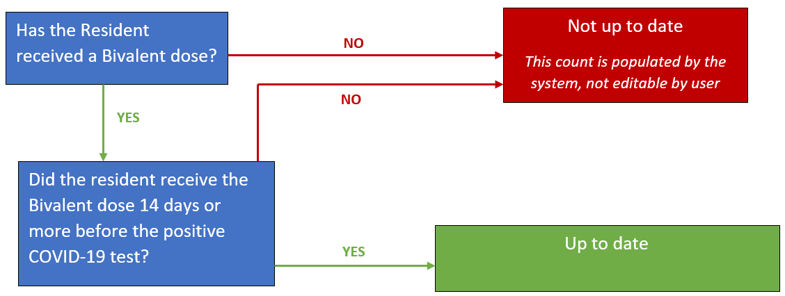
Hospitalizations
This is not a subset of the “Positive Tests” count. Include only the number of new hospitalizations with a positive COVID-19 test since the most recent date data were reported to NHSN.
Hospitalizations with a positive COVID-19 Test: Indicate the number of residents who have been hospitalized and have had a positive COVID-19 test in the 10 days prior to the hospitalization. | Hospitalizations with a positive COVI-19 Test: This count includes residents who have been newly admitted to the hospital since the last date data was reported to NHSN and have also had a positive COVID-19 test in the 10 days prior to the hospitalization.  This can include residents who have been counted in the positive test count and those who have not been counted in the positive test count. This is NOT a subset of the positive test count, meaning this does NOT ONLY include residents who have been counted in the positive test count for this reporting period.  Note: Only include residents who have been hospitalized during the reporting period and had a positive COVID-19 test in the 10 days prior to the hospitalization, date of specimen collection is calendar day 1.  Note: Admission to the hospital refers to residents who have been admitted as inpatient to the hospital. This does NOT include residents who have only been transferred to the Emergency Department or transferred to the hospital for observation. This count ONLY includes residents who have been officially admitted to the hospital.  To calculate the count for Hospitalizations with a positive COVID-19 Test, answer the following:  Of the residents who were admitted to the hospital during this reporting week, how many of those residents have also had a positive COVID-19 test in the 10 days prior to the hospitalization?  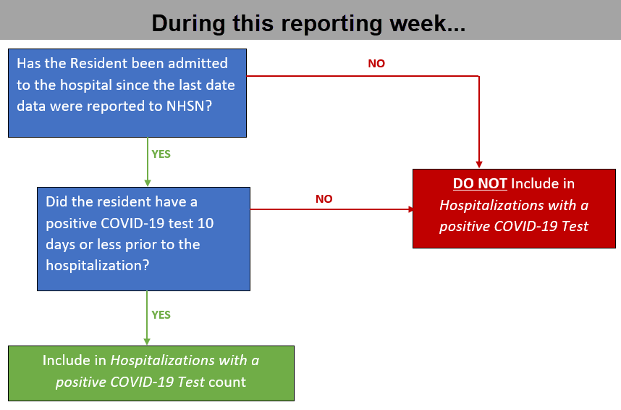  Example: Since the last date data were reported to NHSN, 4 residents have been admitted to the hospital.  - Resident A was transferred to the ER for shortness of breath and fever and then admitted to the 4th floor. Resident A had a positive COVID-19 test 10 days ago (10 days prior to the hospitalization).  - This resident would be included in the Hospitalizations with a positive COVID-19 test count.  - Resident B was transferred to the ER for nausea and vomiting, however, was transferred back to the facility the same day after receiving IV fluids in the ER.  - This resident would NOT be included in the Hospitalizations with a positive COVID-19 Test count.  - This resident was not admitted to the hospital, only transferred to the ER for treatment then transferred back to the facility  - Resident C was admitted to the hospital on Monday for a routine procedure. The resident stayed in the hospital on the medical/surgical floor for continued observation after the procedure. The resident was then discharged from the hospital and transferred back to the facility later that week.  - This resident would NOT be included in the Hospitalizations with a positive COVID-19 Test count.  - The resident did not have a positive COVID-19 test in the 10 days prior to the hospital admission.  - Resident D was tested for COVID-19 last week and the test result was positive. The positive test was reported to NHSN during the previous reporting period (last week when the positive result was received). This week (8 days from the time the resident tested positive), the resident required higher acuity respiratory care and was admitted to the hospital.  - This resident would be included in the Hospitalizations with a positive COVID-19 Test count.  - The positive test was counted in the previous reporting period, however the hospitalization occurred during this current reporting period. For this reason, this resident was counted during the current reporting week for Hospitalizations with a positive COVID-19 Test.
Hospitalizations with a positive COVID-19 Test and Up to Date: Based on the number reported for “Hospitalizations with a positive COVID-19 Test”, indicate the number of residents who were hospitalized with a positive COVID-19 test and also up to date with COVID-19 vaccinations at the time of the positive COVID-19 test | Hospitalizations with a positive COVID-19 Test and Up to Date: This count includes residents who have been newly admitted to the hospital since the last date data was reported to NHSN, have also had a positive COVID-19 test in the 10 days prior to the hospitalization, and are also up to date with COVID-19 vaccines.  This is a subset of Hospitalizations with a positive COVID-19 Test, the count entered for this variable cannot exceed the number reported for Hospitalizations with a positive COVID-19 Test.  Note: This count must be less than or equal to the count entered for Hospitalizations with a positive COVID-19 Test.  To calculate the count for Hospitalizations with a positive COVID-19 Test and Up to Date answer the following:  - Please review the current NHSN surveillance definition of up to date to determine if the resident should be included in this count. Once it has been determined, if the resident is up to date based on the surveillance definition, there is one more step to determine inclusion in this variable. Has it also been 14 days or more between the time of the up to date vaccine and the positive COVID-19 test?  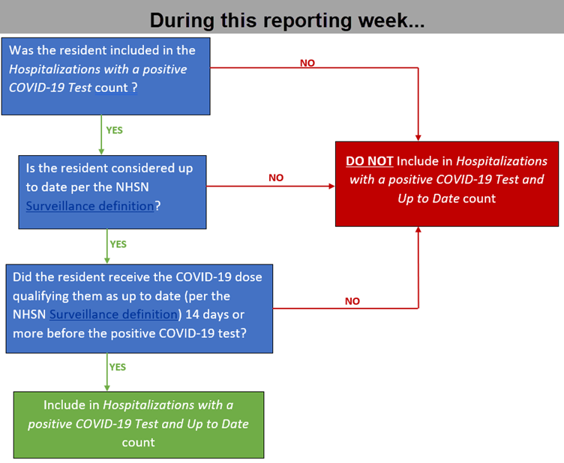  - Meaning, when the resident tested positive were they considered up to date 14 days prior?  Example: Since the last date data were reported to NHSN, 4 residents have been admitted to the hospital.  - Resident A was transferred to the ER for shortness of breath and fever and then admitted to the 4th floor. Resident A had a positive COVID-19 test 10 days ago (10 days prior to the hospitalization) and received the Bivalent booster 4 months ago.  - This resident would be included in the Hospitalizations with a positive COVID-19 Test and Up to Date count.  - Resident B was transferred to the ER for nausea and vomiting, however, was transferred back to the facility the same day after receiving IV fluids in the ER.  - This resident would NOT be included in the Hospitalizations with a positive COVID-19 Test and Up to Date count.  - This resident was not admitted to the hospital, only transferred to the ER for treatment then transferred back to the facility. Since the resident would not be included in the Hospitalizations with a positive COVID-19 Test count they will also NOT be included in the Hospitalizations with a positive COVID-19 Test and Up to Date count.  - Resident C was admitted to the hospital on Monday for a routine procedure. The resident stayed in the hospital on the medical/surgical floor for continued observation after the procedure. The resident was then discharged from the hospital and transferred back to the facility later that week.  - This resident would NOT be included in the Hospitalizations with a positive COVID-19 Test count.  - The resident did not have a positive COVID-19 test in the 10 days prior to the hospital admission. Since the resident would not be included in the Hospitalizations with a positive COVID-19 Test count they will also NOT be included in the Hospitalizations with a positive COVID-19 Test and Up to Date count.  - Resident D was tested for COVID-19 last week and the test result was positive. The positive test was reported to NHSN during the previous reporting period (last week when the positive result was received). This week (8 days from the time the resident tested positive), the resident required higher acuity respiratory care and was admitted to the hospital. The resident received the Bivalent dose 6 months ago.  - This resident would be included in the Hospitalizations with a positive COVID-19 Test and Up to Date count.  - The resident received the Bivalent dose 6 months ago which satisfies the requirement of this variable of having an up to date status (based on the NHSN Surveillance definition) 14 days prior to testing positive for COVID-19, therefore the resident would be included in the Hospitalizations with a positive COVID-19 Test and Up to Date count.
Deaths
Only include the number of new deaths since the most recent date data were reported to NHSN.
*TOTAL DEATHS:  Number of residents who have died for any reason in the facility or another location since the last date Total Death counts were reported to NHSN. | Total Deaths is defined by NHSN as residents who have died from any cause in the facility or another location, including COVID-19 related and non- COVID-19 related deaths. This count must include only new deaths since the last date counts for Total Deaths were reported to NSHN.  Notes:  - Include each resident death only once in Total Deaths count, on the date of death.  - Total Deaths should NEVER be lower than the COVID-19 Deaths in a reporting week.  - Residents discharged from the facility are excluded from the count.  Example: DHQP SNF documented the following Total Deaths this week:  - Monday: 2 Total Deaths submitted. Of the two deaths, 1 resident was on transmission-based precautions for COVID-19 and the second resident recovered from COVID-19 last month.  - Tuesday: 0 Total Deaths submitted.  - Wednesday: 0 Total Deaths submitted.  - Thursday: 1 Total Deaths submitted. The resident did not have a history or positive COVID-19 test result.  - Friday: 0 Total Deaths submitted. A nurse did recognize a previously discharged resident in the obituary of a local newspaper.  - Saturday: 2 Total Deaths submitted. Of these two deaths, one resident had an active COVID-19 infection, and the other resident did not have COVID-19. However, 2 weeks later an autopsy report indicated a positive SARS-CoV-2 (COVID-19) viral test result on the second resident not known to have COVID-19.  - Sunday: 1 Total Deaths submitted for a resident who died 1 week after being transferred to an acute care facility for treatment of COVID-19 infection.  The following counts for Total Deaths were reported to NHSN:  Monday: 2  Tuesday: 0  Wednesday: 0  Thursday: 1  Friday: 0  Saturday: 2  Sunday: 1  If Weekly Reporting Only: Total Deaths count for the reporting week: 6  Important: If reporting daily Total Deaths counts to NHSN, do not also report a weekly Total Deaths count since duplicate reporting will result in falsely inflated death counts.
**COVID-19 DEATHS  Based on the number of reported Total Deaths, indicate the number of residents with COVID-19 who died in the facility or another location. | COVID-19 Deaths: Defined by NHSN as residents who died from SARS-CoV-2 (COVID-19) related complications and includes resident deaths in the facility AND in other locations, such as an acute care facility, in which the resident with COVID-19 was transferred to receive treatment. This count must include only new deaths since the last date counts for COVID-19 Deaths were reported to NSHN.  Conditional. Based on the number of reported new Total Deaths for the reporting period, indicate how many of the deaths were residents with either a positive COVID-19 viral test result, had signs and/or symptoms of COVID-19 as defined by the CDC, were on transmission-based precautions for COVID-19, or who died from ongoing complications related to a previous COVID-19 infection.  Notes:  - If the facility receives an autopsy result indicating a positive SARS-CoV-2 viral test result for a resident who was not initially included in the COVID-19 Deaths count, previously submitted NHSN data must be edited to include the death in the COVID-19 Deaths count. The edited date must reflect the date of death.  - The count for new COVID-19 Deaths cannot be higher than the count for new Total Deaths in a reporting period.  - Residents discharged (specifically, not expected to return to the facility) from the facility are excluded from the count.  Example: The following example is based on the Total Deaths counts reported in the previous example.  Monday: 1  Tuesday: 0  Wednesday: 0  Thursday: 0  Friday: 0  Saturday: 2 (previously submitted count was updated after receiving autopsy report indicating COVID-19 was cause of death)  Sunday: 1  If Weekly Reporting Only: Total COVID-19 Deaths count for the reporting week- 4  Important: If reporting daily new COVID-19 Deaths counts to NHSN, do not also report a weekly Total for new COVID-19 Deaths since duplicate reporting will result in falsely inflated death counts.

Optional Reporting: These data are NOT required

Influenza
Influenza Positive Tests and Vaccination Status of Newly Positive Residents
*POSITIVE TESTS  Number of residents with a newly positive Influenza test result.  (numrespostest) | Positive Tests: Defined by NHSN as a new positive influenza test result, also referred to as a positive flu test result.  This count ONLY includes current residents of the facility, please do not include Influenza admissions in this count.  Notes:  - This count ONLY includes current residents of the facility. Any tests that are administered by/in the facility will need to be included in this count.  Important:  - Positive Tests is a surveillance method for capturing positive diagnostic results only, clinical decisions should not be made based on this definition. Instead, diagnostic test results should be used in the context of available clinical, resident/patient, epidemiological, and diagnostic information.  - Report incidence counts only (specifically, residents newly identified in Positive Tests count) to avoid falsely inflated data. For example, if a facility reports counts to NHSN more than once per week, the facility should report new counts since the last date data were reported to NHSN.  - Positive Tests are based on the date of specimen collection.  Important: If reporting daily Positive Tests counts to NHSN (specifically residents with newly positive viral tests results), do not also report a total weekly count since duplicate reporting will result in falsely inflated counts.
**Up to Date  For the newly positive residents, indicate how many received Influenza vaccination 14 days or more before the specimen collection date. | Vaccination Status: The occurrence, or lack thereof, receiving a dose(s) of the Influenza vaccine. The vaccination status pertains to residents with a newly positive Influenza test for the reporting week. The date vaccine was received is considered as Day 1. Include residents who received the vaccine while in the LTCF or outside of the LTCF.  Conditional. If the number of reported Positive Tests is greater than “0” for the reporting period, indicate the vaccination status of residents included in the positive test count.  Note: The Not Up to Date category is populated based on the counts entered for Up to date. To edit this category, please update/change the counts entered for Up to Date.  Vaccination Status Definitions:  - Up to Date: include residents who meet the CDC recommendations for up to date with Influenza vaccine AND the vaccine was received 14 days or more before the specimen collection of the newly positive Influenza test result. (the vaccination status of the resident 14 days before they tested positive).  - Not Up to Date: Based on the counts entered for Positive Tests and Up to Date, the count for residents who are NOT considered up to date based on the NHSN Surveillance definition has been calculated.  Note:  - This count is not editable by the user, to edit this count please update the count entered for Up to Date and/or Positive Tests.  - This count is calculated by subtracting the count entered for Up to Date from the count entered for Positive Tests (Positive Tests – Up to Date = Not Up to Date)  - If a resident with a newly positive Influenza test is to be included in the Not Up to Date category, that count will be automatically included once the counts for Positive Tests and Up to Date have been entered.
Influenza Hospitalizations
This is not a subset of the Influenza “Positive Tests” count reported above. Include only the number of new hospitalizations in residents with a positive Influenza test since the most recent date data were reported to NHSN.

*Hospitalizations in residents with a positive Influenza Test: Number of residents who have been hospitalized with a positive Influenza test. | Hospitalizations in residents with a positive Influenza Test: This count includes residents who have been newly admitted to the hospital since the last date data were reported to NHSN and have also had a positive Influenza test in the 10 days prior to the hospitalization.  This can include residents who have been counted in the positive test count and those who have not been counted in the positive test count. This is NOT a subset of the positive test count, meaning this does NOT ONLY include residents who have been counted in the positive test count for this reporting period.  Note: Only include residents who have been hospitalized during this reporting period and had a positive Influenza test in the 10 days prior to the hospitalization, date of specimen collection is calendar day 1.  Note: Admission to the hospital refers to residents who have been admitted as inpatient to the hospital. This does NOT include residents who have only been transferred to the Emergency Department or transferred to the hospital for observation. This count ONLY includes residents who have been officially admitted to the hospital.
**Hospitalizations with a positive Influenza Test and Up to Date: Based on the number reported for "Hospitalizations with a positive Influenza Test" indicate the number of residents who were hospitalized with positive Influenza test and also up to date with Influenza vaccine at the time of positive Influenza test | Hospitalizations with a positive Influenza Test and Up to Date: This count includes residents who have been newly admitted to the hospital since the last date data was reported to NHSN, have also had a positive Influenza test in the 10 days prior to the hospitalization, and are also up to date with Influenza vaccine.  This is a subset of Hospitalizations with a positive Influenza Test, the count entered for this variable cannot exceed the number reported for Hospitalizations with a positive Influenza Test.  Note: This count must be less than or equal to the count entered for Hospitalizations with a positive Influenza Test.
RSV (Respiratory Syncytial Virus)
RSV Positive Tests and Vaccination Status of Newly Positive Residents
*POSITIVE TESTS  Number of residents with a newly positive RSV test result. | Positive Tests: Defined by NHSN as a new positive RSV test result.  This count ONLY includes current residents of the facility, please do not include RSV admissions in this count.  Notes:  - This count ONLY includes current residents of the facility. Any tests that are administered by/in the facility will need to be included in this count.  Important:  - Positive Tests is a surveillance method for capturing positive diagnostic results only, clinical decisions should not be made based on this definition. Instead, diagnostic test results should be used in the context of available clinical, resident/patient, epidemiological, and diagnostic information.  - Report incidence counts only (specifically, residents newly identified in Positive Tests count) to avoid falsely inflated data. For example, if a facility reports counts to NHSN more than once per week, the facility should report new counts since the last date data were reported to NHSN.  - Positive Tests are based on the date of specimen collection.
**Up to Date  For the newly positive residents, indicate how many received RSV vaccination 14 days or more before the specimen collection date. | Vaccination Status: The occurrence, or lack thereof, receiving a dose(s) of the RSV vaccine. The vaccination status pertains to residents with a newly positive RSV test for the reporting week. The date vaccine was received is considered as Day 1. Include residents who received the vaccine while in the LTCF or outside of the LTCF.  Conditional. If the number of reported Positive Tests is greater than “0” for the reporting period, indicate the vaccination status of residents included in the positive test count.  Note: The Not Up to Date category is populated based on the counts entered for Up to date. To edit this category, please update/change the counts entered for Up to Date.  Vaccination Status Definitions:  - Up to Date: include residents who meet the CDC recommendations for up to date with RSV vaccine AND the vaccine was received 14 days or more before the specimen collection of the newly positive RSV test result. (the vaccination status of the resident 14 days before they tested positive).  - Not Up to Date: Based on the counts entered for Positive Tests and Up to Date, the count for residents who are NOT considered up to date based on the NHSN Surveillance definition has been calculated.  Note:  - This count is not editable by the user, to edit this count please update the count entered for Up to Date and/or Positive Tests.  - This count is calculated by subtracting the count entered for Up to Date from the count entered for Positive Tests (Positive Tests – Up to Date = Not Up to Date)  If a resident with a newly positive RSV test is to be included in the Not Up to Date category, that count will be automatically included once the counts for Positive Tests and Up to Date have been entered.
RSV Hospitalizations
This is not a subset of the RSV “Positive Tests” count reported above. Include only the number of new hospitalizations in residents with a positive RSV test since the most recent date data were reported to NHSN.

*Hospitalizations in residents with a positive RSV Test: Number of residents who have been hospitalized with a positive RSV test. | Hospitalizations in residents with a positive RSV Test: This count includes residents who have been newly admitted to the hospital since the last date data was reported to NHSN and have also had a positive RSV test in the 10 days prior to the hospitalization.  This can include residents who have been counted in the positive test count and those who have not been counted in the positive test count. This is NOT a subset of the positive test count, meaning this does NOT ONLY include residents who have been counted in the positive test count for this reporting period.  Note: Only include residents who have been hospitalized during this reporting period and had a positive RSV test in the 10 days prior to the hospitalization, date of specimen collection is calendar day 1.  Note: Admission to the hospital refers to residents who have been admitted as inpatient to the hospital. This does NOT include residents who have only been transferred to the Emergency Department or transferred to the hospital for observation. This count ONLY includes residents who have been officially admitted to the hospital.
**Hospitalizations with a positive RSV Test and Up to Date: Based on the number reported for "Hospitalizations with a positive RSV Test" indicate the number of residents who were hospitalized with positive RSV test and also up to date with RSV vaccine at the time of positive RSV test | Hospitalizations with a positive RSV Test and Up to Date: This count includes residents who have been newly admitted to the hospital since the last date data was reported to NHSN, have also had a positive RSV test in the 10 days prior to the hospitalization, and are also up to date with RSV vaccine.  This is a subset of Hospitalizations with a positive RSV Test, the count entered for this variable cannot exceed the number reported for Hospitalizations with a positive RSV Test.  Note: This count must be less than or equal to the count entered for Hospitalizations with a positive RSV Test.

