Cross walk - 2024 form changes

ABCs

- ABCs Case Report Form - Attachment #3
 | 2023 Form | 2024 Form (Changes in yellow highlight)
a) | N/A | Added new question:  6a. Planning Region  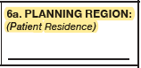

- ABCs Invasive Pneumococcal Disease (IPD) Report Form - Attachment #4
 | 2023 Form | 2024 Form (Changes in yellow highlight)
a) | 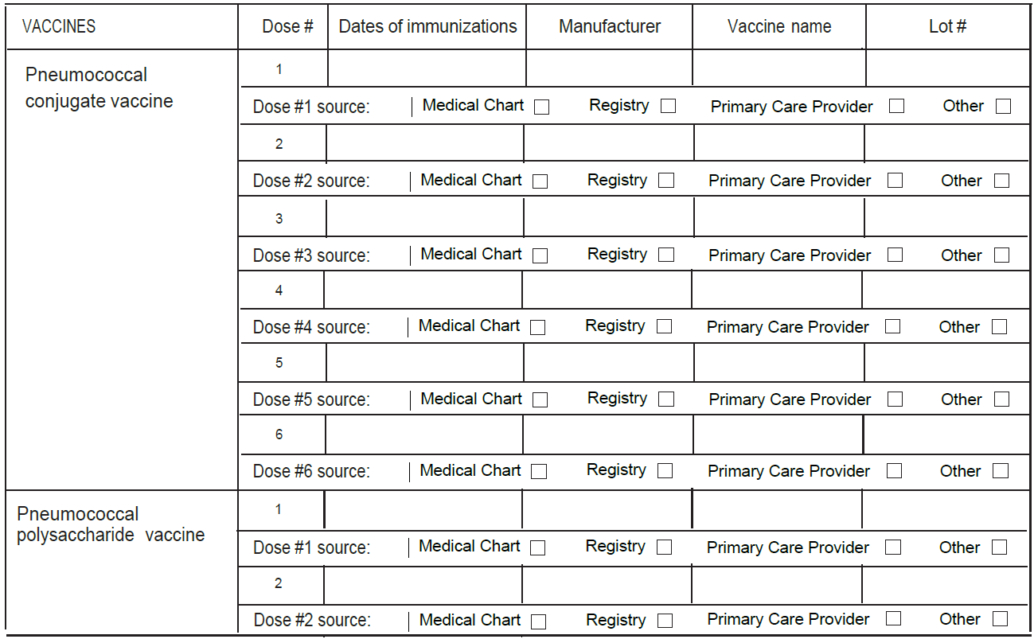 | Updated overall design of the form to show available all data value sets.  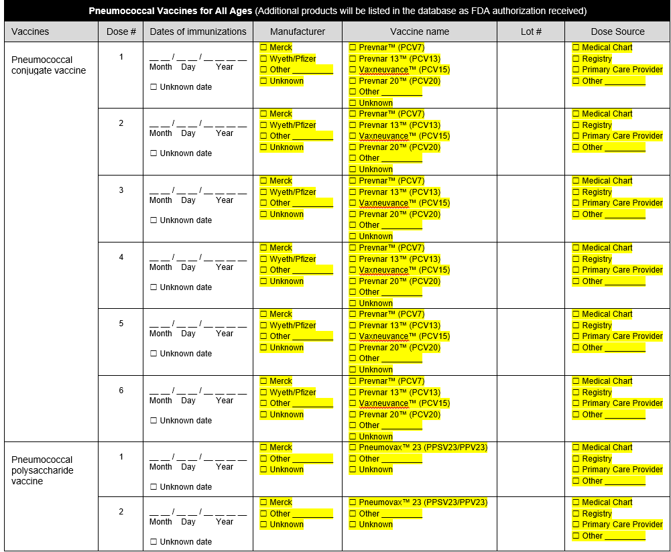
b) |  | i) Added question on most recent influenza vaccine date.  ii) Added question on most recent COVID-19 vaccine date.  iii) Added question on RSV vaccine date  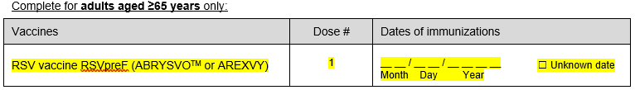  iv) Added question on RSV monoclonal antibody dates (complete for children <5 years only)  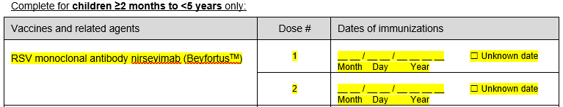
c) | 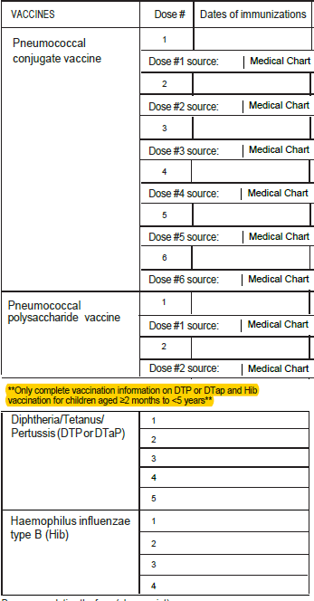 | Addition of unknown checkboxes for all vaccination date variables.  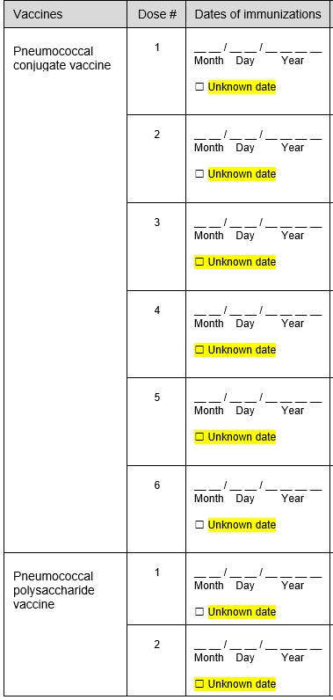  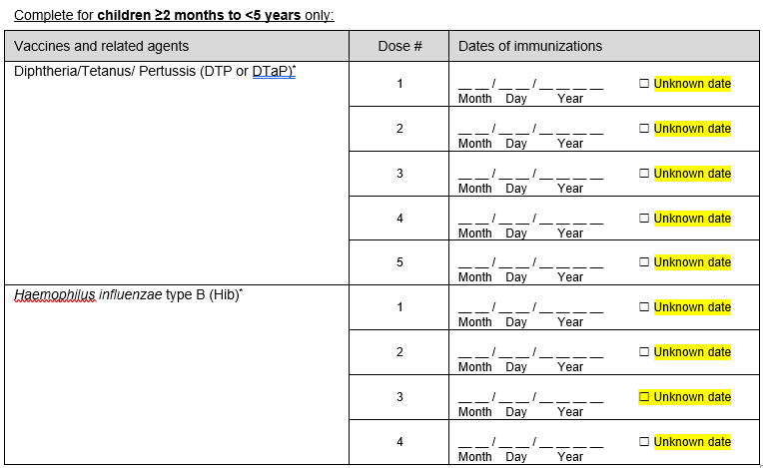
d) | 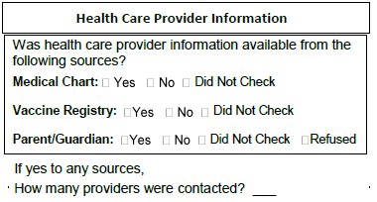 | Removed questions.

FoodNET

- FoodNet Active Surveillance Data Elements List – Attachment #5
Refer to Attachment #5 - Changes are highlighted in Yellow

FluSurv-Net

- FluSurv-NET Influenza Surveillance Project Case Report Form– Attachment #6

Question on 2022-23 Form | Questions on 2023-24 Form
Patient Data – This information is not sent to CDC  - N/A | Patient Data – This information is not sent to CDC  - Pharmacy of Record  - Pharmacy Phone  - Pharmacy Fax  - Pharmacy Address
Case Classification  □ Prospective  □ Surveillance Discharge Audit | Case Classification  □ Surveillance Discharge Audit
C15. Where did the patient reside at the time of hospitalization (Indicate type of residence)  - Private residence  - Private residence with services  - Homeless/Shelter  - Nursing home/Skilled nursing facility  - Alcohol/Drug Abuse Treatment  - Hospitalized at birth  - Rehabilitation facility  - Corrections facility  - Hospice  - Assisted living/Residential care  - LTACH  - Group/Retirement home  - Psychiatric facility  - Other long term care facility  - Other, specify:_______  - Unknown | C15. Where did the patient reside at the time of hospitalization (Indicate type of residence)  - Private residence  - Private residence with services  - Homeless/Shelter/Temporary housing  - Nursing home/Skilled nursing facility  - Substance abuse treatment center  - Hospitalized at birth  - Rehabilitation facility  - Corrections facility  - Hospice  - Assisted living/Residential care  - LTACH  - Group/Retirement home  - Psychiatric facility  - Other long term care facility  - Other, specify:_______  - Unknown
N/A | E5. Supplemental Oxygen?  - Yes  - No  - Unknown
F2. If patient discharged alive, please indicate to where:  - Private residence  - Private residence with services  - Homeless/Shelter  - Nursing home/Skilled nursing facility  - Alcohol/Drug Abuse Treatment  - Hospitalized at birth  - Rehabilitation facility  - Corrections facility  - Hospice  - Assisted living/Residential care  - LTACH  - Group/Retirement home  - Psychiatric facility  - Other long term care facility  - Against medical advice (AMA)  - Discharged to another hospital  - Other, specify:_______  - Unknown | F2. If patient discharged alive, please indicate to where:  - Private residence  - Private residence with services  - Homeless/Shelter/Temporary housing  - Nursing home/Skilled nursing facility  - Substance abuse treatment center  - Hospitalized at birth  - Rehabilitation facility  - Corrections facility  - Hospice  - Assisted living/Residential care  - LTACH  - Group/Retirement home  - Psychiatric facility  - Other long term care facility  - Against medical advice (AMA)  - Discharged to another hospital  - Other, specify:_______  - Unknown
G1. Reason for admission:  - “Influenza/COVID/RSV-related illness”  - OB/Labor and delivery admission  - Inpatient surgery procedures  - Psychiatric admission needing acute medical care  - Trauma  - Unknown  - Other, specify: _________ | G1. Reason for admission:  - “Influenza/COVID/RSV-related illness”  - OB/Labor and delivery admission  - Inpatient surgery procedures  - Psychiatric admission needing acute medical care  - Trauma  - Newborn/Hospitalized at birth  - Unknown  - Other, specify: _________
G2. Acute signs/symptoms present at admission (began or worsened within 2 weeks prior to admission) (Select all that apply)  Non respiratory symptoms  - Abdominal pain  - Altered mental status/confusion  - Anosmia/decreased smell  - Chest pain  - Conjunctivitis  - Diarrhea  - Dysgeusia/decreased taste  - Fatigue  - Fever/chills  - Headache  - Muscle aches/myalgias  - Nausea/vomiting  - Rash  - Seizures | G2. Acute signs/symptoms present at admission (began or worsened within 2 weeks prior to admission) (Select all that apply)  Non respiratory symptoms  - Abdominal pain  - Altered mental status/confusion  - Anosmia/decreased smell  - Chest pain/tightness  - Conjunctivitis  - Diarrhea  - Dysgeusia/decreased taste  - Fatigue  - Fever/chills  - Headache  - Muscle aches/myalgias  - Nausea/vomiting  - Rash  - Seizures
G2. Acute signs/symptoms present at admission (began or worsened within 2 weeks prior to admission) (Select all that apply)  Respiratory symptoms  - Congested/runny nose  - Cough  - Hemoptysis/bloody sputum  - Shortness of breath/respiratory distress  - Sore throat  - URI/ILI  - Wheezing | G2. Acute signs/symptoms present at admission (began or worsened within 2 weeks prior to admission) (Select all that apply)  Respiratory symptoms  - Congested/runny nose  - Chest congestion  - Cough  - Hemoptysis/bloody sputum  - Shortness of breath/respiratory distress  - Sore throat  - URI/ILI  - Wheezing
G2. Acute signs/symptoms present at admission (began or worsened within 2 weeks prior to admission) (Select all that apply)  For cases <2 years  - Apnea  - Cyanosis  - Decreased vocalization/stridor  - Dehydration  - Hypothermia  - Inability to eat/poor feeding  - Lethargy | G2. Acute signs/symptoms present at admission (began or worsened within 2 weeks prior to admission) (Select all that apply)  For cases <12 years  - Apnea  - Cyanosis  - Stridor/decreased vocalization  - Dehydration/decreased urine output  - Hypothermia  - Inability to eat/poor feeding  - Irritability/fussiness/excess crying  - Lethargy/decreased activity  - Nasal flaring/grunting/retractions  - Tachypnea/increased work of breathing
N/A | G8. Environmental tobacco smoke exposure (for pediatric patients <12 years):  - Yes  - No  - Unknown
I1a. If yes, what is the specimen source?  - Blood  - Bronchoalveolar lavage (BAL)  - Pleural fluid  - Cerebrospinal fluid (CSF)  - Sputum  - Endotrache aspirate  - Other, specify: ___________ | I1a. If yes, what is the specimen source?  - Blood  - Bone/joint aspirate  - Bronchoalveolar lavage (BAL), bronchial aspirate/wash  - Cerebrospinal fluid (CSF)  - Endotracheal/tracheal aspirate  - Peritoneal or abdominal fluid/ascites  - Pleural fluid  - Sputum  - Wound- Group A Streptococcus (only)  - Other, specify: ___________
J1. Was patient tested for any of the following viral respiratory pathogens within 14 days prior to admission or ≤3 days after admission?  - RSV  - Adenovirus  - Parainfluenza 1  - Parainfluenza 2  - Parainfluenza 3  - Parainfluenza 4  - Human metapneumovirus  - Rhinovirus/Enterovirus  - Coronavirus SARS-CoV-2  - Coronavirus, other | J1. Was patient tested for any of the following viral respiratory pathogens within 14 days prior to admission or ≤3 days after admission?  - RSV  - Adenovirus  - Parainfluenza 1  - Parainfluenza 2  - Parainfluenza 3  - Parainfluenza 4  - Human metapneumovirus  - Rhinovirus/Enterovirus  - Coronavirus 229E  - Coronavirus HKU1  - Coronavirus NL63  - Coronavirus OC43  - Coronavirus SARS-CoV-2  - Coronavirus (not further specified)
L. Chest Imaging – Based on radiology report only  2b. For the first abnormal chest x-ray, please check all that apply  - Report not available  - Air space density  - Air space opacity  - Bronchopneumonia/pneumonia  - Cannot rule out pneumonia  - Consolidation  - Cavitation  - ARDS (acute respiratory distress syndrome)  - Lung Infiltrate  - Interstitial infiltrate  - Lobar infiltrate  - Pleural Effusion  - Empyema  - Other | L. Chest X-ray – Based on radiology report only  2b. For the first abnormal chest x-ray, please check all that apply  - Report not available  - Air space density  - Air space opacity  - Bronchopneumonia/pneumonia  - Cannot rule out pneumonia  - Consolidation  - Cavitation  - ARDS (acute respiratory distress syndrome)  - Infiltrate (lung, interstitial, other)  - Lobar infiltrate  - Pleural Effusion  - Empyema  - Other
M1. Did the patient have any of the following new diagnoses at discharge? (Select all that apply)  - Acute encephalopathy/encephalitis  - Acute liver failure  - Acute myocardial infarction  - Acute myocarditis  - Acute renal failure/acute kidney injury  - Acute respiratory distress syndrome (ARDS)  - Acute respiratory failure  - Asthma exacerbation  - Bacteremia  - Bronchiolitis  - Bronchitis  - Chronic lung disease of prematurity/BPD  - Congestive heart failure  - COPD exacerbation  - Deep vein thrombosis (DVT)  - Diabetic ketoacidosis  - Disseminated intravascular coagulation (DIC)  - Guillain-Barre syndrome  - Hemophagocytic syndrome  - Invasive pulmonary aspergillosis  - Kawasaki disease  - Mucormycosis  - Multisystem inflammatory syndrome in children (MIS-C) or adults (MIS-A)  - Other thrombosis/embolism/coagulopathy  - Pneumonia  - Pulmonary embolism (PE)  - Reye’s syndrome  - Rhabdomyolysis  - Sepsis  - Seizures  - Stroke (CVA)  - Toxic shock syndrome (TSS) | M1. Did the patient have any of the following new diagnoses at discharge? (Select all that apply)  - Acute complication of sickle cell  - Acute encephalopathy/encephalitis  - Acute liver failure  - Acute myocardial infarction  - Acute myocarditis  - Acute renal failure/acute kidney injury  - Acute respiratory distress syndrome (ARDS)  - Acute respiratory failure  - Asthma exacerbation  - Atrial fibrillation (Afib) new-onset or paroxysmal/chronic  - Bacteremia  - Bronchiolitis  - Bronchitis  - Cardiac arrest  - Chronic lung disease of prematurity/BPD  - Congestive heart failure exacerbation  - COPD exacerbation  - Deep vein thrombosis (DVT)  - Diabetic ketoacidosis  - Disseminated intravascular coagulation (DIC)  - Guillain-Barre syndrome  - Hemophagocytic syndrome  - Invasive pulmonary aspergillosis  - Kawasaki disease  - Mucormycosis  - Multisystem inflammatory syndrome in children (MIS-C) or adults (MIS-A)  - Other thrombosis/embolism/coagulopathy  - Pneumonia  - Pulmonary embolism (PE)  - Reye’s syndrome  - Rhabdomyolysis  - Sepsis  - Seizures  - Stroke (CVA)  - Supraventricular tachycardia (SVT)  - Toxic shock syndrome (TSS)  - Ventricular fibrillation (Vfib)  - Ventricular tachycardia (V-tach)
N/A | O5. Pregnancy complications during current pregnancy? (Select all that apply)  - None  - Gestational diabetes  - Pre-eclampsia  - Pregnancy-induced hypertension (PIH)  - Intrauterine growth restriction (IUGR)  - Unknown
O6a. If patient was pregnant on admission but no longer pregnant at discharge, indicate pregnancy outcome at discharge. | O6a. If patient was pregnant on admission but no longer pregnant at discharge, indicate pregnancy outcome at discharge. (If multiple fetuses, indicate outcome at discharge for each fetus in the database separately.)

- FluSurv-NET/RSV Laboratory Survey– Attachment #7

Question on 2022-23 form | Question on 2023-24 form
N/A | Title of person responding to questions for laboratory
N/A | 3. Does the laboratory currently (or plan to in the next year) send out specimens to be tested with the Karius Test?  - Yes  - No  - Unknown
4A. Select the kit name(s) (manufacturer) for the rapid influenza antigen diagnostic test performed or planned to be used at the laboratory: (Check all that apply)  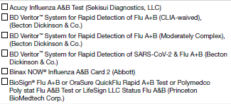  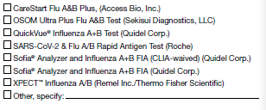 | 5A. Select the kit name(s) (manufacturer) for the rapid influenza antigen diagnostic test performed or planned to be used at the laboratory: (Check all that apply)  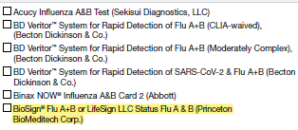  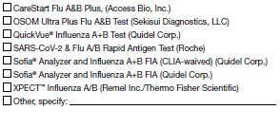
5a. Select the kit name(s) (manufacturer) for all molecular assays performed or planned to be used at the laboratory: (Check all that apply)  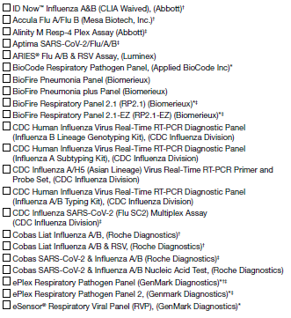  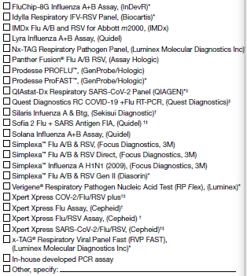 | 6a. Select the kit name(s) (manufacturer) for all molecular assays performed or planned to be used at the laboratory: (Check all that apply)  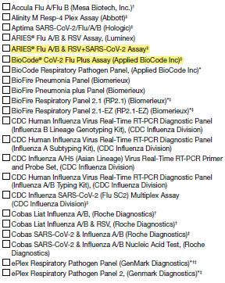  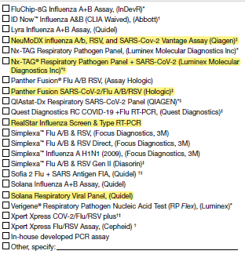
5b. If more than one kit is selected above, please select the one kit name that is (or will be) used most frequently for molecular assay at the laboratory during the current influenza season:  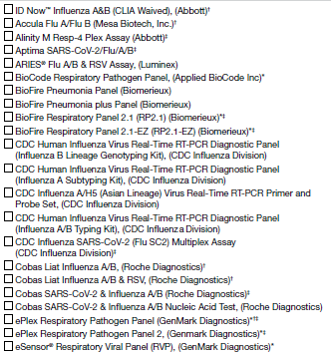  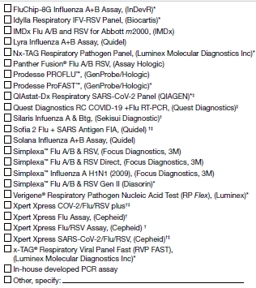 | 6b. If more than one kit is selected above, please select the one kit name that is (or will be) used most frequently for molecular assay at the laboratory during the current influenza season:  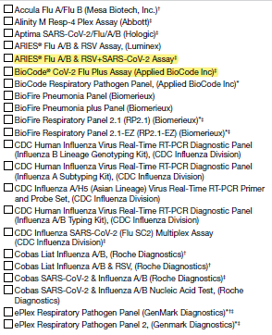  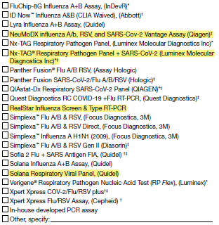

- COVID19 Vaccination Status on FluSurv-NET Cases – Attachment #8
Questions on 2022-23 form | Questions on 2023-24 form
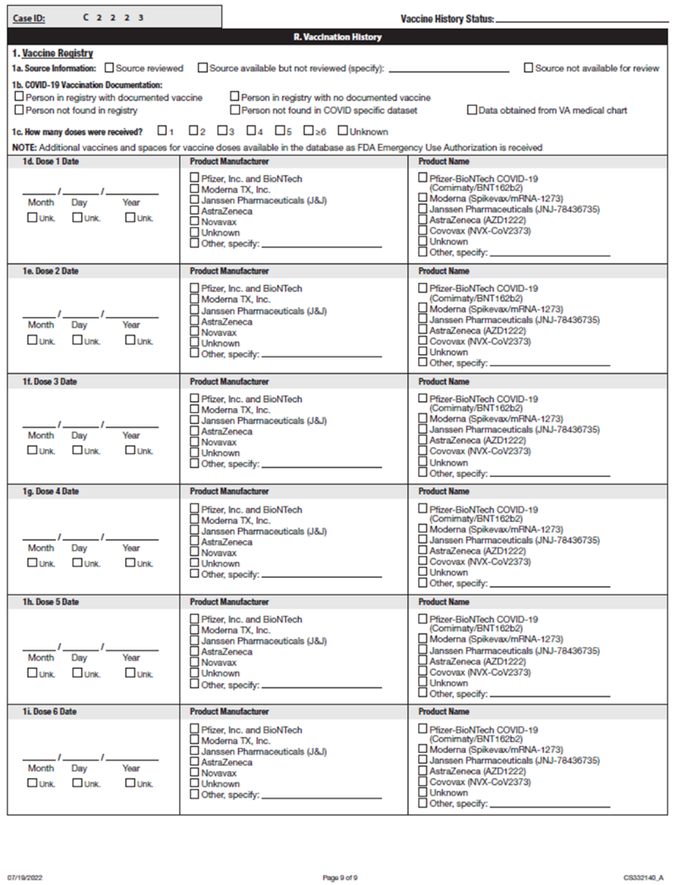 | 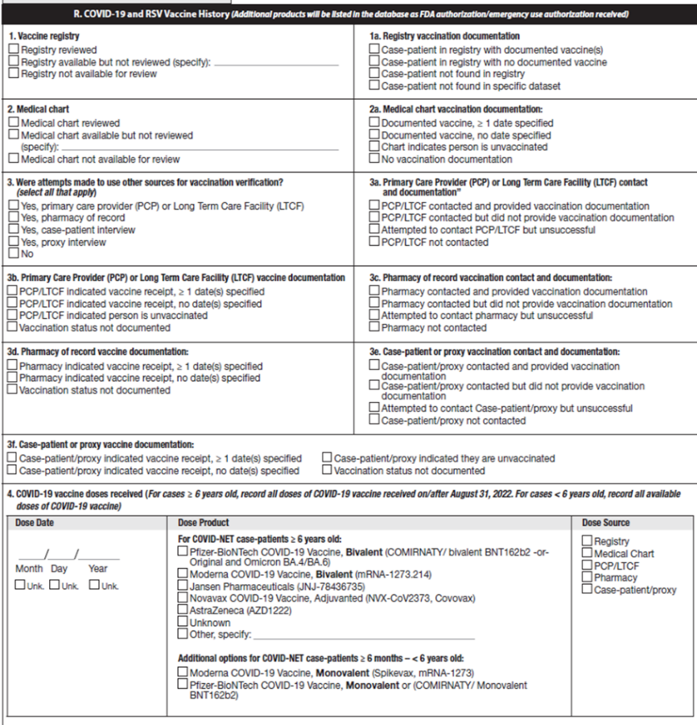

HAIC
  - Multi-site Gram-Negative Surveillance Initiative (MuGSI) Case Report Form (CRF) Attachment #9

Question on original 2023 form | Question on 2024 form | Description of change
2023 Carbapenem Resistant Enterobacteriaceae (CRE)/ Carbapenem Resistant A. baumannii  (CRAB) Multi-site Gram-Negative Surveillance Initiative (MuGSI)  Healthcare-Associated Infections Community Interface (HAIC) Case Report | 2024 Multi-site Gram-Negative Surveillance Initiative (MuGSI)  Healthcare-Associated Infections Community Interface (HAIC) Case Report | I. Updated year to 2024  II. Removed the pathogens from the title since this one form covers all of MuGSI surveillance pathogens
10. Organism:  CRE CRAB  If CRE, select one of the following:  Escherichia coli Klebsiella aerogenes Klebsiella oxytoca  Enterobacter cloacae Klebsiella pneumoniae | 10. Organism:  Carbapenem-Resistant Enterobacterales (CRE)  Escherichia coli  Klebsiella pneumoniae  Klebsiella oxytoca  Klebsiella aerogenes  Enterobacter cloacae  Extended-spectrum beta-lactamase-producing Enterobacterales (ESBL-E)  Escherichia coli  Klebsiella pneumoniae  Klebsiella oxytoca  Carbapenem-Resistant A. baumannii (CRAB)  Invasive Escherichia coli (iEC)  (not CRE or ESBL-E) | I. Updated all MuGSI pathogens and phenotypes under surveillance
16. Patient Outcome:  On the day of or in the 6 calendar days before death, was the pathogen of interest isolated from a site that meets the case definition?  Yes  No  Unknown | 16. Patient Outcome  [Removed] | I. Removed the specified question from “16. Patient Outcome:” on the 2024 form
17a. Types of infection associated with culture(s):  (Check all that apply) None Colonized Unknown  Abscess, not skin  AV fistula/graft infection  Bacteremia  Bursitis  Catheter site infection (CVC)  Cellulitis  Chronic Ulcer/wound (not decubitus)  Decubitus/pressure ulcer  Empyema  Endocarditis  Epidural abscess  Meningitis  Osteomyelitis  Peritonitis  Pneumonia (CRAB cases, complete Q23c)  Pyelonephritis  Septic arthritis  Septic emboli  Septic shock  Skin abscess  Surgical incision infection  Surgical site infection (internal)  Traumatic wound  Urinary tract infection  Other (specify):______________ | 17a. Types of infection associated with culture(s):  (Check all that apply) None Colonized Unknown  Abscess, not skin  AV fistula/graft infection  Bacteremia  Bursitis  Catheter site infection (CVC)  Cellulitis  Chronic Ulcer/wound (not decubitus)  Decubitus/pressure ulcer  Empyema  Endocarditis  Epidural abscess  Meningitis  Osteomyelitis  Peritonitis  Pneumonia (CRAB cases, complete Q23c)  Pyelonephritis  Sepsis  Urosepsis  Septic arthritis  Septic emboli  Septic shock  Skin abscess  Surgical incision infection  Surgical site infection (internal)  Traumatic wound  Urinary tract infection  Other (specify):______________ | I. Included “Sepsis” as an infection type, including a sub-choice for “Urosepsis”
 | 20. Risk factors: (Check all that apply)  Invasive or diagnostic urologic procedure in the year before DISC:  Yes No Unknown  If yes, check all that apply:  Prostate procedure Cystoscopy  Other | I. Added a new risk factor question.
23b. Risk factors in the 7 days before the DISC:  Non-invasive positive pressure ventilation (CPAP or BiPAP) at any time in the  7 calendar days before the DISC  Nebulizer treatment at any time in the 7 calendar days before the DISC  Mechanical ventilation at any time in the 7 calendar days before the DISC  None | 23b. Risk factors prior to CRAB DISC:  Non-invasive positive pressure ventilation (CPAP or BiPAP) at any time in the  7 calendar days before the DISC  Nebulizer treatment at any time in the 7 calendar days before the DISC  Mechanical ventilation at any time in the 7 calendar days before the DISC  Visited a wound care clinic at any time in the year before the DISC  None | I. Revised the text for the question.  II. Added an additional risk factor in the year before the DISC
 | 24a. Is antimicrobial use (IV or Oral) in the 30 days before the DISC documented?  Yes No Unknown | I. Added question  Note: This question is not new to MuGSI surveillance nor the MuGSI database. It is being included in the consolidated 2024 form from the OMB-approved 2023 ESBL/iEC form
 | 24b. If yes, check all antimicrobials used in the 30 days before the DISC:  (Check all that apply)  Amikacin  Amoxicillin  Amoxicillin/clavulanic acid  Ampicillin  Ampicillin/sulbactam  Azithromycin  Aztreonam  Cefadroxil  Cefazolin  Cefdinir  Cefepime  Cefiderocol  Ceixime  Cefotaxime  Cefoxitin  Cefpodoxime  Ceftaroline  Ceftazidime  Ceftazidime/avibactam  Ceftizoxime  Ceftolozane/tazobactam  Ceftriaxone  Cefuroxime  Cephalexin  Ciprofloxacin  Clarithromycin  Clindamycin  Dalbavancin  Daptomycin  Delafloxacin  Doripenem  Doxycycline  Eravacycline  Ertapenem  Fidaxomicin  Fosfomycin  Gentamicin  Imipenem/cilastatin  Levofloxacin  Linezolid  Meropenem  Meropenem/vaborbactam  Metronidazole  Moxifloxacin  Nitrofurantoin  Omadacycline  Oritavancin  Penicillin  Piperacillin/tazobactam  Polymyxin B  Polymyxin E (colistin)  Rifaximin  Tedizolid  Telavancin  Tigecycline  Tobramycin  Trimethoprim  Trimethoprim/sulfamethoxazole  Vancomycin  IV  PO  Other (specify):___________  Other (specify):___________  Reminder: Any prior antimicrobial use that is not noted above should be documented in the other (specify) field. | I. Added question  Note: This question is not new to MuGSI surveillance nor the MuGSI database. It is being included in the consolidated 2024 form from the OMB-approved 2023 ESBL/iEC form
24c. COVID-Net Case ID:_________ | 25c. COVID-Net Case ID in the year before or day of DISC:_________  None or N/A | I. Updated the question number  II. Added the specified timeframe  III. Included a checkbox for “None or N/A”

- Multi-site Gram-Negative Surveillance Initiative (MuGSI) Community-Associated Carbapenemase-Producing Carbapenem-Resistant Enterobacterales (CA CP-CRE) Health interview - Attachment #10

Original Instruction | Proposed Change to Instruction
[If answer to Q22 = 1, i.e., interviewee lives alone, skip to Section G] | [If answer to Q22 = 1, i.e., interviewee lives alone, skip to Section 9]

- Multi-site Gram-Negative Surveillance Initiative (MuGSI) Supplemental Surveillance Officer Survey - Attachment #11
2023 Survey Question | 2024 Survey Question
Description:  Please answer the following questions for the year 2023. The purpose of the survey is to verify and document current surveillance procedures, including isolate collection and testing methods at clinical laboratories. Please enter your responses into the corresponding RedCap database. If you have any questions, please contact Julian Grass (hij3@cdc.gov) and Joshua Brandenburg (ode4@cdc.gov). | Description:  Please answer the following questions for the year 2024, unless otherwise specified. The purpose of the survey is to verify and document current surveillance procedures, including isolate collection and testing methods at clinical laboratories. Please enter your responses into the corresponding REDCap database. If you have questions, please contact Julian Grass (hij3@cdc.gov) and Joshua Brandenburg (ode4@cdc.gov).
Surveillance area characteristics:  - What counties are under surveillance for MuGSI activities at your site?  - Carbapenem-resistant Enterobacterales (CRE) surveillance area, please specify:  - Carbapenem-resistant Acinetobacter baumannii (CRAB) surveillance area, please specify:  - Extended-spectrum β-lactamases-producing Enterobacterales (ESBL-E) surveillance area, please specify: | Surveillance area characteristics:  - What counties are under surveillance for MuGSI activities at your site?  - Carbapenem-resistant Enterobacterales (CRE) surveillance area, please specify:  - Carbapenem-resistant Acinetobacter baumannii (CRAB) surveillance area, please specify:  - Extended-spectrum β-lactamases-producing Enterobacterales (ESBL-E) surveillance area, please specify:  - Invasive Escherichia coli (iEC) surveillance area, please specify:
Surveillance area characteristics:  - Is CRE state reportable at your site? ___ yes___ no  - If yes:  - Please describe your state reportable definition of CRE:______________  - What is the catchment area where CRE is reportable at your site?  _______ Statewide  _______ Defined catchment area, please specify__________  - Is isolate submission to the State Health Department Laboratory required?  _______ yes _______ no  - If no:  - What mechanism do you have in place that allows for SOs to have access to CRE case counts and medical records?  _______ Agent of the state  _______ State Health Department Regulation  _______ Other, please explain: __________________________________  - Does your state/site plan to make CRE reportable? ___ yes ___ no | Surveillance area characteristics:  2. Is CRE reportable at your state/site? ___ yes ___ no  - If yes:  - Please describe your state reportable definition of CRE:______________  - Where in your state is CRE reportable?  _______ Statewide  _______ Defined area, such as a county(ies). Please specify  - Is isolate submission to the State Health Department Laboratory required?  _______ yes _______ no specify ___________  - If no:  - What mechanism do you have in place that allows for surveillance officers (SOs) to have access to CRE laboratory reports and medical records?  _______ Agent of the state  _______ State Health Department Regulation  _______ Other, please explain: _____________  - Does your state/site plan to make CRE reportable? ___ yes ___ no ___ unknown  - If yes, when does your state/site plan to make CRE reportable?
Surveillance area characteristics:  3. Is CRAB state reportable at your site? ___ yes___ no  - If yes:  - Please describe your state reportable definition of CRAB:______________  - What is the catchment area where CRAB is reportable at your site?  _______ Statewide  _______ Defined catchment area, please specify__________  - Is isolate submission to the State Health Department Laboratory required?  _______ yes _______ no  - If no:  - What mechanism do you have in place that allows for SOs to have access to CRAB case counts and medical records?  _______ Agent of the state  _______ State Health Department Regulation  _______ Other, please explain: __________________________________  - Does your state/site plan to make CRAB reportable? ___ yes ___ no | Surveillance area characteristics:  - Is CRAB state reportable at your site? ___ yes___ no  - If yes:  - Please describe your state reportable definition of CRAB:______________  - Where in your state is CRAB reportable?  _______ Statewide  _______ Defined area, such as a county(ies). Please specify  - Is isolate submission to the State Health Department Laboratory required?  _______ yes _______ no specify ___________  - If no:  - What mechanism do you have in place that allows for surveillance officers (SOs) to have access to CRAB laboratory reports and medical records?  _______ Agent of the state  _______ State Health Department Regulation  _______ Other, please explain: _____________  - Does your state/site plan to make CRAB reportable? ___ yes ___ no ___ unknown  - If yes, when does your state/site plan to make CRAB reportable?
Surveillance area characteristics:  - Is ESBL-E state reportable at your site? ___ yes___ no  - If yes:  - Please describe your state reportable definition of ESBL-E:______________  - What is the catchment area where ESBL-E is reportable at your site?  _______ Statewide  _______ Defined catchment area, please specify__________  - Is isolate submission to the State Health Department Laboratory required?  _______ yes _______ no  - If no:  - What mechanism do you have in place that allows for SOs to have access to ESBL-E case counts and medical records?  _______ Agent of the state  _______ State Health Department Regulation  _______ Other, please explain: __________________________________  - Does your state/site plan to make ESBL-E reportable? ___ yes ___ no | Surveillance area characteristics:  4. Is ESBL-E reportable at your state/site? ___ yes ___ no  - If yes:  - Please describe your state reportable definition of ESBL-E:______________  - Where in your state is ESBL-E reportable?  _______ Statewide  _______ Defined area, such as a county(ies). Please specify  - Is isolate submission to the State Health Department Laboratory required?  _______ yes _______ no specify ___________  - If no:  - What mechanism do you have in place that allows for surveillance officers (SOs) to have access to ESBL-E laboratory reports and medical records?  _______ Agent of the state  _______ State Health Department Regulation  _______ Other, please explain: _____________  - Does your state/site plan to make ESBL-E reportable? ___ yes ___ no ___ unknown  - If yes, when does your state/site plan to make ESBL-E reportable?
Surveillance area characteristics:
- Is iEC reportable at your state/site? ___ yes ___ no
  - If yes:
- Please describe your state reportable definition of iEC:______________
- Where in your state is iEC reportable?
_______ Statewide
_______ Defined area, such as a county(ies). Please specify
- Is isolate submission to the State Health Department Laboratory required?
_______ yes _______ no specify ___________
  - If no:
- What mechanism do you have in place that allows for surveillance officers (SOs) to have access to iEC laboratory reports and medical records?
_______ Agent of the state
_______ State Health Department Regulation
_______ Other, please explain: _____________
- Does your state/site plan to make iEC reportable? ___ yes ___ no ___ unknown
      - If yes, when does your state/site plan to make iEC reportable?
Laboratory Participation and Isolate Testing  - Please describe the clinical laboratories in the MuGSI catchment area:  - CRE  - Proportion of clinical laboratories serving that catchment area that participate in MuGSI CRE surveillance: ___________________  - Number of clinical laboratories serving the catchment area that participate in MuGSI CRE surveillance with queries installed on their automated testing instrument (ATI) or laboratory information system (LIS): ___________________  - Total number of clinical laboratories serving the MuGSI CRE catchment area:______________  - Please describe how MuGSI CRE surveillance is conducted at laboratories where ATI/LIS queries are not installed (e.g., HL7 messages from LabCorp):_______________________________________  - CRAB  - Proportion of clinical laboratories serving that catchment area that participate in MuGSI CRAB surveillance: ___________________  - Number of clinical laboratories serving the catchment area that participate in MuGSI CRAB surveillance with queries installed on their ATI or LIS: ___________________  - Total number of clinical laboratories serving the MuGSI CRAB catchment area:______________  - Please describe how MuGSI CRAB surveillance is conducted at laboratories where ATI/LIS queries are not installed (e.g., HL7 messages from LabCorp):_________________________________  - ESBL  - Proportion of clinical laboratories serving that catchment area that participate in MuGSI ESBL surveillance: ___________________  - Number of clinical laboratories serving the catchment area that participate in MuGSI ESBL surveillance with queries installed on their ATI or LIS: ___________________  - Total number of clinical laboratories serving the MuGSI ESBL catchment area:______________  - Please describe how MuGSI ESBL surveillance is conducted at laboratories where ATI/LIS queries are not installed (e.g., HL7 messages from LabCorp):_________________________________ | Laboratory Participation and Isolate Testing – Part 1  - Please describe the clinical laboratories in the MuGSI catchment area:  - CRE  - Proportion of clinical laboratories serving the MuGSI CRE surveillance area with queries installed on their automated testing instrument (ATI) or laboratory information system (LIS): ___________________  - Numerator: Number of clinical laboratories serving the MuGSI CRE surveillance area with queries installed on their ATI or LIS: ___________________  - Denominator: Total number of clinical laboratories that receive and process specimens from residents of the MuGSI CRE surveillance area:______________  - Please describe how MuGSI CRE surveillance is conducted at laboratories where ATI/LIS queries are not installed (e.g., HL7 messages from LabCorp): __________________________________________________________________  - CRAB  - Proportion of clinical laboratories serving the MuGSI CRAB surveillance area with queries installed on their ATI or LIS: ___________________  - Numerator: Number of clinical laboratories serving the MuGSI CRAB surveillance area with queries installed on their ATI or LIS: _________________  - Denominator: Total number of clinical laboratories that receive and process specimens from residents of the MuGSI CRAB surveillance area: _____________  - Please describe how MuGSI CRAB surveillance is conducted at laboratories where ATI/LIS queries are not installed (e.g., HL7 messages from LabCorp): __________________________________________________________________  - ESBL-E  - Proportion of clinical laboratories serving the MuGSI ESBL-E surveillance area with queries installed on their ATI or LIS: ___________________  - Numerator: Number of clinical laboratories serving the MuGSI ESBL-E surveillance area with queries installed on their ATI or LIS: _________________  - Denominator: Total number of clinical laboratories that receive and process specimens from residents of the MuGSI ESBL-E surveillance area:____________  - Please describe how MuGSI ESBL-E surveillance is conducted at laboratories where ATI/LIS queries are not installed (e.g., HL7 messages from LabCorp): __________________________________________________________________  - iEC  - Proportion of clinical laboratories serving the MuGSI iEC surveillance area with queries installed on their ATI or LIS: ___________________  - Numerator: Number of clinical laboratories serving the MuGSI iEC surveillance area with queries installed on their ATI or LIS: ___________________  - Denominator: Total number of clinical laboratories that receive and process specimens from residents of the MuGSI iEC surveillance area:______________  - Please describe how MuGSI iEC surveillance is conducted at laboratories where ATI/LIS queries are not installed (e.g., HL7 messages from LabCorp): _________________________________________________________________
Laboratory Participation and Isolate Testing – Part 1
- Did any laboratories drop out of participation in 2023? _______ yes _______ no

- If yes, how many? _________
- Why did these laboratories drop out of participation?
________________________________________________________________________
________________________________________________________________________

Laboratory Participation and Isolate Testing – Part 1
- In 2023, did you identify additional laboratories, regardless of location, which identify MuGSI isolates from persons who are residents of the MuGSI surveillance area at your site?
_______ yes _______ no

  - If yes, how many? _________
  - If yes, how many of these laboratories were added? _______
    - If all new laboratories identified were not added, why not? __________________________________________________________________
__________________________________________________________________
  - If yes, how did you identify these new laboratories?
_____________________________________________________________________
  - Approximately how many cases are identified at the new laboratories each year among residents of the MuGSI surveillance area? ________

Laboratory Participation and Isolate Testing  2. Did your site send MuGSI isolates to CDC for characterization in 2023? ____yes ____no  - If yes, please describe the sampling strategy for MuGSI isolates sent to CDC:  - CRE: __________________________  - CRAB: _________________________  - ESBL______________________________  - If yes, how many clinical laboratories contribute MuGSI isolates:  - CRE: __________________________  - CRAB: _________________________  - ESBL: _________________________ | Laboratory Participation and Isolate Testing – Part 1  - Did your site send any MuGSI isolates to CDC for characterization in calendar year 2023? _______ yes _______ no  - If yes, please describe how your site determines which MuGSI isolates to send to CDC:  - CRE: ____________________________________  - CRAB: ___________________________________  - ESBL: ____________________________________  - iEC: _____________________________________  - If yes, how many clinical laboratories contributed MuGSI isolates:  - CRE: ____________________________________  - CRAB: ___________________________________  - ESBL: ____________________________________  - iEC: _____________________________________
Laboratory Participation and Isolate Testing  - If yes, how many isolates did you expect to be able to collect from the clinical laboratories in 2023?  _______ CRE; _______ CRAB; _______ ESBL | Laboratory Participation and Isolate Testing – Part 1  - How many isolates with a specimen collection date in 2023 did you expect to be able to collect from the clinical laboratories?  _______ CRE; _______ CRAB; _______ ESBL; ________iEC
Laboratory Participation and Isolate Testing  d.If yes, what was the total number of isolates collected from the clinical laboratories in 2023?  _______ CRE; _______ CRAB; _______ ESBL | Laboratory Participation and Isolate Testing – Part 1  - What was the total number of isolates with a specimen collection date in 2023 that were collected from the clinical laboratories?  _______ CRE; _______ CRAB; _______ ESBL; _______iEC
Laboratory Participation and Isolate Testing  Type of Laboratory | Laboratory Participation and Isolate Testing – Part 2  - Type of laboratory:  _____clinical laboratory  _____public health laboratory  _____research laboratory  _____reference laboratory
Laboratory Participation and Isolate Testing  MuGSI pathogens under surveillance | Laboratory Participation and Isolate Testing – Part 2  - MuGSI pathogen(s) under surveillance:  _____CRE  _____CRAB  _____ESBL  _____iEC
Laboratory Participation and Isolate Testing | Laboratory Participation and Isolate Testing – Part 2  - Method for sharing laboratory reports with your site:  _____electronic messaging, such as HL7  _____e-mail  _____fax  _____EIP staff manually generate reports on-site  _____other, please specify_____________________  _____unknown
Laboratory Participation and Isolate Testing  Method for case identification | Laboratory Participation and Isolate Testing – Part 2  - Method for case identification:  _____automated testing instrument  _____laboratory information system  _____medical record  _____other, please specify_____________________  _____unknown
Laboratory Participation and Isolate Testing  Carbapenem confirmatory testing and method | Laboratory Participation and Isolate Testing – Part 2  7.Carbapenem confirmatory testing method  - Please report the carbapenem confirmatory testing method(s) performed for each MuGSI organism separately.  kirby bauer:_____CRE _____CRAB _____ESBL _____iEC  other, please specify: _____CRE _____CRAB _____ESBL _____iEC  laboratory not testing _____CRE _____CRAB _____ESBL _____iEC  unknown _____CRE _____CRAB _____ESBL _____iEC
Laboratory Participation and Isolate Testing  Carbapenemase testing method | Laboratory Participation and Isolate Testing – Part 2  8.Carbapenemase testing method  - Please report the carbapenemase testing method(s) performed for each MuGSI organism separately.  Non-molecular test methods  carbaNP: _____CRE _____CRAB _____ESBL _____iEC  carbapenemase inactivation method: _____CRE _____CRAB _____ESBL _____iEC  CPO detect: _____CRE _____CRAB _____ESBL _____iEC  disk diffusion/ROSCO disk e-test: _____CRE _____CRAB _____ESBL _____iEC  modified carbapenemase inactivation method: _____CRE _____CRAB _____ESBL _____iEC  modified hodge test: _____CRE _____CRAB _____ESBL _____iEC  RAPIDEC: _____CRE _____CRAB _____ESBL _____iEC  Other, please specify: _____CRE _____CRAB _____ESBL _____iEC  laboratory not testing: _____CRE _____CRAB _____ESBL _____iEC  unknown: _____CRE _____CRAB _____ESBL _____iEC  Molecular test methods  automated molecular assay: _____CRE _____CRAB _____ESBL _____iEC  carba-R: _____CRE _____CRAB _____ESBL _____iEC  check points: _____CRE _____CRAB _____ESBL _____iEC  MALDI-TOF MS: _____CRE _____CRAB _____ESBL _____iEC  next generation nucleic acid sequencing: _____CRE _____CRAB _____ESBL _____iEC  polymerase chain reaction: _____CRE _____CRAB _____ESBL _____iEC  streck ARM-D: _____CRE _____CRAB _____ESBL _____iEC  other, please specify:____________________ _____CRE _____CRAB _____ESBL _____iEC  laboratory not testing: _____CRE _____CRAB _____ESBL _____iEC  unknown: _____CRE _____CRAB _____ESBL _____iEC
Laboratory Participation and Isolate Testing  ESBL production testing and method | Laboratory Participation and Isolate Testing – Part 2  - ESBL production testing method  - Please report the ESBL production testing method(s) performed for each MuGSI organism separately.  broth microdilution – ESBL well:_____CRE _____CRAB _____ESBL _____iEC  broth microdilution – ATI flag: _____CRE _____CRAB _____ESBL _____iEC  broth microdilution – manual: _____CRE _____CRAB _____ESBL _____iEC  disk diffusion: _____CRE _____CRAB _____ESBL _____iEC  e-test: _____CRE _____CRAB _____ESBL _____iEC  molecular test, please specify_____CRE _____CRAB _____ESBL _____iEC  other non-molecular test, please specify:_____CRE _____CRAB _____ESBL _____iEC  laboratory not testing: _____CRE _____CRAB _____ESBL _____iEC  unknown: _____CRE _____CRAB _____ESBL _____iEC
Laboratory Participation and Isolate Testing  Organism identification method | Laboratory Participation and Isolate Testing – Part 2  - Organism identification method†  - Please report the organism identification method(s) performed for each MuGSI organism separately.  MALDI-TOF: _____CRE _____CRAB _____ESBL _____iEC  polymerase chain reaction: _____CRE _____CRAB _____ESBL _____iEC  whole genome sequencing: _____CRE _____CRAB _____ESBL _____iEC  DNA sequencing, please specify:_____CRE _____CRAB _____ESBL _____iEC  rRNA gene sequencing, please specify:_____CRE _____CRAB _____ESBL _____iEC  biochemical tests, please specify:_____CRE _____CRAB _____ESBL _____iEC  immunological techniques, please specify:_____CRE _____CRAB _____ESBL _____iEC  other, please specify:_____CRE _____CRAB _____ESBL _____iEC  laboratory not testing:_____CRE _____CRAB _____ESBL _____iEC  unknown: _____CRE _____CRAB _____ESBL _____iEC  - Please specify the database or library for the instrument(s) selected above:___________________________
Laboratory Participation and Isolate Testing  Culture-independent diagnostic test | Laboratory Participation and Isolate Testing – Part 2  - Culture-independent diagnostic test:  _____yes, please specify the type of test________________  If yes, is a positive test result always followed up by a culture?  _______ yes _______ no _______ unknown  _____no  _____unknown
Laboratory Participation and Isolate Testing  Isolate submission to state public health laboratory | Laboratory Participation and Isolate Testing – Part 2  - Isolate submission to state public health laboratory  _____yes  _____no  _____unknown
Laboratory Participation and Isolate Testing – Part 2
- Most recent year a check-in was completed for the laboratory: _____________________

Laboratory Participation and Isolate Testing – Part 2
- Please describe the participating laboratory’s policy on maximum duration of referral for antimicrobial susceptibility testing for successive isolates of the same MuGSI organism. Successive isolates are defined as two microorgansims with similar identification that was cultured from the same patient at two different time points. Please indicate if the policy differs depending on whether successive isolates were cultured from the same specimen source or different specimen source.
Additional information on MuGSI surveillance activities
- In 2023, did your site update its inventory of facilities within the MuGSI surveillance area? _______ yes _______ no
  - If no, why not?
_______________________________________________________________________________________________________________
_______________________________________________________________________________________________________________
  - If yes, how many facilities serve the MuGSI surveillance area? _________
  - If yes, how many facilities have you identified the clinical laboratory that serves it?__________
Additional information on MuGSI surveillance activities
- Does your site run a data edit program in addition to the CDC edit program that is sent out monthly? This could include the data edits available on the MuGSI Case Management System dashboard.
_______ yes _______ no
  - If yes, how often:
_______ Monthly
_______ Quarterly
_______ Other time frame, specify: ______________________________________
_______ Never
b. If yes, what type of edits are you running? Do you think they would be helpful to add to edits generated by CDC? ________________________
Additional information on MuGSI surveillance activities
- Did your site geocode MuGSI cases in 2023? _____ yes ______ no
a. If yes, what is the most recent year of surveillance data that was geocoded? ___________________
b. If no, why not?
________________________________________________________________________________________________________________________________________________________________________________________________________________________
Additional information on MuGSI surveillance activities
- Did your site match MuGSI cases to the state vital statistics death registry in 2023? _____ yes ______ no
  - If yes, what is the most recent year of surveillance data that was matched?___________________
  - If no, why not? _________________________________
Additional information on MuGSI surveillance activities
- Did your site complete CRF re-abstractions in 2023? _____ yes ______ no
a. If yes, what was the most recent year of surveillance data with CRFs re-abstracted? ___________________
b. If no, why not? ________________________________
Additional information on MuGSI surveillance activities  - What is the IRB determination for MuGSI at your site? Please describe: _____________________________ | Additional information on MuGSI surveillance activities  - What is the IRB determination for MuGSI at your site? ____Research ____Non-Research ____Other ____Unknown
Additional information on MuGSI surveillance activities
- General comments________________________________________

- Invasive Staphylococcus aureus Infection Case Report - Attachment #12
2023 CRF Question | Changes to the 2023 CRF Question
15a. Is the isolate MRSA or MSSA?
□ MRSA □ MSSA □ Unknown
[new question]
22. SUSCEPTIBILITY RESUTLS (S=Sensitive (1), I=Intermediate (2), R=Resistant (3), U=Unknown/Not Reported (9)  Cefazolin □S □I □R □U Cefoxitin □S □R □U Clindamycin □S □I □R □U  Nafcillin □S □I □R □U Oxacillin □S □R □U Trimethoprim-Sulfamethoxazole □S □I □R □U  Vancomycin  □S □I □R □U | 22. SUSCEPTIBILITY RESULTS (S=Sensitive (1), I=Intermediate (2), R=Resistant (3), NS=Non-susceptible (4), SDD=Susceptible dose-dependent (5), U=Unknown/Not Reported (9)  Cefazolin □S □I □R □U Cefoxitin □S □R □U Ceftaroline □S □SDD □R □U Clindamycin □S □I □R □U  Daptomycin □S □I □R □U Doxycycline □S □I □R □U Linezolid □S □R □U Nafcillin □S □I □R □U  Oxacillin □S □R □U Tetracycline □S □I □R □U TMP-SMX □S □I □R □U Vancomycin □S □I □R □U  [added antimicrobial agents]
28a.
Does the patient have: |  | If yes, is it associated with the MRSA/MSSA infection?
Indwelling cardiac device (e.g., prosthetic heart value, pacemaker, AICD, LVAD) | □Yes □No □Unknown | □Yes □No □Unknown
Orthopedic device (e.g., prosthetic joint or orthopedic hardware? | □Yes □No □Unknown | □Yes □No □Unknown
Non-dialysis vascular graft | □Yes □No □Unknown | □Yes □No □Unknown
[New question]

28b. Does the patient have another type of indwelling prosthetic device associated with the infection?
□ Yes, specify:_____________ □ No □ Unknown
34a. COVID-NET CASE ID: ________________ | 34a. COVID-NET CASE ID in the year before or day of the DISC: ________________ □ None or N/A  [updated language, added checkbox]

- Invasive Staphylococcus aureus Supplemental Surveillance Officer Survey - Attachment #13
2022 Survey Question | Changes to the 2022 Survey Question
Surveillance area characteristics  5a. If yes:  - Please mark which NHSN data your site can access  _______ Hospital MRSA LabID event  _______ Hospital central line-associated bloodstream infection (CLABSI) data  _______ Dialysis event | Surveillance area characteristics  If yes:  - Please mark which NHSN data your site can access  _______ Hospital MRSA LabID event  _______ Hospital central line-associated bloodstream infection (CLABSI) data  _______ Hospital Antimicrobial Use and Resistance (AUR) Option  _______ Dialysis event  [Added a checkbox]
Surveillance area characteristics  5b. If no:  - Please mark which NHSN data can be accessed  _______ Hospital MRSA LabID event  _______ Hospital CLABSI data  _______ Dialysis event | Surveillance area characteristics  5b. If no:  - Please mark which NHSN data can be accessed  _______ Hospital MRSA LabID event  _______ Hospital CLABSI data  _______ Hospital AUR Option  _______ Dialysis event  [Added a checkbox]
Lab participation and case finding  - Please list the total number of each type of lab serving your MRSA surveillance catchment area (both inside and outside of the catchment area) and the total number of each type of lab participating (i.e., submit test results when available) in surveillance (both inside and outside the catchment area): | Lab participation and case finding  - Please list the total number of each type of lab serving (i.e., routinely processes “sterile site” specimens from residents of the surveillance area) your MRSA surveillance catchment area (both inside and outside of the catchment area) and the total number of each type of lab participating (i.e., submit test results when available) in surveillance (both inside and outside the catchment area):  [Updated question wording]
Lab participation and case finding  - If different catchment that MRSA, please list the total number of each type of lab serving your MSSA surveillance catchment area (both inside and outside of the catchment area) and the total number of each type of lab participating (i.e., submit test results when available) in surveillance (both inside and outside the catchment area): | Lab participation and case finding  - If different catchment that MRSA, please list the total number of each type of lab serving (i.e., routinely processes “sterile site” specimens from residents of the surveillance area) your MSSA surveillance catchment area (both inside and outside of the catchment area) and the total number of each type of lab participating (i.e., submit test results when available) in surveillance (both inside and outside the catchment area):  [Updated question wording]
Lab participation and case finding  4. Indicate the percentage contribution of each case finding method to your site’s total SA case counts (100%) in 2022.  Case Finding Method used? % MSSA Case Count Contribution % MRSA Case Count Contribution Method  □ Y □ N NETSS/NEDSS or other passive state reporting system  □ Y □ N Retrospective review of received line lists from hospital labs  □ Y □ N Routinely received line lists from Commercial/outpatient labs  □ Y □ N Routinely received line lists from dialysis referral labs  □ Y □ N Regular lab visits; frequency: ________  □ Y □ N ICPs submitting case report form  □ Y □ N Isolates being received at state lab  □ Y □ N NHSN  □ Y □ N Other, please specify: __________ | Lab participation and case finding  4. Indicate the percentage contribution of each case finding method to your site’s total SA case counts (100%) in 2023.  Case Finding Method used? % MSSA Case Count Contribution % MRSA Case Count Contribution Method  □ Y □ N NETSS/NEDSS or other passive state reporting system  □ Y □ N Routinely received line lists from hospital labs  □ Y □ N Routinely received line lists from Commercial/outpatient labs  □ Y □ N Routinely received line lists from dialysis referral labs  □ Y □ N Regular lab visits; frequency: ________  □ Y □ N ICPs submitting case report form  □ Y □ N Isolates being received at state lab  □ Y □ N NHSN  □ Y □ N Other, please specify: __________  [updated wording to second method listed]
Lab participation and case finding  5. For labs reporting invasive SA, how many of the participating labs are providing case reports through direct electronic messaging, such as HL7 messaging? ________  a. If less <100%, how else are you receiving reports?  _____________________________ | Lab participation and case finding  5. For labs reporting invasive SA, how many of the participating labs are providing case reports through direct electronic messaging, such as HL7 messaging? ________  a. If less <100%, how else are you receiving reports (check all that apply)?  □ Secure email  □ Fax  □ Manual surveillance on-site  □ Mailed hard copies  □ State electronic reporting system  □ Other, specify: _____________________________  [Added checkboxes in place of free text]
Lab participation and case finding  - Did any labs drop out of participation in 2023?  _______ yes _______ no  - If yes, how many? _______  - Why did these labs drop out of participation?__________ | Lab participation and case finding  - Did any labs drop out of participation in 2023?  _______ yes _______ no  - If yes, how many? _______  - Why did these labs drop out of participation?__________  - Approximately how many cases did this/these lab(s) identify each year among residents of your catchment area?  [Added 6c]
Ascertainment of surveillance area and case audits  - Indicate the percentage contribution of each finding method to your site’s audit counts (100%)  Audit Method used? % MSSA Audit Count Contribution % MRSA Audit Count Contribution Method  □ Y □ N NETSS/NEDSS or other passive state reporting system  □ Y □ N Retrospective review of received line lists from hospital labs  □ Y □ N Routinely received line lists from Commercial/outpatient labs  □ Y □ N Routinely received line lists from dialysis referral labs  □ Y □ N Regular lab visits; frequency: ________  □ Y □ N ICPs submitting case report form  □ Y □ N Isolates being received at state lab  □ Y □ N NHSN  □ Y □ N Other, please specify: __________ | Ascertainment of surveillance area and case audits  2. Indicate the percentage contribution of each finding method to your site’s audit counts (100%)  Audit Method used? % MSSA Audit Count Contribution % MRSA Audit Count Contribution Method  □ Y □ N NETSS/NEDSS or other passive state reporting system  □ Y □ N Routinely received line lists from hospital labs  □ Y □ N Routinely received line lists from Commercial/outpatient labs  □ Y □ N Routinely received line lists from dialysis referral labs  □ Y □ N Regular lab visits; frequency: ________  □ Y □ N ICPs submitting case report form  □ Y □ N Isolates being received at state lab  □ Y □ N NHSN  □ Y □ N Other, please specify: __________  [updated wording to second method listed]
Ascertainment of surveillance area and case audits  - Does your site have checks in place to recognize decreasing/increasing case counts or rates of MRSA disease?  _______ yes _______ no  a. If yes, please describe the check(s) that you use____________  - If yes, how often are the check(s) used?  a.If yes, do you plan to use these for MSSA once more surveillance data are available? ___yes ___ no | Ascertainment of surveillance area and case audits  - Does your site have checks in place to recognize decreasing/increasing case counts or rates of MRSA disease?  _______ yes _______ no  a. If yes, please describe the check(s) that you use ___________  b. If yes, how often are the check(s) used?  [deleted 7ba]
Ascertainment of surveillance area and case audits
- Does your site have checks in place to recognize decreasing/increasing case counts or rates of MSSA disease?
_______ yes _______ no
a. If yes, please describe the check(s) that you use

b. If yes, how often are the check(s) used?
[Added]
COVID-19 impact section
1. Did COVID-19 response activities affect or delay 2022 iSA surveillance work (e.g., unable to meet iSA deadlines during 2022)? ___ yes __ no
a. If no, how were you able to meet iSA deadlines?
b. If yes, how did COVID-19 response activities delay your iSA work?

[deleted]

- Invasive Staphylococcus aureus Laboratory Survey: Use of Nucleic Acid Amplification Testing (NAAT) - Attachment #14
2023 Survey Question | 2024 Survey Question
Date Last Survey Completed: _____________
[Added question to header section]
2. During the past year, has your lab changed testing methods used to detect any of the following pathogens:  Yes No NA/ no surveillance  MRSA only  All Staphylococcus aureus | 2. During the past year (i.e., in the past 12 months or since the completion of the last lab survey), has your lab changed testing methods used to detect any of the following pathogens:  Yes No NA/ no surveillance  MRSA only  All Staphylococcus aureus  [Added clarifying language]
5b. Which tests do you use to detect S. aureus directly from a sterile site source without culture (sterile site sources only, i.e., blood, CSF, pleural fluid, bone, etc.)? Please check all that apply.  □ T2Bacteria® Panel…Date started ______  □ Karius TestTM… Date started______  □ Other, Lab developed test (detects MRSA or SA)… Date started _____  □ Other commercial test, specify___ …  Date started _____ | 5b. Which tests do you use to detect S. aureus directly from a sterile site source without culture (sterile site sources only, i.e., blood, CSF, pleural fluid, bone, etc.)? Please check all that apply.  □ T2Bacteria® Panel…Date started ______  □ Other FDA-approved test, specify___ Date started __  Method: □ PCR □ Next generation sequencing (NGS)  □ Other, specify __________  □ Karius TestTM… Date started______  □ Other, Lab developed test (detects MRSA or SA)… Date started _____  Method: □ PCR □ Next generation sequencing (NGS)  □ Other, specify __________  [changed wording and option order for other commercial test option; added a sub question ‘Method’ for two of the options]
5g. Where do you plan to have these tests performed?  □ On-site  □ Send out, please specify lab _______ | 5g. Where do you plan to have these tests performed?  □ On-site  □ Send out, please specify lab _______ - GO TO Q5i  [Added skip pattern]
5h. Which tests do you plan to use to detect S. aureus directly from a sterile site source without culture? (sterile site sources only, i.e., blood, CSF, pleural fluid, bone, etc.)? Please check all the apply.
□ T2Bacteria® Panel…Date started ______
□ Other FDA-approved test, specify___ Date started __
□ Karius TestTM… Date started______
□ Other, Lab developed test (detects MRSA or SA)… Date started _____
[new question]
5i. Will all positive tests directly from sterile sources (without positive culture) appear in the S. aureus surveillance laboratory line lists?
□ Yes □ No □ Unknown
[new question]
5j. Will you still obtain an isolate for S. aureus or MRSA if these tests are used?
□ Yes-END SURVEY □ No-END SURVEY □ Unknown – END SURVEY
[new question]

- Clostridiodies difficile Infection (CDI) Case Report and Treatment Form - Attachment #15
2023 CRF | 2024 CRF | Changes
9a. EIA  - Positive  - Negative  - Not tested | 9a. EIA  - Positive  - Negative  - Not tested  - Unknown | Added option for “unknown”
9b. GDH  - Positive  - Negative  - Not tested | 9b. GDH  - Positive  - Negative  - Not tested  - Unknown | Added option for “unknown”
9c. Cytotoxin  - Positive  - Negative  - Not tested | 9c. Cytotoxin  - Positive  - Negative  - Not tested  - Unknown | Added option for “unknown”
9d. NAAT (C. diff only)  - Positive  - Negative  - Not tested | 9d. NAAT (C. diff only)  - Positive  - Negative  - Not tested  - Unknown | Added option for “unknown”
9e. NAAT (GI panel)  - Positive  - Negative  - Not tested | 9e. NAAT (GI panel)  - Positive  - Negative  - Not tested  - Unknown | Added option for “unknown”
9f. Other (specify)  - Positive  - Negative  - Not tested | 9f. Other (specify)  - Positive  - Negative  - Not tested  - Unknown | Added option for “unknown”
21. Underlying conditions  - Transplant, solid organ | 21. Underlying conditions  - Transplant, solid organ:  ____________________ | Added a field to specify organ transplanted
34f.1 If YES, which medication was taken | 34f.1 If YES, which treatment was taken? | Changed “medication” to “treatment”
37. COVID-NET Case IDs: ________ | 37. COVID-NET Case IDs in the year before or day of DISC: _________  - None or N/A | Clarified the time period of the question  Added a checkbox for “none or N/A”

- Clostridiodies difficile Infection (CDI) Annual Surveillance Officers Survey - Attachment #16
Existing question | Modified question
2. In 2022, did any laboratories drop out of participation? | 2. In 2023, did any laboratories drop out of participation?  (changed year to 2023 to reflect change in survey year)
3. In 2022, did you identify any additional laboratories inside or outside of your catchment area which identify C.diff assays from persons who are residents of your catchment area? | 3. In 2023, did you identify any additional laboratories inside or outside of your catchment area which identify C.diff assays from persons who are residents of your catchment area?  (changed year to 2023 to reflect change in survey year)
10. Did your site complete a physician/outpatient provider survey in 2022? | 10. Did your site complete a physician/outpatient provider survey in 2023?  (changed year to 2023 to reflect change in survey year)
13. For each facility that treated a case in 2022, please provide the following | 13. For each facility that treated a case in 2023, please provide the following  (changed year to 2023 to reflect change in survey year)

- Annual Survey of Laboratory Testing Practices for C. difficile Infections - Attachment #17
Existing question | Modified question
Was this a new laboratory in 2022? | Was this a new laboratory in 2023?
How often did you receive line lists from this lab in 2022? | How often did you receive line lists from this lab in 2023?
How did you receive line lists from this lab in 2022? | How did you receive line lists from this lab in 2023?
Did you receive specimens from this lab in 2022? | Did you receive specimens from this lab in 2023?
Was this lab audited in 2022? | Was this lab audited in 2023?
Types of facilities in your catchment area served by this lab in 2022 | Types of facilities in your catchment area served by this lab in 2023
Did your laboratory ever send specimens off-site for Clostridioides difficile testing in 2022? | Did your laboratory ever send specimens off-site for Clostridioides difficile testing in 2023?
2a. Which testing method(s) for Clostridioides difficile (C. difficile) did your laboratory perform in 2022? | 2a. Which testing method(s) for Clostridioides difficile (C. difficile) did your laboratory perform in 2023?
Did your laboratory use this testing method for Clostridioides difficile (C. difficile) in 2022? | Did your laboratory use this testing method for Clostridioides difficile (C. difficile) in 2023?
Did you use this testing method in this way for all of 2022? | Did you use this testing method in this way for all of 2023?
3a. Which EIA test kit was used by your laboratory in 2022? | 3a. Which EIA test kit was used by your laboratory in 2023?
3b. Which Nucleic Acid Amplification test was used by your laboratory in 2022? | 3b. Which Nucleic Acid Amplification test was used by your laboratory in 2023?
4a. If your laboratory used a multiplexed molecular diagnostic (e.g., Biofire Filmarray GI Panel, Luminex xTAG GPP) to test for several GI pathogens in 2022, did your laboratory suppress the C. difficile result so that clinicians could not see it? | 4a. If your laboratory used a multiplexed molecular diagnostic (e.g., Biofire Filmarray GI Panel, Luminex xTAG GPP) to test for several GI pathogens in 2023, did your laboratory suppress the C. difficile result so that clinicians could not see it?
4b. If your laboratory used a multiplexed diagnostic in 2022 and the result was suppressed, where does the suppression occur? | 4b. If your laboratory used a multiplexed diagnostic in 2023 and the result was suppressed, where does the suppression occur?
5a. If your laboratory used a nucleic acid amplification test (NAAT) (e.g., Cepheid Xpert C. difficile) as first line testing followed by a toxin EIA test (whenever NAAT result is positive) in 2022, did your laboratory suppress the positive NAAT result so that clinicians could not see it? | 5a. If your laboratory used a nucleic acid amplification test (NAAT) (e.g., Cepheid Xpert C. difficile) as first line testing followed by a toxin EIA test (whenever NAAT result is positive) in 2023, did your laboratory suppress the positive NAAT result so that clinicians could not see it?
5b. If your laboratory used NAAT as first line testing followed by confirmatory toxin EIA testing in 2022, and both the NAAT and toxin EIA results were released to the clinician, did your laboratory provide any comments to help the clinician interpret the test results (e.g., NAAT-positive only result might represent colonization, etc.)? | 5b. If your laboratory used NAAT as first line testing followed by confirmatory toxin EIA testing in 2023, and both the NAAT and toxin EIA results were released to the clinician, did your laboratory provide any comments to help the clinician interpret the test results (e.g., NAAT-positive only result might represent colonization, etc.)?
6. What are the LOINC or internal testing codes associated with the tests your lab used in 2022 (e.g. LOINC codes 13957-6, 34713-8, or 54067-4)? | 6. What are the LOINC or internal testing codes associated with the tests your lab used in 2023 (e.g. LOINC codes 13957-6, 34713-8, or 54067-4)?
7. Did your lab have a policy to reject stool specimens for C. difficile testing in 2022? | 7. Did your lab have a policy to reject stool specimens for C. difficile testing in 2023?
7a. Did your rejection policy for stool specimens change between January 1, 2022 and December 31, 2022? | 7a. Did your rejection policy for stool specimens change between January 1, 2023 and December 31, 2023?
8. How many stool samples did you test for C. difficile each month in 2022? | 8. How many stool samples did you test for C. difficile each month in 2023?

- HAIC Candidemia Case Report - Attachment #18
2023 CRF Question | 2024 CRF Question
CANDIDEMIA 2023 CASE REPORT FORM (header) | CANDIDEMIA 2024 CASE REPORT FORM (header)  (changed year)
Version: Short Form 2023, Last Updated: 07/29/2022 (footnotes) | Version: Short Form 2024, Last Updated: 07/29/2023 (footnotes)  (changed year and date)
23. Candida species from initial positive blood culture (check all that apply):  Candida albicans (CA)  Candida glabrata (CG)  Candida parapsilosis (CP)  Candida tropicalis (CT)  Candida dubliniensis (CD)  Candida lusitaniae (CL)  Candida krusei (CK)  Candida guilliermondii (CGM)  Candida, other (CO) specify: ______________  Candida, germ tube negative/non albicans (CGN)  Candida species (CS)  Pending | 23. Candida species from initial positive blood culture (check all that apply):  Candida albicans (CA)  Candida auris (CAU)  Candida glabrata (CG)  Candida parapsilosis (CP)  Candida tropicalis (CT)  Candida dubliniensis (CD)  Candida lusitaniae (CL)  Candida krusei (CK)  Candida guilliermondii (CGM)  Candida, other (CO) specify: ______________  Candida, germ tube negative/non albicans (CGN)  Candida species (CS)  Pending  (added new response option)
24. Antifungal susceptibility testing  Species  CA  CG  CP  CT  CD  CL  CK  CGM  CO  CGN  CS  Pending | 24. Antifungal susceptibility testing  Species  CA  CAU  CG  CP  CT  CD  CL  CK  CGM  CO  CGN  CS  Pending  (added new response option)
25. Did the patient have a culture-independent diagnostic test (CIDT) for Candida, (e.g., T2), on the day of or in the 6 days before the DISC?  1 Yes 0 No 9 Unknown | 25. Did the patient have a PCR molecular test for Candida (e.g., T2) in the 6 days before or two days after the DISC?  1 Yes 0 No 9 Unknown  (changed question wording)
26a. If yes, provide dates of all subsequent positive Candida blood cultures and select the species:  Date Drawn (mm-dd-yyyy)  ___ ___ - ___ ___ - ___ ___ ___ ___  Species identified* CA CG CP CT CD CL CK CGM CO:_________ CGN CS Pending | 26a. If yes, provide dates of all subsequent positive Candida blood cultures and select the species:  Date Drawn (mm-dd-yyyy)  ___ ___ - ___ ___ - ___ ___ ___ ___  Species identified* CA CAU CG CP CT CD CL CK CGM  CO:_________ CGN CS Pending  (added new response option)
40. Underlying conditions (Check all that apply):  Chronic Lung Disease  Cystic Fibrosis  Chronic Pulmonary disease  Chronic Metabolic Disease  Diabetes Mellitus  With Chronic Complications  Cardiovascular Disease  CVA/Stroke/TIA  Congenital Heart disease  Congestive Heart Failure  Myocardial infarction  Peripheral Vascular Disease (PVD)  Gastrointestinal Disease  Diverticular disease  Inflammatory Bowel Disease  Peptic Ulcer Disease  Short gut syndrome  Immunocompromised Condition  HIV infection  AIDS/CD4 count <200  Primary Immunodeficiency  Transplant, Hematopoietic Stem Cell  Transplant, Solid Organ | 40. Underlying conditions (Check all that apply):  Chronic Lung Disease  Cystic Fibrosis  Chronic Pulmonary disease  Chronic Metabolic Disease  Diabetes Mellitus  With Chronic Complications  Cardiovascular Disease  CVA/Stroke/TIA  Congenital Heart disease  Congestive Heart Failure  Myocardial infarction  Peripheral Vascular Disease (PVD)  Gastrointestinal Disease  Diverticular disease  Inflammatory Bowel Disease  Peptic Ulcer Disease  Short gut syndrome  Immunocompromised Condition  HIV infection  AIDS/CD4 count <200  Primary Immunodeficiency  Transplant, Hematopoietic Stem Cell  Transplant, Solid Organ (specify): ________  (added new response option)
52. Did the patient have a CVC in the 2 calendar days before, not including the DISC?  1 Yes 2 No 3 Had CVC but can’t find dates 9 Unknown  If yes, check here if central line in place for > 2 calendar days: | 52. Did the patient have a CVC in the 2 calendar days before, not including the DISC?  1 Yes 2 No 3 Had CVC but can’t find dates 9 Unknown  If yes, was the central line in place for > 2 calendar days: 1 Yes 0 No 9 Unknown  (changed question wording, added additional response options)
55b. If yes, EIP COVID-NET Case ID: ____________ 9 Unknown Out of EIP COVID-NET catchment area | 55b. If yes, EIP COVID-NET Case ID: ____________ None or N/A  (added new response option)
AFST results for additional Candida isolates  Species  CA  CG  CP  CT  CD  CL  CK  CGM  CO  CGN  CS  Pending | AFST results for additional Candida isolates  Species  CA  CAU  CG  CP  CT  CD  CL  CK  CGM  CO  CGN  CS  Pending  (added new response option)

- Laboratory Testing Practices for Candidemia Questionnaire - Attachment #19
2023 Lab Survey Question | 2024 Lab Survey Question
2023 LABORATORY TESTING PRACTICES FOR CANDIDEMIA QUESTIONNAIRE (header) | 2024 LABORATORY TESTING PRACTICES FOR CANDIDEMIA QUESTIONNAIRE (header)  (changed year)
2023 Page # of # (footnotes) | 2024 Page # of # (footnotes)  (changed year)
- Does this laboratory employ culture-independent diagnostic tests (CIDTs) to identify Candida from blood specimens?  Yes (got to Q14)  No (got to Q17)  Unknown | - Does this laboratory employ PCR molecular tests to identify Candida from blood specimens?  Yes (go to Q14)  No (go to Q17)  Unknown  (changed question wording)
- Does this laboratory employ any other CIDTs to identify Candida from blood specimens?  Yes (specify) _____________  No  Unknown  Not applicable | - Does this laboratory employ any other PCR molecular tests to identify Candida from blood specimens?  Yes (specify) _____________  No  Unknown  Not applicable  (changed question wording)
17) If No for Question 13, does this laboratory have plans to employ culture independent diagnostics for Candida identification in the near future (e.g., T2Candida Panel, BioFire)?  Yes  No  Unknown  Not applicable | 17) If No for Question 13, does this laboratory have plans to employ PCR molecular tests for Candida identification in the near future (e.g., T2Candida Panel, BioFire)?  Yes  No  Unknown  Not applicable  (changed question wording)

