**ATTACHMENT: SCREENSHOT OF DATA COLLECTION APP**

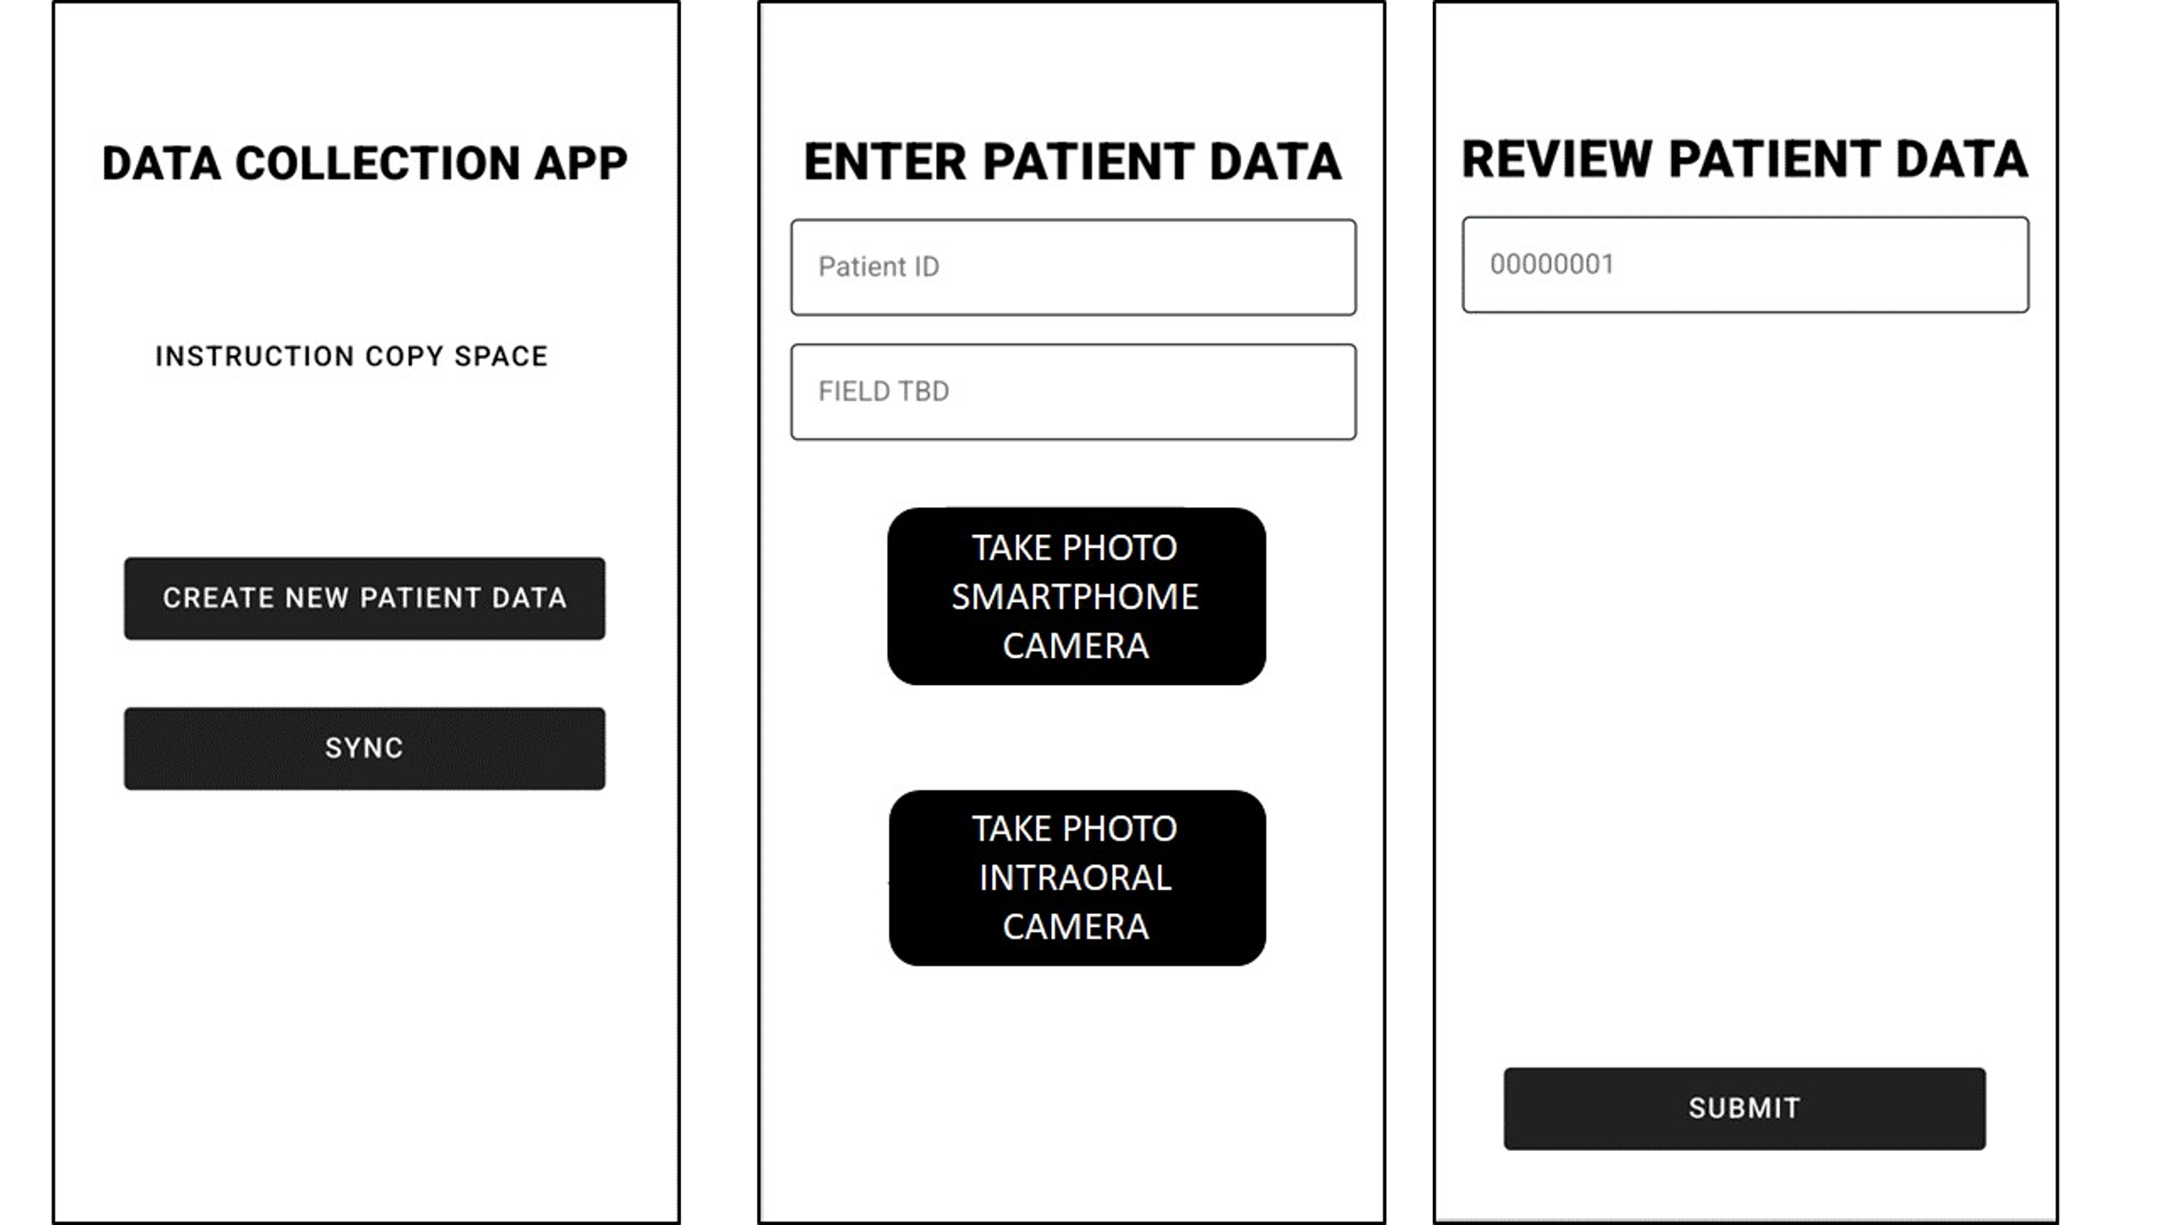

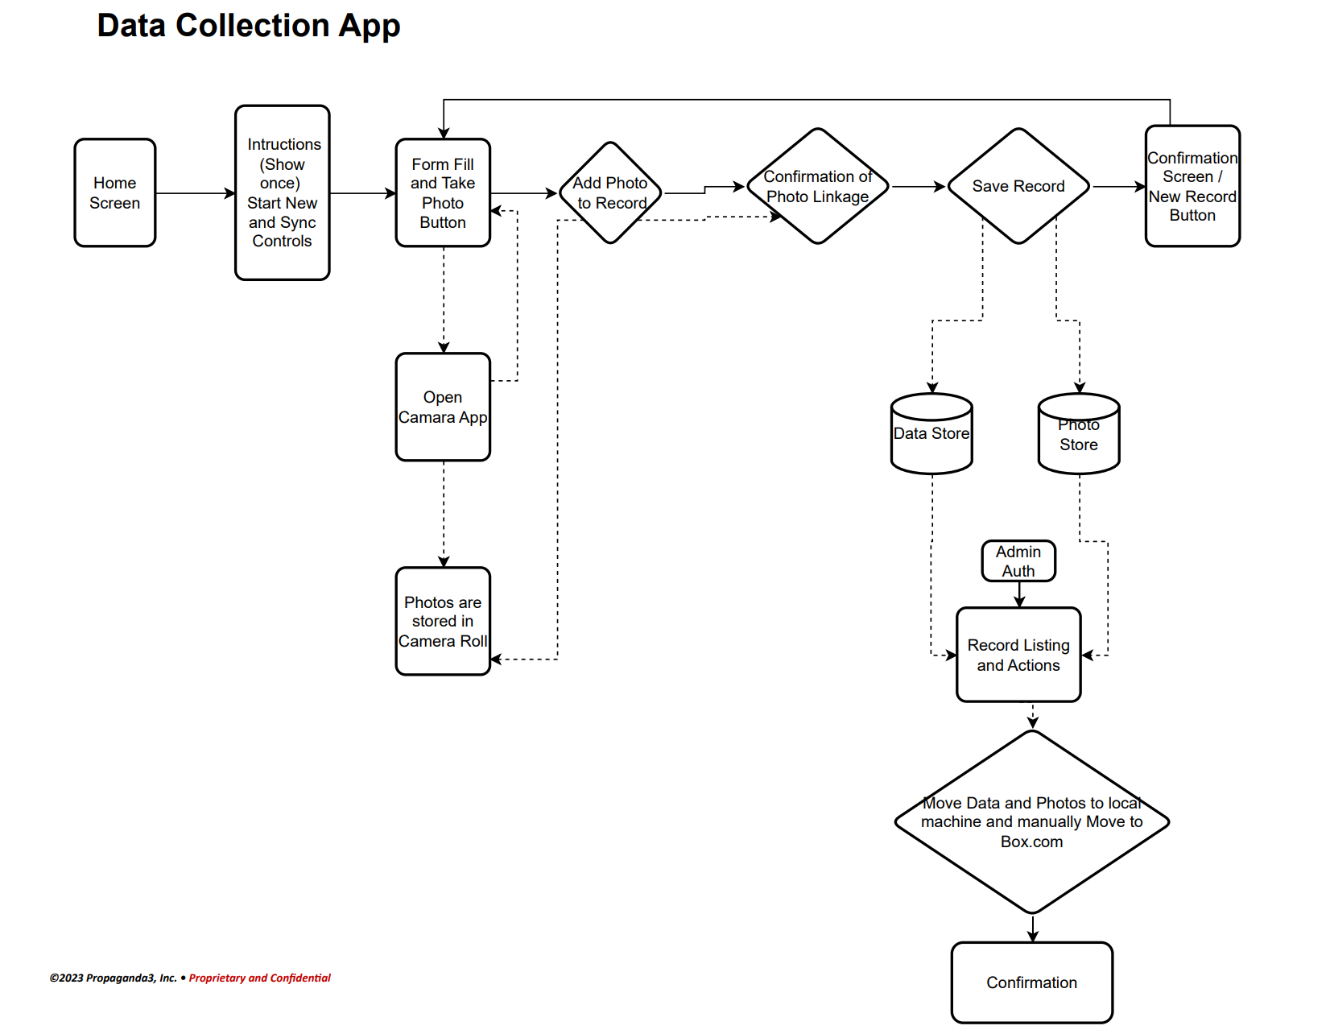

Cccc