English SHGQ Side-by-Side Comparison by Modes of Administration
Description | Interviewer-administered form | Self-administered web form
INTRODUCTION  Allow respondent to provide information on behalf of their spouse or child | Hello, my name is <interviewer name>. I am from <interviewer health department name>. We are contacting you because you (or the ill person) were recently sick with a Shigella infection, also called shigellosis. Shigella are a group of bacteria that cause diarrheal illness. We are trying to determine how you (or the ill person) became sick with a Shigella infection. This interview will also help prevent others from getting sick. | 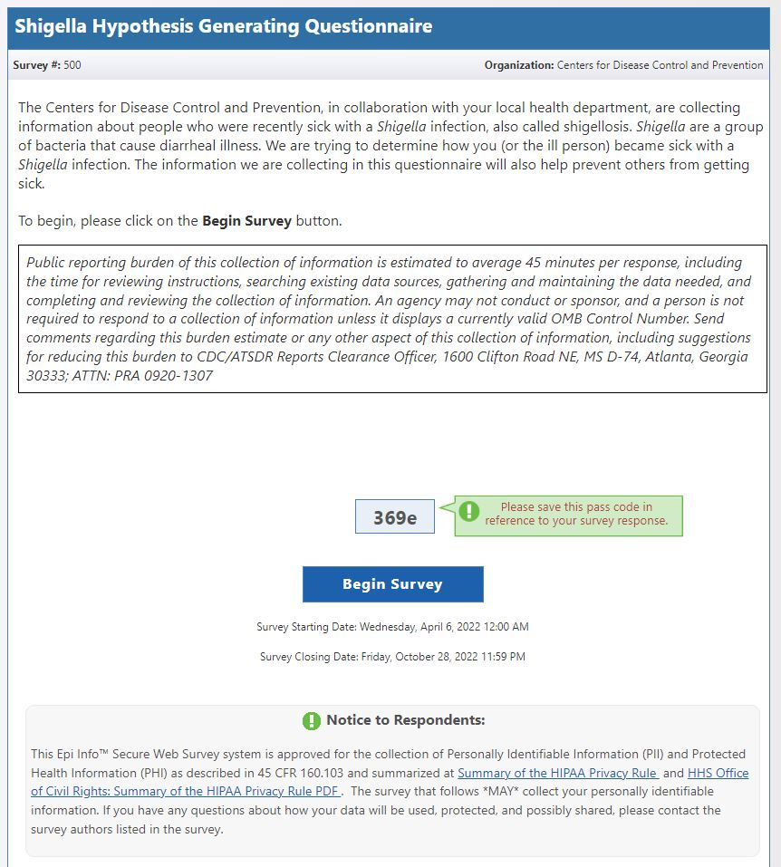
CONSENT  Allow respondent to provide information on behalf of their spouse or child | You may have already been contacted by the health department. I would like to ask you a few additional questions about your (or the ill person’s) recent illness and about any exposures you (or the ill person) may have had before becoming ill. Your help in the investigation is very important. Your participation is voluntary, and you may refuse to answer any question at any time. All information will be kept confidential to the extent permitted by law. No names or other identifying information will be used in any reports. This interview will likely take about 25 to 30 minutes. Are you willing to participate?  If yes: Thank you. [Proceed to Section 2]  If no: Thank you for your time. Would you like any additional materials about Shigella or can I answer any questions for you? If you wish at any time to complete the questionnaire, please call <health department phone number>. | 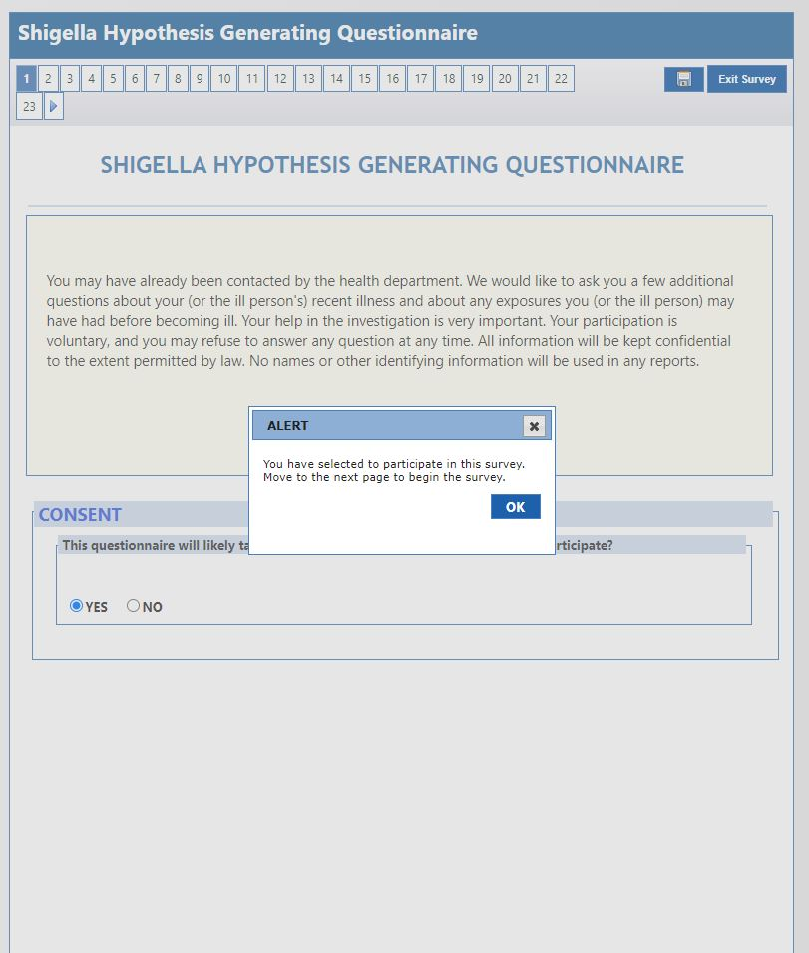
SECTION 1. INTERVIEW INFORMATION | Section 1: INTERVIEW INFORMATION  - PulseNet ID #:____________________________ - WGS ID #: ____________________________  - Interviewer information Name: ________________________________ Agency or organization: ________________________  - Reporting state: ___________ - Reporting county: ___________  - Language interview conducted in: ☐English ☐Spanish ☐Other (specify):______________  - Respondent was: ☐ Self ☐ Parent ☐ Spouse ☐ Other (specify): _______________ | 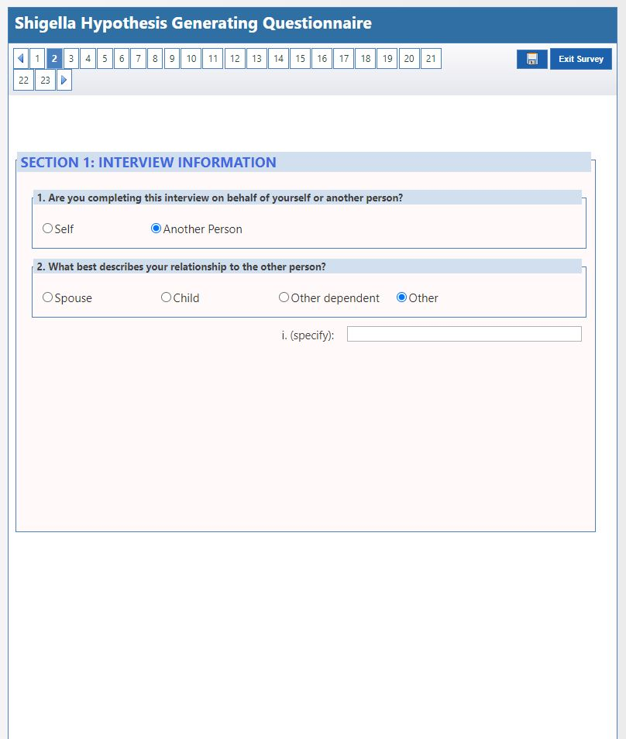
SECTION 2. CASE INFORMATION  Allow respondent to provide information on behalf of their spouse or child | For the first few questions, I will ask some basic demographic questions so I can learn more about you (or the ill person).  Section 2: CASE INFORMATION  - State (of residence): _______________ - County (of residence): ____________________  - Age (of case): __________ ☐ Years ☐ Months ☐ Days  - What sex were you (or the ill person) assigned at birth? ☐ Female ☐ Male ☐ Unknown ☐ Refused  How do you describe your (or the ill person’s):  - Ethnicity? ☐ Hispanic or Latino ☐ Not Hispanic or Latino  - Race? (select all that apply) ☐ American Indian or Alaska Native ☐ Asian ☐ Black or African American  - ☐ Native Hawaiian or Pacific Islander ☐ White ☐ Refused  - If case is ≥14 years old, what is your (or the ill person’s) current occupation? ______________________________ | 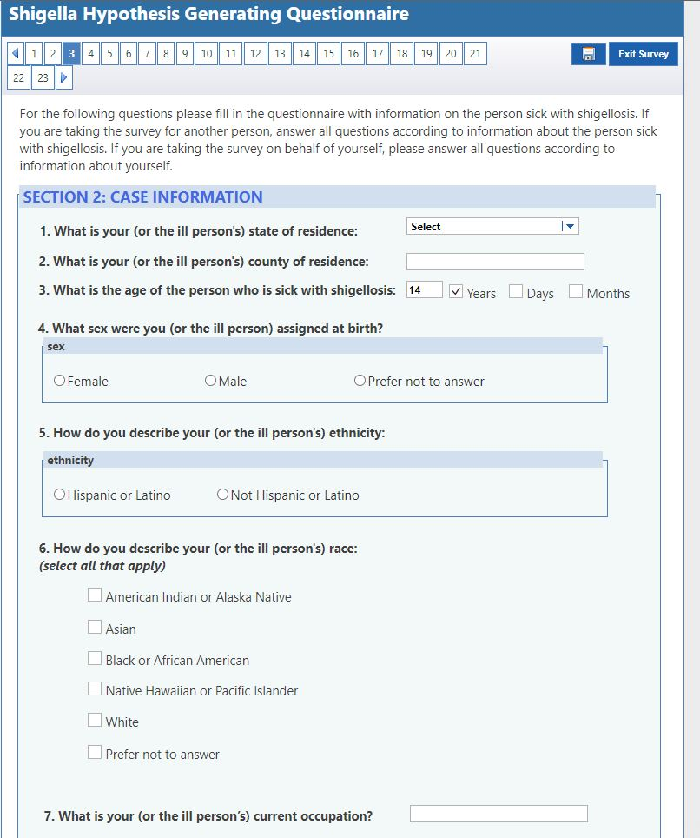
SECTION 3. HOUSEHOLD INFORMATION  Allow respondent to provide information on behalf of their spouse or child | Section 3: HOUSEHOLD INFORMATION  - What would best describe the type of housing you (or the ill person) currently live in? For example, a house, apartment, or mobile home.  ☐ House/single family home ☐ Apartment ☐ Hotel/motel ☐ Long term care facility ☐ Nursing home/assisted living facility  ☐ Mobile home ☐ Shelter ☐ Rehabilitation center ☐ Half-way house ☐ Unknown ☐ Other (specify): _______________  - In the past 30 days, did you (or the ill person) double up or stay overnight with friends, relatives, or someone you didn’t know well because you didn’t have a regular place to stay at night? ☐ Yes ☐ No ☐ Prefer not to answer ☐ Unknown  - In the past 30 days, were you (or the ill person) ever homeless? That is, were you (or the ill person) living on the street, in a shelter, in a single room occupancy hotel, or in a car? ☐ Yes ☐ No ☐ Prefer not to answer ☐ Unknown  - What is the water source at your (or the ill person’s) primary place of residence?  ☐ Municipal ☐ Well ☐ Unknown ☐ Other (specify): _______________  - What is the sewer connection at your (or the ill person’s) primary place of residence?  ☐ Municipal ☐ Septic tank ☐ Unknown ☐ Other (specify): _______________  - How many people, including you (or the ill person), live in your (or the ill person’s) primary place of residence? _______ ☐ Unknown  - Do any of these people (either children or adults) wear diapers? ☐ Yes ☐ No ☐ Unknown  - How many people living in your (or the ill person’s) household are under the age of 5? _______ ☐ Unknown  What was your (or the ill person’s) household income last year from all sources before taxes? That is, the total amount of money earned and shared by all people living in your (or the ill person’s) household.  ☐ <$20,000 ☐ $20,000-$39,999 ☐ $40,000-$59,999 ☐ $60,000-$79,999 ☐ $80,000-99,999 ☐ $100,000 or more  ☐ Prefer not to answer ☐ Unknown | 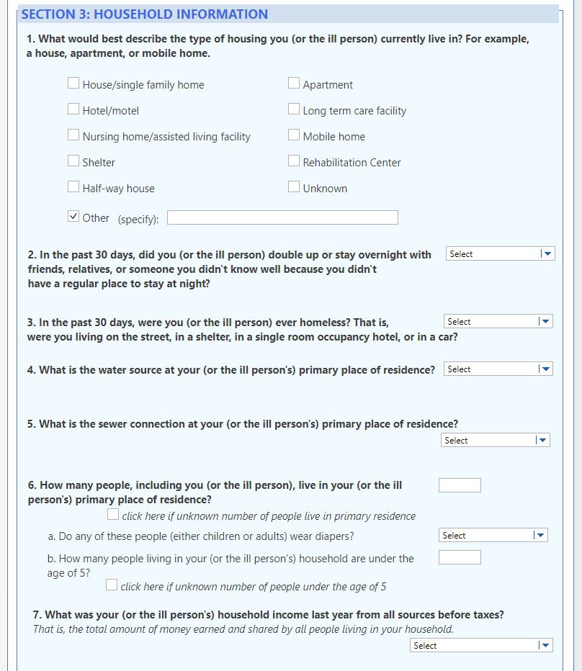
SECTION 4. CLINICAL INFORMATION  Allow respondent to provide information on behalf of their spouse or child | Next, I have a few questions about your (or the ill person’s) recent illness. It may be helpful to have a calendar in front of you because I will be asking about the dates your (or the ill person’s) symptoms started and stopped. Do you need some time to get one?  Section 4: CLINICAL INFORMATION  - What date did you (or the ill person) first feel sick? ______ /_____ /_______ ☐ Approximate date ☐ Unknown  Month / Day / Year  - What date did you (or the ill person) stop feeling sick? ______ /_____ /_______ ☐ Approximate date ☐ Unknown ☐ Ongoing  Month / Day / Year  - If unsure of specific dates in questions 1 and 2, about how many days were you (or the ill person) sick? __________  Yes No Don’t Know - Have you (or the ill person) had any of the following symptoms?  ☐ ☐ ☐ - Diarrhea (at least 3 loose, watery stools in 24 hours)  - If yes to question 3a, about how many days did you (or the ill person) have diarrhea?________  ☐ ☐ ☐ - Abdominal pain/cramps  ☐ ☐ ☐ - Fever  ☐ ☐ ☐ - Nausea  ☐ ☐ ☐ - Vomiting  ☐ ☐ ☐ - Bloody stools/bloody diarrhea  ☐ ☐ ☐ - Seizures  ☐ ☐ ☐ - Achy joints/muscles  ☐ ☐ ☐ - Tenesmus (or feeling the need to pass stool [poop] even when bowels are empty)  ☐ ☐ ☐ - Other symptoms I didn’t ask about (specify): _________________________________________ | 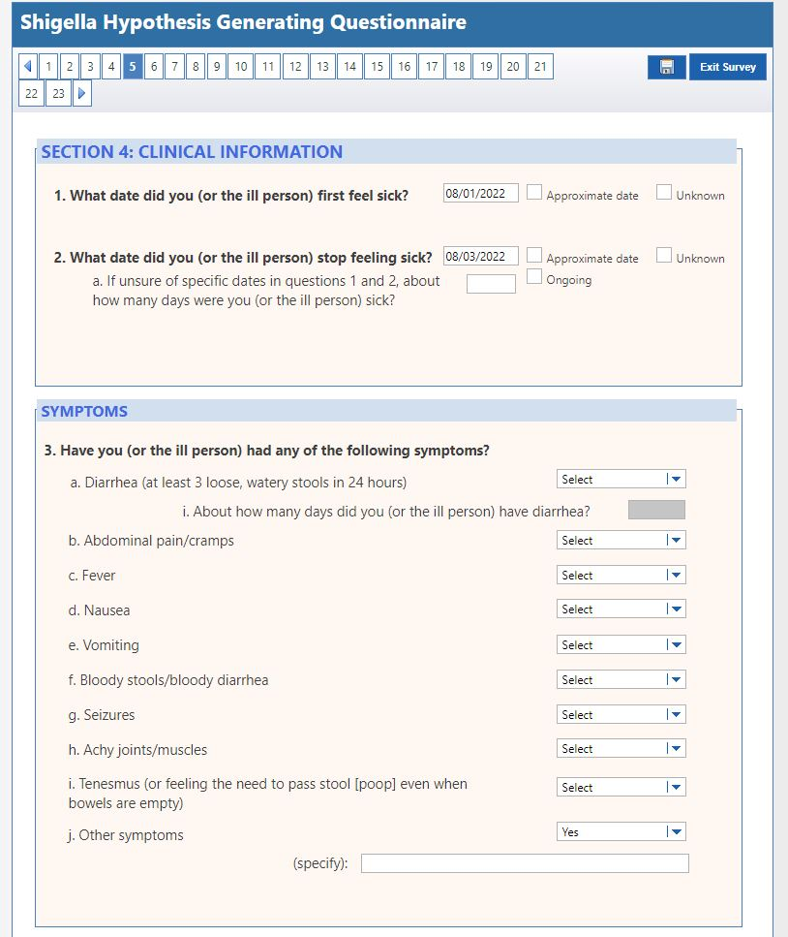
SECTION 5. MEDICAL CARE AND TREATMENT INFORMATION  Allow respondent to provide information on behalf of their spouse or child | The next set of questions are about any recent medical care and treatment you (or the ill person) may have received.  Section 5: MEDICAL CARE AND TREATMENT INFORMATION  Yes No Don’t Know  ☐ ☐ ☐ - As a result of your (or the ill person’s) illness, did you (or the ill person) seek medical care?  - If yes to question 1, where did you (or the ill person) seek medical care? (select all that apply)  ☐ Doctor’s office ☐ Urgent care ☐ Pharmacy clinic ☐ STD clinic  ☐ Emergency department ☐ Hospital ☐ Unknown ☐ Other (specify): _______________  ☐ ☐ ☐ - If yes to question 1, were you (or the ill person) admitted to a hospital overnight?  - If yes to question 1b, for how many nights were you (or the ill person) hospitalized? _____________  ☐ ☐ ☐ - If yes to question 1, were you (or the ill person) admitted to the intensive care unit?  ☐ ☐ ☐ - In addition to infection with Shigella, did your (or the ill person’s) doctor tell you that you were sick with any other infection(s)?  - If yes to question 2, what was the name of the other infection(s): ______________________  ☐ ☐ ☐ - Were you (or the ill person) prescribed any antibiotics for this illness? If yes, I will be asking more questions about the antibiotic, so it may be helpful to get the pill bottles or packages if available.  - If yes to question 3, what was the name of the antibiotic(s), dose, and frequency? __________________________________________  - If yes to question 3, which date did you (or the ill person) start taking the antibiotic(s)?  ______ /_____ /_______ ☐ Approximate date ☐ Unknown  Month / Day / Year  - If yes to question 3, which date did you (or the ill person) stop taking the antibiotic(s)?  ______ /_____ /_______ ☐ Approximate date ☐ Unknown ☐ Still taking antibiotic(s)  Month / Day / Year  - If yes to question 3, in the 24 hours after taking the antibiotic(s), did your (or the ill person’s) symptoms  ☐ Get better/Improve ☐ Stay the Same ☐ Get Worse ☐ Other (specify): _____________ | 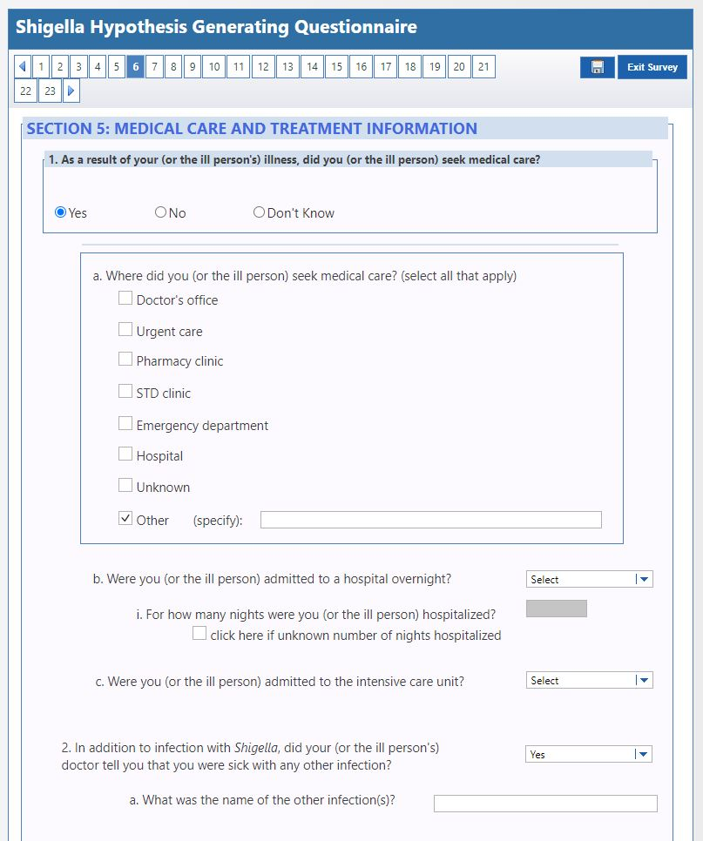
SECTION 6. EXPOSURE INFORMATION  Allow respondent to provide information on behalf of their spouse or child | I would now like to know about your (or your child’s) recent activities, including travel, events, and contact with others.  Section 6: EXPOSURE INFORMATION  Yes No Don’t Know  ☐ ☐ ☐ - In the 7 days before your illness started, did you (or the ill person) spend any time outside of your home state?  - If yes to question 1, list all U.S. states where you (or the ill person) traveled: _________________________________________________________  - List dates of domestic travel: ___________________________________________  - What was the purpose of this travel? (select all that apply)  ☐ Tourism ☐ Work ☐ Visiting friends/relatives  ☐ Other (specify):________________________  - Where did you (or the ill person) stay while traveling domestically? (select all that apply):  ☐ Hotel, hostel, guest house, resort ☐ Private home ☐ Hospital ☐ Cruise ship  ☐ Other (e.g., school, dormitory, tent) (specify):________________________  - What activities did you (or the ill person) engage in while traveling domestically? (select all that apply)  ☐ Purchase or eat food ☐ Go swimming ☐ Attend gathering of people  ☐ Drink untreated water ☐ Other (specify):________________________  - If yes to question 1, list all countries outside the United States where you (or the ill person) traveled: __________________________________________________ ☐ Did not travel internationally  - List dates of international travel: ___________________________________________  - What was the purpose of this travel? (select all that apply)  ☐ Tourism ☐ Work ☐ Visiting friends/relatives  ☐ Other (specify):________________________  - Where did you (or the ill person) stay while traveling internationally? (select all that apply):  ☐ Hotel, hostel, guest house, resort ☐ Private home ☐ Hospital ☐ Cruise ship  ☐ Other (e.g., school, dormitory, tent) (specify):________________________  - What activities did you (or the ill person) engage in while traveling internationally? (select all that apply)  ☐ Purchase or eat food ☐ Go swimming ☐ Attend gathering of people  ☐ Drink untreated water ☐ Other (specify):__________________________  ☐ ☐ ☐ - In the past month, have you (or the ill person) had contact with any individuals who traveled outside the United States?  - If yes to question 2, where did they travel? (specify): __________________________________  ☐ ☐ ☐ - If yes to question 2, were they ill with symptoms similar to your (or the ill person’s) symptoms?  ☐ ☐ ☐ - If yes to question 2, did you (or the ill person) eat any food or drink any beverages they brought back?  - If yes to question 2c, what did you (or the ill person) eat or drink? (specify): _______________  - In the 7 days before your (or the ill person’s) illness started, did you (or the ill person) attend, visit, work in, or volunteer at any of the following:  ☐ ☐ ☐ - A religious gathering (such as church, mosque, or synagogue)? (specify): _______________  ☐ ☐ ☐ - Camp? (specify): _______________  ☐ ☐ ☐ - Conference or other large meeting? (specify): _______________  ☐ ☐ ☐ - Festival, fair, play, or concert? (specify): _______________  ☐ ☐ ☐ - Party, picnic, or barbeque? (specify): _______________  ☐ ☐ ☐ - Sports practice, sports game, or exercise class? (specify): _______________  ☐ ☐ ☐ - Other gathering of people I did not ask about? (specify): _______________  Yes No Don’t Know - In the 7 days before your (or the ill person’s) illness started, did you (or the ill person):  ☐ ☐ ☐ - Drink water from an untreated source, such as lake, pond, or river? (specify): _______________  ☐ ☐ ☐ - Eat any foods prepared by a friend, neighbor, or coworker in their home? (specify): ____________  ☐ ☐ ☐ - Eat any foods prepared by a catering company? (such as food served at a wedding or conference?) (specify): _____________________  ☐ ☐ ☐ - Eat at a restaurant? (specify): _____________________  ☐ ☐ ☐ - Swim in treated water, such as a swimming pool? (specify): ________________________  ☐ ☐ ☐ - Swim in untreated water, such as a lake, river, or ocean? (specify): __________________  ☐ ☐ ☐ - Play in an interactive water fountain, water table, children’s pool, kiddie pool, or baby pool? (specify): _______________  - In the 7 days before your (or the ill person’s) illness started, did you (or the ill person) visit, work in, or volunteer at:  ☐ ☐ ☐ - A place that serves food, such as a restaurant or cafeteria? (specify): _______________  ☐ ☐ ☐ - A homeless shelter? (specify): _______________  ☐ ☐ ☐ - A health care facility? (specify): _______________  ☐ ☐ ☐ - A nursing home, long term care, or assisted living facility? (specify): _______________  ☐ ☐ ☐ - In the 7 days before your (or the ill person’s) illness started, did you (or the ill person) have contact with someone with diarrhea (at least 3 loose, watery stools in 24 hours) or symptoms similar to your (or the ill person’s) symptoms?  ☐ ☐ ☐ - If yes to question 6, was this person diagnosed with a Shigella infection?  ☐ ☐ ☐ - If yes to question 6, was this person a member of your (or your child’s) household? (specify): _______________  ☐ ☐ ☐ - If yes to question 6, does this person wear diapers?  ☐ ☐ ☐ - If yes to question 6e, did you (or your child) change this person’s diapers?  - While you (or the ill person) were sick with the Shigella infection, did you (or the ill person) do any of the following:  ☐ ☐ ☐ - Prepare or handle food for other people? (specify): _______________  ☐ ☐ ☐ - Go swimming or play in a swimming pool, baby pool, interactive fountain, or water table? (specify): _______________  ☐ ☐ ☐ - Visit, work in, or volunteer at a healthcare facility? (specify): _______________  ☐ ☐ ☐ - Visit, work in, or volunteer at a nursing home, long term care, or assisted living facility? (specify): _______________  ☐ ☐ ☐ - Visit, work in, volunteer, or attend a school or childcare facility? (specify): _______________  ☐ ☐ ☐ - Visit, work in, volunteer, or attend any gathering of people? For example, a picnic, party, concert, conference, or religious gathering. (specify): _________________________________ | 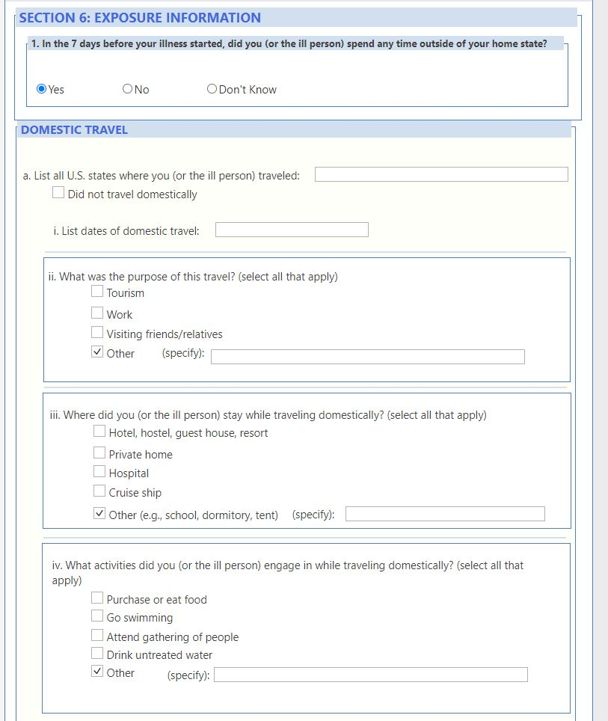
SECTION 7. CHILD CARE AND SCHOOL INFORMATION  Allow respondent to provide information on behalf of their spouse or child | We are nearly finished. I have a few questions about your (or your child’s) recent child care or school attendance.  Section 7: CHILD CARE AND SCHOOL INFORMATION  Yes No Don’t Know  ☐ ☐ ☐ - In the 7 days before your (or the ill person’s) illness started, did you (or the ill person) visit, work in, volunteer, or attend a child care center, daycare, or preschool?  - If yes to question 1, what is the name of the facility? ______________________________  ☐ ☐ ☐ - If yes to question 1, at this facility were there any other children or adults ill with diarrhea (at least 3 loose, watery stools in 24 hours) or symptoms similar to yours (or the ill person’s) before you (or the ill person) became ill?  ☐ ☐ ☐ - If yes to question 1, did you (or the ill person) use a school bus or other school transport to get to and from the child care center, daycare, or preschool?  ☐ ☐ ☐ - If yes to question 1, were you (or the ill person) excluded from this facility while ill?  - If yes to question 1d, how many days were you (or the ill person) excluded? _______________  - If yes to question 1d and case is ≤ 18 years, while excluded from daycare, what alternative care did your child receive? (select all that apply)  ☐ Babysitter ☐ Care at home ☐ Other child care center ☐ Unknown  ☐ Other (specify): _______________  ☐ ☐ ☐ - In the 7 days before your (or the ill person’s) illness started, did you (or the ill person) attend, visit, work in, or volunteer in a school (such as an elementary, middle, after school center, or other type of school)?  - If yes to question 2, what is the name of the school? ______________________________  ☐ ☐ ☐ - If yes to question 2, at this school were there any other children or adults ill with diarrhea (at least 3 loose, watery stools in 24 hours) or symptoms similar to your (or the ill person’s) before you became ill?  ☐ ☐ ☐ - If yes to question 2, did you (or the ill person) use a school bus or other school transport to get to and from the school?  ☐ ☐ ☐ - If yes to question 2, were you (or the ill person) excluded from school while ill?  - If yes to question 2d, how many days were you (or the ill person) excluded? _______________  - If yes to question 2d and case is ≤ 18 years, while excluded from school, what alternative care did your child receive? (select all that apply)  ☐ Babysitter ☐ Care at home ☐ Self-care ☐ Unknown  ☐ Other (specify): _______________ | 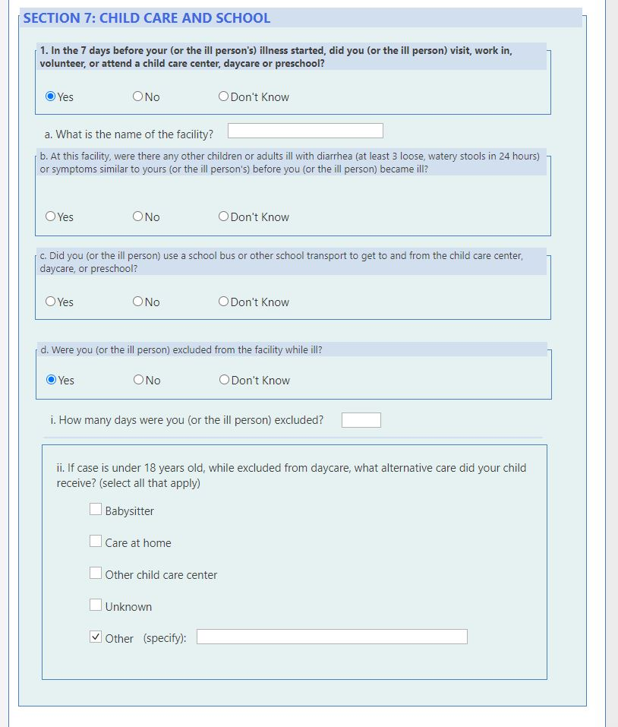
CONSENT: RECENT SEXUAL ACTIVITY SECTION | [Proceed if participant is ≥ 18 years of age and answering survey on behalf of themself. Otherwise skip section 8 and conclude interview]  Finally, I would like to ask about your recent sexual activity because Shigella can be spread through sexual contact. Shigella germs are very contagious; it takes just a small number of Shigella germs to make someone sick. People can get shigellosis when they put something in their mouths or swallow something that has come into contact with the stool of someone else who is sick with shigellosis. This can happen during sex.  As I stated previously, your responses are voluntary, and you may refuse to answer any question at any time. We ask all adults who were diagnosed with a Shigella infection these questions. Your answers to these questions will be kept private and may help us to identify how you became sick with a Shigella infection. This will also help us to prevent others from getting sick.  Do you wish to proceed with the next section?  If yes: Thank you [Begin section 8]  If no: That is OK. We appreciate the information you have given us. ☐ Refused/Prefer Not to Complete  [Skip to Section 9 to close out interview] | 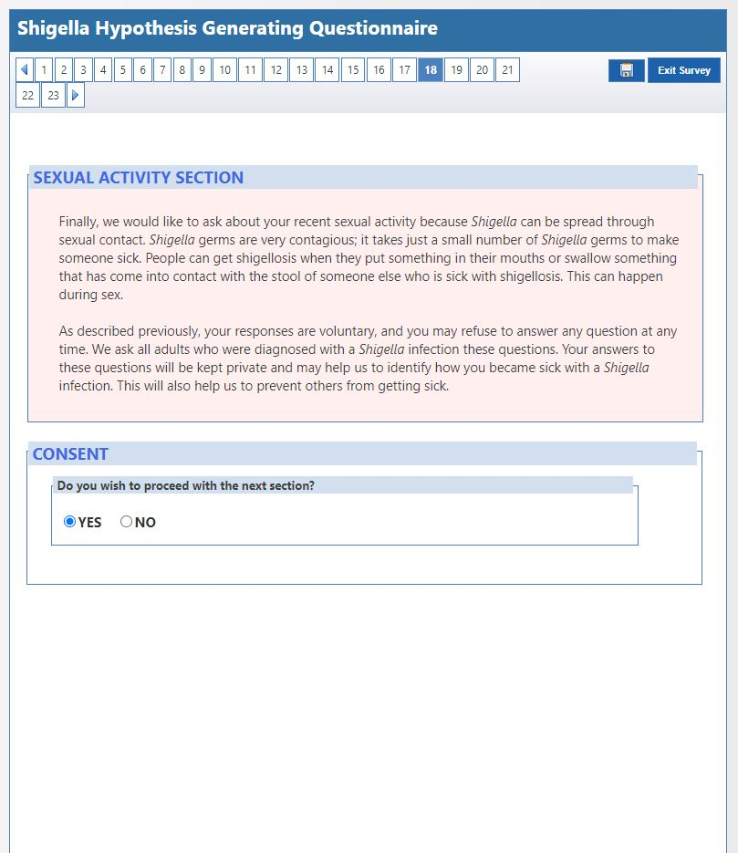
SECTION 8. RECENT SEXUAL ACTIVITY (Only ask if > 18 years of age)  The answer choice of “Don’t know” for these questions was replaced with “Prefer not to answer” to more appropriately reflect answering sensitive questions | Section 8: RECENT SEXUAL ACTIVITY [Only ask if ≥ 18 years of age]  - Which of the following best represents how you think of yourself?  ☐ Lesbian or gay ☐ Straight, that is not lesbian or gay ☐ Bisexual ☐ Something else (specify): _______________  ☐ I don’t know ☐ Prefer not to answer  - Do you currently describe yourself as male, female, or transgender?  ☐ Male ☐ Female ☐ Transgender ☐ None of these ☐ Prefer not to answer  Yes No Prefer not to answer  ☐ ☐ ☐ - Are you currently sexually active? (if no skip to question 4)  ☐ ☐ ☐ - If yes to question 3, since your illness started, have you had sexual contact with another person? Sexual contact would include genital sex, anal sex, oral sex, or any other sexual contact.  ☐ ☐ ☐ - If yes to question 3, in the 7 days before your illness started, did you have sexual contact with another person? Sexual contact would include genital sex, anal sex, oral sex, or any other sexual contact.  - If yes to question 3b, were your sex partners (select all that apply):  ☐ Female ☐ Male ☐ Transgender Female ☐ Transgender Male  ☐ Another ☐ Unknown ☐ Prefer Not to Answer  ☐ ☐ ☐ - If yes to question 3b, in the 7 days before your illness started did any of your sex partners have diarrhea or symptoms similar to your own?  If yes to question 3b, read prompt. For the next questions I’m going to be more explicit about the kind of sex you had in the week before your illness started. This will help me to better understand how you could have become sick.  - In the 7 days before your illness started, what kind of sexual contact did you have?  ☐ ☐ ☐ - Genital sex (for example, penis in the vagina)?  ☐ ☐ ☐ - Anal sex (for example, penis in the anus)?  ☐ ☐ ☐ - Oral sex (for example, mouth on penis or vagina)?  ☐ ☐ ☐ - Anilingus or rimming (meaning mouth on anus)?  ☐ ☐ ☐ - Other sexual contact (for example touching your partner’s anus with your hands, your partner touching your anus with their hands, or sharing of sex toys)?  ☐ ☐ ☐ - If yes to question 3b, in the 7 days before your illness started did you use drugs or alcohol during or immediately before sex? Some examples include alcohol, Viagra, meth, GHB, cocaine, or poppers. (specify): __________________________________  - In the 7 days before your illness, how many sex partners did you have? (specify):_________  ☐ ☐ ☐ - If yes to question 3bv, were any of these partners new?  - If yes to question 3bv1, in the 7 days before your illness started, did you meet your new sex partner(s) at any of the following places?  ☐ ☐ ☐ - Bar, restaurant or club? (specify): _______________________  ☐ ☐ ☐ - Bathhouse? (specify): _______________________  ☐ ☐ ☐ - Bookstore? (specify): _______________________  ☐ ☐ ☐ - Gym? (specify): _______________________  ☐ ☐ ☐ - Park? (specify): _______________________  ☐ ☐ ☐ - Social media sites? (specify): _______________________  ☐ ☐ ☐ - Dating or hookup sites? (specify): ______________________  ☐ ☐ ☐ - Party, conference, or other type of event? (specify): ______________  ☐ ☐ ☐ - Sex club or sex party? (specify): _______________________  ☐ ☐ ☐ - Other location I didn’t ask about? (specify): _______________  ☐ ☐ ☐ - In the past 12 months have you been told by a doctor that you have a sexually transmitted infection?  - If yes to question 4, which infection? (select all that apply)  ☐ Chlamydia ☐ Gonorrhea ☐ Syphilis ☐ Genital warts ☐ Herpes  ☐ Other (specify):_____________ | 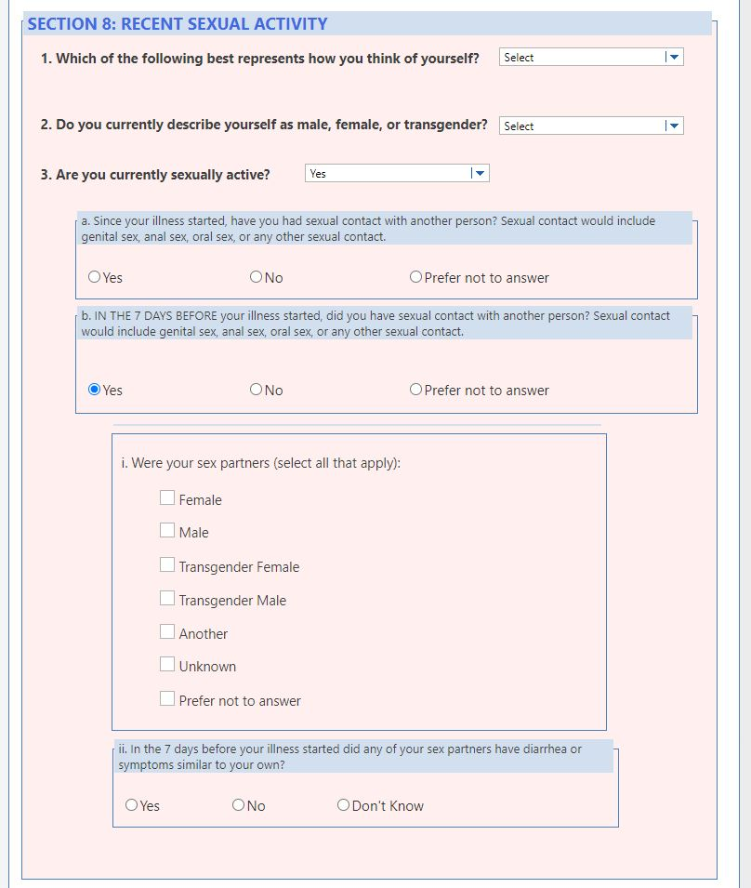
SECTION 9. CLOSING | Section 9: CLOSING  This is the end of the questionnaire. Thank you very much for your time.  Would you like any additional materials about Shigella or can I answer any questions for you?  Thank you for your time. Have a nice day.  [Conclude interview] | 