Form Approved
OMB No. 0920-New
Expiration Date: XX/XX/XXXX

Expanding PrEP in Communities of Color (EPICC+)

Attachment 4l
Aim 2a Cohort Blood Collection Instructions English

Public reporting burden of this collection of information is estimated to average 30 minutes per response, including the time for reviewing instructions, searching existing data sources, gathering and maintaining the data needed, and completing and reviewing the collection of information. An agency may not conduct or sponsor, and a person is not required to respond to a collection of information unless it displays a currently valid OMB control number. Send comments regarding this burden estimate or any other aspect of this collection of information, including suggestions for reducing this burden to CDC/ATSDR Reports Clearance Officer; 1600 Clifton Road NE, MS D-74, Atlanta, Georgia 30333; Attn: OMB-PRA (0920-New)

This Kit Includes:
Blood Card Collection Kit

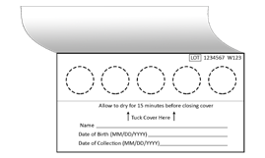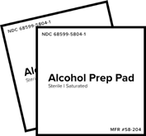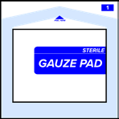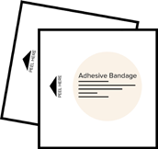

Blood Collection Card
(1 or 2 depending on test kit)

2 Alcohol Pads 1 Sterile Gauze Pad
Single Use Lancets
(Up to 4 depending on test kit)

2 Adhesive Bandages 1 Specimen Bag
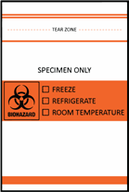
(with Desiccant Silica Gel Pack)

TO PREVENT REJECTED SPECIMENS, PLEASE READ ALL INSTRUCTIONS BEFORE BEGINNING COLLECTION
Tips for proper blood collection
- Hydration promotes blood flow. Be sure you are not dehydrated while performing collection.
- Do not perform collection immediately after smoking.
- Washing and warming your hands under warm water will help promote blood flow in your hands.
- Shake hands vigorously towards the floor to encourage blood flow to your fingers.
- Keep collection device and hands below your heart during collection for best blood flow.
- You may need more than one finger prick. Repeat these tips between each finger prick.

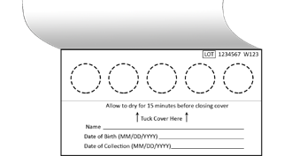
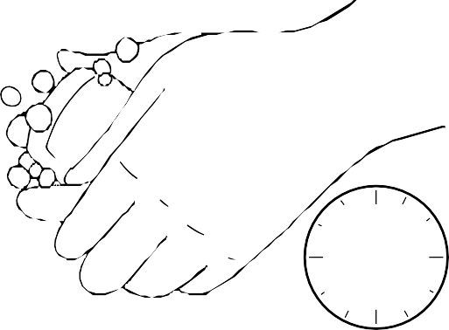
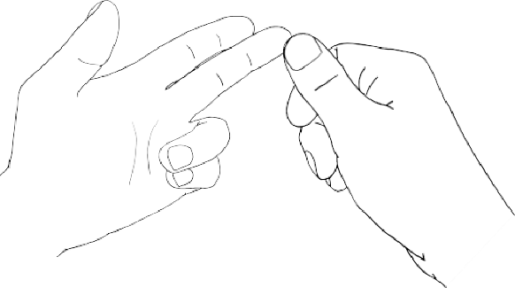
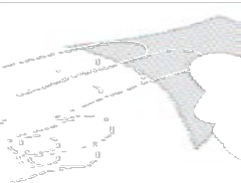
1. 2. 3. 4.

Please review Blood Collection Instructions at: moleculartestinglabs.com/instructions
30
sec

Write your name, date of birth, and the date of collection in the designated fields. Use MM/DD/YYYY format.
Open blood card flap to expose the circles on the blood collection paper. Do not touch the blood collection paper (i.e., circles).
Wash hands with warm water for at least 30 seconds, then shake hands vigorously for 15 seconds to
encourage blood flow to your fingers.
Clean fingertip with alcohol pad. It is best to use the middle or ring finger of your non-dominant hand.

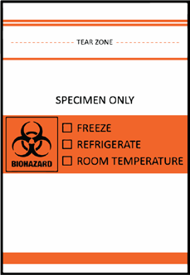
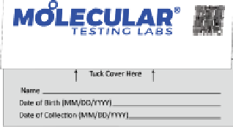
5. 6.
Please review Blood Collection Instructions at: moleculartestinglabs.com/instructions
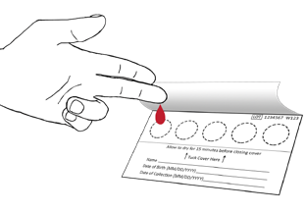
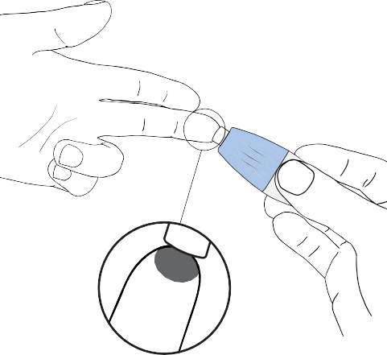
7.

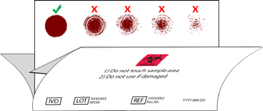
YES
Proper Collection.

8. 9.

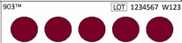

Take the lancet and twist off the cap. Press the small tip firmly into the tip of your finger, near the tip, until the needle ejects with a click. Lancet is single use. All lancets need to be returned with your sample to the laboratory for disposal. Keeping your hand below your heart during collection, massage finger from base to tip to encourage blood flow.
h
s
n
i
k
c
a
d
e
d
a

Starting at the center, apply 3-6 drops to fill the circle and soak through the collection paper. Do not touch the paper with your finger as this will restrict blood flow. Once circle is full move on to next circle. It is okay for blood to extend beyond lines, but do not let blood spots spread into each other.
i
e
r

Do not add additional blood to a circle once completed or dry. The “layering” of blood will invalidate the collection.
NO
Not enough blood.
Fill circles completely.
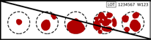

NO
Do not layer blood once the paper has begun to dry.
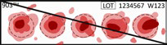

Check the back side of blood collection paper. Blood should saturate all the way through and fill each circle of the collection paper.
r
P
a
Without closing the blood card, lay it on a flat surface and allow the blood collection paper to air dry at room temperature, for at least 30 minutes.
Do not heat, blow dry, or expose the blood collection paper to direct sunlight. Heat will damage the specimen.

When blood collection paper is dry, close blood card by tucking flap. Place the blood card and lancets into biohazard bag with the desiccant pack. Ensure biohazard bag is properly sealed.

©2022 Molecular Testing Labs® — (V.1.0) DBS Collection English — Effective Date: 05/20/2022

Note: Participants will see the following paragraph and question in the app.
Thank you for ordering and completing your blood collection kit. Now that you’ve completed the blood collection, we have some brief questions for you to answer. Once you’ve answered these questions, mailed the kit back using the preaddressed return envelope, and the lab has received the kit, you will receive $25 for completing the mail in blood collection.

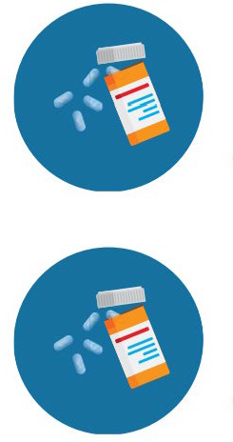
What kind of PrEP are you currently using?

 | Daily oral PrEP | A pill taken daily | Truvada®, Descovy®, emtricitabine/tenofovir disoproxil fumarate, emtricitabine/tenofovir  alafenamide
 | Intermitten t oral PrEP | A pill taken before and after sex.  Also called PrEP 2-1-1, on-demand, intermittent, or event-driven PrEP | Truvada®, emtricitabine/tenofovir disoproxil fumarate
 | Injectable PrEP | A shot, an injection given by a doctor/health  care provider | Apretude®, cabotegravir | 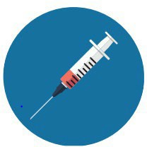
When did you start the PrEP you are currently on? It’s OK if you don’t knowthe exact date. Please provide your best guess.
dd/mm/yyyy
[If Daily oral PrEP selected above]
Which daily PrEP are you on? If you aren’t sure, you can look at your pill bottle or pills.
*Note – If you are on generic Truvada you pills may look different to the image below. Read your bottle to make sure.
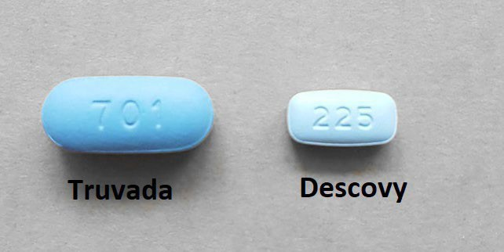
Truvada®, emtricitabine/tenofovir disoproxil fumarate

Descovy®, emtricitabine and tenofoviralafenamide

[If daily oral PrEP or intermittent PrEP selected in question 1]
When did you last take your PrEP pill? If you are unsure of the exact date/time, please provide your best estimate.
dd/mm/yyyy
x:xx am/pm
[If intermittent PrEP selected in question 1]
When did you last have condomless, anal intercourse?
dd/mm/yyyy
x:xx am/pm
[If injectable PrEP selected in question 1]
When was the date of your last PrEP injection? (If exact date is unknown, then use the 1st of the month of injection).
dd/mm/yyyy

[All participants]

When did you collect your blood sample?
dd/mm/yyyy
x:xx am/pm

THANK YOU for completing these questions and the mail in blood collection for the EPICC Research Study. We greatly appreciate all your time and efforts!

