Form Approved
OMB No. 0920-New
Expiration Date: XX/XX/XXXX

Expanding PrEP in Communities of Color (EPICC+)

Attachment 4f
Aim 2a Cohort Screener English

Public reporting burden of this collection of information is estimated to average 5 minutes per response, including the time for reviewing instructions, searching existing data sources, gathering and maintaining the data needed, and completing and reviewing the collection of information. An agency may not conduct or sponsor, and a person is not required to respond to a collection of information unless it displays a currently valid OMB control number. Send comments regarding this burden estimate or any other aspect of this collection of information, including suggestions for reducing this burden to CDC/ATSDR Reports Clearance Officer; 1600 Clifton Road NE, MS D-74, Atlanta, Georgia 30333; Attn: OMB-PRA (0920-New)

Cohort Screener

Thank you for your interest in our research study – Expanding PrEP In Communities of Color (EPICC+)! The goal of EPICC+ is to improve PrEP adherence and PrEP use over time among young cisgender (cis) men who take PrEP. We are currently looking for young cis men on PrEP who can take part in a study lasting at least 12 months and up to 18 months.
Participation will include an enrollment session and follow-up activities at 3, 6, 9, and 12 months. Some participants may also complete follow-up activities at 15 and 18 months. Study activities include: surveys at the enrollment and follow-ups and collection of blood samples.
Some participants will also be asked to complete an in-depth interview at the end of their participation. Participants enrolled for 12 months may earn up to $350 for completing app download, all 5 surveys, 3 blood samples, and an exit interview. Participants enrolled for 18 months may earn up to $475 for completing app download, all 7 surveys, 4 blood samples, and an exit interview.

Interested in joining the study? Please answer the following questions as part of the study screening process to see whether you are eligible to participate. It takes about 5 minutes to complete, and you are welcome to message our study team with any questions you may have. If you consent to be screened and screen eligible, clinic staff from the clinic where you report getting care will verify your eligibility by confirming you receive care at that clinic and reviewing your medical record to confirm you have an active PrEP prescription.

The screener asks questions about topics like age, gender identity, sexual orientation, and HIV status. We understand that these are personal questions and can be uncomfortable to answer in a survey. Please note that the process is voluntary, and you can decide to quit at any time. You may also choose "Decline to answer" on any questions that make you feel uncomfortable; however, choosing that option may affect our ability to determine if you are eligible for the study. If you do complete the survey and want to learn more about this study or future research, please enter your contact information so that the study team can call you regarding next steps. Any information shared in this survey is confidential and will only be used for research purposes. All information will be kept on a secure server. If you choose not to be contacted for future studies, your information will be deleted.

The possible risks of screening for the study include risk of breach of confidentiality. Data is encrypted on this survey website to minimize this risk. When study staff receive your information, it will be kept on a secure server. You may not benefit personally from being in this research study. All participants will receive financial incentives to support study participation.

We want to acknowledge that some of the language used in our study questions may include some outdated language or lack the diversity of experiences that we now understand exist. Although we do our best to use measures that reflect emerging language, at times the items available in research are not where they need to be and are drawn from items developed ten (or

more) years ago. Wherever possible, we have updated the language or are working with developers to get new versions.

If you have questions, or concerns, you may contact the study coordinator at (448) 488-9069 or you may email the study team at EPICC@nursing.fsu.edu. If you have questions or concerns about your rights as a research subject, you may contact FSU Institutional Review Board (IRB) 850-644-7900 or by email to humansubjects@fsu.edu. Please provide the FSU IRB# 00003652 for this study.

Do you consent to be screened and have your eligibility confirmed by clinic staff if you screen eligible?
- Yes (1)
- No (2)

Page Break
Sorry, if you do not consent to be screened, you cannot continue the screener. Thank you for your time.

What is your date of birth? (dd/mm/yyyy)

- Decline to answer

Are you Hispanic or Latino?
- Yes (1)
- No (0)
- Decline to answer
What race or races do you consider yourself to be (CHOOSE ALL THAT APPLY)
▢ African American or Black
▢ American Indian or Alaskan Native
▢ Asian
▢ Native Hawaiian or other Pacific Islander
▢ White
▢ Decline to answer

Do you understand and are you comfortable speaking and reading English and/or Spanish?
- Yes (1)
- No (2)
- Decline to answer

[If yes to previous question: Do you understand and are you comfortable speaking and reading English and/or Spanish]
What is your preferred language?

- English (1)
- Spanish (2)
- Decline to answer
Do you have a personal cell phone with texting and internet?
- Yes (1)
- No (2)
- Decline to answer

Are you willing to provide a mailing address within the 50 states or Puerto Rico where you can receive packages?
- Yes (1)
- No (2)
- Decline to answer

Which of the following BEST represents how you think about yourself?
- Lesbian or gay
- Straight, that is not lesbian or gay
- Bisexual
- Something else
- Decline to answer

What sex were you assigned at birth, on your original birth certificate?
- Male
- Female
- Refused
- Decline to answer

Do you currently describe yourself as male, female, or transgender female or male?
- Male
- Female

- Transgender female
- Transgender male
- None of these
- Decline to answer

Beyond the gender identities listed above, are there any other identities that you would use to describe yourself? (Select all that apply)
- Gender non-conforming (38)
- Genderfluid (41)
- Genderqueer (40)
- Non-binary (39)
- Two-spirit (37)
- Agender
- Another identity, please specify: (42)
- None of these
- ⊗Decline to answer (44)

Page Break

Have you had anal sex in the last 12 months?
- Yes (1)
- No (2)
- Decline to answer

Are you living with HIV?
- Yes (1)
- No (2)
- Decline to answer (4)
Are you currently taking PrEP?
- Yes, I am currently taking PrEP (1)
- No, I am not currently taking PrEP, but I have a PrEP prescription.
- No, I am not currently taking PrEP and do not have a PrEP prescription.
- Decline to answer

Do you get PrEP from one of the clinics listed below or a clinic affiliated with one of the clinics below?

Pediatric Specialty Clinics (Cook County Health) - Chicago, IL
- Adolescent and Young Adult Clinic (AYAC) 1969 Ogden Ave.
- Englewood Health Center - Cook County Health 1135 W 69th Street
Montefiore MAYS Clinic - Bronx, NY
Adolescent Initiative, Children’s Hospital of Philadelphia - Philadelphia, PA Amity Medical Group - Charlottte, NC
- Amity Medical Group Park Road Location
- Amity Medical Group Harris Boulevard Location
- Amity Medical Group Monroe Road Location
- Amity Medical Group Dallas Hwy Location
Wake County Health Department (Sunnybrook Road) – Raleigh, NC Five Horizons Health Services - Tuscaloosa, AL
Ybor Youth Clinic 1315 E 7th Ave STE 104 - Tampa, FL
USF Student Health Services 4107 USF Cedar Cir – Tampa, FL
USF Curran Children’s Medical Services 13101 Bruce B Downs Blvd – Tampa, FL Bliss Healthcare Services - Orlando, FL
Texas Children’s Hospital or Harris Health PrEP Clinic at Thomas Street - Houston, TX

- Yes (1)
- No (2)
- Decline to answer
Display This Question:
If previous question = 1

Which clinic or affiliated clinic do you get your PrEP from?

Pediatric Specialty Clinics (Cook County Health) - Chicago, IL
- Adolescent and Young Adult Clinic (AYAC) 1969 Ogden Ave.
- Englewood Health Center - Cook County Health 1135 W 69th Street
Montefiore MAYS Clinic - Bronx, NY
Adolescent Initiative, Children’s Hospital of Philadelphia - Philadelphia, PA Amity Medical Group - Charlotte, NC
- Amity Medical Group Park Road Location
- Amity Medical Group Harris Boulevard Location
- Amity Medical Group Monroe Road Location
- Amity Medical Group Dallas Hwy Location
Wake County Health Department (Sunnybrook Road) – Raleigh, NC Five Horizons Health Services - Tuscaloosa, AL
Ybor Youth Clinic 1315 E 7th Ave STE 104 - Tampa, FL
USF Student Health Services 4107 USF Cedar Cir – Tampa, FL
USF Curran Children’s Medical Services 13101 Bruce B Downs Blvd – Tampa, FL Bliss Healthcare Services - Orlando, FL
Texas Children’s Hospital or Harris Health PrEP Clinic at Thomas Street - Houston, TX

Thank you for your response - it looks like you may be eligible to participate in the study.

Enter your contact information below and our study team will reach out to you about the next steps.
- Phone Number (1)
- Email (2)
- Name (5)

FOR THOSE ELIGIBLE

[Required question] Would you like to receive email updates in the future about other research study opportunities and/or research findings?
- Yes, I want to receive email updates about opportunities to enroll in other research studies
- Yes, I want to receive email updates about research findings
- No, I do not want to sign up for this
Example of research findings: [this can be embedded as a thumbnail that links to full-size]:

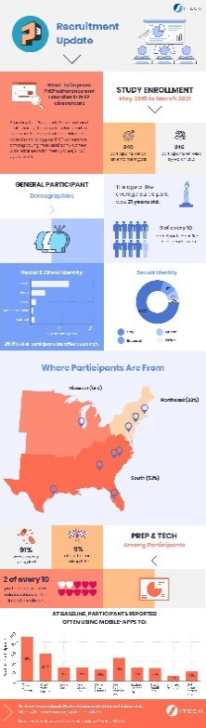
[https://imgur.com/0LxDVhA]

Please click here to continue.

What are your pronouns (select all that apply)?
▢ He/Him/His
▢ She/Her/Hers
▢ They/Them/Theirs
▢ Other
▢ Decline to answer

Thank you so much for answering all of the questions! We really appreciate your time. Unfortunately, you are not eligible for this particular research study.

FOR THOSE INELIGIBLE

[Required question] Would you like to receive email updates in the future about other research study opportunities and/or research findings?
- Yes, I want to receive email updates about opportunities to enroll in other research studies
- Yes, I want to receive email updates about research findings
- No, I do not want to sign up for this
Example of research findings: [this can be embedded as a thumbnail that links to full-size]:
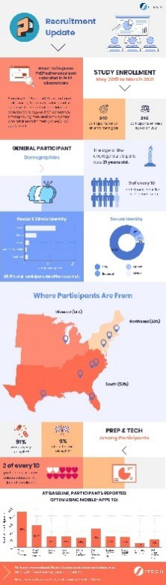[https://imgur.com/0LxDVhA]

Please click here to continue.

If you are interested in receiving updates, please enter your contact information below so that we may contact you.

Name: Phone:
Email:

