Original Screen with passive non consent to electronic messaging, original informational banner for electronic messaging, and text message information presented to all users.
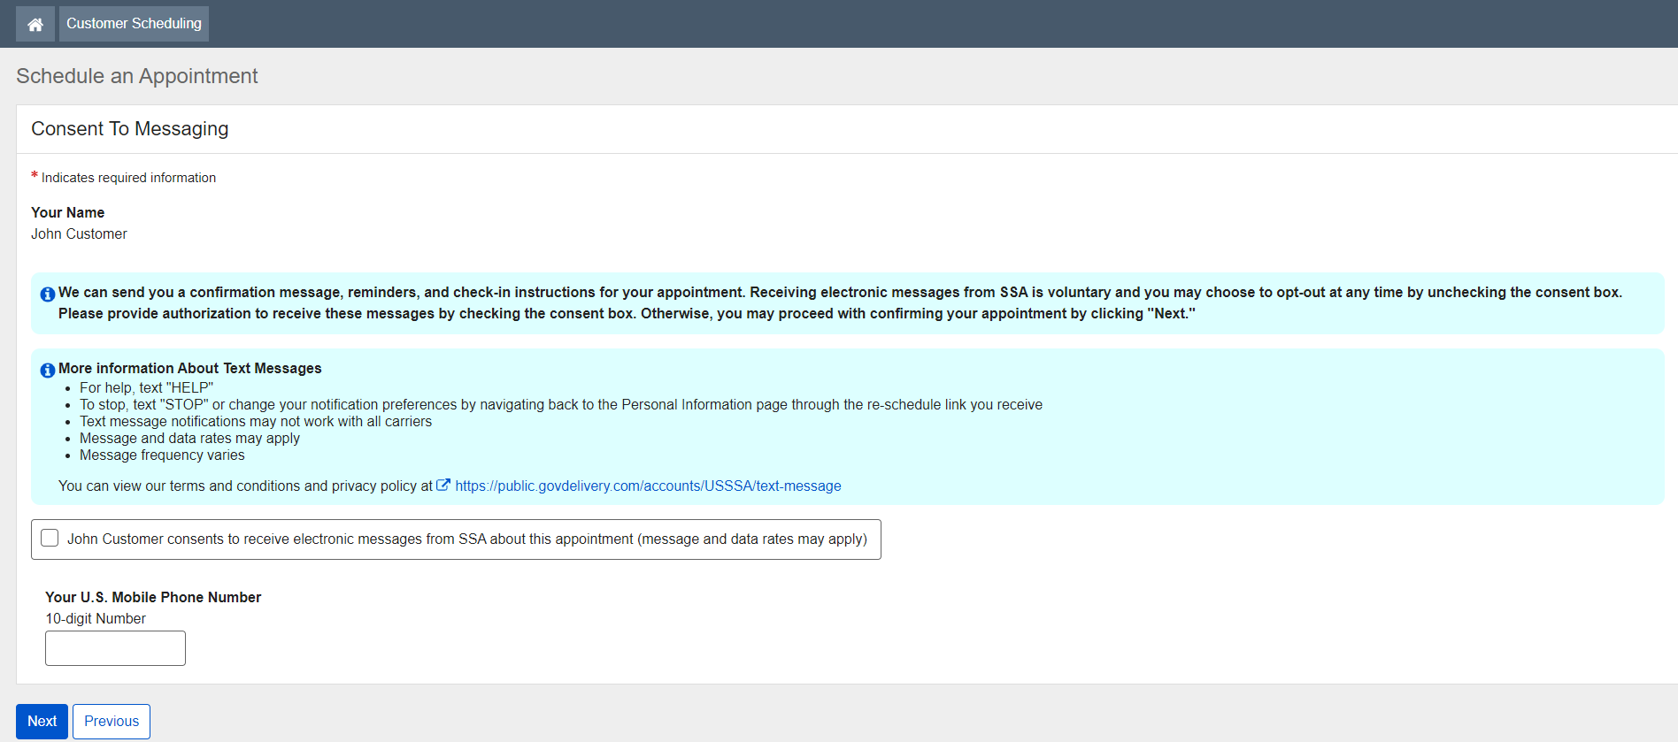

New screen with ‘Yes’ and ‘No’ options to consent to messaging and updated informational electronic messaging banner.
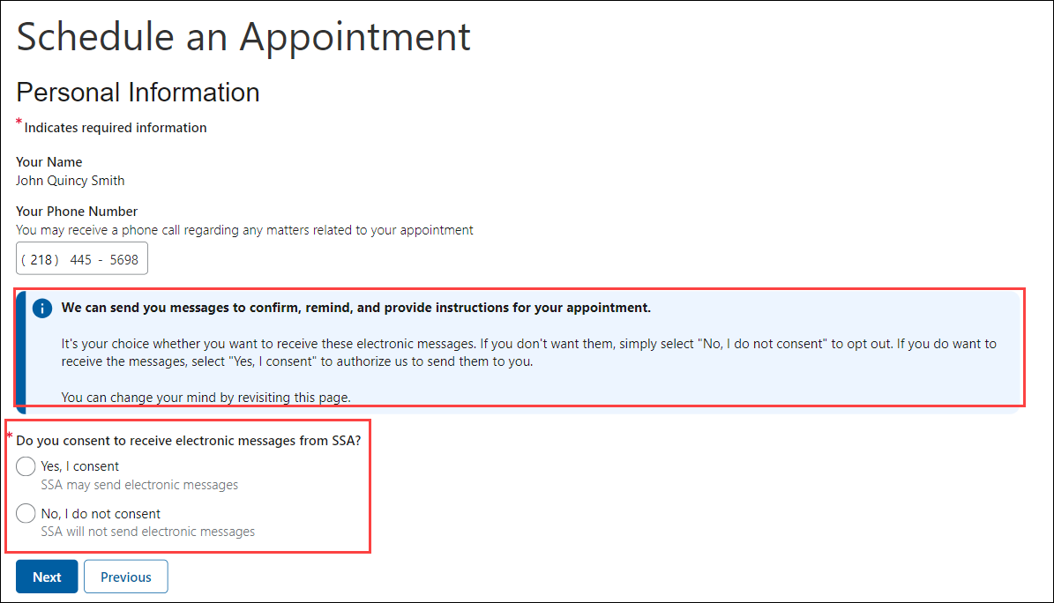

Original screen with U.S. Mobile Phone Number collection
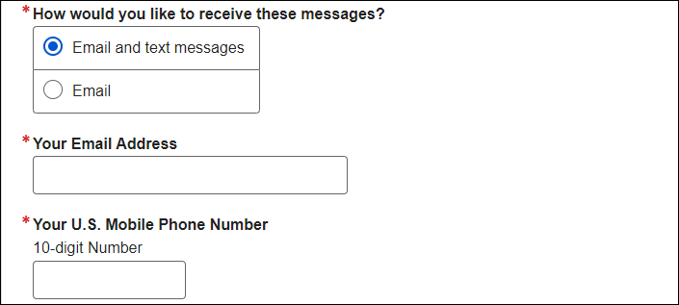

New screen display when user selects ‘Yes’ to receive text messages and to display ‘More Information About Text Messages’ after a customer consents to receive text messages.
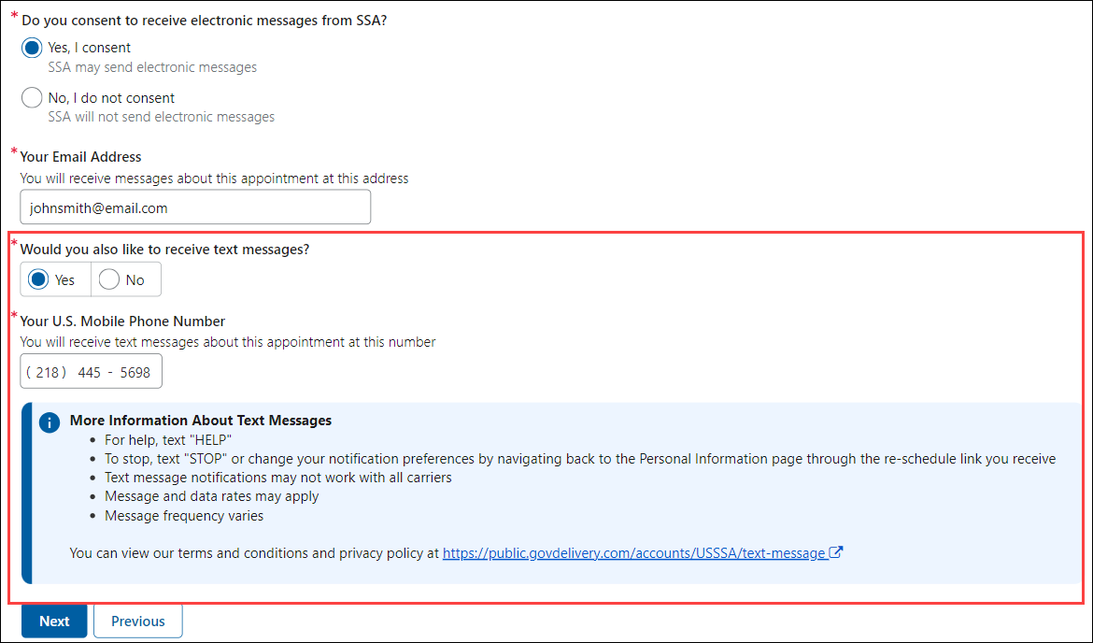

Original screen display in update path when the checkmark box is unselected and pop-up message displays.
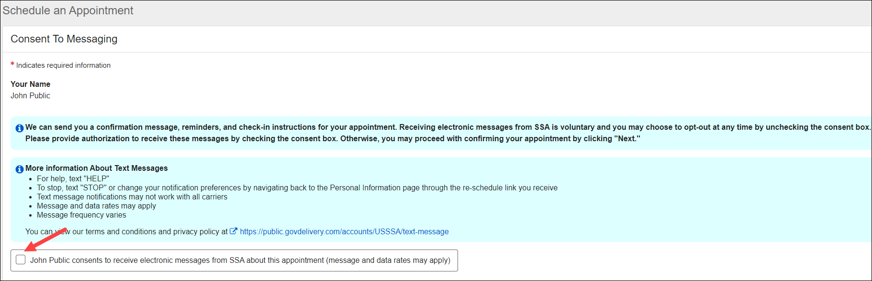
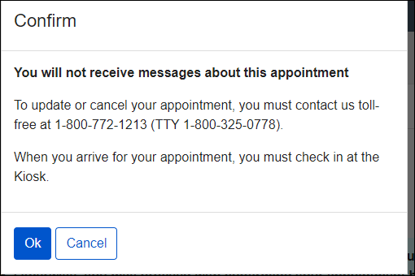

New screen display for update path when a customer changes their response from ‘Yes’ to ‘No’ for consent to messaging.
