**CURRENT Wage and Employment Information Authorization- Title II/XVI Web and Internet iClaim**

**1. WEB: WAGE AND EMPLOYMENT INFORMATION AUTHORIZATION - PROGRAMMATIC WAGE AUTHORIZATION - CURRENT AUTHORIZATION DETAILS**

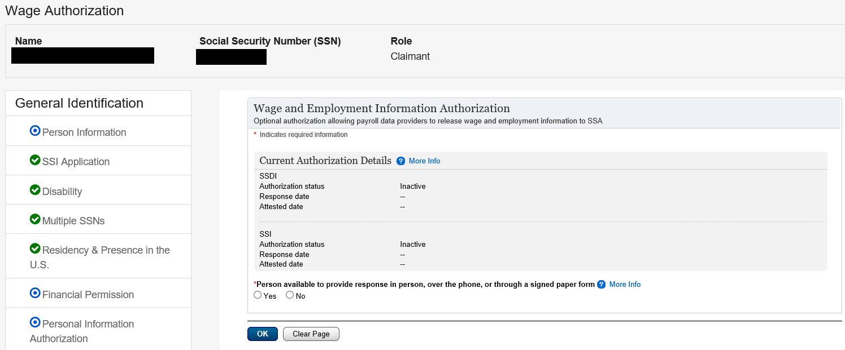

**2. WEB: WAGE AND EMPLOYMENT INFORMATION AUTHORIZATION - PERSON AVAILABLE**

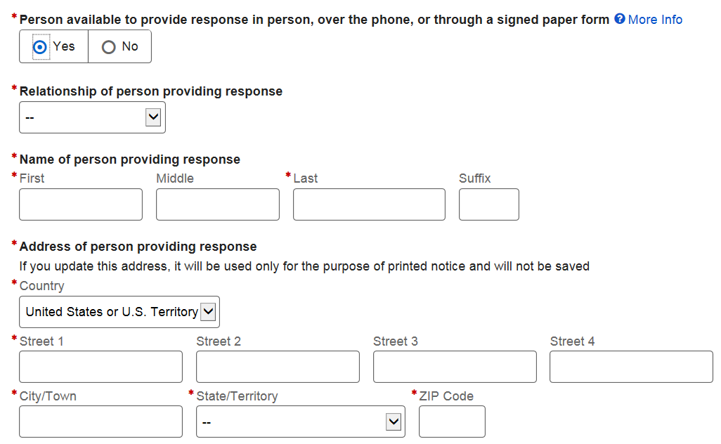

**3. WEB: WAGE AND EMPLOYMENT INFORMATION AUTHORIZATION - FOREIGN ADDRESS**

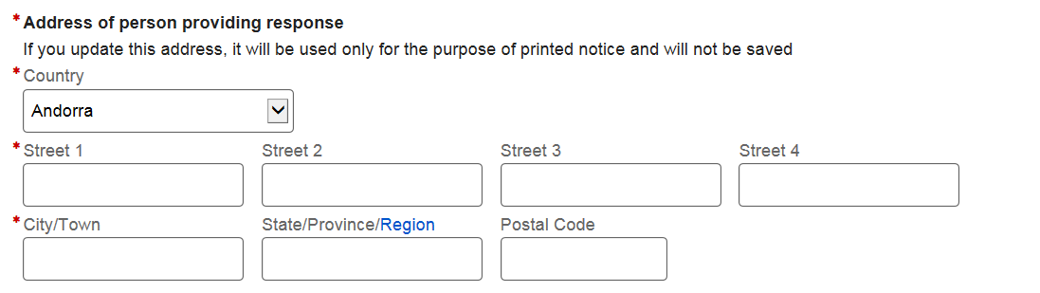

**4. WEB: EXAMPLE 1 WAGE AND EMPLOYMENT INFORMATION AUTHORIZATION - INITIAL CLAIM - CONCURRENT**

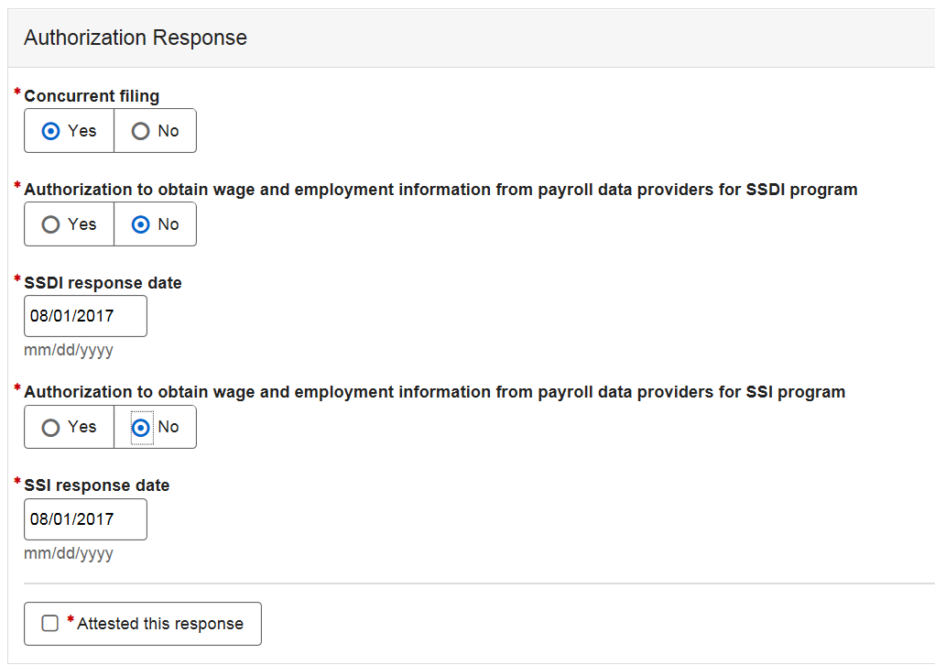

**5. WEB: EXAMPLE 2 WAGE AND EMPLOYMENT INFORMATION AUTHORIZATION - INITIAL CLAIM - CONCURRENT**

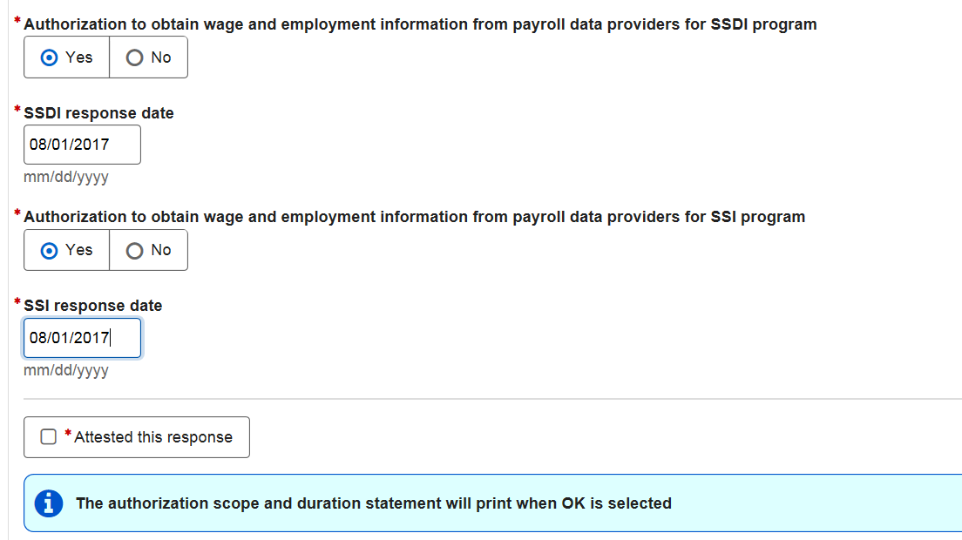

**5. WEB: WAGE AND EMPLOYMENT INFORMATION AUTHORIZATION - AUTHORIZATION STATUS ACTIVE**

Person requests to revoke.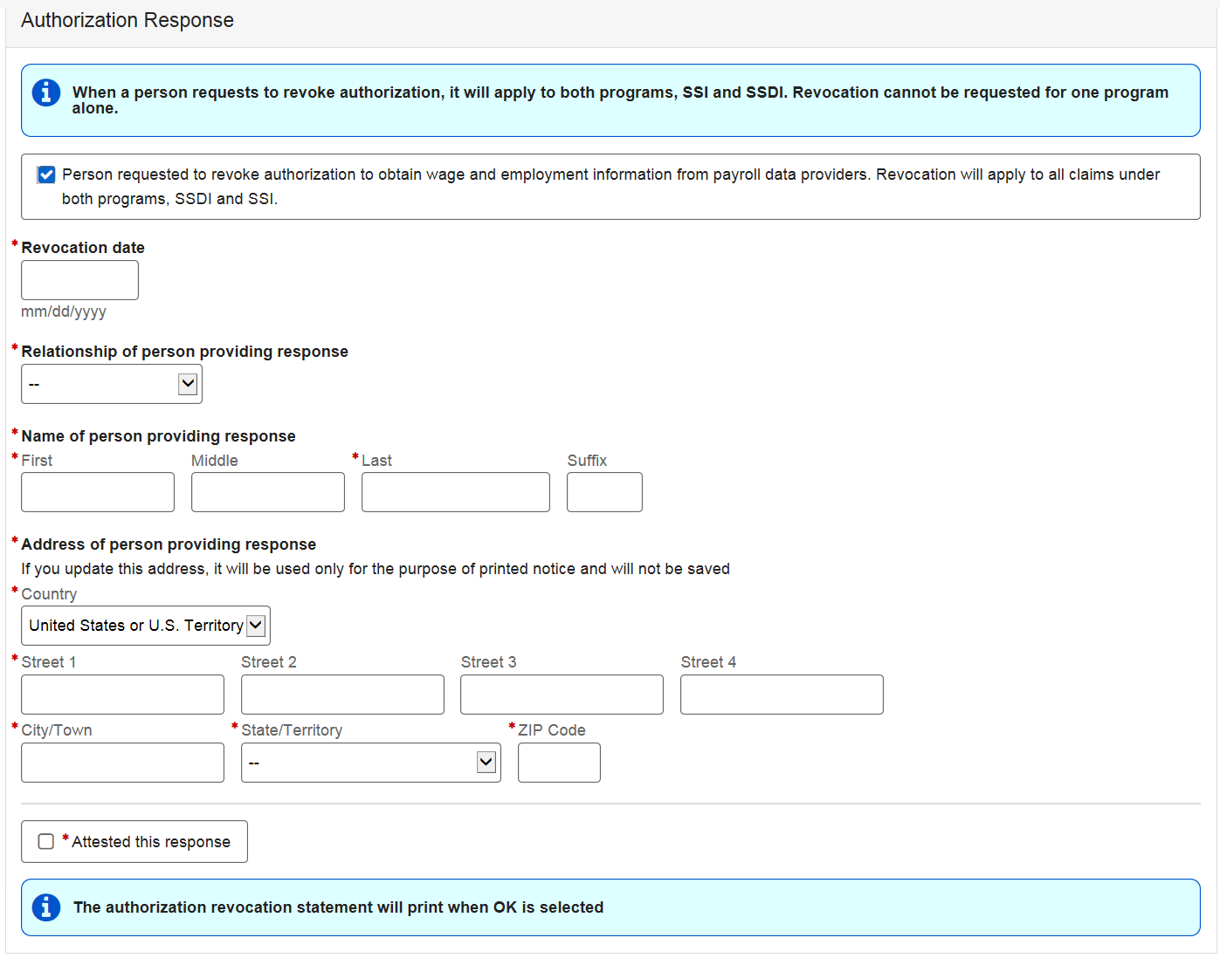

**6. INTERNET iCLAIM- EXAMPLE AUTHORIZATION TO OBTAIN WAGE AND EMPLOYMENT INFORMATION-CONCURRENT**

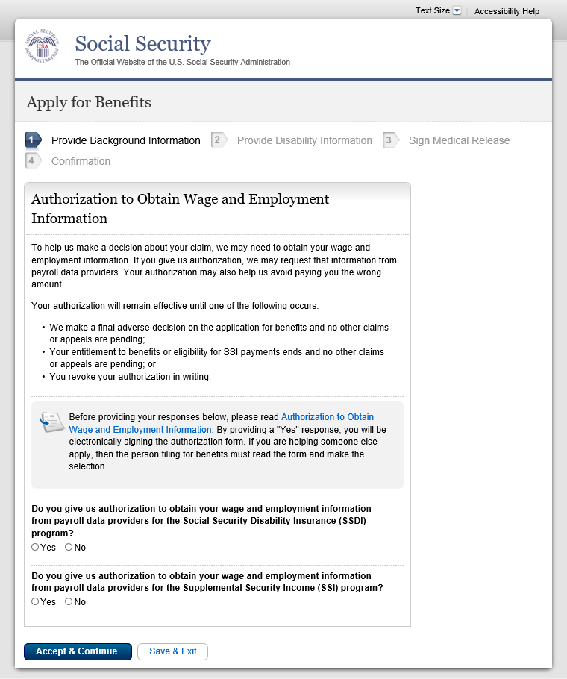

**7. INTERNET iCLAIM- INFORMATION ABOUT YOUR WAGE ANS EMPLOYMENT AUTHORIZATION**

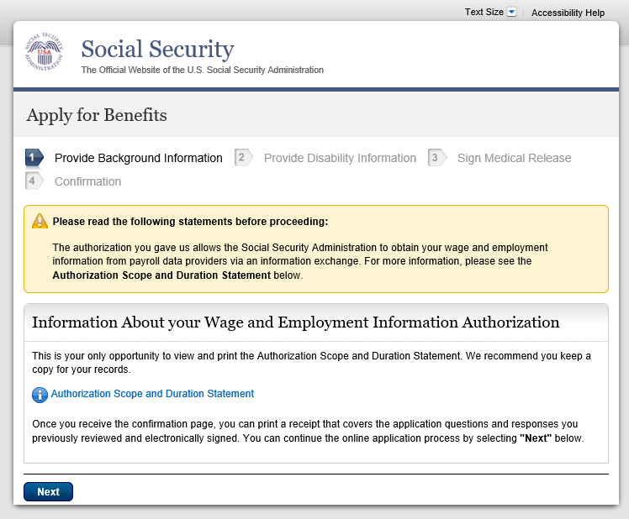

**8. INTERNET iCLAIM- AUTHORIZATION SCOPE AND DURATION STATEMENT**

