SSA-3369 EDCS Screenshots for PRW NPRM
Work History
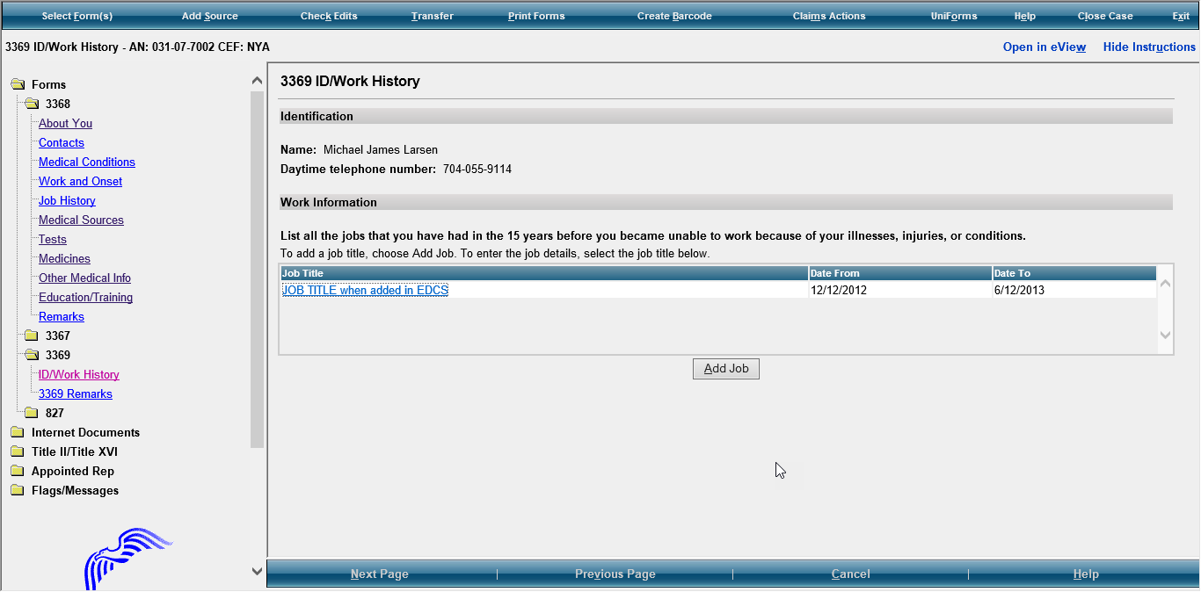
Modify the instructions to say: “List the jobs (up to 5) that you had in the past 5 years. List all the jobs that you have had in the last 5 years:
- Include self-employment
- Include work in a foreign country
- List your most recent job first”
Add question: “Did you have a job in the last 5 years?” Add checkboxes for YES NO
If yes, modify Job Listing instructions to say, “Select the number of jobs you have had in the past 5 years”.

Include- Suffix for the name
Modify to read: “Daytime numbers where we can call to speak with you or leave a message, if needed. Include area code or IDD and country code if outside the USA or Canada.”
Add “Primary” to add the number
Modify Alternate to “Secondary”

Job History

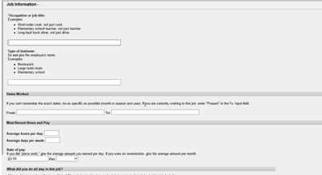
For Rate of Pay- Frequency in drop-down should be Per: hour, day, week, month, or year

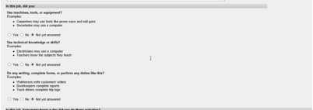
Modify the questions to read as follows:
“For this job, describe in detail the tasks you did in a typical workday. Examples of tasks include stocking shelves, greeting customers, scheduling appointments, and maintaining records.” Add a text box for description.
“If any of the tasks listed above involved writing or completing reports, describe the type of report you wrote or completed and how much time you spent on it per workday or workweek.” Add a text box for description.
If any of the tasks listed above involved supervising others, describe who or what you supervised and what supervisory duties you had. Examples of supervisory duties include performance management, making schedules, and maintaining time records.” Add a text box for explanation.
“List the machines, tools, and equipment you used regularly when doing this job and explain what you used them for. Examples include computer, telephones, forklift, air compressor, and meat slicer.” Add a text box for description.
“Tell us about the work-related skills you used in this job and the job duties you completed using these skills. Examples of work-related skills include reading blueprints to instruct workers on how to build houses and medical coding to determine the amount providers should be paid.” Add a text box for explanation.
Add this question, “Did your job require you to interact with coworkers, the general public, or anyone else?” YES NO
If they select yes, display a textbox with the following instructions:
“Describe who you interacted with, the purpose of this interaction, how you interacted, and how much time you spent doing it per workday or workweek. Examples include answering customer questions on the telephone for 5 hours per day or showing clients sale properties for 4 hours per day.” Add a text box for explanation.

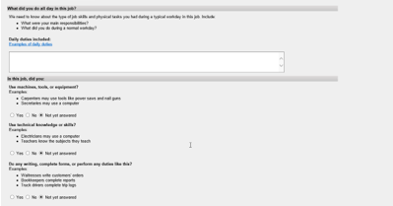

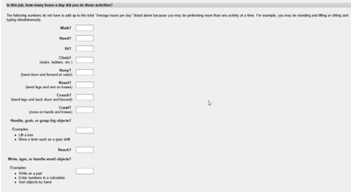
Modify the instructions to read: “Tell us how much time you spent performing the following physical activities in a typical workday. The total hours/minutes for standing and/or walking and sitting should equal the Hours per Day. The example below shows an 8-hour workday with 2 hours standing and/or walking and 6 hours sitting (8 hours total).” For each activity, add a text box or radio buttons to select for “Hours/ Minutes” to indicate time for each activity.
*The paper form includes an “Example” text box that shows how many hours/minutes for each activity. Standing and walking- 2 hours; stooping- 6 minutes. Work with Systems to determine how to include this on EDCS.
of how to select the activity to total an 8- hour workday. Need to discuss with systems how to display.

Combine walk and stand to show, “Standing and/or Walking”
Sit to “Sitting”
Stoop to “Stooping”; keep explanation

Kneel to “Kneeling”; keep explanation
Crouch to “Crouching”; keep explanation

Crawl to “Crawling”; keep explanation
“Using fingers to touch, pick, or pinch (e.g., using a mouse, keyboard, turning pages, or buttoning a shirt)” Add radio buttons to select One Hand and Both Hands

“Using hands to seize, hold, grasp, or turn (e.g., holding a large envelope, a small box, a hammer, or water bottle)”; Add radio buttons to select One Hand and Both Hands

Reach to “Reaching at or below the shoulder”; Add radio button to select One Arm and Both Arms

“Reaching overhead (above the shoulder)”: Add radio buttons to select One Arm and Both Arms
Climb to “Climbing stairs or ramps”

“Climbing ladders, ropes, or scaffolds”

Modify Physical Activities Lifting and Carrying instructions: “Tell us about lifting and carrying in this job. Explain what you lifted, how far you carried it, and how often you did it in a typical workday.”

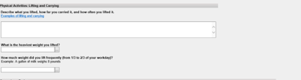
Modify the question to “Select the heaviest weight lifted” Add “Less than 1 lb.” to the list of options in the drop down.

Modify the question to “Select the weight frequently lifted (i.e., 1/3 to 2/3 of the workday)”. Add “Less than 1 lb.” to the list of options in the drop down.

After last heaviest weight question, add this question: “Did your job expose you to any of the following? Check all that apply.” Add radio buttons and text to select the following options:
“ Outdoors Extreme Heat (non-weather related) Extreme Cold (non-weather related) Wetness Humidity Hazardous Substances Moving Mechanical Parts High Exposed Places Heavy Vibration Loud Noise Other”
If one or more of the options are checked, add a text box with instructions that say, “Tell us about the exposure(s) and how often you were exposed.”

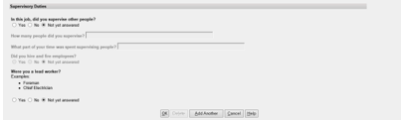
Remove the last two questions. - “Did you supervise other people in this job?” and “Were you a lead worker?”

Add this question and a textbox for explanation:
“Explain how your medical conditions affect your ability to do this job.”

Section 3- Remarks

Section 4 “Who Is Completing this Report?”
This is a new section to add to the 3369 in EDCS.
Section Title: “Who is Completing this Report”
Modify this section as follows:
Remove Who is providing the information?
Add the following”
“Date Report Completed (MM/DD/YYYY)”
“Who is completing this report?” Add radio buttons and the following options:
“John Doe
Contact Person
Additional Contact Person
Someone else”
If they select radio button for Someone else, provide text boxes to complete the following information:
“Name (First, Middle Initial, Last)
Relationship to John Doe
Mailing Address (Street or PO Box) include the apartment number, if applicable.
CITY
STATE/Province
ZIP/Postal Code
Country (if not USA)
DAYTIME PHONE NUMBER where we may reach you or leave a message, if needed. Include the area code or IDD and country code if outside the USA or Canada.”

