**SSA-3368 EDCS Screenshots for PRW NPRM**

About You/ Section 1- Information About You

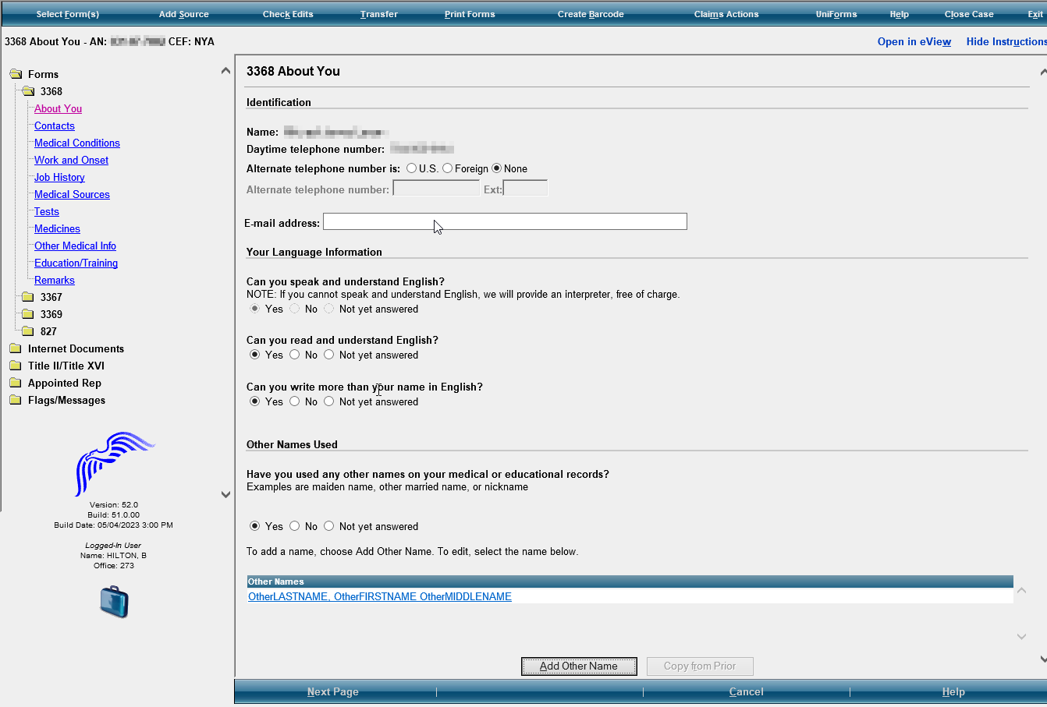

Modify the examples to read as follows:

“Examples **include** maiden name, other married names, **other names**, or nickname.”

Modify to read: “Daytime numbers where we can call to speak with you or leave a message, if needed.”

Add “Primary” to add the number

Modify Alternate to “Secondary”

Include- Suffix for the name

3368 Contacts/ Section 2- Contacts

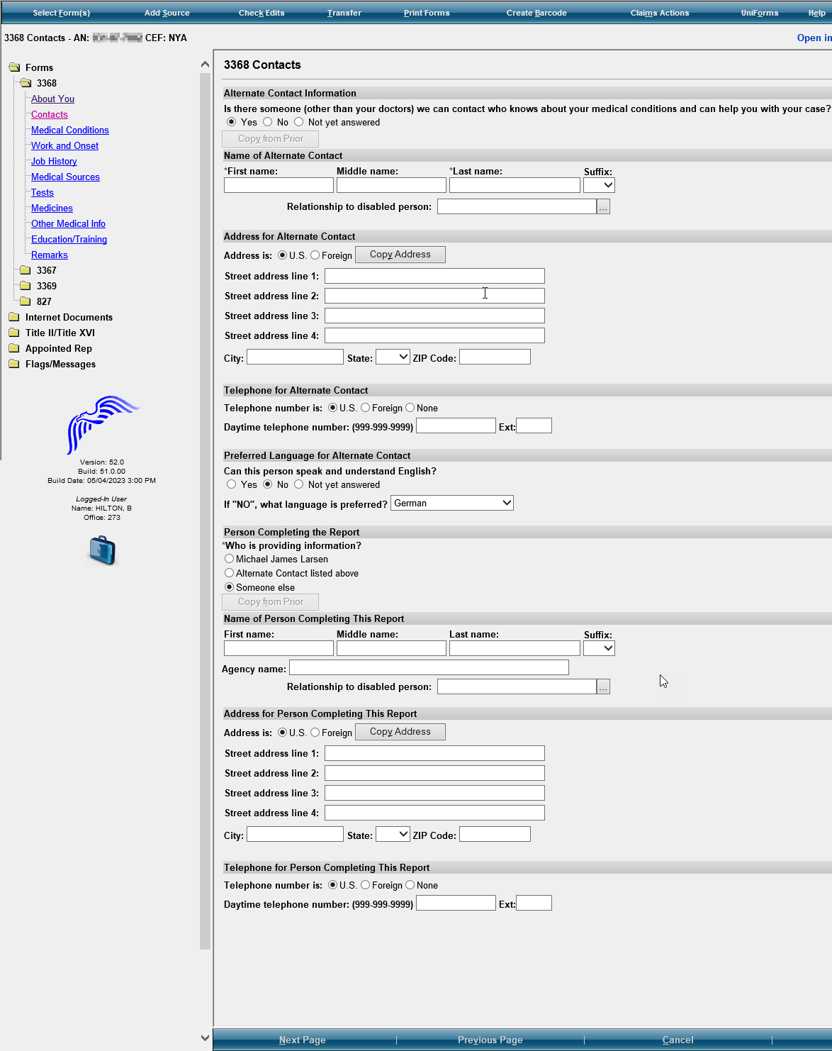

In the 3368 Contacts section, modify section subtitles to the following:

Alternate Contact title to **“Contact Person Information”**

Name of Alternate Contact title to **“Name of Contact”**

Address for Alternate Contact to **“Address for Contact”**

Telephone for Alternate Contact to **“Telephone for Contact”**

Preferred Language for Alternate Contact to **“Preferred Language of Contact”**

When adding a second contact, the subtitles should be **“Additional Contact Person”**

Modify the question to read as follows:

“**Is there someone we can contact who can help with your claim if needed? Examples include a family member, friend, or neighbor.”**

Add the ability to enter two contacts. **“Contact Person Information” and “Additional Contact Person Information”**

**If they select yes, add: “Please provide the names of two people (other than your doctors) we can contact who know about your medical condition(s) and can help you with your claim and can help us reach you if you become unavailable.”**

**If they select no, add: “We recommend that you provide at least one contact, if available. Providing the name of someone who knows you may help us to make a quicker decision on your claim.”**

Add section to provide an additional contact with Name, Relationship to You, Address of the person, Daytime phone number of this person, and Preferred Language.

**Please move the Person Completing the Report Section, Name of Person Completing this Report, Address for Person Completing the Report, and Telephone for Person Completing the Report to the end of the screens after the Remarks screen.**

Medical Conditions/ Section 3- Medical Information

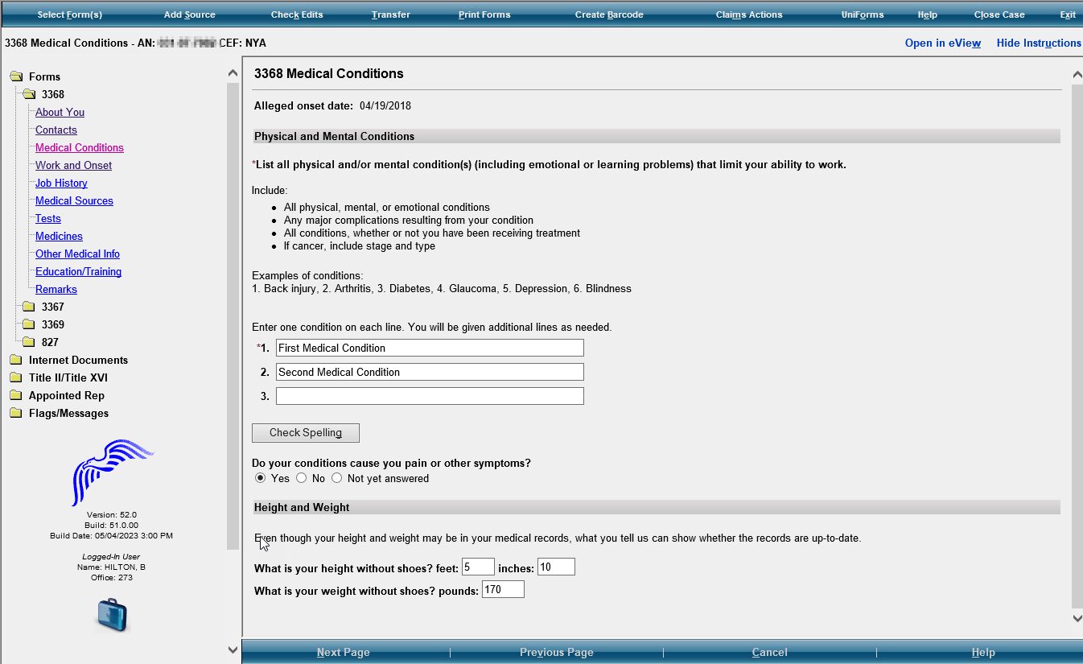

In the Height and Weight section **remove** the instructions that say, “**Even though your height and weight may be in your medical records, what you tell us can show whether the records are up to date”.** No instructions needed.

Modify the Height and Weight questions to read as follows:

**“What is your height?”** Add text and radio box to include **“OR centimeters”**

**“What is your weight?”** Add text and radio buttons to include **“OR kilograms”**

Remove this question.

Modify the instructions to read as follows:

“**Separately list each** physical **and/or** mental condition that limits your ability to work.”

Work and Onset/ Section 4- Work Activity

With answer “No, I have stopped working”

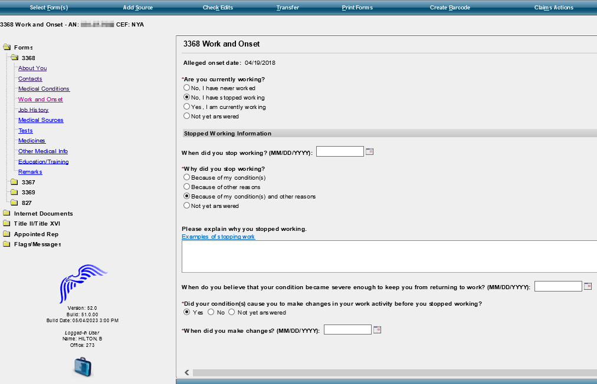

Modify the question to read as follows: “Did your condition(s) cause you **or your employer** to make changes in your work activity? **Examples include job duties, hours, or rate of pay.”**

If yes, modify the question to read as follows: “**When did the changes start**?” MM/DD/YYYY format

Modify the last radio button option “Because of other reasons” to say:

“Because of other reasons. Please explain the other reasons why they stopped working. **Examples include laid off, early retirement, seasonal work ended, or business closed.”**

With Answer “Yes, I am currently working”

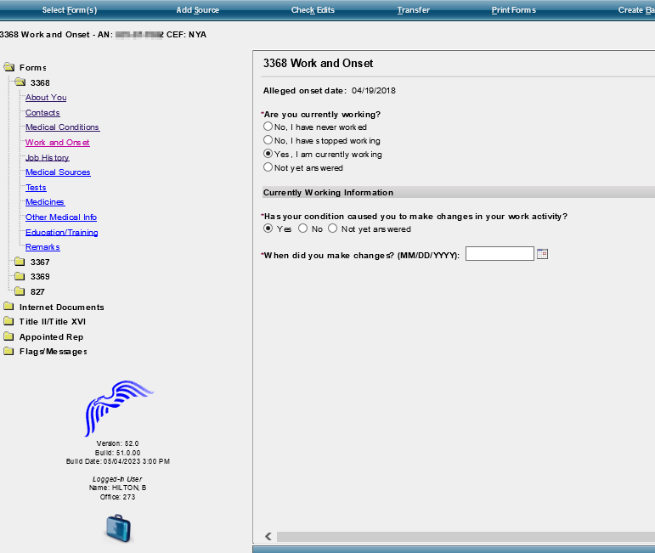

Modify the question in the to read as follows:

“Has your condition**(s) caused you** **or your employer** to make changes in your work activity? **Examples include job duties, hours, or rate of pay.”**

If yes, modify question to read, **“When did the changes start?”**

If no, modify the question to read, **“When did your condition(s) first start bothering you?”**

Job History/ Section 6- Work History

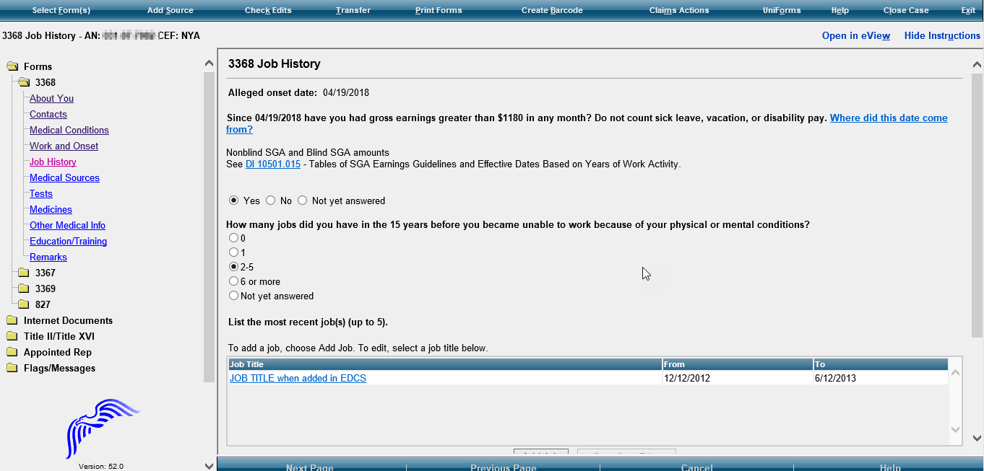

Modify the instructions to say: “List the jobs (up to 5) that you had in the past 5 years. List **all** the jobs that you have had in the last **5** years:

* **Include self-employment**
* **Include work in a foreign country**
* List your most recent job first”

Add question: **“Did you have a job in the last 5 years?”** Add checkboxes to select YES NO

If yes, modify Job Listing instructions to say, **“Select the number of jobs you have had in the past 5 years”.**

Modify this question to read: “Since ….have you had earnings greater than $____**before tax** in any month?”

Job Information Page

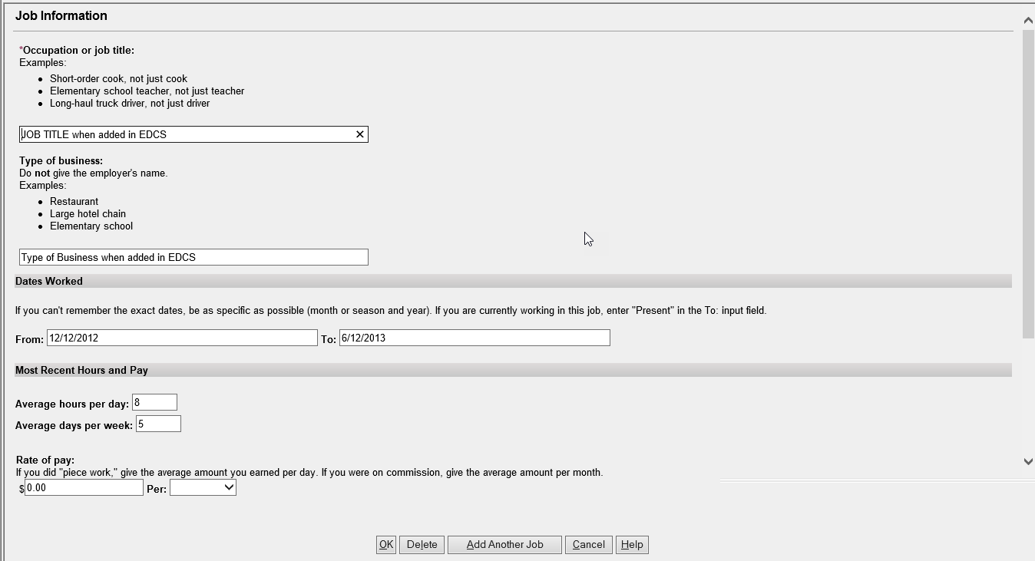

For Rate of Pay- Frequency in drop-down should be Per: hour, day, week, month, or year

Section 6.B- Information about your work

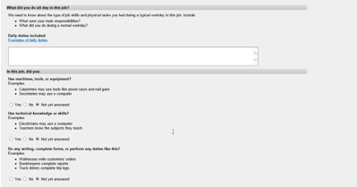

Modify the questions to read as follows:

**“For this job, describe in detail the tasks that you did in a typical workday. Examples of tasks include stocking shelves, greeting customers, scheduling appointments, and maintaining records.”** Add a text box for description.

**“If any tasks listed above involved writing or completing reports, describe the type of report that you wrote or completed and how much time you spent on it per workday or workweek.”** Add a text box for description.

**If any of the tasks listed above involved supervising others, describe who and what you supervised and what supervisory duties you had. Examples of supervisory duties include performance management, making schedules, or maintaining time records.”** Add a text box for explanation.

**“List the machines, tools, and equipment you used regularly when doing this job and explain what you used them for. Examples of equipment include computer, telephone, forklift, air compressor, and meat slicer.”** Add a text box for description.

**“Tell us about the work-related skills you used in this job. Examples of work-related skills include reading blueprints to instruct workers on how to build houses and medical coding to determine the amounts providers should be paid.”** Add a text box for explanation.

Add this question, **“Did your job require you to interact with coworkers, the general public, or anyone else?”** **YES**  **NO**

If they select yes, add the following instructions:

**“Describe who you interacted with, the purpose of this interaction, how you interacted, and how much time you spent doing it per workday or workweek. Examples include answering customer questions on the telephone for 5 hours per day or showing clients sale properties for 4 hours per day.”** Add a text box for explanation.

Section 6C. Physical requirements of your work

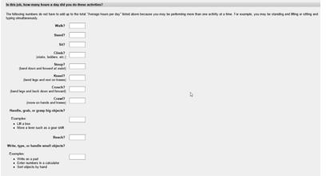

Modify the instructions to read: “**Tell us how much time you spent performing the following physical activities in a typical workday. The total hours/minutes for standing and/or walking and sitting should equal the Hours per Day.** **The example below shows an 8-hour workday with 2 hours standing and/or walking and 6 hours sitting (8 hours total).”** For each activity, add text boxes for “Hours/Minutes” to indicate activity identify activity times.

* The paper form includes an “Example” text box that shows how many hours/minutes for each activity. Standing and walking- 2 hours; stooping- 6 minutes. Work with Systems to determine how to include this on EDCS.

Combine walk and stand to show**, “Standing and/or Walking”**

Sit to **“Sitting”**

Modify the activity section accordingly:

Stoop to **“Stooping”;** keep explanation

Kneel to **“Kneeling”;** keep explanation

Crouch to **“Crouching”;** keep explanation

Crawl to **“Crawling”;** keep explanation

**Using fingers to touch, pick, or pinch (e.g., using a mouse, keyboard, turning pages, or buttoning a shirt)** Add radio buttons to select One Hand and Both Hands

**Using hands to seize, hold, grasp, or turn (e.g., holding a large envelope, a small box, a hammer, or water bottle);** Add radio buttons to select One Hand and Both Hands

Reach to **“Reaching at or below the shoulder”**; Add radio button to select One Arm and Both Arms

**Reaching overhead (above the shoulder):** Add radio buttons to select One Arm and Both Arms

**Climb to “Climbing stairs or ramps”**

**“Climbing ladders, ropes, or scaffolds”**

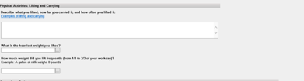

Modify the question to “**Select the weight frequently lifted (i.e., 1/3 to 2/3 of the workday)**”. Add **“Less than 1 lb.”** to the list of options in the drop down.

Modify the question to “**Select the heaviest weight lifted”** Add **“Less than 1 lb.”** to the list of options in the drop down.

Modify Physical Activities Lifting and Carrying instructions: “**Tell us about lifting and carrying in this job. Explain what you lifted, how far you carried it, and how often you did it in a typical workday.”**

After last heaviest weight question, add this question: **“Did your job expose you to any of the following? Check all that apply.”** Add radio buttons and text to select the following options:

**“ Outdoors**  **Extreme Heat (non-weather related)**  **Extreme Cold (non-weather related)**  **Wetness** **Humidity**  **Hazardous Substances**  **Moving Mechanical Parts** **High Exposed Places**  **Heavy Vibration**  **Loud Noise** **Other”**

If one or more of the options are checked, add a text box with instructions that say, **“Tell us about the exposure(s) and how often you were exposed.”**

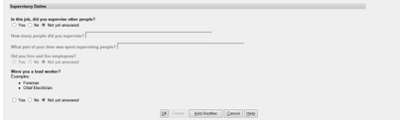

Remove the two questions “Did you supervise other people in this job?” and “Were you a lead worker.

Add this question and a textbox for explanation:

**“Explain how your medical conditions affect your ability to do this job.”**

Medical Sources/ Section 8- Medical Treatment

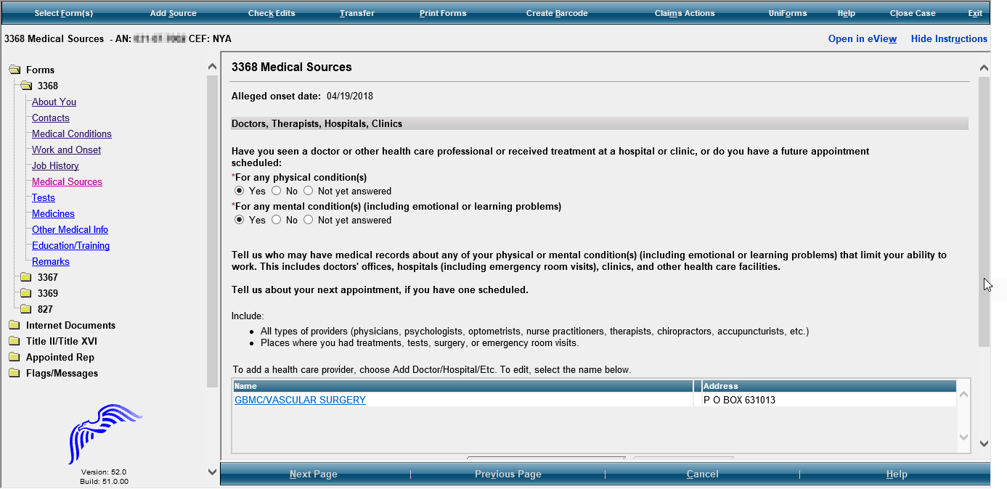

Modify section title to read **“Medical Treatment”**

Modify this question to read, “Have you seen or received treatment from a health care **provider (doctor, hospital, clinic, psychiatrist, nurse practitioner, therapist, physical therapist, or other medical professional**) or do you have a future appointment scheduled?

**Add, “You may find this information on medical bills, online medical chart, or the internet.”**

Doctor/Therapist Information

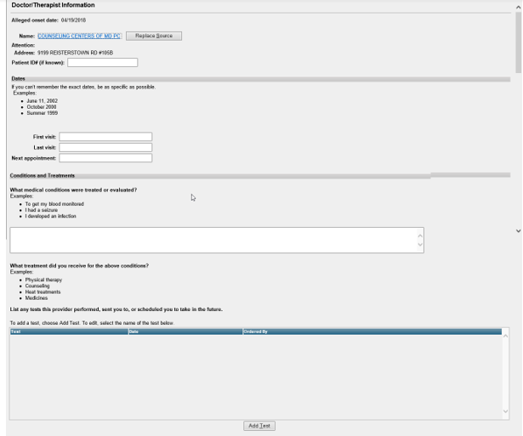

Modify as follows

**“Name of Facility or Office”**

**“Name of Healthcare Provider that treated you”**

**“Phone Number”**

**“Street Address”**

**“City”**

**“STATE/Province”**

**“ZIP/Postal Code”**

**Remove Patient ID # (if known)**

In Dates section, modify the Dates boxes as follows:

“**Date First Seen: MM/YYYY”**

**“Date Last Seen: MM/YYYY”**

**“Date Next Seen: MM/YYYY”**

Tests/ Section 8B- Medical tests

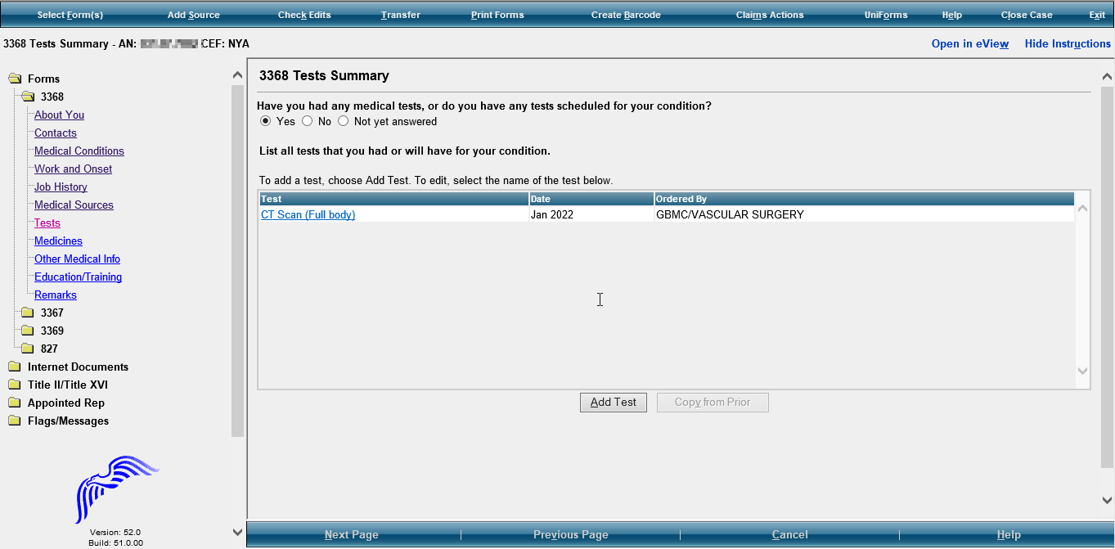

Modify this question read, **“Did any of the providers order any medical tests for you? Include tests already performed and scheduled in the future.”**

Test Information

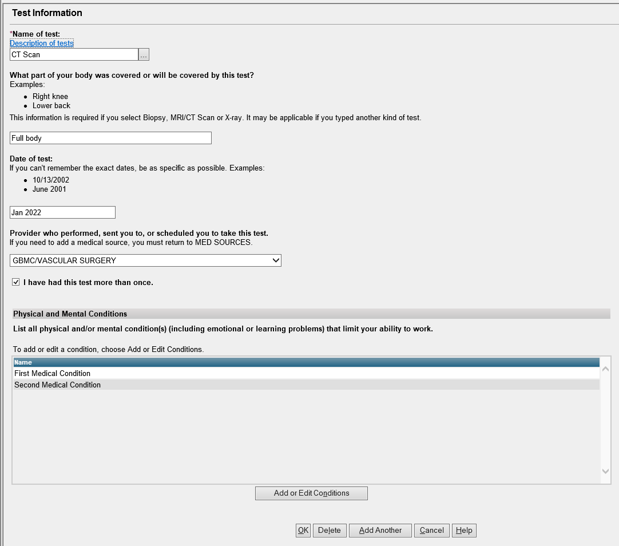

Modify instructions, “Provider who performed, sent you to, or scheduled you to take this test” to

**“Name of healthcare provider or facility** who performed, sent you to, or scheduled you to take this test.”

Add “**Psychological/IQ test**” to drop down selection to “Name of test”

If “Other”, add **“please specify” and provide a text box for explanation.**

**Date of test should be in MM/YYYY format**

Medicines/ Section 7- Medicines

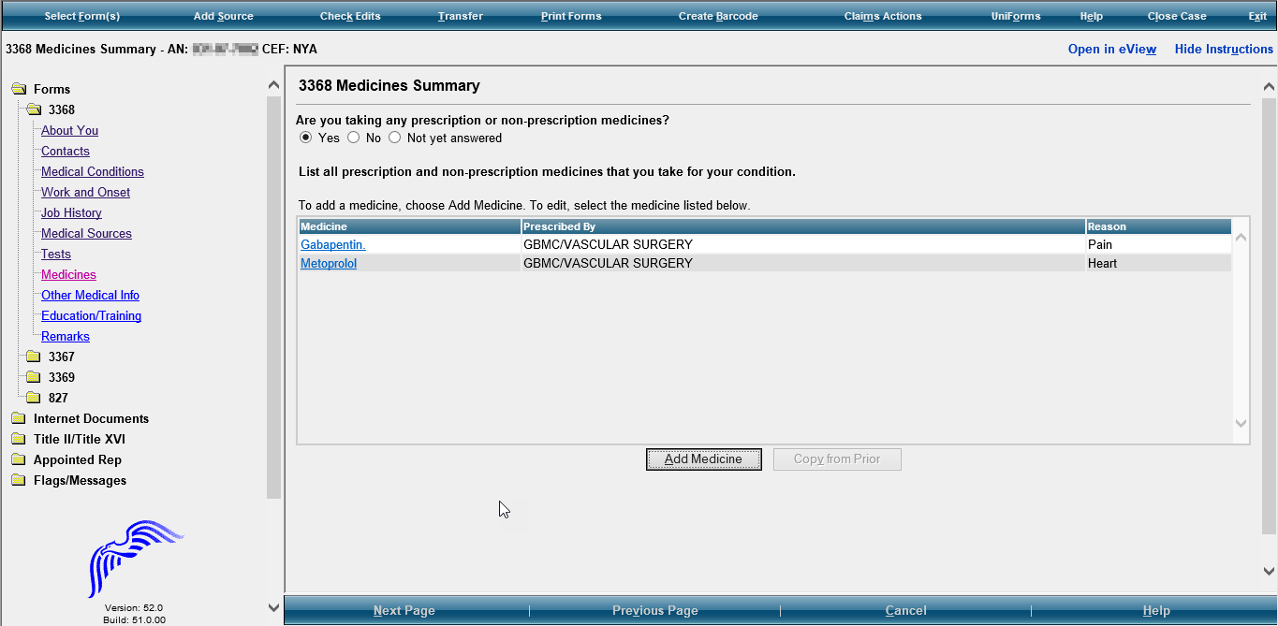

Modify instructions in listing medication section:

**Prescribed By- “If Prescribed Give Doctor Name (If Known)”**

**Reason- “Reason for Medicine (If Known)”**

Modify this question to read, “Are you **currently** taking any prescription or non-prescription medicine(s)?”

Other Medical Info/ Section 9- Other Medical Information

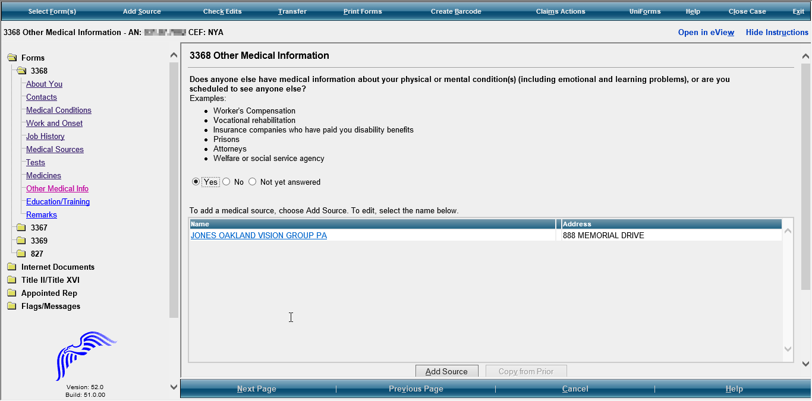

If yes, provide text boxes for:

**“Name or Organization, Phone Number, Mailing Address, City, State/Province, Zip/Postal Code, Country (if not USA), Name of Contact Person, Claim Number (if any), Date of First Contact, Date of Last Contact, Date of Next Contact (if any), Reason(s) for Contacts”**

Modify this question to read, “Does anyone else **(other than your medical providers)** have your medical information? Examples include **social service agencies, welfare agencies, attorneys, prisons,** workers’ compensation, and insurance companies who have paid you disability benefits.”

Education and Training

Modify Education and Training Section title to: **“Education, Training and Literacy”**

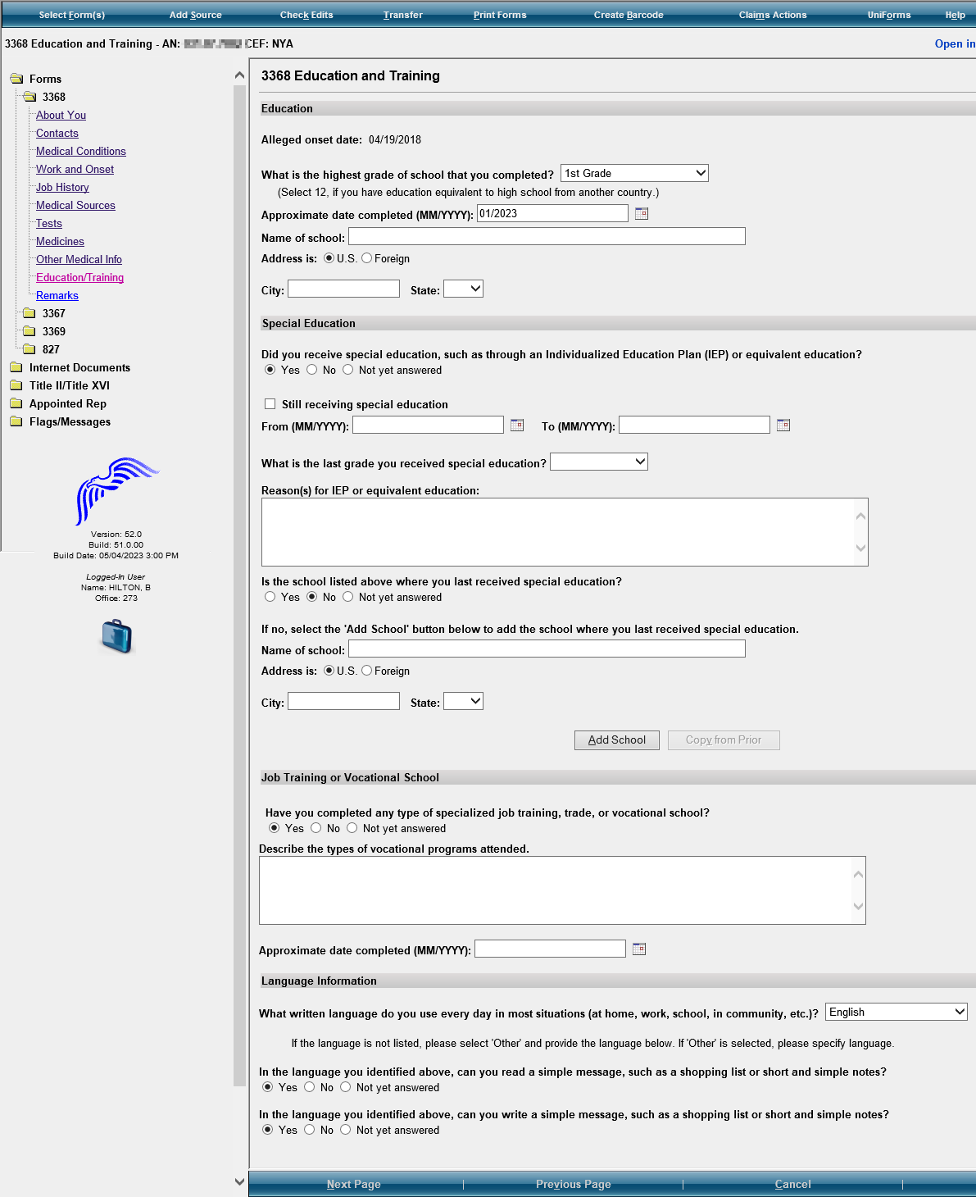

Modify the first question to read, “**Select** the highest level of high school completed, **including homeschooling, online education, and education received in another country. Select “12” if you completed a graduate equivalence degree (GED).”**

Keep the drop down box to select the highest grade of school completed from the drop down selections.

**Add “College 1, 2, 3, 4**” to the drop-down selections.

Modify this question to read, “If no, select the ‘Add School’ button below to add the **school where you were last in special education.”**

Modify this question to read, **“Is the school listed above where you were last in special education?”**

In Job Training or Vocational School, modify question to read, **“Have you received any type of training (specialized job trade, or vocation training)?”** Text box instructions should say **“Type of Program”**

Modify the question to read, “**Select the last grade you were in special education.”**

Modify question: Did you receive special education, such as through an IEP…) to “**Were you in special education?”**

Modify Reason(s) for IEP or equivalent education to: **“Reason(s) for special education:”**

Modify section title to **“Literacy Information”**

In Language Information, modify the questions to read,

“**READING**- In the language you identified…can you read…?

**WRITING**- In the language you identified… can you write…?”

If yes, add sections to complete:

**“Name of Training Facility, Phone Number, Mailing Address, City, State/Province, Zip/Postal Code, Country (if not USA), Type of Program, Date Completed (or scheduled to be completed)”** MM/YYYY format. Keep text box for Type of Program

Modify these two questions to read,

“**READING-** In the language that you identified above can you read...?”

“**WRITING**- In the language you identified above can you write….?”

Modify this question to read, “Have you completed any type of **training** **(**specialized job, trade, or vocational training**)**?

If yes, special education was received, modify this question to read, “**Select** the last grade you received special education.”

**Support Services**

**Please add this section/page at the end of the Education and Training Section (before REMARKS).**

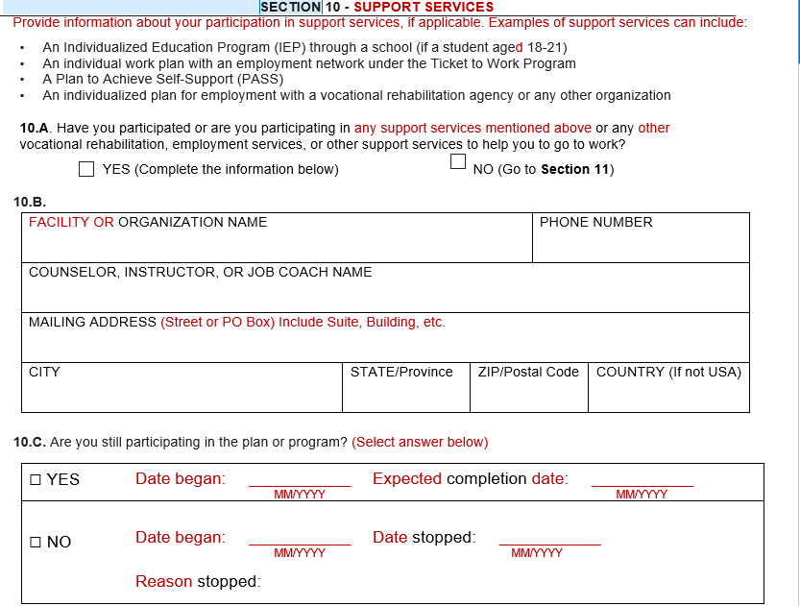

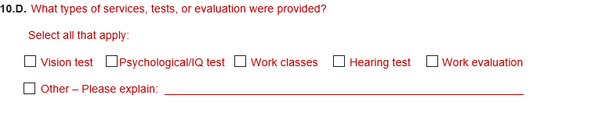

**Section 11- Remarks Section- Here**

**Section 12- Who is Completing this Report**

Modify this section as follows:

Remove Who is providing the information?

Add the following”

**“Date Report Completed (MM/DD/YYYY)”**

**“Who is completing this report?”** Add radio buttons and the following options:

**“John Doe**

**Contact Person**

**Additional Contact Person**

**Someone else**

**If they select radio button for Someone else, provide text boxes to complete the following information:**

**Name (First, Middle Initial, Last)**

**Relationship to John Doe**

**Mailing Address (Street or PO Box) include the apartment number, if applicable.**

**CITY**

**STATE/Province**

**ZIP/Postal Code**

**Country (if not USA)**

**DAYTIME PHONE NUMBER where we may reach you or leave a message, if needed. Include the area code or IDD and country code if outside the USA or Canada.”**

