**SSA-3368 /i3368 Screenshots**

i3368-Contact Information for John Doe/ Section 1- Information About You

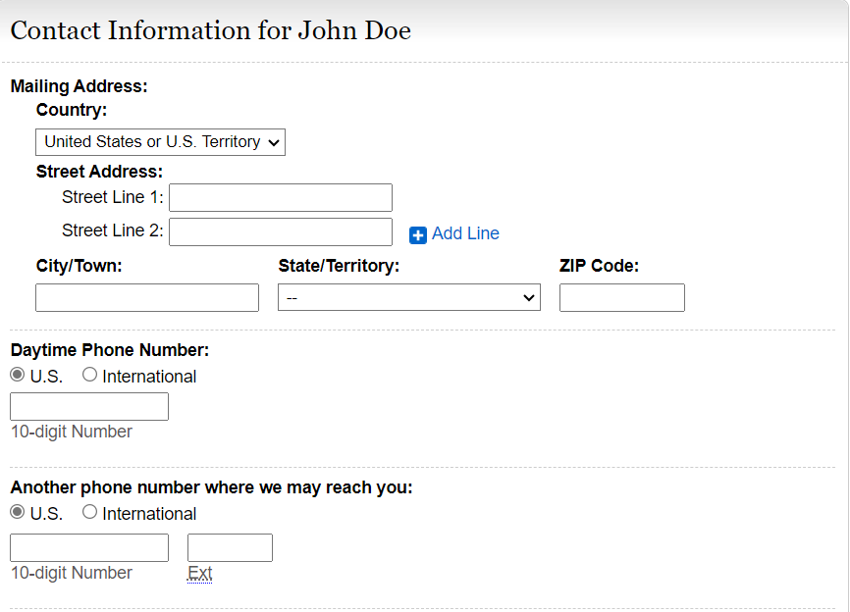

**Update instructions as follows:**

**“Daytime Phone Number(s) where we can call to speak with you or leave a message, if needed.** **Include area code or IDD and country code if outside the USA or Canada.”**

Add **“Primary”** with text box to include number**.**

Add **“Secondary (if available**)” with text box to include number.

Remove “Another phone number where we may reach you.”

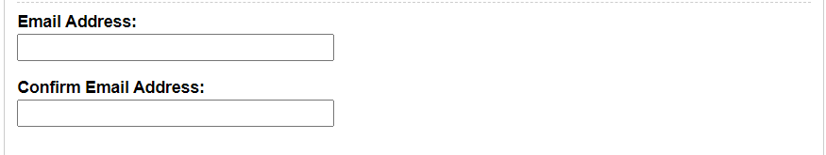

i3368-Other Names/ Section 1- Information About You

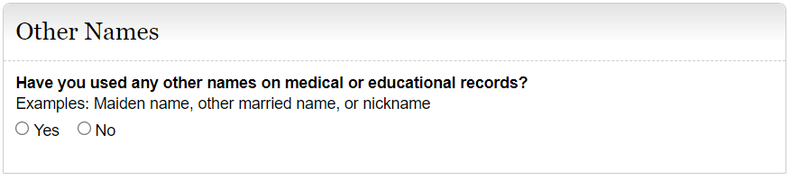

Modify example list as follows: Examples **include** maiden name, other married name, **other names**, or nickname.

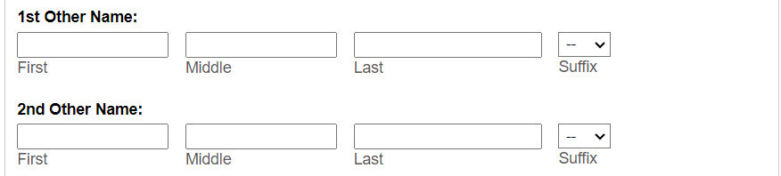

i3368- Other Contact / Section 2- Contacts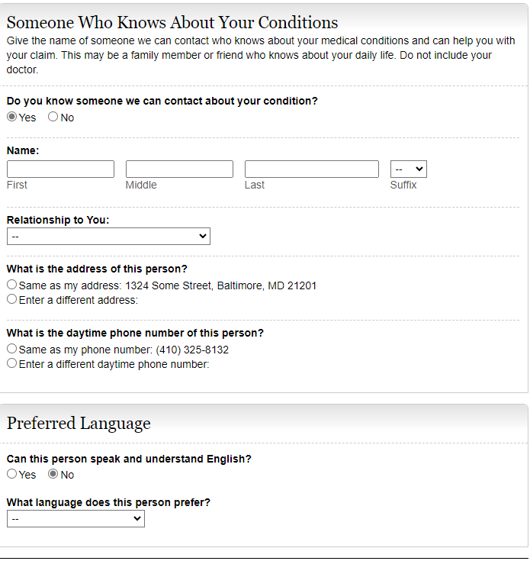

**Change instructions to the following:**

**Is there someone we can contact who can help with your claim, if needed? Examples include a family member, friend, or neighbor.**

**Yes. Please provide the names of two people (other than your doctors) we can contact who know about your medical condition(s) and can help with your claim and help us reach you if you become unavailable.**

Add the ability to enter two contacts.

**No. We recommend that you provide at least one contact, if available. Providing the name of someone who knows you may help us to make a quicker decision on your claim**.

Add section to provide an additional contact with Name, Relationship to You, Address of the person, Daytime phone number of this person, and Preferred Language.

Paper- Section 3- Medical Information/ i3368- Conditions

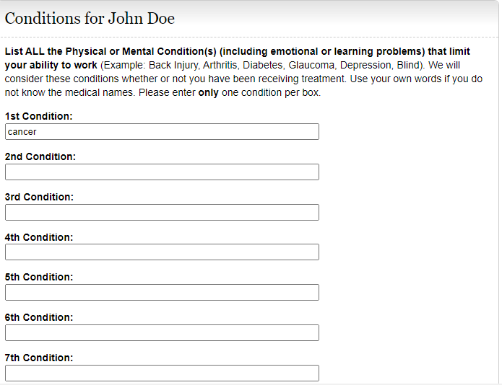

Update the instructions to read “**Separately** list each **physical** **and/or** mental condition that limits your ability to work.”

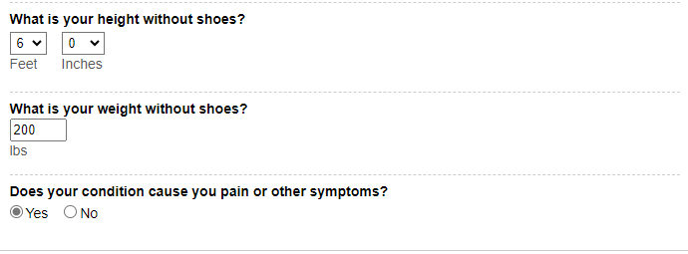

**Remove this question**.

Modify the Height and Weight questions to read as follows:

**“What is your height?”** Add text and radio button to include **“OR centimeters”**

**“What is your weight?”** Add text and radio button to include “**OR kilograms”**

I3368-Currently Working

Select yes

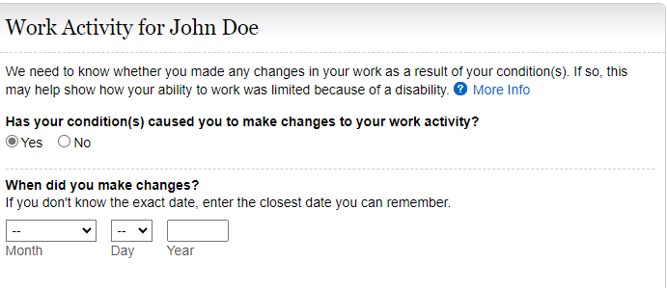

Edit instructional text as follows: “**We need to know whether you or your employer made any changes in your work as a result of your conditions.”**

Edit the language on the More Info screen to include “**Examples include job duties, hours, or rate of pay.”**

Modify question to read as follows:

Has your condition(s) caused you **or** **your employer** to make changes in your work activity?

If yes, modify question to read as follows:

**“When did the changes start? (MM/DD/YYYY)”**

Select No

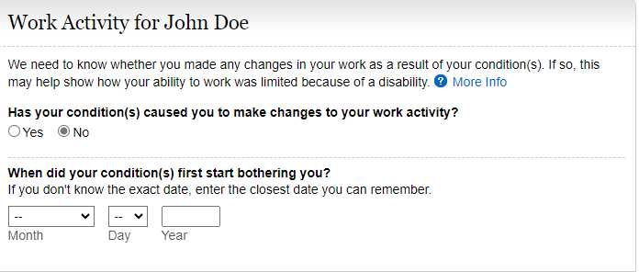

Edit instructional text as follows: “**We need to know whether you or your employer made any changes in your work as a result of your conditions.”**

Edit the language on the More Info screen to include “**Examples include job duties, hours, or rate of pay.”**

Modify question to read as follows:

Has your condition(s) caused you **or** **your employer** to make changes in your work activity?

i3368- Work Activity for John Doe (Stopped Working) /Section 4- Work Activity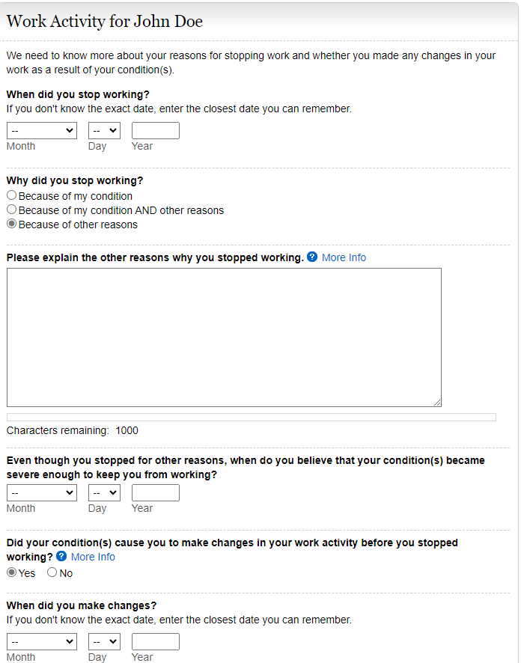

Edit instructions to say, “We need to know more about your reasons for stopping working and whether you **or your employer** made any changes in your work as a result of you condition(s).”

Modify the last radio button option “Because of other reasons” to say:

“Because of other reasons. Please explain the other reasons why you stopped working. **Examples include laid off, early retirement, seasonal work ended, or business closed.”**

Modify the question to read as follows: “Did your condition(s) cause you **or your employer** to make changes in your work activity?

Edits needed to the More Info screen to include the following language: **“Examples include job duties, hours, or rate of pay.”**

If yes, modify the question to read as follows: “**When did the changes start**?”

I3368 Education and Training / Section 5- EDUCATION, TRAINING, AND LITERACY

Edit i3368 section title to “**Education, Training, and Literacy”**

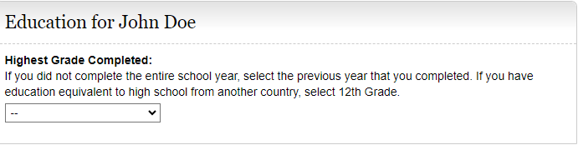

Change section Title to: **“Education, Training and Literacy”**

Modify section to read as follows:

Instructions should read, “**Select the highest level of school completed, including homeschooling, online education, and education received in another country. Select “12” if you completed a graduate equivalency degree (GED).”**

Keep drop-down box to select grade level.

Add “College 1, 2, 3, 4” to the drop-down box selections.

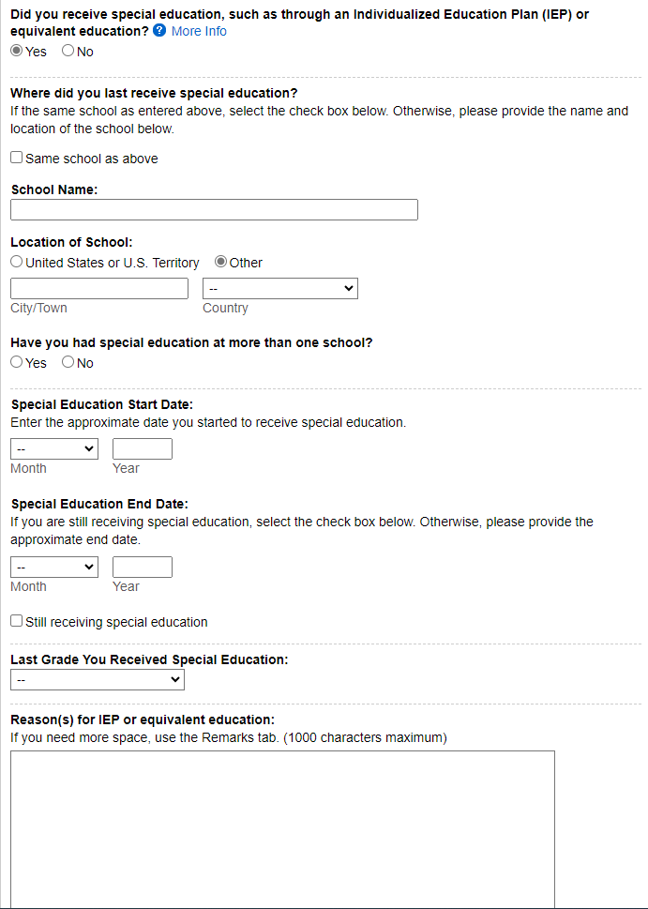

Modify title: “Last Grade You Received Special Education” to “**Last Grade You Were in Special Education:”**

Modify- “Did you receive special education, such as through an Individualized Education Plan (IEP) or equivalent education to **“Were you in special education?”**

Add **“Dates from: MM/YYYY to MM/YYYY”** after this question.

Remove this question.

Change this question to a statement:

“**The school where you were last in special education.”**

Keep radio button for “Same school as above.”

Add radio button and text: “**If different from school above.”**

Keep School Name and Location of School

Edit instructions for the Reason(s) for IEP or equivalent education to read, **“Reason(s) for special education**”.

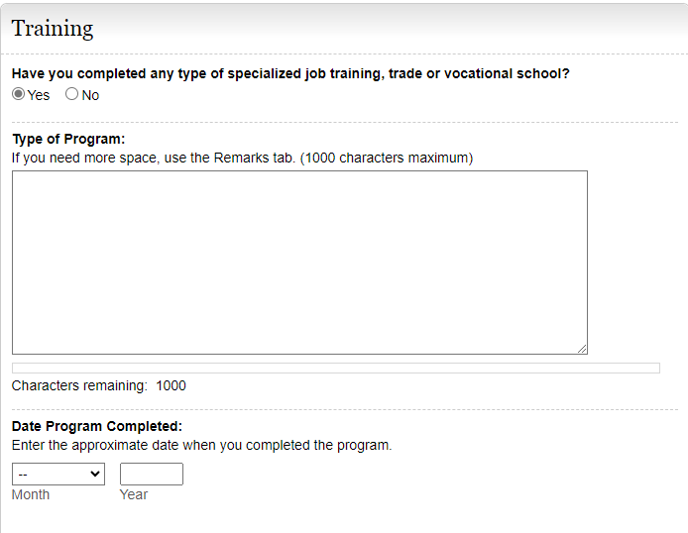

Modify: **Date Completed (or scheduled to be completed)**

Modify the question to read as follows:

“Have you received any type of training **(specialized job, trade, or vocational training)?”**

If yes, add sections to provide**: Name of Training Facility, Phone Number, Mailing Address, City, STATE/Province, ZIP/Postal Code, Country (if not USA)**

Keep text box for Type of Program

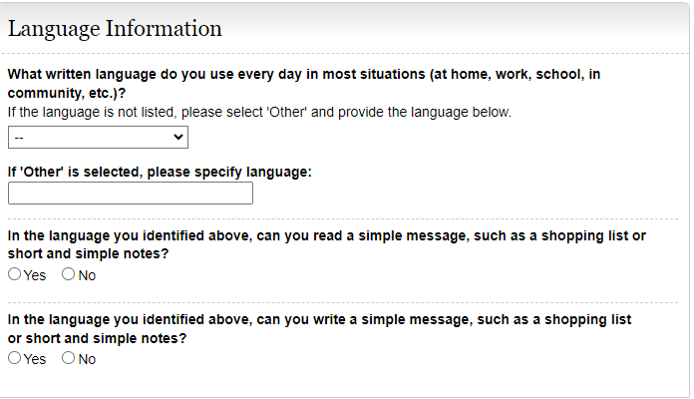

Modify section title to **“Literacy Information”**

Modify the beginning of the language questions as follows:

**WRITING**- “In the language you identified above, can you write…”

Modify the beginning of the language question as follows:

**READING**- “In the language you identified above, can you read …”

i3368 Job History / Section 4- Work Activity (Question 4.E) Currently Working

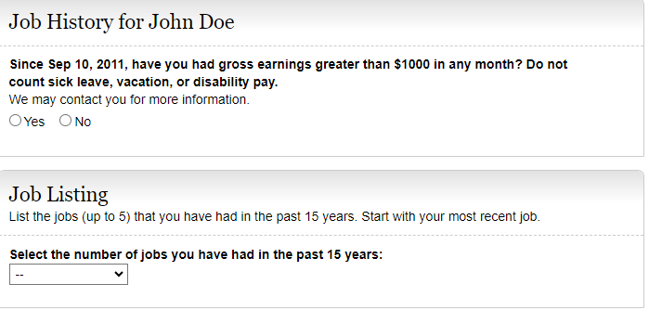

Modify Job Listing instructions to: “List the jobs (up to 5) that you had in the past 5 years. List **all** the jobs that you have had in the last **5** years:

* **Include self-employment**
* **Include work in a foreign country**
* List your most recent job first”

Add question: **“Did you have a job in the last 5 years?**

**YES NO**

If yes, modify Job Listing instructions to say, **“Select the number of jobs you have had in the past 5 years”.**

Modify the question to read as follows: “Since Sep 10, 2011, have you had earnings greater than $___ **before tax** in any month…?”

i3368 Job History / Paper-Section 6-Work History

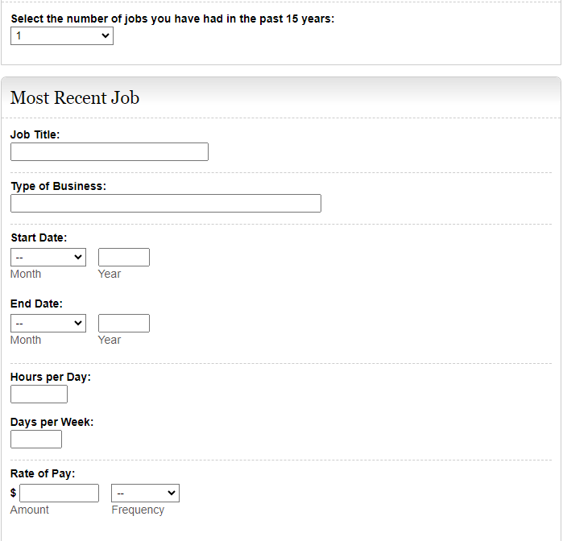

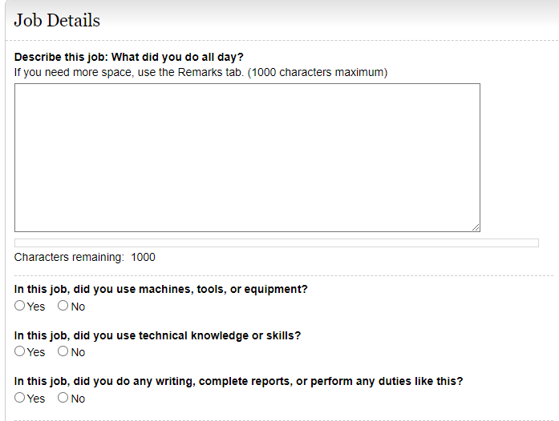

Modify the questions to read as follows:

**“For this job, describe in detail the tasks that you did in a typical workday. Examples of tasks include stocking shelves, greeting customers, scheduling appointments, and maintaining records.”** Add a text box for explanation.

**“If any tasks listed above involved writing or completing reports, describe the type of report you wrote or completed and how much time you spent on it per workday or workweek.”** Add a text box for description.

**“If any tasks listed above involved supervising others, describe who and what you supervised and what supervisory duties you had. Examples of supervisory duties include performance management, making schedules, or maintaining time records.”** Add a text box for explanation.

**“List the machines, tools, and equipment you used regularly when doing this job and explain what you used them for. Examples of equipment include computer, telephone, forklift, air compressor, and meat slicer.”** Add a text box for explanation.

**“Tell us about the work-related skills you used in this job and the job duties you completed using these skills. Examples of work-related skills include reading blueprints to instruct workers on how to build houses and medical coding to determine the amounts providers should be paid.”** Add a text box for explanation.

After question, “Tell us about the work-related skills…” add question:

Add this question, **“Did your job require you to interact with coworkers, the general public, or anyone else?”**  **YES**  **NO**

If they select yes, add a textbox with the following instructions:

**“Describe who you interacted with, the purpose of the interaction, how you interacted, and how much time you spent doing it per workday or workweek. Examples include answering customer questions on the telephone for 5 hours per day or showing clients sale properties for 4 hours per day.”**

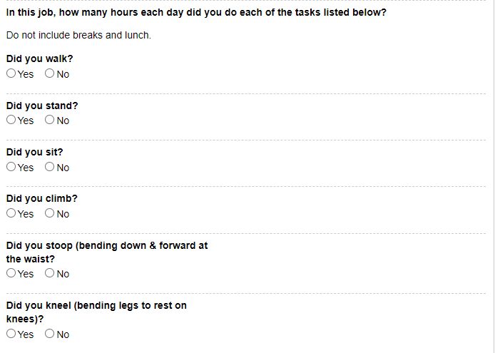

Modify the instructions to read: **“Tell us how much time you spent performing the following physical activities in a typical workday. The total hours/minutes for standing and/or walking and sitting should equal the Hours per Day.** **The example below shows an 8-hour workday with 2 hours standing and/or walking and 6 hours sitting (8 hours total).”** For each activity add a text box for “**Hours/Minutes”** to indicate time for each activity.

*The paper form includes an “Example” text box that shows how many hours/minutes for each activity. Standing and walking- 2 hours; stooping- 6 minutes. Work with Systems to determine how to include this on i3368.

Combine **“Standing and/or Walking”**

**“Sitting”**

**Stooping (i.e., bending down and forward at waist)**

**Kneeling (i.e., bending legs to rest on knees)**

**Crouching (i.e., bending legs & back down & forward)**

**Crawling (i.e., moving on hands and knees)**

**Using fingers to touch, pick, or pinch (e.g., using a mouse, keyboard, turning pages, or buttoning a shirt);** add radio buttons to select One Hand or Both Hands

**Using hands to seize, hold, grasp, or turn (e.g., holding a large envelope, a small box, a hammer, or water bottle)**; add radio buttons to select One Hand or Both Hands

**Reaching at or below the shoulder**; add radio buttons to select One Arm or Both Arms

**Reaching overhead (above the shoulder);** add radio buttons to select One Arm or Both Arms

**Climbing stairs or ramps**

**Climbing ladders, ropes, or scaffolds**

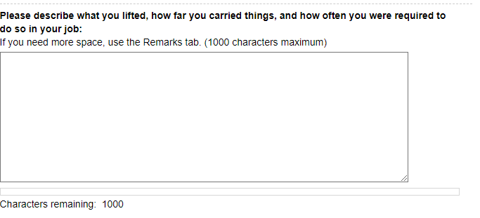

Modify these instructions: “**Tell us about lifting and carrying in this job. Explain what you lifted, how far you carried it, and how often you did it in a typical workday.”**

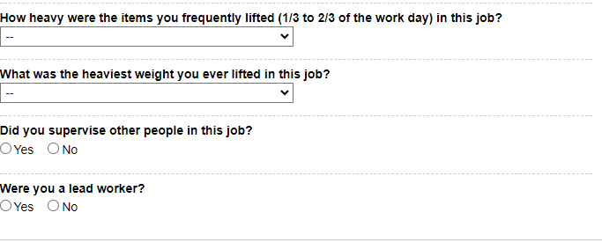

Modify the question to “**Select the heaviest weight lifted”** Add **“Less than 1 lb.”** to the list of options in the drop down.

Modify the question to “**Select the weight frequently lifted (i.e., 1/3 to 2/3 of the workday)**”. Add **“Less than 1 lb.”** to the list of options in the drop down.

After last heaviest weight question, add this question: **“Did your job expose you to any of the following? Check all that apply.”**

Add radio buttons to select the following options:

**“ Outdoors**  **Extreme Heat (non-weather related)**  **Extreme Cold (non-weather related)**  **Wetness** **Humidity** **Hazardous Substances**  **Moving Mechanical Parts**  **High, Exposed Places**  **Heavy Vibration**  **Loud Noise**  **Other”**

If one or more of the options are checked, add a text box with instructions that say, **“Tell us about the exposure(s) and how often you were exposed.”**

**Remove the questions- “Did you supervise other people in this job?” and “Were you a lead worker?”**

Add the following question and a textbox for explanation:

**“Explain how your medical conditions affect your ability to do this job.”**

Stopped Working / Work History

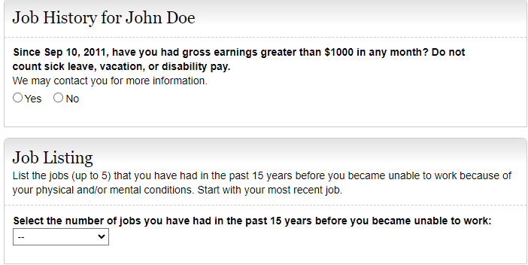

Modify Job Listing instructions to: “List the jobs (up to 5) that you had in the past 5 years. List **all** the jobs that you have had in the last **5** years:

* **Include self-employment**
* **Include work in a foreign country**
* List your most recent job first”

Add question: **“Did you have a job in the last 5 years?**

**YES NO**

If yes, modify Job Listing instructions to say, **“Select the number of jobs you have had in the past 5 years”.**

Modify the question to read as follows: “Since Sep 10, 2011, have you had earnings greater than $___ **before tax** in any month…?”

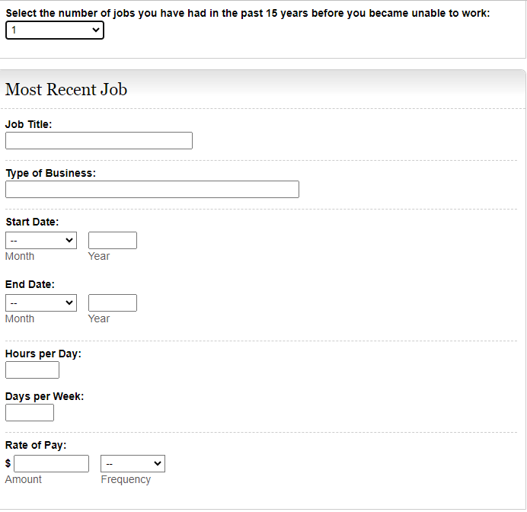

Dates Worked

From: MM/YY**YY**

To: MM/YY**YY**

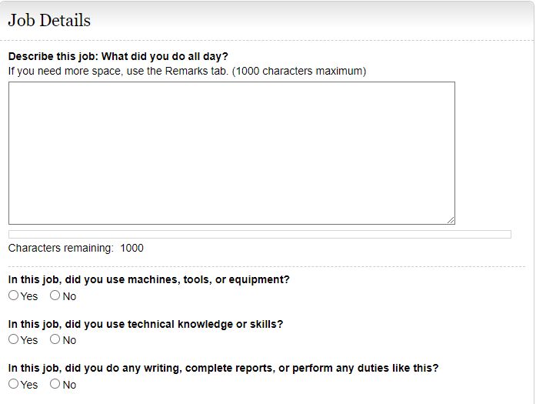

Modify the Job Details section questions to read as follows:

**“For this job, describe in detail the tasks you did in a typical workday. Examples of tasks include stocking shelves, greeting customers, scheduling appointments, and maintaining records.”** Add a text box for explanation.

**“If any of the tasks listed above involved writing or completing reports, describe the type of report you wrote or completed and how much time you spent on it per workday or workweek.”** Add a text box for explanation.

**“If any of the tasks listed above involved supervising others, describe who or what you supervised and what supervisory duties you had. Examples of supervisory duties include performance management, making schedules, and maintaining time records.”** Add a text box for explanation.

**“List the machines, tools, and equipment you used regularly when doing this job and explain what you used them for. Examples of equipment include computer, telephones, forklift, air compressor, and meat slicer.”** Add a text box for explanation.

**“Tell us about the work-related skills you used in this job and the job duties you completed using these skills. Examples of work-related skills include reading blueprints to instruct workers on how to build houses and medical coding to determine the amount providers should be paid.”** Add a text box for explanation.

Add this question, **“Did your job require you to interact with coworkers, the general public, or anyone else?”**  **YES**  **NO**

If they select yes, add a textbox with the following instructions:

**“Describe who you interacted with, the purpose of the interaction, how you interacted, and how much time you spent doing it per workday or workweek. Examples include answering customer questions on the telephone for 5 hours per day or showing clients sale properties for 4 hours per day.”**

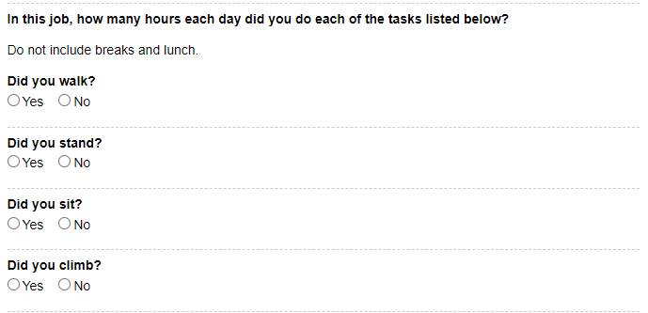

Modify the instructions to read: **“Tell us how much time you spent performing the following physical activities in a typical workday. The total hours/minutes for standing and/or walking and sitting should equal the Hours per Day.**” For each activity add a text box or radio buttons to select Hours/Minutes to indicate time for each activity.

*The paper form includes an “Example” text box that shows how many hours/minutes for each activity. Standing and walking- 2 hours; stooping- 6 minutes. Work with Systems to determine how to include this on i3368.

Combine **“Standing and/or Walking”**

**“Sitting”**

**Stooping (i.e., bending down and forward at waist)**

**Kneeling (i.e., bending legs to rest on knees)**

**Crouching (i.e., bending legs & back down & forward)**

**Crawling (i.e., moving on hands and knees)**

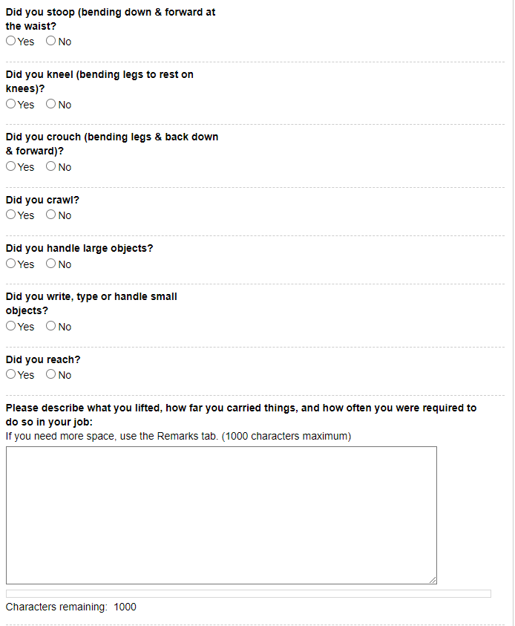

**Using hands to seize, hold, grasp, or turn (e.g., holding a large envelope, a small box, a hammer, or water bottle)**; add radio buttons to select One Hand or Both Hands

Modify these instructions: “**Tell us about lifting and carrying in this job. Explain what you lifted, how far you carried it, and how often you did it in a typical workday.”**

**Climbing ladders, ropes, or scaffolds**

**Climbing stairs or ramps**

**Reaching overhead (above the shoulder)**; add radio buttons to select One Arm or Both Arms

**Reaching at or below the shoulder;** add radio buttons to select One Arm or Both Arms

**Using fingers to touch, pick, or pinch (e.g., using a mouse, keyboard, turning pages, or buttoning a shirt);** add radio buttons to select One Hand or Both Hands

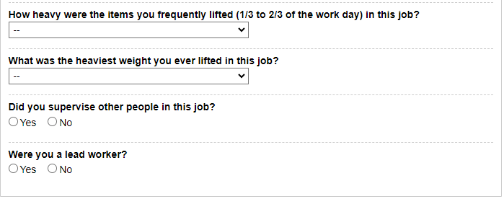

After last heaviest weight question, add this question: **“Did your job expose you to any of the following? Check all that apply.”**

Add radio buttons to select the following options:

**“ Outdoors**  **Extreme Heat (non-weather related)**

 **Extreme Cold (non-weather related)**  **Wetness**

 **Humidity**  **Hazardous Substances**  **Moving Mechanical Parts**  **High, Exposed Places**  **Heavy Vibration**

 **Loud Noise**  **Other”**

If one or more of the options are checked, add a text box with instructions that say, **“Tell us about the exposure(s) and how often you were exposed.”**

Modify the question to “**Select the heaviest weight lifted”** Add **“Less than 1 lb.”** to the list of options in the drop down.

Modify the question to “**Select the weight frequently lifted (i.e., 1/3 to 2/3 of the workday)**”. Add **“Less than 1 lb.”** to the list of options in the drop down.

Remove the questions “Did you supervise other people in this job?” and “Were you a lead worker?”

Add this question and a textbox for explanation:

**“Explain how your medical conditions affect their ability to do this job.”**

Paper Section 7- Medicine/ i3368 Medicine

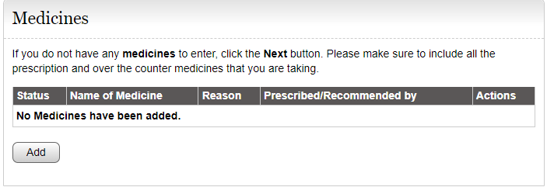

Modify instructions to ask this question say **“Are you currently taking any prescription or non-prescription medicine(s)?”**

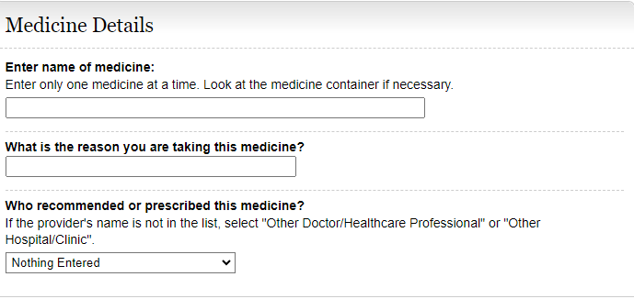

Modify question to **“Reason for Medicine (if known)”**

Modify question to **“If prescribed give Doctor’s Name (if known)”**

Paper Section 8- Medical Treatment/ i3368 Doctors and Other Healthcare Professionals

The i3368 currently lists Doctors and Other Healthcare Professionals AND Hospital and Clinics separately. We would like to combine these two separate sections into one section titled “Medical Treatment” because the same information is asked for in both sections.  Tests and Medical Sources should be listed separately. This section should mirror the revised SSA-3368. Maybe we can borrow the functionality from the i454.

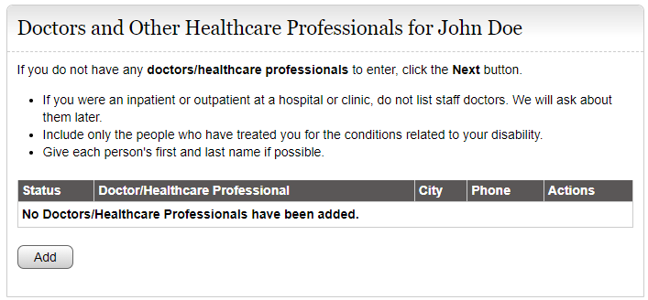

Remove these instructions. Add this question:

**“Have you seen or received treatment from a healthcare provider (doctor, hospital, clinic, psychiatrist, nurse practitioner, therapist, physical therapist, or other medical professional, or do you have a future appointment scheduled?”**

Add this statement:

**“You may find this information on medical bills, online medical chart, or the internet.”**

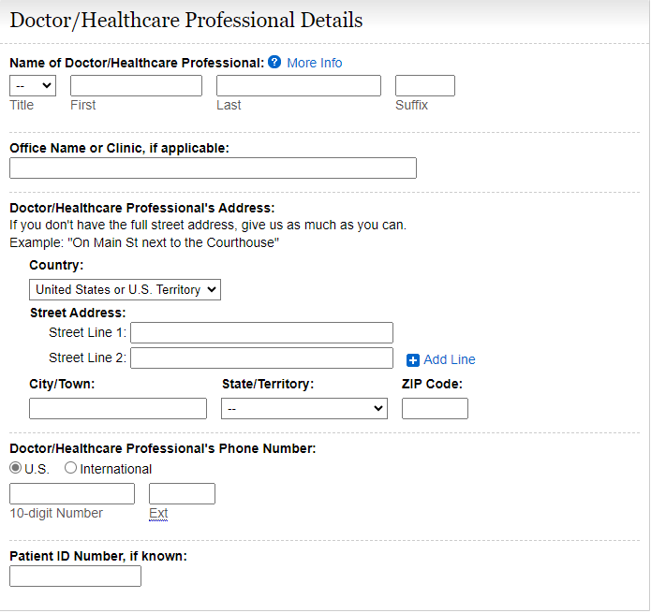

This section should include text boxes for the following:

**“Name of Facility or Office**

**Name of Health Care Provider that treated you**

**What medical conditions were treated or evaluated?**

**Phone Number**

**Street Address**

**City**

**STATE/Province**

**ZIP/Postal Code**

**Country (if not USA)”**

Remove Patient ID Number, if known:

Modify section title to **“Doctors, Therapists, Hospitals, Clinics”**

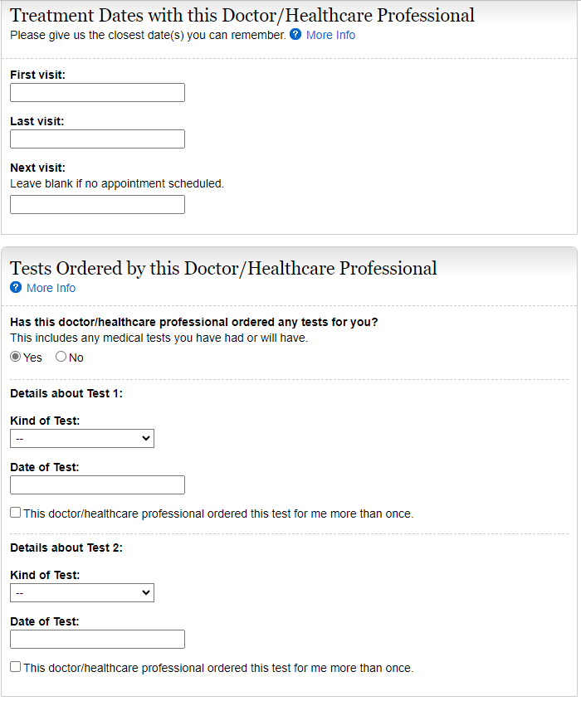

Modify this question to read as follows:

“Has this doctor/healthcare professional ordered any **medical** tests for you? **Include tests already performed and scheduled in the future.**

In “Kind of Test”, **add “Psychological/IQ test”** to the list of tests.

As previously stated, Tests should be separate from Medical Sources.

**Date First Seen (MM/YYYYY)**

**Date Last Seen (MM/YYYY)**

**Date Next Seen (MM/YYYY)**

Hospitals and Clinics

The i3368 currently lists Doctors and Other Healthcare Professionals AND Hospital and Clinics separately. We would like to combine these two separate sections into one section titled “Medical Treatment” because the same information is asked for in both sections. Tests and medical sources should be listed separately. This section should mirror the revised SSA-3368. Maybe we can borrow the functionality from the i454.

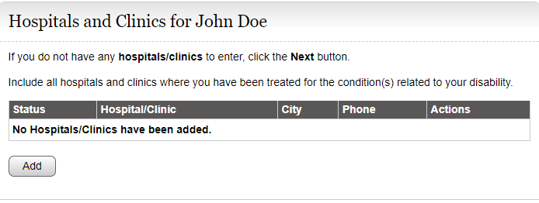

Remove these instructions. Add this question:

“**Have you seen or received treatment from a healthcare provider (doctor, hospital, clinic, psychiatrist, nurse practitioner, therapist, physical therapist, or other medical professional, or do you have a future appointment scheduled?”**

Add this statement:

**“You may find this information on medical bills, online medical chart, or the internet.”**

**scheduled. You may find this information on medical bills, online medical chart, or the internet.”**

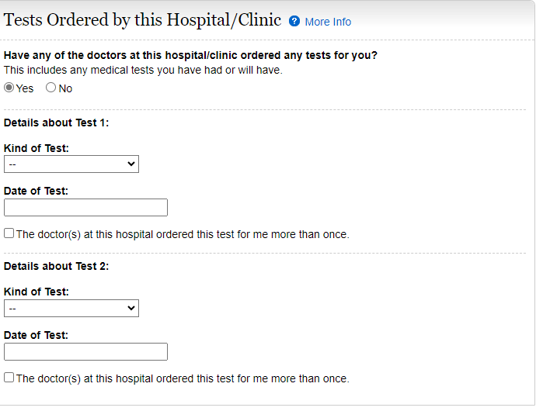

Modify this question to read as follows:

“Has this hospital/clinic ordered any **medical** tests for you? **Include tests already performed and scheduled in the future.**

In “Kind of Test”, **add “Psychological/IQ test”** to the list of tests.

As previously stated, Tests should be separate from Medical Sources.

Medical Tests

Edit instructions:

**“Did any of the providers listed above order any medical tests for you?”** **Include tests already performed and scheduled in the future.”**

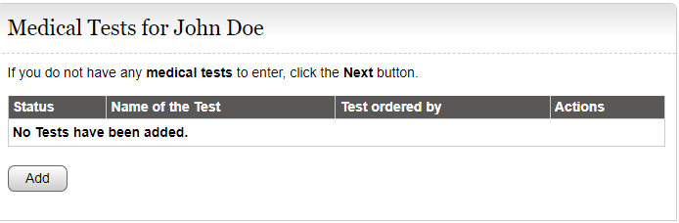

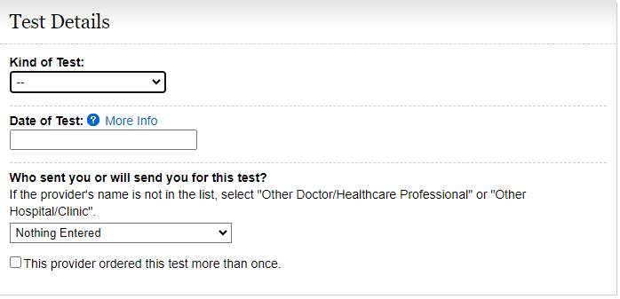

In “Kind of Test”, **add “Psychological/IQ test”** to the list of tests.

Section 9- Other Medical Information/ Other Medical Records

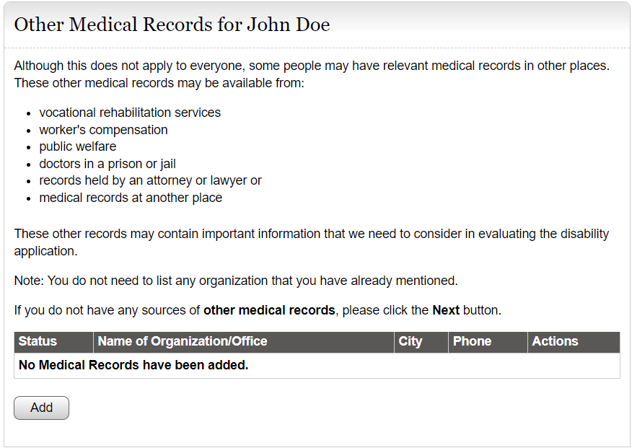

Edit instructions as follows:

**“Does anyone else (other than your medical providers) have your medical information? Examples include social service agencies, welfare agencies, attorneys, prisons, workers’ compensation, and insurance companies who have paid you disability benefits.”**

**Add radio buttons to select Yes or No.**

Other Medical Record Details

IF yes,

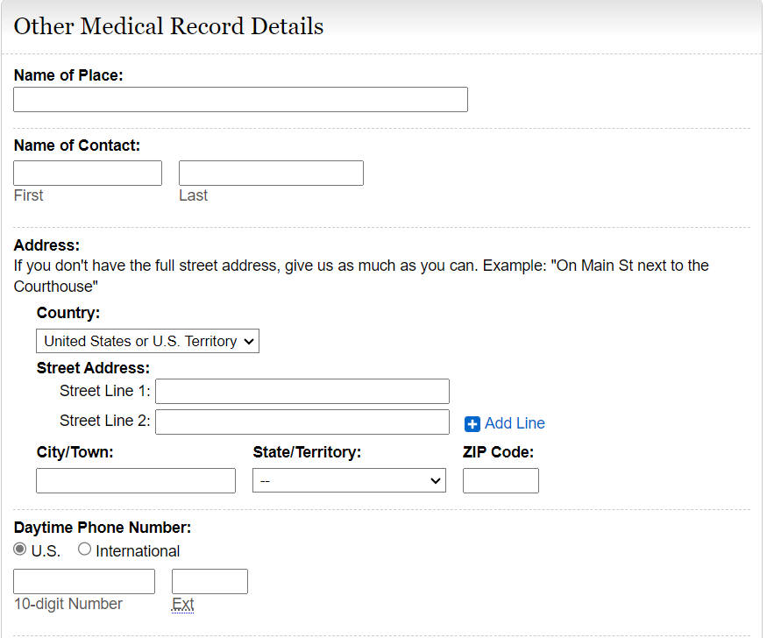

Edit this section as follows:

**“Name or Organization**

**Phone Number**

**Mailing Address**

**City**

**STATE/Province**

**ZIP/Postal Code**

**Country (if not USA)**

**Name of Contact Person**

**Claim Number (if any)**

**Date of First Contact**

**Date of Last Contact**

**Date of Next Contact (if any)**

**Reason(s) for Contacts”**

Allow them to add multiple people or organizations with details.

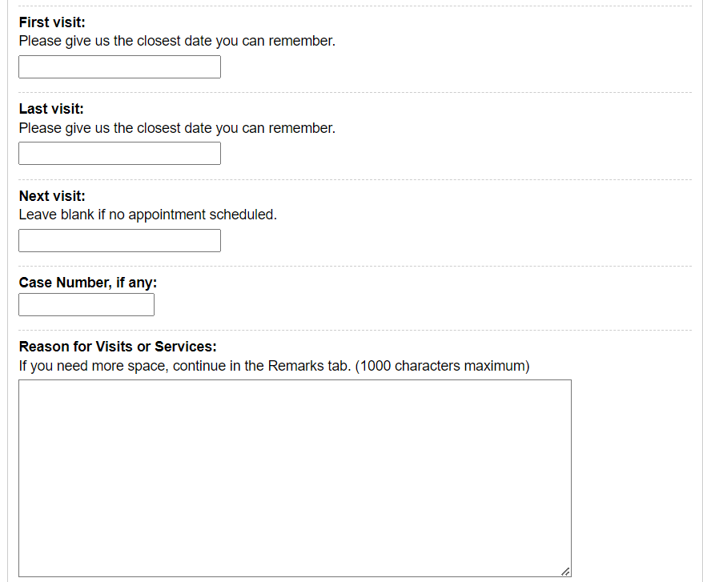

**Section 10- Support Services**

**This is a new section to add to the i3368 Work/Education Pages after the Education, Training, and Literacy Section.**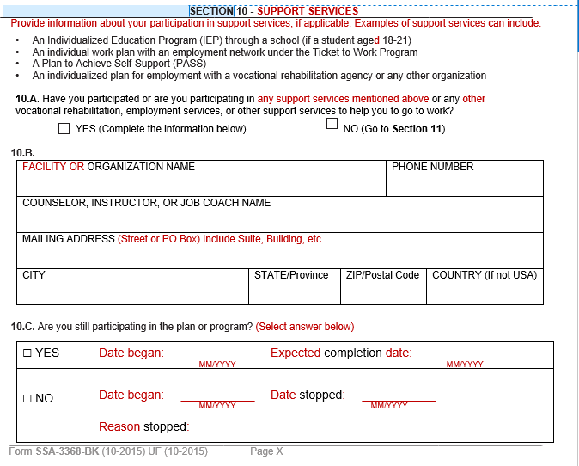

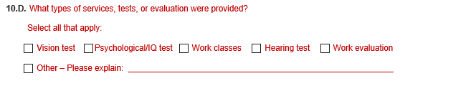

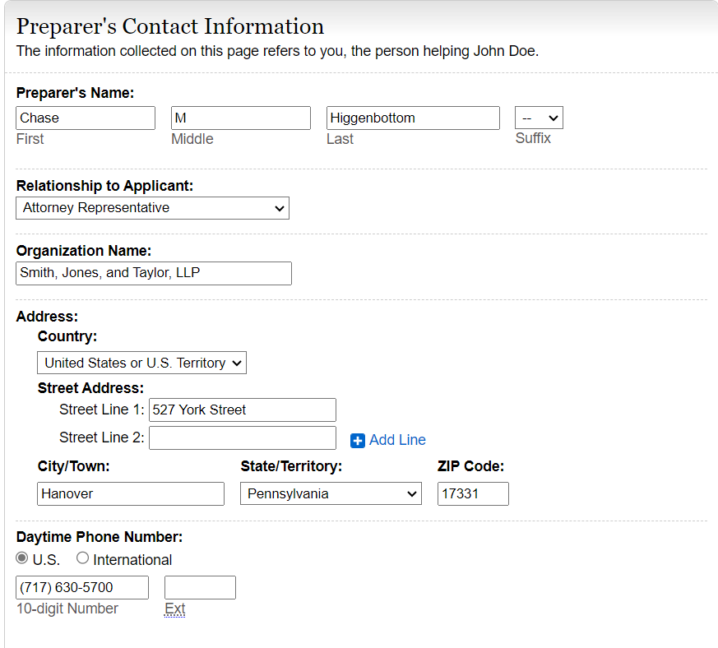

Modify this section as follows:

**“Date Report Completed (MM/DD/YYYY)”**

“**Who is completing this report?”** Add radio buttons and the following options:

**“John Doe**

**Contact Person**

**Additional Contact Person**

**Someone else”**

If they select “Someone else” provide text boxes to complete the following information:

**“NAME (First, Middle Initial, Last)**

**Relationship to John Doe**

**MAILING ADDRESS (Street or PO Box) Include the apartment, if applicable.**

**CITY**

**STATE/Province**

**ZIP/Postal Code**

**Country (if not USA)**

**Daytime Phone Number where we may reach you or leave a message, if needed. Include the area code or IDD and country code if outside the USA or Canada.”**

Modify title of section to **“Who Is Completing This Report”**