i3368 Third Party Screenshots PRW NPRM
Contact Information for John Doe/ Section 1- Information About John Doe
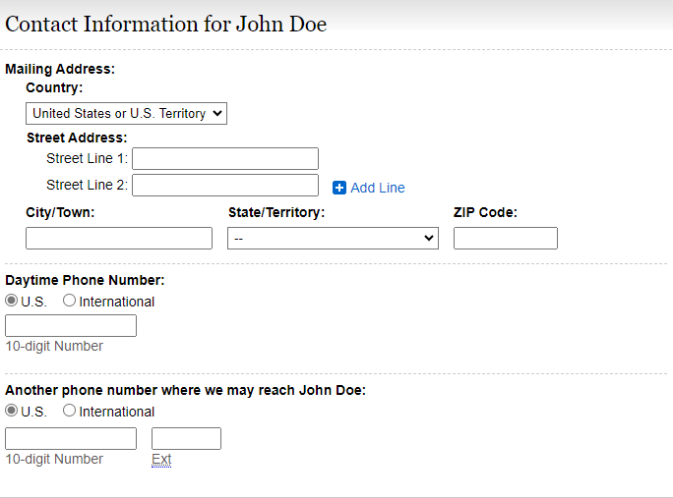
Update instructions as follows:
“Daytime Phone Number(s) where we can call to speak with them or leave a message, if needed. Include area code or IDD and country code if outside the USA or Canada.”
Add “Primary” with text box to include number.
Add “Secondary (if available)” with text box to include number.
Remove “Another phone number where we may reach you.”

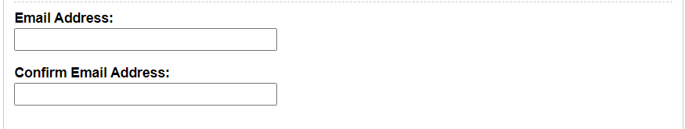

i3368-Other Names/ Section 1- Information About John Doe
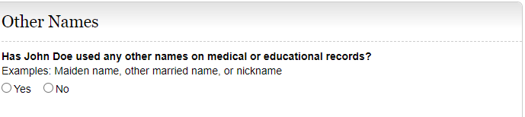
Modify example list as follows: Examples include maiden name, other married name, other names, or nickname”.

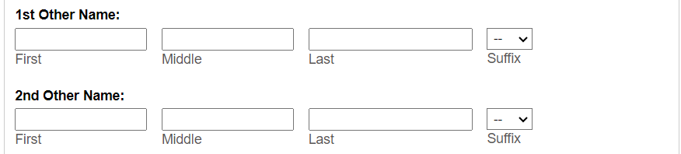

I3368-Other Contacts/ Section 2- Contacts
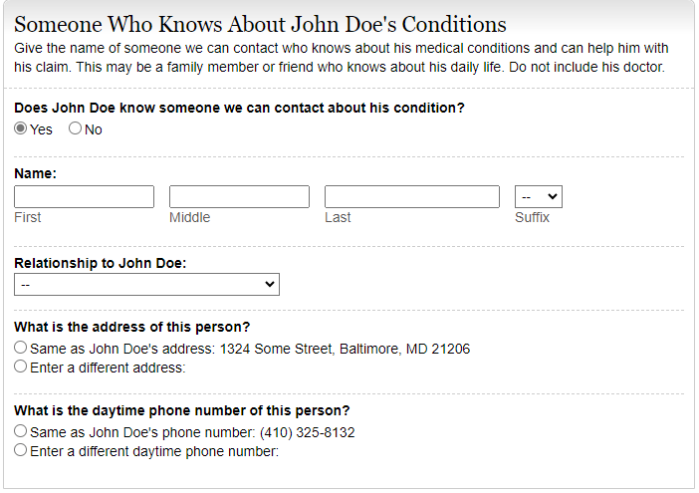
Change instructions to the following:
Is there someone we can contact who can help with their claim, if needed? Examples include a family member, friend, or neighbor.
Yes. Please provide the names of two people (other than their doctors) we can contact who know about their medical condition(s) and can help with their claim and help us reach them if they become unavailable.
Add the ability to enter two contacts.
No. We recommend that they provide at least one contact, if available. Providing the name of someone who knows them may help us to make a quicker decision on their claim.
Add section to provide an additional contact with Name, Relationship to You, Address of the person, Daytime phone number of this person, and Preferred Language.

I3368-Conditions/ Section 3- Medical Information
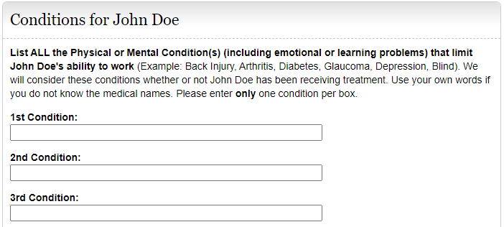
Update the instructions to read “Separately list each physical and/or mental condition that limits their ability to work.”

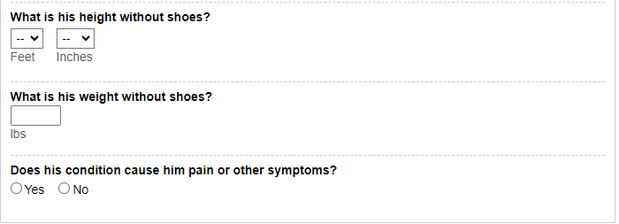
Modify the Height and Weight questions to read as follows:
“What is their height? Add text and radio button to include “OR centimeters”
“What is their weight? Add text and radio button to include “OR kilograms”

Remove this question.

I3368- Work Activity (Currently Working)/ Section 4- Work Activity
Select yes
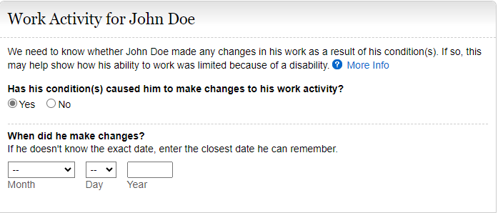
Edit instructional text as follows: “We need to know whether they or their employer made any changes in their work as a result of your conditions.”
Edit the language on the More Info screen to include “Examples include job duties, hours, or rate of pay.”
Modify question to read as follows:
Has their condition(s) caused them or their employer to make changes in their work activity?
If yes, modify question to read, “When did the changes start? MM/DD/YYYY)

Select No
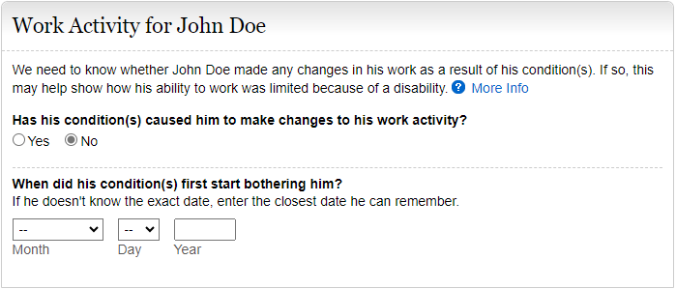
Edit instructional text as follows: “We need to know whether they or their employer made any changes in their work as a result of their conditions.” Edit the language on the More Info screen to include “Examples include job duties, hours, or rate of pay”.
Modify question to read as follows:
“Has their condition(s) caused them or their employer to make changes in their work activity?”

i3368- Work Activity (Stopped Working)/ Section 4- Work Activity 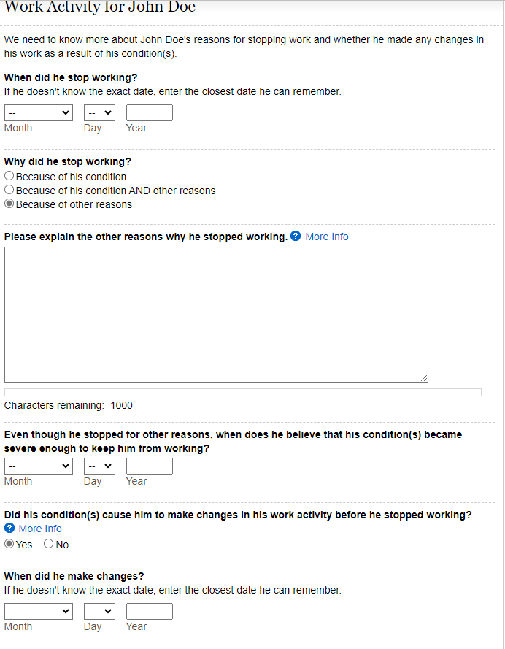
Modify the last radio button option “Because of other reasons” to say:
“Because of other reasons. Please explain the other reasons why they stopped working. Examples include laid off, early retirement, seasonal work ended, or business closed.”

Edit instructions to say, “We need to know more about their reasons for stopping working and whether they or their employer made any changes in your work as a result of you condition(s).”

Modify the question to read as follows: “Did their condition(s) cause them or their employer to make changes in their work activity?
Edits needed to the More Info screen to include the following language: “Examples include job duties, hours, or rate of pay.”

If yes, modify the question to read as follows: “When did the changes start?”

Education and Training
Edit i3368 section title to “Education, Training, and Literacy”
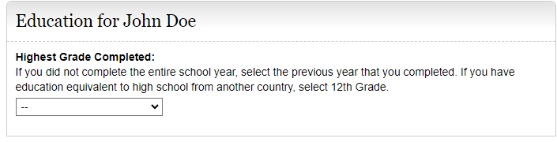
Change section title to: “Education, Training, and Literacy”
Modify section to read as follows:
Instructions should read, “Select the highest level of school completed, including homeschooling, online education, and education received in another country. Select “12” if they completed a graduate equivalency degree (GED).”
Keep drop down box to select grade level.
Add “College- 1, 2, 3, 4 to the drop-down box selections.

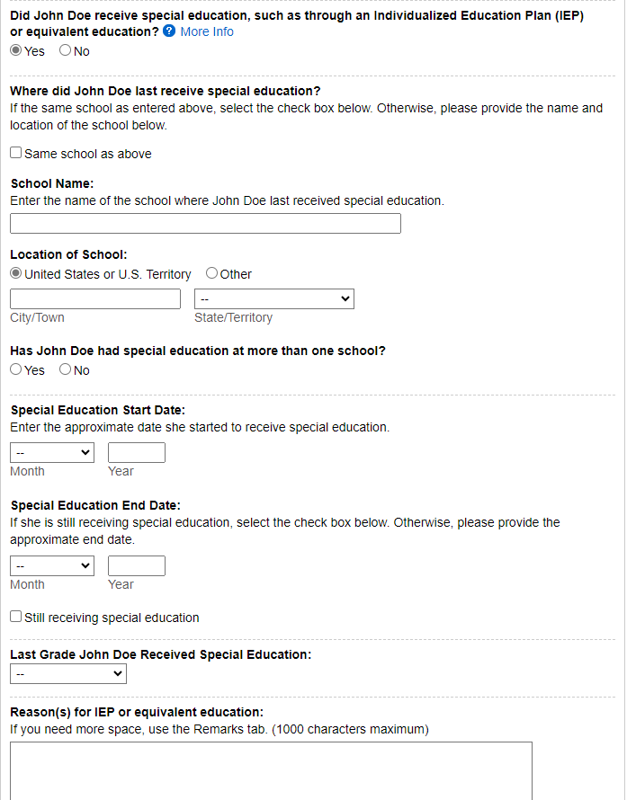
Edit instructions for the Reason(s) for IEP or equivalent education to say, “Reason(s) for special education”.

Modify- “Did they receive special education, such as through an Individualized Education Plan (IEP) or equivalent education?” question to “Were they in special education?”
Add “Dates from: MM/YYYY to MM/YYYY” after this question.

Modify title: “Last Grade John Doe Received Special Education” to “Last Grade John Doe Was in Special Education:”

Change this question to a statement:
“The school where they were last in special education.”
Keep radio button for “Same school as above.”
Add radio button and text: “If different from school above.”
Keep School Name and Location of School
Remove this question.

Training
If yes,
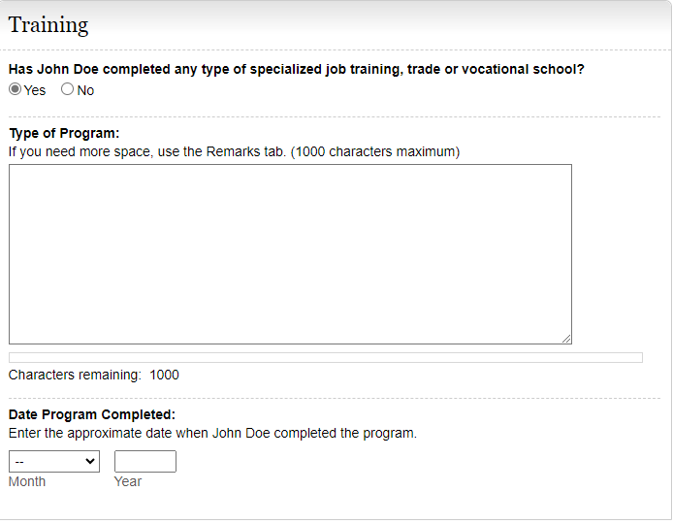
Modify: Date Completed (or scheduled to be completed)

Modify the question to read as follows:
“Has John Doe received any type of training (specialized job, trade, or vocational training)?”
If yes, add sections to provide: Name of Training Facility, Phone Number, Mailing Address, City, STATE/Province, ZIP/Postal Code, Country (if not USA)
Keep text box for Type of Program

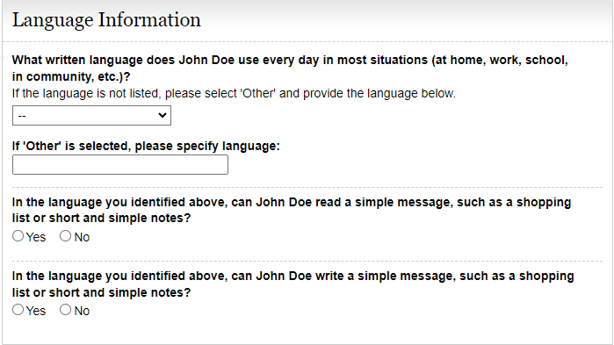
Modify section title to “Literacy Information”
Modify the beginning of the language questions as follows:
READING- “In the language they identified above, can they read …”

Modify the beginning of the language questions as follows:
WRITING- “In the language they identified above, can they write…”

Job History- Currently Working
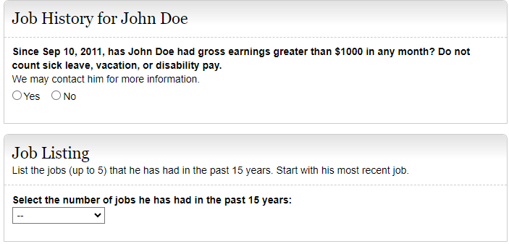
Modify Job Listing instructions to: “List the jobs (up to 5) that they had in the past 5 years. List all the jobs that they have had in the last 5 years:
- Include self-employment
- Include work in a foreign country
- List your most recent job first”
Add question: “Did they have a job in the last 5 years?
YES NO

If yes, modify Job Listing instructions to say, “Select the number of jobs er1 they had in the past 5 years.”

Modify the question to read as follows:
“Since Sep 10, 2011, has John Doe had earnings greater than $___ before tax in any month…?”

Job History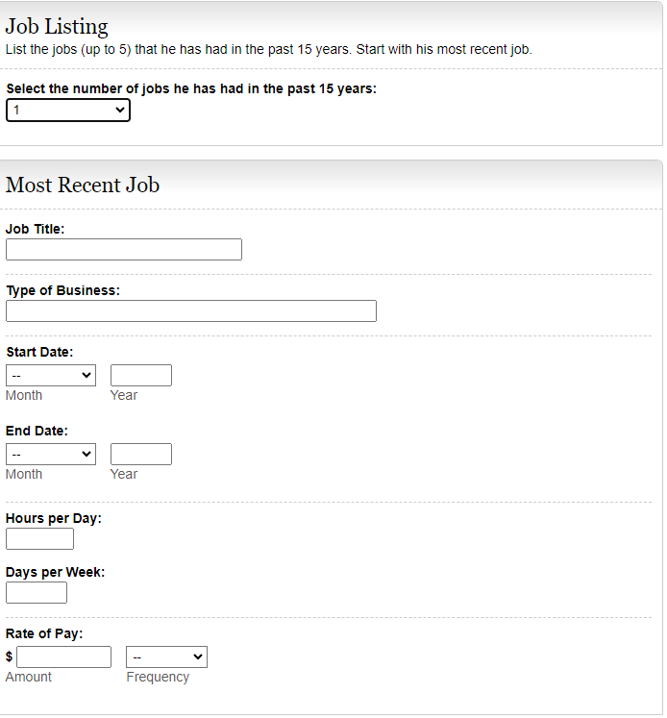

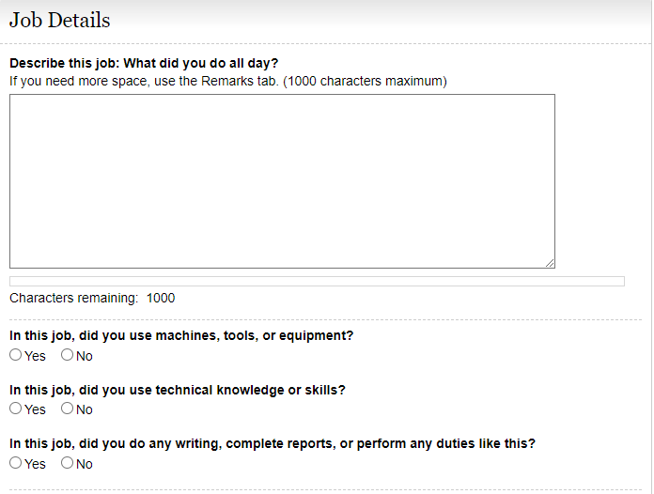
After question, “Tell us about their work-related skills…” add question:
Add this question, “Did their job require them to interact with coworkers, the general public, or anyone else?” YES NO
If they select yes, add a textbox with the following instructions:
“Describe who they interacted with, the purpose of the interaction, how they interacted, and how much time they spent doing it per workday or workweek. Examples include answering customer questions on the telephone for 5 hours per day or showing clients sale properties for 4 hours per day.”

Modify the questions to read as follows:
“For this job, describe in detail the tasks that they did in a typical workday. Examples of tasks include stocking shelves, greeting customers, scheduling appointments, and maintaining records.” Add a text box for explanation.
“If any tasks listed above involved writing or completing reports, describe the type of report they wrote or completed and how much time they spent on it per workday or workweek.” Add a text box for description.
“If any tasks listed above involved supervising others, describe who or what they supervised and what supervisory duties they had. Examples of supervisory duties include performance management, making schedules, and maintaining time records.” Add a text box for explanation.
“List the machines, tools, and equipment they used regularly when doing this job and explain what they used them for. Examples include computer, telephones, forklift, air compressor, and meat slicer.” Add a text box for explanation.
“Tell us about the work-related skills they used in this job and the job duties they completed using these skills. Examples of work-related skills include reading blueprints to instruct workers on how to build houses and medical coding to determine the amount providers should be paid.” Add a text box for explanation.

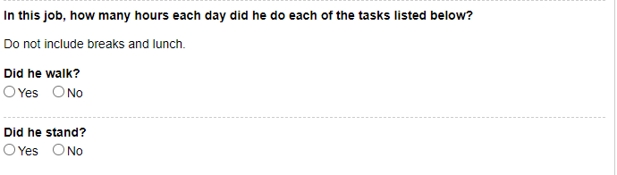
Modify the instructions to read: “Tell us how much time they spent performing the following physical activities in a typical workday. The total hours/minutes for standing and/or walking and sitting should equal the Hours per Day. The example below shows an 8-hour workday with 2 hours standing and/or walking and 6 hours sitting (8 hours total).” For each activity add a text box for “Hours/Minutes” to indicate time for each activity.
*The paper form includes an “Example” text box that shows how many hours/minutes for each activity. Standing and walking- 2 hours; stooping- 6 minutes. Work with Systems to determine how to include this on i3368.

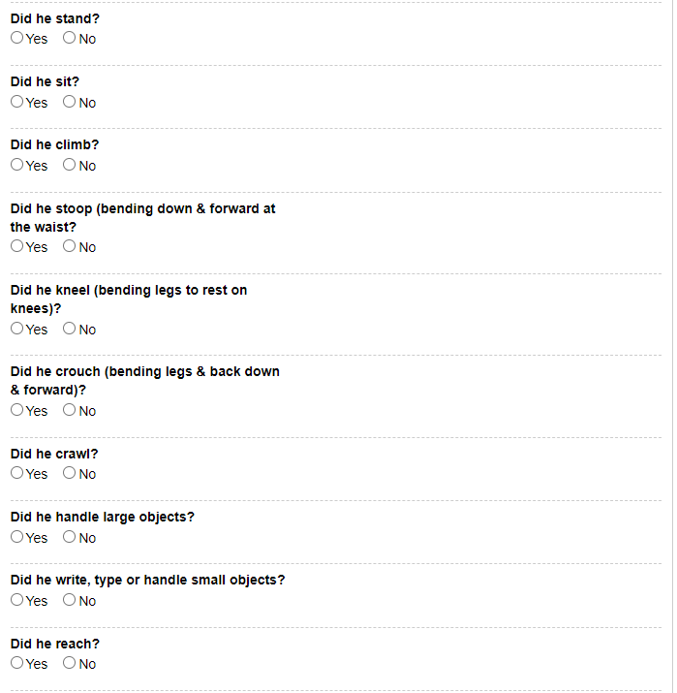
“Stooping (i.e., bending down and forward at waist)”
“Climbing ladders, ropes, or scaffolds”
“Climbing stairs or ramps”
“Reaching overhead (above the shoulder)”; add radio buttons to select One Arm or Both Arms
“Reaching at or below the shoulder”; add radio buttons to select One Arm or Both Arms
“Using hands to seize, hold, grasp, or turn (e.g., holding a large envelope, a small box, a hammer, or water bottle)”; add radio buttons to select One Hand or Both Hands
“Using fingers to touch, pick, or pinch (e.g., using a mouse, keyboard, turning pages, or buttoning a shirt)”; add radio buttons to select One Hand or Both Hands
“Crawling (i.e., moving on hands and knees)”
“Kneeling (i.e., bending legs to rest on knees)”
“Sitting”
Combine “Standing and/or Walking”
“Crouching (i.e., bending legs & back down & forward)”

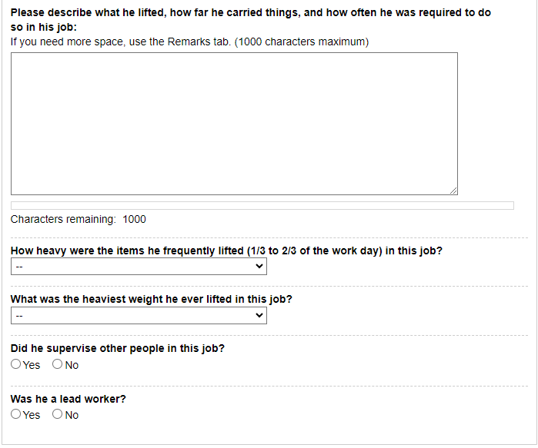
Modify the question to “Select the heaviest weight lifted” Add “Less than 1 lb.” to the list of options in the drop down.

Modify the question to “Select the weight frequently lifted (i.e., 1/3 to 2/3 of the workday)”. Add “Less than 1 lb.” to the list of options in the drop down.

After last heaviest weight question, add this question: “Did their job expose them to any of the following? Check all that apply.”
Add radio buttons to select the following options:
” Outdoors Extreme Heat (non-weather related) Extreme Cold (non-weather related) Wetness Humidity Hazardous Substances Moving Mechanical Parts High, Exposed Places Heavy Vibration Loud Noise Other”
If one or more of the options are checked, add a text box with instructions that say, “Tell us about the exposure(s) and how often they were exposed.”

Modify these instructions: “Tell us about lifting and carrying in this job. Explain what they lifted, how far they carried it, and how often they did it in a typical workday.”

Remove the questions “Did they supervise other people in this job?” and “Were they a lead worker?”
Add this question and a textbox for explanation:
“Explain how their medical conditions affect their ability to do this job.”

Stopped Working

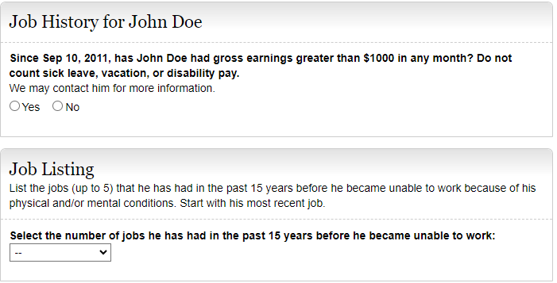
Modify Job Listing instructions to: “List the jobs (up to 5) that they had in the past 5 years. List all the jobs that they have had in the last 5 years:
- Include self-employment
- Include work in a foreign country
- List your most recent job first”

Add question: “Did they have a job in the last 5 years?
YES NO
If yes, modify Job Listing instructions to say, “Select the number of jobs they have had in the past 5 years”.

Modify the question to read as follows:
“Since Sep 10, 2011, has John Doe had earnings greater than $____ before tax in any month…?”

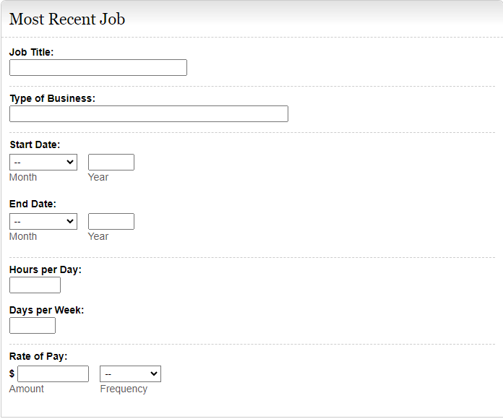
Dates Worked
From: MM/YYYY
To: MM/YYYY

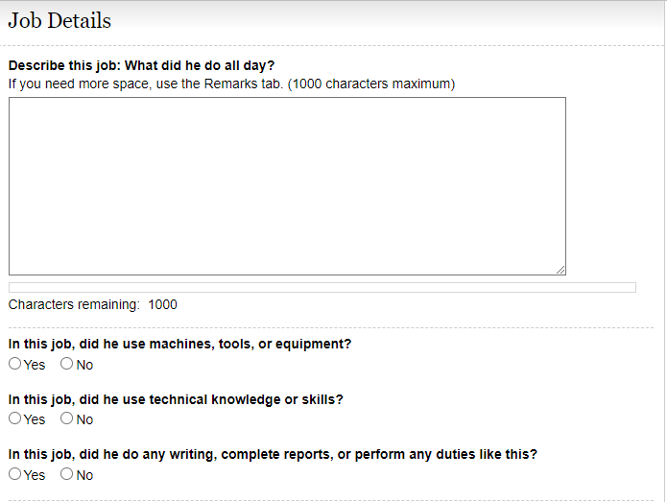
Modify the Job Details section questions to read as follows:
“For this job, describe in detail the tasks they did in a typical workday. Examples of tasks include stocking shelves, greeting customers, scheduling appointments, and maintaining records.” Add a text box for explanation.
“If any of the tasks listed above involved writing or completing reports, describe the type of report they wrote or completed and how much time they spent on it per workday or workweek.” Add a text box for description.
“If any of the tasks listed above involved supervising others, describe who or what they supervised and what supervisory duties they had. Examples of supervisory duties include performance management, making schedules, and maintaining time records.” Add a text box for explanation.
“List the machines, tools, and equipment they used regularly when doing this job and explain what they used them for. Examples include computer, telephones, forklift, air compressor, and meat slicer.” Add a text box for explanation.
“Tell us about the work-related skills they used in this job and the job duties they completed using these skills. Examples of work-related skills include reading blueprints to instruct on how to build houses or medical coding to determine amount providers should be paid.” Add a text box for explanation.
Add this question, “Did their job require them to interact with coworkers, the general public, or anyone else?” YES NO
If they select yes, add a textbox with the following instructions:
“Describe who they interacted with, the purpose of the interaction, how they interacted, and how much time they spent doing it per workday or workweek. Examples include answering customer questions on the telephone for 5 hours per day or showing clients sale properties for 4 hours per day.”

“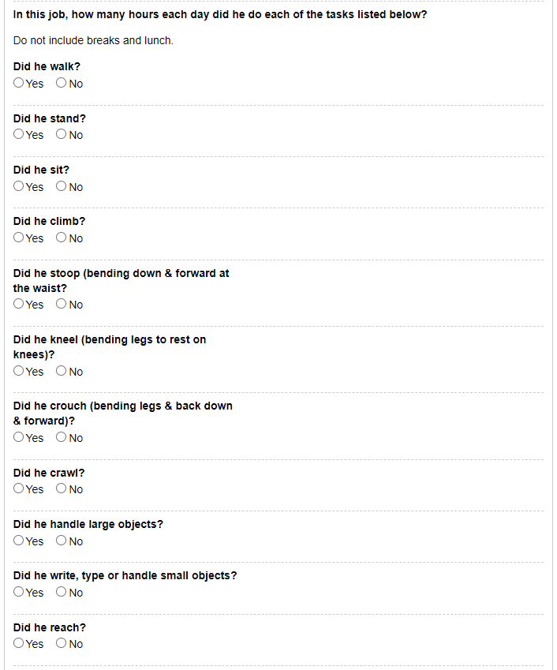
“Using fingers to touch, pick, or pinch (e.g., using a mouse, keyboard, turning pages, or buttoning a shirt)”; add radio buttons to select One Hand or Both Hands

Modify the instructions to read: “Tell us how much time they spent performing the following physical activities in a typical workday. The total hours/minutes for standing and/or walking and sitting should equal the Hours per Day. The example below shows an 8-hour workday with 2 hours standing and/or walking and 6 hours sitting (8 hours total).” For each activity add a text box for “Hours/Minutes” to indicate time for each activity.
*The paper form includes an Example text box that shows how many hours or minutes for each activity. Standing and walking- 2 hours; stooping- 6 minutes. Work with Systems to determine how to include this on the i3368.

Combine “Standing and/or Walking”

“Sitting”

“Stooping (i.e., bending down and forward at waist)”

“Kneeling (i.e., bending legs to rest on knees)”

“Crouching (i.e., bending legs & back down & forward)”

“Crawling (i.e., moving on hands and knees)”

“Using hands to seize, hold, grasp, or turn (e.g., holding a large envelope, a small box, a hammer, or water bottle)”; add radio buttons to select One Hand or Both Hands

“Reaching at or below the shoulder”; add radio buttons to select One Arm or Both Arms

“Reaching overhead (above the shoulder)”; add radio buttons to select One Arm or Both Arms

“Climbing stairs or ramps”

“Climbing ladders, ropes, or scaffolds”

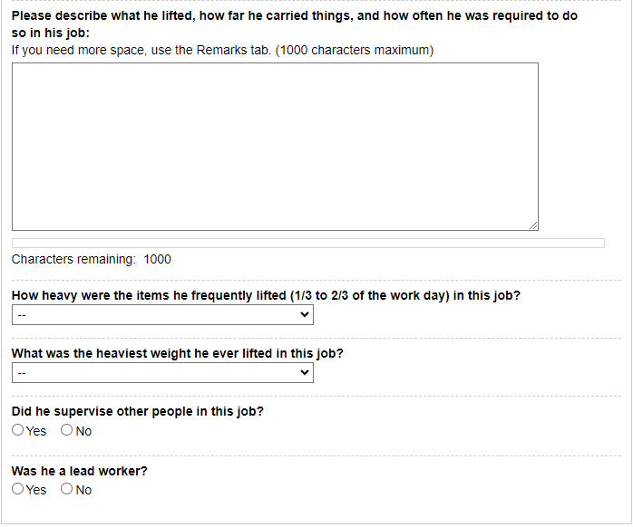
After last heaviest weight question, add this question: “Did their job expose them to any of the following? Check all that apply.”
Add radio buttons to select the following options:
“ Outdoors Extreme Heat (non-weather related) Extreme Cold (non-weather related) Wetness Humidity Hazardous Substances Moving Mechanical Parts High, Exposed Places Heavy Vibration Loud Noise Other”
If one or more of the options are checked, add a text box with instructions that say, “Tell us about the exposure(s) and how often they were exposed.”

Modify the question to “Select the heaviest weight lifted” Add “Less than 1 lb.” to the list of options in the drop down.

Modify these instructions: “Tell us about lifting and carrying in this job. Explain what they lifted, how far they carried it, and how often they did it in a typical workday.”

Modify the question to “Select the weight frequently lifted (i.e., 1/3 to 2/3 of the workday)”. Add “Less than 1 lb.” to the list of options in the drop down.

Remove the last two questions, “Did they supervise other people in this job?” and “Were they a lead worker?”
Add this question and a textbox for explanation:
“Explain how their medical conditions affect their ability to do this job.”

Add explanation (i.e., at or below the shoulder, or overhead)

Medicines
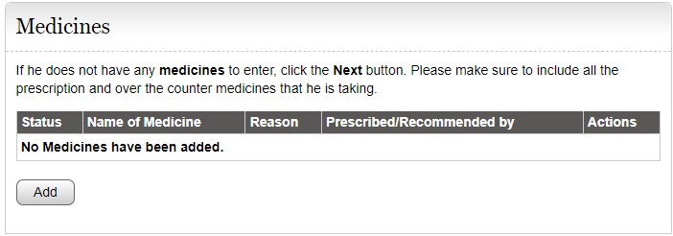
Modify instructions to ask this question say “Are they currently taking any prescription or non-prescription medicine(s)?”
.

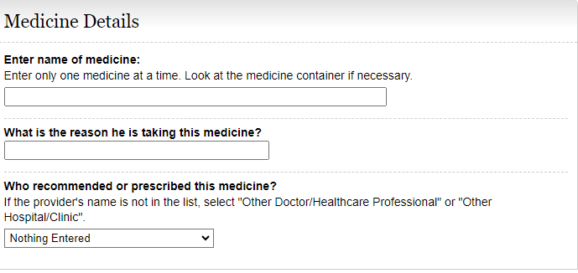
Modify question to “If prescribed give Doctor’s Name (if known)”
Modify question to “Reason for Medicine (if known)”

Paper Section 8 Medical Treatment/ Doctors and Other Healthcare Professionals
The i3368 currently lists Doctors and Other Healthcare Professionals AND Hospital and Clinics separately. We would like to combine these two separate sections into one section titled “Medical Treatment” because the same information is asked for in both sections. Tests and Medical Sources should be listed separately. This section should mirror the revised SSA-3368. Maybe we can borrow the functionality from the i454.

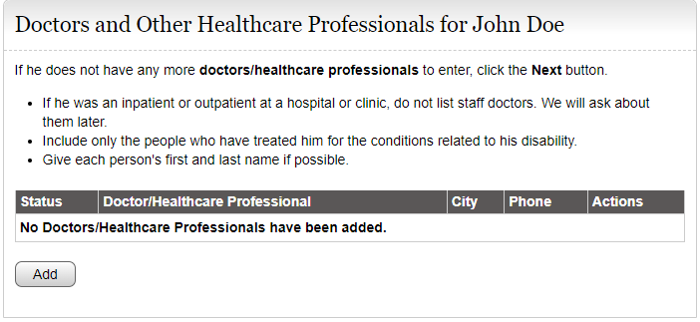
Remove these instructions. Add this question:
“Have they seen or received treatment from a healthcare provider (doctor, hospital, clinic, psychiatrist, nurse practitioner, therapist, physical therapist, or other medical professional, or do you have a future appointment scheduled?”
Include this statement: “They may find this information on medical bills, online medical chart, or the internet.”

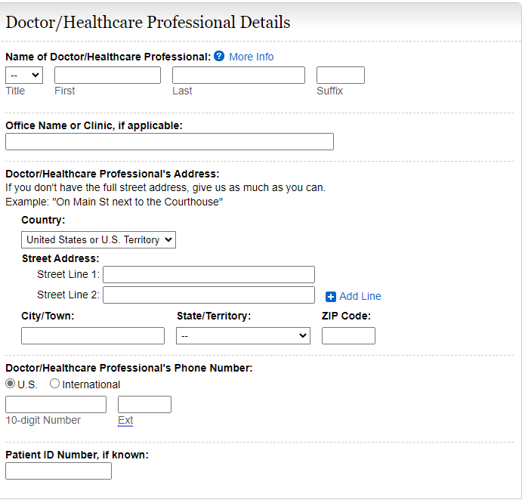
Modify section title to “Doctors, Therapists, Hospitals, Clinics”
This section should include text boxes for the following:
“Name of Facility or Office
Name of Health Care Provider that treated you
What medical conditions were treated or evaluated?
Phone Number
Date First Seen (MM/YYYYY)
Date Last Seen (MM/YYYY)
Date Next Seen (MM/YYYY)
Street Address
City
STATE/Province
ZIP/Postal Code
Country (if not USA)”
Remove Patient ID#, if known:

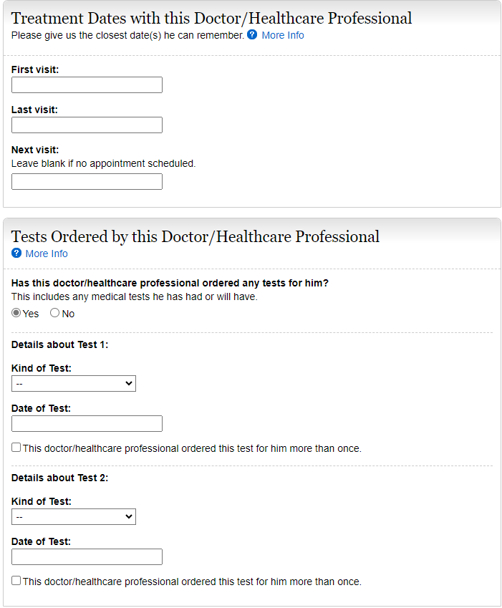
Modify this question to read as follows:
“Has this doctor/healthcare professional ordered any medical tests for them? Include tests already performed and scheduled in the future.
In “Kind of Test”, add “Psychological/IQ test” to the list of tests.
As stated previously, Tests should be separate from the Medical Sources.

Date First Seen (MM/YYYYY)
Date Last Seen (MM/YYYY)
Date Next Seen (MM/YYYY)

Hospitals and Clinics
The i3368 currently lists Doctors and Other Healthcare Professionals AND Hospital and Clinics separately. We would like to combine these two separate sections into one section titled “Medical Treatment” because the same information is asked for both sections. Tests and Medical Sources should be listed separately. This section should mirror the revised SSA-3368. Maybe we can borrow the functionality from the i454.

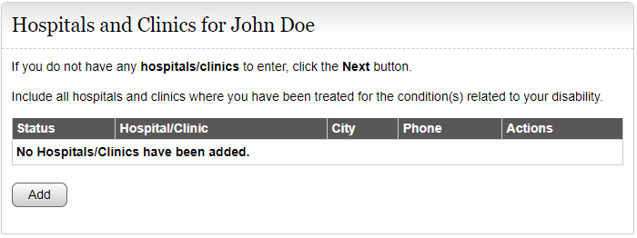
Remove these instructions. Add this question:
“Have they seen or received treatment from a healthcare provider (doctor, hospital, clinic, psychiatrist, nurse practitioner, therapist, physical therapist, or other medical professional, or do they have a future appointment scheduled?”
Add this statement:
“You may find this information on medical bills, online medical chart, or the internet.”

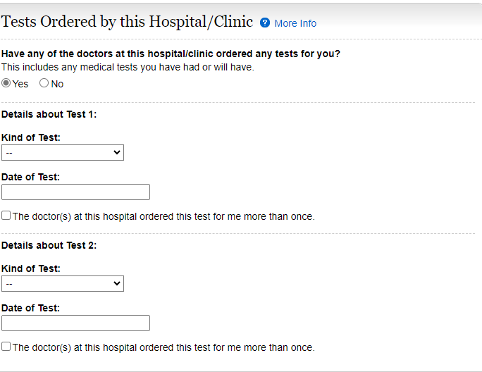
Modify this question to read as follows:
“Has this doctor/healthcare professional ordered any medical tests for them? Include tests already performed and scheduled in the future.
In “Kind of Test”, add “Psychological/IQ test” to the list of tests.”
As previously stated, Tests should be separate from Medical Sources.

Medical Tests
Edit instructions:
“Did any of the providers listed above order any medical tests for them?” Include tests already performed and scheduled in the future.”

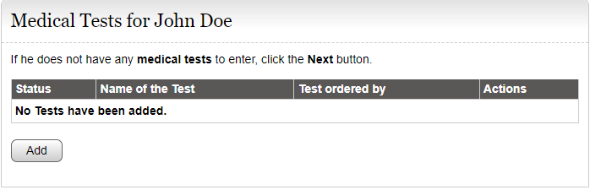

Test Details
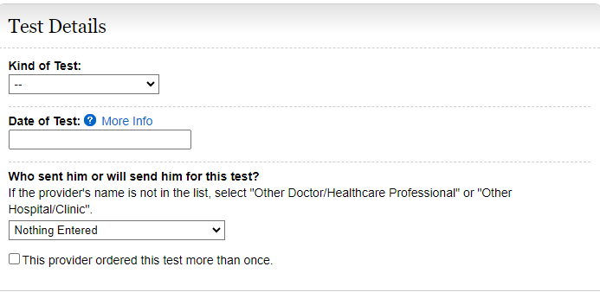
In “Kind of Test”, add “Psychological/IQ test” to the list of tests.

Section 9-Other Medical Information/ Other Medical Records
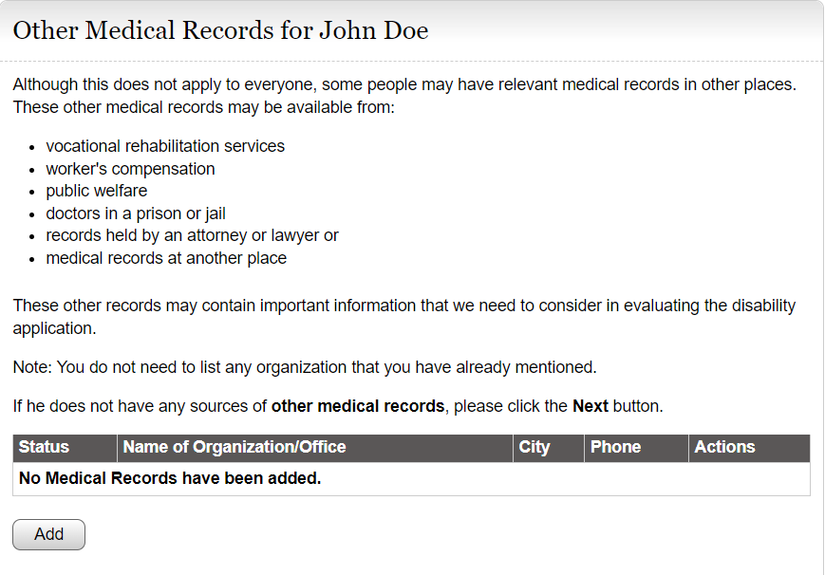
Edit instructions as follows:
“Does anyone else (other than their medical providers) have their medical information? Examples include social service agencies, welfare agencies, attorneys, prisons, workers’ compensation, and insurance companies who have paid them disability benefits.”
Add radio buttons to select Yes or No.

Other Medical Record Details
If yes,
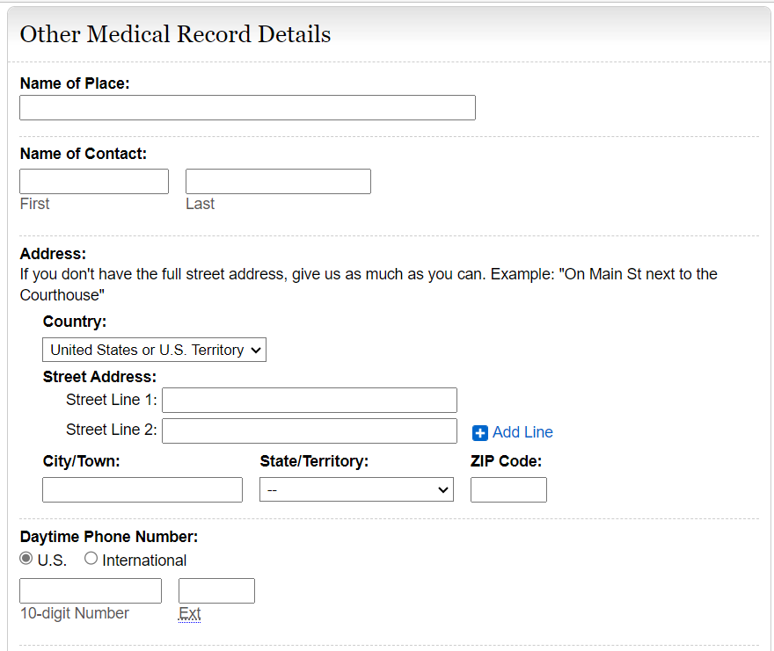
Edit this section as follows:
“Name or Organization
Phone Number
Mailing Address
City
STATE/Province
ZIP/Postal Code
Country (if not USA)
Name of Contact Person
Claim Number (if any)
Date of First Contact
Date of Last Contact
Date of Next Contact (if any)
Reason(s) for Contacts”
Allow them to add multiple people or organizations with details.

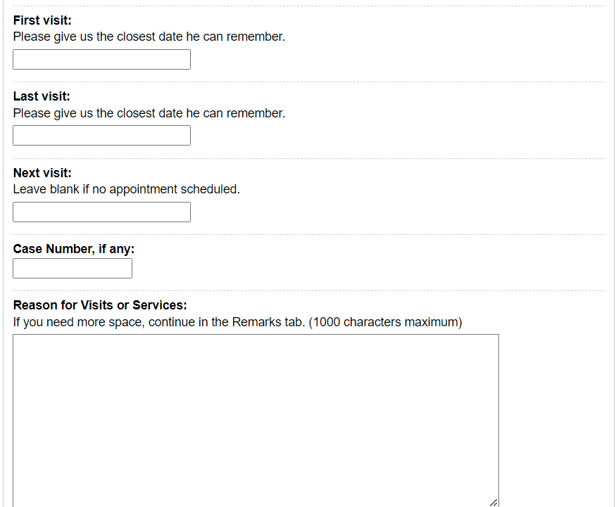

Section 10- Support Services
This is a new section to add to the i3368 Work/Education Pages after the Education, Training, and Literacy Section
(Third party- pronouns should be changed to they, their, and them as appropriate)
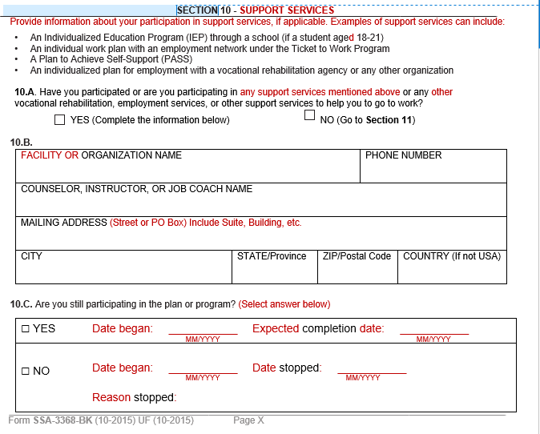
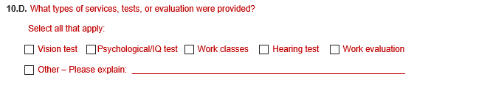

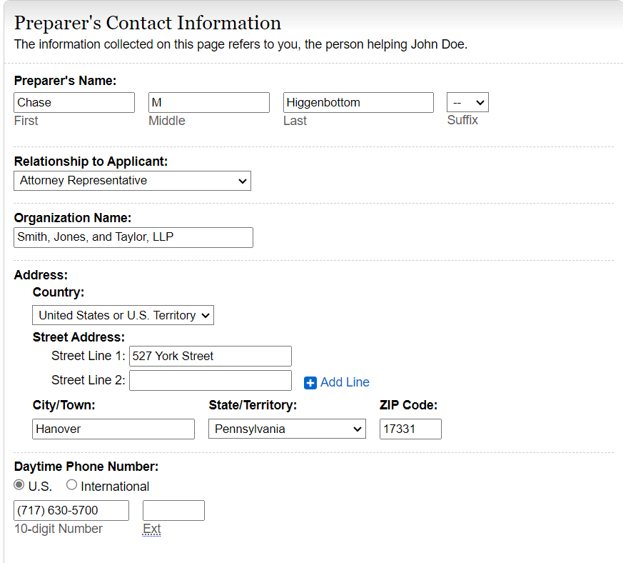
Modify this section as follows:
“Date Report Completed (MM/DD/YYYY)”
“Who is completing this report?” Add radio buttons and the following options:
“John Doe
Contact Person
Additional Contact Person
Someone else”
If they select “Someone else” provide text boxes to complete the following information:
“NAME (First, Middle Initial, Last)
Relationship to John Doe
MAILING ADDRESS (Street or PO Box) Include the apartment, if applicable.
CITY
STATE/Province
ZIP/Postal Code
Country (if not USA)
Daytime Phone Number where we may reach you or leave a message, if needed. Include the area code or IDD and country code if outside the USA or Canada.”

6

326++++++++++++++++++.

.

.
.

25222020..000107\
774
Modify title of section to “Who Is Completing This Report”

