**2020 Spring-Summer Bird and Egg Harvest, Kodiak Roaded Area**

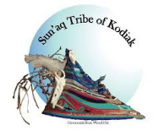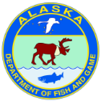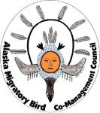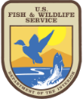

Permit #:

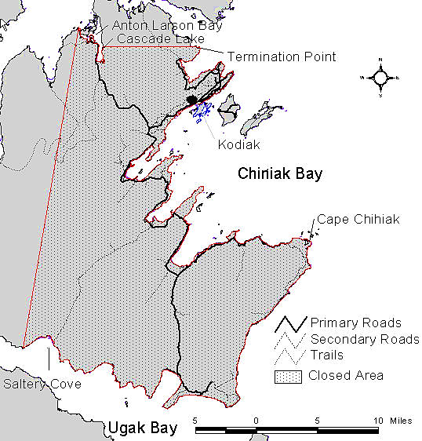**Permit Holder** (*please use print font*)

Last name: __________________________________________

First name:________________________________ M.I._______

**Permanent residency** (*please use print font*)

Address: ___________________________________________

PO Box: ____________________________________________

City: _____________________________ ZIP: ______________

Phone: _____________________________________________

**Agreed with terms of the registration**: ___________________________________________________

(*signature of permit holder*)

Vendor name: ______________________________________,

Sun’aq Tribe Office, Date issued: ___ / ___ / 2020

**PRIVACY ACT STATEMENT:**

**Authority:** The Migratory Bird Treaty Act (MBTA) of 1918 (16 U.S.C. 703-712) and the Fish and Wildlife Act of 1956 (16 U.S.C. 742d).

**Purpose:** The information collected will be used for the continuation of customary and traditional subsistence uses of migratory birds in Alaska and to prescribe regional information on when and where the harvesting of birds may occur.

**Routine Uses:** The information collected may be shared in accordance with the Privacy Act of 1974 and the routine uses listed in the System of Records Notices INTERIOR/FWS-21 Permits System (June 4, 2008) 73 FR 31877 and INTERIOR/FWS/-26, Migratory Bird Population and Harvest Systems - 64 FR 29055 (May 28, 1999) available at https://www.doi.gov/privacy/doi-notices.

**Disclosure:** Furnishing this information is voluntary; however, failure to provide the requested information may prevent FWS from being able to determine the take’s legality or may limit FWS’ ability to monitor migratory bird harvests.

**PAPERWORK REDUCTION ACT STATEMENT:** In accordance with the Paperwork Reduction Act (44 U.S.C. 3501 *et seq.*), the U.S. Fish and Wildlife Service collects information necessary as a required condition of permits requested and authorized under the applicable laws governing the requested activity, and to respond to requests made under the Freedom of Information Act and the Privacy Act of 1974. Information requested in this form is purely voluntary. However, submission of requested information is required in order to process applications for permits authorized under the above laws. Failure to provide all requested information may be sufficient cause for the U.S. Fish and Wildlife Service to deny the request. According to the Paperwork Reduction Act of 1995, an agency may not conduct or sponsor and a person is not required to respond to a collection of information unless it displays a currently valid OMB control number. OMB has approved this collection of information and assigned Control No. 1018-0178.

**ESTIMATED BURDEN STATEMENT:** We estimate public reporting for this collection of information to average 15 minutes, including time for reviewing instructions, gathering and maintaining data and completing and reviewing the form. Direct comments regarding the burden estimate or any other aspect of the form to the Service Information Clearance Officer, Fish and Wildlife Service, U.S. Department of the Interior, 5275 Leesburg Pike, MS: PRB (JAO/3W), Falls Church, VA 22041-3803, or via email at [Info_Coll@fws.gov](mailto:Info_Coll@fws.gov). Please do not send your completed form to this address.

✂

**Spring-Summer Subsistence Harvest of Birds and Eggs, Kodiak Roaded Area**

**Season:** Seabirds 2 Apr–30 Jun, 31 Jul–31 Aug (closed 1–30 Jul).

Other birds 2 Apr–20 Jun, 22 Jul–31 Aug (closed 21Jun–21 Jul).

**Eligibility:** Permanent residents of Alaska areas eligible to participate in the spring-summer harvest of migratory birds and of excluded Alaska areas who are in possession of a harvest invitation letter issued by a Kodiak tribe.

**Harvesters are required to carry:**

All bird hunters 18 years or older are required to carry a current ***State of Alaska hunting license******and duck stamp***. Disabled veterans, people 60 years or older, and people that qualify for a low income hunting license are exempted from the state duck stamp requirement. The state hunting license and duck stamp are not required for harvest of eggs. The federal duck stamp is not required for this harvest of birds and eggs.

A ***Kodiak roaded area permit*** is required for harvest of birds and eggs on all land and water within 500 feet from the water’s edge (including exposed tidelands) east of a line extending from Crag Point in the north to the west end of Saltery Cove in the south and all lands and water south of a line extending from Termination Point along the north side of Cascade Lake extending to Anton Larsen Bay. **Permits are available at the Sun'aq Tribe of Kodiak** (bring proof of eligibility). A registration is not required for harvest in other Kodiak areas and offshore islands.

**Species opened for harvest:**In Kodiak areas outside the above-described roaded area, birds and eggs from dozens of species are opened to harvest as listed at <http://www.alaskamigratorybirds.com/index.php/regulations-by-region/species-open-to-harvest>. Bird species not specifically opened to harvest are closed. ***In the Kodiak roaded area, harvest of birds and eggs of Emperor Goose, Aleutian Tern, Arctic Tern, and Mew Gull are closed.***

**Required harvest monitoring:** At the end of the season (early Sep), harvesters are required to report their bird and egg harvest via the harvest calendar (provided with permit) or mail survey.

**For more information:**

|  |  |
| --- | --- |
| ● Sun'aq Tribe of Kodiak: | 🕿 (907) 486-4449. 312 W Marine Way, Kodiak |
| ● USFWS-AMBCC Program: | 🕿 (907) 786-3887. Anchorage |
| ● Alaska Migratory Bird Co-Management Council (AMBCC) website:  https://www.fws.gov/alaska/pages/co-management | |

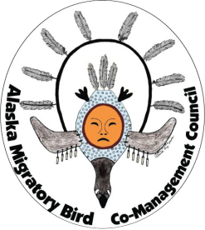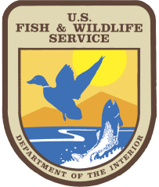

* Native Village of Eyak: phone 907-424-7738; 110 Nicholoff Way, Cordova.
* U.S. Forest Service: phone 907-424-7661; 612 2nd Street, Cordova.
* USFWS-AMBCC Program: phone 907-786-3499, Anchorage.

**For more information:**

✂