ATF.gov Website Feedback Form (Generic)
Existing form: https://www.atf.gov/contact/give-us-your-feedback
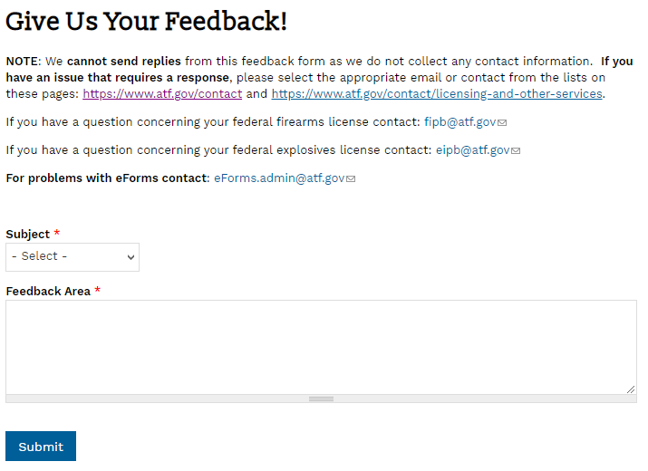
Expanded Subject field:
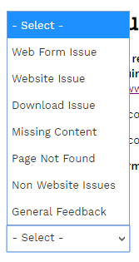

ATF.gov Individual Web Page Feedback Forms
In addition to the generic feedback form above, we will also have individual feedback forms for key web pages across the site. These will appear as a floating button at the bottom of the screen that can be expanded to show the survey.
In English:
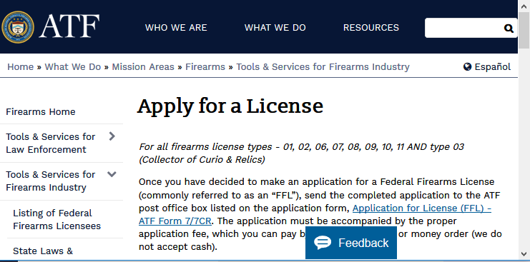
In Spanish:
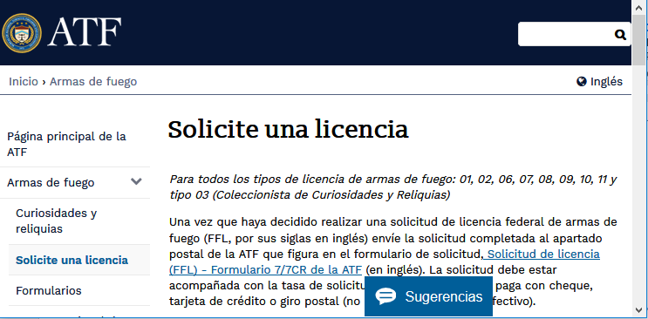

“How helpful is this page?”
English version: | Spanish version:
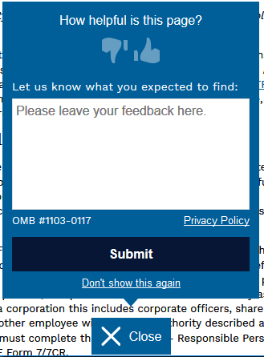 | 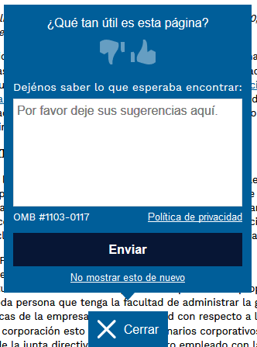

“Did you find what you were looking for?”
English version: | Spanish version:
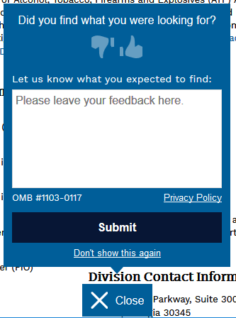 | 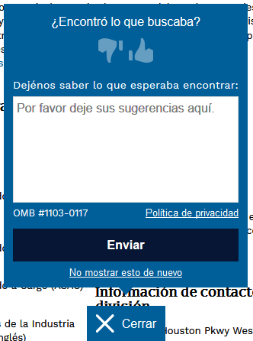

“Did we answer your question?”
English version: | Spanish version:
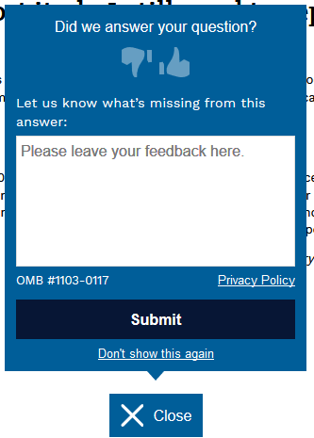 | 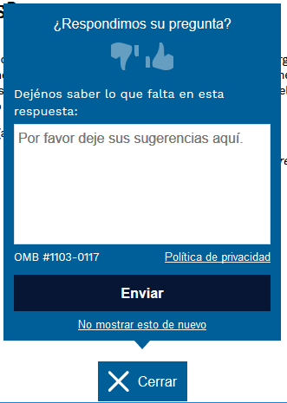

“Have a question that’s not on this page?”
English version: | Spanish version:
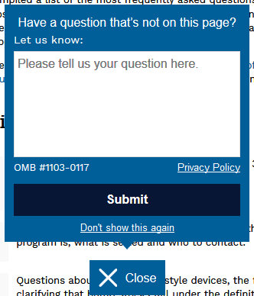 | 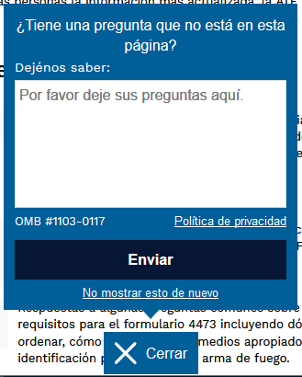

“How easy was it to complete your order?”
English version:
