§ 1910.1048 Formaldehyde.
(a) Scope and application. This standard applies to all occupational exposures to formaldehyde, i.e. from formaldehyde gas, its solutions, and materials that release formaldehyde.
(b) Definitions. For purposes of this standard, the following definitions shall apply:
Action level means a concentration of 0.5 part formaldehyde per million parts of air (0.5 ppm) calculated as an eight (8)-hour time-weighted average (TWA) concentration.
Assistant Secretary means the Assistant Secretary of Labor for the Occupational Safety and Health Administration, U.S. Department of Labor, or designee.
Authorized person means any person required by work duties to be present in regulated areas, or authorized to do so by the employer, by this section, or by the OSH Act of 1970.
Director means the Director of the National Institute for Occupational Safety and Health, U.S. Department of Health and Human Services, or designee.
Emergency is any occurrence, such as but not limited to equipment failure, rupture of containers, or failure of control equipment that results in an uncontrolled release of a significant amount of formaldehyde.
Employee exposure means the exposure to airborne formaldehyde which would occur without corrections for protection provided by any respirator that is in use.
Formaldehyde means the chemical substance, HCHO, Chemical Abstracts Service Registry No. 50–00–0.
(c) Permissible Exposure Limit (PEL) —
(1) TWA: The employer shall assure that no employee is exposed to an airborne concentration of formaldehyde which exceeds 0.75 parts formaldehyde per million parts of air (0.75 ppm) as an 8-hour TWA.
(2) Short Term Exposure Limit (STEL): The employer shall assure that no employee is exposed to an airborne concentration of formaldehyde which exceeds two parts formaldehyde per million parts of air (2 ppm) as a 15-minute STEL.
(d) Exposure monitoring —
(1) General.
(i) Each employer who has a workplace covered by this standard shall monitor employees to determine their exposure to formaldehyde.
(ii) Exception. Where the employer documents, using objective data, that the presence of formaldehyde or formaldehyde-releasing products in the workplace cannot result in airborne concentrations of formaldehyde that would cause any employee to be exposed at or above the action level or the STEL under foreseeable conditions of use, the employer will not be required to measure employee exposure to formaldehyde.
(iii) When an employee's exposure is determined from representative sampling, the measurements used shall be representative of the employee's full shift or short-term exposure to formaldehyde, as appropriate.
(iv) Representative samples for each job classification in each work area shall be taken for each shift unless the employer can document with objective data that exposure levels for a given job classification are equivalent for different work shifts.
(2) Initial monitoring. The employer shall identify all employees who may be exposed at or above the action level or at or above the STEL and accurately determine the exposure of each employee so identified.
(i) Unless the employer chooses to measure the exposure of each employee potentially exposed to formaldehyde, the employer shall develop a representative sampling strategy and measure sufficient exposures within each job classification for each workshift to correctly characterize and not underestimate the exposure of any employee within each exposure group.
(ii) The initial monitoring process shall be repeated each time there is a change in production, equipment, process, personnel, or control measures which may result in new or additional exposure to formaldehyde.
(iii) If the employer receives reports of signs or symptoms of respiratory or dermal conditions associated with formaldehyde exposure, the employer shall promptly monitor the affected employee's exposure.
(3) Periodic monitoring.
(i) The employer shall periodically measure and accurately determine exposure to formaldehyde for employees shown by the initial monitoring to be exposed at or above the action level or at or above the STEL.
(ii) If the last monitoring results reveal employee exposure at or above the action level, the employer shall repeat monitoring of the employees at least every 6 months.
(iii) If the last monitoring results reveal employee exposure at or above the STEL, the employer shall repeat monitoring of the employees at least once a year under worst conditions.
(4) Termination of monitoring. The employer may discontinue periodic monitoring for employees if results from two consecutive sampling periods taken at least 7 days apart show that employee exposure is below the action level and the STEL. The results must be statistically representative and consistent with the employer's knowledge of the job and work operation.
(5) Accuracy of monitoring. Monitoring shall be accurate, at the 95 percent confidence level, to within plus or minus 25 percent for airborne concentrations of formaldehyde at the TWA and the STEL and to within plus or minus 35 percent for airborne concentrations of formaldehyde at the action level.
(6) Employee notification of monitoring results. The employer must, within 15 working days after the receipt of the results of any monitoring performed under this section, notify each affected employee of these results either individually in writing or by posting the results in an appropriate location that is accessible to employees. If employee exposure is above the PEL, affected employees shall be provided with a description of the corrective actions being taken by the employer to decrease exposure.
(7) Observation of monitoring.
(i) The employer shall provide affected employees or their designated representatives an opportunity to observe any monitoring of employee exposure to formaldehyde required by this standard.
(ii) When observation of the monitoring of employee exposure to formaldehyde requires entry into an area where the use of protective clothing or equipment is required, the employer shall provide the clothing and equipment to the observer, require the observer to use such clothing and equipment, and assure that the observer complies with all other applicable safety and health procedures.
(e) Regulated areas —
(1) Signs.
(i) The employer shall establish regulated areas where the concentration of airborne formaldehyde exceeds either the TWA or the STEL and post all entrances and access ways with signs bearing the following legend:
DANGER
FORMALDEHYDE
MAY CAUSE CANCER
CAUSES SKIN, EYE, AND RESPIRATORY IRRITATION
AUTHORIZED PERSONNEL ONLY
(ii) Prior to June 1, 2016, employers may use the following legend in lieu of that specified in paragraph (e)(1)(i) of this section:
DANGER
FORMALDEHYDE
IRRITANT AND POTENTIAL CANCER HAZARD
AUTHORIZED PERSONNEL ONLY
(2) The employer shall limit access to regulated areas to authorized persons who have been trained to recognize the hazards of formaldehyde.
(3) An employer at a multiemployer worksite who establishes a regulated area shall communicate the access restrictions and locations of these areas to other employers with work operations at that worksite.
(f) Methods of compliance —
(1) Engineering controls and work practices. The employer shall institute engineering and work practice controls to reduce and maintain employee exposures to formaldehyde at or below the TWA and the STEL.
(2) Exception. Whenever the employer has established that feasible engineering and work practice controls cannot reduce employee exposure to or below either of the PELs, the employer shall apply these controls to reduce employee exposures to the extent feasible and shall supplement them with respirators which satisfy this standard.
(g) Respiratory protection —
(1) General. For employees who use respirators required by this section, the employer must provide each employee an appropriate respirator that complies with the requirements of this paragraph. Respirators must be used during:
(i) Periods necessary to install or implement feasible engineering and work-practice controls.
(ii) Work operations, such as maintenance and repair activities or vessel cleaning, for which the employer establishes that engineering and work-practice controls are not feasible.
(iii) Work operations for which feasible engineering and work-practice controls are not yet sufficient to reduce employee exposure to or below the PELs.
(iv) Emergencies.
(2) Respirator program.
(i) The employer must implement a respiratory protection program in accordance with § 1910.134(b) through (d) (except (d)(1)(iii), (d)(3)(iii)(b)(1), and (2)), and (f) through (m), which covers each employee required by this section to use a respirator.
(ii) When employees use air-purifying respirators with chemical cartridges or canisters that do not contain end-of-service-life indicators approved by the National Institute for Occupational Safety and Health, employers must replace these cartridges or canisters as specified by paragraphs (d)(3)(iii)(B)(1) and (B)(2) of 29 CFR 1910.134, or at the end of the workshift, whichever condition occurs first.
(3) Respirator selection.
(i) Employers must:
(A) Select, and provide to employees, the appropriate respirators specified in paragraph (d)(3)(i)(A) of 29 CFR 1910.134.
(B) Equip each air-purifying, full facepiece respirator with a canister or cartridge approved for protection against formaldehyde.
(C) For escape, provide employees with one of the following respirator options: A self-contained breathing apparatus operated in the demand or pressure-demand mode; or a full facepiece respirator having a chin-style, or a front-or back-mounted industrial-size, canister or cartridge approved for protection against formaldehyde.
(ii) Employers may substitute an air-purifying, half mask respirator for an air-purifying, full facepiece respirator when they equip the half mask respirator with a cartridge approved for protection against formaldehyde and provide the affected employee with effective gas-proof goggles.
(iii) Employers must provide employees who have difficulty using negative pressure respirators with powered air-purifying respirators permitted for use under paragraph (g)(3)(i)(A) of this standard and that affords adequate protection against formaldehyde exposures.
(h) Protective equipment and clothing. Employers shall comply with the provisions of 29 CFR 1910.132 and 29 CFR 1910.133. When protective equipment or clothing is provided under these provisions, the employer shall provide these protective devices at no cost to the employee and assure that the employee wears them.
(1) Selection. The employer shall select protective clothing and equipment based upon the form of formaldehyde to be encountered, the conditions of use, and the hazard to be prevented.
(i) All contact of the eyes and skin with liquids containing 1 percent or more formaldehyde shall be prevented by the use of chemical protective clothing made of material impervious to formaldehyde and the use of other personal protective equipment, such as goggles and face shields, as appropriate to the operation.
(ii) Contact with irritating or sensitizing materials shall be prevented to the extent necessary to eliminate the hazard.
(iii) Where a face shield is worn, chemical safety goggles are also required if there is a danger of formaldehyde reaching the area of the eye.
(iv) Full body protection shall be worn for entry into areas where concentrations exceed 100 ppm and for emergency reentry into areas of unknown concentration.
(2) Maintenance of protective equipment and clothing.
(i) The employer shall assure that protective equipment and clothing that has become contaminated with formaldehyde is cleaned or laundered before its reuse.
(ii) When formaldehyde-contaminated clothing and equipment is ventilated, the employer shall establish storage areas so that employee exposure is minimized.
(A) Signs. Storage areas for contaminated clothing and equipment shall have signs bearing the following legend:
DANGER
FORMALDEHYDE-CONTAMINATED [CLOTHING] EQUIPMENT
MAY CAUSE CANCER
CAUSES SKIN, EYE AND RESPIRATORY IRRITATION
DO NOT BREATHE VAPOR
DO NOT GET ON SKIN
(B) Labels. The employer shall ensure containers for contaminated clothing and equipment are labeled consistent with the Hazard Communication Standard, § 1910.1200, and shall, as a minimum, include the following:
DANGER
FORMALDEHYDE-CONTAMINATED [CLOTHING] EQUIPMENT
MAY CAUSE CANCER
CAUSES SKIN, EYE, AND RESPIRATORY IRRITATION
DO NOT BREATHE VAPOR
DO NOT GET ON SKIN
(C) Prior to June 1, 2016, employers may use the following legend in lieu of that specified in paragraph (h)(2)(ii)(A) of this section:
DANGER
FORMALDEHYDE-CONTAMINATED [CLOTHING] EQUIPMENT
AVOID INHALATION AND SKIN CONTACT
(D) Prior to June 1, 2015, employers may include the following information on containers of protective clothing and equipment in lieu of the labeling requirements in paragraphs (h)(2)(ii)(B) of this section:
DANGER
FORMALDEHYDE-CONTAMINATED [CLOTHING] EQUIPMENT
AVOID INHALATION AND SKIN CONTACT
(iii) The employer shall assure that only persons trained to recognize the hazards of formaldehyde remove the contaminated material from the storage area for purposes of cleaning, laundering, or disposal.
(iv) The employer shall assure that no employee takes home equipment or clothing that is contaminated with formaldehyde.
(v) The employer shall repair or replace all required protective clothing and equipment for each affected employee as necessary to assure its effectiveness.
(vi) The employer shall inform any person who launders, cleans, or repairs such clothing or equipment of formaldehyde's potentially harmful effects and of procedures to safely handle the clothing and equipment.
(i) Hygiene protection.
(1) The employer shall provide change rooms, as described in 29 CFR 1910.141 for employees who are required to change from work clothing into protective clothing to prevent skin contact with formaldehyde.
(2) If employees' skin may become spashed with solutions containing 1 percent or greater formaldehyde, for example, because of equipment failure or improper work practices, the employer shall provide conveniently located quick drench showers and assure that affected employees use these facilities immediately.
(3) If there is any possibility that an employee's eyes may be splashed with solutions containing 0.1 percent or greater formaldehyde, the employer shall provide acceptable eyewash facilities within the immediate work area for emergency use.
(j) Housekeeping. For operations involving formaldehyde liquids or gas, the employer shall conduct a program to detect leaks and spills, including regular visual inspections.
(1) Preventative maintenance of equipment, including surveys for leaks, shall be undertaken at regular intervals.
(2) In work areas where spillage may occur, the employer shall make provisions to contain the spill, to decontaminate the work area, and to dispose of the waste.
(3) The employer shall assure that all leaks are repaired and spills are cleaned promptly by employees wearing suitable protective equipment and trained in proper methods for cleanup and decontamination.
(4) Formaldehyde-contaminated waste and debris resulting from leaks or spills shall be placed for disposal in sealed containers bearing a label warning of formaldehyde's presence and of the hazards associated with formaldehyde. The employer shall ensure that the labels are in accordance with paragraph (m) of this section.
(k) Emergencies. For each workplace where there is the possibility of an emergency involving formaldehyde, the employer shall assure appropriate procedures are adopted to minimize injury and loss of life. Appropriate procedures shall be implemented in the event of an emergency.
(l) Medical surveillance —
(1) Employees covered.
(i) The employer shall institute medical surveillance programs for all employees exposed to formaldehyde at concentrations at or exceeding the action level or exceeding the STEL.
(ii) The employer shall make medical surveillance available for employees who develop signs and symptoms of overexposure to formaldehyde and for all employees exposed to formaldehyde in emergencies. When determining whether an employee may be experiencing signs and symptoms of possible overexposure to formaldehyde, the employer may rely on the evidence that signs and symptoms associated with formaldehyde exposure will occur only in exceptional circumstances when airborne exposure is less than 0.1 ppm and when formaldehyde is present in material in concentrations less than 0.1 percent.
(2) Examination by a physician. All medical procedures, including administration of medical disease questionnaires, shall be performed by or under the supervision of a licensed physician and shall be provided without cost to the employee, without loss of pay, and at a reasonable time and place.
(3) Medical disease questionnaire. The employer shall make the following medical surveillance available to employees prior to assignment to a job where formaldehyde exposure is at or above the action level or above the STEL and annually thereafter. The employer shall also make the following medical surveillance available promptly upon determining that an employee is experiencing signs and symptoms indicative of possible overexposure to formaldehyde.
(i) Administration of a medical disease questionnaire, such as in appendix D, which is designed to elicit information on work history, smoking history, any evidence of eye, nose, or throat irritation; chronic airway problems or hyperreactive airway disease: allergic skin conditions or dermatitis; and upper or lower respiratory problems.
(ii) A determination by the physician, based on evaluation of the medical disease questionnaire, of whether a medical examination is necessary for employees not required to wear respirators to reduce exposure to formaldehyde.
(4) Medical examinations. Medical examinations shall be given to any employee who the physician feels, based on information in the medical disease questionnaire, may be at increased risk from exposure to formaldehyde and at the time of initial assignment and at least annually thereafter to all employees required to wear a respirator to reduce exposure to formaldehyde. The medical examination shall include:
(i) A physical examination with emphasis on evidence of irritation or sensitization of the skin and respiratory system, shortness of breath, or irritation of the eyes.
(ii) Laboratory examinations for respirator wearers consisting of baseline and annual pulmonary function tests. As a minimum, these tests shall consist of forced vital capacity (FVC), forced expiratory volume in one second (FEV₁), and forced expiratory flow (FEF).
(iii) Any other test which the examining physician deems necessary to complete the written opinion.
(iv) Counseling of employees having medical conditions that would be directly or indirectly aggravated by exposure to formaldehyde on the increased risk of impairment of their health.
(5) Examinations for employees exposed in an emergency. The employer shall make medical examinations available as soon as possible to all employees who have been exposed to formaldehyde in an emergency.
(i) The examination shall include a medical and work history with emphasis on any evidence of upper or lower respiratory problems, allergic conditions, skin reaction or hypersensitivity, and any evidence of eye, nose, or throat irritation.
(ii) Other examinations shall consist of those elements considered appropriate by the examining physician.
(6) Information provided to the physician. The employer shall provide the following information to the examining physician:
(i) A copy of this standard and appendix A, C, D, and E;
(ii) A description of the affected employee's job duties as they relate to the employee's exposure to formaldehyde;
(iii) The representative exposure level for the employee's job assignment;
(iv) Information concerning any personal protective equipment and respiratory protection used or to be used by the employee; and
(v) Information from previous medical examinations of the affected employee within the control of the employer.
(vi) In the event of a nonroutine examination because of an emergency, the employer shall provide to the physician as soon as possible: A description of how the emergency occurred and the exposure the victim may have received.
(7) Physician's written opinion.
(i) For each examination required under this standard, the employer shall obtain a written opinion from the examining physician. This written opinion shall contain the results of the medical examination except that it shall not reveal specific findings or diagnoses unrelated to occupational exposure to formaldehyde. The written opinion shall include:
(A) The physician's opinion as to whether the employee has any medical condition that would place the employee at an increased risk of material impairment of health from exposure to formaldehyde;
(B) Any recommended limitations on the employee's exposure or changes in the use of personal protective equipment, including respirators;
(C) A statement that the employee has been informed by the physician of any medical conditions which would be aggravated by exposure to formaldehyde, whether these conditions may have resulted from past formaldehyde exposure or from exposure in an emergency, and whether there is a need for further examination or treatment.
(ii) The employer shall provide for retention of the results of the medical examination and tests conducted by the physician.
(iii) The employer shall provide a copy of the physician's written opinion to the affected employee within 15 days of its receipt.
(8) Medical removal.
(i) The provisions of paragraph (l)(8) apply when an employee reports significant irritation of the mucosa of the eyes or the upper airways, respiratory sensitization, dermal irritation, or dermal sensitization attributed to workplace formaldehyde exposure. Medical removal provisions do not apply in the case of dermal irritation or dermal sensitization when the product suspected of causing the dermal condition contains less than 0.05% formaldehyde.
(ii) An employee's report of signs or symptoms of possible overexposure to formaldehyde shall be evaluated by a physician selected by the employer pursuant to paragraph (l)(3). If the physician determines that a medical examination is not necessary under paragraph (l)(3)(ii), there shall be a two-week evaluation and remediation period to permit the employer to ascertain whether the signs or symptoms subside untreated or with the use of creams, gloves, first aid treatment or personal protective equipment. Industrial hygiene measures that limit the employee's exposure to formaldehyde may also be implemented during this period. The employee shall be referred immediately to a physician prior to expiration of the two-week period if the signs or symptoms worsen. Earnings, seniority and benefits may not be altered during the two-week period by virtue of the report.
(iii) If the signs or symptoms have not subsided or been remedied by the end of the two-week period, or earlier if signs or symptoms warrant, the employee shall be examined by a physician selected by the employer. The physician shall presume, absent contrary evidence, that observed dermal irritation or dermal sensitization are not attributable to formaldehyde when products to which the affected employee is exposed contain less than 0.1% formaldehyde.
(iv) Medical examinations shall be conducted in compliance with the requirements of paragraph (l)(5) (i) and (ii). Additional guidelines for conducting medical exams are contained in appendix C.
(v) If the physician finds that significant irritation of the mucosa of the eyes or of the upper airways, respiratory sensitization, dermal irritation, or dermal sensitization result from workplace formaldehyde exposure and recommends restrictions or removal, the employer shall promptly comply with the restrictions or recommendation of removal. In the event of a recommendation of removal, the employer shall remove the effected employee from the current formaldehyde exposure and if possible, transfer the employee to work having no or significantly less exposure to formaldehyde.
(vi) When an employee is removed pursuant to paragraph (l)(8)(v), the employer shall transfer the employee to comparable work for which the employee is qualified or can be trained in a short period (up to 6 months), where the formaldehyde exposures are as low as possible, but not higher than the action level. The employeer shall maintain the employee's current earnings, seniority, and other benefits. If there is no such work available, the employer shall maintain the employee's current earnings, seniority and other benefits until such work becomes available, until the employee is determined to be unable to return to workplace formaldehyde exposure, until the employee is determined to be able to return to the original job status, or for six months, whichever comes first.
(vii) The employer shall arrange for a follow-up medical examination to take place within six months after the employee is removed pursuant to this paragraph. This examination shall determine if the employee can return to the original job status, or if the removal is to be permanent. The physician shall make a decision within six months of the date the employee was removed as to whether the employee can be returned to the original job status, or if the removal is to be permanent.
(viii) An employer's obligation to provide earnings, seniority and other benefits to a removed employee may be reduced to the extent that the employee receives compensation for earnings lost during the period of removal either from a publicly or employer-funded compensation program or from employment with another employer made possible by virtue of the employee's removal.
(ix) In making determinations of the formaldehyde content of materials under this paragraph the employer may rely on objective data.
(9) Multiple physician review.
(i) After the employer selects the initial physician who conducts any medical examination or consultation to determine whether medical removal or restriction is appropriate, the employee may designate a second physician to review any findings, determinations or recommendations of the initial physician and to conduct such examinations, consultations, and laboratory tests as the second physician deems necessary and appropriate to evaluate the effects of formaldehyde exposure and to facilitate this review.
(ii) The employer shall promptly notify an employee of the right to seek a second medical opinion after each occasion that an initial physician conducts a medical examination or consultation for the purpose of medical removal or restriction.
(iii) The employer may condition its participation in, and payment for, the multiple physician review mechanism upon the employee doing the following within fifteen (15) days after receipt of the notification of the right to seek a second medical opinion, or receipt of the initial physician's written opinion, whichever is later;
(A) The employee informs the employer of the intention to seek a second medical opinion, and
(B) The employee initiates steps to make an appointment with a second physician.
(iv) If the findings, determinations or recommendations of the second physician differ from those of the initial physician, then the employer and the employee shall assure that efforts are made for the two physicians to resolve the disagreement. If the two physicians are unable to quickly resolve their disagreement, then the employer and the employee through their respective physicians shall designate a third physician who shall be a specialist in the field at issue:
(A) To review the findings, determinations or recommendations of the prior physicians; and
(B) To conduct such examinations, consultations, laboratory tests and discussions with the prior physicians as the third physician deems necessary to resolve the disagreement of the prior physicians.
(v) In the alternative, the employer and the employee or authorized employee representative may jointly designate such third physician.
(vi) The employer shall act consistent with the findings, determinations and recommendations of the third physician, unless the employer and the employee reach an agreement which is otherwise consistent with the recommendations of at least one of the three physicians.
(m) Communication of hazards —
(1) Hazard communication—General.
(i) Chemical manufacturers, importers, distributors and employers shall comply with all requirements of the Hazard Communication Standard (HCS) (§ 1910.1200) for formaldehyde.
(ii) In classifying the hazards of formaldehyde at least the following hazards are to be addressed: Cancer; skin and respiratory sensitization; eye, skin and respiratory tract irritation; acute toxicity effects; and flammability.
(iii) Employers shall include formaldehyde in the hazard communication program established to comply with the HCS (§ 1910.1200). Employers shall ensure that each employee has access to labels on containers of formaldehyde and to safety data sheets, and is trained in accordance with the requirements of HCS and paragraph (n) of this section.
(iv) Paragraphs (m)(1)(i), (m)(1)(ii), and (m)(1)(iii) of this section apply to chemicals associated with formaldehyde gas, all mixtures or solutions composed of greater than 0.1 percent formaldehyde, and materials capable of releasing formaldehyde into the air at concentrations reaching or exceeding 0.1 ppm.
(v) In making the determinations of anticipated levels of formaldehyde release, the employer may rely on objective data indicating the extent of potential formaldehyde release under reasonably foreseeable conditions of use.
(2)
(i) In addition to the requirements in paragraphs (m)(1) through (m)(1)(iv) of this section, for materials listed in paragraph (m)(1)(iv) capable of releasing formaldehyde at levels above 0.5 ppm, labels shall appropriately address all hazards as defined in paragraph (d) of § 1910.1200 and Appendices A and B to § 1910.1200, including cancer and respiratory sensitization, and shall contain the hazard statement “May Cause Cancer.”
(ii) As a minimum, for all materials listed in paragraph (m)(1)(i) and (iv) of this section capable of releasing formaldehyde at levels of 0.1 ppm to 0.5 ppm, labels shall identify that the product contains formaldehyde; list the name and address of the responsible party; and state that physical and health hazard information is readily available from the employer and from safety data sheets.
(iii) Prior to June 1, 2015, employers may include the phrase “Potential Cancer Hazard” in lieu of “May Cause Cancer” as specified in paragraph (m)(2)(i) of this section.
(n) Employee information and training —
(1) Participation. The employer shall assure that all employees who are assigned to workplaces where there is exposure to formaldehyde participate in a training program, except that where the employer can show, using objective data, that employees are not exposed to formaldehyde at or above 0.1 ppm, the employer is not required to provide training.
(2) Frequency. Employers shall provide such information and training to employees at the time of initial assignment, and whenever a new exposure to formaldehyde is introduced into the work area. The training shall be repeated at least annually.
(3) Training program. The training program shall be conducted in a manner which the employee is able to understand and shall include:
(i) A discussion of the contents of this regulation and the contents of the Material Safety Data Sheet.
(ii) The purpose for and a description of the medical surveillance program required by this standard, including:
(A) A description of the potential health hazards associated with exposure to formaldehyde and a description of the signs and symptoms of exposure to formaldehyde.
(B) Instructions to immediately report to the employer the development of any adverse signs or symptoms that the employee suspects is attributable to formaldehyde exposure.
(iii) Description of operations in the work area where formaldehyde is present and an explanation of the safe work practices appropriate for limiting exposure to formaldehyde in each job;
(iv) The purpose for, proper use of, and limitations of personal protective clothing and equipment;
(v) Instructions for the handling of spills, emergencies, and clean-up procedures;
(vi) An explanation of the importance of engineering and work practice controls for employee protection and any necessary instruction in the use of these controls; and
(vii) A review of emergency procedures including the specific duties or assignments of each employee in the event of an emergency.
(4) Access to training materials.
(i) The employer shall inform all affected employees of the location of written training materials and shall make these materials readily available, without cost, to the affected employees.
(ii) The employer shall provide, upon request, all training materials relating to the employee training program to the Assistant Secretary and the Director.
(o) Recordkeeping —
(1) Exposure measurements. The employer shall establish and maintain an accurate record of all measurements taken to monitor employee exposure to formaldehyde. This record shall include:
(i) The date of measurement;
(ii) The operation being monitored;
(iii) The methods of sampling and analysis and evidence of their accuracy and precision;
(iv) The number, durations, time, and results of samples taken;
(v) The types of protective devices worn; and
(vi) The names, job classifications, and exposure estimates of the employees whose exposures are represented by the actual monitoring results.
(2) Exposure determinations. Where the employer has determined that no monitoring is required under this standard, the employer shall maintain a record of the objective data relied upon to support the determination that no employee is exposed to formaldehyde at or above the action level.
(3) Medical surveillance. The employer shall establish and maintain an accurate record for each employee subject to medical surveillance under this standard. This record shall include:
(i) The name of the employee;
(ii) The physician's written opinion;
(iii) A list of any employee health complaints that may be related to exposure to formaldehyde; and
(iv) A copy of the medical examination results, including medical disease questionnaires and results of any medical tests required by the standard or mandated by the examining physician.
(4) Respirator fit testing.
(i) The employer shall establish and maintain accurate records for employees subject to negative pressure respirator fit testing required by this standard.
(ii) This record shall include:
(A) A copy of the protocol selected for respirator fit testing.
(B) A copy of the results of any fit testing performed.
(C) The size and manufacturer of the types of respirators available for selection.
(D) The date of the most recent fit testing, the name of each tested employee, and the respirator type and facepiece selected.
(5) Record retention. The employer shall retain records required by this standard for at least the following periods:
(i) Exposure records and determinations shall be kept for at least 30 years.
(ii) Medical records shall be kept for the duration of employment plus 30 years.
(iii) Respirator fit testing records shall be kept until replaced by a more recent record.
(6) Availability of records.
(i) Upon request, the employer shall make all records maintained as a requirement of this standard available for examination and copying to the Assistant Secretary and the Director.
(ii) The employer shall make employee exposure records, including estimates made from representative monitoring and available upon request for examination, and copying to the subject employee, or former employee, and employee representatives in accordance with 29 CFR 1910.1020 (a)–(e) and (g)–(i).
(iii) Employee medical records required by this standard shall be provided upon request for examination and coying, to the subject employee or former employee or to anyone having the specific written consent of the subject employee or former employee in accordance with 29 CFR 1910.1020 (a)–(e) and (g)–(i).

Appendix A to § 1910.1048—Substance Technical Guidelines for Formalin
The following Substance Technical Guideline for Formalin provides information on uninhibited formalin solution (37% formaldehyde, no methanol stabilizer). It is designed to inform employees at the production level of their rights and duties under the formaldehyde standard whether their job title defines them as workers or supervisors. Much of the information provided is general; however, some information is specific for formalin. When employee exposure to formaldehyde is from resins capable of releasing formaldehyde, the resin itself and other impurities or decomposition products may also be toxic, and employers should include this information as well when informing employees of the hazards associated with the materials they handle. The precise hazards associated with exposure to formaldehyde depend both on the form (solid, liquid, or gas) of the material and the concentration of formaldehyde present. For example, 37–50 percent solutions of formaldehyde present a much greater hazard to the skin and eyes from spills or splashes than solutions containing less than 1 percent formaldehyde. Individual Substance Technical Guidelines used by the employer for training employees should be modified to properly give information on the material actually being used.

Substance Identification
Chemical Name: Formaldehyde
Chemical Family: Aldehyde
Chemical Formula: HCHO
Molecular Weight: 30.03
Chemical Abstracts Service Number (CAS Number): 50–00–0
Synonyms: Formalin; Formic Aldehyde; Paraform; Formol; Formalin (Methanol-free); Fyde; Formalith; Methanal; Methyl Aldehyde; Methylene Glycol; Methylene Oxide; Tetraoxymethalene; Oxomethane; Oxymethylene

Components and Contaminants
Percent: 37.0 Formaldehyde
Percent: 63.0 Water
(Note—Inhibited solutions contain methanol.)
Other Contaminants: Formic acid (alcohol free)
Exposure Limits:
OSHA TWA—0.75 ppm
OSHA STEL—2 ppm

Physical Data
Description: Colorless liquid, pungent odor
Boiling point: 214 °F (101 °C)
Specific Gravity: 1.08 (H₂ O = 1 @ 20 °C)
pH: 2.8–4.0
Solubility in Water: Miscible
Solvent Solubility: Soluble in alcohol and acetone
Vapor Density: 1.04 (Air = 1 @ 20 °C)
Odor Threshold: 0.8–1 ppm

Fire and Explosion Hazard
Moderate fire and explosion hazard when exposed to heat or flame.
The flash point of 37% formaldehyde solutions is above normal room temperature, but the explosion range is very wide, from 7 to 73% by volume in air.
Reaction of formaldehyde with nitrogen dioxide, nitromethane, perchloric acid and aniline, or peroxyformic acid yields explosive compounds.
Flash Point: 185 °F (85 °C) closed cup
Lower Explosion Limit: 7%
Upper Explosion Limit: 73%
Autoignition Temperature: 806 °F (430 °C)
Flammability (OSHA): Category 4 flammable liquid
Extinguishing Media: Use dry chemical, “alcohol foam”, carbon dioxide, or water in flooding amounts as fog. Solid streams may not be effective. Cool fire-exposed containers with water from side until well after fire is out.
Use of water spray to flush spills can also dilute the spill to produce nonflammable mixtures. Water runoff, however, should be contained for treatment.

National Fire Protection Association Section 325M Designation:
Health: 2—Materials hazardous to health, but areas may be entered with full-faced mask self-contained breathing apparatus which provides eye protection.
Flammability: 2—Materials which must be moderately heated before ignition will occur. Water spray may be used to extinguish the fire because the material can be cooled below its flash point.
Reactivity: D—Materials which (in themselves) are normally stable even under fire exposure conditions and which are not reactive with water. Normal fire fighting procedures may be used.

Reactivity
Stability: Formaldehyde solutions may self-polymerize to form paraformaldehyde which precipitates.
Incompatibility (Materials to Avoid): Strong oxidizing agents, caustics, strong alkalies, isocyanates, anhydrides, oxides, and inorganic acids. Formaldehyde reacts with hydrochloric acid to form the potent carcinogen, bis-chloromethyl ether. Formaldehyde reacts with nitrogen dioxide, nitromethane, perchloric acid and aniline, or peroxyformic acid to yield explosive compounds. A violent reaction occurs when formaldehyde is mixed with strong oxidizers.
Hazardous Combustion or Decomposition Products: Oxygen from the air can oxidize formaldehyde to formic acid, especially when heated. Formic acid is corrosive.

Health Hazard Data

Acute Effects of Exposure
Ingestion (Swallowing): Liquids containing 10 to 40% formaldehyde cause severe irritation and inflammation of the mouth, throat, and stomach. Severe stomach pains will follow ingestion with possible loss of consciousness and death. Ingestion of dilute formaldehyde solutions (0.03–0.04%) may cause discomfort in the stomach and pharynx.
Inhalation (Breathing): Formaldehyde is highly irritating to the upper respiratory tract and eyes. Concentrations of 0.5 to 2.0 ppm may irritate the eyes, nose, and throat of some individuals. Concentrations of 3 to 5 ppm also cause tearing of the eyes and are intolerable to some persons. Concentrations of 10 to 20 ppm cause difficulty in breathing, burning of the nose and throat, cough, and heavy tearing of the eyes, and 25 to 30 ppm causes severe respiratory tract injury leading to pulmonary edema and pneumonitis. A concentration of 100 ppm is immediately dangerous to life and health. Deaths from accidental exposure to high concentrations of formaldehyde have been reported.
Skin (Dermal): Formalin is a severe skin irritant and a sensitizer. Contact with formalin causes white discoloration, smarting, drying, cracking, and scaling. Prolonged and repeated contact can cause numbness and a hardening or tanning of the skin. Previously exposed persons may react to future exposure with an allergic eczematous dermatitis or hives.
Eye Contact: Formaldehyde solutions splashed in the eye can cause injuries ranging from transient discomfort to severe, permanent corneal clouding and loss of vision. The severity of the effect depends on the concentration of formaldehyde in the solution and whether or not the eyes are flushed with water immediately after the accident.
Note.
The perception of formaldehyde by odor and eye irritation becomes less sensitive with time as one adapts to formaldehyde. This can lead to overexposure if a worker is relying on formaldehyde's warning properties to alert him or her to the potential for exposure.
Acute Animal Toxicity:
Oral, rats: LD50 = 800 mg/kg
Oral, mouse: LD50 = 42 mg/kg
Inhalation, rats: LCLo = 250 mg/kg
Inhalation, mouse: LCLo = 900 mg/kg
Inhalation, rats: LC50 = 590 mg/kg

Chronic Effects of Exposure
Carcinogenicity: Formaldehyde has the potential to cause cancer in humans. Repeated and prolonged exposure increases the risk. Various animal experiments have conclusively shown formaldehyde to be a carcinogen in rats. In humans, formaldehyde exposure has been associated with cancers of the lung, nasopharynx and oropharynx, and nasal passages.
Mutagenicity: Formaldehyde is genotoxic in several in vitro test systems showing properties of both an initiator and a promoter.
Toxicity: Prolonged or repeated exposure to formaldehyde may result in respiratory impairment. Rats exposed to formaldehyde at 2 ppm developed benign nasal tumors and changes of the cell structure in the nose as well as inflamed mucous membranes of the nose. Structural changes in the epithelial cells in the human nose have also been observed. Some persons have developed asthma or bronchitis following exposure to formaldehyde, most often as the result of an accidental spill involving a single exposure to a high concentration of formaldehyde.

Emergency and First Aid Procedures
Ingestion (Swallowing): If the victim is conscious, dilute, inactivate, or absorb the ingested formaldehyde by giving milk, activated charcoal, or water. Any organic material will inactivate formaldehyde. Keep affected person warm and at rest. Get medical attention immediately. If vomiting occurs, keep head lower than hips.
Inhalation (Breathing): Remove the victim from the exposure area to fresh air immediately. Where the formaldehyde concentration may be very high, each rescuer must put on a self-contained breathing apparatus before attempting to remove the victim, and medical personnel should be informed of the formaldehyde exposure immediately. If breathing has stopped, give artificial respiration. Keep the affected person warm and at rest. Qualified first-aid or medical personnel should administer oxygen, if available, and maintain the patient's airways and blood pressure until the victim can be transported to a medical facility. If exposure results in a highly irritated upper respiratory tract and coughing continues for more than 10 minutes, the worker should be hospitalized for observation and treatment.
Skin Contact: Remove contaminated clothing (including shoes) immediately. Wash the affected area of your body with soap or mild detergent and large amounts of water until no evidence of the chemical remains (at least 15 to 20 minutes). If there are chemical burns, get first aid to cover the area with sterile, dry dressing, and bandages. Get medical attention if you experience appreciable eye or respiratory irritation.
Eye Contact: Wash the eyes immediately with large amounts of water occasionally lifting lower and upper lids, until no evidence of chemical remains (at least 15 to 20 minutes). In case of burns, apply sterile bandages loosely without medication. Get medical attention immediately. If you have experienced appreciable eye irritation from a splash or excessive exposure, you should be referred promptly to an opthamologist for evaluation.

Emergency Procedures
Emergencies: If you work in an area where a large amount of formaldehyde could be released in an accident or from equipment failure, your employer must develop procedures to be followed in event of an emergency. You should be trained in your specific duties in the event of an emergency, and it is important that you clearly understand these duties. Emergency equipment must be accessible and you should be trained to use any equipment that you might need. Formaldehyde contaminated equipment must be cleaned before reuse.
If a spill of appreciable quantity occurs, leave the area quickly unless you have specific emergency duties. Do not touch spilled material. Designated persons may stop the leak and shut off ignition sources if these procedures can be done without risk. Designated persons should isolate the hazard area and deny entry except for necessary people protected by suitable protective clothing and respirators adequate for the exposure. Use water spray to reduce vapors. Do not smoke, and prohibit all flames or flares in the hazard area.
Special Firefighting Procedures: Learn procedures and responsibilities in the event of a fire in your workplace. Become familiar with the appropriate equipment and supplies and their location. In firefighting, withdraw immediately in case of rising sound from venting safety device or any discoloration of storage tank due to fire.

Spill, Leak, and Disposal Procedures
Occupational Spill: For small containers, place the leaking container in a well ventilated area. Take up small spills with absorbent material and place the waste into properly labeled containers for later disposal. For larger spills, dike the spill to minimize contamination and facilitate salvage or disposal. You may be able to neutralize the spill with sodium hydroxide or sodium sulfite. Your employer must comply with EPA rules regarding the clean-up of toxic waste and notify state and local authorities, if required. If the spill is greater than 1,000 lb/day, it is reportable under EPA's Superfund legislation.
Waste Disposal: Your employer must dispose of waste containing formaldehyde in accordance with applicable local, state, and Federal law and in a manner that minimizes exposure of employees at the site and of the clean-up crew.

Monitoring and Measurement Procedures
Monitoring Requirements: If your exposure to formaldehyde exceeds the 0.5 ppm action level or the 2 ppm STEL, your employer must monitor your exposure. Your employer need not measure every exposure if a “high exposure” employee can be identified. This person usually spends the greatest amount of time nearest the process equipment. If you are a “representative employee”, you will be asked to wear a sampling device to collect formaldehyde. This device may be a passive badge, a sorbent tube attached to a pump, or an impinger containing liquid. You should perform your work as usual, but inform the person who is conducting the monitoring of any difficulties you are having wearing the device.
Evaluation of 8-hour Exposure: Measurements taken for the purpose of determining time-weighted average (TWA) exposures are best taken with samples covering the full shift. Samples collected must be taken from the employee's breathing zone air.
Short-term Exposure Evaluation: If there are tasks that involve brief but intense exposure to formaldehyde, employee exposure must be measured to assure compliance with the STEL. Sample collections are for brief periods, only 15 minutes, but several samples may be needed to identify the peak exposure.
Monitoring Techniques: OSHA's only requirement for selecting a method for sampling and analysis is that the methods used accurately evaluate the concentration of formaldehyde in employees' breathing zones. Sampling and analysis may be performed by collection of formaldehyde on liquid or solid sorbents with subsequent chemical analysis. Sampling and analysis may also be performed by passive diffusion monitors and short-term exposure may be measured by instruments such as real-time continuous monitoring systems and portable direct reading instruments.
Notification of Results: Your employer must inform you of the results of exposure monitoring representative of your job. You may be informed in writing, but posting the results where you have ready access to them constitutes compliance with the standard.

Protective Equipment and Clothing
[Material impervious to formaldehyde is needed if the employee handles formaldehyde solutions of 1% or more. Other employees may also require protective clothing or equipment to prevent dermatitis.]
Respiratory Protection: Use NIOSH-approved full facepiece negative pressure respirators equipped with approved cartridges or canisters within the use limitations of these devices. (Present restrictions on cartridges and canisters do not permit them to be used for a full workshift.) In all other situations, use positive pressure respirators such as the positive-pressure air purifying respirator or the self-contained breathing apparatus (SCBA). If you use a negative pressure respirator, your employer must provide you with fit testing of the respirator at least once a year.
Protective Gloves: Wear protective (impervious) gloves provided by your employer, at no cost, to prevent contact with formalin. Your employer should select these gloves based on the results of permeation testing and in accordance with the ACGIH Guidelines for Selection of Chemical Protective Clothing.
Eye Protection: If you might be splashed in the eyes with formalin, it is essential that you wear goggles or some other type of complete protection for the eye. You may also need a face shield if your face is likely to be splashed with formalin, but you must not substitute face shields for eye protection. (This section pertains to formaldehyde solutions of 1% or more.)
Other Protective Equipment: You must wear protective (impervious) clothing and equipment provided by your employer at no cost to prevent repeated or prolonged contact with formaldehyde liquids. If you are required to change into whole-body chemical protective clothing, your employer must provide a change room for your privacy and for storage of your normal clothing.
If you are splashed with formaldehyde, use the emergency showers and eyewash fountains provided by your employer immediately to prevent serious injury. Report the incident to your supervisor and obtain necessary medical support.

Entry Into an IDLH Atmosphere
Enter areas where the formaldehyde concentration might be 100 ppm or more only with complete body protection including a self-contained breathing apparatus with a full facepiece operated in a positive pressure mode or a supplied air respirator with full facepiece and operated in a positive pressure mode. This equipment is essential to protect your life and health under such extreme conditions.

Engineering Controls
Ventilation is the most widely applied engineering control method for reducing the concentration of airborne substances in the breathing zones of workers. There are two distinct types of ventilation.
Local Exhaust: Local exhaust ventilation is designed to capture airborne contaminants as near to the point of generation as possible. To protect you, the direction of contaminant flow must always be toward the local exhaust system inlet and away from you.
General (Mechanical): General dilution ventilation involves continuous introduction of fresh air into the workroom to mix with the contaminated air and lower your breathing zone concentration of formaldehyde. Effectiveness depends on the number of air changes per hour. Where devices emitting formaldehyde are spread out over a large area, general dilution ventilation may be the only practical method of control.
Work Practices: Work practices and administrative procedures are an important part of a control system. If you are asked to perform a task in a certain manner to limit your exposure to formaldehyde, it is extremely important that you follow these procedures.

Medical Surveillance
Medical surveillance helps to protect employees' health. You are encouraged strongly to participate in the medical surveillance program.
Your employer must make a medical surveillance program available at no expense to you and at a reasonable time and place if you are exposed to formaldehyde at concentrations above 0.5 ppm as an 8-hour average or 2 ppm over any 15-minute period. You will be offered medical surveillance at the time of your initial assignment and once a year afterward as long as your exposure is at least 0.5 ppm (TWA) or 2 ppm (STEL). Even if your exposure is below these levels, you should inform your employer if you have signs and symptoms that you suspect, through your training, are related to your formaldehyde exposure because you may need medical surveillance to determine if your health is being impaired by your exposure.
The surveillance plan includes:
(a) A medical disease questionnaire.
(b) A physical examination if the physician determines this is necessary.
If you are required to wear a respirator, your employer must offer you a physical examination and a pulmonary function test every year.
The physician must collect all information needed to determine if you are at increased risk from your exposure to formaldehyde. At the physician's discretion, the medical examination may include other tests, such as a chest x-ray, to make this determination.
After a medical examination the physician will provide your employer with a written opinion which includes any special protective measures recommended and any restrictions on your exposure. The physician must inform you of any medical conditions you have which would be aggravated by exposure to formaldehyde.
All records from your medical examinations, including disease surveys, must be retained at your employer's expense.

Emergencies
If you are exposed to formaldehyde in an emergency and develop signs or symptoms associated with acute toxicity from formaldehyde exposure, your employer must provide you with a medical examination as soon as possible. This medical examination will include all steps necessary to stabilize your health. You may be kept in the hospital for observation if your symptoms are severe to ensure that any delayed effects are recognized and treated.

Appendix B to § 1910.1048—Sampling Strategy and Analytical Methods for Formaldehyde
To protect the health of employees, exposure measurements must be unbiased and representative of employee exposure. The proper measurement of employee exposure requires more than a token commitment on the part of the employer. OSHA's mandatory requirements establish a baseline; under the best of circumstances all questions regarding employee exposure will be answered. Many employers, however, will wish to conduct more extensive monitoring before undertaking expensive commitments, such as engineering controls, to assure that the modifications are truly necessary. The following sampling strategy, which was developed at NIOSH by Nelson A. Leidel, Kenneth A. Busch, and Jeremiah R. Lynch and described in NIOSH publication No. 77–173 (Occupational Exposure Sampling Strategy Manual) will assist the employer in developing a strategy for determining the exposure of his or her employees.
There is no one correct way to determine employee exposure. Obviously, measuring the exposure of every employee exposed to formaldehyde will provide the most information on any given day. Where few employees are exposed, this may be a practical solution. For most employers, however, use of the following strategy will give just as much information at less cost.
Exposure data collected on a single day will not automatically guarantee the employer that his or her workplace is always in compliance with the formaldehyde standard. This does not imply, however, that it is impossible for an employer to be sure that his or her worksite is in compliance with the standard. Indeed, a properly designed sampling strategy showing that all employees are exposed below the PELs, at least with a 95 percent certainty, is compelling evidence that the exposure limits are being achieved provided that measurements are conducted using valid sampling strategy and approved analytical methods.
There are two PELs, the TWA concentration and the STEL. Most employers will find that one of these two limits is more critical in the control of their operations, and OSHA expects that the employer will concentrate monitoring efforts on the critical component. If the more difficult exposure is controlled, this information, along with calculations to support the assumptions, should be adequate to show that the other exposure limit is also being achieved.

Sampling Strategy

Determination of the Need for Exposure Measurements
The employer must determine whether employees may be exposed to concentrations in excess of the action level. This determination becomes the first step in an employee exposure monitoring program that minimizes employer sampling burdens while providing adequate employee protection. If employees may be exposed above the action level, the employer must measure exposure. Otherwise, an objective determination that employee exposure is low provides adequate evidence that exposure potential has been examined.
The employer should examine all available relevant information, eg. insurance company and trade association data and information from suppliers or exposure data collected from similar operations. The employer may also use previously-conducted sampling including area monitoring. The employer must make a determination relevant to each operation although this need not be on a separate piece of paper. If the employer can demonstrate conclusively that no employee is exposed above the action level or the STEL through the use of objective data, the employer need proceed no further on employee exposure monitoring until such time that conditions have changed and the determination is no longer valid.
If the employer cannot determine that employee exposure is less than the action level and the STEL, employee exposure monitoring will have to be conducted.

Workplace Material Survey
The primary purpose of a survey of raw material is to determine if formaldehyde is being used in the work environment and if so, the conditions under which formaldehyde is being used.
The first step is to tabulate all situations where formaldehyde is used in a manner such that it may be released into the workplace atmosphere or contaminate the skin. This information should be available through analysis of company records and information on the MSDSs available through provisions of this standard and the Hazard Communication standard.
If there is an indication from materials handling records and accompanying MSDSs that formaldehyde is being used in the following types of processes or work operations, there may be a potential for releasing formaldehyde into the workplace atmosphere:
(1) Any operation that involves grinding, sanding, sawing, cutting, crushing, screening, sieving, or any other manipulation of material that generates formaldehyde-bearing dust
(2) Any processes where there have been employee complaints or symptoms indicative of exposure to formaldehyde
(3) Any liquid or spray process involving formaldehyde
(4) Any process that uses formaldehyde in preserved tissue
(5) Any process that involves the heating of a formaldehyde-bearing resin.
Processes and work operations that use formaldehyde in these manners will probably require further investigation at the worksite to determine the extent of employee monitoring that should be conducted.

Workplace Observations
To this point, the only intention has been to provide an indication as to the existence of potentially exposed employees. With this information, a visit to the workplace is needed to observe work operations, to identify potential health hazards, and to determine whether any employees may be exposed to hazardous concentrations of formaldehyde.
In many circumstances, sources of formaldehyde can be identified through the sense of smell. However, this method of detection should be used with caution because of olfactory fatigue.
Employee location in relation to source of formaldehyde is important in determining if an employee may be significantly exposed to formaldehyde. In most instances, the closer a worker is to the source, the higher the probability that a significant exposure will occur.
Other characteristics should be considered. Certain high temperature operations give rise to higher evaporation rates. Locations of open doors and windows provide natural ventilation that tend to dilute formaldehyde emissions. General room ventilation also provides a measure of control.

Calculation of Potential Exposure Concentrations
By knowing the ventilation rate in a workplace and the quantity of formaldehyde generated, the employer may be able to determine by calculation if the PELs might be exceeded. To account for poor mixing of formaldehyde into the entire room, locations of fans and proximity of employees to the work operation, the employer must include a safety factor. If an employee is relatively close to a source, particularly if he or she is located downwind, a safety factor of 100 may be necessary. For other situations, a factor of 10 may be acceptable. If the employer can demonstrate through such calculations that employee exposure does not exceed the action level or the STEL, the employer may use this information as objective data to demonstrate compliance with the standard.

Sampling Strategy
Once the employer determines that there is a possibility of substantial employee exposure to formaldehyde, the employer is obligated to measure employee exposure.
The next step is selection of a maximum risk employee. When there are different processes where employees may be exposed to formaldehyde, a maximum risk employee should be selected for each work operation.
Selection of the maximum risk employee requires professional judgment. The best procedure for selecting the maximum risk employee is to observe employees and select the person closest to the source of formaldehyde. Employee mobility may affect this selection; eg. if the closest employee is mobile in his tasks, he may not be the maximum risk employee. Air movement patterns and differences in work habits will also affect selection of the maximum risk employee.
When many employees perform essentially the same task, a maximum risk employee cannot be selected. In this circumstance, it is necessary to resort to random sampling of the group of workers. The objective is to select a subgroup of adequate size so that there is a high probability that the random sample will contain at least one worker with high exposure if one exists. The number of persons in the group influences the number that need to be sampled to ensure that at least one individual from the highest 10 percent exposure group is contained in the sample. For example, to have 90 percent confidence in the results, if the group size is 10, nine should be sampled; for 50, only 18 need to be sampled.
If measurement shows exposure to formaldehyde at or above the action level or the STEL, the employer needs to identify all other employees who may be exposed at or above the action level or STEL and measure or otherwise accurately characterize the exposure of these employees.
Whether representative monitoring or random sampling are conducted, the purpose remains the same—to determine if the exposure of any employee is above the action level. If the exposure of the most exposed employee is less than the action level and the STEL, regardless of how the employee is identified, then it is reasonable to assume that measurements of exposure of the other employees in that operation would be below the action level and the STEL.

Exposure Measurements
There is no “best” measurement strategy for all situations. Some elements to consider in developing a strategy are:
(1) Availability and cost of sampling equipment
(2) Availability and cost of analytic facilities
(3) Availability and cost of personnel to take samples
(4) Location of employees and work operations
(5) Intraday and interday variations in the process
(6) Precision and accuracy of sampling and analytic methods, and
(7) Number of samples needed.
Samples taken for determining compliance with the STEL differ from those that measure the TWA concentration in important ways. STEL samples are best taken in a nonrandom fashion using all available knowledge relating to the area, the individual, and the process to obtain samples during periods of maximum expected concentrations. At least three measurements on a shift are generally needed to spot gross errors or mistakes; however, only the highest value represents the STEL.
If an operation remains constant throughout the workshift, a much greater number of samples would need to be taken over the 32 discrete nonoverlapping periods in an 8-hour workshift to verify compliance with a STEL. If employee exposure is truly uniform throughout the workshift, however, an employer in compliance with the l ppm TWA would be in compliance with the 2 ppm STEL, and this determination can probably be made using objective data.

Need To Repeat the Monitoring Strategy
Interday and intraday fluctuations in employee exposure are mostly influenced by the physical processes that generate formaldehyde and the work habits of the employee. Hence, in-plant process variations influence the employer's determination of whether or not additional controls need to be imposed. Measurements that employee exposure is low on a day that is not representative of worst conditions may not provide sufficient information to determine whether or not additional engineering controls should be installed to achieve the PELs.
The person responsible for conducting sampling must be aware of systematic changes which will negate the validity of the sampling results. Systematic changes in formaldehyde exposure concentration for an employee can occur due to:
(1) The employee changing patterns of movement in the workplace
(2) Closing of plant doors and windows
(3) Changes in ventilation from season to season
(4) Decreases in ventilation efficiency or abrupt failure of engineering control equipment
(5) Changes in the production process or work habits of the employee.
Any of these changes, if they may result in additional exposure that reaches the next level of action (i.e. 0.5 or 1.0 ppm as an 8-hr average or 2 ppm over 15 minutes) require the employer to perform additional monitoring to reassess employee exposure.
A number of methods are suitable for measuring employee exposure to formaldehyde or for characterizing emissions within the worksite. The preamble to this standard describes some methods that have been widely used or subjected to validation testing. A detailed analytical procedure derived from the OSHA Method 52 for acrolein and formaldehyde is presented below for informational purposes.
Inclusion of OSHA's method in this appendix in no way implies that it is the only acceptable way to measure employee exposure to formaldehyde. Other methods that are free from significant interferences and that can determine formaldehyde at the permissible exposure limits within ±25 percent of the “true” value at the 95 percent confidence level are also acceptable. Where applicable, the method shou1d a1so be capab1e of measuring formaldehyde at the action level to ±35 percent of the “true” value with a 95 percent confidence level. OSHA encourages emp1oyers to choose methods that will be best for their individual needs. The employer must exercise caution, however, in choosing an appropriate method since some techniques suffer from interferences that are likely to be present in workplaces of certain industry sectors where formaldehyde is used.

OSHA's Analytical Laboratory Method
Method No: 52
Matrix: Air
Target Concentration: 1 ppm (1.2 mg/m³)
Procedures: Air samples are collected by drawing known volumes of air through sampling tubes containing XAD–2 adsorbent which have been coated with 2-(hydroxymethyl) piperidine. The samples are desorbed with toluene and then analyzed by gas chromatography using a nitrogen selective detector.
Recommended Sampling Rate and Air Volumes: 0.1 L/min and 24 L
Reliable Quantitation Limit:16 ppb (20 µg/m³)
Standard Error of Estimate at the Target Concentration: 7.3%
Status of the Method: A sampling and analytical method that has been subjected to the established evaluation procedures of the Organic Methods Evaluation Branch.
Date: March 1985

1. General Discussion
1.1 Background: The current OSHA method for collecting acrolein vapor recommends the use of activated 13X molecular sieves. The samples must be stored in an ice bath during and after sampling and also they must be analyzed within 48 hours of collection. The current OSHA method for collecting formaldehyde vapor recommends the use of bubblers containing 10% methanol in water as the trapping solution.
This work was undertaken to resolve the sample stability problems associated with acrolein and also to eliminate the need to use bubb1ers to sample formaldehyde. A goal of this work was to develop and/or to evaluate a common sampling and analytical procedure for acrolein and formaldehyde.
NIOSH has developed independent methodologies for acrolein and formaldehyde which recommend the use of reagent-coated adsorbent tubes to collect the aldehydes as stable derivatives. The formaldehyde sampling tubes contain Chromosorb 102 adsorbent coated with N-benzylethanolamine (BEA) which reacts with formaldehyde vapor to form a stable oxazolidine compound. The acrolein sampling tubes contain XAD–2 adsorbent coated with 2-(hydroxymethyl)piperidine (2–HMP) which reacts with acrolein vapor to form a different, stable oxazolidine derivative. Acrolein does not appear to react with BEA to give a suitable reaction product. Therefore, the formaldehyde procedure cannot provide a common method for both aldehydes. However, formaldehyde does react with 2–HMP to form a very suitable reaction product. It is the quantitative reaction of acrolein and formaldehyde with 2–HMP that provides the basis for this evaluation.
This sampling and analytical procedure is very similar to the method recommended by NIOSH for acrolein. Some changes in the NIOSH methodology were necessary to permit the simultaneous determination of both aldehydes and also to accommodate OSHA laboratory equipment and analytical techniques.
1.2 Limit-defining parameters: The analyte air concentrations reported in this method are based on the recommended air volume for each analyte collected separately and a desorption volume of 1 mL. The amounts are presented as acrolein and/or formaldehyde, even though the derivatives are the actual species analyzed.
1.2.1 Detection limits of the analytical procedure: The detection limit of the analytical procedure was 386 pg per injection for formaldehyde. This was the amount of analyte which gave a peak whose height was about five times the height of the peak given by the residual formaldehyde derivative in a typical blank front section of the recommended sampling tube.
1.2.2 Detection limits of the overall procedure: The detection limits of the overall procedure were 482 ng per sample (16 ppb or 20 µg/m³ for formaldehyde). This was the amount of analyte spiked on the sampling device which allowed recoveries approximately equal to the detection limit of the analytical procedure.
1.2.3 Reliable quantitation limits: The reliable quantitation limit was 482 ng per sample (16 ppb or 20 µg/m³) for formaldehyde. These were the smallest amounts of analyte which could be quantitated within the limits of a recovery of at least 75% and a precision (±1.96 SD) of ±25% or better.
The reliable quantitation limit and detection limits reported in the method are based upon optimization of the instrument for the smallest possible amount of analyte. When the target concentration of an analyte is exceptionally higher than these limits, they may not be attainable at the routine operating parameters.
1.2.4 Sensitivity: The sensitivity of the analytical procedure over concentration ranges representing 0.4 to 2 times the target concentration, based on the recommended air volumes, was 7,589 area units per µg/mL for formaldehyde. This value was determined from the slope of the calibration curve. The sensitivity may vary with the particular instrument used in the analysis.
1.2.5 Recovery: The recovery of formaldehyde from samples used in an 18-day storage test remained above 92% when the samples were stored at ambient temperature. These values were determined from regression lines which were calculated from the storage data. The recovery of the analyte from the collection device must be at least 75% following storage.
1.2.6 Precision (analytical method only): The pooled coefficient of variation obtained from replicate determinations of analytical standards over the range of 0.4 to 2 times the target concentration was 0.0052 for formaldehyde (Section 4.3).
1.2.7 Precision (overall procedure): The precision at the 95% confidence level for the ambient temperature storage tests was ±14.3% for formaldehyde. These values each include an additional ±5% for sampling error. The overall procedure must provide results at the target concentrations that are ±25% at the 95% confidence level.
1.2.8 Reproducibility: Samples collected from controlled test atmospheres and a draft copy of this procedure were given to a chemist unassociated with this evaluation. The formaldehyde samples were analyzed following 15 days storage. The average recovery was 96.3% and the standard deviation was 1.7%.
1.3 Advantages:
1.3.1 The sampling and analytical procedures permit the simultaneous determination of acrolein and formaldehyde.
1.3.2 Samples are stable following storage at ambient temperature for at least 18 days.
1.4 Disadvantages: None.

2. Sampling Procedure
2.1 Apparatus:
2.1.1 Samples are collected by use of a personal sampling pump that can be calibrated to within ±5% of the recommended 0.1 L/min sampling rate with the sampling tube in line.
2.1.2 Samples are collected with laboratory prepared sampling tubes. The sampling tube is constructed of silane treated glass and is about 8-cm long. The ID is 4 mm and the OD is 6 mm. One end of the tube is tapered so that a glass wool end plug will hold the contents of the tube in place during sampling. The other end of the sampling tube is open to its full 4-mm ID to facilitate packing of the tube. Both ends of the tube are fire-polished for safety. The tube is packed with a 75-mg backup section, located nearest the tapered end and a 150-mg sampling section of pretreated XAD–2 adsorbent which has been coated with 2–HMP. The two sections of coated adsorbent are separated and retained with small plugs of silanized glass wool. Following packing, the sampling tubes are sealed with two 7⁄32 inch OD plastic end caps. Instructions for the pretreatment and the coating of XAD–2 adsorbent are presented in Section 4 of this method.
2.1.3 Sampling tubes, similar to those recommended in this method, are marketed by Supelco, Inc. These tubes were not available when this work was initiated; therefore, they were not evaluated.
2.2 Reagents: None required.
2.3 Technique:
2.3.1 Properly label the sampling tube before sampling and then remove the plastic end caps.
2.3.2 Attach the sampling tube to the pump using a section of flexible plastic tubing such that the large, front section of the sampling tube is exposed directly to the atmosphere. Do not place any tubing ahead of the sampling tube. The sampling tube should be attached in the worker's breathing zone in a vertical manner such that it does not impede work performance.
2.3.3 After sampling for the appropriate time, remove the sampling tube from the pump and then seal the tube with plastic end caps.
2.3.4 Include at least one blank for each sampling set. The blank should be handled in the same manner as the samples with the exception that air is not drawn through it.
2.3.5 List any potential interferences on the sample data sheet.
2.4 Breakthrough:
2.4.1 Breakthrough was defined as the relative amount of analyte found on a backup sample in relation to the total amount of analyte collected on the sampling train.
2.4.2 For formaldehyde collected from test atmospheres containing 6 times the PEL, the average 5% breakthrough air volume was 41 L. The sampling rate was 0.1 L/min and the average mass of formaldehyde collected was 250 µg.
2.5 Desorption Efficiency: No desorption efficiency corrections are necessary to compute air sample results because analytical standards are prepared using coated adsorbent. Desorption efficiencies were determined, however, to investigate the recoveries of the analytes from the sampling device. The average recovery over the range of 0.4 to 2 times the target concentration, based on the recommended air volumes, was 96.2% for formaldehyde. Desorption efficiencies were essentially constant over the ranges studied.
2.6 Recommended Air Volume and Sampling Rate:
2.6.1 The recommended air volume for formaldehyde is 24 L.
2.6.2 The recommended sampling rate is 0.1 L/min.
2.7 Interferences:
2.7.1 Any collected substance that is capable of reacting 2-HMP and thereby depleting the derivatizing agent is a potential interference. Chemicals which contain a carbonyl group, such as acetone, may be capable or reacting with 2-HMP.
2.7.2 There are no other known interferences to the sampling method.
2.8 Safety Precautions:
2.8.1 Attach the sampling equipment to the worker in such a manner that it well not interfere with work performance or safety.
2.8.2 Follow all safety practices that apply to the work area being sampled.

3. Analytical Procedure
3.1 Apparatus:
3.1.1 A gas chromatograph (GC), equipped with a nitrogen selective detector. A Hewlett-Packard Model 5840A GC fitted with a nitrogen-phosphorus flame ionization detector (NPD) was used for this evaluation. Injections were performed using a Hewlett-Packard Model 7671A automatic sampler.
3.1.2 A GC column capable of resolving the analytes from any interference. A 6 ft × 1⁄4 in OD (2mm ID) glass GC column containing 10% UCON 50–HB–5100 + 2% KOH on 80/100 mesh Chromosorb W-AW was used for the evaluation. Injections were performed on-column.
3.1.3 Vials, glass 2-mL with Teflon-lined caps.
3.1.4 Volumetric flasks, pipets, and syringes for preparing standards, making dilutions, and performing injections.
3.2 Reagents:
3.2.1 Toluene and dimethylformamide. Burdick and Jackson solvents were used in this evaluation.
3.2.2 Helium, hydrogen, and air, GC grade.
3.2.3 Formaldehyde, 37%, by weight, in water. Aldrich Chemical, ACS Reagent Grade formaldehyde was used in this evaluation.
3.2.4 Amberlite XAD–2 adsorbent coated with 2-(hydroxymethyl—piperidine (2-HMP), 10% by weight (Section 4).
3.2.5 Desorbing solution with internal standard. This solution was prepared by adding 20 µL of dimethylformamide to 100 mL of toluene.
3.3 Standard preparation:
3.3.1 Formaldehyde: Prepare stock standards by diluting known volumes of 37% formaldehyde solution with methanol. A procedure to determine the formaldehyde content of these standards is presented in Section 4. A standard containing 7.7 mg/mL formaldehyde was prepared by diluting 1 mL of the 37% reagent to 50 mL with methanol.
3.3.2 It is recommended that analytical standards be prepared about 16 hours before the air samples are to be analyzed in order to ensure the complete reaction of the analytes with 2–HMP. However, rate studies have shown the reaction to be greater than 95% complete after 4 hours. Therefore, one or two standards can be analyzed after this reduced time if sample results are outside the concentration range of the prepared standards.
3.3.3 Place 150-mg portions of coated XAD–2 adsorbent, from the same lot number as used to collect the air samples, into each of several glass 2-mL vials. Seal each vial with a Teflon-lined cap.
3.3.4 Prepare fresh analytical standards each day by injecting appropriate amounts of the diluted analyte directly onto 150-mg portions of coated adsorbent. It is permissible to inject both acrolein and formaldehyde on the same adsorbent portion. Allow the standards to stand at room temperature. A standard, approximately the target levels, was prepared by injecting 11 µL of the acrolein and 12 µL of the formaldehyde stock standards onto a single coated XAD–2 adsorbent portion.
3.3.5 Prepare a sufficient number of standards to generate the calibration curves. Analytical standard concentrations should bracket sample concentrations. Thus, if samples are not in the concentration range of the prepared standards, additional standards must be prepared to determine detector response.
3.3.7 Desorb the standards in the same manner as the samples following the 16-hour reaction time.
3.4 Sample preparation:
3.4.1 Transfer the 150-mg section of the sampling tube to a 2-mL vial. Place the 75-mg section in a separate vial. If the glass wool plugs contain a significant number of adsorbent beads, place them with the appropriate sampling tube section. Discard the glass wool plugs if they do not contain a significant number of adsorbent beads.
3.4.2 Add 1 mL of desorbing solution to each vial.
3.4.3 Seal the vials with Teflon-lined caps and then allow them to desorb for one hour. Shake the vials by hand with vigorous force several times during the desorption time.
3.4.4 Save the used sampling tubes to be cleaned and recycled.
3.5 Analysis:
3.5.1 GC Conditions
Column Temperature:
Bi-level temperature program—First level: 100 to 140 °C at 4 °C/min following completion of the first level.
Second level: 140 to 180 °C at 20 °C/min following completion of the first level.
Isothermal period: Hold column at 180 °C until the recorder pen returns to baseline (usually about 25 min after injection).
Injector temperature: 180 °C
Helium flow rate: 30 mL/min (detector response will be reduced if nitrogen is substituted for helium carrier gas).
Injection volume: 0.8 µL
GC column: Six-ft × 1⁄4-in OD (2 mm ID) glass GC column containing 10% UCON 50–HB–5100 + 2% KOH on 80/100 Chromosorb W-AW.
NPD conditions:
Hydrogen flow rate: 3 mL/min
Air flow rate: 50 mL/min
Detector temperature: 275 °C
3.5.2 Chromatogram: For an example of a typical chromatogram, see Figure 4.11 in OSHA Method 52.
3.5.3 Use a suitable method, such as electronic integration, to measure detector response.
3.5.4 Use an internal standard method to prepare the calibration curve with several standard solutions of different concentrations. Prepare the calibration curve daily. Program the integrator to report results in µg/mL.
3.5.5 Bracket sample concentrations with standards.
3.6 Interferences (Analytical)
3.6.1 Any compound with the same general retention time as the analytes and which also gives a detector response is a potential interference. Possible interferences should be reported to the laboratory with submitted samples by the industrial hygienist.
3.6.2 GC parameters (temperature, column, etc.) may be changed to circumvent interferences.
3.6.3 A useful means of structure designation is GC/MS. It is recommended this procedure be used to confirm samples whenever possible.
3.6.4 The coated adsorbent usually contains a very small amount of residual formaldehyde derivative (Section 4.8).
3.7 Calculations:
3.7.1 Results are obtained by use of calibration curves. Calibration curves are prepared by plotting detector response against concentration for each standard. The best line through the data points is determined by curve fitting.
3.7.2 The concentration, in µg/mL, for a particular sample is determined by comparing its detector response to the calibration curve. If either of the analytes is found on the backup section, it is added to the amount found on the front section. Blank corrections should be performed before adding the results together.
3.7.3 The acrolein and/or formaldehyde air concentration can be expressed using the following equation:
mg/m³ = (A)(B)/C
where A = µg/mL from 3.7.2, B = desorption volume, and C = L of air sampled.
No desorption efficiency corrections are required.
3.7.4 The following equation can be used to convert results in mg/m³ to ppm.
ppm = (mg/m³)(24.45)/MW
where mg/m³ = result from 3.7.3, 24.45 = molar volume of an ideal gas at 760 mm Hg and 25 °C, MW = molecular weight (30.0).

4. Backup Data
4.1 Backup data on detection limits, reliable quantitation limits, sensitivity and precision of the analytical method, breakthrough, desorption efficiency, storage, reproducibility, and generation of test atmospheres are available in OSHA Method 52, developed by the Organics Methods Evaluation Branch, OSHA Analytical Laboratory, Salt Lake City, Utah.
4.2 Procedure to Coat XAD–2 Adsorbent with 2–HMP:
4.2.1 Apparatus: Soxhlet extraction apparatus, rotary evaporation apparatus, vacuum dessicator, 1–L vacuum flask, 1–L round-bottomed evaporative flask, 1–L Erlenmeyer flask, 250-mL Buchner funnel with a coarse fritted disc, etc.
4.2.2 Reagents:
4.2.2.1 Methanol, isooctane, and toluene.
4.2.2.2 2-(Hydroxymethyl)piperidine.
4.2.2.3 Amberlite XAD–2 non-ionic polymeric adsorbent, 20 to 60 mesh, Aldrich Chemical XAD–2 was used in this evaluation.
4.2.3 Procedure: Weigh 125 g of crude XAD–2 adsorbent into a 1–L Erlenmeyer flask. Add about 200 mL of water to the flask and then swirl the mixture to wash the adsorbent. Discard any adsorbent that floats to the top of the water and then filter the mixture using a fritted Buchner funnel. Air dry the adsorbent for 2 minutes. Transfer the adsorbent back to the Erlenmeyer flask and then add about 200 mL of methanol to the flask. Swirl and then filter the mixture as before. Transfer the washed adsorbent back to the Erlenmeyer flask and then add about 200 mL of methanol to the flask. Swirl and then filter the mixture as before. Transfer the washed adsorbent to a 1–L round-bottomed evaporative flask, add 13 g of 2–HMP and then 200 mL of methanol, swirl the mixture and then allow it to stand for one hour. Remove the methanol at about 40 °C and reduced pressure using a rotary evaporation apparatus. Transfer the coated adsorbent to a suitable container and store it in a vacuum desiccator at room temperature overnight. Transfer the coated adsorbent to a Soxhlet extractor and then extract the material with toluene for about 24 hours. Discard the contaminated toluene, add methanol in its place and then continue the Soxhlet extraction for an additional 4 hours. Transfer the adsorbent to a weighted 1–L round-bottom evaporative flask and remove the methanol using the rotary evaporation apparatus. Determine the weight of the adsorbent and then add an amount of 2-HMP, which is 10% by weight of the adsorbent. Add 200 mL of methanol and then swirl the mixture. Allow the mixture to stand for one hour. Remove the methanol by rotary evaporation. Transfer the coated adsorbent to a suitable container and store it in a vacuum desiccator until all traces of solvents are gone. Typically, this will take 2–3 days. The coated adsorbent should be protected from contamination. XAD–2 adsorbent treated in this manner will probably not contain residual acrolein derivative. However, this adsorbent will often contain residual formaldehyde derivative levels of about 0.1 µg per 150 mg of adsorbent. If the blank values for a batch of coated adsorbent are too high, then the batch should be returned to the Soxhlet extractor, extracted with toluene again and then recoated. This process can be repeated until the desired blank levels are attained.
The coated adsorbent is now ready to be packed into sampling tubes. The sampling tubes should be stored in a sealed container to prevent contamination. Sampling tubes should be stored in the dark at room temperature. The sampling tubes should be segregated by coated adsorbent lot number. A sufficient amount of each lot number of coated adsorbent should be retained to prepare analytical standards for use with air samples from that lot number.
4.3 A Procedure to Determine Formaldehyde by Acid Titration: Standardize the 0.1 N HCl solution using sodium carbonate and methyl orange indicator.
Place 50 mL of 0.1 M sodium sulfite and three drops of thymophthalein indicator into a 250-mL Erlenmeyer flask. Titrate the contents of the flask to a colorless endpoint with 0.1 N HCl (usually one or two drops is sufficient). Transfer 10 mL of the formaldehyde/methanol solution (prepared in 3.3.1) into the same flask and titrate the mixture with 0.1 N HCl, again, to a colorless endpoint. The formaldehyde concentration of the standard may be calculated by the following equation:
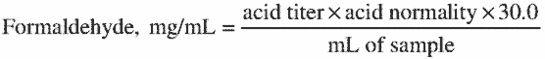
This method is based on the quantitative liberation of sodium hydroxide when formaldehyde reacts with sodium sulfite to form the formaldehyde-bisulfite addition product. The volume of sample may be varied depending on the formaldehyde content but the solution to be titrated must contain excess sodium sulfite. Formaldehyde solutions containing substantial amounts of acid or base must be neutralized before analysis.

Appendix C to § 1910.1048—Medical Surveillance—Formaldehyde

I. Health Hazards
The occupational health hazards of formaldehyde are primarily due to its toxic effects after inhalation, after direct contact with the skin or eyes by formaldehyde in liquid or vapor form, and after ingestion.

II. Toxicology

A. Acute Effects of Exposure
1. Inhalation (breathing): Formaldehyde is highly irritating to the upper airways. The concentration of formaldehyde that is immediately dangerous to life and health is 100 ppm. Concentrations above 50 ppm can cause severe pulmonary reactions within minutes. These include pulmonary edema, pneumonia, and bronchial irritation which can result in death. Concentrations above 5 ppm readily cause lower airway irritation characterized by cough, chest tightness and wheezing. There is some controversy regarding whether formaldehyde gas is a pulmonary sensitizer which can cause occupational asthma in a previously normal individual. Formaldehyde can produce symptoms of bronchial asthma in humans. The mechanism may be either sensitization of the individual by exposure to formaldehyde or direct irritation by formaldehyde in persons with pre-existing asthma. Upper airway irritation is the most common respiratory effect reported by workers and can occur over a wide range of concentrations, most frequently above 1 ppm. However, airway irritation has occurred in some workers with exposures to formaldehyde as low as 0.1 ppm. Symptoms of upper airway irritation include dry or sore throat, itching and burning sensations of the nose, and nasal congestion. Tolerance to this level of exposure may develop within 1–2 hours. This tolerance can permit workers remaining in an environment of gradually increasing formaldehyde concentrations to be unaware of their increasingly hazardous exposure.
2. Eye contact: Concentrations of formaldehyde between 0.05 ppm and 0.5 ppm produce a sensation of irritation in the eyes with burning, itching, redness, and tearing. Increased rate of blinking and eye closure generally protects the eye from damage at these low levels, but these protective mechanisms may interfere with some workers' work abilities. Tolerance can occur in workers continuously exposed to concentrations of formaldehyde in this range. Accidental splash injuries of human eyes to aqueous solutions of formaldehyde (formalin) have resulted in a wide range of ocular injuries including corneal opacities and blindness. The severity of the reactions have been directly dependent on the concentration of formaldehyde in solution and the amount of time lapsed before emergency and medical intervention.
3. Skin contact: Exposure to formaldehyde solutions can cause irritation of the skin and allergic contact dermatitis. These skin diseases and disorders can occur at levels well below those encountered by many formaldehyde workers. Symptoms include erythema, edema, and vesiculation or hives. Exposure to liquid formalin or formaldehyde vapor can provoke skin reactions in sensitized individuals even when airborne concentrations of formaldehyde are well below 1 ppm.
4. Ingestion: Ingestion of as little as 30 ml of a 37 percent solution of formaldehyde (formalin) can result in death. Gastrointestinal toxicity after ingestion is most severe in the stomach and results in symptoms which can include nausea, vomiting, and servere abdominal pain. Diverse damage to other organ systems including the liver, kidney, spleen, pancreas, brain, and central nervous systems can occur from the acute response to ingestion of formaldehyde.

B. Chronic Effects of Exposure
Long term exposure to formaldehyde has been shown to be associated with an increased risk of cancer of the nose and accessory sinuses, nasopharyngeal and oropharyngeal cancer, and lung cancer in humans. Animal experiments provide conclusive evidence of a causal relationship between nasal cancer in rats and formaldehyde exposure. Concordant evidence of carcinogenicity includes DNA binding, genotoxicity in short-term tests, and cytotoxic changes in the cells of the target organ suggesting both preneoplastic changes and a dose-rate effect. Formaldehyde is a complete carcinogen and appears to exert an effect on at least two stages of the carcinogenic process.

III. Surveillance considerations

A. History
1. Medical and occupational history: Along with its acute irritative effects, formaldehyde can cause allergic sensitization and cancer. One of the goals of the work history should be to elicit information on any prior or additional exposure to formaldehyde in either the occupational or the non-occupational setting.
2. Respiratory history: As noted above, formaldehyde has recognized properties as an airway irritant and has been reported by some authors as a cause of occupational asthma. In addition, formaldehyde has been associated with cancer of the entire respiratory system of humans. For these reasons, it is appropriate to include a comprehensive review of the respiratory system in the medical history. Components of this history might include questions regarding dyspnea on exertion, shortness of breath, chronic airway complaints, hyperreactive airway disease, rhinitis, bronchitis, bronchiolitis, asthma, emphysema, respiratory allergic reaction, or other preexisting pulmonary disease.
In addition, generalized airway hypersensitivity can result from exposures to a single sensitizing agent. The examiner should, therefore, elicit any prior history of exposure to pulmonary irritants, and any short- or long-term effects of that exposure.
Smoking is known to decrease mucociliary clearance of materials deposited during respiration in the nose and upper airways. This may increase a worker's exposure to inhaled materials such as formaldehyde vapor. In addition, smoking is a potential confounding factor in the investigation of any chronic respiratory disease, including cancer. For these reasons, a complete smoking history should be obtained.
3. Skin Disorders: Because of the dermal irritant and sensitizing effects of formaldehyde, a history of skin disorders should be obtained. Such a history might include the existence of skin irritation, previously documented skin sensitivity, and other dermatologic disorders. Previous exposure to formaldehyde and other dermal sensitizers should be recorded.
4. History of atopic or allergic diseases: Since formaldehyde can cause allergic sensitization of the skin and airways, it might be useful to identify individuals with prior allergen sensitization. A history of atopic disease and allergies to formaldehyde or any other substances should also be obtained. It is not definitely known at this time whether atopic diseases and allergies to formaldehyde or any other substances should also be obtained. Also it is not definitely known at this time whether atopic individuals have a greater propensity to develop formaldehyde sensitivity than the general population, but identification of these individuals may be useful for ongoing surveillance.
5. Use of disease questionnaires: Comparison of the results from previous years with present results provides the best method for detecting a general deterioration in health when toxic signs and symptoms are measured subjectively. In this way recall bias does not affect the results of the analysis. Consequently, OSHA has determined that the findings of the medical and work histories should be kept in a standardized form for comparison of the year-to-year results.

B. Physical Examination
1. Mucosa of eyes and airways: Because of the irritant effects of formaldehyde, the examining physician should be alert to evidence of this irritation. A speculum examination of the nasal mucosa may be helpful in assessing possible irritation and cytotoxic changes, as may be indirect inspection of the posterior pharynx by mirror.
2. Pulmonary system: A conventional respiratory examination, including inspection of the thorax and auscultation and percussion of the lung fields should be performed as part of the periodic medical examination. Although routine pulmonary function testing is only required by the standard once every year for persons who are exposed over the TWA concentration limit, these tests have an obvious value in investigating possible respiratory dysfunction and should be used wherever deemed appropriate by the physician. In cases of alleged formaldehyde-induced airway disease, other possible causes of pulmonary disfunction (including exposures to other substances) should be ruled out. A chest radiograph may be useful in these circumstances. In cases of suspected airway hypersensitivity or allergy, it may be appropriate to use bronchial challenge testing with formaldehyde or methacholine to determine the nature of the disorder. Such testing should be performed by or under the supervision of a physician experienced in the procedures involved.
3. Skin: The physician should be alert to evidence of dermal irritation of sensitization, including reddening and inflammation, urticaria, blistering, scaling, formation of skin fissures, or other symptoms. Since the integrity of the skin barrier is compromised by other dermal diseases, the presence of such disease should be noted. Skin sensitivity testing carries with it some risk of inducing sensitivity, and therefore, skin testing for formaldehyde sensitivity should not be used as a routine screening test. Sensitivity testing may be indicated in the investigation of a suspected existing sensitivity. Guidelines for such testing have been prepared by the North American Contact Dermatitis Group.

C. Additional Examinations or Tests
The physician may deem it necessary to perform other medical examinations or tests as indicated. The standard provides a mechanism whereby these additional investigations are covered under the standard for occupational exposure to formaldehyde.

D. Emergencies
The examination of workers exposed in an emergency should be directed at the organ systems most likely to be affected. Much of the content of the examination will be similar to the periodic examination unless the patient has received a severe acute exposure requiring immediate attention to prevent serious consequences. If a severe overexposure requiring medical intervention or hospitalization has occurred, the physician must be alert to the possibility of delayed symptoms. Followup nonroutine examinations may be necessary to assure the patient's well-being.

E. Employer Obligations
The employer is required to provide the physician with the following information: A copy of this standard and appendices A, C, D, and E; a description of the affected employee's duties as they relate to his or her exposure concentration; an estimate of the employee's exposure including duration (e.g., 15 hr/wk, three 8-hour shifts, full-time); a description of any personal protective equipment, including respirators, used by the employee; and the results of any previous medical determinations for the affected employee related to formaldehyde exposure to the extent that this information is within the employer's control.

F. Physician's Obligations
The standard requires the employer to obtain a written statement from the physician. This statement must contain the physician's opinion as to whether the employee has any medical condition which would place him or her at increased risk of impaired health from exposure to formaldehyde or use of respirators, as appropriate. The physician must also state his opinion regarding any restrictions that should be placed on the employee's exposure to formaldehyde or upon the use of protective clothing or equipment such as respirators. If the employee wears a respirator as a result of his or her exposure to formaldehyde, the physician's opinion must also contain a statement regarding the suitability of the employee to wear the type of respirator assigned. Finally, the physician must inform the employer that the employee has been told the results of the medical examination and of any medical conditions which require further explanation or treatment. This written opinion is not to contain any information on specific findings or diagnoses unrelated to occupational exposure to formaldehyde.
The purpose in requiring the examining physician to supply the employer with a written opinion is to provide the employer with a medical basis to assist the employer in placing employees initially, in assuring that their health is not being inpaired by formaldehyde, and to assess the employee's ability to use any required protective equipment.

Appendix D to § 1910.1048—Nonmandatory Medical Disease Questionnaire
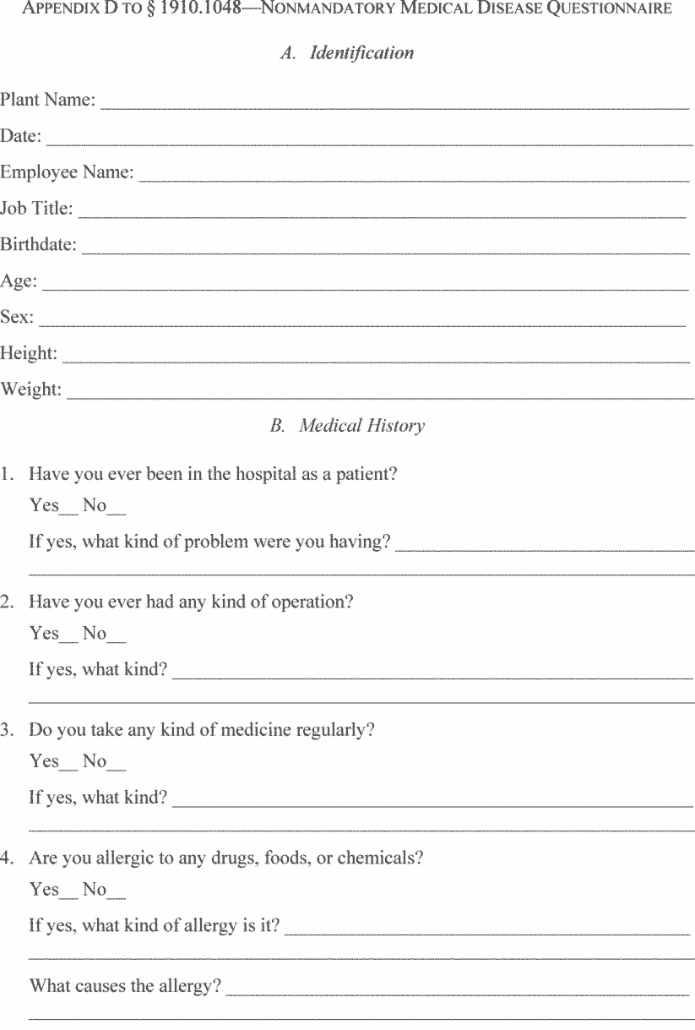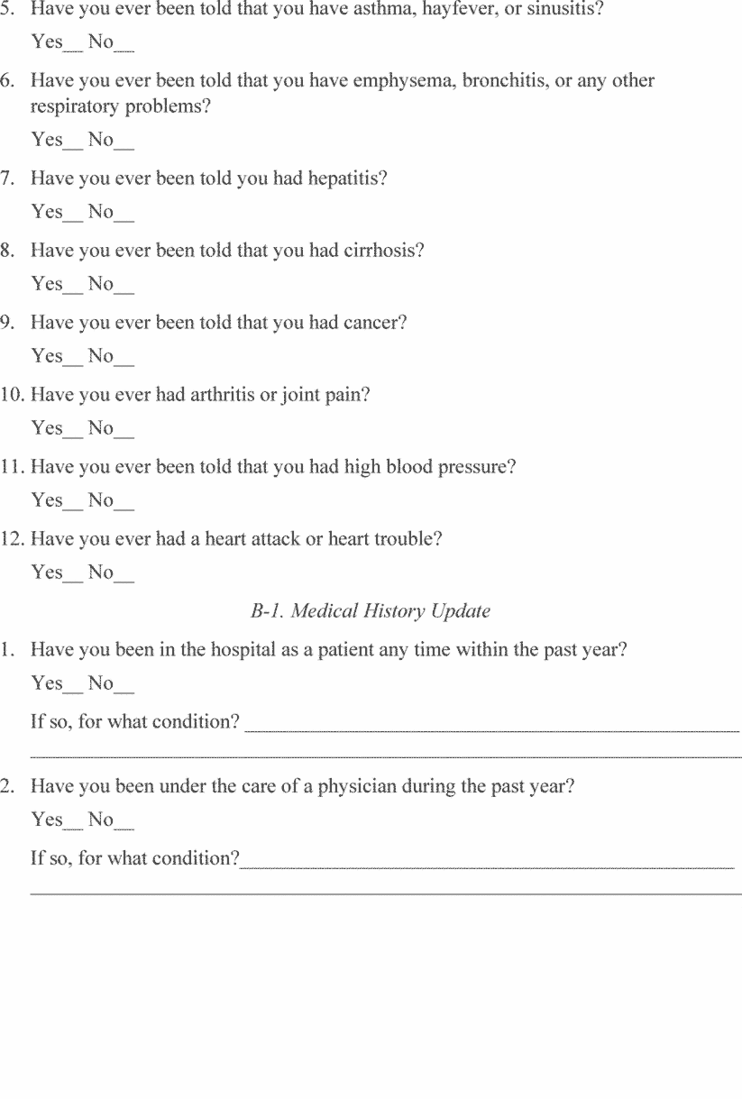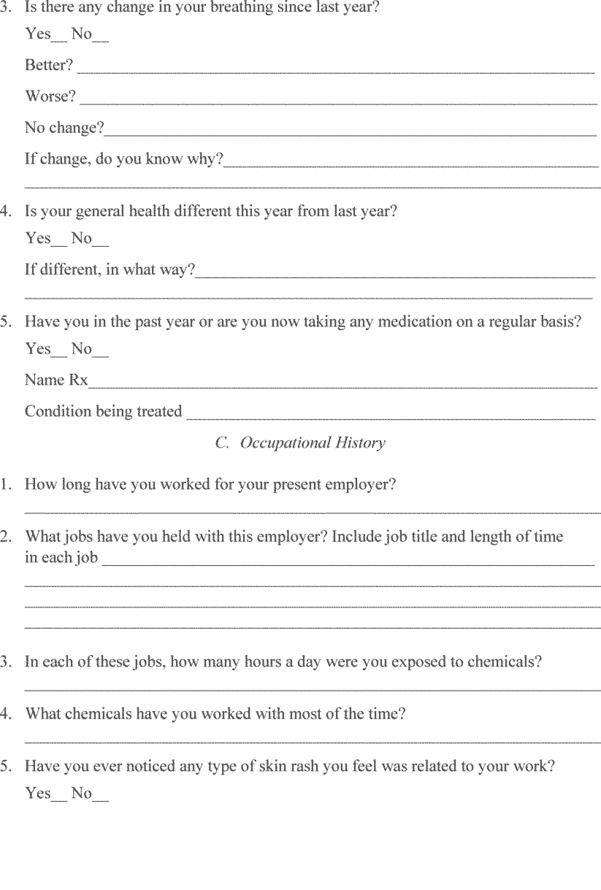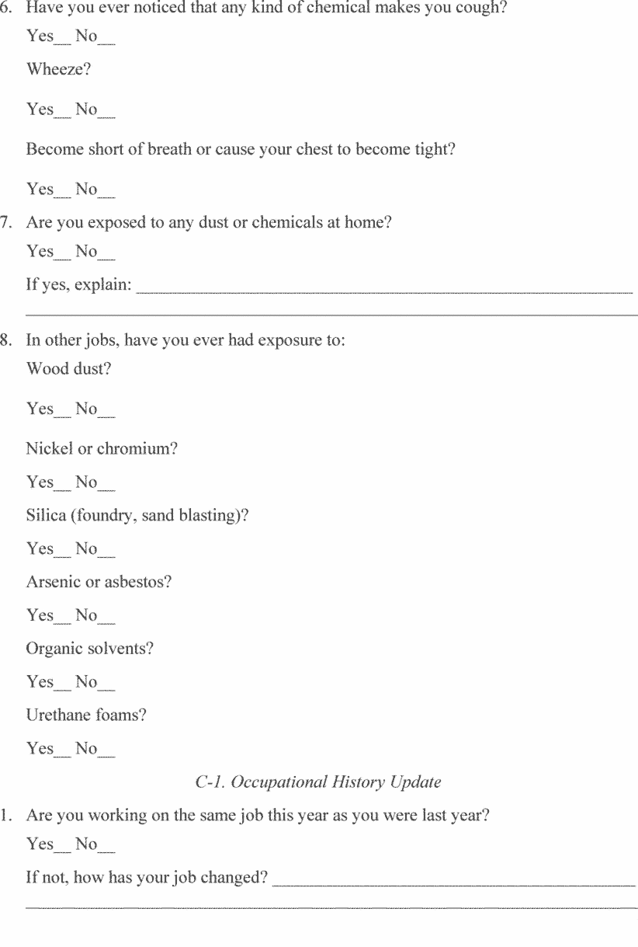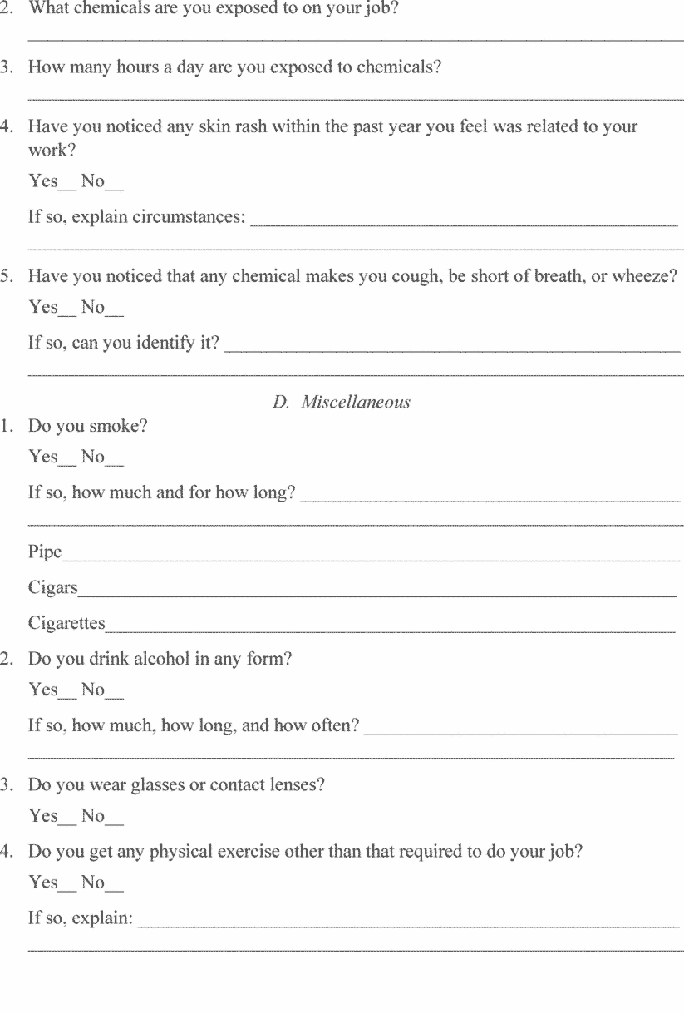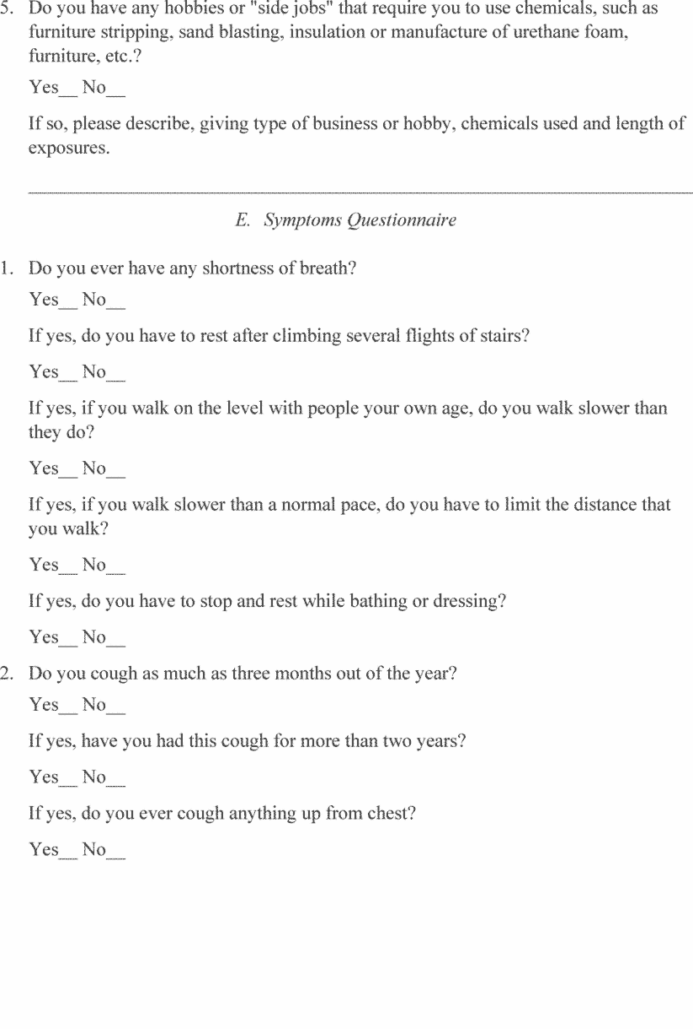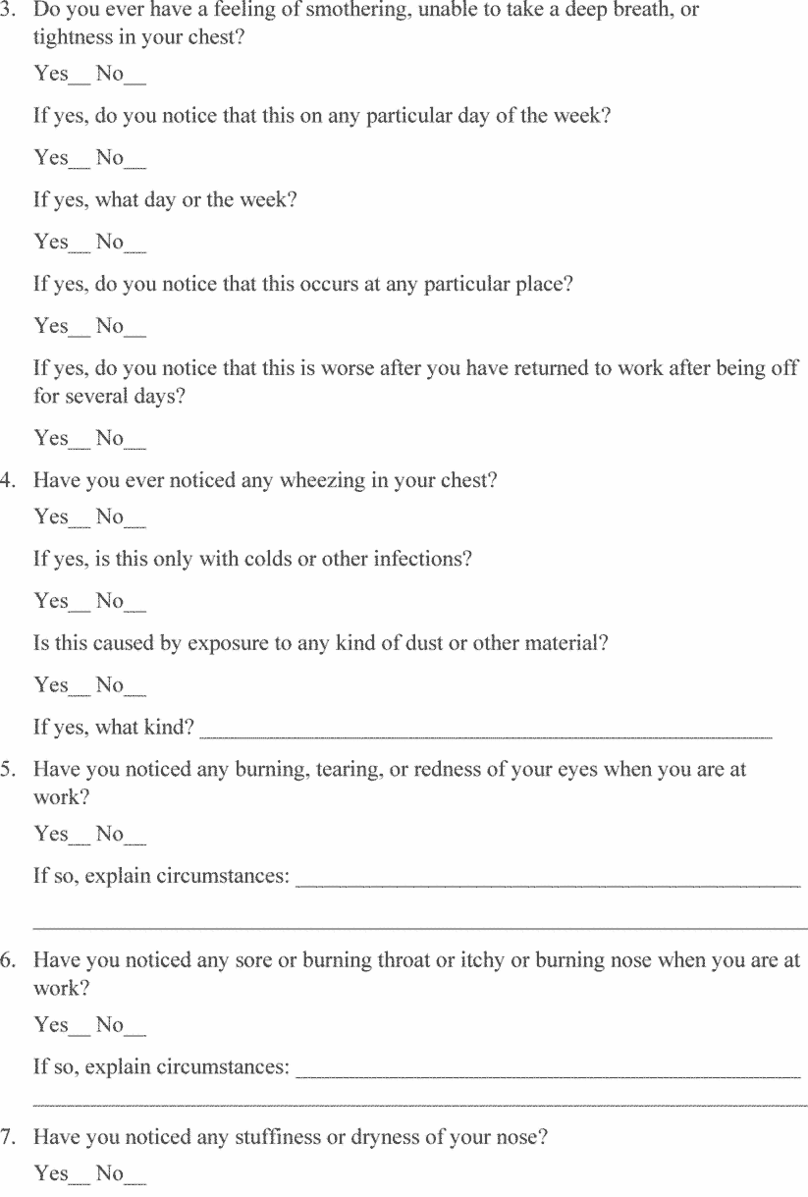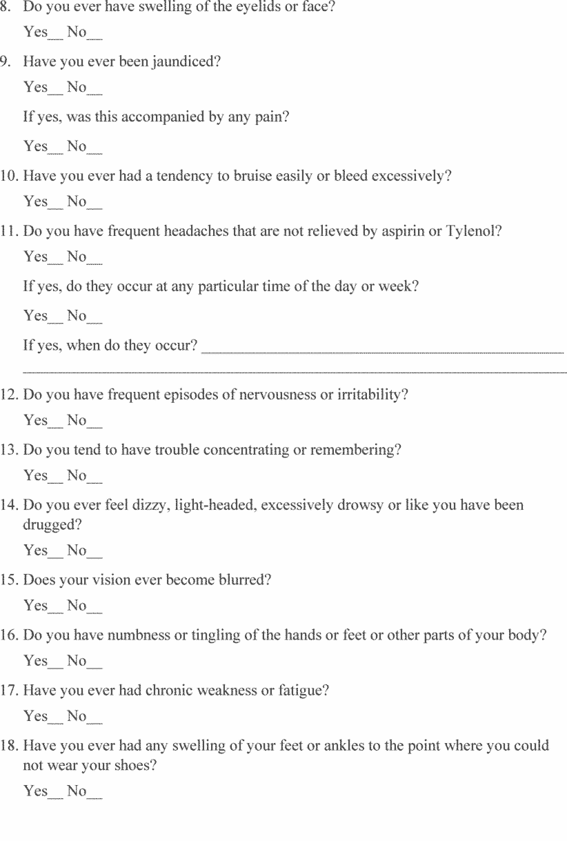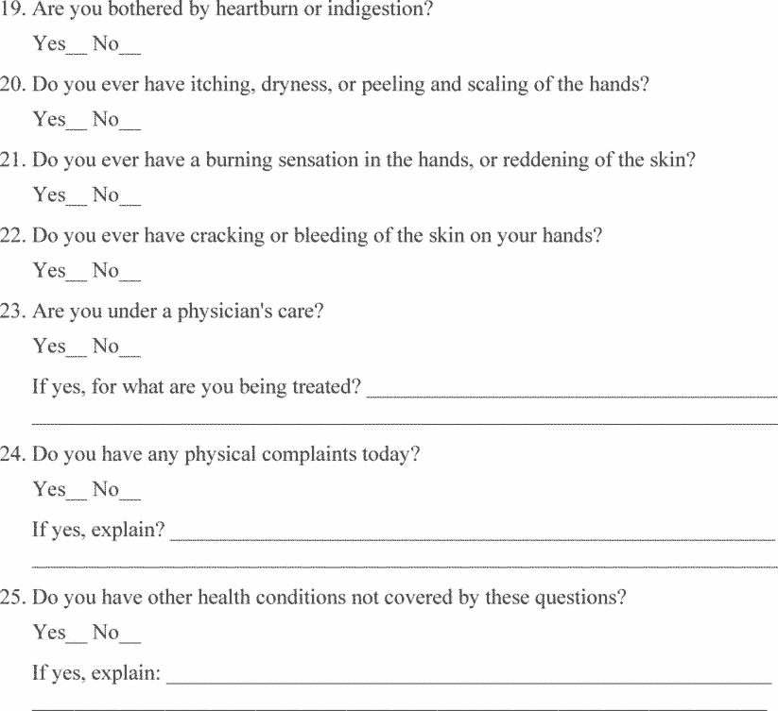
[57 FR 22310, May 27, 1992; 57 FR 27161, June 18, 1992; 61 FR 5508, Feb. 13, 1996; 63 FR 1292, Jan. 8, 1998; 63 FR 20099, Apr. 23, 1998; 70 FR 1143, Jan. 5, 2005; 71 FR 16672, 16673, Apr. 3, 2006; 71 FR 50190, Aug. 24, 2006; 73 FR 75586, Dec. 12, 2008; 77 FR 17784, Mar. 26, 2012; 84 FR 21518, May 14, 2019]

