**SUPPORTING STATEMENT**

**FOR PAPERWORK REDUCTION ACT SUBMISSION**

**I2U2 PROJECT PROPOSAL SUBMISSION TEMPLATE**

**(OMB #1405-XXXX)**

**A. JUSTIFICATION**

1. *Why is this collection necessary and what are the legal statutes that allow this?*

I2U2 is a partnership between the heads of government of India, Israel, the United Arab Emirates (UAE), and the United States. This grouping of countries identifies bankable projects and initiatives, with a particular focus on joint investments and new initiatives in water, energy, transportation, space, health, food security, and technology. The I2U2 initiative aims to mobilize private sector capital and expertise to achieve a variety of economic goals.

The purpose of this collection is to gather the required details necessary to determine if applicants’ projects qualify to participate in the I2U2 initiative. This information is necessary to select participants and share information with I2U2 partners. The window to receive project proposals will remain open as long as the I2U2 initiative exists.

The authority for the Department of State to collect this information is 22 U.S.C. § 2656 (Management of Foreign Affairs).

1. *What business purpose is the information gathered going to be used for?*

I2U2 will consider projects and initiatives on an individual basis that meet the following criteria:

1. Fall into at least one of these seven sectors: water, climate/energy, transportation, space, health, food security, or technology.
2. Preferably operate in the Middle East, India, the United States, or Africa. However, the I2U2 Group will consider opportunities anywhere in the world.
3. Allow each of the four partner countries to benefit from and/or contribute to the project. Priority will be given to projects based on cooperation and/or involvement of participants from all four I2U2 partner countries.

The form requests the following information:

*Section I*

1. Title of your project/initiative – this information will be used to identify project submissions.
2. Name/contact – this information will be used to communicate with the submitter if the I2U2 partner countries have any questions or require any additional information.
3. Email – this information will be used to communicate with the submitter if the I2U2 partner countries have any questions or require any additional information.
4. Phone number – this information will be used to communicate with the submitter if the I2U2 partner countries have any questions or require any additional information.
5. Date – this information will be for version control if revised project proposals are submitted. This information will also used for timing on the submission flow chart below. Please note that processing times in the flow chart are estimates.

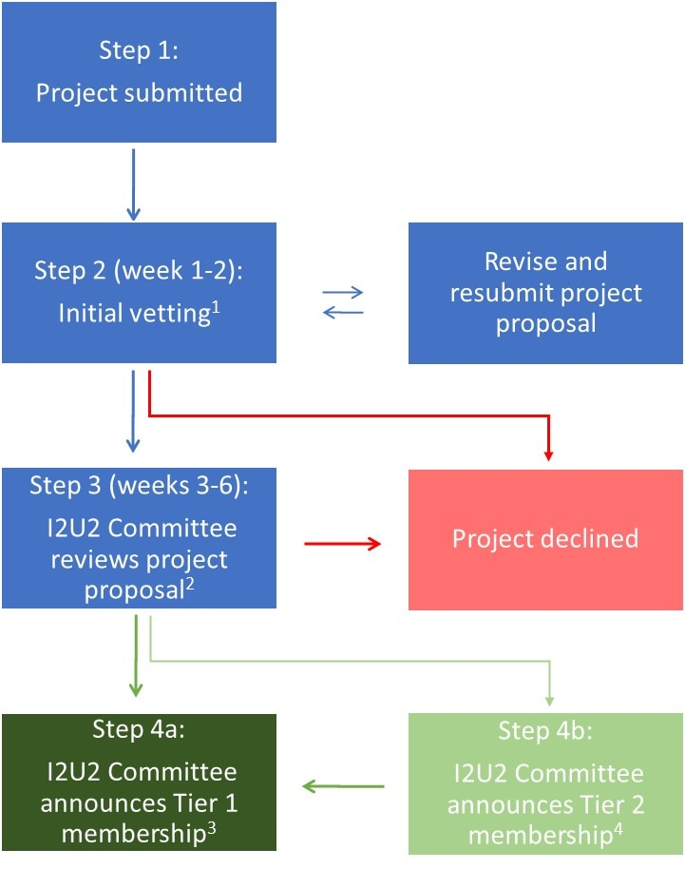

1Country from which project originates conducts initial vetting to ensure it meets the basic requirements (e.g., submission template complete, eligible sector, benefit to and role of each I2U2 country clearly identified).

2The I2U2 Committee is comprised of a representative from each of the four I2U2 member countries.

3Tier 1 membership: A project or initiative that the I2U2 Committee determines as having met the criteria above and shows strong potential to advance I2U2’s objectives.

4Tier 2 membership: A project or initiative that the I2U2 Committee determines as demonstrating potential for Tier 1 status but has not sufficiently met the criteria. Tier 2 projects or initiatives are considered candidates for Tier 1 status and should advance within a reasonable period of time, as determined by the I2U2 Committee, or risk losing Tier 2 status.

1. Location of project – this information will be used in the selection criteria, given the preference for operation in the Middle East, India, the United States, or Africa. This information will also assist in determining which I2U2 partner country will conduct initial vetting.
2. Country(s) of origin – this information will be used to determine which I2U2 partner country will conduct initial vetting.
3. Sector – this information will be used in the selection criteria, given the focus on water, climate/energy, transportation, space, health, food security, and technology.

*Section II*

1. Proposed role of/benefits to India – this information will be used in the selection criteria, given the goal to allow each of the four partner countries to benefit from and/or contribute to a project.
2. Proposed role of/benefits to Israel – this information will be used in the selection criteria, given the goal to allow each of the four partner countries to benefit from and/or contribute to a project.
3. Proposed role of/benefits to United Arab Emirates – this information will be used in the selection criteria, given the goal to allow each of the four partner countries to benefit from and/or contribute to a project.
4. Proposed role of/benefits to United States – this information will be used in the selection criteria, given the goal to allow each of the four partner countries to benefit from and/or contribute to a project.
5. Does your project or initiative require funding – this information will be used to vet potential monetary support for a project.
6. How do you propose to fund it / are you seeking funding support from the I2U2 Group – this information will be used to vet potential monetary support for a project.
7. Amount requested, if applicable – this information will be used to vet potential monetary support for a project.
8. Are you requesting nonmonetary resources – this information will be used to vet potential nonmonetary support for a project.

*Section III*

Provide a description of your proposal and an estimated timeline – this information will be used to vet the project proposal. Submitters may also optionally provide additional supporting documentation, such as a detailed budget, marketing brochure, or other relevant materials, which will be used for vetting.

1. *Is this collection able to be completed electronically (e.g., through a website or application)?*

The collection will be completed 100 percent electronically. The respondent will access the form at the following link: [*www.state.gov/I2U2*](http://www.state.gov/I2U2). The respondent will complete the form online and submit the form by email to [*I2U2@state.gov*](mailto:I2U2@state.gov).

1. *Does this collection duplicate any other collection of information?*

This collection does not duplicate any other collection of information.

1. *Describe any impacts on small business.*

Small businesses or other small entities may submit project proposals for participation in the I2U2 initiative. The form is voluntary, and the requested information for all entities, including small businesses, has been minimized to the extent possible.

1. *What are consequences if this collection is not done?*

Without this form, the I2U2 partner countries would not be able to obtain the standardized information necessary to determine if applicants’ projects qualify for participation in the I2U2 initiative. This would restrict the expansion of the initiative and inclusion of new projects.

1. *Are there any special collection circumstances?*

No special circumstances exist.

1. *Document publication or intent to publish a request for public comments in the Federal Register.*

This is an emergency request. The Department of State will publish a 60-day notice in the *Federal Register* to solicit public comments after the Office of Information and Regulatory Affairs approves the Notice of Action.

1. *Are payments or gifts given to the respondents?*

No payment or gift is provided to respondents.

1. *Describe assurances of privacy/confidentiality.*

There are no assurances of confidentiality to the respondents other than those contained in federal statutes and regulations.

1. *Are any questions of a sensitive nature asked?* *Provide additional justification for any questions of a sensitive nature, such as sexual behavior and attitudes, religious beliefs, and other matters that are commonly considered private. This justification should include the reasons why the agency considers the questions necessary, the specific uses to be made of the information, the explanation to be given to persons from whom the information is requested, and any steps to be taken to obtain their consent.*

No questions of a sensitive nature are asked.

1. *Describe the hour time burden and the hour cost burden on the respondent needed to complete this collection.*

The hour burden of 10 hours per year is based on the form being completed by an average of 10 persons per fiscal year. Only one response is expected per applicant. The form is expected to take each respondent an average of 1 hour to complete.

The estimated cost to respondents is based on the March 2023 weighted civilian hourly wage rate from the [Bureau of Labor Statistics](http://web.archive.org/web/20230701085751/https:/www.bls.gov/news.release/pdf/ecec.pdf) ($43.07/hour) multiplied by the annual time burden (10 hours).

$43.07/hour x 10 burden hours = $430.70 annual cost burden.

1. *Describe the monetary burden to respondents (out of pocket costs) needed to complete this collection.*

There is no monetary burden to respondents needed to complete this collection.

1. *Describe the cost incurred by the Federal Government to complete this collection.*

The annual cost to the federal government is expected to be 10 hours per submission of a [GS-13, step 1](https://www.opm.gov/policy-data-oversight/pay-leave/salaries-wages/salary-tables/23Tables/html/DCB_h.aspx) employee in Washington, DC ($53.67/hour).

10 submissions/year x 10 hours/submission x $53.67/hour = $5,367 annual cost to the federal government.

1. *Explain any changes/adjustments to this collection since the previous submission.*

There are no changes/adjustments since this is a new collection.

1. *Specify if the data gathered by this collection will be published.*

If a project is selected to participate in the I2U2 initiative, the title and select other information about the project will be released on [*www.state.gov/I2U2*](http://www.state.gov/I2U2) and in messaging from the four partner countries.

1. *If applicable, explain the reason(s) for seeking approval to not display the OMB expiration date.*

The OMB expiration date will be displayed.

1. *Explain any exceptions to the OMB certification statement below.*

No exceptions are requested.

Upon approval by OMB, the OMB control number, OMB expiration date, and the following PRA statement will be added to the form: Public reporting burden for this collection of information is estimated to average 1 hour per response, including time required for searching existing data sources, gathering the necessary documentation, providing the information and/or documents required, and reviewing the final collection. You do not have to supply this information unless this collection displays a currently valid OMB control number. If you have comments on the accuracy of this burden estimate and/or recommendations for reducing it, please send them to I2U2@state.gov.

**B. COLLECTION OF INFORMATION EMPLOYING STATISTICAL METHODS**

This collection does not employ statistical methods.