TSA Checkpoint Quarterly Trust Survey

**Instructions**

Would you please answer some questions about your experience going through Security Screening today? This survey is being conducted by Transportation Security Administration. It should take about one minute and is completely voluntary. Your insights will be used to help improve the traveler experience at airports like this one. Your responses are anonymous. Please do not include any personally identifiable information in open responses.

OMB 1601-0029

Exp: 12/31/2026

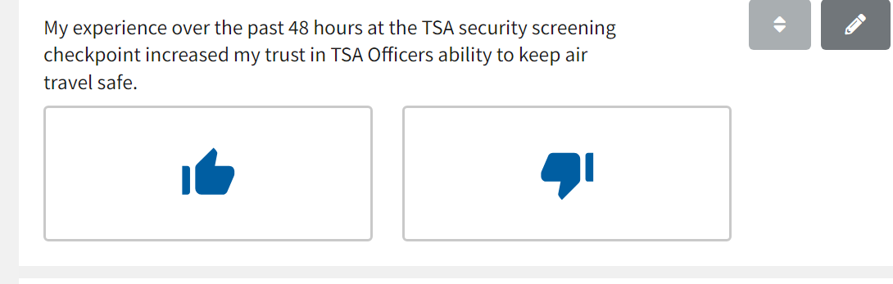

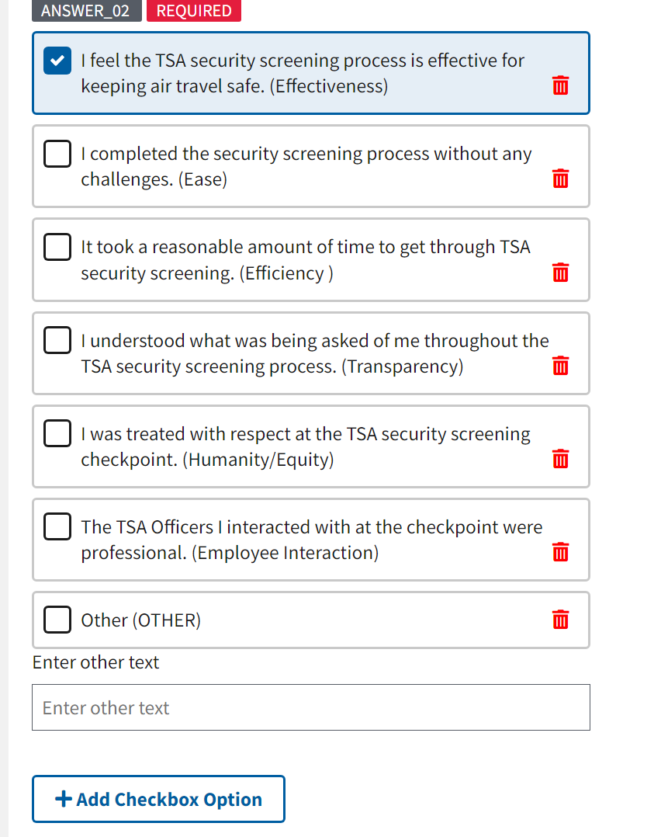

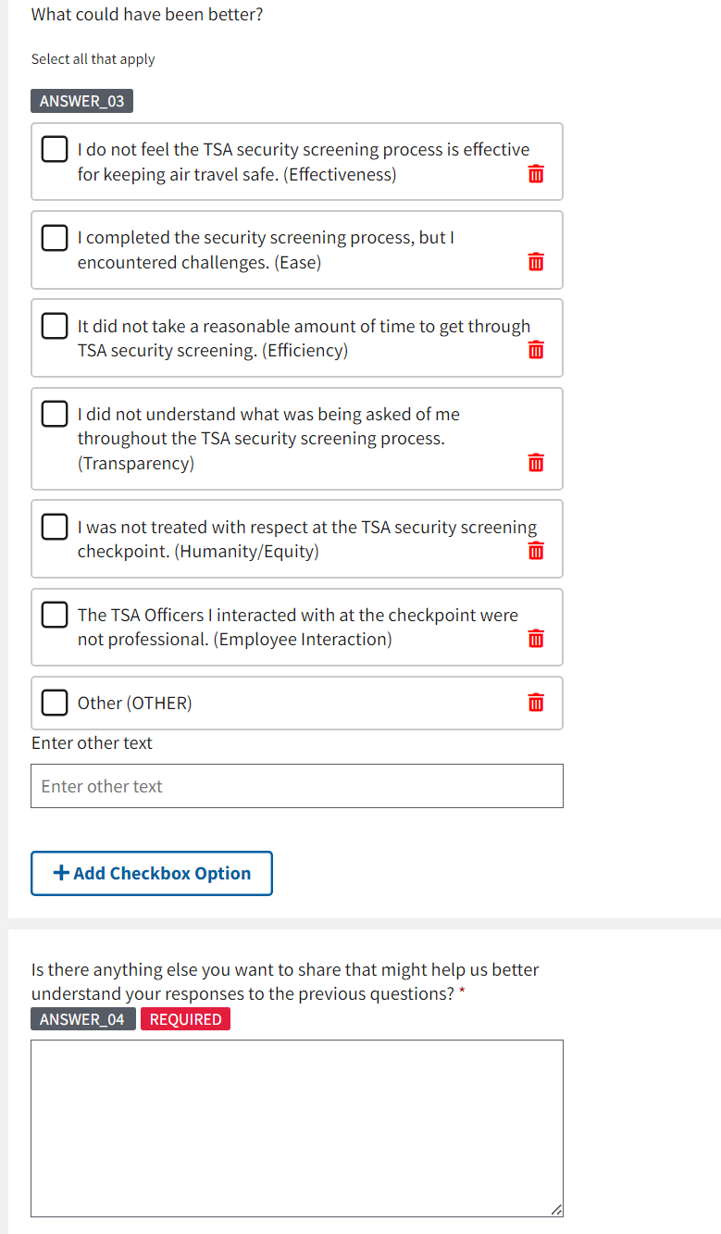

**Paperwork Reduction Act Statement:**

TSA will use the information to improve customer service and may share it with airport operators for this purpose. This is a voluntary collection. It is estimated that it will take no more than 1 minute to complete this form. An agency may not conduct or sponsor, and a person is not required to respond to a collection of information unless it displays a valid OMB control number. The control number assigned to this collection is OMB 1601-0029, which expires 12/31/2026. Send comments regarding this burden estimate or any other aspect of this collection of information including suggestions for reducing this burden to DHS/TSA, TSAPRA@tsa.dhs.gov or 6595 Springfield Center Drive, Springfield, 20598-6011. Attn: PRA 1601-0029 TSA Checkpoint Quarterly Trust Survey.