December 04, 2023
Supporting Statement for OMB Extension Request
Part A: Justification
Study of District and School Uses of Federal Education Funds
Submitted to:
Claire Allen-Platt
National Center for Education Evaluation and Regional Assistance
Institute of Education Sciences
U.S. Department of Education
550 12th Street, SW
Washington, DC 20202

Prepared by:
SRI International
Paul Burkander
Yesica Lopez
Rebecca Goetz
Shari Golan
Augenblick, Palaich & Associates
Robert Reichardt
Amanda Brown
Contract GS-10F-0554N/BPA Order ED-PEP-16-A-0005/91990019F0407
Contents
Introduction 1
A. Justification 2
1. Circumstances that make the collection of information necessary 2
2. How the information will be collected, by whom, and for what purpose 2
3. Use of technology to reduce burden 4
4. Efforts to avoid duplication of burden 4
5. Methods used to minimize burden on small businesses or other small entities 4
6. Consequences of less-frequent data collection 4
7. Special circumstances 5
8. Federal Register announcement and consultation 5
9. Payment or gift 6
10. Assurances of confidentiality 6
11. Justification for sensitive questions 7
12. Estimate of burden hours for respondents 7
13. Estimated cost burden for respondents 9
14. Annualized costs to the federal government 9
15. Program changes in burden/cost estimates 9
16. Plans for tabulation and publication 9
17. Expiration date omission approval 10
18. Exceptions to the certification statement 10
Appendix A: Public Comment and Response 11
Full Comment from The National Association of ESEA State Program Administrators (NAESPA) 11
Memo in Response to Comment from NAESPA 13

Exhibits
Exhibit 1. Burden hour estimates for data collection, original and revised 8
Exhibit 2. Burden changes 9

Introduction
The Institute of Education Sciences (IES) is submitting this package to request an extension to complete the already-approved collection of fiscal data from a nationally representative sample of 400 school districts for the Study of District and School Uses of Federal Education Funds. OMB cleared all data collection activities including the selection and recruitment of the study sample and the data collection instruments in two separate packages, one on 06/24/2020^{[1]} and the other on 02/04/2021.^{[2]} The study examines the targeting and resource allocation for major federal education programs under the Elementary and Secondary Education Act (ESEA), the Individuals with Disabilities Education Act (IDEA), and the COVID relief fund programs. Due to the complexities of fiscal data (in particular revenue, expenditure, and personnel files), IES requests additional time to complete routine follow-up with sampled districts to ensure their data are accurate, to fill in missing values where possible, and to understand data discrepancies between district-reported data and other sources.

^{[1]} OMB Control Number 1850-0951 (https://www.reginfo.gov/public/do/PRAViewICR?ref_nbr=201912-1850-004)
^{[2]} OMB Control Number 1850-0951, revision (https://www.reginfo.gov/public/do/PRAViewICR?ref_nbr=202008-1850-006)

A. Justification

1. Circumstances that make the collection of information necessary
The justification for this data collection was detailed in the original, approved Supporting Statement, and remains the same.
To briefly recap, the five federal education programs covered in this study provide over $33 billion annually to support elementary and secondary schools and their students, or about 80 percent of total funding for elementary-secondary programs administered by the U.S. Department of Education. Obtaining objective information on how federal funds are targeted and used is central to understanding whether and how these programs are meeting program goals. Other evaluations of individual federal programs provide information on the types of services that are supported under each program, typically based on surveys of educators who deliver those services at the district and school levels – but the fiscal data collected through this study provide more detailed, concrete, and objective information on the amounts of funds allocated for various purposes as well as how funds are distributed among grantees. In addition, looking across federal programs provides a more comprehensive view of federal support given that many of the programs can fund similar purposes.

2. How the information will be collected, by whom, and for what purpose
How the information will be collected, by whom, and for what purpose, were detailed in the original, approved Supporting Statement, and remain the same. The purpose of this request is limited to extending the data collection window for the originally approved district data collection activities.
To recap, the data are being collected by SRI and its partner, Augenblick, Palaich & Associates. The purpose of the district data collection is to examine the distribution and uses of federal education funds under ESEA, IDEA, and the COVID relief fund programs. To date, the study has collected the following data:
- State extant data
  - State suballocations of federal program funds
  - State chart of accounts
- District fiscal and personnel data
  - Amounts of revenues and expenditures
  - The source of the funds (e.g., Title I, Part A; Title II, Part A)
  - What activities the expenditures went towards, as described in the accounting system
  - The location that benefited from the expenditure (e.g., specific school, central office)
  - Full-time equivalent (FTE) positions by job type (e.g., teacher, principal)
  - The source of funds to pay for those positions (e.g., Title I, Part A; Title II, Part A)
  - Where the positions were located (e.g., specific school, central office)
  - The salary and benefits associated with a position
The originally-approved data collection activities included requests for state extant data and district fiscal and personnel data; a survey of district and school officials; and district and school interviews. The study team collected initial district revenue data from states, and fiscal and personnel data from districts, but requires additional time to complete that round due to the complexities of finance data.
To minimize burden in the collection of UFEF data, districts provided native accounting and human resource files that described revenues, expenditures, and personnel data for the 2018/19 and 2019/20 school years. Initial district-level data collection took place in 2021. The study team reviewed the data that districts submitted for completeness and conducted some quality checks as the data were received. Initial completeness checks, completed in 2022, suggested that a substantial portion of districts submitted either incomplete data or data that might be invalid (for example, revenues that are very different from state reported sub-allocations). However, at the time it was not feasible for the study team to fully unpack these issues because the many Charts of Accounts (COAs) that states and districts use to categorize their revenues and expenditures were not standardized or entirely comparable across data sources.

To proceed with more in-depth validation checks, the study team first had to “crosswalk” the various COAs. A state’s COA provides the guidance for how to categorize expenses and revenues in a way that allows for uniform financial reporting for its districts. States vary in the structure and level of detail included in their COA, and states, and sometimes districts within states, do not have common definitions of location codes, accounting codes, and job type codes. After devoting significant time creating crosswalks that harmonized roughly 4,000 accounting codes from each district’s finance data and enabled comparisons of sample data with other sources of school finance information, the study team determined that additional follow-up should take place with districts in the sample. Overall, this validation process took place from 2022 to spring 2023 and identified many districts with discrepancies across sources that needs to be resolved.

Due to the significant time spent developing the crosswalks and implementing the data validation process, it is not feasible to complete this routine follow-up before the current clearance expires on February 29, 2024. Therefore, this package requests an extension of the expiration date by one year, to February 28, 2025. Such an extension is needed to guarantee enough time and flexibility to complete these critical data collection activities and fully address the study’s research questions.

3. Use of technology to reduce burden
Use of technology to reduce burden was detailed in the original, approved Supporting Statement, and remains the same. In brief, the study team collected native accounting files from districts to minimize the districts’ role in preparing data for submission. Districts were provided detailed instructions for data submission, a frequently asked questions guide, and were provided contact information for a study team member with regional expertise who responded to questions from districts.

4. Efforts to avoid duplication of burden
All of the federal education programs included in this study were also the subject of other NCEE studies. NCEE staff and contractors for the various studies have worked closely together to avoid duplication of burden. For example, the subgrantee lists collected by this study were shared with the Title III and Title IV study teams for use in sample selection and outreach. Fiscal data collected through this study will not be collected under the other NCEE studies of these programs.

5. Methods used to minimize burden on small businesses or other small entities
No small businesses will be involved as respondents. Every effort will be made to minimize the burden on respondents.

6. Consequences of less-frequent data collection
This study is designed to collect detailed fiscal data, in order to help policymakers and educators better understand how federal funds are allocated and used at the district levels. Although the five ESEA and IDEA programs in this study accounted for four-fifths of federal funding for elementary and secondary education in FY 2020, detailed fiscal data have not been collected on most of these programs since 2004-05. The data from the Department’s last cross-cutting study of resource allocation are now 14 years old and reflect ESEA programs and provisions that existed prior to the 2016 reauthorization. For IDEA, which was not included in the 2004-05 cross-cutting study, the most recent collection of detailed fiscal data was conducted by the Center for Special Education Finance (CSEF), which was discontinued in 2004.
Choosing not to complete this data collection would leave policymakers, educators, and the public with very dated information about the distribution and uses of federal funds in school districts across the nation. In addition, because previous studies were conducted prior to the most recent reauthorizations of ESEA and IDEA, a consequence of not completing the proposed study is that available information on the uses of federal education funds will not reflect current policy goals and priorities.

7. Special circumstances
None of the special circumstances listed apply to this data collection.

8. Federal Register announcement and consultation
a. Federal register announcement
A 60-day notice to solicit public comments was published in the Federal Register, Volume 88, No. 176, page 62777-62778 on September 13, 2023.
Substantive comments were received from the National Association of ESEA State Program Administrators (NAESPA) with concerns about duplicative reporting, burden, and the overall purpose of the extension request. The study team considered each of the concerns but made no changes to the information collection for several reasons. This extension request actually represents a significant reduction in overall burden relative to what the study was already approved for under the original request (see Section 12 and Exhibit 1), and the study is not duplicative with survey-based data collections conducted by ED, because districts participating in the study provided native accounting and human resource files. Analyses of these data revealed discrepancies with federal surveys, and this extension request will provide time to better understand these discrepancies by following up with the original source. The full comments and response are provided in Appendix A.
An additional public comment was received that was non-substantive and did not require a response.
The 30-day notice will be published to solicit additional public comments.

b. Consultations outside the agency
In framing the study design, data collection instruments, analysis methods, and reporting, the study team sought input from a Technical Working Group (TWG) of expert researchers and practitioners. All input from this group (and others who provided comments) was considered and utilized to revise the design and methods as appropriate. TWG members are:
- Bruce Baker, Rutgers University
- Jordan Ely, Portland (OR) Public Schools
- Peg Goertz, University of Pennsylvania (retired)
- Pedro Martinez, San Antonio Unified School District
- Chris May, Michigan Department of Education
- Karen Hawley Miles, Education Resource Strategies
- Sean Reardon, Stanford University
- Marguerite Roza, Georgetown University, Edunomics Lab (Project Team Advisor)
- Jason Willis, WestEd

9. Payment or gift
No payment or gift will be provided to state, district, or school staff who participate in this study.

10. Assurances of confidentiality
Other than the names and contact information for the fiscal data coordinators, which is information typically already available in the public domain (i.e., state, district, and school websites), no data collected contains personally identifiable information. No names and contact information will be released.
Responses will be used for research or statistical purposes. The following language is included on the fiscal workbooks under the Notice of Confidentiality:
Information collected for this study comes under the confidentiality and data protection requirements of the Institute of Education Sciences (The Education Sciences Reform Act of 2002, Title I, Part E, Section 183). Responses to this data collection will be used only for statistical purposes. The reports prepared for the study will summarize findings across the sample and will not associate responses with a specific district or individual. We will not provide information that identifies you or your district to anyone outside the study team, except as required by law.
Extant data and documents collected from states are public information and therefore cannot be kept confidential. However, individual respondents will not be identified.
The Education Sciences Reform Act of 2002, Title I, Part E, Section 183 of this Act requires, “All collection, maintenance, use, and wide dissemination of data by the Institute” to “conform with the requirements of section 552 of title 5, United States Code, the confidentiality standards of subsection (c) of this section, and sections 444 and 445 of the General Education Provision Act (20 U.S.C. 1232g, 1232h).” Respondents will be assured that confidentiality will be maintained, except as required by law.
Specific steps to protect confidentiality include the following:
- Identifying information about respondents (e.g., respondent name, address, and telephone number) will not be entered into the analysis data file but will be kept separate from other data and will be password protected. A unique identification number for each respondent will be used for building raw data and analysis files.
- In public reports, findings will be presented in aggregate by type of respondent or for subgroups of interest. No reports will associate information with any individual, school, or district.
- Access to the sample files will be limited to authorized study staff only; no others will be authorized such access.
- All members of the study team will be briefed regarding confidentiality of the data.
- Most data will be entered via the web systems. However, a control system will be established to monitor the status and whereabouts of any hard copy data collection instruments during data entry.
- All data will be stored in secure areas accessible only to authorized staff members. Computer-generated output containing identifiable information will be maintained under the same conditions.
- Hard copies containing confidential information that is no longer needed will be shredded.

11. Justification for sensitive questions
No questions of a sensitive nature will be included in any data collection forms.

12. Estimate of burden hours for respondents
Exhibit 1 provides the estimate of total burden for this ICR. The extension of the ICR will result in a reduction in total burden, all incurred in the fiscal and personnel data collection activities. The state extant data collections are unchanged.
The reduction is a result of several factors. The previously approved package reported total burden as a three-year total (rather than an annual total) and reported burden for the fiscal and personnel data collection with a slightly higher number of respondents and three collection rounds. Exhibit 1 corrects the total estimate by identifying it as an annualized estimate and corrects the fiscal/personnel estimate by lowering the number of respondents, removing rounds of data collection that did not occur, and adding the hours estimated for thorough follow-up of the round that did occur. The number of targeted respondents for the follow-up activities is reduced from the previously approved 400 to 343 (the number of districts in the sample who actually responded to the request for data), and the expected number of responses is reduced to 292 (or 85% of 343). The burden hours for the intensive follow-up to the initial round of data collection is estimated at 1,752 hours. Therefore the total burden hours for the fiscal and personnel data collection is reduced by a net 2,328 hours (less 4,080 hours for two rounds of data collection that will not occur; plus 1,752 hours for follow-up to the first round). At an average labor cost of $45 per hour, the revised cost burden for the fiscal and personnel data collection is estimated as $170,640, a reduction of $104,760.
The revised total burden across all study activities is therefore estimated at 4,889 hours, or an average of approximately 1,630 annual burden hours across three years, and based on a labor cost of $45 per hour, an estimated $220,005, or an average of approximately $73,335 annually.

Exhibit 1. Burden hour estimates for data collection, original and revised
 | Respondent category | Number of targeted respondents | Expected response rate (%) | Expected number of responses | Estimated burden per respondent | Total burden hours | Total cost burden
 | State extant data (50 states and D.C.)
Previously approved ICR | - SEA suballocation data for ESEA and IDEA programs; contact information for LEA program coordinators | 306 | 100% | 306 | 3 hours | 918 | $41,310
 | - SEA suballocations and LEA contacts for initial CARES Act funding appropriated in March 2020 | 51 | 100% | 51 | 1 hour | 51 | $2,295
 | - State chart of accounts | 51 | 100% | 51 | 1 hour | 51 | $2,295
 | Subtotal (previously approved in 2020) | 408 |  | 408 |  | 1,020 | $45,900
 | Fiscal and personnel data  (400 districts) | 400 | 85% | 340 | 6 hours x 3 rounds of data collection | 6,120 | $275,400
 | State extant data (50 states and D.C.)  - SEA suballocations for additional CARES Act funding appropriated in December 2020 and March 2021 | 51 | 100% | 51 | 1.5 hours | 77 | $3,465
 | Subtotal (previously approved in 2021) | 451 |  | 391 |  | 6,197 | $278,865
 | A. Cost burden (previously approved in 2020 & 2021) | 859 |  | 799 |  | 7,217 | $324,765
Current ICR | Fiscal and personnel data  (revision to fiscal and personnel data estimate provided above) | 343 | 85% | 292 | 6 hours x  1 round of data collection (2,040 hrs) with extended follow-up activities (1,752 hrs) | 3,792 | $170,640
 | B. Difference between previously approved and current ICR | (57) |  | (48) |  | (2,328) | ($104,760)
TOTAL COST BURDEN (A-B) |  | 802 |  | 751 |  | 4,889 | $220,005
ANNUAL BURDEN |  | 267 |  | 250 |  | 1,630 | $73,335

13. Estimated cost burden for respondents
There is no capital or start-up cost component to these data collection activities, nor is there any operations, maintenance, or purchase cost associated with the study.

14. Annualized costs to the federal government
The total cost to the federal government for this study is $2,926,715. The annualized cost over five years is $585,343.

15. Program changes in burden/cost estimates
This is a request for an extension of a currently approved collection. The extension of the ICR will result in a reduction in total burden, a result of several factors. The previously approved package reported total burden as a three-year total (rather than an annual total) and reported burden for the fiscal and personnel data collection with a slightly higher number of respondents and three collection rounds. Exhibit 1 corrects the total estimate by identifying it as an annualized estimate and corrects the fiscal/personnel estimate by lowering the number of respondents, removing rounds of data collection that did not occur, and adding the hours estimated for thorough follow-up of the round that did occur. These changes are summarized in Exhibit 2, with greater explanation provided in Exhibit 1.
Exhibit 2. Burden changes
 | Program Change Due to New Statute | Program Change Due to Agency Discretion | Change Due to Adjustment in Agency Estimate
Total Burden |  | -5,587
Total Responses |  | -549
Total Costs (if applicable)

16. Plans for tabulation and publication
The study will produce an analysis-ready data file for future education finance research with crosswalks and documentation, as well as a snapshot report, as described below.
Analysis file and state chart of accounts crosswalks. A primary objective of the study is to produce an analysis-ready dataset that includes district-reported revenue, expenditure, and personnel data for the 2018/19 and 2019/20 school years from a nationally representative sample of school districts. This dataset will include three separate Stata files, one for each type of data, and each at the district by school-year level. The data files will be accompanied by documentation, including a codebook defining each variable and a description of data processes such as imputation decisions, and state COA crosswalks. These crosswalks will be a set of Excel files that include the mapping from roughly 4,000 state COA codes to federal NCES codes, as well as accompanying documentation explaining the development of these crosswalks and how they can be applied.
A Snapshot Report on the Initial Distribution of COVID Funds. The report will describe the extent to which states allocated federal relief funds to school districts, the average amount of funding per student for each relief fund, and the extent to which funding reached high-need districts.

17. Expiration date omission approval
Not applicable. All data collection instruments will include the OMB data control number and data collection expiration date.

18. Exceptions to the certification statement
Not applicable. There are no exceptions requested.

Appendix A: Public Comment and Response

Full Comment from The National Association of ESEA State Program Administrators (NAESPA)
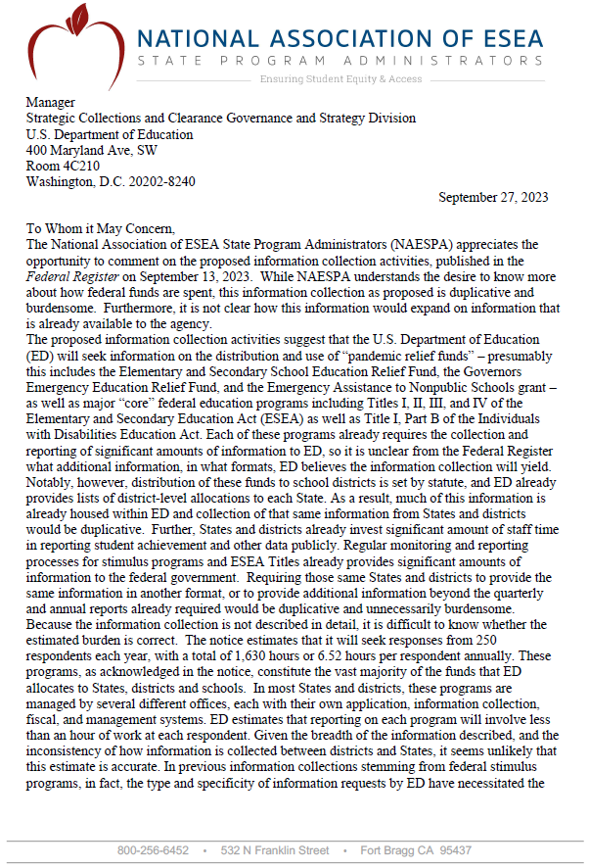
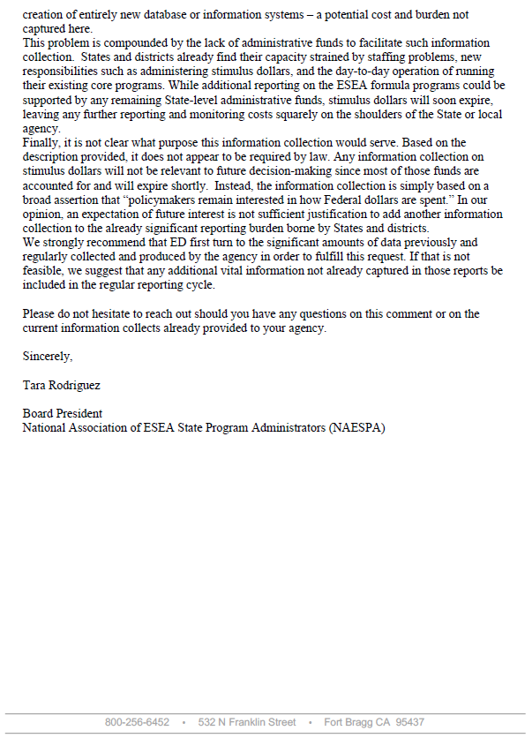

Memo in Response to Comment from NAESPA

Study of District and School Uses of Federal Education Funds

To: Tara Rodriguez, Board President,
National Association of ESEA State Program Administrators (NAESPA)
From: UFEF study team
Date: December 04, 2023
Re: Response to Comments on the information collection request for the Study of District and School Uses of Federal Education Funds, OMB control number 1850-0951

Dear Tara Rodriguez,

Thank you for your comments regarding the information collection request for the Study of District and School Uses of Federal Education Funds (UFEF), OMB control number 1850-0951, published in the Federal Register on September 13, 2023, which requests an extension to a collection originally approved in 2020 and 2021. We appreciate your organization’s perspectives on our study.
To clarify the overall purpose of the ICR, in 2021 the study team sought and obtained fiscal and personnel data related to pandemic relief funds and core federal education programs. To minimize burden on districts, this already-conducted data collection requested districts’ native accounting files. As you note, there are inconsistencies across states and districts in how this information is collected and reported. The study team has processed these data and developed crosswalks to reconcile these inconsistencies. In reviewing the processed data, the study team identified discrepancies between UFEF data, and the much less detailed data collected by the federal Local Education Agency (School District) Finance Survey (F-33). The intent of the requested extension is to obtain additional time, on our already approved ICR, to complete routine follow-up with a subset of sampled districts to ensure the data they already provided are accurate, to fill in missing values where possible and feasible for districts, and to understand data discrepancies between district-reported data and other sources.
Regarding NAESPA’s concern on burden, the extension of the ICR will result in a substantial reduction in total burden to both states and districts relative to the already approved data collection. The approved data collection included time for districts and states to provide data for two additional school years, which we will no longer be collecting. Under the extension, no further follow-up with state respondents will be done, and only limited, targeted follow-up with a subset of the original sample of district respondents will be conducted. Districts responding to this targeted follow-up will be asked specific questions related to their accounting practices – for example, how carryover funds are recorded in their native accounting files. Respondents are expected to be able to respond to these questions during a short interview after limited preparation for that interview.
Regarding NAESPA’s concern on duplication, this study is not duplicative with survey-based data collections conducted by ED. While the F-33 collects information on revenues by federal program, and expenditures on various functions and objects, a key limitation of these data is that expenditures are not linked to federal programs, and therefore these data do not support an understanding of how federal dollars contribute to specific expenditures. The UFEF data collection addressed this limitation by collecting detailed expenditure data tied to the federal programs that support those expenditures. Data such as these can be used to better understand how these funds contribute to district spending, how fund use differs between districts, and how the use of specific federal program funds compare to other federal programs or funding sources. For example, these data can be used to describe the share of Title I, Part A revenues spent on instruction; how this share differs across districts; and how the share of Title I, Part A funds spent on instruction differs from other sources, such as Title IV, Part A or state and local sources. This information can be used to improve the distribution of federal funds in the future, but only if the data are of sufficiently high quality. This extension request will provide time to better understand discrepancies identified between UFEF data and F-33 data, which were identified by the study team during analyses of the native accounting and human resource files that participating districts in the study provided to the study team in 2021.
Because the ICR will result in a significant reduction in burden relative to the already-approved data collection, and because the data are not duplicative with other sources, we will not be making changes to the requested ICR.
Sincerely,
UFEF study team
Study of District and School Uses of Federal Education Funds

Fiscal data were more recently collected for the Title I Part A program as part of the Department’s study of Title I schoolwide and targeted assistance programs, which collected such data for 2015-16. However, that study focused on comparing school-level uses of funds between schoolwide programs and targeted assistance programs and did not provide a holistic picture of all local uses of Title I funds; also, it did not include Title I funds provided through School Improvement Grants under Sction 1003.
Chambers, Lam, Mahitivanichcha, Esra, Shambaugh, and Stullich (2009). State and Local Implementation of the No Child Left Behind Act: Volume VI—Targeting and Uses of Federal Education Funds. Washington, DC: U.S. Department of Education, Office of Planning, Evaluation and Policy Development, Policy and Program Studies Service.

