According to the Paperwork Reduction Act of 1995, no persons are required to respond to a collection of information unless such collection displays a valid OMB control number. The valid OMB control number for this information collection is 1850-xxxx. Public reporting burden for this collection of information is estimated to average 50 minutes per response, including time for reviewing instructions, searching existing data sources, gathering and maintaining the data needed, and completing and reviewing the collection of information. The obligation to respond to this collection is voluntary. If you have any comments concerning the accuracy of the time estimate, suggestions for improving this individual collection, or if you have comments or concerns regarding the status of your individual form, application or survey, please contact Janelle Sands at the Institute of Education Sciences (IES) at janelle.sands@ed.gov directly.

Your teacher is participating in a study to help us learn different ways of teaching math to their students. We are asking you and many other students to help us with this project. If you agree to help out, we’ll ask you to take a short math test on the computer and then solve a few math problems using pencil and paper. You’ll have 50 minutes to answer these questions.
This is not a test like you usually have in school. You will not be graded on these math problems, and the results won’t affect your school grade. All you have to do is try your best to answer the questions. Your teachers, parents and the other students won’t know how you do, and your answers won’t be shared with anyone besides the people working on the study.
You don’t have to answer particular math questions you don’t feel comfortable with or any of them if you don’t want to. You can also stop answering the questions at any time. It’s okay if you don’t want to be in the study or if your parents asked you not to participate.
If you’re willing to help us out, please click the I AGREE button. If you prefer not to participate, please press I DO NOT AGREE. Again, even if you agree to participate you are free to stop answering the questions at any time.
- I agree
- I do not agree

Proportional Problem Solving (PPS) Test

Select ONE answer for each question

- The weight of an object on the Moon is 1 the weight of that object on the Earth. An object that
6
weighs 72 pounds on Earth would weigh how many pounds on the Moon?

  - 10 pounds
  - 11 pounds
  - 12 pounds
  - 13 pounds

- Which of the following ratios is equivalent to the ratio of 6 to 4?

  - 12 to 8
  - 4 to 6
  - 2 to 3

- In making a garden fertilizer, a gardener mixes 2 kg of a nitrate, 3 kg of a phosphate, and 6 kg of potash. What is the ratio of nitrate to the total amount of fertilizer?
  - 11 9

  - 2 3

  - 2 9

  - 2 11

- At the school carnival, Carmen sold 3 times as many hot dogs as Shawn. The two of them sold 152 hot dogs all together. How many hot dogs did Carmen sell?

A. | 38
B. | 51
C. | 114

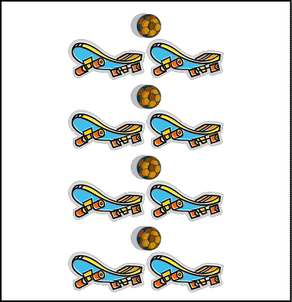

The picture to the right shows several skateboards and soccer balls.
- There are skateboards and soccer balls shown below in boxes i and ii. The ratio of skateboards to soccer balls in box i is equivalent to the ratio of skateboards to soccer balls in the box above. The ratio of skateboards to soccer balls in ii is not equivalent to the ratio of skateboards to soccer balls in the box above. Explain why the ratio in box ii is not equivalent to the ratio in the box above.
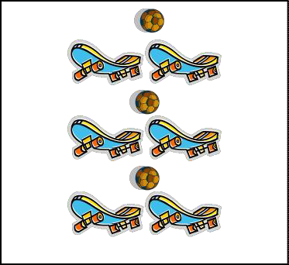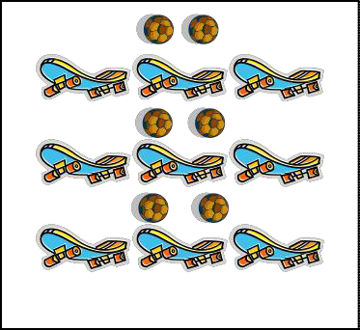
(i)
(ii)

- If 2 cups of flour are needed to make one dozen cookies, how many cups of flour will be needed to make 18 cookies?
A. | 3
B. | 36
C. | 4
D. | 6

- A club held a car wash and washed 21 cars. If the club raised $84, how much did it charge per car?

A. | $0.25
B. | $4.00
C. | $5.00
D. | $4.50

- If there are 300 calories in 200 g of a certain food, how many calories are there in a 40 g portion of this food?
  - 60
B. 26 2
3
C. 6
D. 140

- A machine uses 2.4 liters of gasoline for every 30 hours of operation. How many liters of gasoline will the machine use in 100 hours?
A. | 7.2
B. | 8.0
C. | 8.4

- Below are pictures of two parking lots at the Mall of America, showing which parking spaces are full and which are empty.

Parking Lot A Parking Lot B

John says that parking lot A is emptier than parking lot B, because parking lot A has 6 empty spaces while parking lot B has only 4 empty spaces.

Do you agree or disagree with John?

Agree Disagree
Why? Explain your answer in 1–2 sentences.

- In the model town that a class is building, a car that is 15 feet long is represented by a scale model 3 inches long. If the same scale is used, a house 35 feet high would be represented by a scale model how many inches high?
  - 45 35
  - 5
  - 7
  - 35 3

- Marcel’s drawing of an ant is long is the actual ant?
2
  - 1 inch 3

  - 3 inch 8

  - 1 inch 2

  - 8 inch 3
4 ¹ inches long. If his drawing is 12 times the ant’s actual size, how

- Alice is looking at a map to see how far it is from her home to the state fair in Pueblo. The scale on the map is 1 inch = 125 miles. The distance between her home and the state fair is 1 ¹ inches on
2
the map. What is the actual distance between Alice’s home and the state fair?
  - 175 ¹ miles
2
  - 187 1 miles
2
  - 250 miles

- Of the students in Tara’s class, 2
5
joined the soccer club. What percent of the students joined the

soccer club?

A. | 2.5%
B. | 4%
C. | 25%
D. | 40%

- Sue has 350 newspapers to deliver. She has 28 newspapers still left to deliver. What percent of the newspapers does Sue still have left to deliver?

A. | 3%
B. | 8%
C. | 13%

- Tammy scored 52 out of 57 possible points on a quiz. Which of the following is closest to the percent of the total number of points that Tammy scored?

a. | 0.91%
b. | 91%
c. | 92%

- Some classmates compared their scores on a recent math test.
- Molly answered 15 out of every 20 questions correctly.
- Brittany answered 7 out of every 8 questions correctly.
- Desiree answered 7 out of every 10 questions correctly.
- Nick answered 4 out of every 5 questions correctly

Which student answered more than 80% of the questions correctly?

  - Molly
  - Brittany
  - Desiree
  - Nick

- Jill and Dushawn joined a book club in middle school. The picture below shows how many books Jill and Dushawn each read in September and December. In September, Jill read 5 books and in December she read 8 books. In September, Dushawn read 6 books and in December he read 9 books. All books are the same length and have the same number of pages.
 | September |  | December
Jill |  | Jill
Dushawn |  | Dushawn

Dushawn thinks that the change in the amount of books he and Jill read from September to December is the same. Use mathematics to explain how Dushawn might have justified his claim.

Jill thinks that the change in the amount of books she read from September to December is more than the change in the amount of books Dushawn read from September to December. Use mathematics to explain how Jill might have justified her claim.

Page 9

- Conrad went to the mall to buy a CD for his brother. The original price of the CD was $15.95, but the store was offering a 15% discount. What was the cost of the CD after the discount?
A. | $13.56
B. | $14.45
C. | $15.80

- If the price of a can of beans is raised from 50 cents to 60 cents, what is the percent increase in the price?
A. | 83.3%
B. | 20.0%
C. | 16.7%
D. | 10.0%

- There were 90 employees in a company last year. This year the number of employees increased by 10 percent. How many employees are in the company this year?
a. | 9
b. | 81
c. | 99
d. | 100

- Taylor was earning an income of $1,000 a week. Then his income was reduced by 10%. Two months later, his income increases by 10%. How much is Taylor earning, in dollars, after his income increases?
a. $990
b. $1,000
c. $1,100

- Lisa and Tracy have both gotten taller this year. Last year, Lisa was 45 inches tall, but now she is 51 inches tall. Last year Tracy was 40 inches tall, but now she is 46 inches tall. Who had the greatest percent of increase in their heights, Lisa or Tracy?
- Tracy has the greatest percent of increase in her height.
- Lisa has the greatest percent of increase in her height.
- Both girls have the same percent of increase in their heights.

- Maria has a coupon for $15 off a sweater that she wants to buy at Target. The sweater originally costs $40, and the tax on the purchase is 5%. When Maria uses her coupon to buy the sweater, what is the total cost of the purchase, including tax?
a. $30.00
b. $26.25
c. $27.00

PISA 2012 Mathematics Self-Concept (SCMAT)

Thinking about studying mathematics: to what extent do you agree with the following statements?
- I am just not good at mathematics.
  - Strongly Agree
  - Agree
  - Disagree
  - Strongly Disagree
- I get good grades in mathematics.*
  - Strongly Agree
  - Agree
  - Disagree
  - Strongly Disagree
- I learn mathematics quickly.*
  - Strongly Agree
  - Agree
  - Disagree
  - Strongly Disagree
- I have always believed that mathematics is one of my best subjects.*
  - Strongly Agree
  - Agree
  - Disagree
  - Strongly Disagree
- In my mathematics class, I understand even the most difficult work.*
  - Strongly Agree
  - Agree
  - Disagree
  - Strongly Disagree

*indicates that items are reverse scored

PISA 2012 Mathematics Anxiety (ANXMAT)

Thinking about studying mathematics: to what extent do you agree with the following statements?

- I often worry that it will be difficult for me in mathematics classes.*
  - Strongly Agree
  - Agree
  - Disagree
  - Strongly Disagree
- I get very tense when I have to do mathematics homework.*
  - Strongly Agree
  - Agree
  - Disagree
  - Strongly Disagree
- I get very nervous doing mathematics problems.*
  - Strongly Agree
  - Agree
  - Disagree
  - Strongly Disagree
- I feel helpless when doing a mathematics problem.*
  - Strongly Agree
  - Agree
  - Disagree
  - Strongly Disagree
- I worry that I will get a poor grade in mathematics.*
  - Strongly Agree
  - Agree
  - Disagree
  - Strongly Disagree

*indicates that items are reverse scored

