DFC-006
OMB 3015-0010

JUSTIFICATION FOR NON-SUBSTANTIVE CHANGES
- Justification for Requested Changes

Adding an option to the checklist in Question 1 PIF Submitting Party Summary Information. We are adding the option circled in red below.

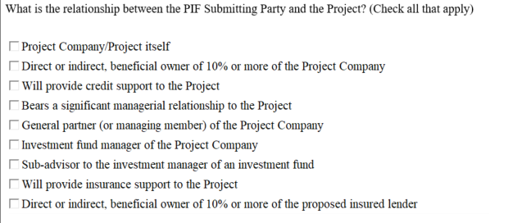

- There is no change to the estimated burden associated with these changes.

- There is no change to the estimated annualized cost to the Federal government associated with these changes.

