FY 2019 Public Libraries Survey

**PLS Web Portal User’s Guide**

Guide for Using the PLS Web Portal to Report FY 2019 Data

**December 2019**

Institute of Museum and Library Services

American Institutes for Research

Contents

1 Introduction 4

1.1 Background of the Public Libraries Survey 4

1.2 Reporting Data: Administrative Entities and Outlets 5

1.3 PLS Web Portal Revisions 5

1.4 Data Element Changes 5

2 Getting Started 6

2.1 Login 7

2.2 PLS Web Portal 8

2.2.1 Home 8

2.2.2 Survey Status 11

2.3 Web Instructions 12

2.4 Other Helpful Tools 14

2.4.1 Export Data 14

2.4.2 Tables 15

2.4.3 Help Menu Options 16

2.5 External Links 17

3 Import 18

3.1 Overview 18

3.2 Upload and Import Data Files 18

3.3 Uploading Annotation Files 20

3.4 Preparing Administrative Entity and Outlet Import Files 21

4 User Options, Input Data, and Structure Changes 23

4.1 User Options 23

4.1.1 Sort Order for Administrative Entities or Outlets in Input Data 24

4.1.2 Sort Order for Edit Report by Edit Number 24

4.1.3 Auto Save Data in Input Data 24

4.2 Input Data Through PLS Web Portal 24

4.2.1 State Characteristics 24

4.2.2 Administrative Entity (AE) 25

4.2.3 Outlets 25

4.3 Structure Changes 25

5 Match Report 28

5.1 Match Report 28

5.2 Resolving Unsuccessful Records 31

6 Edit Report 33

6.1 Edit Messages and Conditions 33

6.1.1 Critical Edits 33

6.1.2 Noncritical and Internal Edits 34

6.2 Annotations 34

7 Lock Data 36

7.1 Estimate of Burden 36

8 Chief Officer Certification 38

8.1 Chief Officer Web Instructions 38

Appendix A Survey Instrument 40

Appendix B Name, Address, and Structure Changes 80

Appendix C Resolving the Match Report 109

Appendix D Import File Specifications 133

Appendix E PLS Contacts 139

Appendix F Francis Keppel Award Criteria 140

Appendix G Standard Abbreviations 143

Appendix H Summed Data Elements 145

# 1 Introduction

## 1.1 Background of the Public Libraries Survey

The Institute of Museum and Library Services (IMLS) has administered the Public Libraries Survey (PLS) since October 1, 2007. From its inception in 1989 until 2007, the survey was administered by the National Center for Education Statistics (NCES). The survey data are collected under the Museum and Library Services Act of 2018, as stated in 20 U.S.C sec. 9108 (policy research, data collection, analysis and modeling, evaluation, and dissemination). Current, accurate, and ongoing collection of library data is an essential foundation for quality library services in the United States. IMLS is committed to the continued excellence of this program.

The PLS first began to take shape in 1985, when NCES and the American Library Association conducted a pilot project in 15 states to assess the feasibility of a federal–state cooperative program for collecting public library data. The NCES and the U.S. Department of Education’s former Library Programs office jointly funded this project. In 1987, the project’s final report recommended the development of a nationwide data collection system. The Hawkins-Stafford Elementary and Secondary School Improvement Amendments of 1988 (P.L. 100-297)[1] charged NCES with developing a voluntary federal–state cooperative system (FSCS) for the annual collection of public library data. NCES and the U.S. National Commission on Libraries and Information Science (NCLIS) formed a task force to carry out this mandate, establishing the FSCS in 1988.

The 1988 NCES-NCLIS task force evolved into the FSCS Steering Committee. This committee has been integral to the design and conduct of the survey. Its membership has included State Data Coordinators (SDCs), representatives of the Chief Officers of State Library Agencies, NCLIS, the American Library Association, IMLS, the U.S. Census Bureau (the former data collection agent), and NCES. With the transition of the collection from NCES to IMLS, the steering committee was renamed the Public Library Statistics Cooperative. Effective December 2008, this committee became part of the new Library Statistics Working Group.

SDCs, appointed by Chief Officers of state library administrative agencies, submit data for the annual PLS for a universe of more than 9,300 public libraries with approximately 17,000 individual public library outlets in the 50 states, the District of Columbia, and the outlying territories. IMLS releases the collection results in an annual data file, the only national database on public libraries, as well as a report based on the survey. Federal, state, and local officials; professional associations; researchers; educators; local practitioners; and other interested parties use these data for planning, research, evaluation, and policymaking decisions.

## 1.2 Reporting Data: Administrative Entities and Outlets

The PLS collects data on administrative entities and outlets.

The administrative entity (AE) is the legally established agency that provides library services to the population of a local jurisdiction. An AE must operate one or more direct public library service outlets. The AE’s offices may be located in one of the outlets (e.g., a single-outlet central library or a branch of a decentralized multi-outlet operation) or in separate quarters (e.g., an office adjacent to an independent bookmobile’s garage). The data reported for each AE are the combined data for all of its outlets. (See Appendix A to review the AE data elements included on the PLS.)

An outlet is a unit (i.e., central, branch, bookmobile, books-by-mail only) of an AE that provides direct public library services. A single-outlet central library should not be confused with the AE to which it belongs. Some data are reported for each outlet of an AE, such as the outlet’s name, address, telephone number, type of outlet, and square footage. (See Appendix A to review the outlet data elements included on the PLS.)

## 1.3 PLS Web Portal Revisions

The FY 2019 PLS Web Portal did not have any major structural revisions, any revisions to the PLS Web Portal were minor enhancements to the interface and/or functionality. Remember, the PLS Web Portal has a new URL: <https://submitpls.imls.gov>.

## 1.4 Data Element Changes

This section outlines changes to data elements for the FY 2019 data collection:

* No new data elements have been added for the FY 2019 collection.

# 2 Getting Started

The data collection process begins when you first receive an e-mail from AIR. This e-mail from AIR will include your login credentials (username and link to create your password). If you are a returning SDC, the e-mail will include only a link to the PLS Web Portal because your credentials are the same as your login credentials for the FY 2018 PLS collection. If you do not remember your password or wish to reset your password, select the Forgot Password button, and follow the on-screen instructions.

After you log in to the PLS Web Portal (<https://submitpls.imls.gov>), you must enter your state characteristics. **After you enter the state characteristics information, the PLS Web Portal will use your FY 2018 data to prepopulate the current year (FY 2019) data in the AE and outlet sections of the PLS Web Portal.** If you have minimal changes between FY 2018 and FY 2019 collections, the pre-population will help in updating your data. Please import or input your FY 2019 AE and outlet data to continue.

Different areas of the PLS Web Portal will become available to you as you progress through the collection process. After you input all data, perform a successful match, and complete an edit review (i.e., no critical edits remain, and all non-critical and internal edits have been annotated), you can lock your data. Your submission is complete when you lock your data. Detailed instructions about these steps are in Section 2.3.

**NOTE: You must enter data on the state characteristics page before you can access the Import Data or Input Data features.**

Exhibit 2.1 shows the process for collecting the PLS data.

Exhibit 2.1. PLS Data Collection Process

## 2.1 Login

To access the PLS Web Portal, a username and password are required. **Your username will be your e-mail address**. On the day the PLS Web Portal opens, AIR will send you login instructions via e-mail. If you have any trouble logging in to the PLS Web Portal, please contact us at [PLS@air.org](mailto:PLS@air.org) or 1-866-744-5746, option 1 from Monday through Friday, 9 a.m. to 5 p.m. Eastern Time.

The URL for logging in to the PLS Web Portal is <https://submitpls.imls.gov>. See Exhibit 2.2 for a screenshot of the PLS Web Portal login page.

If you forgot your password, click **Forgot Password** on the login page, or go directly to [<https://submitpls.imls.gov>/Account/ForgotPassword](https://submitpls.imls.gov/Account/ForgotPassword). This link will take you to a page where you will enter your username (e-mail address) and then click **Submit**, which will automatically send you an e-mail with a temporary link to reset your password. The process will be the same as when you created your initial password.

**NOTE: Your password must contain at least eight characters, one lowercase letter, one uppercase letter, one digit, and one special character. Valid special characters are: @ ! # $ % ^ & + =**

Use the following space to write your username and password:

|  |  |
| --- | --- |
| Username (e-mail address): |  |
| Password: |  |

Exhibit 2.2 PLS Web Portal Login Page

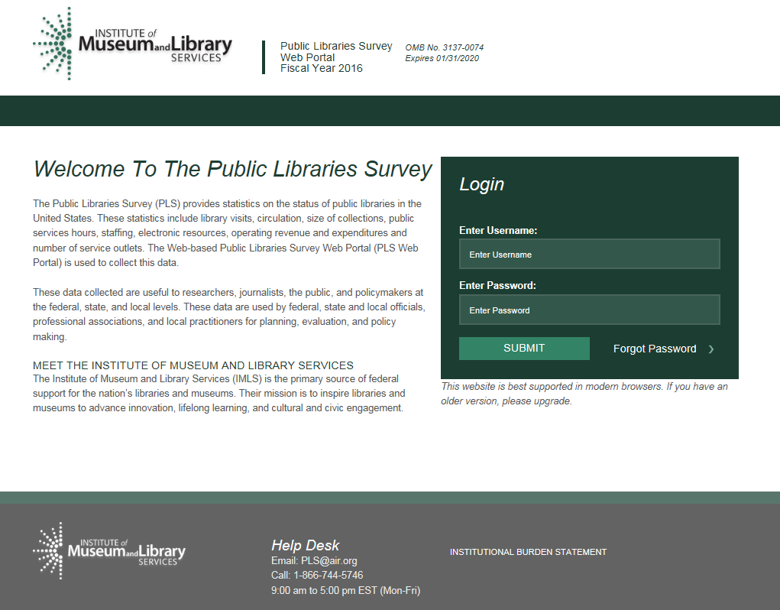

## 2.2 PLS Web Portal

The first time you successfully enter the PLS Web Portal ([https://submitpls.imls.gov](https://submitpls.imls.gov/)), you will see step-by-step instructions for entering your data, which are the same as the Web Instructions in Section 2.3. You can access these instructions again, at any time, from the Help menu at the top right of the page.

### 2.2.1 Home

The Home page (Exhibit 2.3) will be the first page you will go to after you log in and after you close out the Web instructions on your first login. This is a landing page where you can quickly view your survey status, access important documents, and view any important correspondence. This page includes the following tools and resources:

* **Survey Information:** This table provides an update of the status and next processing steps for your survey and is an abbreviated version of the Survey Status table. You can view the full table by clicking **Survey Status** in the dark green navigation bar at the top of the page.
* **Import a New File:** This link takes you directly to the Import Data page so that you can import additional files. You also can access Import Data from the Tools drop-down menu in the dark green navigation bar.
* **Helpful Documents:** This section provides easy access to documents that will be useful during data collection, including Web Instructions (see Section 2.3), this User’s Guide, and the Match and Edit Report Terminology reference guide. These links will open in separate browser windows.
* **Latest Correspondence:** This section includes any updates we may need to convey to you during the data collection process or reminders of important deadlines.
* **Navigation Bar:** The dark green navigation bar at the top of the page provides links and drop-down menus to different pages of the survey. This navigation bar will always be present throughout the survey.
* **Help Desk Information:** The contact information for the Help Desk is located at the bottom of every page.

Exhibit 2.3 PLS Web Portal Home Page

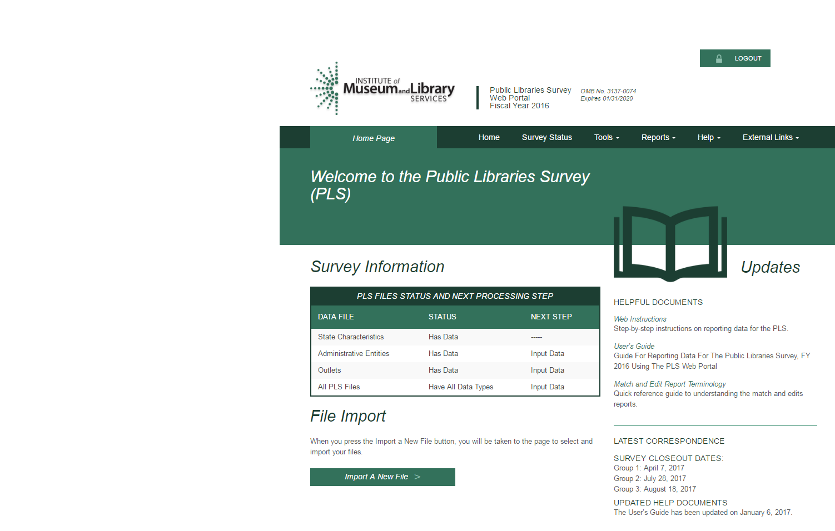

### 2.2.2 Survey Status

In addition to the Survey Information table on the Home page, you can refer to the Survey Status page (Exhibit 2.4) to see where your submission stands at any time and what your next steps are in the data submission process.

**NOTE:** **Once you have saved your State Characteristics data in the system, the Survey Status table will automatically indicate that you have data for the Administrative Entities and outlets.**

This process will happen before you upload your AE or outlet data. The status reflects that your current year data have been prepopulated with your prior year data. **You will still need to import or input current year AE and outlet data.** The Survey Status will update to let you know when to run a Match or Edit report and if you need to make any changes to the data.

Exhibit 2.4 PLS Web Portal Survey Status Page

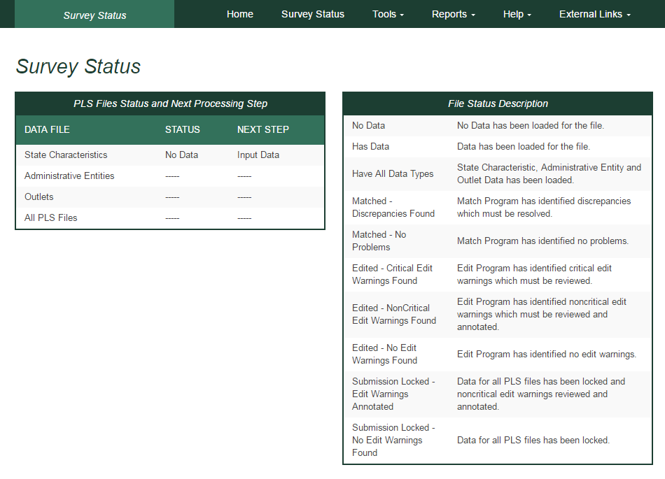

## 2.3 Web Instructions

The following instructions for SDCs will pop up when you first log in at the PLS Web Portal. After your initial login, these instructions are available under the **Help** menu. Instructions for Chief Officers are available in Section 8.1 of this User’s Guide.

**Step 1:** You must enter your ***State Characteristics*** data before you can input or import AE or outlet data.

* Select **Tools** then **Input Data: State Char**.
* Enter data into the fields, and press the **Save** button.
* Press the **Print** button to print a copy of your state’s data.

**Step 2:** Import or manually enter ***Administrative Entity (AE)*** data.

* Option 1—Import Data Files:
  + Select **Tools** then **Import Data**
  + Select the **Browse** button to find your AE file.
* Once you have selected your AE file, click the **Upload and Import File** button.
* Select the **Administrative Entity** option in the pop-up window, and click the **Yes, Import File** button.
* Once the file is uploaded, you will see a pop-up window indicating whether your upload was successful or had errors.
  + If you receive an import error, click the **Download Errors** link in the pop-up window to open or save **ParserErrors.txt**. This file contains your import errors and can be displayed on the screen *or* downloaded and saved for further review.
* Review all import errors, revise, and re-import the data files.
* **NOTE: You must correct all import errors before you can continue.**
* Option 2—Manually Enter Data:
  + You can enter AE data manually by selecting **Tools** then **Input Data: AE**.
* The top horizontal section labeled **Administrative Entity** allows you to navigate between AEs. Use the innermost arrows to navigate to the previous or next AE on the list. Use the outermost arrows (with a line) to navigate to the first or last AE. You can use the drop-down menu to navigate to a specific AE.
* The left vertical menu labeled **Section Navigation** allows you to navigate to specific sections of questions for the AE and outlet data collection.

**Step 3:** ***Outlet data*** are preloaded from the prior year’s file.

* Option 1—Import Data Files: If there are major changes to the data, we suggest importing a new outlet file by selecting **Tools** then **Import Data**.
* You can make minor changes by selecting **Associated Outlet(s)** under **Selection Navigation** in **Input Data: AE** from the **Tools** menu.
* Option 2—Manually Enter Data: You can update outlet data manually by selecting **Tools** then **Input Data: Outlet**.

**Step 4:** Select **Reports** then **Run Match Report**after all data have been imported or entered.

* The Match process will run in the background. When the Match process is completed, select the **Download Match Report** button. AIR recommends saving the workbook to your hard drive and using it as a reference when correcting any errors found in your AE and/or outlet files.
* All match errors must be resolved before you can run your edit report (Step 5).
* We suggest that you correct your data file(s) and re-import the revised data. You can change only PARENTID, LINKID, and OLDID using this method.
* You can manually correct the data using the **Input Data** or **Structure Changes** menus (under **Tools**). However, you can revise PARENTID, LINKID, and OLDID only by correcting and re-importing your data file.
* Check the **Restorable AE** and **Restorable Outlet** tabs on your Match Report.
* These tabs provide a list of all closed, deleted, and temporarily closed entities for your state. We suggest checking these tabs to make sure that any AEs or outlets you are trying to open (birth; Structure Code 02) are truly new.
* **NOTE: You must re-import your outlet file each time you import an AE file. If you do not re-import your outlet file, your outlet data will revert to the prior year’s data.**

**Step 5:** Once your Match Report is resolved, select **Reports** then **Run Edit Report**.

* **NOTE: All match errors must be resolved before you can run your edit report.**
* The Edit Report process runs in the background and can take several minutes depending upon the amount of data. When the Edit Report process is completed, select the **Download Edit Report** button. Review all the Edit Report worksheets contained within the downloaded Excel file. AIR recommends saving the workbook to your hard drive in order to record your annotations during your review of the reports.
* All critical edits must be resolved and noncritical edits annotated before you can lock your data (Step 6).
* **Address Critical Edits.** We suggest that you correct your data file(s) and re-import the revised data. You also can manually correct the data using the **Input Data** menu (under **Tools**).
* **Annotate Noncritical Edits.** You can annotate noncritical edits in the Edit Report Excel worksheets or as a separate Annotation File. Once all noncritical edits are annotated, you will import the annotations by selecting **Tools** then **Import Data** and uploading the annotated Edit Report Excel file (file type: **Edit Report**) or separate Annotation Excel file (file type: **Annotation**).
* **Rerun Match and Edit Reports.** Once you have addressed the critical edits, rerun your Match Report, correct any issues found, and then rerun the Edit Report.

**Step 6:** Once you are satisfied with your data, select **Tools** then **Lock Data**.

* **NOTE: After you have locked your PLS survey submission, you will not be allowed to change any data.**
* If you need to make revisions, please contact us at [**PLS@air.org**](mailto:PLS@air.org) or **1-866-744-5746, option 1**, and we will assist you in correcting your data submission.
* When you lock your data, you will be asked to estimate the number of hours it took for you to complete the survey.
* After locking your data, the PLS Web Portal will send an automated e-mail to you, notifying you that the data are locked, and that AIR will conduct post-lock data review. AIR may send you questions requesting clarification of your submission.
* Once the post-lock data review is completed, an email with be sent to your Chief Officer requesting that they certify the data. You will be copied on the certification request e-mail.

## 2.4 Other Helpful Tools

### 2.4.1 Export Data

The Export Data feature is located under the **Tools** menu (Exhibit 2.5). Current year and prior year data are available for AEs, outlets, and state characteristics in either individual files or one collective file. AE and outlet records deleted on the prior year data (i.e., closed or removed as an incorrect record) are available from the Export Data page should any of these records need to be restored to the survey. AE and outlet records deleted in the current year data are available only on the Match Report’s restorable tabs. To export and re-import a file downloaded from the PLS Web Portal, select **Data ready to re-import** under **Select File Format(s)**. This file format keeps the FSCS ID assignments for re-import. This format also will allow you to export your file with changes you made in the PLS Web Portal, make further revisions, and re-import the file.

To obtain the files:

1. Click **Tools** then **Export Data**.
2. Select the file format you would like to download.
3. Select the data set you would like to export.
4. Click **Generate File Export**.
5. Access the file according to your Web browser settings.

**NOTE: How you access downloaded files depends on your Web browser and settings.** The file may download and save to a specific folder automatically (e.g., Firefox), remain in your browser downloads until you click on it (e.g., Chrome), or you may be asked where you would like to save the file (e.g., Internet Explorer).

To export all the current year and prior year data into one Excel file, you can click **Export All Datasets in 1 Excel File**. This file will include all data sets, plus the restorable AE and outlets.

Exhibit 2.5 PLS Web Portal Export Data Page

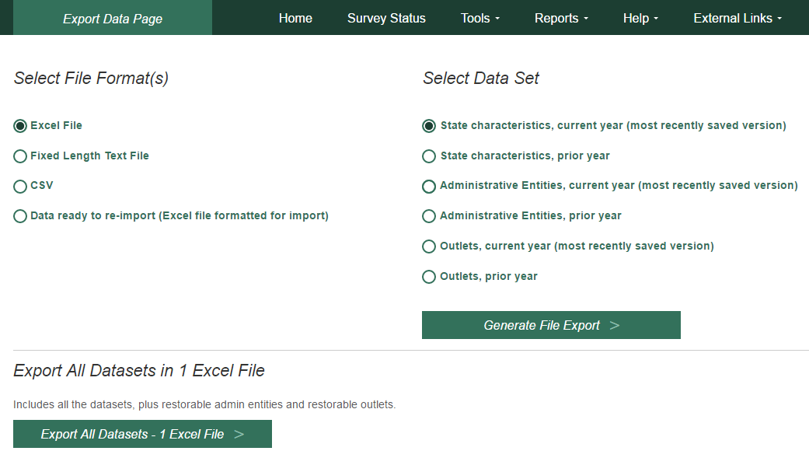

### 2.4.2 Tables

The **Run Tables** feature is located under the **Reports** menu and creates an Excel workbook that contains 18 tables. You will be able to save the Tables Report to your hard drive. There are two summary tables and 16 individual library tables. The two summary tables are a two-year comparison of the state totals for each survey item and a two-year comparison of the item response rates for the state. The individual library tables list each library in the state, and some tables report the per capita and percent distributions for those individual libraries.

The two summary tables provide a macro view of the state’s library data. The individual library tables provide a micro view of the individual libraries.

To run and save your tables:

1. Click **Reports** then **Run Tables**.
2. Click the **Download Tables Report** button.
3. Access the file according to your Web browser settings.

**NOTE: The time stamp on the Reports table is in Eastern Time.** You may use the following chart to convert the time:

|  |  |  |
| --- | --- | --- |
| **Time Zone** | **Time Difference From Eastern Time** | **Time in Time Zone (if time in Eastern Time is 12 p.m. Monday)** |
| Atlantic | + 1 hour | 1 p.m. Monday |
| Eastern | 0 hour | 12 p.m. Monday |
| Central | -1 hour | 11 a.m. Monday |
| Mountain | -2 hours | 10 a.m. Monday |
| Pacific | -3 hours | 9 a.m. Monday |
| Alaska | -4 hours | 8 a.m. Monday |
| Hawaii-Aleutian | -5 hours | 7 a.m. Monday |
| Samoa | -6 hours | 6 a.m. Monday |
| Chamorro | +15 hours | 3 a.m. Tuesday |

### 2.4.3 Help Menu Options

The **Help** menu provides access to this User’s Guide and all appendices in the User’s Guide. These links will open in separate browser windows.

#### Web Instructions

The Web Instructions (also found at the beginning of this section) include a two-page list of the necessary steps to complete the submission process for the survey. In addition, this page is displayed the first time you log in at the PLS Web Portal.

#### Data Element Definitions

Data Element Definitions (part of Appendix A) are all the items collected on the survey, with the official definitions and item numbers.

#### Name, Address, and Structure Changes

Name, Address, and Structure Changes (Appendix B) provide descriptions and diagrams of the correct format of records for administrative entities and outlets.

#### Resolving the Match Report

Resolving the Match Report (Appendix C) is a more detailed list of suggestions than is available in Section 5.

#### Import Specifications

The import files must conform exactly to the specifications provided (Appendix D).

#### PLS Contacts

PLS Contacts (Appendix E) is a list of AIR and IMLS contact information, including the Help Desk telephone number and e-mail address. The Help Desk contact information is also located at the bottom of every page of the PLS Web Portal.

#### Francis Keppel Award Criteria

The Francis Keppel Award for timely and accurate submission of data is based on a point system (Appendix F) covering important aspects of the original-submission and post-submission processing.

#### Standard Abbreviations

Standard Abbreviations (Appendix G) are used in this survey when the data exceed the field length.

#### Edit Messages and Conditions (available online but not in print)

Edit Messages and Conditions is a list of all checks performed by the Edit Report routine as well as a list of internal checks executed by AIR during the post-lock edit follow-up.

## 2.5 External Links

The following external links might be helpful in preparing for the FY 2019 data submission. These links will open in separate browser windows.

* IMLS Public Libraries Survey (<https://www.imls.gov/research-evaluation/data-collection/public-libraries-survey>)

This external link will take you to the IMLS PLS page. Items found on this page include the following:

* Public release data files and publications for the previous years of the PLS
* Search for Public Libraries tool that will search for public libraries by Library System, Central Library, Branch Library, Bookmobiles, and Books-by-Mail
* Resources to help you report PLS data, including links to the PLS Web Portal and training materials

# 3 Import

## 3.1 Overview

After entering the state characteristics data, you can import data for AEs, outlets, and annotation files into the PLS Web Portal. The Administrative Entity Import File Specifications, Outlet Import File Specifications, and Annotation Import File Specifications are located in Appendix D.

* You can import AE data, outlet data, the Annotation File, and the Annotated Edit Report in Excel (.xls or .xlsx), comma delimited text (.csv), or fixed length text formats (.txt).
* Each import file must contain only records of the same record type. For example, the AE file can contain only AE records; outlet records cannot be included in the same import file.
* To export and re-import a file, choose the **Data** **ready to re-import (Excel file formatted for import)** file format found on the **Export** **Data** page. This file format keeps the FSCS ID assignments for re-import. This format also will allow you to export your file with changes you made in the PLS Web Portal, make further revisions, and re-import the file.

## 3.2 Upload and Import Data Files

Once you have prepared your files (see Section 3.4), you need to import the files into the PLS Web Portal.

After you log in at the website, go to **Tools** then **Import Data**. Click the **Browse** button to find the file you wish to import from your computer. After you have located your file, click **Upload and Import File** (Exhibit 3.1).

Exhibit 3.1 PLS Web Portal Import Data Page

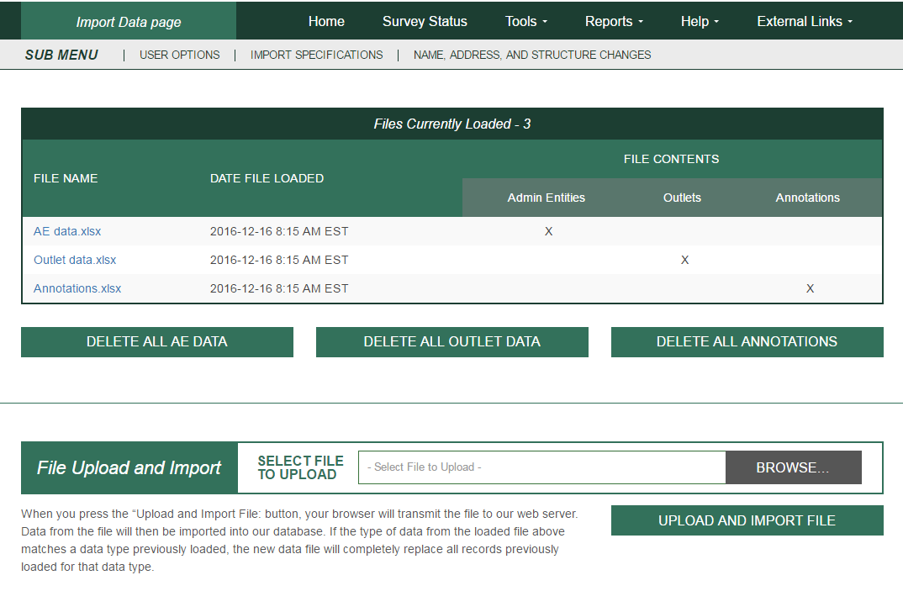

Once you click **Upload and Import File**, the system will prompt you to choose what type of file you are importing (Administrative Entity, Outlet, Annotation, or Edit Report).

**NOTE: When you import a file with the same file name as a previous file, the previous file is deleted.** When you click **Delete All**, all current year imports are deleted from the PLS Web Portal. If you click **Delete All AE Data**, all of the associated outlet data also are deleted.

Several checks are performed while your file is being imported:

* If your AE or outlet file is successfully imported, a message box will display the number of records in the successfully imported file and the number of existing records from the prior year. If the number of imported records is less than the number of prior year records, the following message will display:

WARNING: Imported file may be missing records that existed in the prior year. Please verify by comparing imported file with data export of prior year data. Removal of records (e.g., library closure) must be accomplished using structure status codes; otherwise, prior year data will persist into current year for those records.

Even if the number of imported and prior year records matches, we recommend checking the export of your current year data to confirm that all expected records are present before proceeding with the Match Report.

* If you have any problems that prevent a successful import, a message box will prompt you with the record(s) affected. This message box will provide a downloadable report that shows all errors preventing the file from importing. Once these errors are resolved, the file should import correctly. Refer to the following sections for instructions about preparing files for import. Imported data must be valid (see the following table):

|  |  |
| --- | --- |
| **Numeric Data Elements** | |
| Any positive number for numeric data elements | Enter the appropriate numeric data. |
| 0 | Zero for numeric data means the library has none of that item (e.g., the library does not maintain a video collection). Do not use zero when the value is not known (e.g., the city pays benefits but does not provide the figure). Use -1, described next. |
| -1 | -1 means that the appropriate figure is unavailable. |
| -3 | -3 means Not Applicable and is used for this item:   * Square Footage of Outlet (use only for Bookmobiles and Books-by-Mail Only outlets) |
| **Alphanumeric Data Elements** | |
| Alphabetic or numeric data for alphanumeric data elements | Enter the appropriate alphabetic or numeric data. Some items require the selection of codes for data (e.g., Interlibrary Relationship Code = HQ, ME, or NO). See Appendix A. |
| -3 | -3 means Not Applicable and is used for this item:   * Phone (use only if library has no phone) |
| **Structure, Name, and Address Changes** | |
| -3 | -3 means Not Applicable and is used for these items:   * FSCSKEY, FSCS_SEQ, LINKID, OLDID, and PARENTID |

## 3.3 Uploading Annotation Files

You can import a file that contains annotations prior to running your first Edit Report. You must include the FSCSKEY and Edit ID# in order for the explanation to apply to the correct edit record. After successfully importing the Annotation File, you can run the Edit Report after you have successfully run the Match Report and have reviewed the results. See Appendix D for the Import File Specifications.

## 3.4 Preparing Administrative Entity and Outlet Import Files

Each year, your current year records are compared to the prior year information. Any variance in the name, address, or organizational structure between years must be explained by status codes defining the change.

The FSCS ID links each year’s data. You must account for each record as it exists on the final FSCS ID data file for the prior year. You can obtain the prior year information through the **Export Data** option on the **Tools** menu.

If you are unsure what changes may have occurred since the last submission, import your file, run the match, and use the report to see what you need to resolve. You can then decide whether to process the changes within the PLS Web Portal (please see details in Section 4), or you can include the information on your data files and import again.

To process structure, name, and location changes from your import file, the following information must be included. Please see Appendix D for technical information about formatting your import records.

* **STATSTRU:** This code indicates the structure status of the record.

|  |
| --- |
| 00 – No Change |
| 01 – Existing Administrative Entity/Outlet Absorbs Another (Adoption) |
| 02 – Newly Created Administrative Entity/Outlet |
| 03 – Closed Administrative Entity/Outlet (Death) |
| 04 – Move Outlet to Newly Created Administrative Entity (Divorce) |
| 05 – Merge Two or More Administrative Entities/Outlets to Form a New Administrative Entity/Outlet (Marriage) |
| 08 – Restore (Reopen) a Previously Closed Administrative Entity/Outlet |
| 09 – Restore (Undo) a Previously Deleted Administrative Entity/Outlet |
| 10 – Delete an Incorrect Record (includes Out of Scope/Errors or for Planned But Never Opened [formerly 26])[2] |
| 11 – Outlet Moves to Different Previously Existing Administrative Entity |
| 13 – Add an Existing Administrative Entity/Outlet Not Previously Reported |
| 22 – Future Administrative Entity/Outlet FSCS ID Request |
| 23 – Temporary Closure |
| 24 – Reopen a Temporarily Closed Administrative Entity/Outlet |

* **STATNAME**: This code indicates the status of the library name.

|  |
| --- |
| 00 – No Change |
| 06 – Official Name Change |
| 14 – Preferred Spelling for Library Name |

* **STATADDR:** This code indicates the status of the physical location.

|  |  |
| --- | --- |
| 00 – No Change | |
| 07 – Move to a New Location |
| 15 – Preferred Street Address |

* **LINKID:** This is an identifier defined by the SDC and is used to associate two or more records that are involved in an adoption or marriage structure change. The LINKID must be unique for each set of records. For example, a merger requires at least three import records with the same LINKID. (See Appendix B, structure change 05 – Merge Two or More Administrative Entities to Form a New Administrative Entity [Marriage]).
* **PARENTID:** This identifier is on the outlet import file and is used to associate an outlet to its parent AE. The value for this field should be the same as the LIBID of the parent AE.
* **OLDID:** This identifier is reserved for structure changes where it is necessary to track the prior year FSCSKEY information for records that will not be on the current year file.

# 4 User Options, Input Data, and Structure Changes

The **Tools** menu contains selections that allow you to enter data directly into the PLS Web Portal:

* **User Options** allows you to choose the sort order for retrieving AE and outlet records and viewing the Edit Report. You can also choose to save changes automatically (default option). These options are available on every **Input Data** page.
* **Input Data** is the only means of entering State Characteristics data. It also provides access to current AE and outlet records.
* **Structure Changes** allows you to add, close, modify, or restore AEs or outlets. You also can reset a record previously coded or marked for a structure change. Choose AE or Outlet, as appropriate, for the change you want to make. For further details, see Section 4.3.

## 4.1 User Options

The User Options selected in Exhibit 4.1 are the default settings.

Exhibit 4.1 PLS Web Portal User Option Page

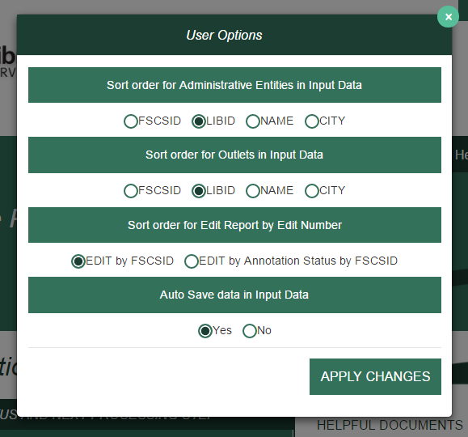

### 4.1.1 Sort Order for Administrative Entities or Outlets in Input Data

You determine how your AE records display. Sorting can be by:

* FSCS ID (default setting)
* LIBID
* NAME
* CITY

### 4.1.2 Sort Order for Edit Report by Edit Number

You can sort your Edit Report by Edit Number with these options:

* Edit number by FSCS ID (default setting)
* Edit number by Annotation Status by FSCS ID

### 4.1.3 Auto Save Data in Input Data

You can set this option to:

* Yes (default setting; the system automatically saves your data whenever values are updated)
* No

**NOTE: The Auto Generate Totals option has been removed. The PLS Web Portal automatically generates totals for data input through the Input Data pages. It is not possible to turn off the automatic totals.**

## 4.2 Input Data Through PLS Web Portal

Select **Tools** then **State Char**, **AE**, or **Outlet** to navigate to the page you wish to update. Buttons that allow you to **Save** and **Print Page** appear at the bottom of every page. Use the tab key to move from field to field, or use your mouse by clicking on the section you wish to go to under **Section Navigation**.

By default, the user options are set to automatically save your corrections. If you choose not to save your corrections automatically, be sure to click **Save** before leaving the page. To exit any of these pages, select **Home** from the navigation bar to return to the main PLS Web Portal page.

### 4.2.1 State Characteristics

This page consists of four data items for you to fill out. Once you have completed your updates and saved your data, you can return to the **Home** page or **Survey Status** page to check for further actions.

### 4.2.2 Administrative Entity (AE)

Data for AE records are collected in nine sections, or pages. An additional section for the associated outlets is available to access outlet data for that AE. The names of each section are provided as links on the left side of the page. You can use your mouse to click on any of the links to go to the section you wish to correct or review.

You can go to another AE record by selecting the record from the drop-down menu at the top of the page. By default, records are listed by FSCS ID. You can choose another sort order under **User Options**. The arrow buttons available at the top of the page next to the AE name navigate you to the next or previous AE. The arrows with the line will navigate you to the first or last AE in the list.

If you make a change to name and/or address information for an AE, you also must select the appropriate status code (the name/address status codes and their values are included in Appendix B) to identify whether the change is an official name change or whether the address change indicates an actual location change.

**NOTE: Any changes to the name or address fields will require you to run the Match Report before you can proceed with any further processing of your submission.**

### 4.2.3 Outlets

Outlet records require only one section and can be accessed through the parent AE record.

You can access all outlet records from the **Tools** menu. You can navigate through all of the outlet records from this option by using the drop-down menu or the arrow buttons if you choose.

If you make a change to name and address information for an outlet, you also must select the appropriate status code (the name/address status codes and their values are included in Appendix B) to identify whether the change is an official name change or whether the address change indicates an actual location change.

**NOTE: Any changes to the name or address fields will require you to run the Match Report before you can proceed with any further processing of your submission.**

## 4.3 Structure Changes

You can add, close, modify, restore, or reset records through the **Structure Changes** menu. Under **Tools**, select **Structure Changes** and then **AE** or **Outlet** depending on the record you need to change. Currently, you are restricted to one structure change per AE or outlet record (Exhibits 4.2 and 4.3). See Appendix B for detailed instructions for reporting structure changes via the AE and outlet import files.

**NOTE:** **If an AE or Outlet was closed for part of a fiscal year but you are reporting data for it, do not report it as closed this reporting cycle. Wait until the next reporting cycle, after the entity has closed, when you have no data to report for it, and then report it as closed. If the entity was temporarily closed and reopened during the next fiscal year, such that you have some data to report in consecutive fiscal years, do not report any structure change. Records with structure changes indicating closure will be ignored, and any data reported with those records will be excluded from analysis in the annual PLS report, the supplementary tables, and the state profiles.**

**NOTE: When you complete all structure changes, you must complete a successful Match Report before you can continue processing your submission.**

Exhibit 4.2 PLS Web Portal Structure Change: AE Page

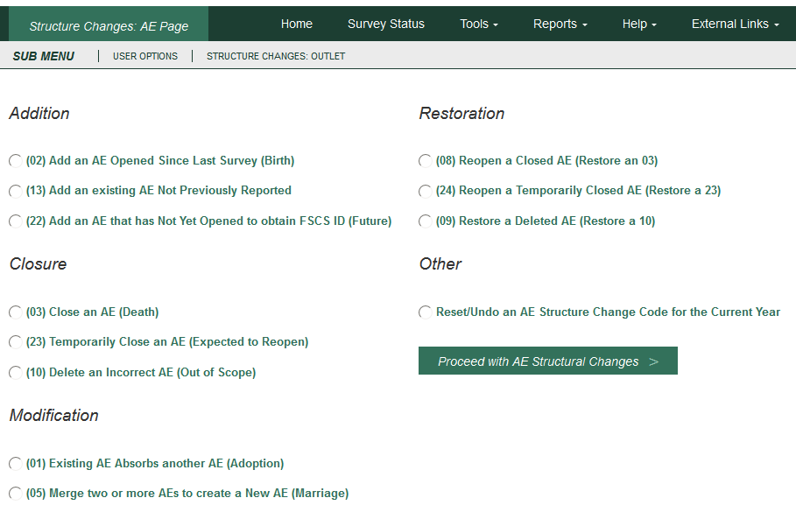

Exhibit 4.3 PLS Web Portal Structure Change: Outlet Page

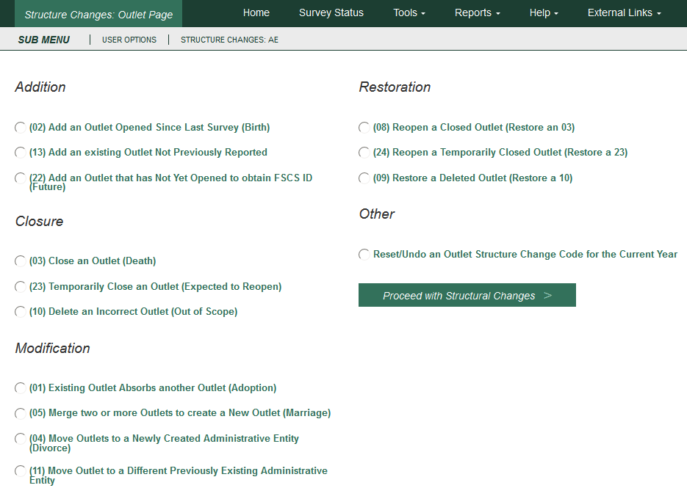

# 5 Match Report

After you import or enter data, you must run a successful Match Report. This step is necessary to record structure changes (e.g., new or closed libraries) as well as official name and location changes to ensure file integrity. The Match Report compares your current year records to the prior year records on the publicly released data file using FSCS ID information. After a successful Match has run, new IDs are assigned to new libraries.

From the **Reports** menu, select **Run Match Report** to generate an Excel workbook that will detail the results of the Match. If the program does not encounter a problem, any new AEs and outlets are assigned FSCS IDs, and you will see a message to proceed with the Edit Report. If the program cannot resolve the information you provide, you will see messages in the report that identify the problem(s).

You **must resolve** all discrepancies in the Match Report. You can fix your original file and re-import, or you may be able to resolve problems through the **Structure Change** options under the **Tools** menu. If you need the prior year FSCS ID information, you can use the **Export** **Data** function under the **Tools** menu. Appendix C provides additional guidance for understanding the Match Report messages.

**NOTE: Any time you import a data file or make any structure, name, or address changes to either an outlet or AE record from the data input pages, you must rerun the Match Report.**

## 5.1 Match Report

Results of the Match Report are displayed in an Excel workbook across multiple worksheets.

**The report is not linked to the database (PLS Web Portal). You must make any corrections by either importing a new file or manually inputting data into the PLS Web Portal pages (i.e., Structure Change menu and the name and address status code fields).**

**NOTE: Sometimes one type of error will produce more than one error message for the Match Report.**

The Excel workbook has 10 worksheets, as follows:

* **Summary:** This worksheet provides an overview and count of errors found in the Match Report. Specific errors can be found on the subsequent worksheets.

If you do not have any Match Report problems, you will see the following message:

“Match has completed successfully. Check ‘New ID’ Sheet.”

New FSCS IDs are assigned to new AEs and outlets and are listed on the New ID worksheet.

Otherwise, you will see which of the following conditions failed, with a count of match errors per AE or outlet.

|  |
| --- |
| Invalid Status Code (STATSTRU) |
| Record found current year but not prior year |
| Record found prior year but not current year |
| All FSCSKEYs and OLDIDs must be unique (unless -3) |
| All LIBIDs must be unique for AE records |
| FSCS ID information must equal -3 |
| FSCS ID information cannot equal -3 |
| LINKID must equal -3 |
| LINKID cannot equal -3 |
| PARENTID must equal -3 |
| PARENTID cannot equal -3 |
| OLDID must equal -3 |
| OLDID cannot equal -3 |
| These records do not comply with the rules for Adoption |
| These records do not comply with the rules of Marriage |
| Cannot restore Record, there is no old AE |
| Administrative Entity does not have any Outlets |
| Outlet record is not on the AE file |
| PARENTID is not on the AE file |
| STATNAME and LIBNAME are inconsistent with the prior year file |
| STATADDR and ADDRESS are inconsistent with the prior year file |

* **New ID:** This worksheet provides the list of new FSCS IDs generated. No resolution is required for these records because the software does not assign new identification numbers until Match is successful.
* **Admin Single:** This worksheet displays problems with structure changes involving only one AE record.

|  |
| --- |
| INVALID Status Code |
| This AE was not on the prior year file |
| This AE was reported last year but is missing on the current year file |
| FSCSKEY cannot be -3 for STATUS (00, 08, 09, or 24) Records |
| FSCSKEY must be -3 for STATUS (02, 03, 04, 05, 10, 13, 22, or 23) Records |
| LINKID cannot be -3 for STATUS (01 or 05) Records |
| LINKID must be -3 for STATUS (00, 02, 03, 04, 08, 09, 10, 13, 22, 23, or 24) Records |
| OLDID cannot be -3 for STATUS (03, 10, or 23) Records |
| OLDID must be -3 for STATUS (00, 02, 04, 08, 09, 13, 22, or 24) Records |
| Cannot restore AE, there is no old AE with STATUS (03, 10, or 23) |
| Admin record does not have any outlets |

* **Admin Multi:** This worksheet displays problems with structure changes involving multiple AE records.

|  |
| --- |
| All FSCSKEYs and OLDIDs must be Unique (unless -3) |
| All LIBIDs must be unique for AE records |
| These records do not comply with the rules of Adoption |
| These records do not comply with the rules of Marriage |

* **Outlet Single:** This worksheet displays problems with structure changes involving only one outlet record.

|  |
| --- |
| INVALID Status Code |
| This Outlet was not on the prior year file |
| This Outlet was reported last year, but is missing on the current year file |
| FSCSKEY cannot be -3 for STATUS (00, 08, 09, or 24) Records |
| FSCSKEY must be -3 for STATUS (02, 03, 04, 05, 10, 11, 13, 22, or 23) Records |
| FSCS_SEQ cannot be -3 for STATUS (00, 08, 09, or 24) Records |
| FSCS_SEQ must be -3 for STATUS (02, 03, 04, 05, 10, 11, 13, 22, or 23) Records |
| LINKID cannot be -3 for STATUS (01 or 05) Records |
| LINKID must be -3 for STATUS (00, 02, 03, 04, 08, 09, 10, 13, 22, 23, or 24) Records |
| OLDID cannot be -3 for STATUS (03, 04, 10, 11, or 23) Records |
| OLDID must be -3 for STATUS (00, 02, 08, 09, 13, 22, or 24) Records |
| PARENTID cannot be -3 for STATUS (02, 04, 11, 13, or 22) Records |
| PARENTID must be -3 for STATUS (00, 01, 03, 08, 09, 10, 23, or 24) Records |
| Cannot restore Outlet, there is no old AE with STATUS (03, 10, or 23) |
| Outlet Record is not on the AE File |
| PARENTID is not on the AE File |

* **Outlet Multi:** This worksheet displays problems with structure changes involving multiple outlet records.

|  |
| --- |
| All FSCSKEYs and OLDIDs must be unique (unless -3) |
| These records do not comply with the rules of Adoption |
| These records do not comply with the rules of Marriage |

* **Name Changes:** This worksheet displays records with name change problems.

|  |
| --- |
| STATNAME Invalid |
| STATNAME 00 and Name Change |
| STATNAME 07 and no Name Change |
| STATNAME 15 and no Name Change |

* **Address Changes:** This worksheet displays records with address change problems.

|  |
| --- |
| STATADDR Invalid |
| STATADDR 00 and Address Change |
| STATADDR 07 and no Name Change |
| STATADDR 15 and no Name Change |

* **Restorable AE:** This worksheet provides a list of all closed, deleted, and temporary closure entities for the state used as a reference.
* **Restorable Outlet:** This worksheet provides a list of all closed, deleted, and temporary closure for the state used as a reference.

## 5.2 Resolving Unsuccessful Records

*Please see Appendix C: Resolving the Match Report, for specific instructions and examples for how to resolve each individual Match error.*

The Match Report runs assuming that the status structure code is the intended value and checks that the format of the record is consistent with the code. For example, if you close a library and used the correct STATSTRU = 03 but did not make the appropriate entries for the FSCSKEY and OLDID fields, the software will generate an error message.

The report displays information about the record, status code, and error messages. The error messages refer to problems with the format of a record based on the reported status code for the structure change. If the status code is incorrect, you simply have to change it to the correct code. Otherwise, you must adjust the AE or outlet information to match the status code.

You can correct information in your data file and import the revised file, or, for most problems, you can use the **Structure Changes** menu options under the **Tools** menu. However, you must fix problems with duplicate FSCS ID or OLDID information directly in the data file and import again.

The **Restorable AE** tab and the **Restorable Outlet** tab are for your reference. The **Restorable AE** tab provides a list of all closed, deleted, and temporarily closed entities for your state. Before you open a newly created AE (birth), structure code 02, you should check this tab to make sure the AE you are trying to create is truly new, meaning the AE was not previously reported, then either closed, deleted, or temporarily closed. This preserves the historical and longitudinal record for your state. This also applies for the **Restorable Outlet** tab.

**HINT:** Name and address changes can generate the largest number of error messages. You can run the Match Report and then decide how best to make corrections. For example, if you find that you are getting messages because all the current year address fields are incorrect, you might want to copy the prior year addresses to the current year file and import the revised file. However, if you need to change the status code for only a few records, you can simply use the Input pages.

# 

# 6 Edit Report

Once you have completed a successful Match you must run the Edit Report by selecting **Reports** then **Run Edit Report**.

The report is displayed in an Excel workbook with multiple worksheets and is **not** linked to the PLS Web Portal. You must make changes to your data through the data input options or through an updated import file. (Please note that, if you import a corrected file, you will have to run the Match Report again.)

**NOTE: You must save the Edit Report, record and save your annotation(s) in the workbook, and import the revised version into the PLS Web Portal.**

You can select one of two sort orders for the Edit Report from the browser window: Sort by **Edit Number by FSCS ID** or **Edit Number by Annotation Status by FSCS ID** from the **Tools/User Options** menu.

It is necessary to provide an explanation for noncritical and internal edits. The annotations that accompany your Edit Report are an essential part of your submission because they provide verification and explanations for data that are correct but have been flagged with a noncritical edit. You must have at least one of each noncritical or internal edit annotated before you can complete your submission. If you make data changes or add annotations, you must rerun the Match Report and Edit Report before you can lock your submission.

## 6.1 Edit Messages and Conditions

**The full list of edit conditions is published on the IMLS website (**[**https://www.imls.gov/research-evaluation/surveys-data/public-libraries-survey/report-your-pls-data/fy-2019-pls-data**](https://www.imls.gov/research-evaluation/surveys-data/public-libraries-survey/report-your-pls-data/fy-2018-pls-data)**), and the edit messages are also listed in the Help menu of the Web Portal.** The following lists summarize the types of edits within the three broad categories of edits: critical, noncritical, and internal.

### 6.1.1 Critical Edits

Critical edits **must be resolved** before you can lock your submission:

* Any -2 value
* Zero or -1 in any population data element
* Invalid categorical or date values
* The state population is less than the unduplicated population
* Name or address of library or outlet is not reported
* Number of service outlets is not reported
* Discrepancies between the number of outlets reported on the AE record and its outlet records
* A subset item is greater than the total (e.g., Total Circulation is less than Circulation of Children’s Materials)
* Any occurrence where fully reported detail data do not equal the reported total

### 6.1.2 Noncritical and Internal Edits

Noncritical and internal edits **must be annotated** before you can lock your submission. Both noncritical and internal edits are further categorized into current and historical edits.

Current edits identify possible errors in current year data:

* Reporting patterns for data elements with detail items where not all items are reported (e.g., Total Librarians and Total Staff are reported as equal but Other Paid Employees is -1)
* Inter-item comparison ratios (e.g., Total Circulation to Annual Visits)
* Logical (e.g., Total Programs is zero but Program Attendance is not zero)
* Magnitude (e.g., Databases is greater than 1,000)
* Definitional (e.g., Print Materials is zero)

Historical edits identify possible errors in the current year (CY) data by comparing to prior year (PY) data:

* PY was -1, and CY is zero
* PY was -1, and CY is 1
* PY was greater than a calculated value, and CY is zero
* CY is greater than a calculated value, and PY was zero
* CY and PY have the same value
* CY to PY ratio is outside a specified range

## 6.2 Annotations

Annotations are stored in the PLS Web Portal database and are applied to the edits when you run the Edit Report.

You can upload your Annotation File into the PLS Web Portal through the **Import Data** option under the **Tools** menu in the following formats (see Annotation Import File Specifications in Appendix D):

* A comma delimited text file (.csv)
* Fixed length text file (.txt)
* Excel file (.xls and .xlsx)

If you need to make more annotations after the files have been uploaded, you can upload again through the Edit Report. Save the Excel file generated by running the Edit Report, record your annotations, and re-upload the revised version.

Only annotations associated with individual edits will display in the Edit Report. If you have a general explanation that applies to several libraries, you must copy that explanation into the annotations column for each record to which it applies.

# 7 Lock Data

The **Lock Data** page is located under the **Tools** menu. You must verify that you want to lock your data.

Remember to review the **Tables** under the **Reports** option to check for any large statewide discrepancies before locking your data.

The following conditions must be met to lock your data:

1. No critical edits are found when the Edit Report runs.
2. For noncritical edits flagged, at least one annotation is present per edit check.
3. You can perform the following actions after locking your PLS data:

* View Survey Status
* Export data
* View the completed survey form
* Run tables
* View help documents
* Access external links
* Log out

Once locked, the application does not allow the respondent to change any data, import files, run the Match Report, or run the Edit Report. If you lock your data and need to revise the locked data, please contact AIR at [**PLS@air.org**](mailto:PLS@air.org) or 1-866-744-5746, option 1.

## 7.1 Estimate of Burden

After locking your data, you must provide the estimated number of hours it took for you to complete the survey. The estimated number of hours should include the time to review instructions, search existing data resources, gather the data needed, and complete and review information collected. Your burden estimate may also include the following:

* Preparing for the data submission (revising worksheets and, if you are a Bibliostat or Counting Opinions state, submitting to and testing the PLS Web Portal)
* Vetting data submissions of individual libraries
* Readying data for submission to AIR and contacting libraries, as needed, with questions
* Submitting data through the PLS Web Portal
* Responding to post-submittal edit questions (includes all time spent interacting with the PLS Web Portal and AIR during this phase)

Exhibit 7.1 PLS Web Portal Lock Data Confirmation Page

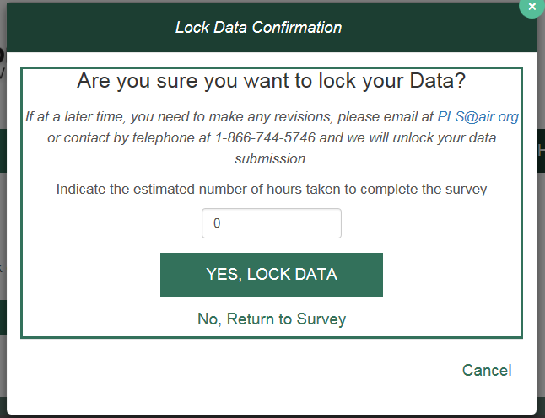

# 8 Chief Officer Certification

The role of the CO is to review and certify the data after the survey is locked and has gone through a post-lock review. The CO will receive login credentials for the PLS Web Portal via e-mail shortly after the start of data collection (usually early to mid-January).

After the survey is locked and the post-lock review completed, an e-mail will be sent to inform your CO that the data are ready for review and certification (SDCs will be copied on this e-mail). When your CO completes the certification process, another automated e-mail will be sent to the SDC and the CO confirming the PLS data have been certified.

## 8.1 Chief Officer Web Instructions

***View Data***

As the Chief Officer you are able to view your states’ Public Libraries Survey (PLS) before and after the SDC locks the data. Below are brief instructions on how to navigate the PLS Web Portal. For more details about the PLS Web Portal please see the User’s Guide under the Helpful Documents on the Home screen.

To view the status of the survey:

* Select **Survey Status** in the dark green navigation panel
  + Here you will be able to see where the SDC is in the process of the survey

To view State Characteristics, AE, and Outlet Data:

* Select **Tools** in the dark green navigation panel
* Select from the drop down the data you would like to view (State Char; AE; Outlet)

To export data:

* Select **Tools** in the dark green navigation panel
* Select **Export Data** from the dropdown menu
  + Select the file format and data set you would like to export then select **Generate File** Export or;
  + Select **Export All Datasets – 1 Excel File** to have all the current year and prior year data in one file

To download the Match Report:

* Select **Reports** in the dark green navigation panel
* Select **View Match Report** from the dropdown menu
* Select **Download Match Report**
* View and save the Match Report for your records

To download the Edit Report:

* Select **Reports** in the dark green navigation panel
* Select **View Edit Report** from the dropdown menu
* Select **Download Edit Report**
  + Note if you get an error saying, "A successful Match Report is required for the current year data," it means the SDC has not run a successful Match Report yet and has not yet run their Edit Report.
* View and save the Edit Report for your records

To download the Tables Report:

* Select **Reports** in the dark green navigation bar
* Select **View Tables** from the dropdown menu
* Select **Download Tables Report**
* View and save the Tables Report for your records

***Certify Data***

Once you have received an e-mail from the PLS team alerting you that your state’s data have been locked and the post-lock review is complete you can certify your data.

To certify your state’s data follow these steps:

1. Login into the PLS Web Portal at <https://submitpls.imls.gov>
2. Navigate to the top right of the screen and click "Certify Data"
3. Review the PLS Certification Form
4. Click the "Certify" button
5. Sign the PLS Certification Form by entering your PLS Web Portal password
6. Click the "Confirm Certification" button
7. Once you have signed the form you and your state’s SDC will receive an e-mail indicating that the data have been certified. The email will include the text from the completed PLS Certification Form.

# Appendix A Survey Instrument

Data Entry Screens and Data Element Definitions

**State Characteristics Page**

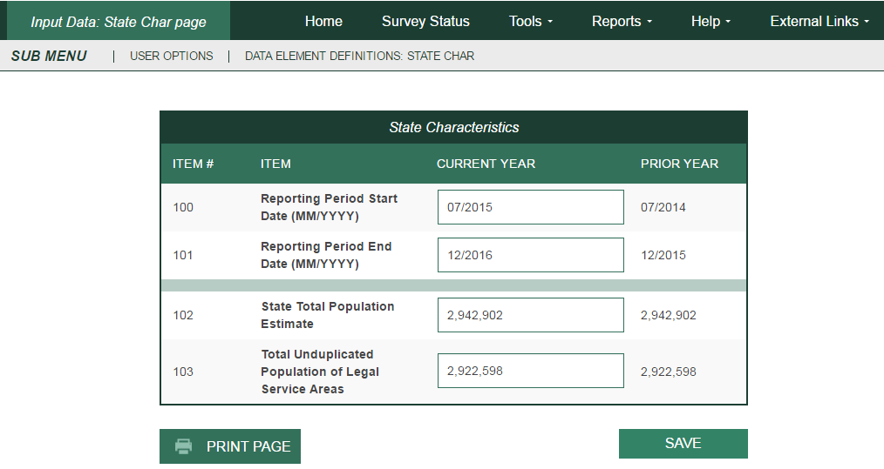

**Administrative Entity –— Name/Addresses**

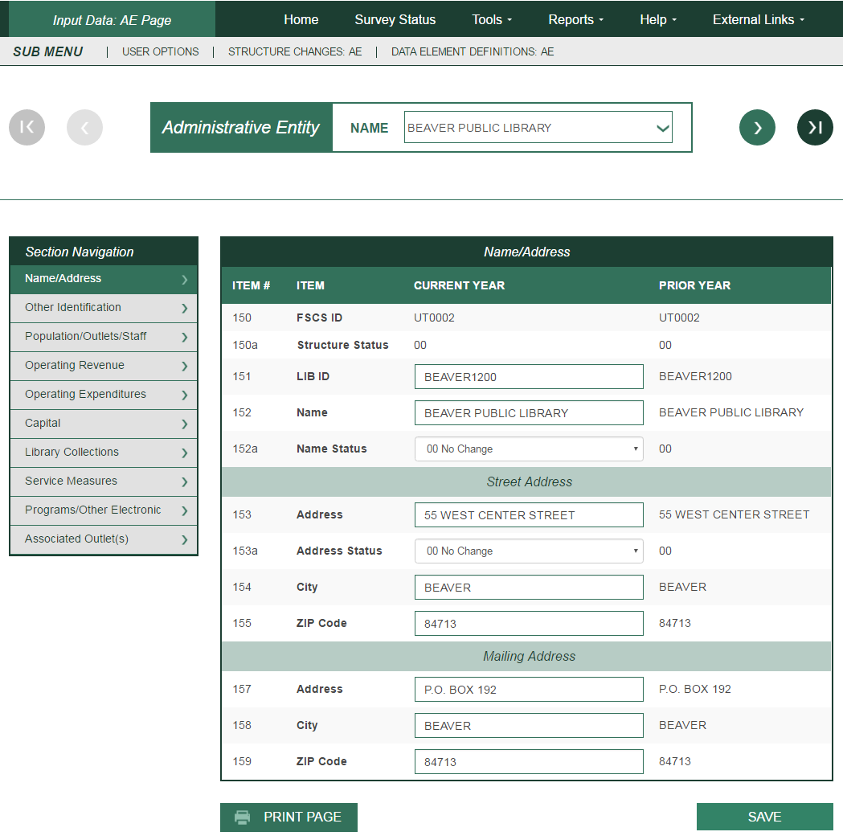

**Administrative Entity –— Other Identification**

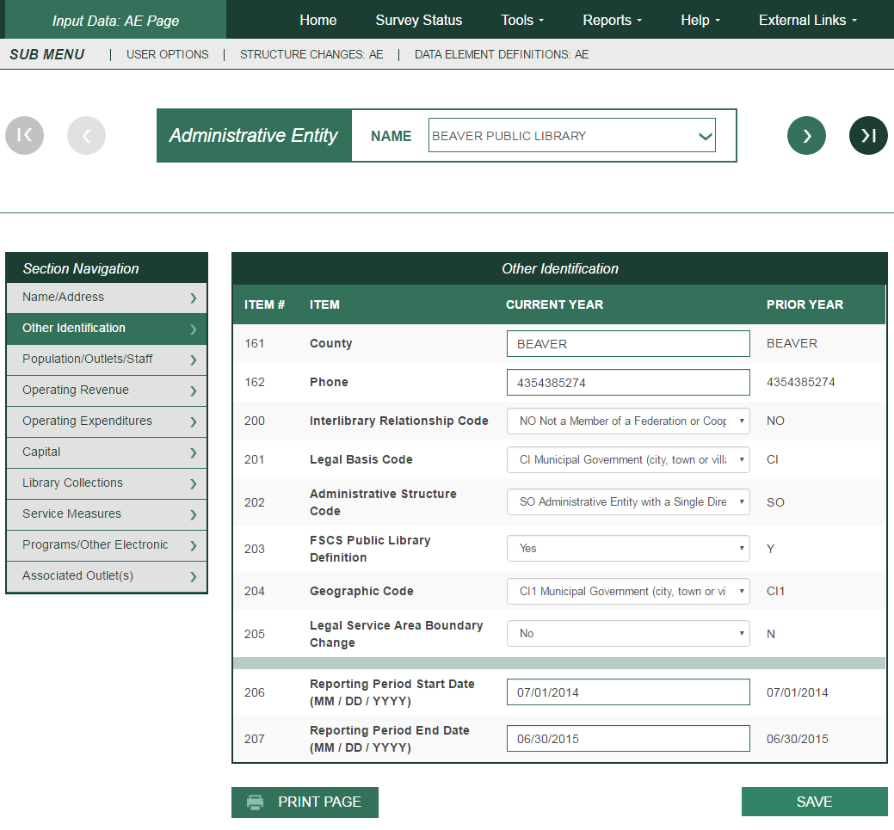

**Administrative Entity –— Population/Outlets/Staff**

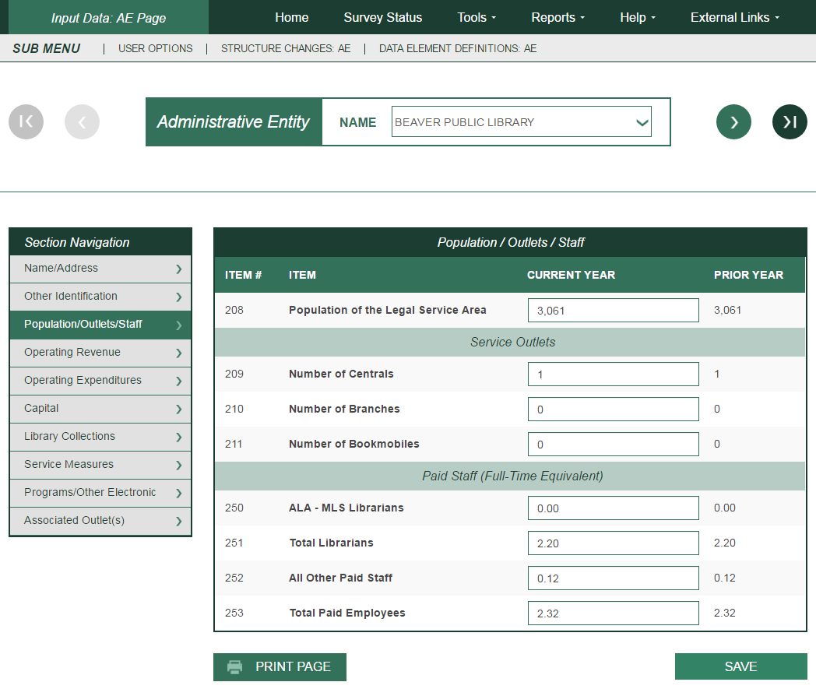

**Administrative Entity –— Operating Revenue**

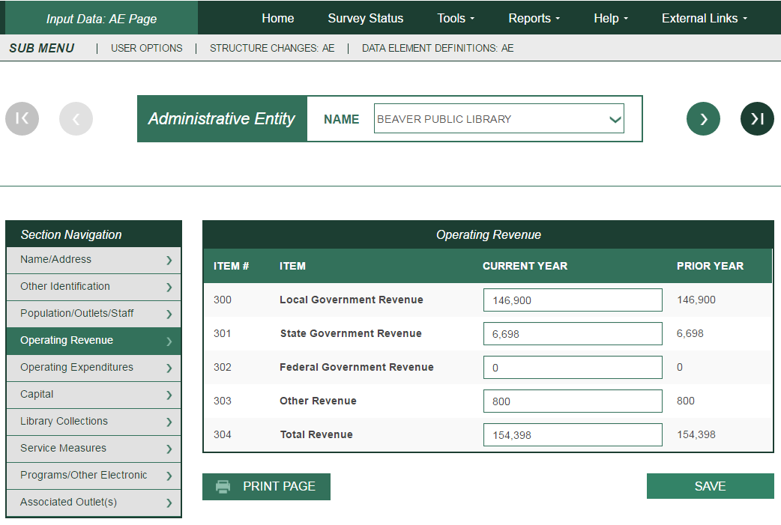

**Administrative Entity –— Operating Expenditures**

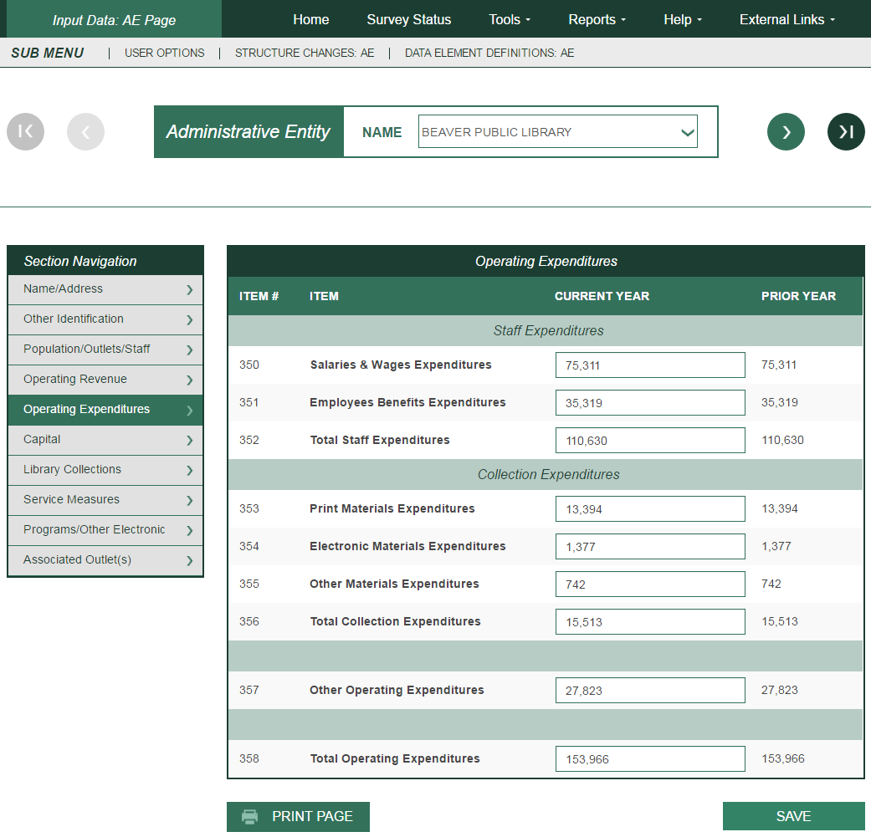

**Administrative Entity –— Capital**

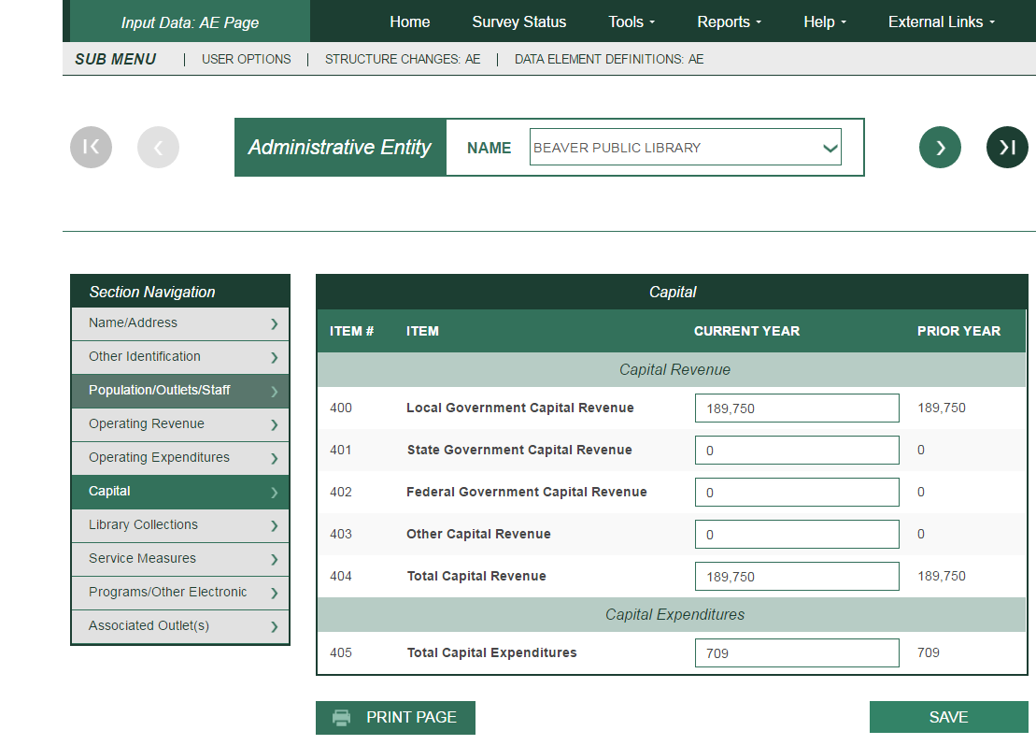

**Administrative Entity –— Library Collections**

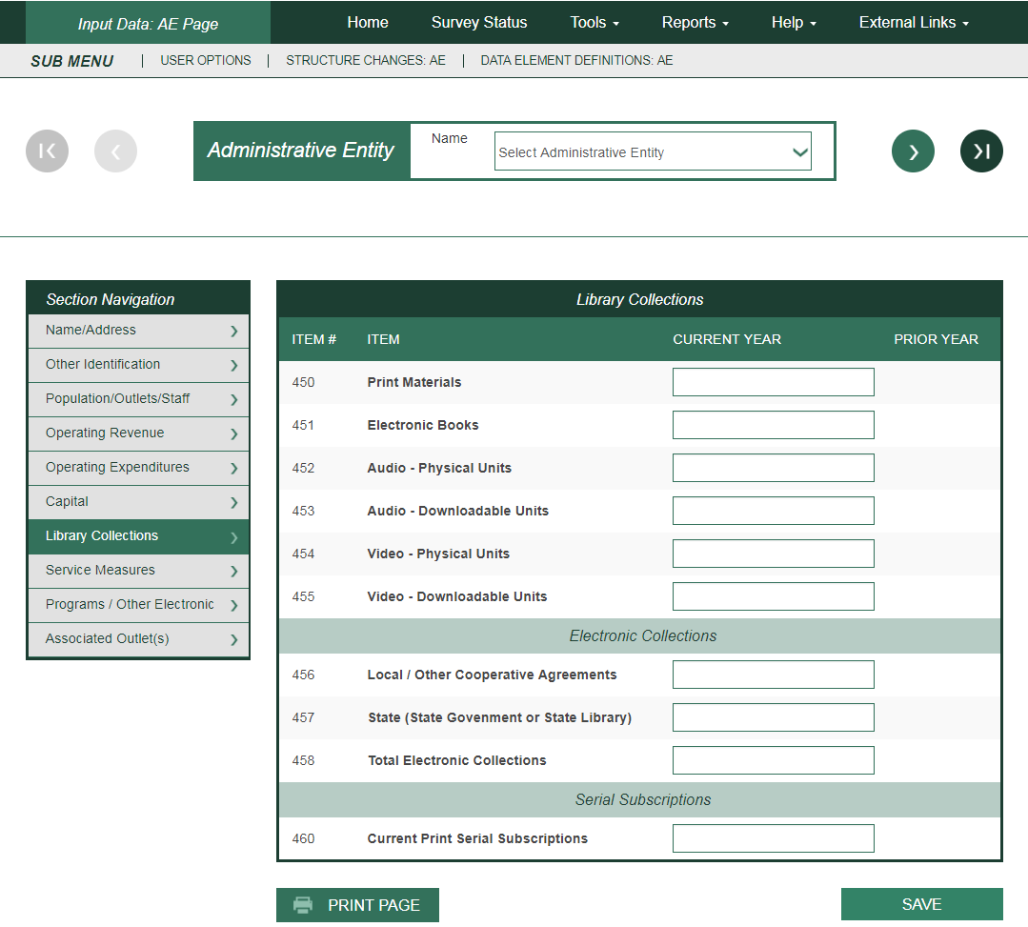

**Administrative Entity –— Service Measures**

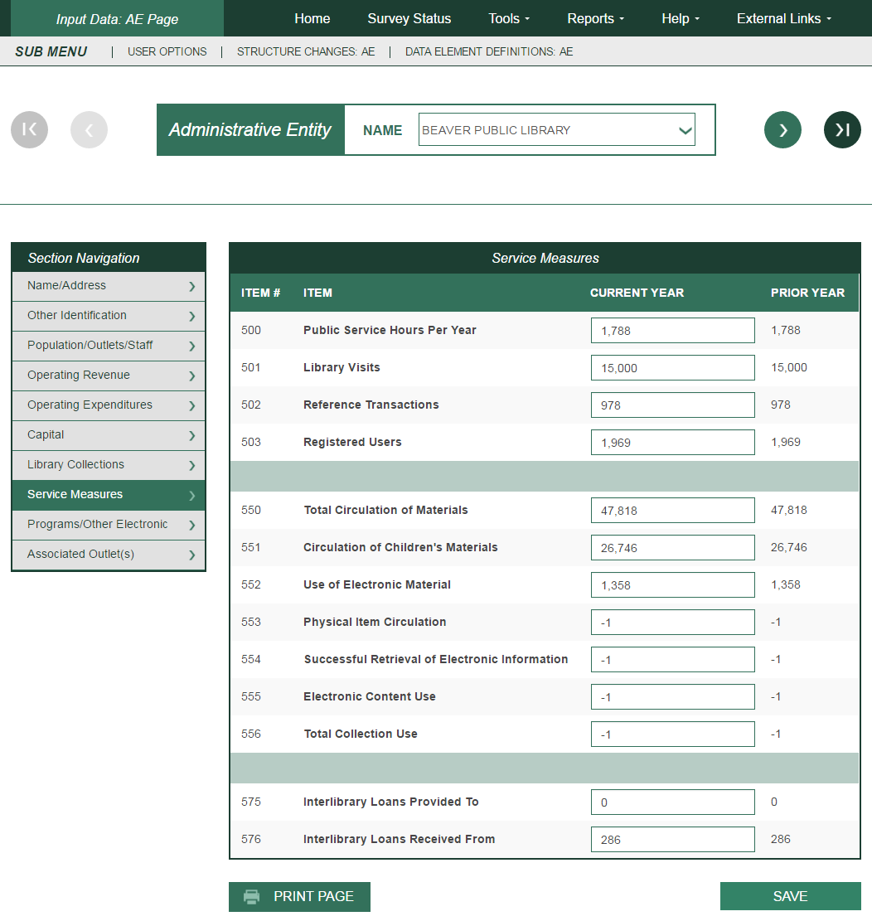

**Administrative Entity –— Programs/Other Electronic**

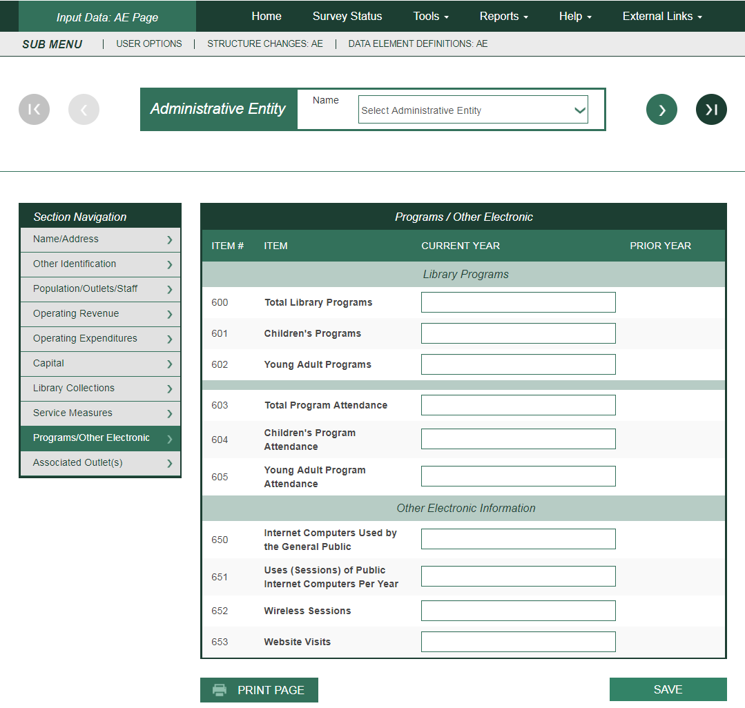

**Administrative Entity—Associated Outlet(s) Page**

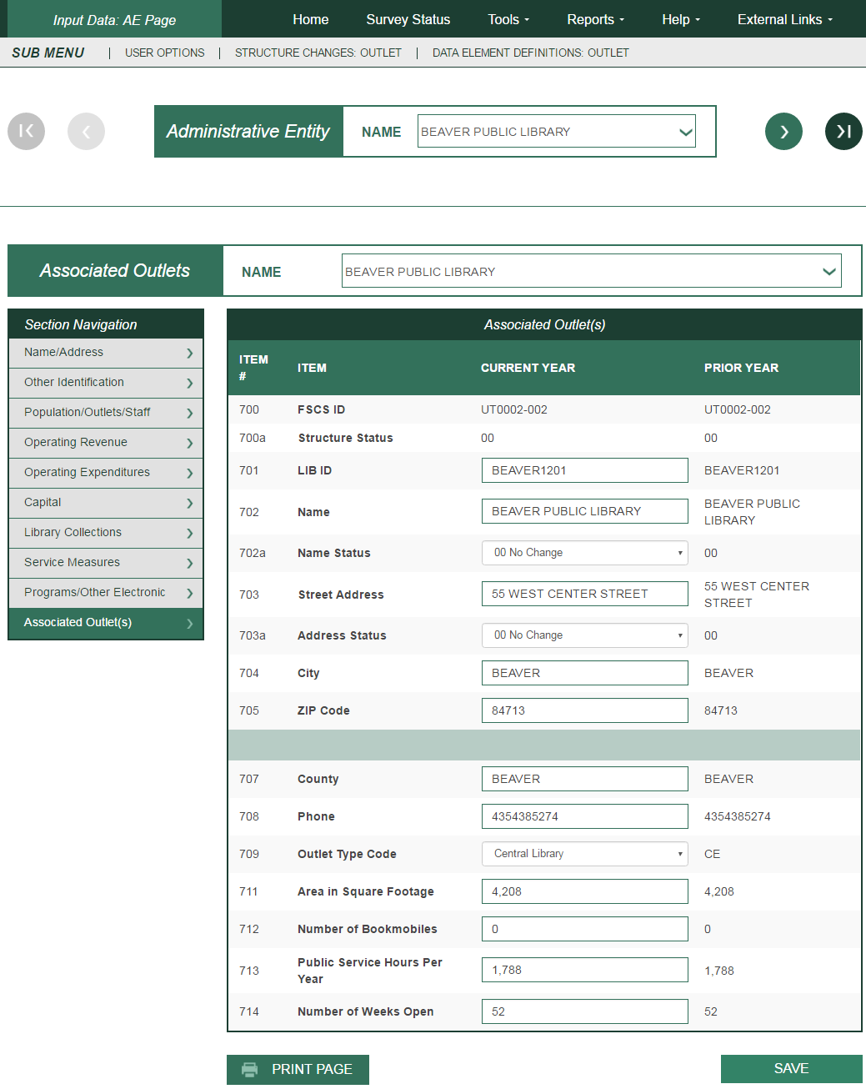

State Characteristics Data Element Definitions

Note: The following items are answered by the state library agency.

|  |  |  |
| --- | --- | --- |
| **#** | **Data Element Name (Variable Name)** | **Data Element Definition** |
| 100 | Reporting Period Starting Date  (STARTDAT) | This is the earliest date (month and year) for a 12-month period that applies to the state’s data being submitted to IMLS.  Note: Reporting period means data for the fiscal year that ended in the previous calendar year. If data are collected for different local reporting periods, provide the earliest starting date. |
| 101 | Reporting Period Ending Date  (ENDDATE) | This is the latest date (month and year) for a 12-month period that applies to the state’s data being submitted to IMLS.  Note: Reporting period means data for the fiscal year that ended in the previous calendar year. If data are collected for different local reporting periods, provide the latest ending date. |
| 102 | State Total Population Estimate  (POPU_ST) | This is the most recent total population figure for your state that matches the local population figures that you are submitting to IMLS. The State Data Coordinator should obtain this figure annually from the State Data Center or other state sources. |
| 103 | Total Unduplicated Population of Legal Service Areas  (POPU_UND) | This is the total unduplicated population of those areas in your state that receive library services. The population of unserved areas is not included in this figure.  Note: A state’s actual total population of legal service areas may be different from the total population of legal service areas as calculated by PLS Web Portal. This happens in states where there are overlaps in population of legal service areas served by individual libraries, resulting in the same population being counted twice in the PLS Web Portal calculation. For states that have no overlapping jurisdictions, this number will be identical to your state’s total population of legal service areas as calculated by PLS Web Portal. For states that do have overlaps in population of legal service areas served by individual libraries, this number must be calculated separately.  Use your state’s most recent state population figures for jurisdictions in your state as the basis for calculating the total unduplicated population of legal service areas. |

Administrative Entity Data Element Definitions

**Administrative Entity.** (This is not a PLS Web Portal Data Element.) This is the agency that is legally established under local or state law to provide public library service to the population of a local jurisdiction. The administrative entity may have a single outlet, or it may have more than one outlet.

| **#** | **Data Element Name (Variable Name)** | **Data Element Definition** |
| --- | --- | --- |
| 150 | FSCS ID (Automatic  Display)  (FSCSKEY) | This is the identification code assigned by PLS Web Portal to the administrative entity. |
| 150a | Structure Status  (STATSTRU) | This is the Structure Change Code to record actions such as adding, deleting, or merging. |
| 151 | LIB ID  (LIBID) | This is the state-assigned identification code for the administrative entity. |
| 152 | Name  (LIBNAME) | This is the legal name of the administrative entity.  Note: Provide the name of the public library. Do not use acronyms. Do not abbreviate the name unless it exceeds the PLS Web Portal field length of 60 characters. Avoid abbreviations at the beginning of the name and do not punctuate abbreviations. (See Standard Abbreviations for PLS Web Portal in Appendix G.) |
| 152a | Name Status  (STATNAME) | This is the Name Change Code to identify whether the change is an official name change. |
| **Street Address** | |  |
| 153 | Street Address  (ADDRESS) | This is the complete street address of the administrative entity.  Note: Do not report a post office box or general delivery. |
| 153a | Address Status  (STATADDR) | This is the Address Change Code to identify whether the address change is an actual location change. |
| 154 | City (of street address)  (CITY) | This is the city or town in which the administrative entity is located. |
| 155 | ZIP Code (of street address)  (ZIP) | This is the standard five-digit postal zip code for the street address of the administrative entity. |
| **Mailing Address** | |  |
| 157 | Mailing Address  (ADDRES_M) | This is the mailing address of the administrative entity. |
| 158 | City (of mailing address)  (CITY_M) | This is the city or town of the mailing address for the administrative entity. |
| 159 | ZIP Code (of mailing address)  (ZIP_M) | This is the standard five-digit postal ZIP code for the mailing address of the administrative entity. |
| 161 | County of the Entity  (CNTY) | This is the county in which the headquarters of the administrative entity is physically located. |
| 162 | Phone  (PHONE) | This is the telephone number of the administrative entity, including area code.  Note: Report telephone number without spacing or punctuation. If the Administrative Entity has no phone, enter -3 (for Not Applicable). |
| 200 | Interlibrary Relationship  Code  (C_RELATN) | Select one of the following:  HQ—Headquarters of a Federation or Cooperative. The library or entity that provides the physical space and staff who manage, coordinate, or administer the programs of the federation or cooperative.  Note: Agencies that serve other libraries rather than the public should not be reported to FSCS.  ME—Member of a Federation or Cooperative. An autonomous library joined by formal or informal agreement(s) with (a) other autonomous libraries in the same state to perform various services cooperatively, such as resource sharing, communications, etc., and (b) libraries that are part of national, multi-state or statewide library federations or cooperatives. (Do not include OCLC.) Do not include multiple outlet administrative entities (e.g., libraries with branches and that have the word “system” in their legal name) if the entity does not have an agreement with another autonomous library.  NO—Not a Member of a Federation or Cooperative. |
| 201 | Legal Basis Code  (C_LEGBAS) | The legal basis is the type of local government structure within which the entity functions. It reflects the state or local law, which authorizes the library.  Select one of the following:  CC—City/County. A multi-jurisdictional entity that is operated jointly by a county and a city.  CI—Municipal Government (city, town or village). A municipal government is an organized local government authorized in a state’s constitution and statutes and established to provide general government for a specific concentration of population in a defined area.  CO—County/Parish. An organized local government authorized in a state’s constitution and statutes and established to provide general government.  LD—Library District. A library district is a local entity other than a county, municipality, township, or school district that is authorized by state law to establish and operate a public library as defined by FSCS. It has sufficient administrative and fiscal autonomy to qualify as a separate government. Fiscal autonomy requires support from local taxation dedicated to library purposes (e.g., a library tax).  MJ—Multi-jurisdictional. An entity operated jointly by two or more units of local government under an intergovernmental agreement which creates a jointly appointed board or similar means of joint governance; to be distinguished from a library which contracts to serve other jurisdictions and from special library districts.  Note: Please put city/county combinations under ‘CC’, rather than under Multi-jurisdictional.  NL—Native American Tribal Government. An organized local government authorized and established to provide general government to residents of a Native American reservation.  Note: Include native Alaskan villages in this category.  NP—Nonprofit Association or Agency. An entity privately controlled but meeting the statutory definition of a public library in a given state; includes association libraries and libraries with 501(c) designation.  SD—School District. An organized local entity providing public elementary, secondary, and/or higher education, which under state law, has sufficient administrative and fiscal autonomy to qualify as a separate government. Excludes “dependent public school systems” of county, municipal, township, or state governments.  OT—Other. |
| 202 | Administrative  Structure Code  (C_ADMIN) | This code identifies an autonomous library entity (administrative entity) that has its own governance and funding.  An administrative entity is the agency that is legally established under local or state law to provide public library service to the population of a local jurisdiction. The administrative entity may have a single outlet, or it may have more than one outlet.  Select one of the following:  MA—Administrative Entity with Multiple Direct Service Outlets where Administrative Offices are separate. An administrative entity that serves the public directly with two or more service outlets, including some combination of one central library, branch(es), bookmobile(s), and/or books-by mail only. The administrative offices are separate from the direct service outlets and do not provide direct library services.  MO—Administrative Entity with Multiple Direct Service  Outlets where Administrative Offices are Not Separate. An administrative entity that serves the public directly with two or more service outlets, including some combination of one central library, branch(es), bookmobile(s), and/or books-by mail only.  SO—Administrative Entity with a Single Direct Service  Outlet. An administrative entity that serves the public directly with one central library, books-by-mail only, or one bookmobile. |
| 203 | FSCS Public Library  Definition  (C_FSCS) | Answer <Y>es or <N>o to the following question: “*Does this public library meet all the criteria of the FSCS public library definition?*”  A public library is an entity that is established under state enabling laws or regulations to serve a community, district, or region, and that provides at least the following:  1. An organized collection of printed or other library materials, or a combination thereof;  2. Paid staff;  3. An established schedule in which services of the staff are available to the public;  4. The facilities necessary to support such a collection, staff, and schedule; and  5. Is supported in whole or in part with public funds.  Note: If the library meets all of the requirements of this definition, respond with a <Y>es. If the library does not meet one or more of the requirements, respond with a <N>o. |
| 204 | Geographic Code  (GEOCODE) | Choose from among the following types of readily available Census geography, one code that either exactly or most nearly describes the geographic area for which the public library has been established to offer services and from which (or on behalf of which) the library derives revenue, plus any areas served under contract for which the library is the primary service provider.  Note: The Population of Legal Service Area (data element #208) should be reflected in the geographic code selected. For further clarification of municipal government, county/parish, and school district, refer to definitions under Legal Basis Code (data element #201).  CI1—Municipal Government (city, town or village) (exactly)  CI2—Municipal Government (city, town or village) (most nearly)  CO1—County/Parish (exactly)  CO2—County/Parish (most nearly)  MA1—Metropolitan Area (exactly)  MA2—Metropolitan Area (most nearly)  MC1—Multi-County (exactly)  MC2—Multi-County (most nearly)  SD1—School District (exactly)  SD2—School District (most nearly)  OTH—Other |
| 205 | Legal Service Area  Boundary Change  (LSABOUND) | Answer <Y>es or <N>o to the following question: “*Did the administrative entity’s legal service area boundaries change since last year?*”  Note: Changes are likely to result, for example, when a municipality annexes land, when one municipality in a county becomes either an independent city or its own county necessitating its exclusion from the first county’s geography, or when an administrative entity contracts to provide public library service for some additional geographic area other than the geographic area for which it was established (e.g., a municipal library contracts to serve county residents). |
| 206 | Reporting Period  Starting Date  (STARTDAT) | This is the starting date (month, day, and year) for a 12-month period that applies to the administrative entity’s data being submitted to IMLS.  Note: Reporting period means data for the fiscal year that ended in the previous calendar year. |
| 207 | Reporting Period Ending  Date  (ENDDATE) | This is the ending date (month, day, and year) for a 12-month period that applies to the administrative entity’s data being submitted to IMLS.  Note: Reporting period means data for the fiscal year that ended in the previous calendar year. |
| 208 | Population of the Legal  Service Area  (POPU_LSA) | The number of people in the geographic area for which a public library has been established to offer services and from which (or on behalf of which) the library derives revenue, plus any areas served under contract for which the library is the primary service provider.  Note: The determination of this population figure shall be the responsibility of the state library agency. This population figure should be based on the most recent state population figures for jurisdictions in your state available from the State Data Center. The State Data Coordinator should obtain these figures annually from the State Data Center or other state sources. |
| 209 | Number of Central  Libraries  (CENTLIB) | This is one type of single outlet library (SO) or the library, which is the operational center of a multiple-outlet library (MO or MA). Usually all processing is centralized here and the principal collections are housed here. Synonymous with main library.  Note: Each administrative entity may report either no central library or one central library. No administrative entity may report more than one central library. In the administrative entity file, this simply means reporting “0” or “1” for central library. Where two or more libraries are considered “centrals” for state or local purposes, one central library and one or more branch libraries should be reported to FSCS. If you wish to identify a central library in the outlet file, identify the library with the largest collection as the central library for FSCS purposes, and report all others as branches. Where there are several co-equal outlets and no principal collection, report all such outlets as branches, not central libraries. |
| 210 | Number of Branch  Libraries  (BRANLIB) | A branch library is an auxiliary unit of an administrative entity which has at least all of the following:  Separate quarters;  An organized collection of library materials;  Paid staff; and  Regularly scheduled hours for being open to the public. |
| 211 | Number of Bookmobiles  (BKMOB) | A bookmobile is a traveling branch library. It consists of at least all of the following:  A truck or van that carries an organized collection of library materials;  Paid staff; and  Regularly scheduled hours (bookmobile stops) for being open to the public.  Note: Count the number of vehicles in use, not the number of stops the vehicle makes. |

PAID STAFF (FULL-TIME EQUIVALENT)

Report figures as of the last day of the fiscal year. Include all positions funded in the library’s budget whether those positions are filled or not. To ensure comparable data, 40 hours per week has been set as the measure of full-time employment (FTE). For example, 60 hours per week of part-time work by employees in a staff category divided by the 40-hour measure equals 1.50 FTEs.

| **#** | **Data Element Name (Variable Name)** | **Data Element Definition** |
| --- | --- | --- |
| 250 | ALA-MLS Librarians (MASTER) | Librarians with master’s degrees from programs of library and information studies accredited by the American Library Association. | |
| 251 | Total Librarians (LIBRARIA) | Persons with the title of librarian who do paid work that usually requires professional training and skill in the theoretical or scientific aspects of library work, or both, as distinct from its mechanical or clerical aspect. This data element also includes ALA-MLS (data element #250). | |
| 252 | All Other Paid Staff (OTHPAID) | This includes all other FTE employees paid from the reporting unit budget, including plant operations, security, and maintenance staff. | |
| 253 | Total Paid Employees (TOTSTAFF) | This is the sum of Total Librarians and All Other Paid Staff (data elements #251 and #252). | |

OPERATING REVENUE

Report revenue used for operating expenditures as defined below. Include federal, state, local, or other grants. DO NOT include revenue for major capital expenditures, contributions to endowments, revenue passed through to another agency (e.g., fines), or funds unspent in the previous fiscal year (e.g., carryover). (Funds transferred from one public library to another public library should be reported by only one of the public libraries. The State Data Coordinator shall determine which library will report these funds.)

| **#** | **Data Element Name (Variable Name)** | **Data Element Definition** |
| --- | --- | --- |
| 300 | Local Government  Revenue  (LOCGVT) | This includes all local government funds designated by the community, district, or region and available for expenditure by the public library. Do not include the value of any contributed or in-kind services or the value of any gifts and donations, library fines, fees, or grants.  Do not include state, federal, and other funds passed through local government for library use. Report these funds with state government revenue or federal government revenue, as appropriate.  Note: Significant funding provided by other local government agencies with the authority to levy taxes “on behalf of” the library should be included if the information is available to the reporting agency and if such funds are supported by documentation (such as certified budgets, payroll records, etc.) |
| 301 | State Government  Revenue  (STGVT) | These are all funds distributed to public libraries by state government for expenditure by the public libraries, except for federal money distributed by the state. This includes funds from such sources as penal fines, license fees, and mineral rights.  Note: If operating revenue from consolidated taxes is the result of state legislation, the revenue should be reported under state revenue (even though the revenue may be from multiple sources). |
| 302 | Federal Government  Revenue  (FEDGVT) | This includes all federal government funds distributed to public libraries for expenditure by the public libraries, including federal money distributed by the state. |
| 303 | Other Operating  Revenue  (OTHINCM) | This is all operating revenue other than that reported under local, state, and federal (data elements #300, #301, and #302). Include, for example, monetary gifts and donations received in the current year, interest, library fines, fees for library services, or grants. Do not include the value of any contributed or in-kind services or the value of any nonmonetary gifts and donations. |
| 304 | Total Operating Revenue  (TOTINCM) | This is the sum of Local Government Revenue, State Government Revenue, Federal Government Revenue, and Other Operating Revenue (data elements #300 through #303). |

OPERATING EXPENDITURES

Operating expenditures are the current and recurrent costs necessary to support the provision of library services. Significant costs, especially benefits and salaries, that are paid by other taxing agencies (government agencies with the authority to levy taxes) “on behalf of” the library may be included if the information is available to the reporting agency. Only such funds that are supported by expenditure documents (such as invoices, contracts, payroll records, etc.) at the point of disbursement should be included. Do not report the value of free items as expenditures. Do not report estimated costs as expenditures. Do not report capital expenditures under this category.

|  |  |  |  |
| --- | --- | --- | --- |
| Staff Expenditures | | | |
| **#** | **Data Element Name (Variable Name)** | **Data Element Definition** |
| 350 | Salaries & Wages Expenditures  (SALARIES) | This includes salaries and wages for all library staff (including plant operations, security, and maintenance staff) for the fiscal year. Include salaries and wages before deductions but exclude employee benefits. | |
| 351 | Employee Benefits Expenditures  (BENEFIT) | These are the benefits outside of salaries and wages paid and accruing to employees (including plant operations, security, and maintenance staff), regardless of whether the benefits or equivalent cash options are available to all employees.  Include amounts for direct paid employee benefits including Social Security, retirement, medical insurance, life insurance, guaranteed disability income protection, unemployment compensation, workmen’s compensation, tuition, and housing benefits | |
| 352 | Total Staff Expenditures  (STAFFEXP) | This is the sum of Salaries & Wages Expenditures and Employee Benefits Expenditures (data elements #350 and #351). | |
| Collection Expenditures  This includes all operating expenditures from the library budget for all materials in print, microform, electronic, and other formats considered part of the collection, whether purchased, leased, or licensed. Exclude charges or fees for interlibrary loans and expenditures for document delivery. | | | |
| **#** | **Data Element Name (Variable Name)** | **Data Element Definition** | |
| 353 | Print Materials Expenditures  (PRMATEXP) | Report all operating expenditures for the following print materials: books, current serial subscriptions, government documents, and any other print acquisitions. | |
| 354 | Electronic Materials Expenditures  (ELMATEXP) | Report all operating expenditures for electronic (digital) materials. Types of electronic materials include e-books, audio and video downloadables, e-serials (including journals), government documents, databases (including locally mounted, full text or not), electronic files, reference tools, scores, maps, or pictures in electronic or digital format, including materials digitized by the library. Electronic materials can be distributed on magnetic tape, diskettes, computer software, CD-ROM, or other portable digital carrier, and can be accessed via a computer, via access to the Internet, or by using an e-book reader. Include expenditures for materials held locally and for remote materials for which permanent or temporary access rights have been acquired. Include expenditures for database licenses. [Note: Based on ISO 2789 definition.]  Note: Expenditures for computer software used to support library operations or to link to external networks, including the Internet, are reported under Other Operating Expenditures (data element #357). | |
| 355 | Other Materials Expenditures  (OTHMATEX) | Report all operating expenditures for other materials, such as microform, audio and video physical units, DVD, and materials in new formats. | |
| 356 | Total Collection Expenditures  (TOTEXPCO) | This is the sum of Print Materials Expenditures, Electronic Materials Expenditures, and Other Materials Expenditures (data elements #353, #354, and #355). | |
|  |  |  | |
|  |  |  | |
| **#** | **Data Element Name (Variable Name)** | **Data Element Definition** | |
| 357 | Other Operating Expenditures  (OTHOPEXP) | This includes all expenditures other than those reported for Total Staff Expenditures (data element #352) and Total Collection Expenditures (data element #356).  Note: Include expenses such as binding, supplies, repair or replacement of existing furnishings and equipment; and costs of computer hardware and software used to support library operations or to link to external networks, including the Internet. Report contracts for services, such as costs of operating and maintaining physical facilities, and fees paid to a consultant, auditor, architect, attorney, etc. | |
| 358 | Total Operating Expenditures  (TOTOPEXP) | This is the sum of Total Staff Expenditures, Total Collection Expenditures, and Other Operating Expenditures (data elements #352, #356, and #357). | |

CAPITAL REVENUE

Report all revenue to be used for major capital expenditures, by source of revenue. Include funds received for (a) site acquisition; (b) new buildings; (c) additions to or renovation of library buildings; (d) furnishings, equipment, and initial collections (print, nonprint, and electronic) for new buildings, building additions, or building renovations; (e) computer hardware and software used to support library operations, to link to networks, or to run information products; (f) new vehicles; and (g) other one-time major projects. Exclude revenue to be used for replacement and repair of existing furnishings and equipment, regular purchase of library materials, and investments for capital appreciation. Exclude income passed through to another agency (e.g., fines), or funds unspent in the previous fiscal year (e.g., carryover). Funds transferred from one public library to another public library should be reported by only one of the public libraries. Report federal, state, local, and other revenue to be used for major capital expenditures in the following categories:

| **#** | **Data Element Name (Variable Name)** | **Data Element Definition** |
| --- | --- | --- |
| 400 | Local Government Capital Revenue  (LCAP_REV) | Report all governmental funds designated by the community, district, or region and available to the public library for the purpose of major capital expenditures, except for state and/or federal money distributed by the local government. |
| 401 | State Government Capital Revenue  (SCAP_REV) | Report all funds distributed to public libraries by state government for expenditure by the public libraries for the purpose of major capital expenditures, except for federal money distributed by the state. |
| 402 | Federal Government  Capital Revenue  (FCAP_REV) | Report federal governmental funds, including federal funds distributed by the state or locality, and grants and aid received by the library for the purpose of major capital expenditures. |
| 403 | Other Capital Revenue  (OCAP_REV) | Report private (nongovernmental funds), including grants received by the library for the purpose of major capital expenditures. |
| 404 | Total Capital Revenue  (CAP_REV) | This is the sum of Local Government Capital Revenue, State Government Capital Revenue, Federal Government Capital Revenue, and Other Capital Revenue (data elements #400 through #403).  Note: The amounts reported for Total Capital Revenue and Total Capital Expenditures are not expected to be equal. |

CAPITAL EXPENDITURES

| **#** | **Data Element Name (Variable Name)** | **Data Element Definition** |
| --- | --- | --- |
| 405 | Total Capital Expenditures  (CAPITAL) | Report major capital expenditures (the acquisition of or additions to fixed assets). Examples include expenditures for (a) site acquisitions; (b) new buildings; (c) additions to or renovation of library buildings; (d) furnishings, equipment, and initial book stock for new buildings, building additions, or building renovations; (e) library automation systems; (f) new vehicles; and (g) other one-time major projects. Include federal, state, local, or other revenue used for major capital expenditures. Only funds that are supported by expenditure documents (e.g., invoices, contracts, payroll records, etc.) at the point of disbursement should be included. Estimated costs are not included. Exclude expenditures for replacement and repair of existing furnishings and equipment, regular purchase of library materials, and investments for capital appreciation.  Exclude contributions to endowments, or revenue passed through to another agency (e.g., fines). Funds transferred from one public library to another public library should be reported by only one of the public libraries. |

LIBRARY COLLECTION

This section of the survey (450-460) collects data on selected types of materials.

It does not cover all materials (i.e., microforms, loose sheet music, maps, and pictures) for which expenditures are reported under Print Materials Expenditures, Electronic Materials Expenditures, and Other Materials Expenditures (data elements #353, #354, and #355). Under this category report only items that have been purchased, leased or licensed by the library, a consortium, the state library, a donor or other person or entity. Included items must only be accessible with a valid library card or at a physical library location; inclusion in the catalog is not required. Do not include items freely available without monetary exchange. Do not include items that are permanently retained by the patron; count only items that have a set circulation period where it is available for their use. Count electronic materials at the administrative entity level; do not duplicate numbers at each branch.

| **#** | **Data Element Name (Variable Name)** | **Data Element Definition** |
| --- | --- | --- |
| 450 | Print Materials  (BKVOL) | Report a single figure that includes the following:  Books in print. Books are non-serial printed publications (including music scores or other bound forms of printed music, and maps) that are bound in hard or soft covers, or in loose-leaf format. Do not include unbound sheet music. Include non-serial government documents. Report the number of physical units, including duplicates. For smaller libraries, if volume data are not available, count the number of titles. Books packaged together as a unit (e.g., a 2-volume set) and checked out as a unit are counted as one physical unit. |
| 451 | Electronic Books – EBooks  (EBOOK) | E-books are digital documents (including those digitized by the library), licensed or not, where searchable text is prevalent, and which can be seen in analogy to a printed book (monograph). E-books are loaned to users on portable devices (e-book readers) or by transmitting the contents to the user’s personal computer for a limited time. Include e-books held locally and remote e-books for which permanent or temporary access rights have been acquired. Report the number of electronic units, including duplicates, at the administrative entity level; do not duplicate unit count for each branch. E-books packaged together as a unit (e.g., multiple titles on a single e-book reader) and checked out as a unit are counted as one unit.  Report the number of units. Report only items that have been purchased, leased or licensed by the library, a consortium, the state library, a donor or other person or entity. Included items must only be accessible with a valid library card or at a physical library location; inclusion in the catalog is not required. Do not include items freely available without monetary exchange. Do not include items that are permanently retained by the patron; count only items that have a set circulation period where it is available for their use. Count electronic materials at the administrative entity level; do not duplicate numbers at each branch.  NOTE: For purposes of this survey, units are defined as “units of acquisition or purchase.” The “unit” is determined by considering whether the item is restricted   to a finite number of simultaneous users or an unlimited number of simultaneous users.  Finite simultaneous use: units of acquisition or purchase is based on the number of simultaneous usages acquired (equivalent to purchasing multiple copies of a single title). For example, if a library acquires a title with rights to a single user at a time, then that item is counted as 1 “unit”; if the library acquires rights to a single title for 10 simultaneous users, then that item is counted as 10 “units.” For smaller libraries, if volume data are not available, the number of titles may be counted.  Unlimited simultaneous use: units of acquisition or purchase is based on the number of titles acquired. For example, if a library acquires a collection of 100 books with unlimited simultaneous users, then that collection would be counted as 100 “units.” |
| 452 | Audio – physical units  (AUDIO_PH) | These are materials circulated in a fixed, physical format on which sounds (only) are stored (recorded) and that can be reproduced (played back) mechanically, electronically, or both. Include records, audiocassettes, audio cartridges, audio discs (including audio-CD-ROMs), audio-reels, talking books, and other sound recordings stored in a fixed, physical format. Do not include downloadable electronic audio files.  Report the number of units, including duplicates. Items packaged together as a unit (e.g. two audiocassettes for one recorded book) and checked out as a unit are counted as one physical unit. |
| 453 | Audio – downloadable  units  (AUDIO_DL) | These are downloadable electronic files on which sounds (only) are stored (recorded) and that can be reproduced (played back) electronically. Audio – Downloadable Units may be loaned to users on portable devices or by transmitting the contents to the user’s personal computer for a limited time. Include Audio – Downloadable Units held locally and remote Audio – Downloadable Units for which permanent or temporary access rights have been acquired.  Report the number of units. Report only items that have been purchased, leased or licensed by the library, a consortium, the state library, a donor or other person or entity. Included items must only be accessible with a valid library card or at a physical library location; inclusion in the catalog is not required. Do not include items freely available without monetary exchange. Do not include items that are permanently retained by the patron; count only items that have a set circulation period where it is available for their use. Count electronic materials at the administrative entity level; do not duplicate numbers at each branch.  NOTE: For purposes of this survey, units are defined as “units of acquisition or purchase.” The “unit” is determined by considering whether the item is restricted to a finite number of simultaneous users or an unlimited number of simultaneous users.  Finite simultaneous use: units of acquisition or purchase is based on the number of simultaneous usages acquired (equivalent to purchasing multiple copies of a single title). For example, if a library acquires a title with rights to a single user at a time, then that item is counted as 1 “unit”; if the library acquires rights to a single title for 10 simultaneous users, then that item is counted as 10 “units. For smaller libraries, if volume data are not available, the number of titles may be counted.  Unlimited simultaneous use: units of acquisition or purchase is based on the number of titles acquired. For example, if a library acquires a collection of 100 books with unlimited simultaneous users, then that collection would be counted as 100 “units.” |
| 454 | Video – physical units  (VIDEO_PH) | These are materials circulated in a fixed, physical format on which moving pictures are recorded, with or without sound.  Electronic playback reproduces pictures, with or without sound, using a television receiver or computer monitor. Video formats may include tape, DVD and CD-ROM. Do not include downloadable electronic video files.  Report the number of units, including duplicates. Items packaged together as a unit (e.g., two DVDs for one movie) and checked out as a unit are counted as one physical unit. |
| 455 | Video – downloadable  units  (VIDEO_DL) | These are downloadable electronic files on which moving pictures are recorded, with or without sound. Electronic playback reproduces pictures, with or without sound, using a television receiver, computer monitor or video-enabled mobile device. Video – Downloadable Units may be loaned to users on portable devices or by transmitting the contents to the user’s personal computer for a limited time. Include Video – Downloadable Units held locally  and remote Video – Downloadable Units for which permanent or temporary access rights have been acquired.  Report the number of units. Report only items that have been purchased, leased or licensed by the library, a consortium, the state library, a donor or other person or entity. Included items must only be accessible with a valid library card or at a physical library location; inclusion in the catalog is not required. Do not include items freely available without monetary exchange. Do not include items that are permanently retained by the patron; count only items that have a set circulation period where it is available for their use. Count electronic materials at the administrative entity level; do not duplicate numbers at each branch.  NOTE: For purposes of this survey, units are defined as “units of acquisition or purchase.” The “unit” is determined by considering whether the item is restricted to a finite number of simultaneous users or an unlimited number of simultaneous users.  Finite simultaneous use: units of acquisition or purchase is based on the number of simultaneous usages acquired (equivalent to purchasing multiple copies of a single title). For example, if a library acquires a title with rights to a single user at a time, then that item is counted as 1 “unit”; if the library acquires rights to a single title for 10 simultaneous users, then that item is counted as 10 “units.” For smaller libraries, if volume data are not available, the number of titles may be counted.  Unlimited simultaneous use: units of acquisition or purchase is based on the number of titles acquired. For example, if a library acquires a collection of 100 books with unlimited simultaneous users, then that collection would be counted as 100 “units.” |

Electronic Collections

Report the number of electronic collections.

An electronic collection is a collection of electronically stored data or unit records (facts, bibliographic data, abstracts, texts, photographs, music, video, etc.) with a common user interface and software for the retrieval and use of the data. An electronic collection may be organized, curated and electronically shared by the library, or rights may be provided by a third party vendor. An electronic collection may be funded by the library, or provided through cooperative agreement with other libraries, or through the State Library. Do not include electronic collections that are provided by third parties and freely linked to on the Web.

**Electronic Collections do not have a circulation period** and may be retained by the patron. Remote access to the collection may or may not require authentication. Unit records may or may not be included in the library’s catalog; the library may or may not select individual titles. Include electronic collections that are available online or are locally hosted in the library.

**Note: The data or records are usually collected with a particular intent and relate to a defined topic.**

Report the number of electronic collections acquired through curation, payment or formal agreement, by source of access:

|  |  |  |  |  |
| --- | --- | --- | --- | --- |
| **#** | | **Data Element Name (Variable Name)** | | **Data Element Definition** |
| 456 | Local/Other cooperative  Agreements  (EC_LO_OT) | | | | |
| 457 | State (state government  or state library)  (EC_ST) | | |  | |
| 458 | Total Electronic Collections  (ELECCOLL) | | | This is the sum of Local/Other cooperative agreements and State electronic collections (data elements #456 and #457). | |
| Current Print Serial Subscriptions  Current serial subscriptions are arrangements by which, in return for a sum paid in advance, serials are provided for a specified number of issues. Include current serial subscriptions in print. | | | | | |
| **#** | | **Data Element Name (Variable Name)** | | **Data Element Definition** |
| 460 | Current Print Serial  Subscriptions  (SUBSCRIP) | | Report the number of current print serial subscriptions, including duplicates, for all outlets. Examples of serials are periodicals (magazines), newspapers, annuals, some government documents, some reference tools, and numbered monographic series. | | |

SERVICES

| **#** | **Data Element Name (Variable Name)** | **Data Element Definition** |
| --- | --- | --- |
| 500 | Public Service Hours Per Year  (HRS_OPEN) | This is the sum of annual public service hours for outlets.  Note: Include the hours open for public service for Centrals (data element #209), Branches (data element #210), Bookmobiles (data element #211), and Books-by-Mail Only.  For each bookmobile, count only the hours during which the bookmobile is open to the public. For administrative entities that offer ONLY books-by-mail service, count the hours that the outlet is staffed for service. Minor variations in scheduled public service hours need not be included, however, extensive hours closed to the public due to natural disasters or other events should be excluded even if the staff is scheduled to work. |
| 501 | Library Visits  (VISITS) | This is the total number of persons entering the library for whatever purpose during the year.  Note: If an actual count of visits is unavailable, determine an annual estimate by counting visits during a typical week in October and multiplying the count by 52. A “typical week” is a time that is neither unusually busy nor unusually slow. Avoid holiday times, vacation periods for key staff, or days when unusual events are taking place in the community or the library. Choose a week in which the library is open its regular hours. Include seven consecutive calendar days, from Sunday through Saturday (or whenever the library is usually open). |
| 502 | Reference Transactions  (REFERENC) | Reference Transactions are information consultations in which library staff recommend, interpret, evaluate, and/or use information resources to help others to meet particular information needs. A reference transaction includes information and referral service as well as unscheduled individual instruction and assistance in using information sources (including websites and computer-assisted instruction). Count Readers Advisory questions as reference transactions. Information sources include (a) printed and nonprinted material; (b) machine-readable databases (including computer-assisted instruction); (c) the library’s own catalogs and other holdings records; (d) other libraries and institutions through communication or referral; and (e) persons both inside and outside the library.  When a staff member uses information gained from previous use of information sources to answer a question, the transaction is reported as a reference transaction even if the source is not consulted again. If a contact includes both reference and directional services, it should be reported as one reference transaction. Duration should not be an element in determining whether a transaction is a reference transaction.  NOTE: It is essential that libraries do not include directional transactions in the report of reference transactions. Directional transactions include giving instruction for locating staff, library users, or physical features within the library. Examples of directional transactions include, “Where is the reference librarian? Where is Susan Smith? Where is the rest room? Where are the 600s? Can you help me make a photocopy?”  If an annual count of reference transactions is unavailable, count reference transactions during a typical week or weeks, and multiply the count to represent an annual estimate. [If the sample is done four times a year, multiply totals by 13, if done twice a year multiply by 26, if done only annually, multiply by 52.] A “typical week” is a time that is neither unusually busy nor unusually slow. Avoid holiday times, vacation periods for key staff, or days when unusual events are taking place in the community or in the library. Choose a week in which the library is open its regular hours. |
| 503 | Number of Registered  Users  (REGBOR) | A registered user is a library user who has applied for and received an identification number or card from the public library that has established conditions under which the user may borrow library materials or gain access to other library resources.  Note: Files should have been purged within the past three (3) years. |
| 550 | Total Circulation of Materials[3]  (TOTCIR) | This is the sum of Use of Electronic Material and Physical Item Circulation (data elements #552 and #553). |
| 551 | Circulation of Children’s Materials  (KIDCIRCL) | The total annual circulation of all children’s materials in all formats to all users, including renewals. |
| 552 | Use of Electronic Material[4]  (ELMATCIR) | Electronic Materials are materials that are distributed digitally online and can be accessed via a computer, the Internet, or a portable device such as an e-book reader. Types of electronic materials include e-books and downloadable electronic video and audio files. Electronic materials packaged together as a unit and checked out as a unit are counted as one use. Include circulation only for items that require a user authentication, and have a limited period of use. |
| 553 | Physical Item Circulation[5]  (PHYSCIR) | The total annual circulation of all physical library materials of all types, including renewals.  Note: Count all physical materials in all formats that are charged out for use outside the library. Interlibrary loan transactions included are only items borrowed for users. Do not include items checked out to another library. |
| 554 | Successful Retrieval of Electronic Information[6]  (ELINFO) | The number of full-content units or descriptive records examined, downloaded, or otherwise supplied to user, from online library resources that require user authentication but do not have a circulation period. Examining documents is defined as having the full text of a digital document or electronic resource downloaded or fully displayed. Some electronic services do not require downloading as simply viewing documents is normally sufficient for user needs.  Include use both inside and outside the library. Do not include use of the OPAC or website. [based on NISO Standard Z39.7 (2013) #7.7, p. 43] |
| 555 | Electronic Content Use[7]  (ELCONT) | The total annual count of the circulation of electronic materials and the successful retrieval of electronic information (Data elements #552 and #554). |
| 556 | Total Collection Use[8]  (TOTCOLL) | The total annual count of physical item circulation, circulation of electronic material and successful retrieval of electronic information (Data elements #552, #553, and #554). |

INTER-LIBRARY LOANS

| **#** | **Data Element Name**  **(Variable Name)** | **Data Element Definition** |
| --- | --- | --- |
| 575 | Provided To  (LOANTO)[9] | These are library materials, or copies of the materials, provided by one autonomous library to another upon request. The libraries involved in interlibrary loans are not under the same library administration. “Library administration” means Administrative Entity (not anything broader). Do not include items loaned between outlets within the same library administrative entity. These data are reported as annual figures. |
| 576 | Received From  (LOANFM)[10] | These are library materials, or copies of the materials, received by one autonomous library from another upon request. The libraries involved in interlibrary loans are not under the same library administration. “Library administration” means Administrative Entity (not anything broader). Do not include items loaned between outlets within the same library administrative entity. These data are reported as annual figures. |

LIBRARY PROGRAMS

| **#** | **Data Element Name (Variable Name)** | **Data Element Definition** |
| --- | --- | --- |
| 600 | Total Number of Library Programs  (TOTPRO) | A program is any planned event which introduces the group attending to any of the broad range of library services or activities or which directly provides information to participants. Programs may cover use of the library, library services, or library tours. Programs may also provide cultural, recreational, or educational information, often designed to meet a specific social need. Examples of these types of programs include film showings, lectures, story hours, literacy, English as a second language, citizenship classes, and book discussions.  Count all programs, whether held on- or off-site, that are sponsored or co-sponsored by the library. Exclude programs sponsored by other groups that use library facilities.  If programs are offered as a series, count each program in the series. For example, a film series offered once a week for eight weeks should be counted as eight programs.  Note: Exclude library activities delivered on a one-to-one basis, rather than to a group, such as one-to-one literacy tutoring, services to homebound, resume writing assistance, homework assistance, and mentoring activities. |
| 601 | Number of Children’s  Programs  (KIDPRO) | A children’s program is any planned event for which the primary audience is children and which introduces the group of children attending to any of the broad range of library services or activities for children or which directly provides information to participants. Children’s programs may cover use of the library, library services, or library tours. Children’s programs may also provide cultural, recreational, or educational information, often designed to meet a specific social need. Examples of these types of programs include story hours and summer reading events.  Count all children’s programs, whether held on- or off-site, that are sponsored or co-sponsored by the library. Do not include children’s programs sponsored by other groups that use library facilities. If children’s programs are offered as a series, count each program in the series. For example, a story hour offered once a week, 48 weeks a year, should be counted as 48 programs. Exclude library activities for children delivered on a one-to-one basis, rather than to a group, such as one-to-one literacy tutoring, services to homebound, homework assistance, and mentoring activities. This figure is a subset of the Total Number of Library Programs (data element #600).  Note: The National Center for Education Statistics (NCES): Children and Young Adults Defined (*Services and Resources for Children and Young Adults in Public Libraries* [August 1995, NCES 95357]) defines children as persons age 11 years and under. |
| 602 | Number of Young Adult Programs  (YAPRO) | A young adult program is any planned event for which the primary audience is young adult and which introduces the group of young adults attending to any of the broad range of library services or activities for young adults or which directly provides information to participants. Young adult programs may cover use of the library, library services, or library tours. Young adult programs may also provide cultural, recreational, or educational information, often designed to meet a specific social need. Examples of these types of programs include book clubs and summer reading events.  Count all young adult programs, whether held on- or off-site, that are sponsored or co-sponsored by the library. Do not include young adult programs sponsored by other groups that use library facilities. If young adult programs are offered as a series, count each program in the series. For example, a book club offered every two weeks, 24 weeks a year, should be counted as 24 programs. Exclude library activities for young adults delivered on a one-to-one basis, rather than to a group, such as one-to-one literacy tutoring, services to homebound, homework assistance, and mentoring activities. This figure is a subset of the Total Number of Library Programs (data element #600).  Note: Young Adult age is defined as 12 through 18 years and includes 18 year olds. Click on the following link to view information:  The [Young Adult Services Association](http://www.ala.org/yalsa/) (YASLA) defines young adults as age 12 through 18. |
| 603 | Total Attendance at Library Programs  (TOTATTEN) | This is a total count of the audience at all library programs during the reporting period. (See Total Number of Library Programs, data element #600, for the definition of a library program.) |
| 604 | Children’s Program Attendance  (KIDATTEN) | The count of the audience at all programs for which the primary audience is children 11 years and under. Include adults who attend programs intended primarily for children.  Note: Do not count attendance at library activities for children that are delivered on a one-to-one basis, rather than to a group, such as one-to-one literacy tutoring, services to homebound, homework assistance, and mentoring activities. (See Number of Children’s Programs, data element #601, for the definition of a children’s library program.) |
| 605 | Young Adult Program  Attendance  (YAATTEN) | The count of the audience at all programs for which the primary audience is young adults 12 to 18 years and includes 18 year olds. Include adults* who attend programs intended primarily for young adults.  Note: Do not count attendance at library activities for young adults that are delivered on a one-to-one basis, rather than to a group, such as one-to-one literacy tutoring, services to homebound, homework assistance, and mentoring activities.  *Please count all patrons that attend the young adult programs regardless of age.  (See Number of Young Adult Programs, data element #602, for the definition of a young adult library program.) |

OTHER ELECTRONIC INFORMATION

| **#** | **Data Element Name (Variable Name)** | **Data Element Definition** |
| --- | --- | --- |
| 650 | Number of Internet Computers Used by General Public  (GPTERMS) | Report the number of the library’s Internet computers [personal computers (PCs) and laptops], whether purchased, leased, or donated, used by the general public in the library. |
| 651 | Number of Uses (Sessions) of Public Internet Computers Per Year  (PITUSR) | Report the total number of uses (sessions) of the library’s Internet computers in the library during the last year. If the computer is used for multiple purposes (Internet access, word-processing, OPAC, etc.) and Internet uses (sessions) cannot be isolated, report all usage. A typical week or other reliable estimate may be used to determine the annual number. Sign-up forms or Web-log tracking software also may provide a reliable count of uses (sessions).  Note: This count includes only the library’s Internet computers. Do not include wifi access using nonlibrary computers. The number of uses (sessions) may be counted manually, using registration logs. Count each use (session) for public internet computers, regardless of the amount of time spent on the computer. A use (session) on the library’s public internet computer(s) three times a year would count as three uses (sessions). Software such as “Historian” can also be used to track the number of uses (sessions) at each public internet computer. If the data element is collected as a weekly figure, multiply that figure by 52 to annualize it. |
| 652 | Wireless Sessions  (WIFISESS) | Report the number of wireless sessions provided by the library wireless service annually. |
| 653 | Website Visits (WEBVISIT) | Visits represent the annual number of sessions initiated by all users from inside or outside the library to the library website. The library website consists of all webpages under the library’s domain. A website “visit” or “session” occurs when a user connects to the library's website for any length of time or purpose, regardless of the number of pages or elements viewed. Usage of library social media accounts (e.g., Facebook, Twitter, etc.) should not be reported here. Libraries unable to collect a count of their website visits should report “-1” (missing). Libraries without websites should report “-3” (not applicable). (Missing values will be imputed in the final dataset, whereas values of not applicable will not be imputed.) |

Outlet Data Element Definitions

| **#** | **Data Element Name (Variable Name)** | **Data Element Definition** |
| --- | --- | --- |
| 700 | FSCS ID and SEQ  (Automatic Display)  (FSCSKEY and FSCS_SEQ) | This is the identification code assigned by PLS Web Portal. Outlets are assigned the same FSCS ID as the administrative entity to which they belong, with a unique three-digit suffix added to distinguish each outlet. |
| 700a | Structure Status  (STATSTRU) | This is the Structure Change Code to record actions such as adding, deleting, or merging. |
| 701 | LIB ID (Optional)  (LIBID) | This is the state-assigned identification code for the outlet. |
| 702 | Name  (LIBNAME) | This is the legal name of the outlet.  Note: Provide the legal name of the outlet. Do not use acronyms. Do not abbreviate the name unless it exceeds the PLS Web Portal field length of 60 characters. Avoid abbreviations at the beginning of the name and do not punctuate abbreviations.  (See Standard Abbreviations for PLS Web Portal in Appendix G.) |
| 702a | Name Status  (STATNAME) | This is the Name Change Code to identify whether the change is an official name change. |
| 703 | Street Address  (ADDRESS) | This is the complete street address of the outlet.  Note: Do not report a post office box or general delivery. For a bookmobile that operates from an administrative entity, branch, or central library, report the address of the administrative entity, branch or central library from which it operates. For a bookmobile that is itself the administrative entity, report the address where the bookmobile is parked at night. |
| 703a | Address Status  (STATADDR) | This is the Address Change Code to identify whether the address change is an actual location change. |
| 704 | City  (CITY) | This is the city or town in which the outlet is located. |
| 705 | ZIP Code  (ZIP) | This is the standard five-digit postal ZIP code for the street address of the outlet. |
| 707 | County of the Outlet  (CNTY) | This is the county in which the outlet is physically located. |
| 708 | Phone  (PHONE) | This is the telephone number of the outlet, including area code.  Note: Report telephone number without spacing or punctuation. If the outlet has no phone, enter “–3” (for Not Applicable). |
| 709 | Outlet Type Code  (C_OUT_TY) | An outlet is a unit of an administrative entity that provides direct public library service.  Select one of the following:  BM—Books-by-Mail Only. A direct mail order service which provides books and other library materials. Books-by-mail typically serves rural residents, the disabled, the homebound, and others without access to another type of public library outlet. Requests for materials are usually received by mail and by telephone only. Only books-by-mail services that are housed separately from any other type of direct public service outlet (that is, central library, branches, or bookmobiles) should be coded here.  BR—Branch Library. A branch library is an auxiliary unit of an administrative entity which has at least all of the following:  Separate quarters;  An organized collection of library materials;  Paid staff; and  Regularly scheduled hours for being open to the public.  BS—Bookmobile(s). A bookmobile is a traveling branch library. It consists of at least all of the following:  A truck or van that carries an organized collection of library materials;  A paid staff; and  Regularly scheduled hours (bookmobile stops) for being open to the public.  Note: A separate outlet record may be created for each bookmobile. You may wish to create separate outlet records for individual bookmobiles if they have different addresses. Alternatively, a bookmobile outlet record may include more than one bookmobile.  CE—Central Library. This is one type of single outlet library (SO) or the library which is the operational center of a multiple outlet library (MO or MA). Usually all processing is centralized here and the principal collections are housed here. Synonymous with main library.  Note: Each administrative entity may report either no central library or one central library. No administrative entity may report more than one central library. If you wish to identify a central library in the outlet file, identify the library with the largest collection as the central library for FSCS purposes, and report all others as branches. Where there are several coequal outlets and no principal collection, report all such outlets as branches, not central libraries. |
| 711 | Square Footage of  Outlet  (SQ_FEET) | Provide the area, in square feet, of the public library outlet (central library or branch). Report the total area in square feet for each library outlet (central library or branch) separately. This is the area on all floors enclosed by the outer walls of the library outlet. Include all areas occupied by the library outlet, including those areas off-limits to the public. Include any areas shared with another agency or agencies if the outlet has use of that area. |
| 712 | Number of Bookmobiles in the Bookmobile Outlet Record  (L_NUM_BM) | The number of bookmobiles in the bookmobile outlet record.  Note: A bookmobile outlet record may include one or more bookmobiles. Complete this data element only if the outlet record is of the type BS—Bookmobile(s) (see outlet data element #709). A bookmobile is a traveling branch library. It consists of at least all of the following:  A truck or van that carries an organized collection of library materials;  A paid staff; and  Regularly scheduled hours (bookmobile stops) for being open to the public. Count vehicles in use, not the number of stops the vehicle makes. |
| 713 | Public Service Hours  Per Year (actual hours)  (HOURS) | This is the number of annual public service hours for outlets (reported individually by central, branch, bookmobile and Books-by-Mail Only)  Note: Include the **actual** hours open for public service for centrals (data element #209), branches (data element #210), and bookmobiles (data element #211), and Books-by-Mail Only. For each bookmobile, count only the hours during which the bookmobile is open to the public. For administrative entities that offer ONLY books-by-mail service, count the hours that the outlet is staffed for service. Minor variations in public service hours need not be included. Extensive hours closed to the public due to natural disasters or other events should be excluded from the count. |
| 714 | Number of Weeks an  Outlet is Open (actual weeks)  (WKS_OPEN) | This is the number of weeks during the year that an outlet was open to the public.  **Note:** Include the number of weeks open for public service for Centrals (data element #209), Branches (data element #210), Bookmobiles (data element #211), and Books-by-Mail Only.  For each bookmobile, count only the weeks during which the bookmobile is open to the public. For administrative entities that offer ONLY books-by-mail service, count the weeks that the outlet is staffed for service. The count should be based on the number of weeks that a library outlet was open for half or more of its scheduled service hours. Extensive weeks closed to the public due to natural disasters or other events should be excluded from the count. **Do not** calculate based on total number of service hours per year at the outlet level. For example, by dividing total hours by the average hours open per week. Round to the nearest whole number of weeks. If the library was open half or more of its scheduled hours in a given week, round up to the next week. If the library was open less than half of its scheduled hours, round down. |

# Appendix B Name, Address, and Structure Changes

Name and Address Changes

In direct data entry, changes to the name and address information for an AE or outlet can be made through the appropriate **Input Data** pages. If you make a change to either field, you also must select the appropriate status code (the codes and their values are listed below) to identify whether the change is an official name change or whether the address change indicates an actual location change. For AEs, status code changes are made in Survey Item 152a, Name Status, and Item 153a, Address Status. For outlets, status code changes are entered in Survey Item 702a, Name Status, and Item 703a, Address Status.

If you are importing your data, the name and address status codes for all AEs and outlets should be recorded in the STATNAME and STATADDR fields on the import files.

Name Changes for Administrative Entities and Outlets

Name changes do not require any additional information other than the FSCS ID information and the code indicating the status (STATNAME) of the field.

No Change From Last Year

* STATNAME is 00

Official Name Change

* STATNAME is 06

Preferred Spelling for Library Name

* STATNAME is 14

Address Changes for Administrative Entities and Outlets

Address changes do not require any additional information other than the FSCS ID information and the code indicating the status (STATADDR) of the field.

No Change From Last Year

* STATADDR is 00

Move to New Location

* STATADDR is 07

Preferred Street Address

* STATADDR is 15

Administrative Entity Structure Changes

Diagrams are included for each type of structure change to indicate clearly what the fields on the file should contain. The diagrams are only partial representations of the file. An *X* is a placeholder and means that information must be supplied for that field. If the information in that column is not needed for the change, use -3 to indicate *not applicable*.

00 – No Change From Last Year

This simply means that nothing about the library’s structure has changed from the previous year. The only information required is the FSCSKEY and STATSTRU.

* FSCSKEY = the prior year FSCSKEY
* STATSTRU = 00
* LINKID = -3
* OLDID = -3

|  |  |  |  |
| --- | --- | --- | --- |
| FSCSKEY | STATSTRU | LINKID | OLDID |
| *X* | 00 | -3 | -3 |

**Example:**

The New York Public Library is still the New York Public Library. The FSCSKEY is provided because the library will be included on the current year file. No other records are involved, so the LINKID is not needed. The OLDID field is not needed because no information is required for the historical tracking.

The record appears as follows:

|  |  |  |  |
| --- | --- | --- | --- |
| FSCSKEY | STATSTRU | LINKID | OLDID |
| NY0778 | 00 | -3 | -3 |

**NOTE: If you are preparing an import file, it is important to remember that you cannot have any empty or blank fields on your file. Fill all non-applicable fields with -3.**

01 – Existing Administrative Entity Absorbs Another Administrative Entity (Adoption)

When one or more AE is no longer functioning independently and now operates as part of another existing AE, the LINKID is required so that we can identify which records are involved. At least two records must exist for a valid adoption to occur.

**NOTE: All outlet records for an adopted AE must be associated with either the adopting AE or a different AE or closed. Please see the section on preparing outlet import files for details. Options for the existing outlets are:**

* Adopted by another outlet of the adopting or a different parent AE
* Closed
* Moved to another AE

For the record that is adopting other AEs:

* FSCSKEY = the prior year FSCSKEY
* STATSTRU = 01
* LINKID is user defined but must be the same as the adopted entity. If the adopting AE does not have a LINKID, one must be created in order to link adopting to adopted (e.g., PA1)
* OLDID = -3

For the record(s) being adopted:

* FSCSKEY = -3
* STATSTRU = 01
* LINKID is user defined but must be the same as the adopting entity
* OLDID = the prior year FSCSKEY

|  |  |  |  |  |
| --- | --- | --- | --- | --- |
|  | FSCSKEY | STATSTRU | LINKID | OLDID |
| Adopting | *X* | 01 | PA1 | -3 |
| Adopted | -3 | 01 | PA1 | *X* |

**Example:**

The Hershey Public Library and the Middletown Public Library operated under the AE of the Dauphin County Library System to form one county library in the current year.

Three records are required to resolve the Match Report. The record for Dauphin should contain the current year data because this is the currently active AE. The other two AEs will not be included on the final release files but will be maintained on the PLS Web Portal file, so the structure change must be properly tracked.

The resulting records appear as follows:

|  |  |  |  |  |
| --- | --- | --- | --- | --- |
|  | FSCSKEY | STATSTRU | LINKID | OLDID |
| Dauphin (Adopting) | PA0222 | 01 | PA1 | -3 |
| Hershey (Adopted) | -3 | 01 | PA1 | PA0221 |
| Middletown (Adopted) | -3 | 01 | PA1 | PA0223 |

02 – Newly Created Administrative Entity (Birth)

When a completely new library has opened in the current year, we track that as a birth. We need the following information in the following fields:

* FSCSKEY = -3
* STATSTRU = 02
* LINKID = -3
* OLDID = -3
* LIBID = State assigned

|  |  |  |  |  |  |
| --- | --- | --- | --- | --- | --- |
|  | FSCSKEY | STATSTRU | LINKID | OLDID | LIBID |
| *New AE* | -3 | 02 | -3 | -3 | *X* |

Because the FSCSKEY has not been assigned, there is no information for the respondent to provide. Adding a new record for a new library does not involve another library, so the LINKID is unnecessary. Because this is a new record, no OLDID exists from the prior year file.

Please reference the Restorable AE tab in the Match Report before you open a newly created AE (birth) to make sure that the AE you are trying to create is truly new, meaning, the AE was not previously reported then closed, deleted, or temporarily closed.

For future AEs that requested an FSCS ID in a prior year, the reporting year that the library does open, the STATSTRU will be a 02 and the FSCSKEY will be the previously assigned FSCS ID when the record was submitted initially as a future library. ID as follows:

|  |  |  |  |  |  |
| --- | --- | --- | --- | --- | --- |
|  | FSCSKEY | STATSTRU | LINKID | OLDID | LIBID |
| *New AE* | *X* | 02 | -3 | -3 | *X* |

03 – Closed (Death)

If an AE was closed for the entire current year, we track the change with the STATSTRU = 03.

**NOTE:** If an AE was closed for part of the current year but you are reporting data for it, do not report it as closed this reporting cycle.

The record should include the following information:

* FSCSKEY = -3
* STATSTRU = 03
* LINKID = -3
* OLDID = the prior year FSCSKEY

|  |  |  |  |  |
| --- | --- | --- | --- | --- |
|  | FSCSKEY | STATSTRU | LINKID | OLDID |
| *Closed AE* | -3 | 03 | -3 | *X* |

**Example:**

The River Bluffs Regional Library did not operate in the current year. The FSCSKEY is not included on the record because it will not be included in the current year. There is no other record involved, so the LINKID is not needed. However, the historical file needs to be updated, so the FSCSKEY from the prior year must be supplied in the OLDID field.

The record appears as follows:

|  |  |  |  |  |
| --- | --- | --- | --- | --- |
|  | FSCSKEY | STATSTRU | LINKID | OLDID |
| River Bluffs | -3 | 03 | -3 | MO0148 |

**To correct inaccurate information, which could include the deletion of a record that was created for a future AE or outlet that never opened, use STATSTRU = 10, Delete an Incorrect Record.**

04 – Move Outlet to a Newly Created Administrative Entity (Divorce)

If an outlet has broken away from a parent AE to form its own independent library, we must create a parent AE record to establish the new FSCSKEY. **Due to the complexity of this Structure Change, it must be completed through the user interface of the PLS Web Portal and NOT an Import file, ideally after all other data have been input and edited.** For assistance executing this Structure Change, please contact the PLS Help Desk.

05 – Merge Two or More Administrative Entities to Form a New Library (Marriage)

When two or more AEs merge into a newly formed library, at least three records should exist on the file. One record includes information for the new library and current year data. In addition, at least two records must exist for the libraries that will be forming the new library.

**NOTE: Outlet records for merged AEs must be associated with either the new AE, a different AE, or closed. Please see the section on preparing outlet import files for details. Options for the existing outlets are:**

* Adopted by another outlet of a different parent AE
* Closed
* Merged to another AE
* Moved to another AE

New AE:

* FSCSKEY = -3
* STATSTRU = 05
* LINKID must be the same for all AEs that are merging. If new AE does not have a LINKID, one must be created in order to link new AE to old AE (e.g., NM1)
* OLDID = -3

Two (or more) AEs are merging together (old AEs):

* FSCSKEY = -3
* STATSTRU = 05
* LINKID is the same as the LINKID of the new AE.
* OLDID = the prior year FSCSKEY

|  |  |  |  |  |
| --- | --- | --- | --- | --- |
|  | FSCSKEY | STATSTRU | LINKID | OLDID |
| *New AE* | -3 | 05 | NM1 | -3 |
| *Old AE* | -3 | 05 | NM1 | *X* |
| *Old AE* | -3 | 05 | NM1 | *X* |

**Example:**

The Bloomfield Public Library, Aztec Public Library, and Farmington Public Library dissolved as individual AEs and formed a new AE under the name of the San Juan Public Library in the current year. This change requires four records to process. One record will contain all the information for the new San Juan Public Library along with the current year data. Each of the AEs that are no longer in operation must be included with the same LINKID as the new record. A new FSCSKEY must be assigned to the new library, so that field is not applicable. The OLDID field is valid only for the previously existing records.

|  |  |  |  |  |
| --- | --- | --- | --- | --- |
|  | FSCSKEY | STATSTRU | LINKID | OLDID |
| San Juan (New AE) | -3 | 05 | NM1 | -3 |
| Bloomfield (Old AE) | -3 | 05 | NM1 | NM0074 |
| Aztec (Old AE) | -3 | 05 | NM1 | NM0004 |
| Farmington (Old AE) | -3 | 05 | NM1 | NM0014 |

08 – Restore/Undo Was a 03 (Reopen a Closed Administrative Entity)

If a library closed for a time and is reopening, you need to keep the previously assigned FSCSKEY ID. You can obtain a list of AEs that are eligible to restore by selecting **Tools** then **Export Data** then **Export All Datasets in 1 Excel File**. Check for restorable tabs for FSCSKEYs with a STATSTRU code of 03 to find the correct identification number for your record.

* FSCSKEY = FSCSKEY from the list of previously closed entities
* STATSTRU = 08
* LINKID = -3
* OLDID = -3

|  |  |  |  |  |
| --- | --- | --- | --- | --- |
|  | FSCSKEY | STATSTRU | LINKID | OLDID |
| *Restored AE* | *X* | 08 | -3 | -3 |

**Example:**

The Old Harbor Library reopened in the current year and needs to be included on the data file. Because the AE existed previously, we want to maintain the original FSCSKEY, so it should be entered on the record. The LINKID field is not necessary because no other records are involved. The OLDID is not needed because the record will be on the current year file.

The record appears as follows:

|  |  |  |  |  |
| --- | --- | --- | --- | --- |
|  | FSCSKEY | STATSTRU | LINKID | OLDID |
| Old Harbor | AK0108 | 08 | -3 | -3 |

Please reference the Restorable AE tab on the Match Report to find closed, but restorable, AEs with STATSTRU 03.

09– Restore/Undo Was a 10 (Undo a Deleted Administrative Entity)

Libraries removed from the survey for other reasons than a closure also can be restored. You can obtain a list of AEs that are eligible to restore by selecting **Tools** then **Export Data** then **Export All Datasets in 1 Excel File.** Check for FSCSKEYs with a STATSTRU code of 10 to find the correct identification number for your record.

* FSCSKEY = the FSCSKEY from the list of previously deleted entities
* STATSTRU = 09
* LINKID = -3
* OLDID = -3

|  |  |  |  |  |
| --- | --- | --- | --- | --- |
|  | FSCSKEY | STATSTRU | LINKID | OLDID |
| *Restored AE* | *X* | 09 | -3 | -3 |

**Example:**

The Winding Rivers Library System should be included in the current year submission but was deleted previously. Because the AE existed previously, the original FSCSKEY should be used for the current year file. The LINKID field is not necessary because no other records are involved. The OLDID is not needed because the record will be on the current year file.

The record appears as follows:

|  |  |  |  |  |
| --- | --- | --- | --- | --- |
|  | FSCSKEY | STATSTRU | LINKID | OLDID |
| Winding Rivers | WI9013 | 09 | -3 | -3 |

Please reference the Restorable AE tab on the Match Report to find closed, but restorable, AEs with STATSTRU 10.

10 – Delete an Incorrect Record

If a library record should not be on the survey, include a record on the file with the following information to indicate the record is no longer on the file:

* FSCSKEY = -3
* STATSTRU = 10
* LINKID = -3
* OLDID = the prior year FSCSKEY

|  |  |  |  |  |
| --- | --- | --- | --- | --- |
|  | FSCSKEY | STATSTRU | LINKID | OLDID |
| *Deleted AE* | -3 | 10 | -3 | *X* |

**Example:**

The Scotia Public Library was removed from the survey. The FSCSKEY field is not applicable because the record will not be on the current year file. There is no other record involved, so the LINKID is not necessary. The OLDID field must contain the FSCSKEY from the prior year file in order to update the historical file.

The resulting record appears as follows:

|  |  |  |  |  |
| --- | --- | --- | --- | --- |
|  | FSCSKEY | STATSTRU | LINKID | OLDID |
| Scotia | -3 | 10 | -3 | NE9038 |

**To correct inaccurate information, which could include the deletion of a record that was created for a future AE or outlet that never opened, use STATSTRU = 10, Delete an Incorrect Record.**

13 – Add an Existing Administrative Entity Not Previously Reported

To add a library that is not brand new but now meets the FSCS requirements for a public library, we require the following information:

* FSCSKEY = -3
* STATSTRU = 13
* LINKID = -3
* OLDID = -3

|  |  |  |  |  |
| --- | --- | --- | --- | --- |
|  | FSCSKEY | STATSTRU | LINKID | OLDID |
| *New AE* | -3 | 13 | -3 | -3 |

Because the FSCSKEY has not been assigned, the respondent has no information to provide. Adding a new record for a library does not involve another library, so the LINKID is unnecessary. And again, because this is a new record, the OLDID field is not needed.

22 – Future Administrative Entity FSCS ID Request

If a library **has not yet opened** in the current year but requires an FSCS ID, you can request a future ID. The library will not be carried on final files that are released to the public for the current year, but the ID will be kept on the prior year file in PLS Web Portal file for the next reporting year. The record should include the following information:

* FSCSKEY = -3
* STATSTRU = 22
* LINKID = -3
* OLDID = -3

|  |  |  |  |  |
| --- | --- | --- | --- | --- |
|  | FSCSKEY | STATSTRU | LINKID | OLDID |
| *Future AE* | -3 | 22 | -3 | -3 |

**Example:**

The River Bluffs Regional Library was built during FY 2019 but will not open its doors until FY 2020. The library would like to have an FSCS ID for budgetary purposes. The library will first need to clear the request with the SDC. The FSCS ID will not be carried on the final current year files that are released to the public, but the ID will be kept, and the library will appear on the following year’s prior year file.

Because the FSCSKEY has not been assigned, there is no information for the respondent to provide. Adding a new record for a future library does not involve another library, so the LINKID is unnecessary. Because this is a new record, no OLDID exists from the previous year.

The record appears as follows:

|  |  |  |  |  |
| --- | --- | --- | --- | --- |
|  | FSCSKEY | STATSTRU | LINKID | OLDID |
| River Bluffs | -3 | 22 | -3 | -3 |

**To correct inaccurate information, which could include the deletion of a record that was created for a future AE or outlet that never opened, use STATSTRU = 10, Delete an Incorrect Record.**

23 – Temporary Closure

If an AE was closed for the entire current year, *but plans to reopen in the future*, we track the change with the STATSTRU = 23.

**NOTE:** If an AE was closed for part of a fiscal year but you are reporting data for it, do not report it as closed this reporting cycle.

The record should include the following information:

* FSCSKEY = -3
* STATSTRU = 23
* LINKID = -3
* OLDID = *X* (the prior year FSCSKEY)

|  |  |  |  |  |
| --- | --- | --- | --- | --- |
|  | FSCSKEY | STATSTRU | LINKID | OLDID |
| *Closed AE* | -3 | 23 | -3 | *X* |

**Example:**

The River Bluffs Regional Library was closed for the current year due to reconstruction. Because the library will be inactive and not included on the current year file, the FSCSKEY is not needed. There is no other record involved, so the LINKID field is not needed. However, the FSCSKEY from the prior year must be supplied in the OLDID field for historical tracking.

The record appears as follows:

|  |  |  |  |  |
| --- | --- | --- | --- | --- |
|  | FSCSKEY | STATSTRU | LINKID | OLDID |
| River Bluffs | -3 | 23 | -3 | MO0148 |

24 – Restore/Undo Was a 23 (Reopen a Temporarily Closed Administrative Entity)

If a library temporarily closed (STATSTRU 23) and will reopen this FY, you must keep the original FSCSKEY. You can obtain a list of AEs that are eligible to restore by selecting **Tools** then, **Export Data** then, **Export All Datasets in 1 Excel File**. Check for FSCSKEYs with a STATSTRU code of 23 to find the correct FSCSKEY for your record.

* FSCSKEY = FSCSKEY from the list of previously closed entities
* STATSTRU = 24
* LINKID = -3
* OLDID = -3

|  |  |  |  |  |
| --- | --- | --- | --- | --- |
|  | FSCSKEY | STATSTRU | LINKID | OLDID |
| *Restored AE* | *X* | 24 | -3 | -3 |

**Example:**

The Old Harbor Library closed temporarily for renovations and reopened in the current year. The library needs to be included on the data file. Because the AE previously existed, we want to maintain the FSCSKEY, so that needs to be entered on the record. The LINKID field is not necessary because no other records are involved. The OLDID is not needed because the record will be on the current year file.

The record appears as follows:

|  |  |  |  |  |
| --- | --- | --- | --- | --- |
|  | FSCSKEY | STATSTRU | LINKID | OLDID |
| Old Harbor | AK0108 | 24 | -3 | -3 |

Please reference the Restorable AE tab on the Match Report to find closed, but restorable, AEs with STATSTRU 23.

Outlet Structure Changes

Diagrams are included for each type of structure change to clearly indicate what the fields on the file should contain. The diagrams are only partial representations of the file. An *X* means that information must be supplied for that field. If the information in that column is not needed for the change, use -3 to indicate *not applicable*.

00– No Change From Last Year

This simply means that nothing about the outlet’s structure has changed from the prior year. The only information required is the FSCSKEY, FSCS_SEQ, and STATSTRU.

* FSCSKEY = the PY FSCSKEY
* FSCS_SEQ = the PY FSCS_SEQ
* STATSTRU = 00
* LINKID = -3
* PARENTID = -3
* OLDID is = -3

|  |  |  |  |  |  |  |
| --- | --- | --- | --- | --- | --- | --- |
|  | FSCSKEY | FSCS_SEQ | STATSTRU | LINKID | PARENTID | OLDID |
| *Outlet* | *X* | *X* | 00 | -3 | -3 | -3 |

**Example:**

The Greenbrier County Library operated in the current year just as it did the prior year. The FSCSKEY is provided because the outlet will be included on the current year file. No other records are involved, so the LINKID is not needed. The PARENTID is not necessary because the FSCSKEY will associate the outlet with the correct AE record. The OLDID field is not needed because no information is required for the historical tracking.

The resulting record appears as follows:

|  |  |  |  |  |  |  |
| --- | --- | --- | --- | --- | --- | --- |
|  | FSCSKEY | FSCS_SEQ | STATSTRU | LINKID | PARENTID | OLDID |
| Greenbrier | WV0082 | 002 | 00 | -3 | -3 | -3 |

01 – Existing Outlet Absorbs Another Outlet (Adoption)

If one or more outlets no longer function independently and now operate as part of another existing outlet, we require the following information for the records involved (i.e., you should have at least two records).

Outlet adopting one or more outlets:

* FSCSKEY = the prior year FSCSKEY
* FSCS_SEQ = the prior year FSCS_SEQ
* STATSTRU = 01
* LINKID is the same as the LINKID of the outlet that is being absorbed. If adopting outlet does not have a LINKID, one must be created in order to link adopting to adopted (e.g., MI01)
* PARENTID = -3
* OLDID = -3

Outlet(s) being adopted:

* FSCSKEY = -3
* FSCS_SEQ = -3
* STATSTRU = 01
* LINKID is the same as the LINKID of the existing outlet
* PARENTID = -3
* OLDID = the prior year FSCSKEY and FSCS_SEQ (e.g., AL0002-002)*

|  |  |  |  |  |  |  |
| --- | --- | --- | --- | --- | --- | --- |
|  | FSCSKEY | FSCS_SEQ | STATSTRU | LINKID | PARENTID | OLDID |
| *Adopting Outlet* | *X* | *X* | 01 | MI01 | -3 | -3 |
| *Adopted Outlet* | -3 | -3 | 01 | MI01 | -3 | *X* |

**Example:**

The Ira Township Library moved its collection to the Yale Public Library and did not operate in the current year. Because the Yale Public Library was open, a current year record should be included on the outlet file with the same FSCSKEY/FSCS_SEQ as the prior year. The LINKID is required for both outlet records to make the appropriate connection. The PARENTID is not necessary for either record. Yale has an FSCSKEY value that associates it with the parent record. Ira Township will not be on the current year file. The OLDID is required for Ira Township in order to make the necessary updates to the historical table.

The resulting records appear as follows:

|  |  |  |  |  |  |  |
| --- | --- | --- | --- | --- | --- | --- |
|  | FSCSKEY | FSCS_SEQ | STATSTRU | LINKID | PARENTID | OLDID |
| Yale (Adopting) | MI0321 | 011 | 01 | MI01 | -3 | -3 |
| Ira (Adopted) | -3 | -3 | 01 | MI01 | -3 | MI0321-006 |

**\* The sequence number that follows the FSCSKEY must be three digits. For example, use AL0002-002, not AL0002-2.**

02 – Newly Created Outlet (Birth)

When a completely new library has opened in the current year, we track that as a birth. We need the following information in the following fields:

* FSCSKEY = -3
* FSCS_SEQ = -3
* STATSTRU = 02
* LINKID = -3
* PARENTID = LIBID of the parent AE
* OLDID = -3

|  |  |  |  |  |  |  |
| --- | --- | --- | --- | --- | --- | --- |
|  | FSCSKEY | FSCS_SEQ | STATSTRU | LINKID | PARENTID | OLDID |
| *New Outlet* | -3 | -3 | 02 | -3 | *X* | -3 |

**Example:**

The Oneida County District added a bookmobile. Although the FSCSKEY exists for the parent AE, the sequence number (FSCS_SEQ) needs to be assigned. The LINKID is not necessary because no other record is involved. The PARENTID must be the LIBID of the parent AE to determine the FSCSKEY and next available sequence number. An OLDID does not exist.

The resulting record appears as follows:

|  |  |  |  |  |  |  |
| --- | --- | --- | --- | --- | --- | --- |
|  | FSCSKEY | FSCS_SEQ | STATSTRU | LINKID | PARENTID | OLDID |
| Oneida | -3 | -3 | 02 | -3 | IDMA | -3 |

Please reference the Restorable Outlet tab on the Match Report before you open a newly created outlet (birth) to ensure the outlet you are trying to create is truly new, meaning, the outlet was not previously reported, then either closed, deleted, or temporarily closed.

For future outlets that requested an FSCS ID in a prior year, the reporting year that the library does open, the STATSTRU will be a 02 and the FSCSKEY and FSCS_SEQ will be the previously assigned FSCS ID when the record was submitted initially as a future ID and the PARENTID will be -3 as follows:

|  |  |  |  |  |  |  |
| --- | --- | --- | --- | --- | --- | --- |
|  | FSCSKEY | FSCS_SEQ | STATSTRU | LINKID | PARENTID | OLDID |
| *New Outlet* | ID | ID | 02 | -3 | -3 | -3 |

03 – Closed (Death)

If an outlet was closed for the entire current year, we track the change simply with the STATSTRU = 03.

**NOTE:** If an outlet was closed for part of a fiscal year but you are reporting data for it, do not report it as closed this reporting cycle.

Include a record on the file with the following information:

* FSCSKEY = -3
* FSCS_SEQ = -3
* STATSTRU = 03
* LINKID = -3
* PARENTID = -3
* OLDID = the prior year FSCSKEY and FSCS_SEQ (e.g., AL0002-002)*

|  |  |  |  |  |  |  |
| --- | --- | --- | --- | --- | --- | --- |
|  | FSCSKEY | FSCS_SEQ | STATSTRU | LINKID | PARENTID | OLDID |
| *Closed Outlet* | -3 | -3 | 03 | -3 | -3 | *X* |

**Example:**

The Kitsap Regional Library stopped its bookmobile service last year. Because the bookmobile outlet will not be on the current year file, the FSCSKEY and FSCS_SEQ fields are not needed. No other record is involved, so the LINKID is not needed. The PARENTID field also is not needed. The OLDID is required for historical tracking.

The record appears as follows:

|  |  |  |  |  |  |  |
| --- | --- | --- | --- | --- | --- | --- |
|  | FSCSKEY | FSCS_SEQ | STATSTRU | LINKID | PARENTID | OLDID |
| Kitsap | -3 | -3 | 03 | -3 | -3 | WA0060-012 |

**To correct inaccurate information, which could include the deletion of a record that was created for a future AE or outlet that never opened, use STATSTRU = 10, Delete an Incorrect Record.**

**\* The sequence number that follows the FSCSKEY must be three digits. For example, use AL0002-002, not AL0002-2.**

04 – Move Outlet to Newly Created Administrative Entity (Divorce)

If an outlet has broken away from a parent AE to form its own independent library, we must associate the existing outlet record with the newly created AE record. **Due to the complexity of this Structure Change it must be completed through the user interface of the PLS Web Portal and NOT an Import file, ideally after all other data have been input and edited.** For assistance executing this Structure Change, please contact the PLS Help Desk.

05 – Merge Two or More Outlets to Form a New Outlet (Marriage)

When two or more outlets merge into a newly formed library, you should include a record for the new library that contains the current year data as well as records for the outlets that are merging (i.e., you should have at least three records). We require the following information:

New outlet:

* FSCSKEY = -3
* FSCS_SEQ = -3
* STATSTRU = 05
* LINKID = the LINKID of the outlets that are merging must all be the same. If the new outlet does not have a LINKID, one must be created in order to link the new outlet to the old outlet (e.g., KS1)
* PARENTID = the LIBID of parent AE
* OLDID = -3

Two (or more) outlets that are merging out of existence:

* FSCSKEY = -3
* FSCS_SEQ = -3
* STATSTRU = 05
* LINKID = the LINKID of the new outlet
* PARENTID = -3
* OLDID = the prior year FSCSKEY and FSCS_SEQ (e.g., AL0002-002)*

|  |  |  |  |  |  |  |
| --- | --- | --- | --- | --- | --- | --- |
|  | FSCSKEY | FSCS_SEQ | STATSTRU | LINKID | PARENTID | OLDID |
| *New Outlet* | -3 | -3 | 05 | KS1 | *X* | -3 |
| *Old Outlet* | -3 | -3 | 05 | KS1 | -3 | *X* |
| *Old Outlet* | -3 | -3 | 05 | KS1 | -3 | *X* |

**Example:**

The Cimarron City Library consolidated all of its collection into a new central facility in the county. A record for the new outlet with the current year information must be on the file as well as a record for each of the outlets that will be closing as a result of the merger. The FSCSKEY and FSCS_SEQ fields will be assigned. The LINKID ensures that the correct records are included in the structure change. The PARENTID is required for the new record only. The LIBID of the AE provides the association to the correct parent record. The OLDID is required for the old outlet records for historical tracking.

The records appear as follows:

|  |  |  |  |  |  |  |
| --- | --- | --- | --- | --- | --- | --- |
|  | FSCSKEY | FSCS_  SEQ | STATSTRU | LINKID | PARENT  ID | OLDID |
| Gray County (New Outlet) | -3 | -3 | 05 | KS1 | KS0048 | -3 |
| Cimarron City 1 (Old Outlet) | -3 | -3 | 05 | KS1 | -3 | KS0299-002 |
| Cimarron City 2 (Old Outlet) | -3 | -3 | 05 | KS1 | -3 | KS0299-004 |
| Cimarron City 3 (Old Outlet) | -3 | -3 | 05 | KS1 | -3 | KS0299-005 |

**\* The sequence number that follows the FSCSKEY must be three digits. For example, use AL0002-002, not AL0002-2.**

08 – Restore/Undo Was a 03 (Reopen a Closed Outlet)

If a library was closed for a time and is reopening, you want to keep the previously assigned FSCSKEY/FSCS_SEQ. You can obtain a list of outlets that are eligible to restore by selecting **Tools** then **Export Data** then **Export All Datasets in 1 Excel File**. Check for FSCSKEY/FSCS_SEQ with a STATSTRU code of 03 to find the correct FSCS ID for your record.

* FSCSKEY = FSCSKEY from the list of previously closed entities
* FSCS_SEQ = FSCS_SEQ from the list of previously closed entities for the FSCSKEY
* STATSTRU = 08
* LINKID = -3
* PARENTID = -3
* OLDID = -3

|  |  |  |  |  |  |  |
| --- | --- | --- | --- | --- | --- | --- |
|  | FSCSKEY | FSCS_SEQ | STATSTRU | LINKID | PARENTID | OLDID |
| *Restored Outlet* | *X* | *X* | 08 | -3 | -3 | -3 |

**Example:**

The Old Harbor Library is restored on the AE file, so the outlet record also is restored. The FSCSKEY and FSCS_SEQ fields are required because the record will be on the current year file. The LINKID is not needed because no other records are involved. The PARENTID is not needed because the outlet can be associated to the parent record from the FSCSKEY field. The OLDID also is not needed.

The record appears as follows:

|  |  |  |  |  |  |  |
| --- | --- | --- | --- | --- | --- | --- |
|  | FSCSKEY | FSCS_SEQ | STATSTRU | LINKID | PARENTID | OLDID |
| Old Harbor | AK0108 | 002 | 08 | -3 | -3 | -3 |

Please reference the Restorable Outlet tab on the Match to find the closed outlets. You can restore outlets with STATSTRU code 03 or STATSTRU code 08, which will prevent you from opening a newly created outlet (birth) that was previously reported and then closed.

09 – Restore/Undo Was a 10 (Undo a Deleted Outlet)

Libraries removed from the survey for other reasons than a closure also can be restored. You can obtain a list of outlets that are eligible to restore by selecting **Tools** then, **Export Data** then **Export All Datasets in 1 Excel File**. Check for FSCSKEY/FSCS_SEQ with a STATSTRU code of 10 to find the correct FSCS ID for your record.

* FSCSKEY = the FSCSKEY from the list of previously deleted outlet records
* FSCS_SEQ = the FSCS_SEQ from the list of previously deleted outlets for the FSCSKEY
* STATSTRU = 09
* LINKID = -3
* PARENTID = -3
* OLDID = -3

|  |  |  |  |  |  |  |
| --- | --- | --- | --- | --- | --- | --- |
|  | FSCSKEY | FSCS_SEQ | STATSTRU | LINKID | PARENTID | OLDID |
| *Restored*  *Outlet* | *X* | *X* | 09 | -3 | -3 | -3 |

**Example:**

The Winding River Library System was restored to the AE file and the outlet also should be restored. The FSCSKEY and FSCS_SEQ fields are required because the library will be on the current year file. The LINKID field is not necessary because no other records are involved. The PARENTID is not necessary because the FSCSKEY provides the association to the parent record. The OLDID also is not needed.

The record appears as follows:

|  |  |  |  |  |  |  |
| --- | --- | --- | --- | --- | --- | --- |
|  | FSCSKEY | FSCS_SEQ | STATSTRU | LINKID | PARENTID | OLDID |
| Winding  River | WI9013 | 003 | 09 | -3 | -3 | -3 |

Please reference the Restorable Outlet tab on the Match to find the outlet with the STATSTRU code 10. To restore the outlet, use STATSTRU code 09, which will prevent you from opening a new outlet (birth) previously reported and then deleted.

10 – Delete an Incorrect Record

If a library record should not be on the survey, include a record on the file with the following information to indicate the record is no longer on the file:

* FSCSKEY = -3
* FSCS_SEQ = -3
* STATSTRU = 10
* LINKID = -3
* PARENTID = -3
* OLDID = the prior year FSCSKEY/FSCS_SEQ (e.g., AL0002-002)*

|  |  |  |  |  |  |  |
| --- | --- | --- | --- | --- | --- | --- |
|  | FSCSKEY | FSCS_SEQ | STATSTRU | LINKID | PARENTID | OLDID |
| *Deleted*  *Outlet* | -3 | -3 | 10 | -3 | -3 | *X* |

**Example:**

The Scotia Public Library was removed from the survey. The FSCSKEY and FSCS_SEQ fields are not applicable because the record will not be on the current year file. There is no other record involved, so the LINKID is not necessary. The OLDID field must contain the FSCSKEY/FSCS_SEQ from the prior year file in order to update the historical file.

The resulting record appears as follows:

|  |  |  |  |  |  |  |
| --- | --- | --- | --- | --- | --- | --- |
|  | FSCSKEY | FSCS_SEQ | STATSTRU | LINKID | PARENTID | OLDID |
| Scotia | -3 | -3 | 10 | -3 | -3 | NE9038-  001 |

**To correct inaccurate information, which could include the deletion of a record that was created for a future AE or outlet that never opened, use STATSTRU = 10, Delete an Incorrect Record.**

**\* The sequence number that follows the FSCSKEY must be three digits. For example, use AL0002-002, not AL0002-2.**

11– Outlet Moves to Different Previously Existing Administrative Entity

If an outlet comes under the jurisdiction of another AE that currently exists, we require the following information:

* FSCSKEY = -3
* FSCS_SEQ = -3
* STATSTRU = 11
* LINKID = -3
* PARENTID = the LIBID of the parent AE the outlet is moving to
* OLDID = the prior year FSCSKEY-FSCS_SEQ (e.g., AL0002-002)*

|  |  |  |  |  |  |  |
| --- | --- | --- | --- | --- | --- | --- |
|  | FSCSKEY | FSCS_SEQ | STATSTRU | LINKID | PARENTID | OLDID |
| *Moved*  *Outlet* | -3 | -3 | 11 | -3 | *X* | *X* |

**Example:**

Going back to the merge example for AEs, in which the Bloomfield, Aztec, and Farmington Public Libraries merged to form a county library, we need to resolve the outlets. For simplicity, we will say that all of the outlets will be operating under the newly created AE called San Juan Public Library. The FSCSKEY and FSCS_SEQ fields will be assigned by the PLS Web Portal application after you run a successful Match Report. The LINKID is not necessary because, even though there are several records, they are processed independently in this structure change. The PARENTID is the LIBID of the new San Juan Public Library, so the outlets can be associated with the correct parent record. The OLDID field is necessary for historical tracking.

The records appear as follows:

|  |  |  |  |  |  |  |
| --- | --- | --- | --- | --- | --- | --- |
|  | FSCSKEY | FSCS_SEQ | STATSTRU | LINKID | PARENTID | OLDID |
| Bloomfield | -3 | -3 | 11 | -3 | SANJUAN | NM0074-  002 |
| Aztec | -3 | -3 | 11 | -3 | SANJUAN | NM0004-  002 |
| Farmington | -3 | -3 | 11 | -3 | SANJUAN | NM0014- 002 |

**\* The sequence number that follows the FSCSKEY must be three digits. For example, use AL0002-002, not AL0002-2.**

13 – Add an Existing Outlet Not Previously Reported

To add an outlet that is not brand new but now meets the FSCS definition for a public library, we require the following information:

* FSCSKEY = -3
* FSCS_SEQ = -3
* STATSTRU = 13
* LINKID = -3
* PARENTID = the LIBID of the parent AE
* OLDID = -3

|  |  |  |  |  |  |  |
| --- | --- | --- | --- | --- | --- | --- |
|  | FSCSKEY | FSCS_SEQ | STATSTRU | LINKID | PARENTID | OLDID |
| *New Outlet* | -3 | -3 | 13 | -3 | 103-445 | -3 |

22 – Future Outlet FSCS ID Request

If a library **has not yet opened** in the current year but requires an FSCS ID, you can request a future ID. The library will not be carried on final files that are released to the public for the current year, but the ID will be kept on the prior year file in PLS Web Portal file for the next reporting year. The record should include the following information:

* FSCSKEY = -3
* FSCS_SEQ = -3
* STATSTRU = 22
* LINKID = -3
* PARENTID = LIBID of the parent AE
* OLDID = -3

|  |  |  |  |  |  |  |
| --- | --- | --- | --- | --- | --- | --- |
|  | FSCSKEY | FSCS_SEQ | STATSTRU | LINKID | PARENTID | OLDID |
| *New Outlet* | -3 | -3 | 22 | -3 | *X* | -3 |

**Example:**

The Oneida Regional Library was built during FY 2019 but will not open its doors until FY 2020. The library would like to have an FSCS ID for budgetary purposes. The library will first need to clear the request with the SDC. The FSCS ID will not be carried on the final current year files that are released to the public, but the ID will be kept and the library will appear on the following year’s prior year file.

Any new AE requires an associated outlet as well. Because the FSCSKEY has not been assigned, there is no information for the respondent to provide. Adding a new record for a future library does not involve another library, so the LINKID is unnecessary. Because this is a new record, no OLDID exists from the prior year. The resulting record appears as follows:

|  |  |  |  |  |  |  |
| --- | --- | --- | --- | --- | --- | --- |
|  | FSCSKEY | FSCS_SEQ | STATSTRU | LINKID | PARENTID | OLDID |
| Oneida | -3 | -3 | 22 | -3 | IDMA | -3 |

If a future outlet is reported for a second (or more) year, the FSCSKEY and FSCS_SEQ fields contain the values previously assigned, and the PARENTID will be -3, as follows:

|  |  |  |  |  |  |  |
| --- | --- | --- | --- | --- | --- | --- |
|  | FSCSKEY | FSCS_SEQ | STATSTRU | LINKID | PARENTID | OLDID |
| New Outlet | ID | ID | 22 | -3 | -3 | -3 |

For the reporting year that the library does open, the STATSTRU will be a 02 and the FSCSKEY and FSCS_SEQ will be the previously assigned FSCS ID when the record was submitted initially as a Future entity and the PARENTID will be -3.

**To correct inaccurate information, which could include the deletion of a record that was created for a future AE or outlet that never opened, use STATSTRU = 10, Delete an Incorrect Record.**

23 – Temporary Closure

If an outlet was closed for the entire current year, *but plans to reopen in the future*, we track the change with the STATSTRU = 23.

**NOTE:** If an outlet was closed for part of a fiscal year but you are reporting data for it, do not report it as closed this reporting cycle.

The record should include the following information:

* FSCSKEY = -3
* FSCS_SEQ = -3
* STATSTRU = 23
* LINKID = -3
* PARENTID = -3
* OLDID = the prior year FSCSKEY and FSCS_SEQ (e.g., AL0002-002)*

|  |  |  |  |  |  |  |
| --- | --- | --- | --- | --- | --- | --- |
|  | FSCSKEY | FSCS_SEQ | STATSTRU | LINKID | PARENTID | OLDID |
| *Closed Outlet* | -3 | -3 | 23 | -3 | -3 | *X* |

**Example:**

The Scotia Public Library closed for the current year due to reconstruction. Because the library will be inactive and not included on the current year file, the FSCSKEY and FSCS_SEQ fields are not needed. There is no other record involved, so the LINKID field is not needed. The PARENTID field also is not needed. However, the FSCSKEY and FSCS_SEQ fields from the prior year must be supplied in the OLDID field for historical tracking.

The record appears as follows:

|  |  |  |  |  |  |  |
| --- | --- | --- | --- | --- | --- | --- |
|  | FSCSKEY | FSCS_SEQ | STATSTRU | LINKID | PARENTID | OLDID |
| Scotia  Public Library | -3 | -3 | 23 | -3 | -3 | NE9038-  001 |

**\* The sequence number that follows the FSCSKEY must be three digits. For example, use AL0002-002, not AL0002-2.**

24 – Restore/Undo Was a 23 (Reopen a Temporarily Closed Outlet)

If a library was temporarily closed with a structure code of 23 and is now ready to reopen, you want to keep the previously assigned FSCS ID. You can obtain a list of AEs that are eligible to restore by selecting **Tools** then, **Export Data** then **Export All Datasets in 1 Excel File**. Check for FSCSKEYs with a STATSTRU code of 23 to find the correct FSCS ID for your record.

* FSCSKEY = FSCSKEY from the list of previously closed entities
* FSCS_SEQ = FSCS_SEQ from the list of previously closed entities for the FSCSKEY
* STATSTRU = 24
* LINKID = -3
* PARENTID = -3
* OLDID = -3

|  |  |  |  |  |  |  |
| --- | --- | --- | --- | --- | --- | --- |
|  | FSCSKEY | FSCS_SEQ | STATSTRU | LINKID | PARENTID | OLDID |
| *Restored Outlet* | *X* | *X* | 24 | -3 | -3 | -3 |

**Example:**

The Old Harbor Library was temporarily closed for renovations and reopened in the current year. The AE and outlet files need to be included on the data file. The FSCSKEY and FSCS_SEQ fields are required because the record will be on the current year file. The LINKID is not needed because no other records are involved. The PARENTID is not needed because the outlet can be associated to the parent record from the FSCSKEY field. The OLDID also is not needed.

The record appears as follows:

|  |  |  |  |  |  |  |
| --- | --- | --- | --- | --- | --- | --- |
|  | FSCSKEY | FSCS_SEQ | STATSTRU | LINKID | PARENTID | OLDID |
| Old Harbor | AK0108 | 002 | 24 | -3 | -3 | -3 |

Please reference the Restorable Outlet tab on the Match to find STATSTRU code 23. To restore the outlet, use STATSTRU code 24, which will prevent you from opening a new outlet (birth) previously reported and then temporarily closed.

# Appendix C Resolving the Match Report

Resolving the Match Report by Worksheet by Message

Except for invalid codes and duplicate IDs, the messages on the Match Report are general because they refer to format problems on the record. The information on each record must be consistent with the status code in order for the Match Report to complete properly.

The following information is organized by worksheet in the report by edit message. Except for an outright invalid value and the restore options, the following instructions assume the status code is the intended value. If you find you need to change the status code, you should check the record’s identifying information (e.g., FSCSKEY, OLDID, LINKID) to be sure it is consistent with the new code. You can refer to Appendix D for the correct structure codes and formats.

Examples and diagrams are provided. Please note that the diagrams are partial representations of the import record that pertain only to the Match Report.

Reminder: Depending on the record format, you may see more than one error message that relates to a single record and possibly on different worksheets.

1. Admin Single

Each record has a message to indicate the type of problem that must be resolved.

1. INVALID Status Code

You can use PLS Web Portal to reset the record to the prior year’s status code through the Structure Change menu, or you can correct the data file to import again. The only valid entries for the STATSTRU field on the administrative entity file are:

00 – no change

01 – one administrative entity or outlet absorbs one or more administrative entities or outlets (adoption)

02 – new

03 – closed

04 – outlet forms independent administrative entity

05 – two administrative entities or outlets merged into a new library (marriage)

08 – previously closed administrative entity or outlet is restored

09 – previously omitted administrative entity or outlet is restored

10 – an administrative entity or outlet is removed from the survey (includes Out of Scope/Errors or for Planned but Never Opened)

13 – a previously existing library is added to the survey for the first time

22 – future administrative entity FSCS ID request

23 – temporary closure of an administrative entity or outlet

24 – previously temporarily closed administrative entity or outlet is restored

1. This AE was not on the prior year file

Any entry other than -3 in the FSCSKEY or OLDID fields must have a corresponding record on the prior year public release data file. You can obtain a prior year file from the Export Data utility under the Tools menu.

Possible solutions:

1. A record was included on the current year file in error and should be removed.

You can delete the record either from your import file or through the Structure Change menu option to Delete an Incorrect Record.

1. The OLDID entry is incorrect. Check for a possible data entry error. If that is not the problem, check the prior year record from the File Export to ensure you are using the correct FSCS ID information.

**Example:**

The Beaver County Public Library System closed in the current year. The prior year FSCS ID for the AE is OK0010. That information was entered incorrectly in the OLDID field.

Note: This record will generate **two** error messages. In addition to the OLDID not being on the prior year file, you will see a message that OK0010 was on the prior year but not the current year.

|  |  |  |  |
| --- | --- | --- | --- |
| FSCSKEY | STATSTRU | LINKID | OLDID |
| -3 | 03 | -3 | OK1011 |

Corrected:

|  |  |  |  |
| --- | --- | --- | --- |
| FSCSKEY | STATSTRU | LINKID | OLDID |
| -3 | 03 | -3 | OK0010 |

1. This AE was reported last year but is missing on the current year file

An AE was on the survey in the last collection but is not included on the current file.

1. The record is not on the import file. You can either:
   * + 1. Add a record to the current file with an appropriate status code.
          1. If the AE is still active, the status code is 00 or possibly 01 with the correct FSCS information in the FSCSKEY field.
          2. If it is inactive, possible status codes are 01, 03, 05, 10, or 23 with the FSCSKEY provided in the OLDID field.

b. The entry in either the FSCSKEY or OLDID field is incorrect. Check the prior year file to ensure you have the same FSCS ID for the AE name listed.

**Example:**

The Beaver County Public Library System prior year FSCS ID appears to be missing because it was entered incorrectly in the OLDID field.

|  |  |  |  |
| --- | --- | --- | --- |
| FSCSKEY | STATSTRU | LINKID | OLDID |
| -3 | 03 | -3 | OK1011 |

Corrected:

|  |  |  |  |
| --- | --- | --- | --- |
| FSCSKEY | STATSTRU | LINKID | OLDID |
| -3 | 03 | -3 | OK0010 |

1. FSCSKEY cannot be -3 for STATUS (00, 08, 09, or 24) Records

You must supply FSCS IDs for all records that will be included on the current year file.

**Example:**

The Stillwater Public Library is being restored to the survey but the FSCSKEY is in the wrong field. (You can obtain a list of restorable records from the Export Data feature under Tools.)

|  |  |  |  |
| --- | --- | --- | --- |
| FSCSKEY | STATSTRU | LINKID | OLDID |
| -3 | 08 | -3 | OK0089 |

Corrected:

|  |  |  |  |
| --- | --- | --- | --- |
| FSCSKEY | STATSTRU | LINKID | OLDID |
| OK0089 | 08 | -3 | -3 |

**Example:**

The FSCSKEY for the Inola Public Library was entered in the OLDID field.

Hint: This error will produce two messages on the report. The other message is “OLDID must be -3 for STATUS (00, 02, 04, 08, 09, 13, 22, or 24) Records.”

|  |  |  |  |
| --- | --- | --- | --- |
| FSCSKEY | STATSTRU | LINKID | OLDID |
| -3 | 00 | -3 | OK0050 |

Corrected:

|  |  |  |  |
| --- | --- | --- | --- |
| FSCSKEY | STATSTRU | LINKID | OLDID |
| OK0050 | 00 | -3 | -3 |

1. FSCSKEY must be -3 for STATUS (02, 03, 04, 05, 10, 13, 22, or 23) Records
2. New records are identified by status codes 02, 04, 05, 13, and 22. Because PLS Web Portal assigns new FSCS IDs only after a successful Match, this information does not exist for records with these structure change codes. If the status code is correct on the record, the only appropriate entry is -3 for the FSCSKEY field.
3. Inactive records that are excluded from the current year are 01 for an adopted AE, 03, 10, and 23. All FSCS ID information is required in the OLDID field so that the information will be recorded appropriately to the historic file and omitted from the current year table.

**Example:**

The Medford Public Library is closed for the current processing year, so the FSCSKEY entry should be in the OLDID field.

|  |  |  |  |
| --- | --- | --- | --- |
| FSCSKEY | STATSTRU | LINKID | OLDID |
| OK0063 | 03 | -3 | -3 |

Corrected:

|  |  |  |  |
| --- | --- | --- | --- |
| FSCSKEY | STATSTRU | LINKID | OLDID |
| -3 | 03 | -3 | OK0063 |

1. Status code 05 signals a newly formed library as well as at least two inactive records. All three records must have -3 in FSCSKEY field.

**Example:**

The Sentinel Public Library and the Chickasha Public Library are forming a new library. When the record for the new Sam Houston Memorial Library was created, the Sentinel Public Library FSCS ID was left on the record.

|  |  |  |  |
| --- | --- | --- | --- |
| FSCSKEY | STATSTRU | LINKID | OLDID |
| OK0024 | 05 | New1 | -3 |

|  |  |  |  |
| --- | --- | --- | --- |
| FSCSKEY | STATSTRU | LINKID | OLDID |
| -3 | 05 | New1 | OK0024 |

|  |  |  |  |
| --- | --- | --- | --- |
| FSCSKEY | STATSTRU | LINKID | OLDID |
| -3 | 05 | New1 | OK0021 |

Corrected: In this instance, only the new record needs to be changed.

|  |  |  |  |
| --- | --- | --- | --- |
| FSCSKEY | STATSTRU | LINKID | OLDID |
| -3 | 05 | New1 | -3 |

1. LINKID cannot be -3 for STATUS (01 or 05) Records

Adoptions and marriages are structure changes that involve more than one AE record. To process the records correctly, the LINKID field must be the same for all associated records.

You must identify the associated records and enter the proper LINKID value.

**Adoption Example:** The Cherokee City-County Library is adopting the Carmen Public Library. Unfortunately, the LINKID fields for the two records were not completed.

|  |  |  |  |
| --- | --- | --- | --- |
| FSCSKEY | STATSTRU | LINKID | OLDID |
| OK0020 | 01 | -3 | -3 |
| -3 | 01 | -3 | OK0016 |

Corrected:

|  |  |  |  |
| --- | --- | --- | --- |
| FSCSKEY | STATSTRU | LINKID | OLDID |
| OK0020 | 01 | OK1 | -3 |
| -3 | 01 | OK1 | OK0040 |

**Merge (marriage) Example:** The Frederick Public Library and the Grandfield Public Library merged to form a new Tillman County Public Library. When the record for the new AE was added to the file, the LINKID was omitted.

|  |  |  |  |
| --- | --- | --- | --- |
| FSCSKEY | STATSTRU | LINKID | OLDID |
| -3 | 05 | OK4 | OK0038 |
| -3 | 05 | OK4 | OK0040 |
| -3 | 05 | -3 | -3 |

Corrected:

|  |  |  |  |
| --- | --- | --- | --- |
| FSCSKEY | STATSTRU | LINKID | OLDID |
| -3 | 05 | OK4 | OK0038 |
| -3 | 05 | OK4 | OK0040 |
| -3 | 05 | OK4 | -3 |

**NOTE: The LINKID field is the same for records in the same transaction but should be unique for each set of records.**

1. LINKID must be -3 for STATUS (00, 02, 03, 04, 08, 09, 10, 13, 22, 23, or 24) Records

The LINKID field is only required when two or more records are affected by the same structure change. Any records with the values listed above for STATSTRU must have the LINKID field as -3.

**Example:**

The Vinita Public Library is closed for the current year. This closing does not involve another AE, so the LINKID is unnecessary.

|  |  |  |  |
| --- | --- | --- | --- |
| FSCSKEY | STATSTRU | LINKID | OLDID |
| -3 | 03 | OK0094 | OK0094 |

Corrected:

|  |  |  |  |
| --- | --- | --- | --- |
| FSCSKEY | STATSTRU | LINKID | OLDID |
| -3 | 03 | -3 | OK0094 |

1. OLDID cannot be -3 for STATUS (03, 10 or 23) Record

Records that will not be on the current year AE file must provide the OLDID field value for historical tracking purposes.

**Example:**

Wynnewood Public Library was closed for the current year. The software is looking for the FSCS ID information in the OLDID field so that the record can be posted successfully to the historic table.

|  |  |  |  |
| --- | --- | --- | --- |
| FSCSKEY | STATSTRU | LINKID | OLDID |
| OK0103 | 03 | -3 | -3 |

Corrected:

|  |  |  |  |
| --- | --- | --- | --- |
| FSCSKEY | STATSTRU | LINKID | OLDID |
| -3 | 03 | -3 | OK0103 |

1. OLDID must be -3 for STATUS (00, 02, 04, 08, 09, 13, 22 or 24) Records

The OLDID is not appropriate for records included on the current year file. Any record with the listed values for STATSTRU must have the OLDID field set to -3.

**Example:**

The Oilton Public Library is reopening and must be restored to the survey. The OLDID field was mistakenly filled with the FSCS ID that should be in the FSCSKEY field.

|  |  |  |  |
| --- | --- | --- | --- |
| FSCSKEY | STATSTRU | LINKID | OLDID |
| -3 | 08 | -3 | OK0072 |

Corrected:

|  |  |  |  |
| --- | --- | --- | --- |
| FSCSKEY | STATSTRU | LINKID | OLDID |
| OK0072 | 05 | -3 | -3 |

1. Cannot restore AE, there is no old AE with STATUS (03, 10, or 23) Records

Each restore code specifically relates to the type of delete action that originally removed the record from the survey. If the current record is truly a restore, refer to the file of eligible restore records to determine the correct status code to restore the record to the survey.

**Example:**

The Elgin Community Library was temporarily closed and is now ready to reopen. The record is on the historical table with a code of 03, so the correct restore code is 08.

|  |  |  |  |
| --- | --- | --- | --- |
| FSCSKEY | STATSTRU | LINKID | OLDID |
| OK0115 | 09 | -3 | -3 |

Corrected:

|  |  |  |  |
| --- | --- | --- | --- |
| FSCSKEY | STATSTRU | LINKID | OLDID |
| OK0115 | 08 | -3 | -3 |

1. Administrative Entity does not have any Outlets

Every AE must be associated with at least one outlet record.

Possible solutions:

1. Check the outlet file to determine if record(s) are missing from the file:
   * 1. If the AE record was added or restored to the current year file but the outlets were omitted, either add or restore the records as appropriate.
     2. If the records were removed from the file through a structure change (e.g., adopted by another AE or merged with another outlet):
        1. If the action is correct, remove the AE record with the appropriate structure change.
        2. If the action is not correct:

Fix the outlet record, import, and rerun the match.

Reset the outlet record through the Structure Change option from the Tools menu.

1. If the records were omitted from the file:
   * + 1. Add the record to the import file, input again, and re-run the match.
       2. Add the record to the database through the Structure Change option from the Tools menu.
2. If the appropriate record or records are on the outlet file:
3. For a new outlet, check the PARENTID field to be sure it is the same as the LIBID of the parent AE.
4. For restored or prior year outlets, check the FSCSKEY field to be sure it is correct.
5. Admin Multi

This worksheet lists all records associated by the LINKID in structure changes that involve more than one AE. Only one message will be provided for each set of associated records because more than one record may require attention.

1. All FSCSKEYs and OLDIDs must be unique (unless -3)

The FSCSKEY is unique for every AE record whether it is active or inactive. The OLDID is the FSCSKEY from prior years and must be uniquely referenced on the current year file.

**Example:**

This record has the same value for the FSCSKEY and OLDID fields. Because the status code is 00 for this example, the OLDID field should be -3.

|  |  |  |  |
| --- | --- | --- | --- |
| FSCSKEY | STATSTRU | LINKID | OLDID |
| OK0003 | 00 | -3 | OK0003 |

Corrected:

|  |  |  |  |
| --- | --- | --- | --- |
| FSCSKEY | STATSTRU | LINKID | OLDID |
| OK0003 | 00 | -3 | -3 |

**Example:**

The Fairview City Library closed but the OLDID information was entered incorrectly and matches another record with the same FSCSKEY value.

|  |  |  |  |
| --- | --- | --- | --- |
| FSCSKEY | STATSTRU | LINKID | OLDID |
| -3 | 03 | -3 | OK0073 |

Corrected:

|  |  |  |  |
| --- | --- | --- | --- |
| FSCSKEY | STATSTRU | LINKID | OLDID |
| OK0037 | 00 | -3 | -3 |

In this case, you also will get a message on the Admin Single page because OK0037 is on the prior year file but is not on the current year.

1. All LIBIDs must be unique for AE records

The LIBID field is used to associate outlet records with the parent AE and therefore must not be duplicated on the AE file.

1. These records do not comply with the rules for Adoption

An adoption occurs when two or more AEs merge but one of them remains on the current file. These records **must** share the same **LINKID** value so that the correct records are processed together. The information required is different for the record that will be on the current file than for the record(s) that will be excluded.

Refer to Appendix D for diagrams illustrating how the records should be constructed. Possible solutions:

1. If your Match Report shows only one record with status 01:
2. If a record is missing, you must include the record(s) for the other AEs involved.
3. If the LINKID is missing on another record in your file, you must correct it.
4. If two or more records have the same LINKID but the status codes are not all 01, determine if the records listed are supposed to be associated:
5. If the records are not supposed to be associated and the status code is correct, change the value of the LINKID field to -3.
6. If the records are supposed to be associated, change the status code to 01.
7. If two or more records exist on the current file with the same LINKID and status 01, you must examine the individual records to determine the problem.
8. The record that will remain on the file:
9. The FSCSKEY must exist on the prior year file.
10. The OLDID must be -3.
11. The record(s) not left on the file:
12. The FSCSKEY must be -3.
13. The OLDID must exist on the prior year file.
14. These records do not comply with the rules for Marriage

A marriage occurs when two or more AEs merge to create a wholly new AE. The marriage is different from the adoption structure change because a record must be on the file that contains the data for the newly formed AE. All of the records **must** share the same **LINKID** value so that the correct records are processed together. Different information is required for each record to determine which is the new AE record and which records are being removed from the survey.

Refer to Appendix B for diagrams illustrating how the records should be constructed. Possible solutions:

1. If your Match Report shows less than three records with status code 05:
2. If any records are missing, you must add them to the file.
3. If the LINKID is missing on one or more records, you must add it to the appropriate AEs.
4. If three or more records share the same LINKID but the status codes are not 05 for all, determine if the records listed are supposed to be associated:
5. Change the LINKID to -3 if the records are not associated and the status codes are correct.
6. Change the status code to 05 if the records are associated.
7. If three or more records exist on the current file with the same LINKID and status 05, you must examine the individual records to determine the problem.
8. The record that will be created for the current file:
   * + - 1. The FSCSKEY must be -3.
         2. The OLDID must be -3.
9. The records not remaining on the file:
10. The FSCSKEY must be -3.
11. The OLDID must exist on the prior year file.
12. Outlet Single

Each record has a message to indicate the type of problem that must be resolved.

1. INVALID Status Code

The only valid entries for the STATSTRU field on the outlet file are:

00 – no change

01 – one AE or outlet absorbs one or more AEs or outlets (adoption)

02 – new

03 – closed

04 – outlet forms independent AE

05 – two AEs or outlets merged into a new library (marriage)

08 – previously closed AE or outlet is restored

09 – previously omitted AE or outlet is restored

10 – an AE or outlet is removed from the survey (includes Out of Scope/Errors or for Planned but Never Opened (formerly 26))

11 – an outlet moves to a different parent AE

13 – a previously existing library is added to the survey for the first time

22 – future outlet FSCS ID request

23 – temporarily closed outlet

24 – previously temporarily closed outlet is restored

1. This outlet was not on the prior year file

Any entry in the FSCSKEY-FSCS_SEQ or OLDID fields must have a corresponding record on the prior year file. You can obtain a prior year file from the Export Data utility under the Tools menu.

Possible solutions:

1. A record was included on the current year file in error and should be removed. You can use the Delete an Incorrect Record option on the Structure Change menu or simply delete the record from your data file and import again.
2. The FSCSKEY-FSCS_SEQ or OLDID entry is incorrect. Check the prior year file to make corrections to your data file. You can correct only the import file for this problem.

**Example:**

The Wright Library closed but the OLDID value is entered incorrectly.

|  |  |  |  |  |  |
| --- | --- | --- | --- | --- | --- |
| FSCSKEY | FSCS_SEQ | STATSTRU | LINKID | PARENTID | OLDID |
| -3 | -3 | 03 | -3 | -3 | CR0074- 02X |

Corrected:

|  |  |  |  |  |  |
| --- | --- | --- | --- | --- | --- |
| FSCSKEY | FSCS_SEQ | STATSTRU | LINKID | PARENTID | OLDID |
| -3 | -3 | 03 | -3 | -3 | CR0074- 022 |

1. You intended to restore a previously closed record.

**Example:**

The Tulsa City-County Library System outlet was previously closed. The record is a legitimate restore candidate, so if it is to remain on the file, the value for STATSTRU should be 08.

|  |  |  |  |  |  |
| --- | --- | --- | --- | --- | --- |
| FSCSKEY | FSCS_SEQ | STATSTRU | LINKID | PARENTID | OLDID |
| OK0093 | 022 | 00 | -3 | -3 | -3 |

Corrected:

|  |  |  |  |  |  |
| --- | --- | --- | --- | --- | --- |
| FSCSKEY | FSCS_SEQ | STATSTRU | LINKID | PARENTID | OLDID |
| OK0093 | 022 | 08 | -3 | -3 | -3 |

**NOTE: The FSCS_SEQ must be three digits. For example, use AL0002-002, not AL0002-2.**

1. This outlet was reported last year but is missing on the current year file

An outlet was on the survey in the last collection but is not included on the current file.

Possible solutions:

1. The entry in either the FSCSKEY-FSCS_SEQ or OLDID field is incorrect. Check the prior year file to ensure you have the same FSCS ID for the outlet name listed.

**Example:**

The Alva Public Library (OK0003-002) is being adopted by another outlet. The OLDID field is not correct, so the record appears to be unaccounted from the previous year.

|  |  |  |  |  |  |
| --- | --- | --- | --- | --- | --- |
| FSCSKEY | FSCS_SEQ | STATSTRU | LINKID | PARENTID | OLDID |
| -3 | -3 | 01 | OK1 | -3 | OK0003- 00X |

Corrected:

|  |  |  |  |  |  |
| --- | --- | --- | --- | --- | --- |
| FSCSKEY | FSCS_SEQ | STATSTR U | LINKID | PARENTI D | OLDID |
| -3 | -3 | 01 | OK1 | -3 | OK0003- 002 |

1. The record was omitted. Add a record to the current file with an appropriate status code.
2. If the outlet is still active, the status code is 00.
3. If the outlet is inactive, possible status codes are 01, 03, 05, 10, or 23.
4. A record was miscoded in the current year file in error.

See Appendix B Name, Address, and Structure Changes for detailed explanation of name, address, and structure codes.

**NOTE: The FSCS_SEQ must be three digits. For example, use AL0002-002, not AL0002-2.**

1. FSCSKEY cannot be -3 for STATUS (00, 08, 09, or 24) Records or FSCS_SEQ cannot be -3 for STATUS (00, 08, 09, or 24) Records

You must supply FSCS ID information for all records that will be included on the current year file.

**Example:**

The Newcastle Public Library is missing from the file because no FSCS ID information was provided. If the value for STATSTRU is correct, check the prior year file for the required information.

|  |  |  |  |  |  |
| --- | --- | --- | --- | --- | --- |
| FSCSKEY | FSCS_SEQ | STATSTRU | LINKID | PARENTID | OLDID |
| -3 | -3 | 00 | -3 | -3 | -3 |

Corrected:

|  |  |  |  |  |  |
| --- | --- | --- | --- | --- | --- |
| FSCSKEY | FSCS_SEQ | STATSTRU | LINKID | PARENTID | OLDID |
| OK0070 | 004 | 00 | -3 | -3 | -3 |

1. FSCSKEY must be -3 for STATUS (02, 03, 05, 10, 11, 13, 22, or 23) Records or FSCS_SEQ must be -3 for STATUS (02, 03, 05, 10, 11, 13, 22, or 23) Records
2. New records are identified by status codes 02, 05 (for a newly created outlet from a merger), 11, 13, and 22. Because the FSCS ID has not been assigned, no information for that field exists. The only appropriate entry is -3 for records with these codes.

**Example:**

The Ardmore Public Library central outlet is going to move to the Chickasaw Regional Library System. Even though the FSCS ID information is available for Chickasaw, the software must still assign the FSCS_SEQ.

|  |  |  |  |  |  |
| --- | --- | --- | --- | --- | --- |
| FSCSKEY | FSCS_SEQ | STATSTRU | LINKID | PARENTID | OLDID |
| OK0006 | -3 | 11 | -3 | 1 | OK0006-002 |

Corrected:

|  |  |  |  |  |  |
| --- | --- | --- | --- | --- | --- |
| FSCSKEY | FSCS_SEQ | STATSTRU | LINKID | PARENTID | OLDID |
| -3 | -3 | 11 | -3 | 1 | OK0006-002 |

1. Inactive records that are excluded from the current year are 03, 05 where existing outlets are forming a new outlet 10 or 23. Any FSCS ID information is required in the OLDID field.

**Example:**

The Walters Public Library central outlet (OK0096-002) is merging with the Watonga Public Library central outlet (OK0097-002). The FSCS ID information for these records should be in the OLDID field so that it can be posted to the historical table.

|  |  |  |  |  |  |
| --- | --- | --- | --- | --- | --- |
| FSCSKEY | FSCS_SEQ | STATSTRU | LINKID | PARENTID | OLDID |
| OK0096 | 002 | 05 | OK55 | -3 | -3 |
| OK0097 | 002 | 05 | OK55 | -3 | -3 |

Corrected:

|  |  |  |  |  |  |
| --- | --- | --- | --- | --- | --- |
| FSCSKEY | FSCS_SEQ | STATSTRU | LINKID | PARENTID | OLDID |
| -3 | -3 | 05 | OK55 | -3 | OK0096-002 |
| -3 | -3 | 05 | OK55 | -3 | OK0097-002 |

**NOTE: The FSCS_SEQ must be three digits. For example, use AL0002-002, not AL0002-2.**

1. LINKID cannot be -3 for STATUS (01 or 05) Records

Adoptions and marriages are structure changes that involve more than one outlet record. To process the records correctly, the LINKID field must be the same for all associated records.

You must identify the associated records and enter the proper LINKID value.

**Example:**

The Chelsea Public Library outlet record is merging with another outlet but no information is provided on the records involved in the structure change.

|  |  |  |  |  |  |
| --- | --- | --- | --- | --- | --- |
| FSCSKEY | FSCS_SEQ | STATSTRU | LINKID | PARENTID | OLDID |
| -3 | -3 | 05 | -3 | -3 | OK0019-002 |

Corrected:

With the LINKID provided, the PLS Web Portal can now identify the other two records involved in the merger.

|  |  |  |  |  |  |
| --- | --- | --- | --- | --- | --- |
| FSCSKEY | FSCS_SEQ | STATSTRU | LINKID | PARENTID | OLDID |
| -3 | -3 | 05 | OK50 | BOONE | -3 |
| -3 | -3 | 05 | OK50 | -3 | OK0019-002 |
| -3 | -3 | 05 | OK50 | -3 | OK0020- 002 |

**NOTE: The FSCS_SEQ must be three digits. For example, use AL0002-002, not AL0002-2.**

1. LINKID must be -3 for STATUS (00, 02, 03, 08, 09, 10, 11, 13, 22, 23 or 24) Records

The LINKID field is required only when two or more records are affected by the same structure change. Any records with the values listed above for STATSTRU must have the LINKID field as -3.

**Example:**

The Florence Park Library central outlet is reopening after renovations are complete. No other outlets are required for this structure change, so there is no need for a LINKID.

|  |  |  |  |  |  |
| --- | --- | --- | --- | --- | --- |
| FSCSKEY | FSCS_SEQ | STATSTRU | LINKID | PARENTID | OLDID |
| OK0093 | 008 | 08 | FLO | -3 | -3 |

Corrected:

|  |  |  |  |  |  |
| --- | --- | --- | --- | --- | --- |
| FSCSKEY | FSCS_SEQ | STATSTRU | LINKID | PARENTID | OLDID |
| OK0093 | 008 | 08 | -3 | -3 | -3 |

1. OLDID cannot be -3 for STATUS (03, 10, 11, or 23) Records

Records that will not be on the current year outlet file must provide the OLDID field value for historical tracking purposes.

**Example:**

The Seiling Public Library is no longer a branch of the Western Plains Library System and is now a branch of the Watonga Public Library. The outlet record will require new FSCS ID information based on the PARENTID provided for Watonga, and the OLDID information is required for historical update.

|  |  |  |  |  |  |
| --- | --- | --- | --- | --- | --- |
| FSCSKEY | FSCS_SEQ | STATSTRU | LINKID | PARENTID | OLDID |
| OK0024 | 006 | 11 | -3 | 98 | -3 |

Corrected:

|  |  |  |  |  |  |
| --- | --- | --- | --- | --- | --- |
| FSCSKEY | FSCS_SEQ | STATSTRU | LINKID | PARENTID | OLDID |
| -3 | -3 | 11 | -3 | 98 | OK0024-006 |

**NOTE: The FSCS_SEQ must be three digits. For example, use AL0002-002, not AL0002-2.**

1. OLDID must be -3 for STATUS (00, 02, 08, 09, 13, 22, or 24) Records

Records that will be on the current year outlet file do not require OLDID information.

**Example:**

The Hollis Public Library is not undergoing any structural change for the current year. The only identification information needed is the FSCS ID fields.

|  |  |  |  |  |  |
| --- | --- | --- | --- | --- | --- |
| FSCSKEY | FSCS_SEQ | STATSTRU | LINKID | PARENTID | OLDID |
| OK0002 | 002 | 00 | -3 | -3 | OK0002-002 |

Corrected:

|  |  |  |  |  |  |
| --- | --- | --- | --- | --- | --- |
| FSCSKEY | FSCS_SEQ | STATSTRU | LINKID | PARENTID | OLDID |
| OK0002 | 002 | 00 | -3 | -3 | -3 |

1. PARENTID cannot be -3 for STATUS (02, 11, 13, or 22) Records

The PARENTID is the field that links the outlet to the correct parent AE. It is defined as the LIBID of the parent record and must be provided when outlets are added to the file or moving to a new parent.

**Example:**

The Davis Public Library is a new branch of the Chickasaw Regional Library System. New FSCS ID information will have to be assigned to the outlet record. The PARENTID must be provided in order to associate the correct outlet and AE records.

|  |  |  |  |  |  |
| --- | --- | --- | --- | --- | --- |
| FSCSKEY | FSCS_SEQ | STATSTRU | LINKID | PARENTID | OLDID |
| -3 | -3 | 02 | -3 | -3 | -3 |

Corrected:

|  |  |  |  |  |  |
| --- | --- | --- | --- | --- | --- |
| FSCSKEY | FSCS_SEQ | STATSTRU | LINKID | PARENTID | OLDID |
| -3 | -3 | 02 | -3 | OK0007 | -3 |

**NOTE: The FSCS_SEQ must be three digits. For example, use AL0002-002, not AL0002-2.**

1. PARENTID must be -3 for STATUS (00, 01, 03, 08, 09, 10, 23, or 24) Records

The FSCS ID information is required for the status codes listed above, so the PARENTID is not needed to identify the parent AE.

**Example:**

The Pond Creek City Library is being restored to the current year file. Restored Outlet records must provide the FSCS ID information and can be associated to the corrected parent AE record. The PARENTID field is not required.

|  |  |  |  |  |  |
| --- | --- | --- | --- | --- | --- |
| FSCSKEY | FSCS_SEQ | STATSTRU | LINKID | PARENTID | OLDID |
| OK0108 | 002 | 08 | -3 | POND | -3 |

Corrected:

|  |  |  |  |  |  |
| --- | --- | --- | --- | --- | --- |
| FSCSKEY | FSCS_SEQ | STATSTRU | LINKID | PARENTID | OLDID |
| OK0108 | 002 | 08 | -3 | -3 | -3 |

1. Cannot restore outlet, there is no old outlet with STATUS (03, 10, or 23)

Each restore code specifically relates to the type of delete action that originally removed the record from the survey. If the current record is truly a restore, refer to the file of eligible restore records to determine the correct status code to restore the record to the survey.

**Example:**

The Kansas Public Library was previously closed and is now reopening. The appropriate restore code for a closed outlet is 08.

|  |  |  |  |  |  |
| --- | --- | --- | --- | --- | --- |
| FSCSKEY | FSCS_SEQ | STATSTRU | LINKID | PARENTID | OLDID |
| OK8001 | 001 | 09 | -3 | -3 | -3 |

Corrected:

|  |  |  |  |  |  |
| --- | --- | --- | --- | --- | --- |
| FSCSKEY | FSCS_SEQ | STATSTRU | LINKID | PARENTID | OLDID |
| OK8001 | 001 | 08 | -3 | -3 | -3 |

1. Outlet Record is not on the AE file

Every outlet record must have an active parent AE record on the current year file.

Possible solutions:

1. If the outlet record is active for the current year under the FSCS ID information provided:
2. The parent AE may require correction in order to be processed as a current year record.
3. If the AE record is missing from the current year file, add it, ensuring that it is coded properly for current processing.
4. If the outlet record is *not* active for the current year under the FSCS ID information provided:
5. Correct the FSCS ID information if appropriate.
6. Remove the outlet record from the file.
7. PARENTID is not on the AE File

The PARENTID is the field that links the outlet to the correct parent AE. It is defined as the LIBID of the parent record and must be provided when outlets are added to the file or moving to a new parent.

Possible solutions:

1. If the AE record is missing, add it to the file, making sure that the LIBID entry matches the PARENTID entry on the outlet record.
2. If the AE record is present, make sure the LIBID and PARENTID fields match.
3. Outlet Multi

This worksheet lists all records associated by the LINKID in structure changes that involve more than one outlet. Only one message will be provided for each set of associated records because more than one record may require attention.

1. All FSCSKEYs and OLDIDs must be unique (unless -3)

The FSCS ID information is unique for every outlet record whether it is active or inactive. The OLDID is the FSCSKEY from prior years and must be uniquely referenced on the current year file.

**Example:**

The Suburban Acres Library is moving from its current parent AE to form its own AE. Two records ended up on the file with the same OLDID information because an incorrect “add” record was not removed.

|  |  |  |  |  |  |
| --- | --- | --- | --- | --- | --- |
| FSCSKEY | FSCS_SEQ | STATSTRU | LINKID | PARENTID | OLDID |
| -3 | -3 | 02 | -3 | OK200 | OK0093-023 |
| -3 | -3 | 04 | -3 | OK200 | OK0093-023 |

Corrected:

Remove the incorrect add record.

|  |  |  |  |  |  |
| --- | --- | --- | --- | --- | --- |
| FSCSKEY | FSCS_SEQ | STATSTRU | LINKID | PARENTID | OLDID |
| -3 | -3 | 04 | -3 | OK200 | OK0093-023 |

**NOTE: The FSCS_SEQ must be three digits. For example, use AL0002-002, not AL0002-2.**

1. These records do not comply with the rules for Adoption

An adoption occurs when two or more outlets merge but one of them remains on the current file. These records **must** share the same **LINKID** value so that the correct records are processed together. The information required is different for the record that will be on the current file than for the record(s) that will be excluded.

Refer to Appendix D for diagrams illustrating how the records should be constructed.

Possible solutions:

1. If your Match Report shows only one record with status 01:
   1. If a record is missing, you must include the record(s) for the other outlet involved.
   2. If the LINKID is missing on another record in your file, you must correct it.
2. If two or more records have the same LINKID but the status codes are not all 01, determine if the records listed are supposed to be associated:
   1. If the records are not supposed to be associated and the status code is correct, change the value of the LINKID field to -3.
   2. If the records are supposed to be associated, change the status code to 01.
3. If two or more records exist on the current file with the same LINKID and status 01, you must examine the individual records to determine the problem.
4. The record that will remain on the file:
5. The FSCSKEY-FSCS_SEQ must exist on the prior year file.
6. The OLDID must be -3.
7. The record(s) not left on the file:
8. The FSCSKEY-FSCS_SEQ must be -3.
9. The OLDID must exist on the prior year file.
10. These records do not comply with the rules for Marriage

A marriage occurs when two or more outlets merge to create a wholly new outlet. This is different from the adoption structure change because a record must be on the file that contains the data for the newly formed outlet. All of the records **must** share the same **LINKID** value so that the correct records are processed together. Different information is required for each record to determine which is the new outlet record and which records are being removed from the survey.

Refer to Appendix D for diagrams illustrating how the records should be constructed.

Possible solutions:

1. If your Match Report shows less than three records with status code 05:
2. If any records are missing, you must add them to the file.
3. If the LINKID is missing on one or more records, you must add it to the appropriate outlets.
4. If three or more records share the same LINKID but the status codes are not 05 for all, determine if the records listed are supposed to be associated:
5. Change the LINKID to -3 if the records are not associated and the status codes are correct.
6. Change the status code to 05 if the records are associated.
7. If three or more records exist on the current file with the same LINKID and status 05, you must examine the individual records to determine the problem.
8. The record that will be created for the current file:
9. The FSCSKEY-FSCS_SEQ must be -3.
10. The OLDID must be -3.
11. The records not remaining on the file:
12. The FSCSKEY-FSCS_SEQ must be -3.
13. The OLDID must exist on the prior year file.
14. Name Changes

This worksheet lists inconsistencies between the name status code (STATNAME) and the year-to-year change in the AE or outlet name.

1. STATNAME Invalid

The only valid values for STATNAME are:

00 – no change from the prior year

06 – the AE or outlet has made an official name change

14 – the AE or outlet name has changed, but it is not an official change

1. STATNAME 00 and Name Change

The name field value is not the same as the prior year, but the status code does not explain the change.

1. STATNAME 06 and no Name Change

The name field value is the same as the prior year, but the status code indicates an official name change.

1. STATNAME 14 and no Name Change

The name field value is the same as the prior year, but the status code indicates that a minor name change has occurred.

1. Address Changes

This worksheet lists inconsistencies between the street address status code (STATADDR) and the year-to-year change in the physical location or street address of the administrative entity or outlet record.

1. STATADDR Invalid

The only valid values for STATADDR are:

00 – no change from the prior year

07 – the AE or outlet has changed its physical location

15 – the address has a minor change from the prior year but is still in the same physical location

1. STATADDR 00 and Address Change

The address field entry is not the same as the prior year, but the status code does not explain the change.

1. STATADDR 07 and no Address Change

The address field entry is the same as the prior year, but the status code indicates a location change.

1. STATADDR 15 and no Address Change

The address field entry is the same as the prior year, but the status code indicates a minor change.

# Appendix D Import File Specifications

Administrative Entity Import File Specifications

| **Variable Name** | **Data Element Name** | | **Width** | **ASCII**  **Position** | **Excel/.csv Column** | **Type/ Decimals** | **Item Number** |
| --- | --- | --- | --- | --- | --- | --- | --- |
| FSCSKEY | IMLS Identification number | | 6 | 1 | A | Character | 150 |
| STATSTRU | Status of AE record current to prior year | | 2 | 7 | B | Character | 150a |
| STATNAME | Status of LIBNAME current to prior year | | 2 | 9 | C | Character | 152a |
| STATADDR | Status of ADDRESS current to prior year | | 2 | 11 | D | Character | 153a |
| LINKID | User Defined, used to link two or more AE together. | | 20 | 13 | E | Character |  |
| OLDID | Old FSCSKEY | | 6 | 33 | F | Character |  |
| LIBID | State assigned identification number MUST BE UNIQUE | | 20 | 39 | G | Character | 151 |
| LIBNAME | Legal Name | | 60 | 59 | H | Character | 152 |
| ADDRESS | Physical Street Address | | 35 | 119 | I | Character | 153 |
| CITY | City | | 20 | 154 | J | Character | 154 |
| ZIP | ZIP Code | | 5 | 174 | K | Character | 155 |
| ADDRES_M | Mailing Address | | 35 | 179 | L | Character | 157 |
| CITY_M | Mailing City | | 20 | 214 | M | Character | 158 |
| ZIP_M | Mailing Zip Code | | 5 | 234 | N | Character | 159 |
| CNTY | County | | 20 | 239 | O | Character | 161 |
| PHONE | Phone | | 10 | 259 | P | Character | 162 |
| C_RELATN | Interlibrary Relationship Code | | 2 | 269 | Q | Character | 200 |
| C_LEGBAS | Legal Basis Code | | 2 | 271 | R | Character | 201 |
| C_ADMIN | Administrative Structure Code | | 2 | 273 | S | Character | 202 |
| C_FSCS | FSCS Public Library Definition | | 1 | 275 | T | Character | 203 |
| GEOCODE | Geographic Code | | 3 | 276 | U | Character | 204 |
| LSABOUND | Legal Service Area Boundary Change | | 1 | 279 | V | Character | 205 |
| STARTDAT | Reporting Period Start Date (mm/dd/yyyy) | | 10 | 280 | W | Character | 206 |
| ENDDATE | Reporting Period End Date (mm/dd/yyyy) | | 10 | 290 | X | Character | 207 |
| POPU_LSA | Population of the Legal Service Area | | 9 | 300 | Y | Numeric/0 | 208 |
| CENTLIB | Number of Central Libraries | | 3 | 309 | Z | Numeric/0 | 209 |
| BRANLIB | | Number of Branch Libraries | 3 | 312 | AA | Numeric/0 | 210 |
| BKMOB | | Number of Bookmobiles | 3 | 315 | AB | Numeric/0 | 211 |
| MASTER | | ALA-MLS | 9 | 318 | AC | Numeric/2 | 250 |
| LIBRARIA | | Total Librarians | 9 | 327 | AD | Numeric/2 | 251 |
| OTHPAID | | All Other Paid Employees | 9 | 336 | AE | Numeric/2 | 252 |
| TOTSTAFF | | Total Paid Employees | 10 | 345 | AF | Numeric/2 | 253 |
| LOCGVT | | Local Government Revenue | 9 | 355 | AG | Numeric/0 | 300 |
| STGVT | | State Government Revenue | 9 | 364 | AH | Numeric/0 | 301 |
| FEDGVT | | Federal Government Revenue | 9 | 373 | AI | Numeric/0 | 302 |
| OTHINCM | | Other Operating Revenue | 9 | 382 | AJ | Numeric/0 | 303 |
| TOTINCM | | Total Operating Revenue | 10 | 391 | AK | Numeric/0 | 304 |
| SALARIES | | Salaries & Wages Expenditures | 9 | 401 | AL | Numeric/0 | 350 |
| BENEFIT | | Employee Benefits Expenditures | 9 | 410 | AM | Numeric/0 | 351 |
| STAFFEXP | | Total Staff Expenditures | 9 | 419 | AN | Numeric/0 | 352 |
| PRMATEXP | | Print Materials Expenditures | 9 | 428 | AO | Numeric/0 | 353 |
| ELMATEXP | | Electronic Materials Expenditures | 9 | 437 | AP | Numeric/0 | 354 |
| OTHMATEX | | Other Materials Expenditures | 9 | 446 | AQ | Numeric/0 | 355 |
| TOTEXPCO | | Total Collection Expenditures | 9 | 455 | AR | Numeric/0 | 356 |
| OTHOPEXP | | Other Operating Expenditures | 9 | 464 | AS | Numeric/0 | 357 |
| TOTOPEXP | | Total Operating Expenditures | 10 | 473 | AT | Numeric/0 | 358 |
| LCAP_REV | | Local Government Capital Revenue | 9 | 483 | AU | Numeric/0 | 400 |
| SCAP_REV | | State Government Capital Revenue | 9 | 492 | AV | Numeric/0 | 401 |
| FCAP_REV | | Federal Government Capital Revenue | 9 | 501 | AW | Numeric/0 | 402 |
| OCAP_REV | | Other Capital Revenue | 9 | 510 | AX | Numeric/0 | 403 |
| CAP_REV | | Total Capital Revenue | 9 | 519 | AY | Numeric/0 | 404 |
| CAPITAL | | Total Capital Expenditures | 9 | 528 | AZ | Numeric/0 | 405 |
| BKVOL | | Print Materials | 9 | 537 | BA | Numeric/0 | 450 |
| EBOOK | | Electronic Books | 9 | 546 | BB | Numeric/0 | 451 |
| AUDIO_PH | | Audio—Physical Units | 9 | 555 | BC | Numeric/0 | 452 |
| AUDIO_DL | | Audio—Downloadable Titles | 9 | 564 | BD | Numeric/0 | 453 |
| VIDEO_PH | | Video—Physical Units | 9 | 573 | BE | Numeric/0 | 454 |
| VIDEO_DL | | Video—Downloadable Units | 9 | 582 | BF | Numeric/0 | 455 |
| EC_LO_OT | | Local/Other Cooperative Agreements | 9 | 591 | BG | Numeric/0 | 456 |
| EC_ST | | State (state government or state library) | 9 | 600 | BH | Numeric/0 | 457 |
| ELECCOLL | | Total Electronic Collections | 9 | 609 | BI | Numeric/0 | 458 |
| SUBSCRIP | | Current Print Serial Subscriptions | 9 | 618 | BJ. | Numeric/0 | 460 |
| HRS_OPEN | | Public Service Hours Per Year | 9 | 627 | BK | Numeric/0 | 500 |
| VISITS | | Library Visits | 9 | 636 | BL | Numeric/0 | 501 |
| REFERENC | | Reference Transactions | 9 | 645 | BM | Numeric/0 | 502 |
| REGBOR | | Number of Registered Users | 9 | 654 | BN | Numeric/0 | 503 |
| TOTCIR | | Total Circulation of Materials | 9 | 663 | BO | Numeric/0 | 550 |
| KIDCIRCL | | Circulation of Children’s Materials | 9 | 672 | BP | Numeric/0 | 551 |
| ELMATCIR | | Use of Electronic Material | 9 | 681 | BQ | Numeric/0 | 552 |
| PHYSCIR | | Physical Item Circulation | 9 | 690 | BR | Numeric/0 | 553 |
| ELINFO | | Successful Retrieval of Electronic Information | 9 | 669 | BS | Numeric/0 | 554 |
| ELCONT | | Electronic Content Use | 10 | 708 | BT | Numeric/0 | 555 |
| TOTCOLL | | Total Collection Use | 10 | 718 | BU | Numeric/0 | 556 |
| LOANTO | | Interlibrary Loans Provided To | 9 | 728 | BV | Numeric/0 | 575 |
| LOANFM | | Interlibrary Loans Received From | 9 | 737 | BW | Numeric/0 | 576 |
| TOTPRO | | Total Number of Library Programs | 9 | 746 | BX | Numeric/0 | 600 |
| KIDPRO | | Number of Children’s Programs | 9 | 755 | BY | Numeric/0 | 601 |
| YAPRO | | Number of Young Adult Programs | 9 | 764 | BZ | Numeric/0 | 602 |
| TOTATTEN | | Total Attendance at Library Programs | 9 | 773 | CA | Numeric/0 | 603 |
| KIDATTEN | | Children’s Program Attendance | 9 | 782 | CB | Numeric/0 | 604 |
| YAATTEN | | Young Adult Program Attendance | 9 | 791 | CC | Numeric/0 | 605 |
| GPTERMS | | Number of Internet Computers Used by General Public | 6 | 800 | CD | Numeric/0 | 650 |
| PITUSR | | Number of Uses (Sessions) of Public Internet Computers Per Year | 9 | 806 | CE | Numeric/0 | 651 |
| WIFISESS | | Wireless Sessions | 10 | 815 | CF | Numeric/0 | 652 |
| WEBVISIT | | Website Visits | 10 | 825 | CG | Numeric/0 | 653 |

Outlet Import File Specifications

| **Variable Name** | **Data Element Name** | **Width** | **ASCII**  **Position** | **Excel/.csv Column** | **Type/ Decimals** | **Item Number** |
| --- | --- | --- | --- | --- | --- | --- |
| FSCSKEY | IMLS assigned identification number | 6 | 1 | A | Character | 700 |
| FSCS_SEQ | IMLS assigned identification number suffix | 3 | 7 | B | Character | 700 |
| STATSTRU | Status of Outlet record current to prior year | 2 | 10 | C | Character | 700a |
| STATNAME | Status of LIBNAME current to prior year | 2 | 12 | D | Character | 702a |
| STATADDR | Status of ADDRESS current to prior year | 2 | 14 | E | Character | 703a |
| LINKID | User Defined, used to link two or more outlets together | 20 | 16 | F | Character |  |
| PARENTID | LIBID of parent AE | 20 | 36 | G | Character |  |
| OLDID | Old FSCSKEY – FSCS_SEQ | 10 | 56 | H | Character |  |
| LIBID | State assigned identification number | 20 | 66 | I | Character | 701 |
| LIBNAME | Legal Name | 60 | 86 | J | Character | 702 |
| ADDRESS | Physical Street Address | 35 | 146 | K | Character | 703 |
| CITY | City | 20 | 181 | L | Character | 704 |
| ZIP | ZIP Code | 5 | 201 | M | Character | 705 |
| CNTY | County of the Outlet | 20 | 206 | N | Character | 707 |
| PHONE | Phone | 10 | 226 | O | Character | 708 |
| C_ OUT_TY | Outlet Type Code | 2 | 236 | P | Character | 709 |
| SQ_FEET | Square Footage of Outlet | 8 | 238 | Q | Numeric/0 | 711 |
| L_NUM_BM | Number of Bookmobiles in the Bookmobile Outlet Record | 2 | 246 | R | Numeric/0 | 712 |
| HOURS | Public Service Hours Per Year (actual hours) | 4 | 248 | S | Numeric/0 | 713 |
| WKS_OPEN | Number of Weeks Open (actual weeks) | 2 | 252 | T | Numeric/0 | 714 |

Annotation Import File Specifications

| **Column** | **Description** | **Width** | **ASCII**  **Position** | **Excel/.csv Column** | **Type** |
| --- | --- | --- | --- | --- | --- |
| RECORD TYPE | Must always be ‘ANNO’ | 4 | 1 | A | Text |
| FSCSKEY - FSCS_SEQ | IMLS assigned identification number with suffix for outlets | 10 | 5 | B | Text |
| EDITID | Edit number | 5 | 15 | C | Text |
| COMMENT | Respondent annotation | Max | 20 | D | Text |

# Appendix E PLS Contacts

|  |  |
| --- | --- |
| **American Institutes for Research (AIR) Contacts** | |
| **PLS Help Desk:** | |
| Phone: 1-866-744-5746, option 1 | E-mail: [PLS@air.org](mailto:PLS@air.org) |
| **PLS Primary Survey Manager:** | |
| Evan Nielsen | [enielsen@air.org](mailto:cstone@air.org) |
| **PLS Deputy Survey Manager:** | |
| Kathryn Low | [klow@air.org](mailto:klow@air.org) |

# Appendix F Francis Keppel Award Criteria

|  |  |
| --- | --- |
| **Keppel Award Point Criteria—Group 1**  **(AK, AZ, CA, CT, DE, GA, HI, IA, KY, MA, MD, MO, MT, NC, NM, NV, OK, OR, RI, SC, TN, VA, WV, WY)** | |
| **(Minimum points required for award = 16, Maximum points = 20)** | |
|  | **Points** |
| **Submission Points** | |
| Data Submission on or before March 20, 2020 | 10 |
| Data Submission received March 20 through March 27, 2020 | 8 |
| Data Submission received March 27 through April 3, 2020 | 6 |
| Data Submission received after April 3, 2020 | Disqualified |
| Final Deadline is April 17, 2020 |  |
|  | |
| **Edit Follow-Up Points** | |
| Responded to Edit Follow-Up within two weeks | 10 |
| Responded to Edit Follow-Up within three weeks | 8 |
| Did not respond to Edit Follow-Up | Disqualified |
|  | |
| **Item Nonresponse** | |
| A data item that has been collected more than three years is missing for an entire state | Disqualified |

Note: IMLS makes the final decision regarding who receives the Keppel Award. A data submission includes a locked data file and an annotated Edit Report.

|  |  |
| --- | --- |
| **Keppel Award Point Criteria—Group 2**  **(AL, AR, CO, DC, FL, ID, IL, IN, KS, LA, ME, MI, MN, MS, ND, NE, NH, NJ, NY, OH, PA, SD, UT, VT, WA, WI, American Samoa, Guam, Northern Mariana Islands, Puerto Rico, U.S. Virgin Islands)** | |
| **(Minimum points required for award = 16, Maximum points = 20)** | |
|  | **Points** |
| **Submission Points** | |
| Data Submission on or before June 26, 2020 | 10 |
| Data Submission received June 26 through July 3, 2020 | 8 |
| Data Submission received July 3 through July 10, 2020 | 6 |
| Data Submission received after July 10, 2020 | Disqualified |
| Final Deadline is July 24, 2020 |  |
|  | |
| **Edit Follow-Up Points** | |
| Responded to Edit Follow-Up within two weeks | 10 |
| Responded to Edit Follow-Up within three weeks | 8 |
| Did not respond to Edit Follow-Up | Disqualified |
|  | |
| **Item Nonresponse** | |
| A data item that has been collected more than three years is missing for an entire state | Disqualified |

Note: IMLS makes the final decision regarding who receives the Keppel Award. A data submission includes a locked data file and an annotated Edit Report.

|  |  |
| --- | --- |
| **Keppel Award Point Criteria—Group 3**  **(TX)** | |
| **(Minimum points required for award = 16, Maximum points = 20)** | |
|  | **Points** |
| **Submission Points** | |
| Data Submission on or before July 31, 2020 | 10 |
| Data Submission received August 1 through August 7, 2020 | 6 |
| Data Submission received after August 7, 2020 | Disqualified |
| Final Deadline is August 14, 2020 |  |
|  | |
| **Edit Follow-Up Points** | |
| Responded to Edit Follow-Up within two weeks | 10 |
| Responded to Edit Follow-Up within three weeks | 8 |
| Did not respond to Edit Follow-Up | Disqualified |
|  | |
| **Item Nonresponse** | |
| A data item that has been collected more than three years is missing for an entire state | Disqualified |

Note: IMLS makes the final decision regarding who receives the Keppel Award. A data submission includes a locked data file and an annotated Edit Report.

# Appendix G Standard Abbreviations

**(Use Only if Data Exceed Field Length)**

| **Term** | **Abbreviation** |
| --- | --- |
| Administrative, Administration | Adm |
| American | Amer |
| Association | Assn |
| Avenue | Ave |
| Board | Bd |
| Bookmobile | Bkmob |
| Branch | Br |
| Building | Bldg |
| Bureau | Bur |
| Center | Ctr |
| Central | Ctrl |
| Circle | Cir |
| Circulation, Circulating | Circ |
| Committee | Com |
| Community | Cmnty |
| Consolidated | Consol |
| Cooperative, Cooperating | Coop |
| County | Cnty |
| Court | Ct |
| Department, Departmental | Dept |
| District | Dist |
| Division, Divisional | Div |
| Extension | Ext |
| Federal | Fed |
| Fort | Ft |
| Foundation | Fdn |
| Free | Fr |
| General Delivery | Gen Del |
| Headquarters | Hq |
| Highway | Hwy |
| Information | Inf |
| Interlibrary | IL |
| Interlibrary Loan | ILL |
| Joint | Jt |
| Library District | LD |
| Library(ies) | L(s) |
| Memorial | Mem |
| Metropolitan | Metro |
| Mount | Mt |
| Mountain | Mtn |
| Municipal | Mun |
| Museum | Mus |
| National | Natl |
| Park | Pk |
| Parkway | Pkwy |
| People’s | Peop |
| Public | P |
| Public Library(ies) | PL(s) |
| Reading | Rdng |
| Reference | Ref |
| Region | Rgn |
| Regional | Rgnl |
| Reorganized, Reorganization | Reorg |
| Research | Res |
| Room(s) | Rm(s) |
| Route | Rt |
| Saint, Street | St |
| School(s) | Sch(s) |
| Service(s) | Serv |
| Society | Soc |
| Supervisor, Supervisory | Supv |
| System(s) | Sys |
| Terrace | Terr |
| Township | Twp |
| Trail, Trustee | Tr |
| University | Univ |

# Appendix H Summed Data Elements

Summed data elements are derived from summing two or more data elements in the Public Libraries Survey. This differs from data elements that are a reported total or sum. The summed data elements are TOTSTAFF (253), TOTINCM (304), STAFFEXP (352), TOTEXPCO (356), TOTOPEXP (358), CAP_REV (404), ELECCOLL (458), TOTCIR (550), ELCONT (555), and TOTCOLL (556).

Calculating Summed Data Elements

|  |  |  |  |  |
| --- | --- | --- | --- | --- |
|  | **Sum** | **Parts** | |  |
| **Data Element** | **TOTSTAFF (253)** | *MASTER (250)+LIBRARIA (251)+OTHPAID (252)* | | |
| **Notes** | *251+252*=**253** | *MASTER (250) is included in LIBRARIA (251). | | |
|  |  |  |  |  |
|  | **Sum** | **Parts** | |  |
| **Data Element** | **TOTINCM (304)** | *LOCGVT (300)+STGVT (301)+FEDGVT (302)+OTHINCM (303)* | | |
| **Notes** | *300+301+302+303*=**304** |  |  |  |
|  |  |  |  |  |
|  | **Sum** | **Parts** | |  |
| **Data Element** | **STAFFEXP (352)** | *SALARIES (350)+BENEFIT (351)* | | |
| **Notes** | *350+351*=**352** |  |  |  |
|  |  |  |  |  |
|  | **Sum** | **Parts** | |  |
| **Data Element** | **TOTEXPCO (356)** | *PRMATEXP (353)+ELMATEXP (354)+OTHMATEX (355)* | | |
| **Notes** | *353+354+355*=**356** |  |  |  |
|  |  |  |  |  |
|  | **Sum** | **Parts** | |  |
| **Data Element** | **TOTOPEXP (358)** | *STAFFEXP (352)+TOTEXPCO (356)+OTHOPEXP (357)* | | |
| **Notes** | *352+356+357*=**358** |  |  |  |
|  |  |  |  |  |
|  | **Sum** | **Parts** | |  |
| **Data Element** | **CAP_REV (404)** | *LCAP_REV (400)+SCAP_REV (401)+FCAP_REV (402)+OCAP_REV (403)* | | |
| **Notes** | *400+401+402+403*=**404** |  |  |  |

|  |  |  |  |  |
| --- | --- | --- | --- | --- |
|  | **Sum** | **Parts** | |  |
| **Data Element** | **ELECCOLL (458)** | *EC_LO_OT (456)+EC_ST (457)* | | |
| **Notes** | *456+457*=**458** |  |  |  |
|  |  |  |  |  |
|  | **Sum** | **Parts** | |  |
| **Data Element** | **TOTCIR (550)** | *ELMATCIR (552)+PHYSCIR (553)* | | |
| **Notes** | *552+553*=**550** |  |  |  |
|  |  |  |  |  |
|  | **Sum** | **Parts** | |  |
| **Data Element** | **ELCONT (555)** | *ELMATCIR (552)+ELINFO (554)* | | |
| **Notes** | *552+554*=**555** |  |  |  |
|  |  |  |  |  |
|  | **Sum** | **Parts** | |  |
| **Data Element** | **TOTCOLL (556)** | *ELMATCIR (552)+PHYSCIR (553)+ELINFO (554)* | | |
| **Notes** | *552+553+554*=**556** |  |  |  |

1. This law was superseded by the National Education Statistics Act of 1994 (P.L. 103-382) and, more recently, by the Education Sciences Reform Act of 2002.
2. STATSTRU 10 is only for removing data entry errors and AEs that never opened. If a library exists but did not submit data for the current year, you should report it as No Change (00) and insert -1 into all accompanying data fields. Contact the PLS Help Desk ([PLS@air.org](mailto:PLS@air.org)) if you have questions.
3. Revised data element name
4. Revised data element name and definition
5. New data element
6. New data element
7. New data element
8. New data element
9. Data element number change
10. Data element number change