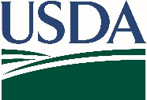
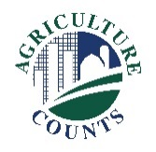
United States Department of Agriculture
National Agricultural Statistics Service
[Choose office]

What do I do next?
Complete your survey in one of the following ways:
Online at agcounts.usda.gov through the Respondent Portal. Online reporting is fast and secure. You just need your unique survey code on the enclosed form to begin.

By mail or fax. Complete the questionnaire and mail it back in the prepaid return envelope provided or fax it to [Click to enter FAX # - text].

Click here to enter a date

Why am I getting this letter?

Enclosed is your [Click here to add Survey Title - text] Survey. Your participation is important. [Click here to enter a brief description of survey benefits] Please complete the questionnaire at your earliest convenience.

You may receive an email reminder to complete your questionnaire. If we do not receive your completed questionnaire by [Click for date], we [Choose one] contact you for an interview.

How will the data be used?

[Click here to describe how this survey data are used]

We recommend you respond online through the new Respondent Portal. On the portal, you can complete your surveys, track upcoming surveys, access data visualizations and reports of interest, link to other USDA agencies, and more.

The information you provide will be used for statistical purposes only. In accordance with federal law, your responses will be kept confidential and will not be disclosed in identifiable form. We will publish the data in the [Click here to enter report name – text] report on [Click to add release date].

Thank you for your participation and for your support of our programs and U.S. agriculture. If you have any questions, please contact us at [Click to enter phone number, email, etc. - text]. For more information on this survey, visit nass.usda.gov/Surveys/Guide_to_NASS_Surveys/index.php.

Sincerely,

[Click here to enter – Name]
Director/State Statistician, [Choose office]
Enclosure

