Supporting Statement – Part A

LIVESTOCK SLAUGHTER
OMB No. 0535-0005

JUSTIFICATION

This submission is a renewal request for approval of this long-running information collection for an additional 3 years. There are no program changes in the survey methodology or sampling, only adjustments to the sample size and burden.

1. Explain the circumstances that make the collection of information necessary. Identify any legal or administrative requirements that necessitate the collection. Attach a copy of the appropriate section of each statute and regulation mandating or authorizing the collection of information.

The primary functions of the National Agricultural Statistics Service (NASS) are to prepare and issue State and national estimates of crop and livestock production, disposition, and prices and to collect information on related environmental and economic factors. Crop and livestock statistics help maintain a stable economic atmosphere and reduce risk for production, marketing, and distribution operations. The agricultural industry increasingly calls upon NASS to supply reliable, timely, and detailed information in its commodity estimation program.

This docket contains the two livestock slaughter surveys conducted by NASS: Federally-Inspected (FI) and Non-Federally-Inspected (NFI) livestock slaughter plants. The FI survey is mandatory. The NFI survey is mandatory for a portion of NFI plants in states with mandatory reporting laws; participation of the remainder of NFI plants in the survey is voluntary.

Information collected from both types of plants are combined to estimate total red meat production, consisting of the number of head slaughtered and live weights of cattle, calves, hogs, sheep/lambs, goats, and buffalo/bison. Knowing total red meat production, the number of head slaughtered, and live weights allows the industry to prepare and address issues related to supply and pricing. The data are also used at the end of the year to confirm production and disposition information for NASS livestock estimates made during the year.

General authority for these data collection activities is granted under U.S. Code Title 7, Section 2204(a) which specifies that "The Secretary of Agriculture shall procure and preserve all information concerning statistics ... and shall distribute them among agriculturists."
2. Indicate how, by whom, and for what purpose the information is to be used. Except for a new collection, indicate the actual use the agency has made of the information received from the current collection.

Federally-Inspected (FI) livestock slaughter is reported under a cooperative arrangement between USDA’s Agricultural Marketing Service (AMS), Food Safety and Inspection Service (FSIS), and NASS. FSIS fulfills its responsibilities mandated by the Federal Meat Inspection Act (U.S. Code Title 21, Sections 620 and 661) by collecting daily slaughter data from all Federally-Inspected plants.

Non-Federally-Inspected (NFI) livestock slaughter data are collected by NASS Regional Field Offices from State inspection agencies and/or by conducting a mail survey. Each office is responsible for maintaining a list frame of all slaughter plants that are not inspected by FSIS or the State so that they can be contacted.

NASS obtains the daily FI data, combines it with the monthly NFI data, and publishes a monthly commercial slaughter report. These published data are used by the United States Department of Agriculture, other Federal and State agencies, and the livestock industry, in combination with data from other NASS livestock surveys, to project future meat supplies and producer prices. Agricultural economists in both the public and private sectors also use this information in economic analysis and research.

3. Describe whether, and to what extent, the collection of information involves the use of automated, electronic, mechanical, or other technological collection techniques or other forms of information technology, e.g. ,permitting electronic submission of responses, and the basis for the decision for adopting this means of collection. Also describe any consideration of using information technology to reduce burden.

FI plants report head slaughtered and live and dressed weight to FSIS using software designed specifically for and by FSIS for FSIS purposes. NASS obtains this previously reported FI plant information from FSIS, eliminating the need for new data collection.

For the portion of NFI plants that are surveyed directly by NASS Regional Field Offices monthly, web-based reporting is available as a response mode (in addition to telephone and paper instruments). The quarterly and annual respondents do not have the option of an on-line instrument at this time. It is estimated that about 30 of 1,200 NFI plants will use the web option. The total percentage of electronic responses is estimated at (946 FI + 900 SI + 30 NFI) / (946 + 900 + 1,200) = 61.6% (see table in A.12 for sample size figures).

4. Describe efforts to identify duplication. Show specifically why any similar information already available cannot be used or modified for use for the purposes described in Item 2 above.

These surveys meet both State and Federal needs. The cooperative agreements between NASS, AMS, and FSIS eliminate duplication and minimize reporting burden on the livestock industry. The data are not available from any other source. NASS receives notification of new grants and withdrawals from FSIS to prevent duplication of data reporting.

5. If the collection of information impacts small businesses or other small entities (Item 5 of OMB Form 83-I), describe any methods used to minimize burden.

Small custom slaughter plants are generally NFI. The data for these plants are collected either from State inspection agencies or through the monthly NFI Slaughter Report. RFOs can also collect the data through quarterly or annual NFI Slaughter Reports, which allow for reporting multiple months on a report, thereby reducing the number of contacts. Information requested on the livestock slaughter surveys can be provided with a minimum of difficulty by operators, generally from normal operating records.

The overall number of small operations that are classified as small operations by the Small Business Administration and will be contacted by these surveys is 100%.

6. Describe the consequence to Federal program or policy activities if the collection is not conducted or is conducted less frequently, as well as any technical or legal obstacles to reducing burden.

Collecting data less frequently would eliminate data that is needed by the Department of Agriculture, markets, and the livestock industry to keep abreast of changes at the State and National level. The Food Safety and Inspection Service is required by law to collect slaughter data from all Federally-Inspected plants each week. Timing and frequency of the various reports have evolved to meet the needs of producers, agribusinesses, and government agencies, yet minimize burden on the reporting public.

7. Explain any special circumstances that would cause an information collection to be conducted in a manner (inconsistent with the general information guidelines in 5 CFR 1320.5):
• requiring respondents to report information to the agency more often than quarterly;
• requiring respondents to prepare a written response to a collection of information in fewer than 30 days after receipt of it; . . .

Data collection plans require the Federally Inspected (FI) plants to respond within 30 days of receipt of the questionnaire and to respond weekly or monthly in order to comply with the Federal Meat Inspection Act (U.S. Code Title 21, Sections 620 and 661) and to publish the releases on time. The government and industry depend on these publication dates to make policy and business decisions. There are no other special circumstances associated with this survey.

8. Provide a copy and identify the date and page number of publication in the Federal Register of the agency's notice, required by 5 CFR 1320.8 (d), soliciting comments on the information collection prior to submission to OMB. Summarize public comments received in response to that notice and describe actions taken by the agency in response to these comments.

The Federal Register Notice soliciting comments was published on August 3, 2023, in Vol. 88, Number 90, on pages 51265 - 51266.

Describe efforts to consult with persons outside the agency to obtain their views on the availability of data, frequency of collection, the clarity of instructions and recordkeeping, disclosure, or reporting format (if any), and on the data elements to be recorded, disclosed, or reported.

Three of the individuals who provide feedback on many of our dockets are:

Katelyn McCullock, Director
Livestock Marketing Information Center
303-716-9936 - www.lmic.info

Roger Cryan, Chief Economist
American Farm Bureau Federation
202-406-3729
www.fb.org
rogerc@fb.org

Bill Lapp
Advanced Economic Solutions
Bill@aesresearch.com
402-496-6015

In addition, statisticians from NASS Regional Field Offices and Headquarters attend numerous meetings throughout the year to explain the crop and livestock estimates programs. These meetings frequently provide feedback on data needs and suggested program improvements. NASS regularly holds data user meetings across the country to solicit comments about its surveys. NASS works closely with FSIS and AMS to keep the slaughter survey instruments current and relevant.

9. Explain any decision to provide any payment or gift to respondents.

There are no payments or gifts to respondents.

10. Describe any assurance of confidentiality provided to respondents and the basis for the assurance in statute, regulation, or agency policy.

Questionnaires include a statement that individual reports are confidential. U.S. Code Title 18, Section 1905; U.S. Code Title 7, Section 2276; and Title III of Pub. L. No. 115-435 (CIPSEA) provide for confidentiality of reported information. All employees of NASS and all enumerators hired and supervised under a cooperative agreement with the National Association of State Departments of Agriculture (NASDA) must read the regulations and sign a statement of compliance.

The following confidentiality pledge statement will appear on all NASS questionnaires.

The information you provide will be used for statistical purposes only. Your responses will be kept confidential and any person who willfully discloses ANY identifiable information about you or your operation is subject to a jail term, a fine, or both. This survey is conducted in accordance with the Confidential Information Protection and Statistical Efficiency Act of 2018, Title III of Pub. L. No. 115-435, codified in 44 U.S.C. Ch. 35 and other applicable Federal laws. For more information on how we protect your information please visit: https://www.nass.usda.gov/confidentiality. Response to this survey is voluntary.

11. Provide additional justification for any questions of a sensitive nature.

There are no questions of a sensitive nature.

12. Provide estimates of the hour burden of the collection of information. The statement should indicate the number of respondents, frequency of response, annual hour burden, and an explanation of how the burden was estimated. If this request for approval covers more than one form, provide separate hour burden estimates for each form and aggregate the hour burdens in Item 13 of OMB Form 83-I.

This renewal has a sample size of 1,225, a total number of 10,675 responses and a total of 2,302 burden hours.

Average minutes per response for the surveys included in this docket are based on the amount of data asked on each questionnaire and the time needed for respondents to find and report the data. Total hours of burden are shown in the table below.

Cost to the public of completing a questionnaire is assumed to be comparable to the hourly rate of those requesting the data. Reporting time of 2,302 hours is multiplied by $40.51 per hour for a total cost to the public of $92,310.20.

NASS uses the Bureau of Labor Statistics’ Occupational Employment Statistics (most recently published on April 25, 2023 for the previous May) to estimate an hourly wage for the burden cost. The May 2022 mean wage for bookkeepers was $22.81. The mean wage for farm managers was $40.29. The mean wage for farm supervisors was $28.28. The mean wage of the three is $30.46. To calculate the fully loaded wage rate (includes allowances for Social Security, insurance, etc.) NASS will add 33% for a total of $40.51 per hour.

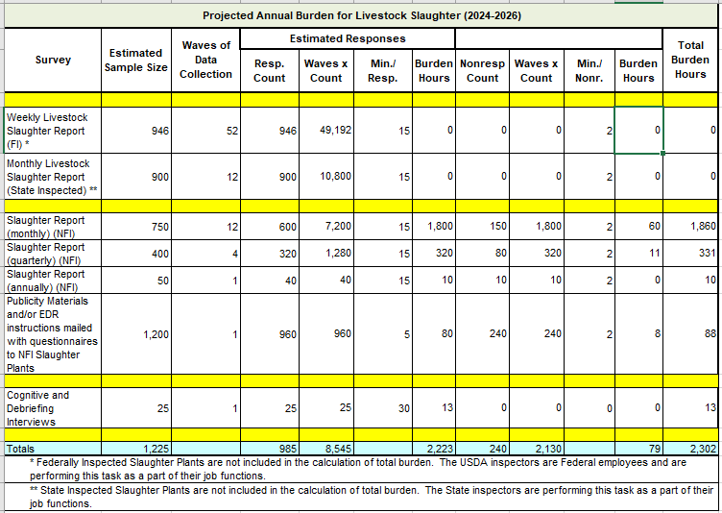
13. Provide an estimate of the total annual cost burden to respondents or record keepers resulting from the collection of information.

There are no capital/start-up or ongoing operation/maintenance costs associated with this information collection.

14. Provide estimates of annualized cost to the Federal government; provide a description of the method used to estimate cost which should include quantification of hours, operational expenses (equipment, overhead, printing, and staff), and any other expense that would not have been incurred without this collection of information.

The total cost to the Federal government for the livestock slaughter surveys will remain at an estimated annual cost of $800,000. Virtually all of the costs are personnel costs associated with data collection and review. Other costs include postage (for the portion of the NFI surveys that are mailed to respondents), computer processing, summarization, and printing.

15. Explain the reasons for any program changes or adjustments reported in Items 13 or 14 of the OMB Form 83-I (reasons for changes in burden).

There were no program changes made to sampling or survey methodology only adjustments in sample sizes due to changes in the overall population of slaughter plants.

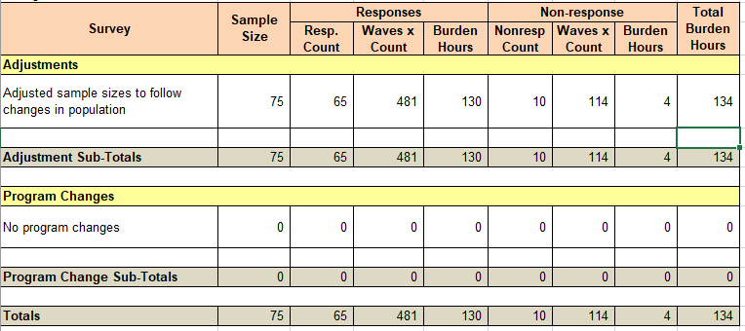

16. For collections of information whose results will be published, outline plans for tabulation and publication. Address any complex analytical techniques that will be used. Provide the time schedule for the entire project, including beginning and ending dates of the collection of information, completion of report, publication dates, and other actions.

The Federally-Inspected (FI) and Non-Federally-Inspected (NFI) slaughter surveys comprise a census of all known plants that slaughter cattle, calves, hogs, sheep, goats, or bison. The combined information collected from plants are used to estimate total red meat production, consisting of the number of head slaughtered and live and dressed weights of cattle, calves, hogs, sheep, goats, and bison. It is also used in preparing production, disposition, and income statistics.

FI livestock slaughter data are reported under a cooperative arrangement between USDA’s Agricultural Marketing Service (AMS), Food Safety and Inspection Service (FSIS), and NASS. FSIS Federal meat inspectors are responsible for compiling daily FI plant data that are comparable to the Weekly Livestock Slaughter Report and submitting that data to FSIS which then shares the data with NASS. NASS then accumulates FI head slaughtered, live weight, and dressed weight by species and class to monthly totals for summarization with NFI totals.

NFI slaughter is collected by NASS Regional Field Offices from State inspection agencies by using the monthly Slaughter Report printed questionnaire or Web-based questionnaire. Each Regional Field Office is responsible for maintaining a list frame of all slaughter plants that are not inspected by FSIS or the State. NASS statisticians review the NFI reports for reasonableness prior to transmitting the data to NASS Headquarters. Small custom slaughter facilities are given the option of reporting quarterly or annually. The data from these smaller operations are included in the annual publications. Data from the FI and NFI plants are combined to produce estimates of commercial slaughter totals for cattle, calves, hogs, sheep, goats, and bison in the U.S. The data are also used to derive total red meat production and prepare production, disposition, and income statistics.

Weekly slaughter totals are published by AMS in Livestock, Meat, & Grain Highlights:

https://mymarketnews.ams.usda.gov/viewReport/3658.

NASS publishes slaughter totals and commercial red meat production monthly in Livestock Slaughter, reached from NASS Web-site at nass.usda.gov or directly:

https://usda.library.cornell.edu/concern/publications/rx913p88g.

NASS publishes the Livestock Slaughter, Annual Summary in April of each year:

https://usda.library.cornell.edu/concern/publications/r207tp32d.

In addition, Meat Animals Production, Disposition, and Income is published each April, and the slaughter data is used to calculate total marketings:

https://usda.library.cornell.edu/concern/publications/02870v85d.

NASS also publishes the Overview of the United States Slaughter Industry:

https://usda.library.cornell.edu/concern/publications/b5644r52v

Data Collection and Publication
Livestock Slaughter | Data Collection  Period | Publication | Release Date(s)
Federally Inspected Surveys * | Weekly | Weekly Livestock, Meat & Grain Highlights | Each Thursday
 |  | Livestock Slaughter | Monthly
 |  | Livestock Slaughter Annual Summary | April
 |  | Meat Animals Production, Disposition, and Income | April
Non-Federally Inspected Surveys * | Monthly, Quarterly, or Annually | Livestock Slaughter | Monthly
 |  | Livestock Slaughter Annual Summary | April
 |  | Meat Animals Production, Disposition, and Income | April
* The Federally inspected data and Non-Federally inspected data are collected at a different frequency, but the data is combined in the same monthly and annual publications.

17. If seeking approval to not display the expiration date for OMB approval of the information collection, explain the reasons that display would be inappropriate.

No approval is requested for non-display of the expiration date.

18. Explain each exception to the certification statement identified in Item 19, “Certification for Paperwork Reduction Act Submissions” of OMB Form 83-I.

There are no exceptions to the certification statement.

October 2023

