Supporting Statement – Part A

HONEY AND HONEY BEE SURVEYS

OMB No. 0535-0153

A. JUSTIFICATION

This is a request for the renewal and change of a currently approved data collection. The National Agricultural Statistics Service (NASS) would like to renew the annual Bee and Honey Inquiry (operations with five or more colonies) and the quarterly Colony Loss Survey (operations with five or more colonies).

1. Explain the circumstances that make the collection of information necessary. Identify any legal or administrative requirements that necessitate the collection. Attach a copy of the appropriate section of each statute and regulation mandating or authorizing the collection of information.

The primary functions of the National Agricultural Statistics Service (NASS) are to prepare and issue State and national estimates of crop and livestock production, disposition, and prices, and to collect information on related environmental and economic factors. Crop and livestock statistics help maintain a stable economic atmosphere and reduce risk for production, marketing, and distribution operations. Modern agriculture increasingly calls upon NASS to supply reliable, timely, and detailed information through its commodity estimation program. As part of this function, estimates are made for honey production, stocks, and prices.

Domestic honeybees are critical to the pollination of U.S. crops, especially fruits, some nuts, vegetables, and some specialty crops. United States honey production in 2022 totaled 125 million pounds, down 1 percent from 2021. There were 2.67 million colonies producing honey in 2022, down 1 percent from 2021. Yield per colony averaged 47.0 pounds, unchanged from 2021. The survival of bees is threatened by parasites, diseases, and other factors. In many areas, the wild European honeybee population is virtually nonexistent. Federal, State and local governments provide programs to assist in the survival of honeybees and to encourage beekeepers to maintain honeybee colonies. The government to administer these programs uses honey production and price data.

General authority for these data collection activities is granted under U.S. Code Title 7, Section 2204. This statute specifies that “The Secretary of Agriculture shall procure and preserve all information concerning agriculture which he can obtain ... by the collection of statistics ... and shall distribute them among agriculturists.”

2. Indicate how, by whom, and for what purpose the information is to be used. Except for a new collection, indicate the actual use the agency has made of the information received from the current collection.

Producers and the agribusiness sector of the honey industry to make production and marketing decisions use NASS estimates. The bee and honey surveys are conducted in all States. These surveys collect data on the number of colonies each operation has, the amount of honey produced and the amount of honey stocks available for sale.

The Agricultural Research Service (ARS), State-level apiarists, and agricultural colleges throughout the U.S. use NASS bee and honey data to administer their honeybee research programs. Current research projects at ARS focus on colony collapse disorder, parasites, Africanized honeybees, foul brood disease, food safety and inspection (including honey), and other topics.

The Agricultural Marketing Service (AMS) uses NASS honey production data as control data for the administration of the research and promotion programs. The Honey Packers and Importers Research, Promotion, Consumer Education, and Industry Information Order (Order) [7 CFR Part 1212] is authorized by the Commodity Promotion, Research, and Information Act of 1996 (1996 Act) [7 U.S.C. 7411-7425]. Under the Order, assessments are collected on honey and honey products packed or imported into the 50 states, Puerto Rico, and the District of Columbia. The funds collected are used by the National Honey Board for research and development, advertising and promotion of honey and honey products, consumer education, and industry information, under AMS supervision. The National Honey Board administers the research and promotion programs and reimburses the Federal government for the costs incurred in implementing and administering the program.

The Economic Research Service (ERS) uses NASS honey data to construct U.S. and per capita caloric sweetener consumption estimates. The data are used in the Sugar and Sweeteners Yearbook tables provided by ERS. The data are also utilized in the Situation and Outlook Report and the Food Consumption series, which are mandated by Congress. Economic data published in the Honey report is also used to prepare valuations related to pollinators.

The Farm Service Agency (FSA) uses NASS honey production data as source data. The Farm Security and Rural Investment Act of 2002 provides that the FSA administer the nonrecourse marketing assistance loan and loan deficiency payment (LDP) program for honey. The honey nonrecourse marketing assistance loan and LDP program provides eligible honey producers with two forms of Federal assistance. The program helps to stabilize America's honey industry and ensure the wellbeing of agriculture in the United States. Nonrecourse marketing assistance loans are administered by FSA on behalf of the Commodity Credit Corporation (CCC). The Food, Conservation, and Energy Act of 2008 (2008 Farm Bill) authorized the Emergency Assistance for Livestock, Honey Bees, and Farm-Raised Fish Program (ELAP). ELAP assistance covers some species, loss conditions, and losses that are not eligible for other disaster assistance programs, including colony collapse disorder. The Agriculture Improvement Act of 2018 (the 2018 Farm Bill) authorized the use of Commodity Credit Corporation funds for the Emergency Assistance for Livestock, Honeybees and Farm-Raised Fish Program (ELAP). ELAP provides emergency assistance to eligible producers of livestock, honeybees and farm-raised fish. It covers losses due to an eligible adverse weather or loss condition, including blizzards and wildfires, as determined by the Secretary of Agriculture. ELAP covers losses that are not covered under other disaster assistance programs authorized by the 2014 Farm Bill, such as the Livestock Forage Disaster Program (LFP) and the Livestock Indemnity Program (LIP).

The Risk Management Agency (RMA) is now offering a pilot insurance program for apiculture. This pilot program uses rainfall and vegetation greenness indices to estimate local rainfall and plant health, allowing beekeepers to purchase insurance protection against production risks. The program will use a 5-year average honey yield at the state level and the annual average honey price at the national level, both based on NASS data, to determine insurance payments.

The Pollinator Health Task Force uses data from the Honey Bee Colonies report to monitor honeybee colony losses during winter. Their goal, as laid out in the Pollinator Research Action Plan, is to reduce these losses to no more than 15 percent within 10 years.
The Food and Drug Administration provided some background information on the importance of honeybees in an article they published in July 2018. “Honey bees are not native to the New World. Most crops grown in the U.S. are not New World natives either. Both the crops and the bees evolved together in other areas of the globe, and were brought here by European settlers. Information suggests that the first honeybee colonies arrived in the Colony of Virginia from England early in 1622.
Today, the commercial production of more than 90 crops relies on bee pollination. Of the approximately 3,600 bee species that live in the U.S., the European honeybee² (scientific name Apis mellifera) is the most common pollinator, making it the most important bee to domestic agriculture. About one-third of the food eaten by Americans comes from crops pollinated by honey bees, including apples, melons, cranberries, pumpkins, squash, broccoli, and almonds, to name just a few. Without the industrious honey bee, American dinner plates would look quite bare.” https://www.fda.gov/animal-veterinary/animal-health-literacy/helping-agricultures-helpful-honey-bees

3. Describe whether, and to what extent, the collection of information involves the use of automated, electronic, mechanical, or other technological collection techniques or other forms of information technology, e.g., permitting electronic submission of responses, and the basis for the decision for adopting this means of collection. Also describe any consideration of using information technology to reduce burden.

Nearly all of NASS’s surveys are now available by Computer Assisted Telephone Interviews (CATI), Computer Assisted Personal Interviews (CAPI), and Computer Assisted Web Interviews (CAWI). Web-based data reporting for the bee and honey surveys was approved and conducted for the first time in December 2003. In 2022, 18.9% of the operations responding to the Bee and Honey Survey completed the questionnaire by use of the internet. In 2022, 7.0% of the Colony Loss operations surveyed completed the questionnaire by use of the internet. Overall, there was a 9% response rate by internet.

4. Describe efforts to identify duplication. Show specifically why any similar information already available cannot be used or modified for use for the purposes described in Item 2 above.

The National Agricultural Statistics Service cooperates with other Federal Agencies, State agriculture departments, and universities to conduct agricultural surveys. These surveys meet both State and Federal needs, thus eliminating duplication and minimizing reporting burden on the agriculture industry. Data collected on these surveys are not available from any other source.

5. If the collection of information impacts small businesses or other small entities (Item 5 of OMB Form 83-I), describe any methods used to minimize burden.

Information requested on the Bee and Honey and the Colony Loss questionnaires, can be provided with a minimum of difficulty by respondents, generally without having to consult their record books. Out of the estimated sample size of 12,225 operations, approximately 87 percent of them would be classified as small operations.

6. Describe the consequence to Federal program or policy activities if the collection is not conducted or is conducted less frequently, as well as any technical or legal obstacles to reducing burden.

Bee and honey data are collected only once a year. Collecting data less frequently would diminish the ability to track changing trends in the honey industry. The frequency of the report has evolved to meet the needs of customers and yet minimize the burden on the reporting public.

NASS commodity statisticians stay in close contact with beekeepers and data users by attending numerous meetings and tradeshows around the country. NASS has obtained a great deal of input from data users as to what sort of published data they need and what sort of production data individual growers can provide relating to colony loss and colony health. It was determined that health data on bee colonies should be collected quarterly in order to be able to monitor trends in colony loss closely and to reduce possible errors in respondent memory recall.

Data for operations with fewer than five colonies was last published in 2018. Data for these smaller operations will be collected once every five years through the Census of Agriculture (OMB no. 0535-0226). Operations with five or more colonies will be contacted by NASS to collect colony loss data for the previous quarter and honey production data in January for the previous year.

Furthermore, data relating to the number and location of commercial apiaries is vital to fruit, vegetable, and many specialty crop farmers. An ample supply of honeybees is crucial to the pollination of these crops. Many of the larger apiaries are contracted to transport their hives to regions producing fruits, vegetables, and specialty crops at the appropriate season(s) to ensure proper pollination of these crops.

7. Explain any special circumstances that would cause an information collection to be conducted in a manner inconsistent with the general information guidelines in 5 CFR 1320.5.

There are no special circumstances associated with this information collection.

8. Provide a copy and identify the date and page number of publication in the Federal Register of the agency's notice, required by 5 CFR 1320.8 (d), soliciting comments on the information collection prior to submission to OMB. Summarize public comments received in response to that notice and describe actions taken by the agency in response to these comments.

The Federal Register Notice soliciting comments was published on August 3, 2023, in Vol. 88, Number 90, on pages 51266 - 51267.

Describe efforts to consult with persons outside the agency to obtain their views on the availability of data, frequency of collection, the clarity of instructions and record-keeping, disclosure, or reporting format (if any), and on the data elements to be recorded, disclosed, or reported.

Some of the individuals who have provided feedback on our pollinator surveys are:

Katelyn McCullock, Director
Livestock Marketing Information Center
303-716-9936
www.lmic.info

John Newton, Ph.D., Chief Economist
American Farm Bureau Federation
202-406-3729 w
502-641-4636
www.fb.org
jnewton@fb.org

Elizabeth Hill
USDA Office of the Secretary – Pollinators
elizabeth.hill2@usda.gov

Kevin Hackett
USDA Agricultural Research Service
National Program Leader
kevin.hackett@usda.gov

Bond, Jennifer - REE-ERS, Washington, DC
USDA Research, Education and Economics Resources (REE)
Economic Research Service (ERS)
Economist
jennifer.bond@usda.gov

In the past NASS has received input from the National Honey Board, the American Beekeeping Federation, Agricultural Marketing Service; Farm Services Agency, National Honey Board, and the National Institute of Food and Agriculture. In addition, many of the NASS Regional and State Directors meet with various beekeeper associations and apiarists around the country.

9. Explain any decision to provide any payment or gift to respondents.

There are no payments or gifts to respondents.

10. Describe any assurance of confidentiality provided to respondents and the basis for the assurance in statute, regulation, or agency policy.

Questionnaires include a statement that individual reports are confidential. U.S. Code Title 18, Section 1905; U.S. Code Title 7, Section 2276; and Title III of Pub. L. No. 115-435 (CIPSEA) provide for confidentiality of reported information. All employees of NASS and all enumerators hired and supervised under a cooperative agreement with the National Association of State Departments of Agriculture (NASDA) must read the regulations and sign a statement of compliance.

The following confidentiality pledge statement will appear on all NASS questionnaires.

The information you provide will be used for statistical purposes only. Your responses will be kept confidential and any person who willfully discloses ANY identifiable information about you or your operation is subject to a jail term, a fine, or both. This survey is conducted in accordance with the Confidential Information Protection and Statistical Efficiency Act of 2018, Title III of Pub. L. No. 115-435, codified in 44 U.S.C. Ch. 35 and other applicable Federal laws. For more information on how we protect your information please visit: https://www.nass.usda.gov/confidentiality. Response to this survey is voluntary.

11. Provide additional justification for any questions of a sensitive nature.

There are no questions of a sensitive nature.

12. Provide estimates of the hour burden of the collection of information. The statement should indicate the number of respondents, frequency of response, annual hour burden, and an explanation of how the burden was estimated. If this request for approval covers more than one form, provide separate hour burden estimates for each form and aggregate the hour burdens in Item 13 of OMB Form 83-I. Provide estimates of annualized cost to respondents for the hour burdens for collections of information, identifying and using appropriate wage rate categories.

This renewal has a sample size of 12,225, a total number of 51,430 responses and a total of 7,920 burden hours.

Average minutes per response for the surveys included in this docket are based on the amount of data asked on each questionnaire and the time needed for respondents to find and report the data. Total hours of burden are shown in the table below.

Cost to the public of completing a questionnaire is assumed to be comparable to the hourly rate of those requesting the data. Reporting time of 7,920 hours is multiplied by $40.51 per hour for a total cost to the public of $320,839.20.

NASS uses the Bureau of Labor Statistics’ Occupational Employment Statistics (most recently published on April 25, 2023 for the previous May) to estimate an hourly wage for the burden cost. The May 2022 mean wage for bookkeepers was $22.81. The mean wage for farm managers was $40.29. The mean wage for farm supervisors was $28.28. The mean wage of the three is $30.46. To calculate the fully loaded wage rate (includes allowances for Social Security, insurance, etc.) NASS will add 33% for a total of $40.51 per hour.

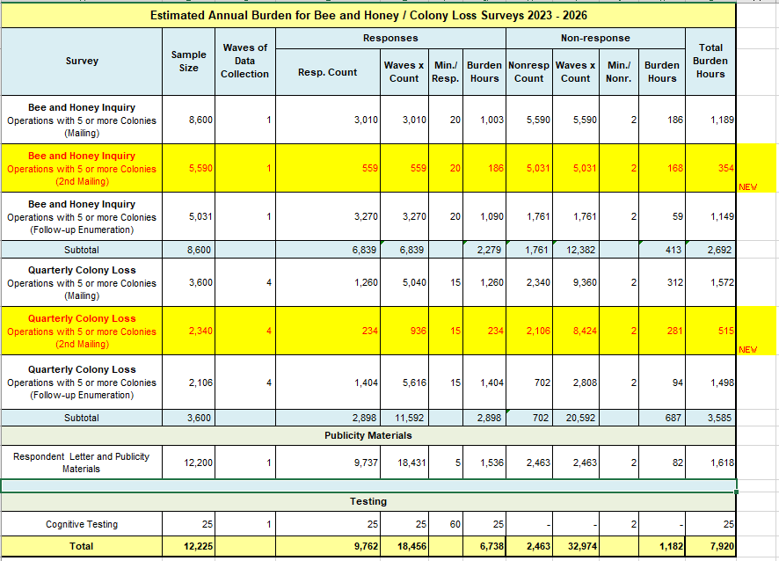
13. Provide an estimate of the total annual cost burden to respondents or record-keepers resulting from the collection of information.

There are no capital/start-up or ongoing operation/maintenance costs associated with this information collection.

14. Provide estimates of annualized cost to the Federal government; provide a description of the method used to estimate cost which should include quantification of hours, operational expenses, and any other expense that would not have been incurred without this collection of information.

The total cost to the Federal Government for the merged Bee and Honey Surveys and the Colony Loss surveys is approximately $1.9 million annually. About $1,700,000 of the total is for Federal salaries, $130,000 for telephone and field enumeration by NASDA employees (National Association of State Departments of Agriculture), and $70,000 for printing, postage, data processing, etc.

15. Explain the reasons for, any program changes or adjustments reported in Items 13 or 14 of the OMB Form 83-I (reasons for changes in burden).

In this request for renewal of the Honey and Honey Bee Surveys (0535-0153) Information Collection Request (ICR), NASS has added a 2nd mailing to both the Bee and Honey Inquiry and the Quarterly Colony Loss Survey. The requested change will increase burden by 478 hours from the previous approved amount.

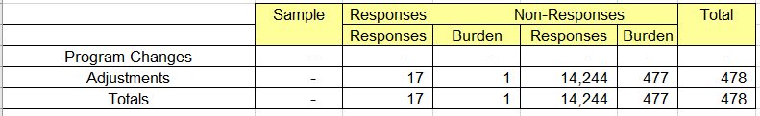

16. For collections of information whose results will be published, outline plans for tabulation and publication. Address any complex analytical techniques that will be used. Provide the time schedule for the entire project, including beginning and ending dates of the collection of information, completion of report, publication dates, and other actions.

Operations with five or more colonies will be mailed a Bee and Honey questionnaire at the end of December referencing production data for that calendar year.

Operations with five or more colonies will continue to receive quarterly Colony Loss Surveys. Questionnaires will be mailed on or about the 1st of January, April, July, and October for the preceding reference period.

Operations that do not respond by the first or second mail attempt or internet within two to three weeks to any of these surveys will receive a phone call or in-person visit for enumeration. After data collection is complete, the data will be edited for reasonableness and completeness. The data will then be summarized. Summarization and preparation of estimates by NASS Regional Field Offices (RFOs) are completed and sent to NASS Headquarters. Headquarters acts as the clearinghouse for multi-State data from RFOs. Survey estimates are based primarily on a direct expansion indication. Summarization also includes matching the current year's report to the comparable report received the previous year to calculate a ratio, which is applied to the previous year’s estimate of colony numbers to provide an indication of the current number of colonies.

The “Honey” report is published from NASS Headquarters in mid-March.

https://usda.library.cornell.edu/concern/publications/hd76s004z

Honey price data are published by color class at the U.S. level and yield, production, and value data are published on an all honey basis (regardless of color class) at the State and U.S. level. Some State estimates may be combined to avoid disclosing data for individual operations.

The “Honey Bee Colonies” reports are published from Headquarters in early August. This report will contain data for all four quarters.

https://usda.library.cornell.edu/concern/publications/rn301137d

17. If seeking approval to not display the expiration date for OMB approval of the information collection, explain the reasons that display would be inappropriate.

There is no request for approval of non-display of the expiration date.

18. Explain each exception to the certification statement identified in Item 19, “Certification for Paperwork Reduction Act Submissions” of OMB Form 83-I.

There are no exceptions to the certification statement.

October 2023

