SUPPLEMENTAL SUPPORTING STATEMENT Part A

STOCKS REPORTS

Substantive Change

OMB No. 0535-0007

This substantive change is being submitted as a supplemental supporting statement to the Stocks Reports docket. This substantive change is to accommodate the addition of the 2024 Off-farm Grain and Oilseeds Operation Profile Survey.

A. JUSTIFICATION

1. Circumstances making collection of information necessary.

NASS is requesting a substantive change to the Off-farm Grain and Oilseeds Survey for the 2023. In order to maintain a complete and comprehensive list of operations, NASS needs to conduct an Operation Profile survey annually to add new operations to the survey population. This profile is also used to identify operations that do not meet the criteria to be included in the Off-farm Grain and Oilseeds Survey.

There are no other changes to the circumstances making collection of information necessary.

2. How, by whom, and for what purpose information is to be used.

There are no changes to the list of potential people who use the data collected by the Off-farm Grain and Oilseeds Program. The Operation Profiles will have three main functions:
1. Inform the respondent about our data needs so they will have the details to calculate monthly prices and quantities according to NASS definitions.
2. Document items the respondent cannot correctly report or estimate for each quarter.
3. Identify respondents who do not purchase any of the commodities of interest from farmers.

3. Use of improved information technology.

There are no changes from the original approval related to information technology.

4. Efforts to identify duplication

There are no changes from the original approval related to duplication reduction.

5. Methods to minimize burden of small businesses.

There are no changes from the original approval related to minimizing burden of small business.

6. Consequence if information collection were less frequent.

There are no changes to the frequency of these surveys that was originally approved.

- Special circumstances.

No special circumstances are associated with this information collection.

- Federal register notice and consultation with outside persons.

Input for the questions to be updated and removed were provided by the following:

Ann George
Executive Director
Hops Growers of America
info@usahops.org

Jesica Kincaid
Manager, International Trade Policy
USA Rice
Jkincaid@usarice.com

John Newton, Ph.D., Chief Economist
American Farm Bureau Federation
202-406-3729 w 502-641-4636 c
www.fb.org
jnewton@fb.org

9. Explain any decision to provide any payment or gift to respondents.

There are no changes to the frequency of these surveys that was originally approved.

10. Describe any assurance of confidentiality provided to respondents and the basis for the assurance in statute, regulation, or agency policy.

Questionnaires include a statement that individual reports are confidential. U.S. Code Title 18, Section 1905; U.S. Code Title 7, Section 2276; and the Confidential Information Protection and Statistical Efficiency Act of 2018, Title III of Pub. L. No. 115-435, codified in 44 U.S.C. Ch. 35 and other applicable Federal laws. All employees of NASS and all enumerators hired and supervised under a cooperative agreement with the National Association of State Departments of Agriculture (NASDA) must read the regulations and sign a statement of compliance.

The following CIPSEA Pledge statement will appear on all future NASS questionnaires.

The information you provide will be used for statistical purposes only. Your responses will be kept confidential and any person who willfully discloses ANY identifiable information about you or your operation is subject to a jail term, a fine, or both. This survey is conducted in accordance with the Confidential Information Protection and Statistical Efficiency Act of 2018, Title III of Pub. L. No. 115-435, codified in 44 U.S.C. Ch. 35 and other applicable Federal laws. For more information on how we protect your information please visit: https://www.nass.usda.gov/confidentiality.

11. Provide additional justification for any questions of a sensitive nature.

There are no questions of a sensitive nature.

12. Provide estimates of the hour burden of the collection of information. The statement should indicate the number of respondents, frequency of response, annual hour burden, and an explanation of how the burden was estimated.

The Operation Profile survey average minutes per response is estimated at 10 minutes. The Operation Profile survey will increase the total burden to 5,342 hours.

The total Stocks Reports sample size of 8,330, a total number of 26,170 responses and a total of 5,342 burden hours.

Average minutes per response for the surveys included in this docket are based on the amount of data asked on each questionnaire and the time needed for respondents to find and report the data. Total hours of burden are shown in the table below.

Cost to the public of completing the questionnaire is assumed to be comparable to the hourly rate of those requesting the data. Reporting time of 5,342 hours is multiplied by $40.51 per hour for a total cost to the public of $214,801.80.

NASS uses the Bureau of Labor Statistics’ Occupational Employment Statistics (most recently published on April 25, 2023 for the previous May) to estimate an hourly wage for the burden cost. The May 2022 mean wage for bookkeepers was $22.81. The mean wage for farm managers was $40.29. The mean wage for farm supervisors was $28.28. The mean wage of the three is $30.46. To calculate the fully loaded wage rate (includes allowances for Social Security, insurance, etc.) NASS will add 33% for a total of $40.51 per hour.

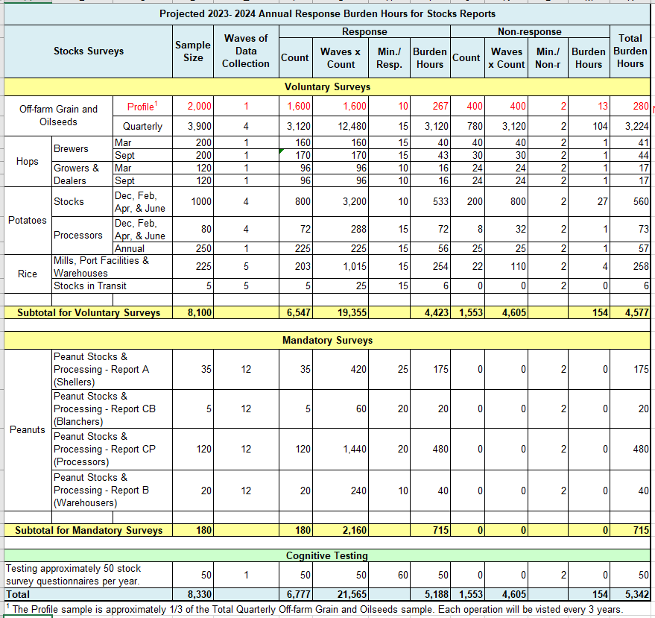
13. Provide an estimate of the total annual cost burden to respondents or record keepers resulting from the collection of information.

There is no cost burden to respondents.

14. Annualized costs to federal government.

The total cost to the Federal Government will remain at approximately $2.0 million. About $1.7 million is for federal salaries, $150,000 for telephone and field enumeration by associated State employees (of the National Association of State Departments of Agriculture), and $150,000 for printing, postage, data processing, travel, etc.

15. Reasons for changes in burden.

By adding the Operation Profile survey, NASS will increase total burden by 280 hours.
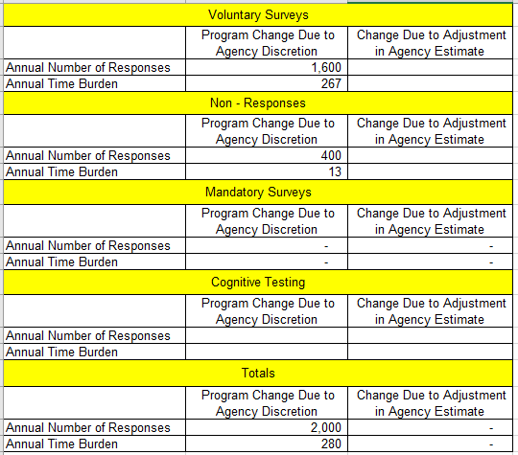

16. Tabulation, analysis, and publication plans.

There are no changes from the current approval related to the publications. The Operation Profile survey will not result in any publications.

The Operation Profile survey timeline is below.
Sample Drawn April
Mail Date June
Non-response follow-up July
Clean Date October

17. Request for approval of non-display of expiration date.

There is no request for approval of non-display of the expiration date.

18. Exceptions to certification statement

There are no exceptions to the certification statement.

October 2023

