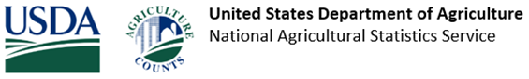
Your response is important and appreciated!
The USDA National Agricultural Statistics Service (NASS) recently mailed you a questionnaire for the [Survey Title].
If you have already responded, thank you! If not, there is still time. Please respond by [Date], in one of the following ways:
- Online at www.agcounts.usda.gov via the Respondent Portal using your survey code on the questionnaire mailed to you.
- Mail your completed questionnaire back using the prepaid envelope. Please allow time for your questionnaire to reach our office by the deadline above.
- Fax your completed questionnaire to 855-415-3687.
The information you provide will be used for statistical purposes only. In accordance with federal law, your responses will be kept confidential and will not be disclosed in identifiable form. The results will be posted on our Publications page.
Thank you for your participation and your support of our programs and U.S. agriculture. If you have any questions or need assistance completing your questionnaire, please contact us at 888-424-7828.

United States Department of Agriculture | National Agricultural Statistics Service
National Operations Division, 9700 Page Avenue, Suite 400, St. Louis, MO 63132-1547
OMB No. [Number] | Approval Expires: [Date] | Confidentiality Policy
USDA is an equal opportunity provider, employer, and lender.
Unsubscribe to email reminders from USDA NASS

