OMB Control Number: 0536-0073
Exp. Date: 04/30/2025

Recruitment and Informed Consent Plan

This appendix contains scripts for recruiting participants for focus groups, cognitive interviews, and pilot testing from the NORC at the U. of Chicago AmeriSpeak Panel.
The appendix also contains scripts for recruitment of participants into the AmeriSpeak Panel. This is not part of the recruitment for this pretesting. The participants in pretesting will be drawn from participants who have already been recruited to be part of the AmeriSpeak Panel. Privacy assurances and informed consent are obtained at the time of enrollment in the AmeriSpeak Panel. We are including the AmeriSpeak Panel recruitment script as background information on how privacy is being maintained by NORC at the U. of Chicago. Additional information needed for specific informed consent for each activity (e.g., a focus group) is given to AmeriSpeak panelists in the invitation to participate in that activity. This information includes the purpose of the activity, how long it will take, and the number of AmeriPoints that will be awarded upon completion of the activity.

Contents:
1. Focus group participant recruiting script and informed consent
2. Cognitive interview participant recruiting script and informed consent
3. Pilot testing participant recruiting script and informed consent
4. Background on AmeriSpeak Panel recruitment, including recruitment and informed consent
5. Time burden estimates
1. Focus group participant recruiting script and informed consent
This online AmeriSpeak survey is a screening survey to determine the AmeriSpeak panelist’s eligibility for the focus group.

Adult Standard Survey Email invitation
Email Subject: You’re invited to complete your new AmeriSpeak survey (SID: [$Survey.ID])
Email Body:

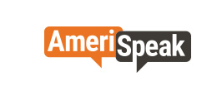 | Having trouble viewing this email? View it in your browser.



You’re invited to complete your new AmeriSpeak survey



And if you are eligible,
Earn 25,000 AmeriPoints.

Dear [FIRSTNAME],
Thank you for the valuable insights you provide to us at AmeriSpeak. We have a new survey for you. Please complete it at your earliest convenience, and if you are eligible, get 25,000 AmeriPoints!

Remember once you have 10,000 AmeriPoints, you can redeem them for a variety of things, such as a Visa rewards card or an Amazon gift card.
We look forward to hearing from you — and hearing your opinions!
Sincerely,
The AmeriSpeak Team

● ● ●

 |  |  |  |  | 

This email is intended for [FIRSTNAME] ([MEMBER_PIN]).
Having trouble with the link? You can copy and paste this into your browser:
https://survey.amerispeak.org/SE/?[$PURLPARAMS] You can also go to my.AmeriSpeak.org or the AmeriSpeak app, log in using your member credentials and click on the “Start Survey” button in your dashboard page. Need more help? Email support@AmeriSpeak.org or call toll-free (888) 326-9424. AmeriSpeak Support: 55 E Monroe St, 19th Floor, Chicago, IL 60603. Copyright AmeriSpeak 2019. Use of any content or images is prohibited without prior written approval.

If the AmeriSpeak Panelist is eligible, a screen with the following text will appear:
We want your help in developing a survey on the value people place on reducing the risk of foodborne illnesses. We are partnering with the US Department of Agriculture Economic Research Service (USDA ERS) and Resources for the Future to provide feedback on a survey (OMB Control Number 0536-0073, Expiration 4/30/2025) being developed on this topic by inviting a small number of AmeriSpeak panelists to participate in small focus groups. The focus group will be conducted by researchers from ERS and Resources for the Future.

If you would like to participate, you will be asked to indicate when you are available between _________ and __________. The focus group will be conducted on Zoom set up by AmeriSpeak.

The focus group will take about two hours to complete and panelists who complete the focus group will receive 25,000 AmeriSpeak points!.

You will be participating in a discussion on Zoom. AmeriSpeak will set up the Zoom call. You will need to be in a private, quiet space so that you can speak with the moderator and other participants. You also will need to be able to look at a screen (preferably on a screen larger than your smartphone) while also talking with the interviewer through Zoom. The discussion will be recorded so that the research team can refer to it in developing the survey. AmeriSpeak will store the recording securely and will share it only with the research team for the purpose of improving the survey.
You will get a chance to tell us the best dates/times for a focus group with a researcher from USDA and Resources for the Future on the following screens.
Are you willing and available to participate in this type of focus group?
- Yes
- No

WINTRO_1
Thank you for agreeing to participate in our new AmeriSpeak focus group (OMB Control Number 0536-0073, Expiration 4/30/2025) on foodborne illness!

This interview is being conducted in compliance with the Confidential Information Protection and Statistical Efficiency Act, otherwise known as CIPSEA. CIPSEA provides protection for information collected for statistical purposes under a pledge of confidentiality. CIPSEA-protected information is not subject to Freedom of Information Act requests.

Assurance of Confidentiality: The information you provide will be used for statistical purposes only. Your response will be kept confidential and any person who willfully discloses ANY identifiable information about you or your operation is subject to a jail term, a fine, or both. This survey is conducted in accordance with the Confidential Information Protection and Statistical Efficiency Act of 2018, Title III of Pub. L. No. 115-435, codified in 44 U.S.C. Ch. 35 and other applicable Federal laws.

The Paperwork Reduction Act requires that the USDA display an OMB control number on all public information requests along with the address where you can send comments regarding the study. You are not required to respond unless a currently valid OMB approval number is displayed. The OMB number for this study is 0536-0073, Exp 04/30/2025. The time to complete this information collection is estimated to be 120 minutes. If you have any comments regarding this study, please write to:
ERSfbdWTPSurvey@usda.gov.

2. Cognitive interview participant recruiting script and informed consent
This online AmeriSpeak survey is a screening survey to determine the AmeriSpeak panelist’s eligibility for the cognitive interview.

Adult Standard Survey Email invitation
Email Subject: You’re invited to complete your new AmeriSpeak survey (SID: [$Survey.ID])
Email Body:

Having trouble viewing this email? View it in your browser.

You’re invited to complete your new AmeriSpeak survey

And if you are eligible,
Earn 25,000 AmeriPoints.

Dear [FIRSTNAME],
Thank you for the valuable insights you provide to us at AmeriSpeak. We have a new survey for you. Please complete it at your earliest convenience, and if you are eligible, get 25,000 AmeriPoints!

Remember once you have 10,000 AmeriPoints, you can redeem them for a variety of things, such as a Visa rewards card or an Amazon gift card.
We look forward to hearing from you — and hearing your opinions!
Sincerely,
The AmeriSpeak Team

● ● ●

This email is intended for [FIRSTNAME] ([MEMBER_PIN]).
Having trouble with the link? You can copy and paste this into your browser:
https://survey.amerispeak.org/SE/?[$PURLPARAMS] You can also go to my.AmeriSpeak.org or the AmeriSpeak app, log in using your member credentials and click on the “Start Survey” button in your dashboard page. Need more help? Email support@AmeriSpeak.org or call toll-free (888) 326-9424. AmeriSpeak Support: 55 E Monroe St, 19th Floor, Chicago, IL 60603. Copyright AmeriSpeak 2019. Use of any content or images is prohibited without prior written approval.

If the AmeriSpeak Panelist is eligible, a screen with the following text will appear:
We want your help in developing a survey on the value people place on reducing the risk of foodborne illnesses. We are partnering with the US Department of Agriculture Economic Research Service (USDA ERS) and Resources for the Future to provide feedback on a survey (OMB Control Number 0536-0073, Expiration 4/30/2025) being developed on this topic by inviting a small number of AmeriSpeak panelists to participate in virtual interviews. The interviews will be conducted by researchers from Resources for the Future and ERS.

If you would like to participate, you will be asked to indicate when you are available between <u>Month/day<u> and <u>Month/day</u>. You will get to preview web survey questions that we are currently developing and provide LIVE feedback on the survey questions!
The interview will take no more than 90 minutes to complete and panelists who complete the interview will receive 25,000 AmeriSpeak points!.

You will be participating in a discussion on Zoom. AmeriSpeak will set up the Zoom call. You will need to be able to look at a screen (preferably on a screen larger than your smartphone) while also talking with the interviewer through Zoom. AmeriSpeak will store the recording securely and will share it only with the research team for the purpose of improving the survey.
You will get a chance tell us the best date/times for an interview with a researcher from ERS and Resources from the Future on the following screens.
Are you willing and available to participate in this type of interview?
RESPONSE OPTIONS:
- Yes
- No

Thank you for your interest in participating in a virtual interview with researchers from ERS and Resources for the Future!

This interview is being conducted in compliance with the Confidential Information Protection and Statistical Efficiency Act, otherwise known as CIPSEA. CIPSEA provides protection for information collected for statistical purposes under a pledge of confidentiality. CIPSEA-protected information is not subject to Freedom of Information Act requests.
Assurance of Confidentiality: The information you provide will be used for statistical purposes only. Your response will be kept confidential and any person who willfully discloses ANY identifiable information about you or your operation is subject to a jail term, a fine, or both. This survey is conducted in accordance with the Confidential Information Protection and Statistical Efficiency Act of 2018, Title III of Pub. L. No. 115-435, codified in 44 U.S.C. Ch. 35 and other applicable Federal laws.

The Paperwork Reduction Act requires that the USDA display an OMB control number on all public information requests along with the address where you can send comments regarding the study. You are not required to respond unless a currently valid OMB approval number is displayed. The OMB number for this study is 0536-0073, Exp 04/30/2025. The time to complete this information collection is estimated to be 90 minutes. If you have any comments regarding this study, please write to:
ERSfbdWTPSurvey@usda.gov.

- Pilot testing participant recruiting script and informed consent

Respondents will be sent an email inviting them to take the online survey. When they begin the survey they will see the text included below. Any screening will be at the beginning of the pilot survey.

Adult Standard Survey Email invitation
Email Subject: You’re invited to complete your new AmeriSpeak survey (SID: [$Survey.ID])
Email Body:

Having trouble viewing this email? View it in your browser.

You’re invited to complete your new AmeriSpeak survey

And if you are eligible,
Earn 5,000 AmeriPoints.

Dear [FIRSTNAME],
Thank you for the valuable insights you provide to us at AmeriSpeak. We have a new survey for you. Please complete it at your earliest convenience, and if you are eligible, get 5,000 AmeriPoints!/

Remember once you have 10,000 AmeriPoints, you can redeem them for a variety of things, such as a Visa rewards card or an Amazon gift card.
We look forward to hearing from you — and hearing your opinions!
Sincerely,
The AmeriSpeak Team

● ● ●

This email is intended for [FIRSTNAME] ([MEMBER_PIN]).
Having trouble with the link? You can copy and paste this into your browser:
https://survey.amerispeak.org/SE/?[$PURLPARAMS] You can also go to my.AmeriSpeak.org or the AmeriSpeak app, log in using your member credentials and click on the “Start Survey” button in your dashboard page. Need more help? Email support@AmeriSpeak.org or call toll-free (888) 326-9424. AmeriSpeak Support: 55 E Monroe St, 19th Floor, Chicago, IL 60603. Copyright AmeriSpeak 2019. Use of any content or images is prohibited without prior written approval.

Thank you for agreeing to participate in our new AmeriSpeak survey!
This survey (OMB Control Number 0536-0073, Expiration 4/30/2025) is about the value people place on reducing the risk of foodborne illnesses and is sponsored by the US Department of Agriculture Economic Research Service (USDA ERS).

To thank you for sharing your opinions, we will give you a reward of 5,000 AmeriPoints after completing the survey. As always, your answers are confidential.
This survey is being conducted in compliance with the Confidential Information Protection and Statistical Efficiency Act, otherwise known as CIPSEA. CIPSEA provides protection for information collected for statistical purposes under a pledge of confidentiality. CIPSEA-protected information is not subject to Freedom of Information Act requests.
Assurance of Confidentiality: The information you provide will be used for statistical purposes only. Your response will be kept confidential and any person who willfully discloses ANY identifiable information about you or your operation is subject to a jail term, a fine, or both. This survey is conducted in accordance with the Confidential Information Protection and Statistical Efficiency Act of 2018, Title III of Pub. L. No. 115-435, codified in 44 U.S.C. Ch. 35 and other applicable Federal laws.

The Paperwork Reduction Act requires that the USDA display an OMB control number on all public information requests along with the address where you can send comments regarding the study. You are not required to respond unless a currently valid OMB approval number is displayed. The OMB number for this study is 0536-0073, Exp 4/30/2025. The time to complete this information collection is estimated to be 30 minutes. If you have any comments regarding this study, please write to:
ERSfbdWTPSurvey@usda.gov.

4. Background on AmeriSpeak Panel Recruitment and Confidentiality Assurance
NORC will provide pretest and pilot testing subjects drawn from their probability-based AmeriSpeak Panel. NORC recruits AmeriSpeak panel participants through address-based sampling, engaging with 40 percent of those who do not respond to multiple mailings in in-person, face-to-face field recruiting. This follow-up strategy secures respondents who are more likely to be low income, young, non-white, and less educated, groups that are underrepresented in most surveys. The result is a sample of Americans that reflect the U.S. Census within 1 to 2 percentage points on key demographics.
AmeriSpeak is a pre-enrolled household survey panel designed to be representative of the U.S. population that includes panelists age 13 and older. As part of their enrollment, every AmeriSpeak panelist is promised that they will be awarded points for each survey or pretest they complete. Respondents redeem these points for cash, Amazon gift codes, virtual Mastercard current, or physical goods via the AmeriSpeak Panel member web portal or by calling the AmeriSpeak support toll-free telephone number. Further information on the AmeriSpeak panel and the recruitment protocol is provided in Appendix 6: AmeriSpeak Technical Overview. The recruitment is reviewed and approved by NORC’s Institutional Review Board. The AmeriSpeak panel also has a Certificate of Confidentiality from the Department of Health and Human Services which provides additional protections for identifiable, sensitive research data.
The AmeriSpeak recruitment script is provided below.
AmeriSpeak Privacy assurances are provided in Appendix 4 Supplement A.

4. AMERISPEAK PANEL RECRUITMENT AND CONSENT

-- TELEPHONE Recruitment
[Note: AmeriSpeak participants are typically recruited by mail which directs respondents to AmeriSpeak’s website, but telephone recruiting is also done. We present the telephone recruiting script first because it is relatively short. We will present the webpages included online in a description of online recruiting]
Hello, my name is [NAME]. I am with NORC at the University of Chicago, and I am calling about AmeriSpeak.
I am calling about an invitation packet from AmeriSpeak that we recently mailed to:
[ADDRESS1]
[ADDRESS2]
[CITY] [STATE] [ZIPCODE]

This call may be recorded for quality purposes. Am I speaking with someone who is 18 years of age or older?

Before we continue, have I called you on your cell phone? If you are currently doing any activity that requires your full attention, I need to call you back at a later time.
- CONTINUE
- UNABLE TO CONTINUE
- NOT A CELL PHONE (CHANGE TO Y_FCELLP=0)
[For Interviewer if needed:] AmeriSpeak is a great way to express your opinions and get rewards. Our organization, NORC at the University of Chicago, has been conducting research in the public interest for more than 80 years.
We are contacting you because your address was randomly selected to represent your community. If you join AmeriSpeak, we will invite you to complete a few short (5-15 minutes) surveys per month, by phone or internet. And we thank you with $2-5 for each survey you complete.
For registering today, we will thank you with AmeriPoints worth $[INCENTDLR]. We will never attempt to sell you anything. We only want to hear your opinions. Let me start by asking you a few questions?

Do you prefer to take this survey in English or Spanish? If your primary language is Spanish, we encourage you to take the survey in Spanish.

Before we continue, I want to make sure that we have reached the address that we intended to reach. Is this your [IF P_BATCH=MR1: mailing address IF P_BATCH<>MR1: residential address]?

What is your age? ________ (TERMINATE IF UNDER 18)

The number we have is [Display phone number received]
Will this be the best contact phone number for you?

Would you please say and spell your first name?

Thank you! Your participation in AmeriSpeak is voluntary. You may choose not to answer any questions you don’t wish to answer. You may withdraw your participation in AmeriSpeak at any time.
We take all possible steps to protect your privacy, and we will use your answers only for statistical research. NORC will not share information that would disclose your identity with any clients unless you give us permission to do so.
To further help NORC protect your privacy, we have obtained a Certificate of Confidentiality from the National Institutes of Health. The researchers can use this Certificate to legally refuse to disclose information that may identify you in any federal, state, or local civil, criminal, administrative, legislative, or other proceedings, for example, if there is a court subpoena. The researchers will use the Certificate to resist any demands for information that would identify you.
You should understand that a Certificate of Confidentiality does not prevent you or a member of your family from voluntarily releasing information about yourself or your involvement in this research. If an insurer, medical care provider, or other person obtains your written consent to receive research information, then the researchers will not use the Certificate to withhold that information. In appreciation for your participation, you will receive <<INCENTWCOMMA>> AmeriPoints worth $[INCENTDLR] for completing your first survey. You will receive between 2,000-5,000 AmeriPoints, which can be redeemed for rewards worth between $2 and $5 for additional surveys you complete.
If this is agreeable to you, I’d like to continue now unless you have any further questions.
01. Yes, agreed – [CONTINUE TO RECRUIT]
02. No, does not agree – [TERMINATE CALL AND DISPLAY: Unfortunately, we won’t be able to enroll you right now as we need your consent to complete your registration. PAUSE. Thank you for talking to us. If you have any questions, you can contact AmeriSpeak at 800-860-1178.]

The recruitment interview continues with questions about demographics.

PANEL RECRUITMENT AND CONSENT – WEB
Potential AmeriSpeak Panelists will be sent the letter below directing them to the AmeriSpeak website if they are interested in learning more about being an AmeriSpeak Panelist.
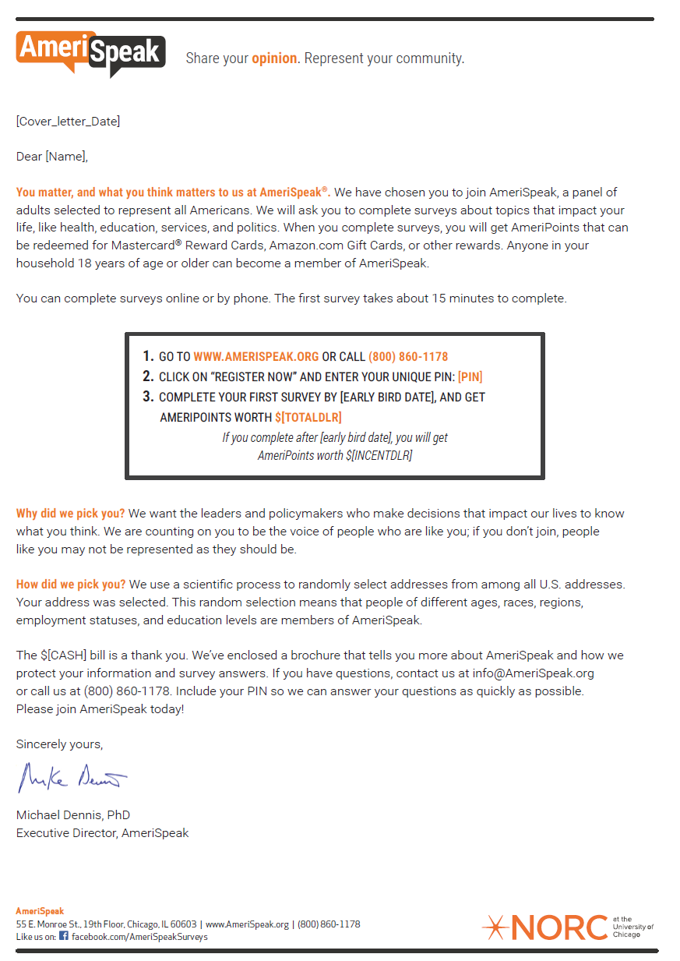
If the potential panelist goes to www.AmeriSpeak.org as instructed in their invitation letter, they will see the following screens:
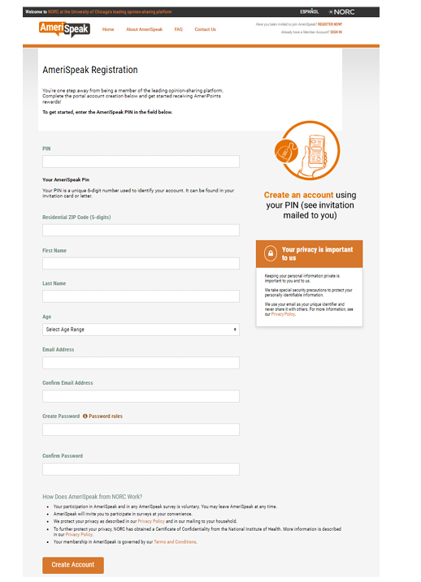

Above page in higher resolution: