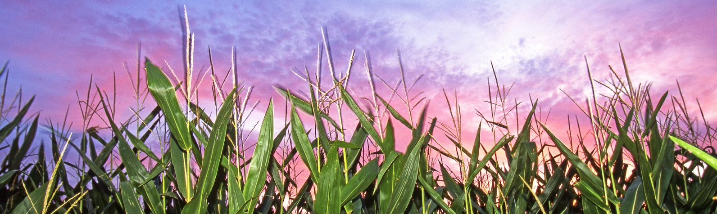

Corn or Soybean Farmer Interviews

Researchers at Michigan State University and the USDA Economic Research Service are conducting interviews with corn or soybean farmers to better understand farming practices, such as cover crops.

Your input will help us design a survey that is clear, easy to complete, and provides valuable information for farm policies. All your responses will be confidential.

We estimate the interview process will take one hour, and it will be done on the internet using the Zoom conferencing program.

As a token of appreciation, you will receive $50 for participating.

If interested, or for more information,
please contact Frank Lupi at:
CropSurvey@usda.gov

