{Spanish version}

Survey Announcement  Dear [Denver/Miami] Area Resident,  In a few days, you will receive a letter in the mail inviting you to participate in an important research project being conducted on behalf of the United States Department of Agriculture (USDA).  We are writing in advance because we have found that many people like to know ahead of time that they will be contacted, so I hope you will choose to participate in this research. It is vital that we hear from as many people as possible.  We appreciate your time and thank you for helping with this important survey!  Sincerely, | Anuncio de la Encuestacio de la encuesta
  Victoria Fields |  | Becca Jablonski |  | Matt Bruce
  U.S. Department of Agriculture |  | Colorado State University |  | Corona Insights


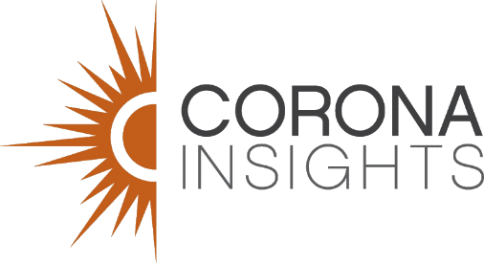
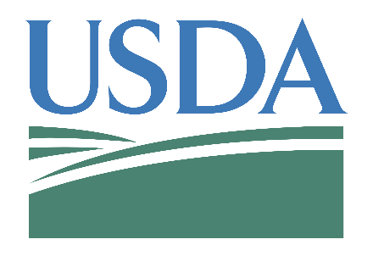
It’s only with the help of people like you that our research can be successful.

Solo con la ayuda de personas como usted nuestra investigación podrá tener éxito.

OMB Approved 0579-XXXX Expires: XX/20XX

