Request for Nonsubstantive Change
ICR 0579-0297

October 31, 2023

APHIS conducted a review of VS Form 1-36A, National Veterinary Accreditation Program Application Form, and requests approval for the following nonsubstantive changes.

The changes are the result of consolidating and modifying several blocks.

The changes do not affect response time or burden.

Block 2: Change “Authorization in a new State” to “Authorization in an additional State”.

Blocks 3 to 12: Unchanged.

Blocks 13 to 16 changes to Blocks 13 to 19: Three new fields added (see screenshots below - changes captured red boxes).

CHANGE
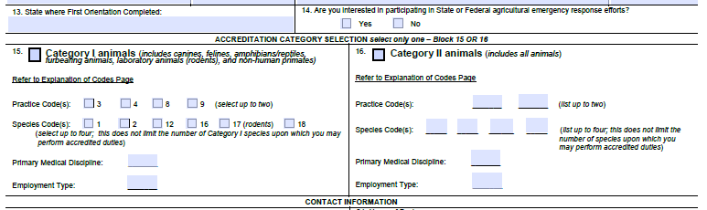

TO
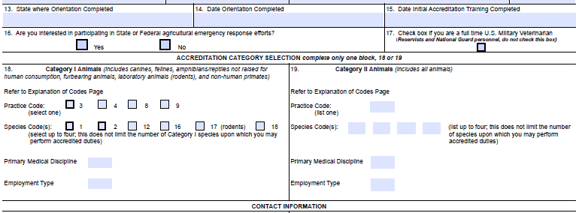

Blocks 17 to 33 Contact Information are now Blocks 20 to 29: Consolidated the number of fields to enter addresses for both homes and businesses. Changed “Email Address” to “Email Address-Mandatory to Maintain your Accreditation”. (see screenshots below).

CHANGE
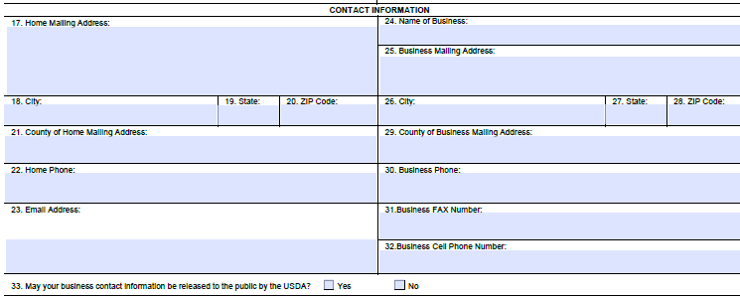

TO
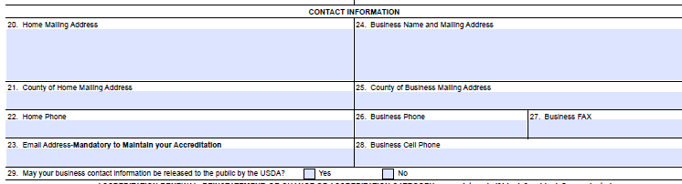

Blocks 34 to 42 are now Blocks 30 to 38 (see screenshots below – changes captured red boxes).

CHANGE
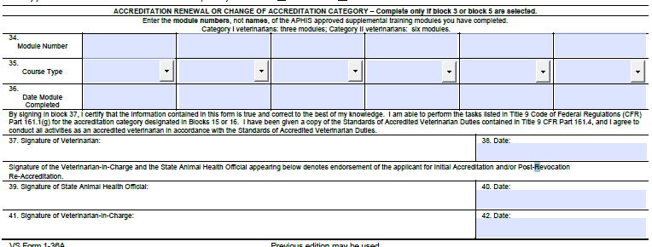

TO
