**Appendix I1.1 Staff Questionnaire Screenshots**

**This page has been left blank for double-sided copying.**

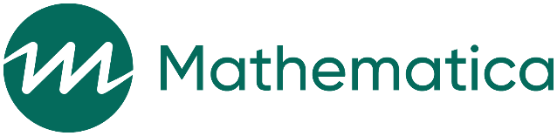

OMB Control Number: 0584-XXXX

Expiration Date: XX/XX/XXXX

Rapid cycle evaluation of operational improvements in SNAP E&T:

Staff questionnaire

|  |
| --- |
| Public Burden Statement  This information is being collected to assist the Food and Nutrition Service in evaluating operational improvements in Supplemental Nutrition Assistance Program (SNAP) Employment and Training (E&T) programs that aim to improve delivery of services and program outcomes. This is a voluntary collection and FNS will use the information to assess the effectiveness of changes made to the SNAP E&T program. This collection does request any personally identifiable information under the Privacy Act of 1974. According to the Paperwork Reduction Act of 1995, an agency may not conduct or sponsor, and a person is not required to respond to, a collection of information unless it displays a valid OMB control number. The valid OMB control number for this information collection is 0584-[xxxx]. The time required to complete this information collection is estimated to average 15 minutes (0.25 hours) per response, including the time for reviewing instructions, searching existing data sources, gathering and maintaining the data needed, and completing and reviewing the collection of information. Send comments regarding this burden estimate or any other aspect of this collection of information, including suggestions for reducing this burden, to: U.S. Department of Agriculture, Food and Nutrition Service, Office of Policy Support, 1320 Braddock Place, 5th Floor, Alexandria, VA 22306 ATTN: PRA (0584-xxxx). Do not return the completed form to this address. |
| **Privacy Act Statement**  **Authority:** This information is being collected under the authority of Section 9 of the Food and Nutrition Act of 2008, as amended, (7 U.S.C. 2018). Disclosure of the information is voluntary.  **Purpose:** The information is being collected to evaluate Child Support Cooperation Requirements in United States Department of Agriculture (USDA) Supplemental Nutrition Assistance Program (SNAP).  **Routine Use:** The information may be shared with SNAP contract researchers and USDA SNAP research and administrative staff.  **Disclosure:** If all or any part of the information is not provided, interviews may not be admissible in data sets. |

