Appendix A

RUDI Survey of RWHAP Providers and Subrecipients

Rapid Uptake of Disseminated Interventions (RUDI)
Survey of RWHAP Providers and Subrecipients
Thank you for participating in the Rapid Uptake of Disseminated Interventions (RUDI) Survey of RWHAP Providers and Subrecipients, administered on behalf of the HIV/AIDS Bureau (HAB) in the U.S. Department of Health and Human Services. The survey should be answered by the person most knowledgeable about the resources your organization has used during the past year to identify and implement innovative interventions to improve care and health outcomes for people with HIV. The person who completes the survey may engage others to determine the most appropriate answers to the questions. The survey should take about 15-20 minutes to complete.
By completing this survey, you understand the following – there is no risk to participating, information you provide will be kept confidential and stored in a secure password-protected file, participation is voluntary, you can skip items you do not want to answer, and you may stop the survey at any time. The information you provide will only be used for the RUDI Evaluation.
If you have any questions or require assistance, please contact Kirsten Barrett at kbarrett@mathematica-mpr.com.
Please click ‘Start’ to begin.

<PROGRAMMER NOTE - PAGE BREAK>
Throughout this survey, you will be asked questions about interventions and resources. We define these terms as follows:
Intervention: An intentionally implemented change strategy to improve the delivery of care and treatment and health outcomes for people with HIV. For this survey, we focus on evidence-based, evidence-informed, and emerging interventions. Most notably, those developed through the Ryan White HIV/AIDS Program (RWHAP) Part F Special Projects of National Significance (SPNS) and other technical assistance initiatives that are made available through the TargetHIV website.
Positive Peers Mobile App, circled in red below, is an example of an intervention located on TargetHIV's Best Practices Compilation webpage.
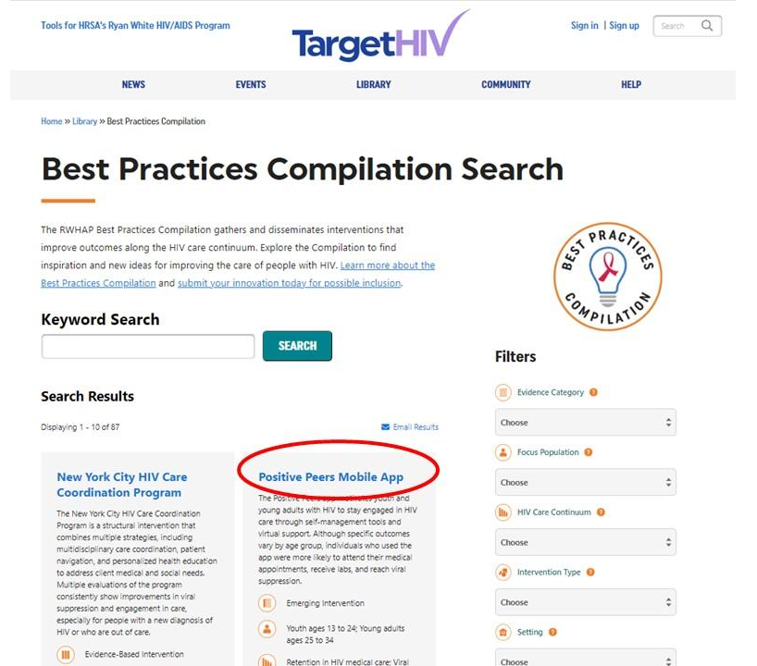

Resources: Web-based documents, materials, and tools available on www.TargetHIV.org, www.ryanwhite.hrsa.gov, AIDS Education and Training Center websites, state or local health department websites, and relevant non-government websites to help organizations implement interventions to improve care delivery and health outcomes for people with HIV. Examples include guidelines and manuals, webinars and trainings, reports and best practices, and conference presentations, as well as links to resources available on other websites.
Resources and tools associated with the Positive Peers Mobile App intervention are circled in red below. It is accessed by clicking 'Resources and Tools' in the 'On This Page' menu (green circle).
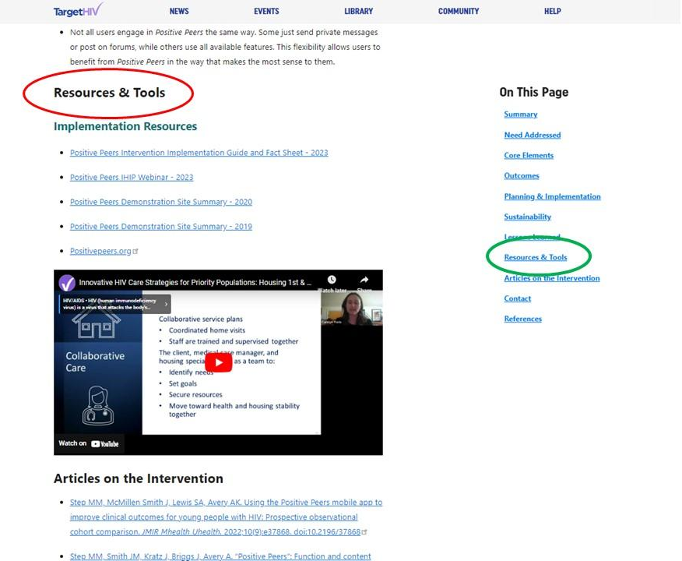

<PROGRAMMER NOTE - PAGE BREAK>

Screener
We want to make sure you are the right person to answer questions on this survey.
S1. Do you know whether and how staff in your organization access and use resources from HAB’s TargetHIV website or other sources to support efforts to improve care for people with HIV?
¹ Yes (Go to Q1)
⁰ No

S2. Please provide the following information for the person at your organization that would best be able to complete the Rapid Uptake of Disseminated Interventions (RUDI) Survey of RWHAP Providers.
We will contact this person with an invitation to complete the survey.
First name __________________________
Last name __________________________
Phone __________________________
Email address __________________________
Confirm email address __________________________
<END SURVEY>
Section I: Access to and Use of Web-Based Resources to Improve Care for People with HIV
In this section, we first ask about any resources your organization may have accessed on the TargetHIV website. We then ask you about any resources accessed on other websites.
- During the past 2 years, did staff in your organization access resources on the TargetHIV website to improve the delivery of care for people with HIV?

If you can’t remember whether the resources you accessed were on TargetHIV, please link to TargetHIV here and enter a keyword or phrase to search for resources you used—if found, answer yes; if not, answer no.
¹ Yes ⁰ No (Go to Q4)

- When staff in your organization accessed resources, which section(s) of the TargetHIV website did they find most helpful? Select up to three.
If you are not sure where resources were located on the TargetHIV website, enter the name of the resource and/or the URL in the ‘Other (specify)’ space provided.
¹ Best Practices Compilation
² HIV Care Innovations
³ HIV Care Continuum
⁴ Medical & Support Services
⁵ Service Models
⁶ Evidence-Informed Interventions (E2i)
⁷ Special Projects of National Significance
⁸ Center for Innovation and Engagement
⁹ Dissemination of Evidence-Informed Interventions
¹⁰ Integrating HIV Innovative Practices
¹¹ Other (specify):

<PROGRAMMER - Responses will be linked when survey is programmed.>
- Did staff in your organization use any of the resources they sought on the TargetHIV website to help implement a new intervention or improve an existing one?

For example, an intervention could be a program or strategy to retain people in HIV care. And a resource could be a manual describing how to develop a program for including peers in retention in care.
¹ Yes
⁰ No (Go to Q6)

(Q1=0)
You indicated that staff in your organization did not access resources on the TargetHIV website to improve the delivery of care for people with HIV. HAB would like to better understand why resources were not accessed.
- For each of the following, please indicate if it was a reason why staff within your organization did not access resources on TargetHIV in the past 2 years.

4a. Staff were not aware of TargetHIV resources. ¹ Yes ⁰ No

4b. Staff had no plan to implement new interventions or programs. ¹ Yes ⁰ No

4c. Staff had all the internal knowledge and resources needed without further support. ¹ Yes ⁰ No

4d. Staff shortages required existing staff to focus on more immediate client needs. ¹ Yes ⁰ No

4e. Staff looked for resources through channels other than TargetHIV. ¹ Yes ⁰ No (Go to 5)

4e1. What other channels did staff use to look for non-TargetHIV resources?

¹ AIDS Education Training Center website
² State health department website
³ Local health department website
⁴ Non-governmental website
⁵ Source other than a website (specify) _____________________________

- Did staff in your organization use any non-TargetHIV resources to help implement a new intervention or improve an existing one focused on care for people with HIV?
¹ Yes
⁰ No (Go to Q14)

5a. Which of the following best describes the type of intervention your organization implemented? Check all that apply.
¹ Clinical service delivery model
² Support service delivery model
³ Use of technology and mobile health
⁴ Data utilization approach
⁵ Outreach and engagement activity
⁶ Systems/structural interventions
⁷ Quality improvement
⁸ Other (specify)

5b. What area(s) of the HIV care continuum did the intervention address? Select all that apply.
¹ HIV diagnosis
² Linkage to HIV medical care
³ Prescription of antiretroviral therapy
⁴ Retention in HIV medical care
⁵ Viral suppression
⁶ Beyond the care continuum

5c. What population(s) did the intervention target? Select all that apply.
¹ American Indian / Alaska Native people ¹³ People with HIV experiencing food insecurity
² Black gay and bisexual men ¹⁴ People with HIV who are NOT in care
³ Gay and bisexual men of color ¹⁵ People with multiple chronic conditions
⁴ Hispanic / Latina(o/x) people ¹⁶ People with newly diagnosed HIV
⁵ People living in rural areas ¹⁷ People with opioid use disorder
⁶ People who are incarcerated ¹⁸ People with substance use disorder
⁷ People who are unstably housed ¹⁹ People with undiagnosed HIV
⁸ People who inject drugs ²⁰ Transgender women
⁹ People with a history of trauma ²¹ Women
¹⁰ People with a diagnosis of mental illness ²² Women of color
¹¹ People with HCV ²³ Young Black men who have sex with men
¹² People with HIV ²⁴ Youth people ages 13 to 24
²⁵ Other (specify): ____________________

<PROGRAMMER – GO TO Q14>
<PROGRAMMER NOTE – PAGE BREAK>
(Q3=0)
You indicated that staff in your organization accessed resources on the TargetHIV website but did not use any of them to improve the delivery of care for people with HIV. HAB would like to better understand why resources were accessed but not used.
- For each of the following, indicate if it was a reason why resources accessed on the TargetHIV website were not used.

6a. The resources addressed interventions that were not well aligned with client needs. ¹ Yes ⁰ No

6b. The resources lacked the detail needed to support implementation. ¹ Yes ⁰ No

6c. The resources were too confusing to understand or use. ¹ Yes ⁰ No

6d. Staff shortages required existing staff to focus on more immediate client needs ¹ Yes ⁰ No

6e. Staff looked for resources through channels other than TargetHIV ¹ Yes ⁰ No (Go to 7)

6e1. What other channels did you use?

¹ AIDS Education Training Center website
² State health department website
³ Local health department website
⁴ Non-governmental website
⁵ Source other than a website (specify) _____________________________

- Did staff in your organization use any non-TargetHIV resources to help implement a new intervention or improve an existing one focused on care for people with HIV?
¹ Yes
⁰ No (Go to Q14)

7a. Which of the following best describes the type of intervention your organization implemented? Check all that apply.
¹ Clinical service delivery model
² Support service delivery model
³ Use of technology and mobile health
⁴ Data utilization approach
⁵ Outreach and engagement activity
⁶ Systems/structural interventions
⁷ Quality improvement
⁸ Other (specify)

7b. What area(s) of the HIV care continuum did the intervention address? Select all that apply.
¹ HIV diagnosis
² Linkage to HIV medical care
³ Prescription of antiretroviral therapy
⁴ Retention in HIV medical care
⁵ Viral suppression
⁶ Beyond the care continuum

7c. What population(s) did the intervention target? Select all that apply.
¹ American Indian / Alaska Native people ¹³ People with HIV experiencing food insecurity
² Black gay and bisexual men ¹⁴ People with HIV who are NOT in care
³ Gay and bisexual men of color ¹⁵ People with multiple chronic conditions
⁴ Hispanic / Latina(o/x) people ¹⁶ People with newly diagnosed HIV
⁵ People living in rural areas ¹⁷ People with opioid use disorder
⁶ People who are incarcerated ¹⁸ People with substance use disorder
⁷ People who are unstably housed ¹⁹ People with undiagnosed HIV
⁸ People who inject drugs ²⁰ Transgender women
⁹ People with a history of trauma ²¹ Women
¹⁰ People with a diagnosis of mental illness ²² Women of color
¹¹ People with HCV ²³ Young Black men who have sex with men
¹² People with HIV ²⁴ Youth people ages 13 to 24
²⁵ Other (specify): ____________________

<PROGRAMMER – GO TO Q14>
<PROGRAMMER NOTE – PAGE BREAK>
Section II: Usefulness of Intervention Resources on TargetHIV for Delivering Care
(Q1=1 and Q3=1)
You indicated that staff in your organization searched for and used intervention resources from the TargetHIV website during the past 2 years to improve care delivery.
- Please indicate the name of an intervention your organization implemented with the support of resources found on the TargetHIV website.
If your organization implemented more than two interventions, indicate the one that had the greatest impact on care delivery and health outcomes.
Name of intervention (example): Peer Linkage and Re-engagement of Women of Color with HIV

Please record the name of an intervention your organization implemented with support of resources found on the TargetHIV website.

Name of intervention:
<PROGRAMMER NOTE – PAGE BREAK>

THE FOLLOWING QUESTIONS ARE ABOUT THE INTERVENTION YOU REPORTED:
<Fill from Q8>

- How did staff in your organization first hear about the intervention? Select one only.

¹ HAB project officer (Go to Q9a)
² non-HAB project officer
³ Professional contact
⁴ Another organization providing care for people living with HIV or another chronic condition
⁵ Announcement by federal agency
⁶ Email listserv or email announcement
⁷ Website
⁸ Social media site
⁹ Conference or professional event
¹⁰ Online community forum
¹¹ Professional association
¹² Other (please specify): ___________________________________________________ (Go to Q9a)

If Q9=2, then Q9_2: With what agency was the non-HAB project officer associated?
If Q9=2, then Q9_3: What was the role of professional contact?
If Q9=3, then Q9_4: What organization?
If Q9=4, then Q9_5: What federal agency?
If Q9=5, then Q9_6: Who distributed the email listserv or announcement?
If Q9=6, then Q9_7: What website?
If Q9=7, then Q9_8: What social media site?
If Q9=8, then Q9_9: Which conference or professional event?
If Q9=9, then Q9_10: What online community forum?
If Q9=10, then Q9_11: What professional association?

9a. Which of the following best describes the type of intervention your organization implemented? Check all that apply.
¹ Clinical service delivery model
² Support service delivery model
³ Use of technology and mobile health
⁴ Data utilization approach
⁵ Outreach and engagement activity
⁶ Systems/structural interventions
⁷ Quality improvement
⁸ Other (specify)

9b. What area(s) of the HIV care continuum did the intervention address? Select all that apply.
¹ HIV diagnosis
² Linkage to HIV medical care
³ Prescription of antiretroviral therapy
⁴ Retention in HIV medical care
⁵ Viral suppression
⁶ Beyond the care continuum

9c. What population(s) did the intervention target? Select all that apply.
¹ American Indian / Alaska Native people ¹³ People with HIV experiencing food insecurity
² Black gay and bisexual men ¹⁴ People with HIV who are NOT in care
³ Gay and bisexual men of color ¹⁵ People with multiple chronic conditions
⁴ Hispanic / Latina(o/x) people ¹⁶ People with newly diagnosed HIV
⁵ People living in rural areas ¹⁷ People with opioid use disorder
⁶ People who are incarcerated ¹⁸ People with substance use disorder
⁷ People who are unstably housed ¹⁹ People with undiagnosed HIV
⁸ People who inject drugs ²⁰ Transgender women
⁹ People with a history of trauma ²¹ Women
¹⁰ People with a diagnosis of mental illness ²² Women of color
¹¹ People with HCV ²³ Young Black men who have sex with men
¹² People with HIV ²⁴ Youth people ages 13 to 24
²⁵ Other (specify): ____________________
<PROGRAMMER NOTE – PAGE BREAK>

THESE ARE THE FINAL QUESTIONS ABOUT THE INTERVENTION YOU REPORTED:
<Fill with Q8>

- How did staff in your organization learn details about the intervention? Select all that apply.
¹ Downloaded reports or best practices ⁹ Participated in a learning collaborative
² Downloaded implementation manuals ¹⁰ Participated in other training
³ Downloaded/viewed conference presentations ¹¹ Attended conference or webinar series (less than 6)
⁴ Listservs ¹² Attended conference or webinar series (6 or more)
⁵ Community forum ¹³ Completed online course(s)
⁶ Discussed with peers outside my organization ¹⁴ Engaged in QuizTime course(s)
⁷ Learned from viewing informative websites ¹⁶ Other (specify)
¹⁵ Participated in online or phone consultation
⁸ Participated in ECHO model

- Thinking again about the resources you used to help implement the intervention, what did staff in your organization find most helpful about the resources accessed on the TargetHIV website? Select all that apply.
¹ Easy to access
² Easy to use
³ High quality content
⁴ Comprehensiveness of the content
⁵ Applicable to my setting
⁶ Applicable to my population
⁷ Availability of technical support
⁸ Resources were not helpful
⁹ Helpful in some other way (specify):

- Did these resources contribute in a meaningful way to any of the following? Select all that apply.
¹ The decision to implement the intervention
² Development of an implementation plan
³ Initial implementation success
⁴ Integrating the intervention into usual practice to sustain its success
⁵ The resources did not contribute meaningfully to any aspect of implementation
⁶ The resources contributed meaningfully in some other way (specify)______________________________
<PROGRAMMER NOTE - PAGE BREAK>

- Did staff implement the intervention like how it was described in the materials you reviewed, or did they need to make changes to best meet client needs?

¹ Implemented as described (Q14)
² Made changes
13a. What types of changes did staff need to make to the intervention? Select all that apply.
¹ Different focus population for the intervention
² Changed how it was implemented to fit our staffing structure
³ Changed how it was implemented to reduce cost and/or implementation time
⁴ Changed what was implemented so that a subset of activities that best met client needs were implemented
⁵ Changed what was implemented so that all activities were implemented but they were modified to best meet client needs.

13b. Overall, did the changes that were made to the intervention increase its scope, decrease its scope, or did the scope remain the same?

1 Increased scope
2 Decreased scope
3 Scope remained the same

<PROGRAMMER NOTE - PAGE BREAK>
Section III. Recommendations for Future Dissemination Activities
We are interested in hearing how HAB can strengthen the reach and effectiveness of the resources it disseminates to improve care delivery and health outcomes for people with HIV.
- In your opinion, what are the most effective ways to obtain information on planning, implementing, adapting, and replicating care delivery interventions? Select all that apply
¹ Download reports or best practices ¹⁰ Participate in a learning collaborative
² Download implementation manuals ¹¹ Participate in other training
³ Download/view conference presentations ¹² Attend conference or webinar series (less than 6)
⁴ Listservs ¹³ Attend conference or webinar series (6 or more)
⁵ Community forum ¹⁴ Complete online course(s)
⁶ Discuss with peers outside my organization ¹⁵ Engage in QuizTime course(s)
⁷ Learn from viewing informative websites ¹⁶ Other (specify)
⁸ Participate in online or phone consultation
⁹ Participate in ECHO model
<PROGRAMMER NOTE - PAGE BREAK>
The next three questions ask about resources your organization might use in the future.
- What type of intervention(s) would benefit the most from additional intervention resources? Select all that apply.
¹ Clinical service delivery model
² Support service delivery model
³ Use of technology and mobile health
⁴ Data utilization approach
⁵ Outreach and engagement activity
⁶ Systems/structural interventions
⁷ Quality improvement

- What area(s) of the HIV care continuum would benefit the most from additional intervention resources? Select all that apply.
¹ HIV diagnosis
² Linkage to HIV medical care
³ Prescription of antiretroviral therapy
⁴ Retention in HIV medical care
⁵ Viral suppression
⁶ Beyond the care continuum

- What population(s) would benefit the most from additional interventions resources? Select all that apply.
¹ American Indian / Alaska Native people ¹³ People with HIV experiencing food insecurity
² Black gay and bisexual men ¹⁴ People with HIV who are NOT in care
³ Gay and bisexual men of color ¹⁵ People with multiple chronic conditions
⁴ Hispanic / Latina(o/x) people ¹⁶ People with newly diagnosed HIV
⁵ People living in rural areas ¹⁷ People with opioid use disorder
⁶ People who are incarcerated ¹⁸ People with substance use disorder
⁷ People who are unstably housed ¹⁹ People with undiagnosed HIV
⁸ People who inject drugs ²⁰ Transgender women
⁹ People with a history of trauma ²¹ Women
¹⁰ People with a diagnosis of mental illness ²² Women of color
¹¹ People with HCV ²³ Young Black men who have sex with men
¹² People with HIV ²⁴ Youth people ages 13 to 24
²⁵ Other (specify): ____________________________________
<PROGRAMMER NOTE - PAGE BREAK>
HAB is interested in suggestions for improving the quality, design, availability, and accessibility of its disseminated intervention resources, or anything else you think would improve them.
- How can HAB improve the way it disseminates intervention resources to help your organization or subrecipients improve care delivery and health outcomes for people with HIV?
__________________________________________________________________________________________________________________________________________________________________
- Please name an intervention resource that helped your organization improve care (if any were helpful).
19a. Intervention resource name: ___________________________________________________________
19b. What made this intervention resource useful? _____________________________________________ _________________________________________________________________________________________

19_check. Is there another intervention resource that helped your organization improve care?
¹ Yes
⁰ No (Go to Q23)

19c. Intervention resource name: ___________________________________________________________
19d. What made this intervention resource useful? _____________________________________________ _________________________________________________________________________________________

- In the past 2 years, did your organization participate in any HRSA-led learning collaboratives or quality improvement initiatives?
¹ Yes
⁰ No (Go to Q21)

20a. Please name the HRSA-led learning collaborative or quality improvement initiative in the space provided. If your organization participated in more than one, report the one with the greatest impact on clients.
_________________________________________________________________________________
- Please share any additional comments that you feel are important, in the space provided.
_________________

- Did you receive help from others in your organization to answers questions on this survey?

¹ Yes
⁰ No

