Appendix B

RUDI Survey of RWHAP Part A and B Administrative Recipients

The Rapid Uptake of Disseminated Interventions (RUDI)

Survey of RWHAP Part A and B Administrative Recipients

Thank you for participating in the Rapid Uptake of Disseminated Interventions (RUDI) Survey of RWHAP Part A and B Administrative Recipients, administered on behalf of the HIV/AIDS Bureau (HAB) in the U.S. Department of Health and Human Services. The survey should be answered by the person most knowledgeable about the resources disseminated by HAB related to interventions or initiatives that your organization has used during the past two years. This includes resources to expand staff knowledge, resources to support the implementation of system-level initiatives, and resources to support providers and subrecipients in their efforts to improve care and health outcomes for people with HIV. The person who completes the survey may engage others to determine the most appropriate answers to the questions. The survey should no more than 15-20 minutes to complete.
By completing this survey, you understand the following – there is no risk to participating, information you provide will be kept confidential and stored in a secure password-protected file, participation is voluntary, you can skip items you do not want to answer, and you may stop the survey at any time. The information you provide will only be used for the RUDI Evaluation.
If you have any questions or require assistance, please contact Kirsten Barrett at kbarrett@mathematica-mpr.com.
Please click ‘Start’ to begin.
<PROGRAMMER NOTE - PAGE BREAK>
Throughout this survey, you will be asked questions about interventions and resources. We define these terms as follows:
Intervention: An intentionally implemented change strategy to improve the delivery of care and treatment and health outcomes for people with HIV. For this survey, we focus on evidence-based, evidence-informed, and emerging interventions. Most notably, those developed through the Ryan White HIV/AIDS Program (RWHAP) Part F Special Projects of National Significance (SPNS) and other technical assistance initiatives that are made available through the TargetHIV website.
Positive Peers Mobile App, circled in red below, is an example of an intervention located on TargetHIV's Best Practices Compilation webpage.
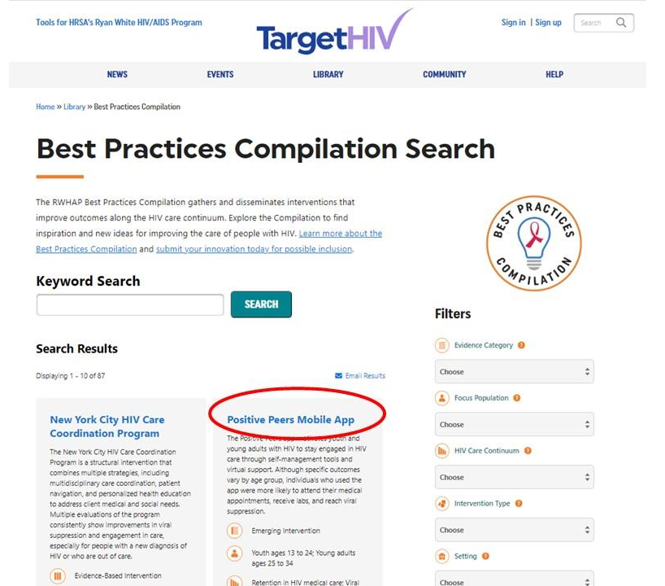

Resources: Web-based documents, materials, and tools available on www.TargetHIV.org, www.ryanwhite.hrsa.gov, AIDS Education and Training Center websites, state or local health department websites, and relevant non-government websites to help organizations implement interventions to improve care delivery and health outcomes for people with HIV. Examples include guidelines and manuals, webinars and trainings, reports and best practices, and conference presentations, as well as links to resources available on other websites.
Resources and tools associated with the Positive Peers Mobile App intervention are circled in red below. They are accessed by clicking 'Resources and Tools' in the 'On This Page' menu (green circle).
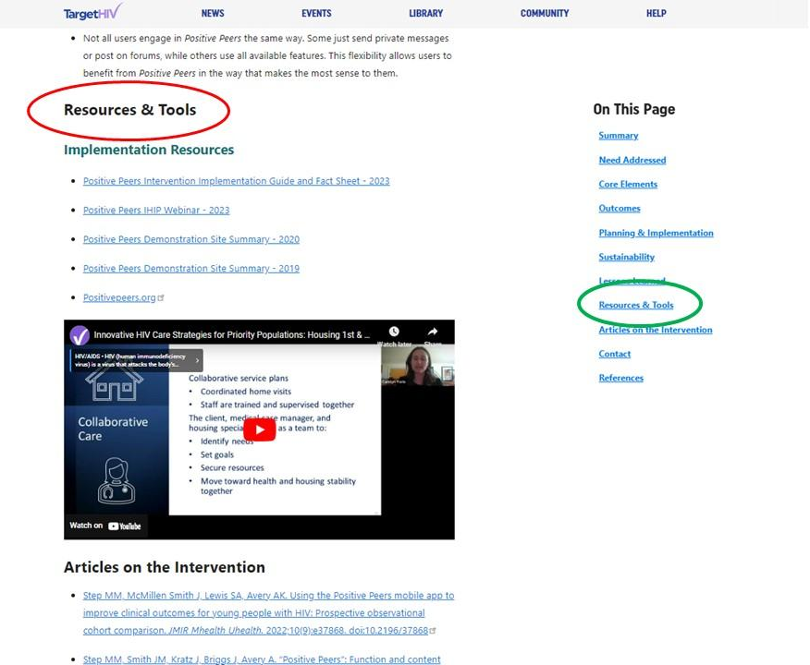

Screener
We want to make sure you are the right person to answer questions on this survey.
S1. Do you know whether and how staff in your organization access and use resources from HAB’s TargetHIV website or other sources to support efforts to improve care for people with HIV?
¹ Yes (Go to Q1)
⁰ No

S2. Please provide the following information for the person at your organization that would best be able to complete the Rapid Uptake of Disseminated Interventions (RUDI) Survey of RWHAP Part A and B Administrative Recipients.
We will contact this person with an invitation to complete the survey.
First name __________________________
Last name __________________________
Phone __________________________
Email address __________________________
Confirm email address __________________________
<END SURVEY>
<PAGE BREAK>
Section I: Access to and Use of Web-Based Resources
- During the past 2 years, did staff in your organization access any resources on the TargetHIV website?

If you can’t remember whether the resources accessed were on TargetHIV, please link to TargetHIV here and enter a keyword or phrase to search for resources used—if found, answer yes; if not, answer no.

¹ Yes
⁰ No

- Did your HAB project officer encourage staff at your organization to access resources on the TargetHIV website?

¹ Yes
⁰ No

<Programmer: If Q1=0, go to Q18. If Q1=1, go to Q3.>

- When staff in your organization accessed resources, which section(s) of the TargetHIV website did they find most helpful? Select up to three.
If you are not sure where resources were located on the TargetHIV website, enter the name of the resource and/or the URL in the ‘Other (specify)’ space provided.
¹ Best Practices Compilation
² HIV Care Innovations
³ HIV Care Continuum
⁴ Medical & Support Services
⁵ Service Models
⁶ Evidence-Informed Interventions (E2i)
⁷ Special Projects of National Significance
⁸ Center for Innovation and Engagement
⁹ Dissemination of Evidence-Informed Interventions
¹⁰ Integrating HIV Innovative Practices
¹¹ Other (specify):

<PROGRAMMER: Responses on Q3 will be linked when survey is programmed.>

- What did staff in your organization find most helpful about the resources accessed on the TargetHIV website?
Select all that apply.

¹ Easy to access
² Easy to use
³ High quality content
⁴ Comprehensiveness of the content
⁵ Applicable to the right setting
⁶ Applicable to the right population
⁷ Availability of technical support
⁸ Other (specify):

- Why did staff in your organization access resources on the TargetHIV website? Select all that apply.

¹ To increase their own knowledge
² To implement a system-level initiative (for example, Strengthening Systems of Care for People with HIV & Opioid Use Disorder, Jurisdictional Approach to Curing Hepatitis C among HIV/HCV Coinfected People of Color, and Building Capacity to Improve Collecting and Reporting Viral Suppression Data to the Medicaid Adult Core Set)
³ To find materials to assist subrecipients with specific needs
⁴ Other (specify)_________________________________________

- Did these resources contribute in a meaningful way to any of the following? Select all that apply.
¹ The decision to implement the initiative
² Development of an implementation plan
³ Initial implementation success
⁴ Integrating the initiative into usual practice to sustain its success
⁵ The resources did not contribute meaningfully to any aspect of implementation
⁶ The resources contributed meaningfully in some other way (specify): ________________________________

PROGRAMMER NOTE:
IF Q5=2, GO TO Q7 (initiative items).
IF Q5=3 and Q5 not = 2, GO TO Q15 (subrecipient items).
IF Q5 not 2 and Q5 not 3, go to Q20 (Section V).

Section II: TargetHIV Resources Supporting System-Level Initiatives
You indicated that staff in your organization accessed resources from the TargetHIV website to support a system-level initiative during the past 2 years.
- Please indicate the name of one system-level initiative your organization has implemented with the support of resources found on the TargetHIV website.
If your organization implemented more than one system-level initiative, indicate the one that had the greatest impact on care delivery and health outcomes.
Name of system-level initiative (example): Strengthening Systems of Care for People with HIV & Opioid Use Disorder

Name of system-level initiative: ____________________________________________________________

<PROGRAMMER NOTE – PAGE BREAK>

THE FOLLOWING QUESTIONS ARE ABOUT THE SYSTEM-LEVEL INITIATIVE YOU REPORTED:
<Fill from Q7>

- How did staff in your organization first hear about the system-level initiative? Select one only.

¹ HAB project officer (Go to Q9)
² Non-HAB project officer
³ Special Projects of National Significance (SPNS) recipient (Go to Q9)
⁴ Professional contact (other than project officer)
⁵ Another organization providing care for people living with HIV or another chronic condition
⁶ Announcement by federal agency
⁷ Email listserv or email announcement
⁸ Website
⁹ Social media site
¹⁰ Conference or professional event
¹¹ Online community forum
¹² Professional association
¹³ Other (please specify): _____________________________________________(Go to Q9)

If Q8=2, then Q8_2: What agency did the non-HAB project officer represent? If Q8=4, then Q8_4: What was the role of professional contact?
If Q8=5, then Q8_5: What organization?
If Q8=6, then Q8_6: What federal agency?
If Q8=7, then Q8_7: Who distributed the email listserv or announcement?
If Q8=8, then Q8_8: What website?
If Q8=9, then Q8_9: What social media site?
If Q8=10, then Q8_10: Which conference or event?
If Q8=11, then Q8_11: What online community forum?
If Q8=12, then Q8_12: What professional association?

- Which of the following best describes the type of system-level initiative your organization has been implementing? Select all that apply.
¹ Clinical service delivery model
² Support service delivery model
³ Use of technology and mobile health
⁴ Data utilization approach
⁵ Outreach and engagement activity
⁶ Systems/structural interventions
⁷ Quality improvement
⁸ Other (specify)

- What area(s) of the HIV care continuum did the system-level initiative address? Select all that apply.
¹ HIV diagnosis
² Linkage to HIV medical care
³ Prescription of antiretroviral therapy
⁴ Retention in HIV medical care
⁵ Viral suppression
⁶ Beyond the care continuum

- What population(s) did the system-level initiative target? Select all that apply.
¹ American Indian / Alaska Native people ¹³ People with HIV experiencing food insecurity
² Black gay and bisexual men ¹⁴ People with HIV who are NOT in care
³ Gay and bisexual men of color ¹⁵ People with multiple chronic conditions
⁴ Hispanic / Latina(o/x) people ¹⁶ People with newly diagnosed HIV
⁵ People living in rural areas ¹⁷ People with opioid use disorder
⁶ People who are incarcerated ¹⁸ People with substance use disorder
⁷ People who are unstably housed ¹⁹ People with undiagnosed HIV
⁸ People who inject drugs ²⁰ Transgender women
⁹ People with a history of trauma ²¹ Women
¹⁰ People with a diagnosis of mental illness ²² Women of color
¹¹ People with HCV ²³ Young Black men who have sex with men
¹² People with HIV ²⁴ Youth people ages 13 to 24
²⁵ Other (specify): ____________________

THESE ARE THE FINAL QUESTIONS ABOUT THE SYSTEM-LEVEL INITIATIVE YOU REPORTED:
<Fill with Q7>

- How did staff in your organization learn details about the system-level initiative? Select all that apply.
¹ Downloaded reports, fact sheets, or related documents ¹⁰ Participated in a learning collaborative
² Participated in online or phone consultation with SPNS recipient ¹¹ Participated in other training
³ Downloaded implementation manuals ¹² Attended conference or webinar series (less than 6)
⁴ Downloaded/viewed conference presentations ¹³ Attended conference or webinar series (6 or more)
⁵ Listservs ¹⁴ Completed online course(s)
⁶ Community forum ¹⁵ Engaged in QuizTime course(s)
⁷ Discussed with peers outside my organization ¹⁶ Other (specify)
⁸ Learned from viewing informative websites
⁹ Participated in ECHO model

- Thinking again about the resources you used to help implement the initiative, what did staff in your organization find most helpful about the resources accessed on the TargetHIV website? Select all that apply.
¹ Easy to access
² Easy to use
³ High quality content
⁴ Comprehensiveness of the content
⁵ Applicable to my setting
⁶ Applicable to my population
⁷ Availability of technical support
⁸ Resources were not helpful
⁹ Helpful in some other way (specify):

- Did these resources contribute in a meaningful way to any of the following? Select all that apply.
¹ The decision to implement the system-level initiative
² Development of an implementation plan
³ Initial implementation success
⁴ Integrating the system-level initiative into usual practice to sustain its success
⁵ The resources did not contribute meaningfully to any aspect of implementation
⁶ The resources contributed meaningfully in some other way (specify):________________________

<PROGRAMMER NOTE: IF Q5=3, GO TO Q15. ELSE GO TO Q20.>
< PAGE BREAK>

Section III: Support for Subrecipients
(Q5=3)
- How many subrecipients do your staff work with that provide direct services to clients living with HIV?
Please provide a numeric response (e.g., 5).
__ __ __ (programmer – response should be > 0)
15a. In the past two years, how many of your subrecipients referenced above were encouraged to or received support from your staff to use TargetHIV resources?

Please provide a numeric response (e.g., 5). Your response should be the less than or the same as the number you reported above.
__ __ __

- In what topic areas does your organization use TargetHIV resources to assist subrecipients with specific needs? Select all that apply.
¹ Outreach and engagement activities
² Clinical services
³ Support services
⁴ Use of technology and mobile health
⁵ Data management and data utilization approaches
⁶ Quality improvement
⁷ Other (specify)

- How often do subrecipients use the TargetHIV resources staff share with them to improve care? Your best estimate is fine.
¹ Never
² Less than 25% of the time
³ Between 25% and 49% of the time
⁴ Between 50% and 75% of the time
⁵ Between 75% and 99% of the time
⁶ Every time

PROGRAMMER NOTE: GO TO Q20.

Section IV: Reasons for Not Accessing TargetHIV Resources
HAB would like to better understand why staff in your organization have not accessed resources on the TargetHIV website in the past two years.
(Q1=0)
- For each of the following, please indicate if it was a reason why staff in your organization did not access resources on the TargetHIV in the past 2 years.
18a. Staff did not need resources because none of our subrecipients
planned to implement new interventions or programs. ¹ Yes ⁰ No

18b. Subrecipient staff planned to make care delivery improvements
but had all the knowledge and resources they needed without further support. ¹ Yes ⁰ No

18c. Staff shortages or turnover within our organization required our staff to
focus on addressing immediate needs of subrecipients, which did not include
care delivery changes. ¹ Yes ⁰ No

18d. Staff within our organization used resources available
through channels other than TargetHIV. ¹ Yes ⁰ No

<Programmer: If 18d=1 go to 18d_1. Else go to 19.>
18d_1. What other channels did staff use?
¹ AIDS Education Training Center website
² State health department website
³ Local health department website
⁴ Non-governmental website
⁵ Source other than a website (specify) _____________________________

- Did staff in your organization use any non-TargetHIV resources to help subrecipients implement a new intervention or improve an existing one focused on care for people with HIV?

¹ Yes
⁰ No (Go to Q20)
19a. What type of intervention(s) did your subrecipients implemented? Check all that apply.
¹ Clinical service delivery model
² Support service delivery model
³ Use of technology and mobile health
⁴ Data utilization approach
⁵ Outreach and engagement activity
⁶ Systems/structural interventions
⁷ Quality improvement
⁸ Other (specify)

19b. What area(s) of the HIV care continuum did the intervention address? Select all that apply.
¹ HIV diagnosis
² Linkage to HIV medical care
³ Prescription of antiretroviral therapy
⁴ Retention in HIV medical care
⁵ Viral suppression
⁶ Beyond the care continuum
19c. What population(s) did the intervention target? Select all that apply.
¹ American Indian / Alaska Native people ¹³ People with HIV experiencing food insecurity
² Black gay and bisexual men ¹⁴ People with HIV who are NOT in care
³ Gay and bisexual men of color ¹⁵ People with multiple chronic conditions
⁴ Hispanic / Latina(o/x) people ¹⁶ People with newly diagnosed HIV
⁵ People living in rural areas ¹⁷ People with opioid use disorder
⁶ People who are incarcerated ¹⁸ People with substance use disorder
⁷ People who are unstably housed ¹⁹ People with undiagnosed HIV
⁸ People who inject drugs ²⁰ Transgender women
⁹ People with a history of trauma ²¹ Women
¹⁰ People with a diagnosis of mental illness ²² Women of color
¹¹ People with HCV ²³ Young Black men who have sex with men
¹² People with HIV ²⁴ Youth people ages 13 to 24
²⁵ Other (specify): ____________________

Section V: Improving Reach and Effectiveness

We are interested in hearing how HAB can strengthen the reach and effectiveness of the resources it disseminates to improve care and health outcomes.
- In your opinion, what are the most effective ways to obtain information on identifying, implementing, adapting, and replicating care delivery interventions or system-level initiatives? Select all that apply.
¹ Download reports, fact sheets, or related documents ¹⁰ Participate in a learning collaborative
² Participate in online or phone consultation with SPNS recipient ¹¹ Participate in other training
³ Download implementation manuals ¹² Attend conference or webinar series (less than 6)
⁴ Download/view conference presentations ¹³ Attend conference or webinar series (6 or more)
⁵ Listservs ¹⁴ Complete online course(s)
⁶ Community forum ¹⁵ Engage in QuizTime course(s)
⁷ Discuss with peers outside my organization ¹⁶ Other (specify)
⁸ Learn from viewing informative websites
⁹ Participate in ECHO model

The next three questions ask about resources your organization or your subrecipients may use in the future.
- What type of intervention(s) would benefit the most from additional intervention resources? Select all that apply.
¹ Clinical service delivery model
² Support service delivery model
³ Use of technology and mobile health
⁴ Data utilization approach
⁵ Outreach and engagement activity
⁶ Systems/structural interventions
⁷ Quality improvement

- What area(s) of the HIV care continuum would benefit the most from additional intervention resources? Select all that apply.
¹ HIV diagnosis
² Linkage to HIV medical care
³ Prescription of antiretroviral therapy
⁴ Retention in HIV medical care
⁵ Viral suppression
⁶ Beyond the care continuum

- What population(s) would benefit the most from additional interventions resources? Select all that apply.
¹ American Indian / Alaska Native people ¹³ People with HIV experiencing food insecurity
² Black gay and bisexual men ¹⁴ People with HIV who are NOT in care
³ Gay and bisexual men of color ¹⁵ People with multiple chronic conditions
⁴ Hispanic / Latina(o/x) people ¹⁶ People with newly diagnosed HIV
⁵ People living in rural areas ¹⁷ People with opioid use disorder
⁶ People who are incarcerated ¹⁸ People with substance use disorder
⁷ People who are unstably housed ¹⁹ People with undiagnosed HIV
⁸ People who inject drugs ²⁰ Transgender women
⁹ People with a history of trauma ²¹ Women
¹⁰ People with a diagnosis of mental illness ²² Women of color
¹¹ People with HCV ²³ Young Black men who have sex with men
¹² People with HIV ²⁴ Youth people ages 13 to 24
²⁵ Other (specify): ____________________________________

HAB is interested in your suggestions for improving the quality, design, availability, and accessibility of its disseminated intervention resources, or anything else you think would improve them.
- How can HAB improve the way it disseminates intervention resources to help your organization or subrecipients improve care delivery and health outcomes for people with HIV?
____________________________________________________________________________________________________________________________________________________________

- Please name an intervention resource that helped your organization or subrecipient providers improve care (if any were helpful).
25_1. Intervention resource name:_____________________________________________________________
25_2. What made this intervention resource useful? ______________________________________
Q25_check. Is there another resource that helped your organization or subrecipient providers improve care?

¹ Yes
⁰ No (Go to Q26)
25_3. Intervention resource name: ___________________________________________________________
25_4. What made this intervention resource useful? ______________________________________
- Please share any additional comments that you feel are important, in the space provided.
_______________________________________________________________________________________________________________________________________________________________________________________________________________________________________________________________________________________________

- Did you receive help from others in your organization to answers questions on this survey?

¹ Yes
⁰ No

