Dear Participant,

Thank you for completing the CHSTRONG-KIDS survey. Your participation is important to us and has added to what we know about how heart conditions affect children and their families. The findings from CHSTRONG-KIDS may help identify unmet needs of children born with heart conditions and their caregivers and may also help families of children with heart conditions plan for the future.

Your gift card worth $20.00 is included in this letter to thank you for your time and effort.

If you have any questions or concerns, please contact the CHSTRONG-KIDS Project Manager at MetroAtlanta@chstrong.org or (855) 484-0105. We will update our website, www.xxxxx, when CHSTRONG-KIDS findings are available.

Thank you again for completing this important survey.

Sincerely,

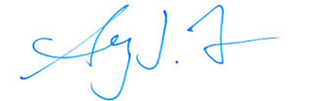

Sherry L. Farr, PhD
National Center on Birth Defects and Developmental Disabilities
Centers for Disease Control and Prevention

Affix gift card here.

