**Appendix D**

Questionnaire on heat stress app to be taken during shift

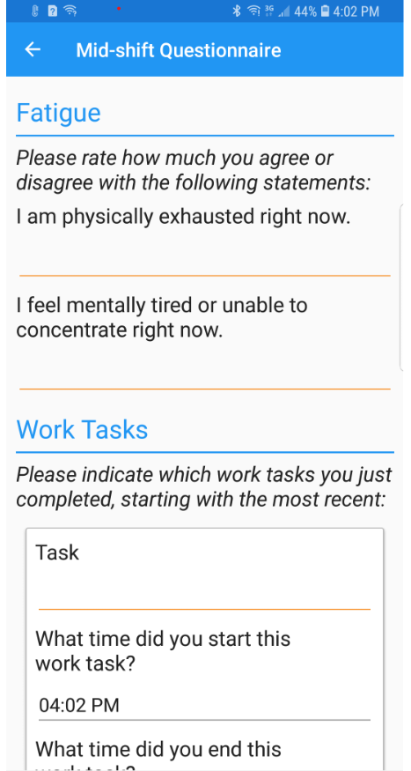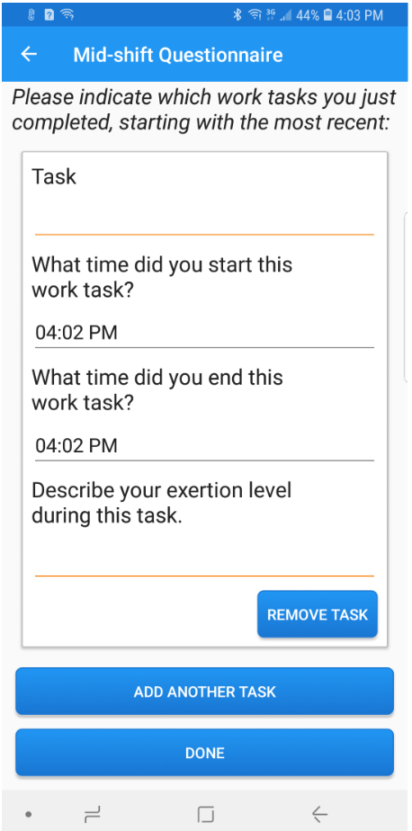

Form Approved

OMB No. 0920-1331

Exp. Date xx/xx/20xx

Questions to be taken on smart phone app

1. Please rate your level of physical fatigue right now (0 to 10)
2. Please rate your level of mental fatigue right now (0 to 10)
3. How do you feel right now? (extremely alert, very alert, alert, rather alert, neither alert nor sleepy, some signs of sleepiness, sleepy but no effort to keep awake, sleepy but some effort to keep awake, very sleepy with great effort to keep awake)
4. What tasks or activities were you doing in the last 15 minutes before beginning this assessment? (Note: participants enter tasks starting from most recent on back)

Describe _________

About what time did you start this work task? _______

Where were you in the mine? _______

How much physical effort did that activity take? (0 to 10)

1. How hot do you feel right now? (scale 1 comfortable, 2 slightly warm, 3 warm, 4 hot 5 very hot

Public reporting burden of this collection of information is estimated to average 1 minutes per response, including the time for reviewing instructions, searching existing data sources, gathering and maintaining the data needed, and completing and reviewing the collection of information. An agency may not conduct or sponsor, and a person is not required to respond to a collection of information unless it displays a currently valid OMB control number. Send comments regarding this burden estimate or any other aspect of this collection of information, including suggestions for reducing this burden to - CDC/ATSDR Reports Clearance Officer; 1600 Clifton Road NE, MS D-74, Atlanta, Georgia 30333 ATTN: PRA (0920-1331).