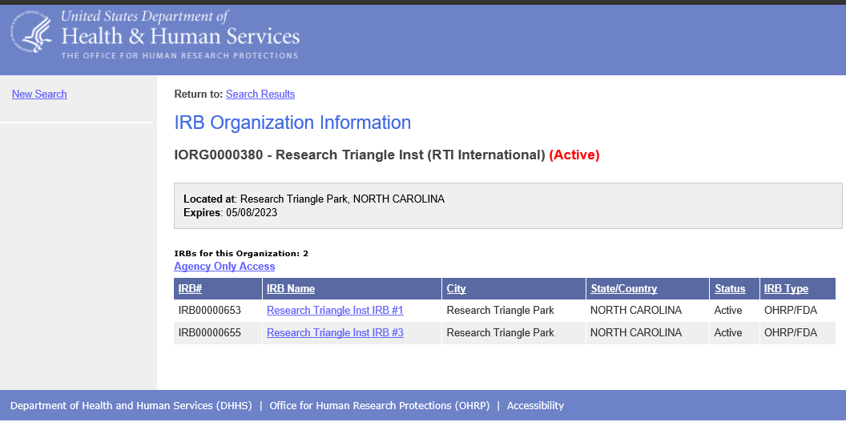

http://ohrp.cit.nih.gov/search/IOrgDtl.aspx

