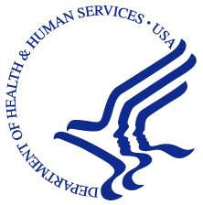**UNITED STATES DEPARTMENT OF HEALTH & HUMAN SERVICES**

ROCKVILLE, MD 20857



Dear Resident:

The U.S. Department of Health and Human Services (**HHS**) is conducting a study called the National Survey on Drug Use and Health(**NSDUH**). Through scientific methods, **your address has been randomly chosen for this study** along with 200,000 other addresses nationwide. NSDUH collects data on the use or non-use of alcohol, tobacco and other substances, as well as mental health and other health-related topics.

Your participation in this study is **voluntary** but **important to the nation**. By participating you help ensure vital information is provided to researchers and agencies for education, treatment, and prevention programs. To ensure your privacy, all answers you give are kept **confidential** by federal law[1] and used only for **statistical purposes** – combined with answers from thousands of other study participants, reported only as overall numbers. **Everyone who is selected for and completes the full interview will receive $30.**

To participate in NSDUH:

* An **adult member** of your household answers a **few general questions online** to determine if zero, one or two household members aged 12 or older may be selected to **complete the full interview**:
* Visit <https://nsduhweb.rti.org/survey> (or scan the QR code below).
* Enter your **Participant Code:**
* Follow the on-screen instructions to answer the general questions. This will only take a few minutes.
* Then, anyone selected to complete the full interview will be provided a unique link to begin that interview from any internet-enabled device (though a desktop or laptop computer is recommended). (Note that parental permission is required before anyone aged 12–17 can participate.)

A professional interviewer from RTI[2] may attempt to contact you in-person to provide more information. During the interviewer’s visit, you can also answer the general questions and if selected, complete the full interview in your home, using a laptop computer.

**If you are unable to respond online and/or would prefer an in-person visit, have questions or need other assistance, please call us toll-free at 1-800-848-4079**. To learn more about the study, please visit <https://nsduhweb.rti.org>.

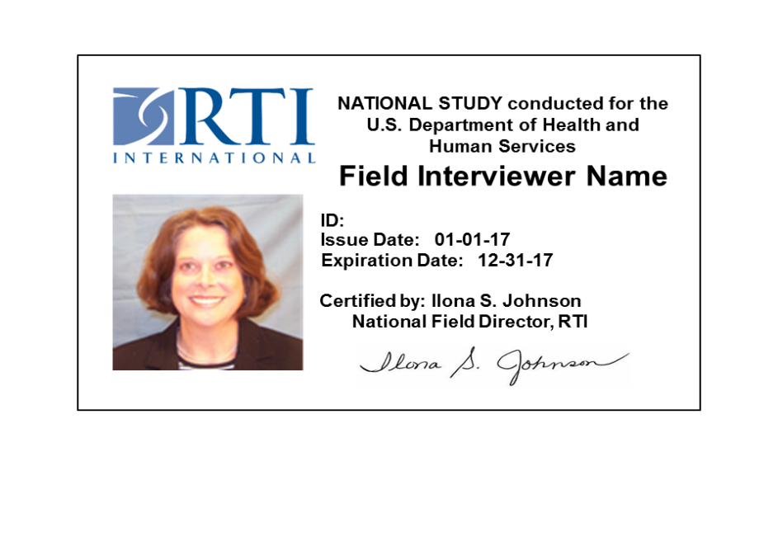Sincerely,

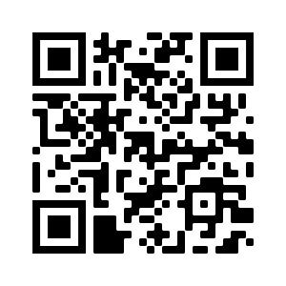

Jennifer Hoenig, Ph.D., MPH Kathleen A. Considine

National Study Director, HHS Director of Data Collection, RTI

1. Confidentiality is protected by the Confidential Information Protection and Statistical Efficiency Act of 2002 (PL 107-347). Authorized by the U.S. Congress as part of Section 505 of the Public Health Service Act (42 USC 290aa4). Approved by Office of Management and Budget (OMB Approval No. 0930-0110)
2. RTI International, a nonprofit organization, has been selected to administer this study for the U.S. Dept. of Health and Human Services.