**Attachment H. System Usability Scale**

Form Approved  
OMB No. 0935-0179  
Exp. Date 11/30/2020

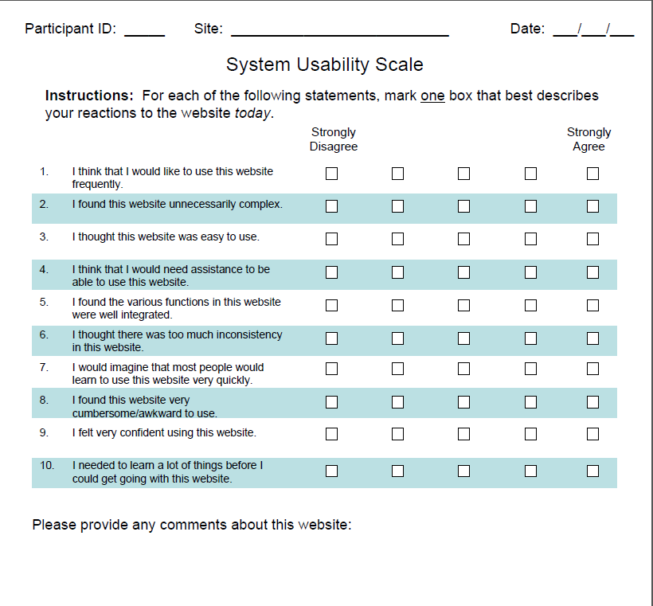

Public reporting burden for this collection of information is estimated to average 5 minutes per response, the estimated time required to complete the survey. An agency may not conduct or sponsor, and a person is not required to respond to, a collection of information unless it displays a currently valid OMB control number. Send comments regarding this burden estimate or any other aspect of this collection of information, including suggestions for reducing this burden, to: AHRQ Reports Clearance Officer Attention: PRA, Paperwork Reduction Project (0935-0179) AHRQ, 5600 Fishers Lane, # 07W41A, Rockville, MD 20857.