Screen Package Document

The Management of Authentication and Authorization of Government Users, Institutions, and Customers (MAGIC) Application:
Registration of an Organization by Their Responsible Entity Officer

September 21^{st,} 2023



Table of Contents
1. Responsible Entity Officer (REO) 3
2. Enter Organization Details 4
3. Cancel Registration 5
4. REO Attestation 5
4.1 Scenario 1 6
4.2 Scenario 2 7
4.3 Scenario 3 8
4.4 Scenario 4 8
4.5 Scenario 5 9
4.6 Scenario 6 9
4.7 Scenario 7 10
5. Confirm Address of Your Organization 11
6. Provide and Verify Work Email Address 12
7. Provide Work Phone Number 14
8. Confirmation: Registration Code to be Mailed 15
9. Complete Registration of Organization 16
10. Registration Confirmation 17
11. Registered Organizations 18
12. Dashboard Versions 20

Responsible Entity Officer (REO)
An REO candidate, referred to in this document as the user, accesses their Business Services Online (BSO) account with an authenticated credential and proceeds to register their organization.
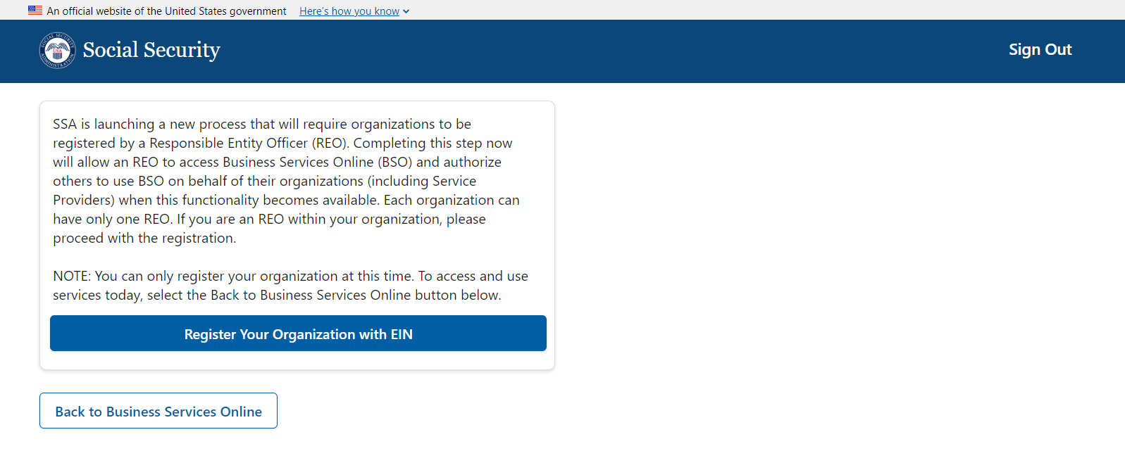

Enter Organization Details
The footer shown on this page will persist on every page of the application. We will omit showing it from this point on.
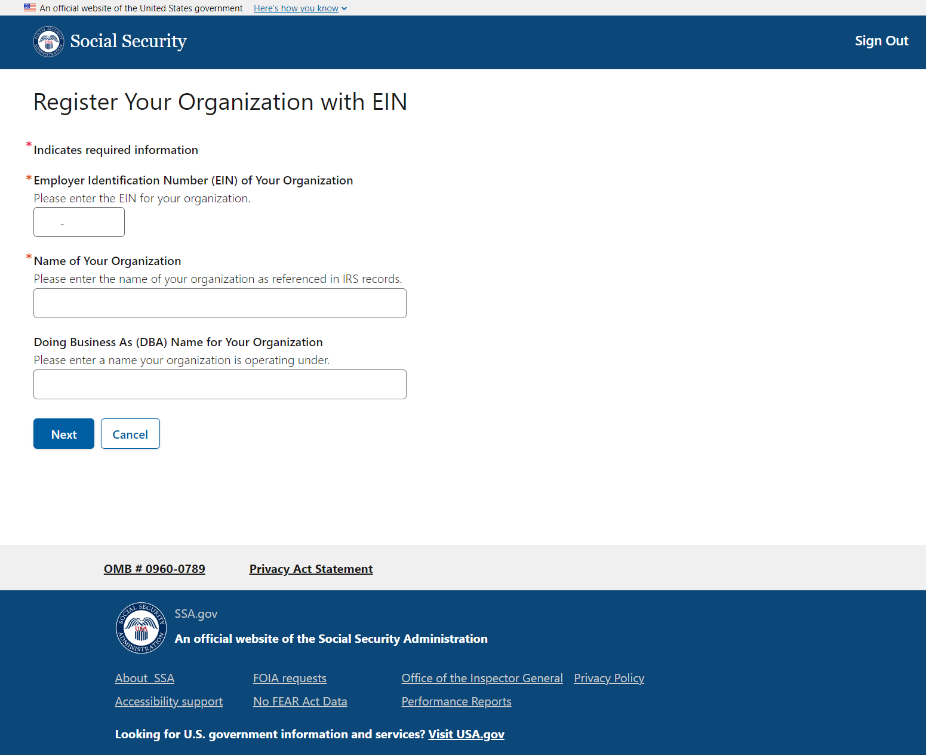

Cancel Registration
The user can cancel registration at any time by selecting the Cancel button. An alert will be displayed to let them know all registration information will be lost if they confirm this option.
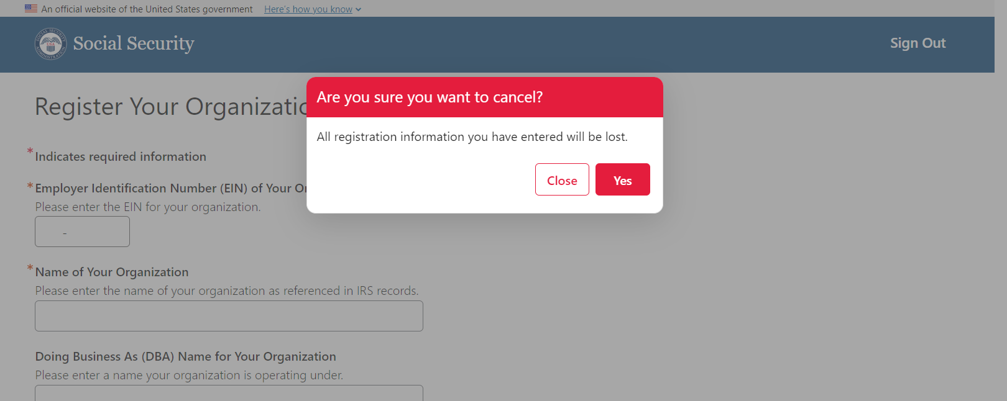

REO Attestation
If they choose to proceed with the registration, the user must answer several dynamic questions and agree to the statement of perjury.
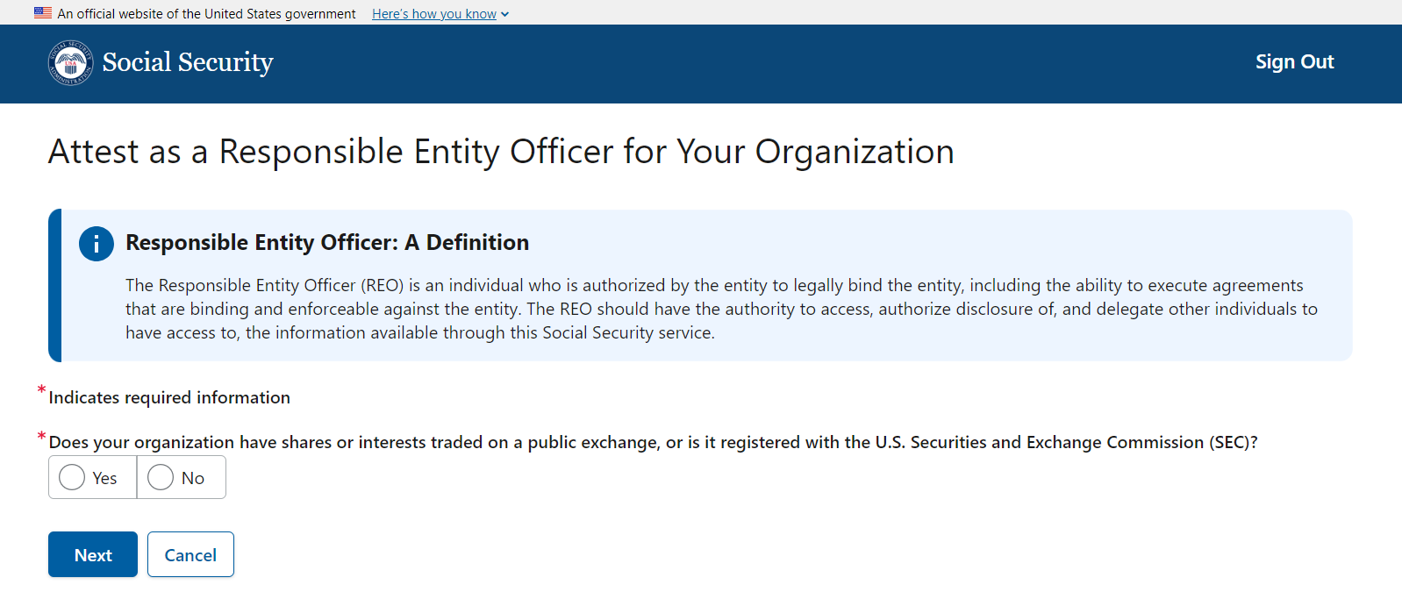

Below, we have included all possible variations of the questions asked.

4.1 Scenario 1
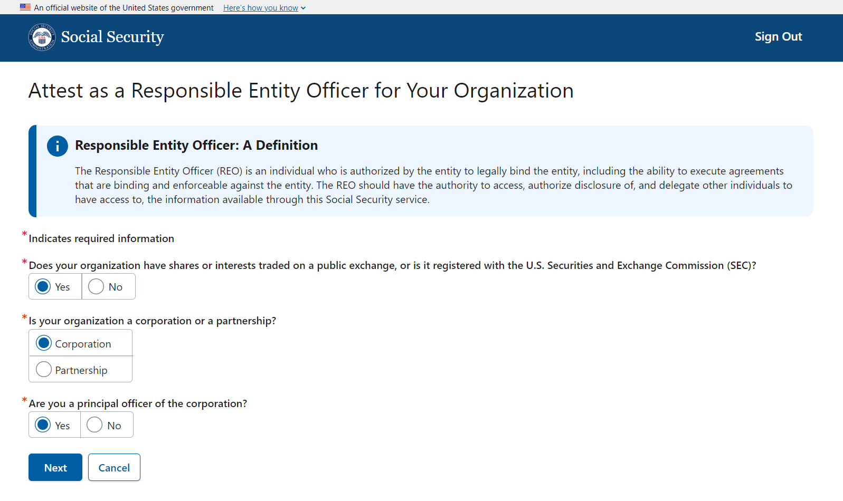

4.2 Scenario 2
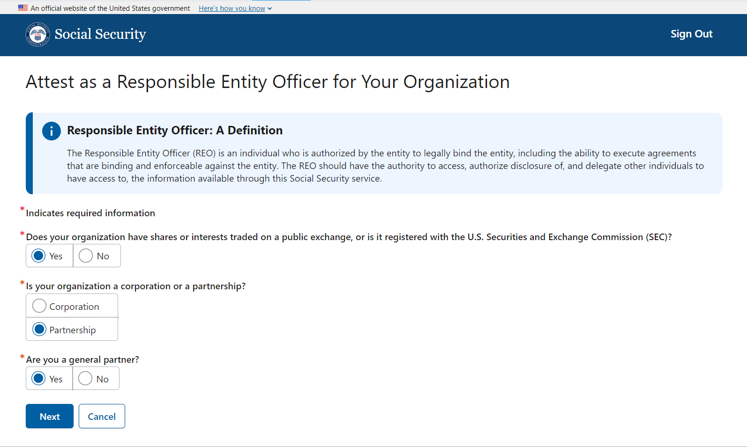

4.3 Scenario 3
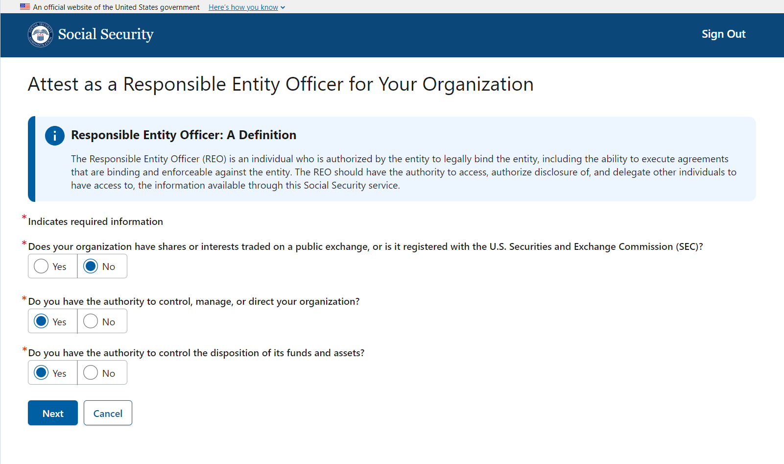

If the user answers “No” to any of the subsequent questions (aside from the first question), they may not proceed with the registration.

4.4 Scenario 4
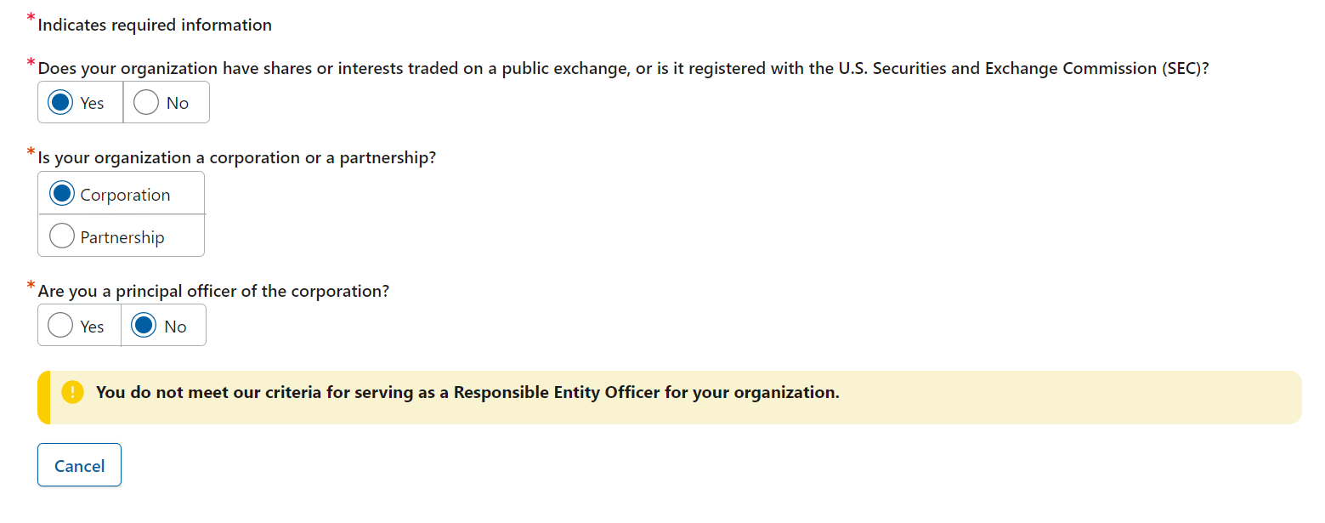

4.5 Scenario 5
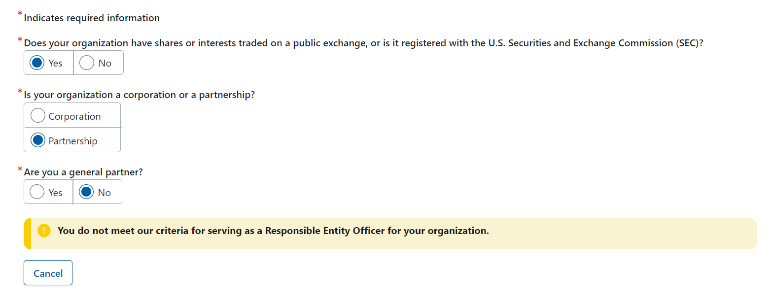

4.6 Scenario 6
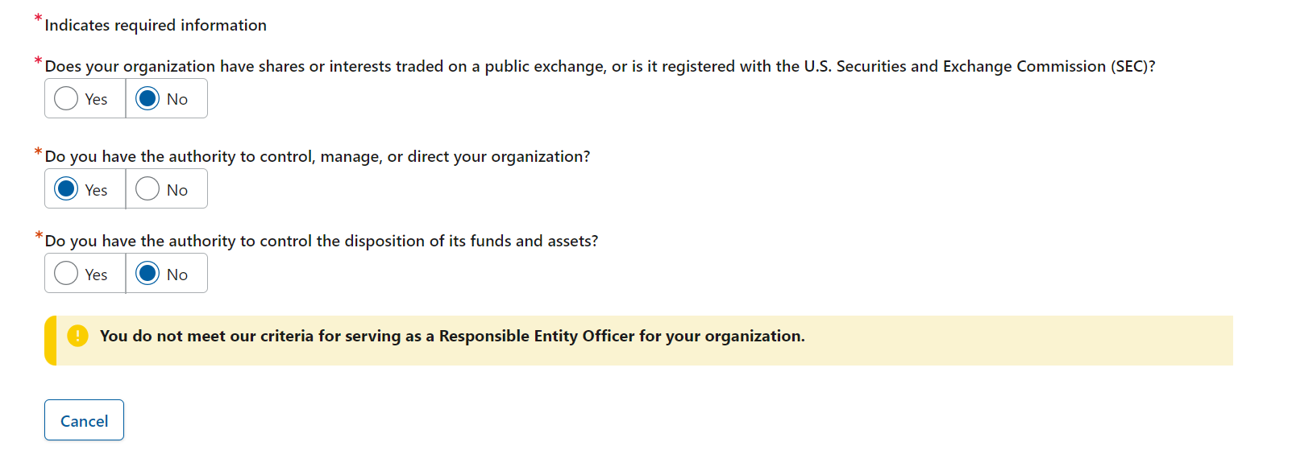

4.7 Scenario 7
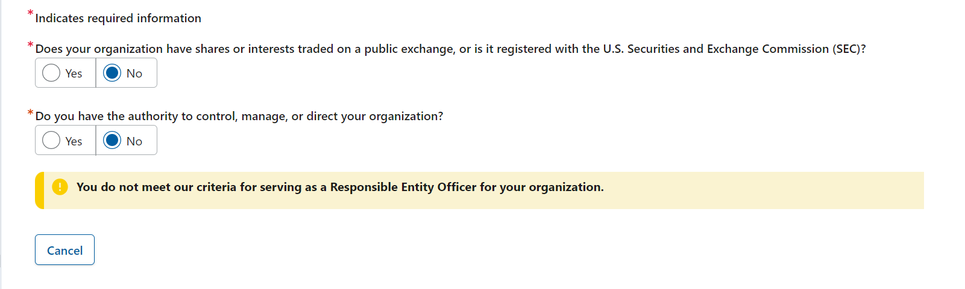

If the user does not meet REO criteria, they will have to cancel their registration.
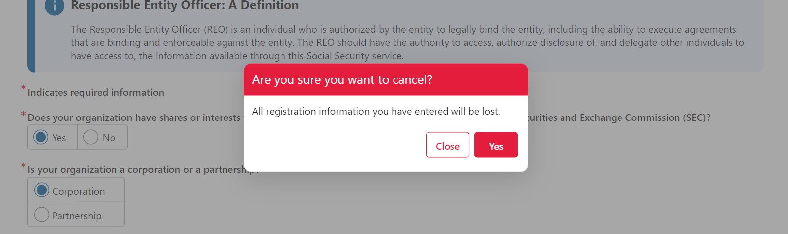

Upon selecting the Next button, the user is provided with the Statement of Perjury statement they must accept.
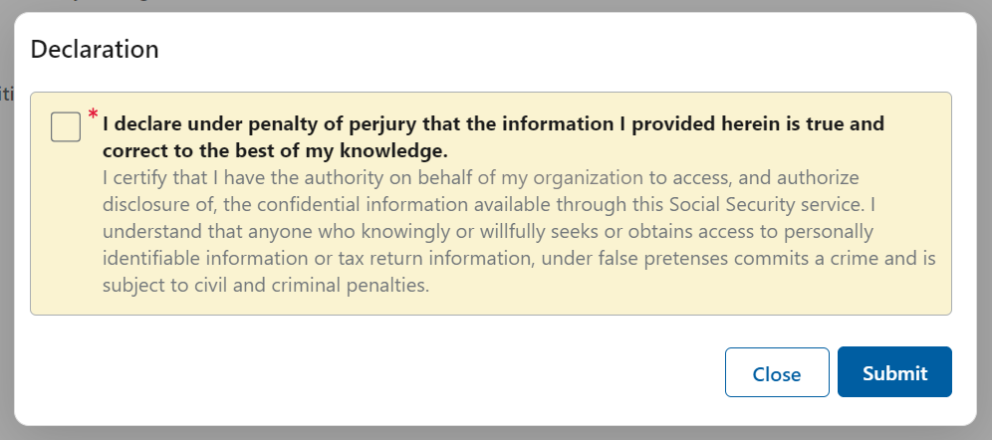

Confirm Address of Your Organization
The user must confirm the address where SSA can send the registration code. The addresses presented are based on IRS data for the EIN entered.
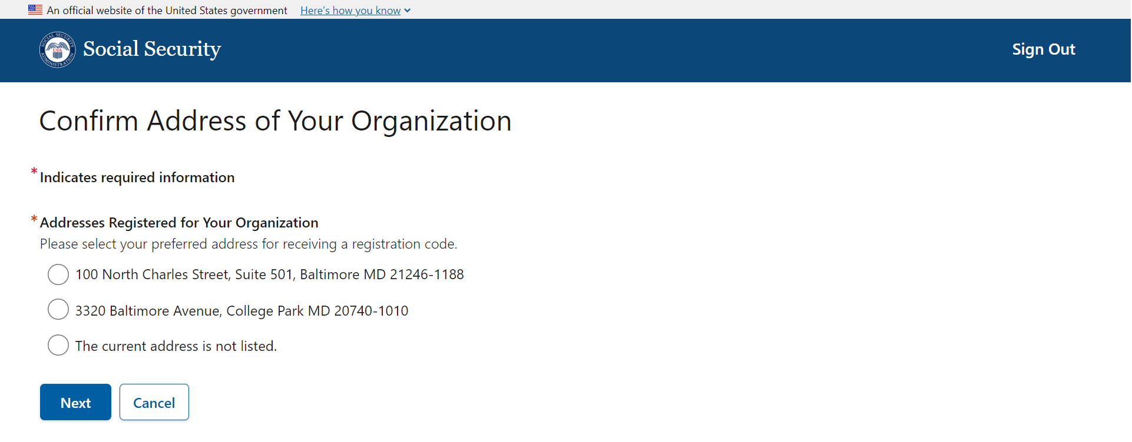

  - Once the address is selected, the user can continue.
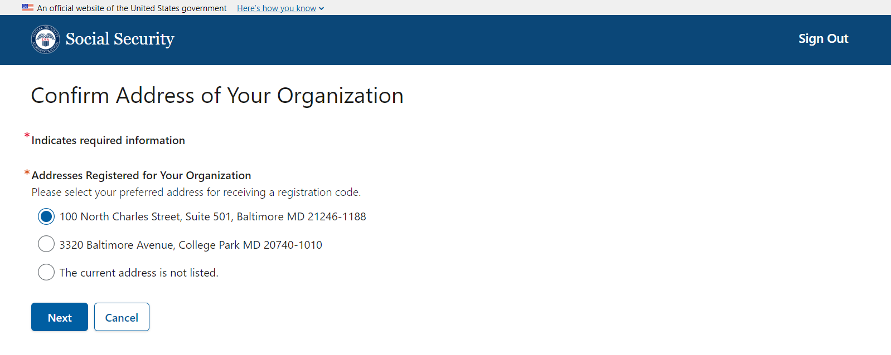

If the address is not listed, the user can select “The current address is not listed.” and review an alert advising them to complete the Change of Address for Businesses 8822-B Form at IRS.gov. The user cannot continue with their registration.
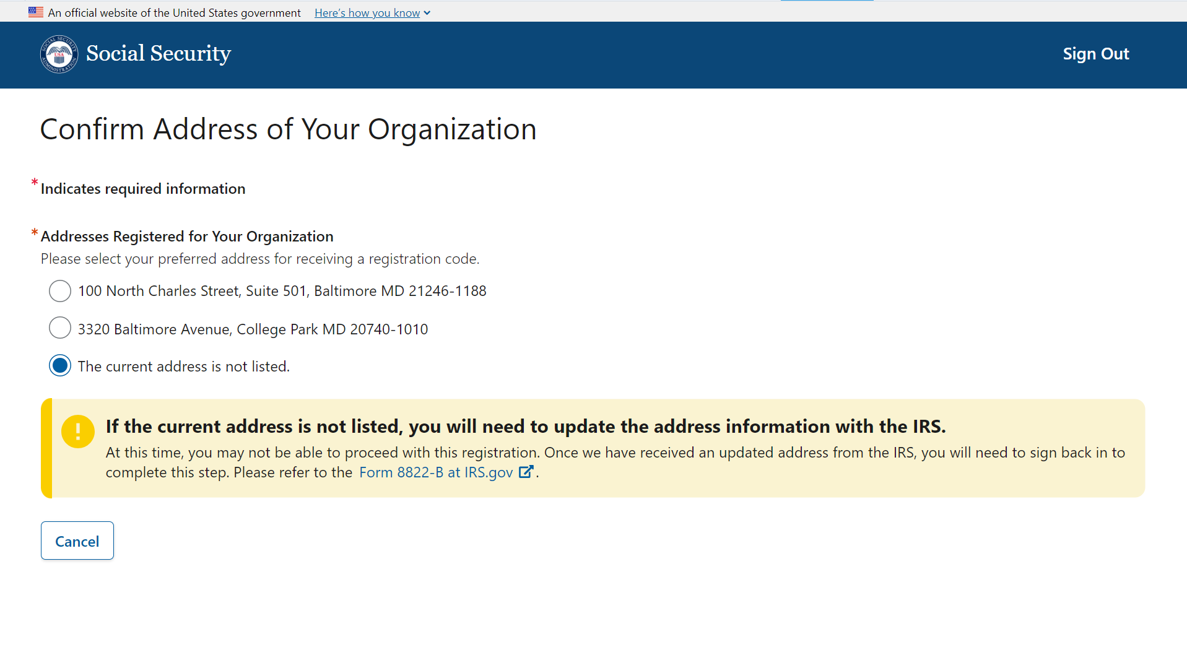

Provide and Verify Work Email Address
The user must provide an email address.
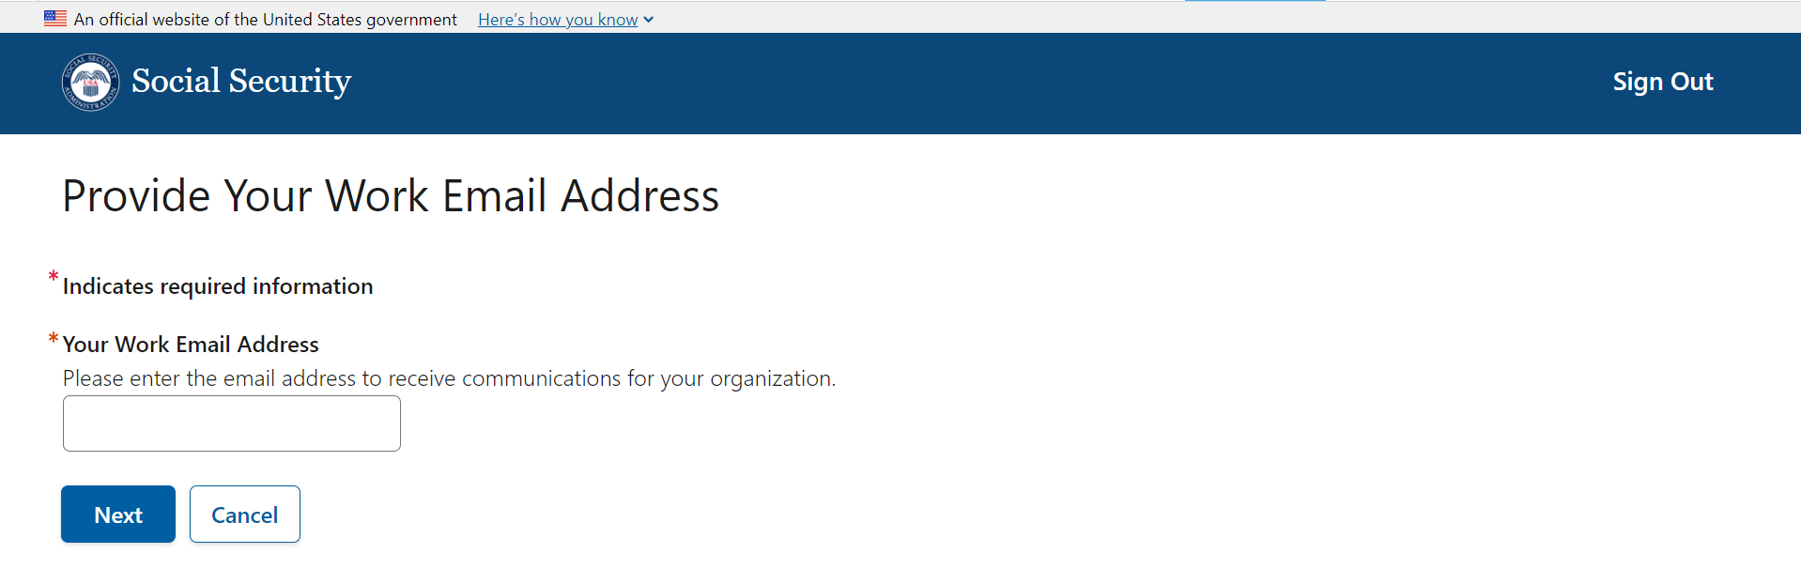
The system will verify the email address by sending a one-time verification code to the user.
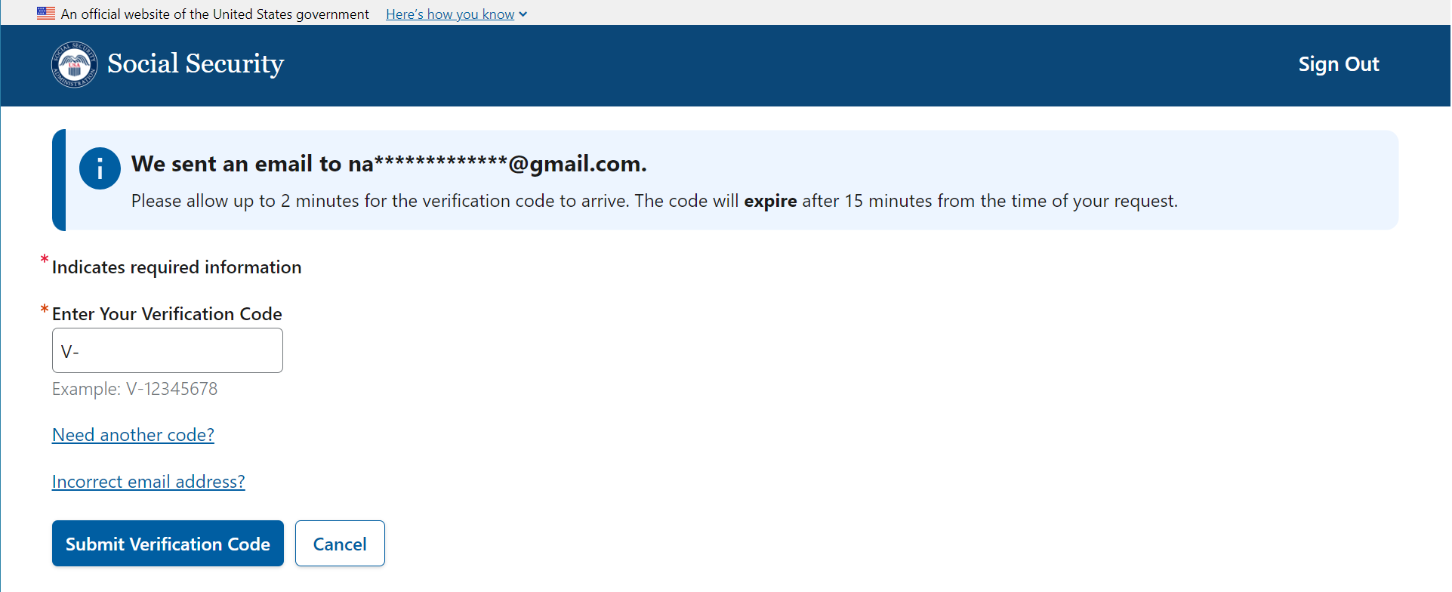

Should the verification code expire, the user has an option to request a new code.
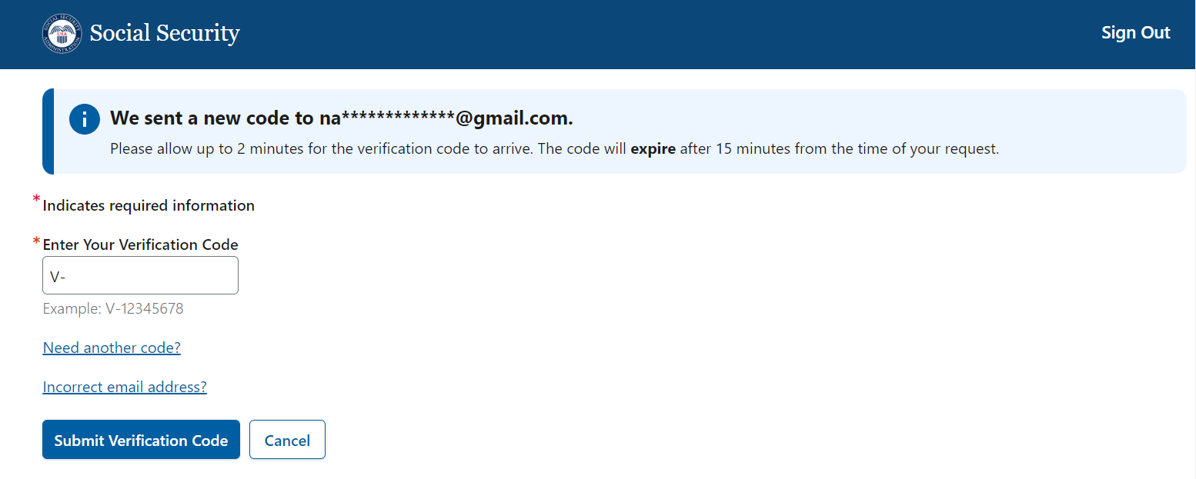

Provide Work Phone Number
The user must provide their primary phone number.
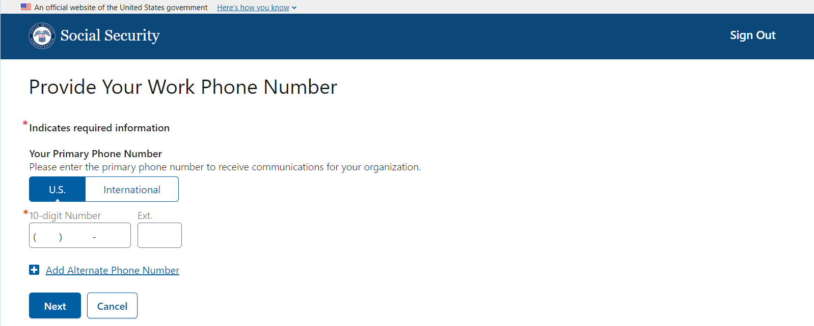

The user can provide an alternate phone number.
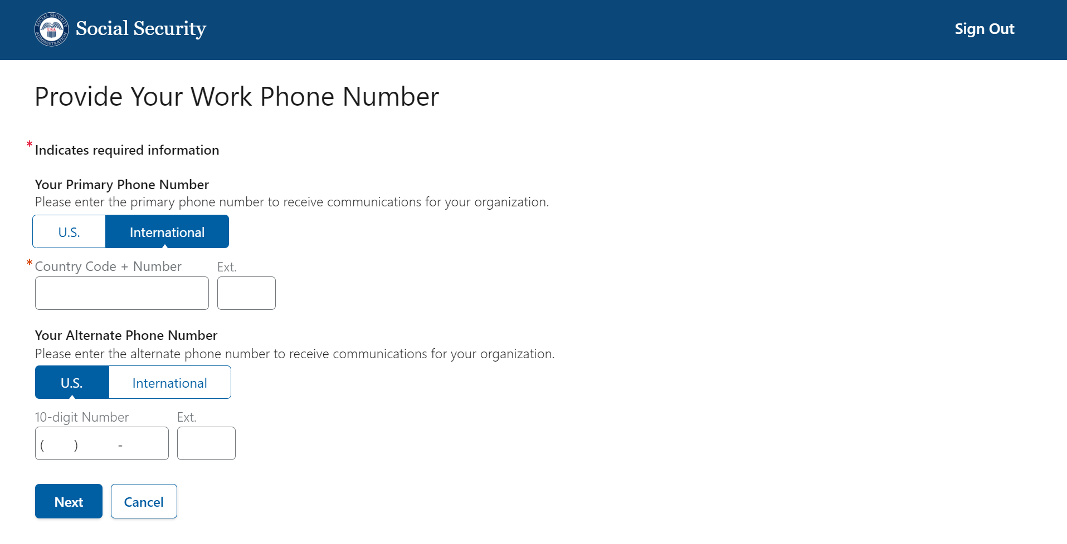

Confirmation: Registration Code to be Mailed
A confirmation page is displayed with details explaining that the registration code will be mailed to the address previously selected. NOTE future release: only the REO will have to go through this authorization process (i.e., mailing of registration code). In a future release, other users will be added and assigned roles by the REO and/or other administrators. Electronic confirmations will be sent.
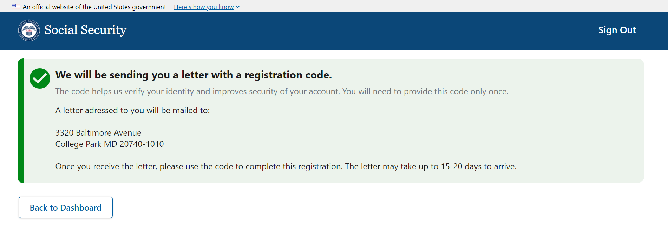

Complete Registration of Organization
Once the user receives a letter with the registration code, they will need to complete the registration process for their organization.
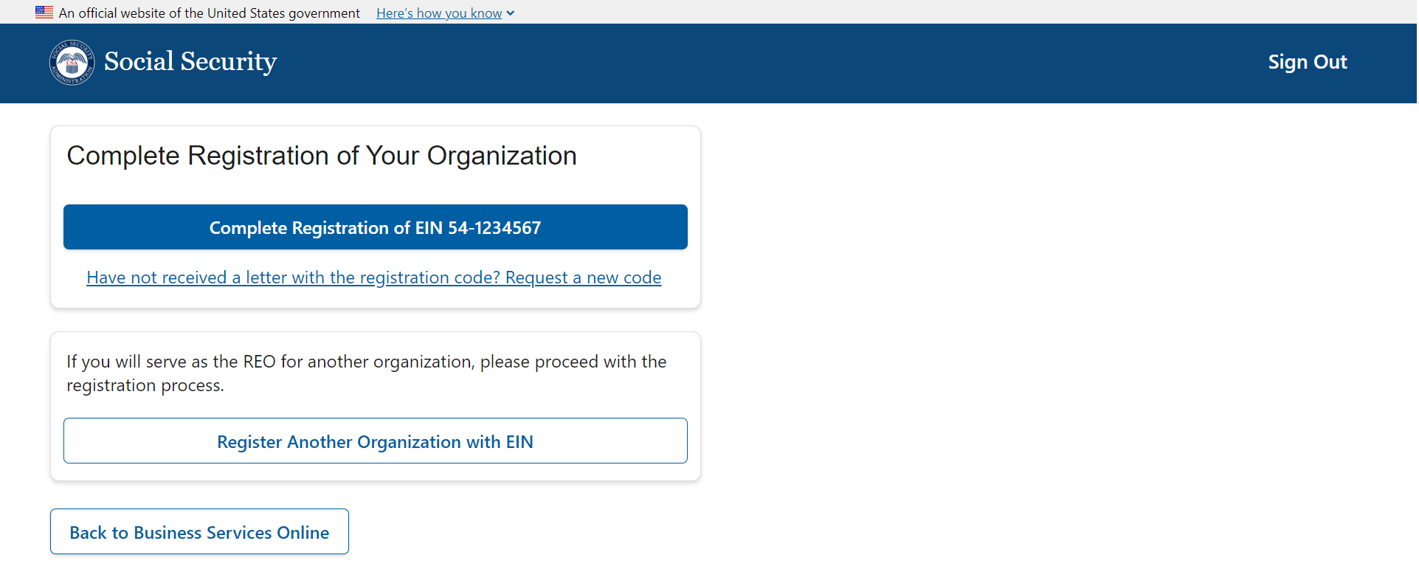

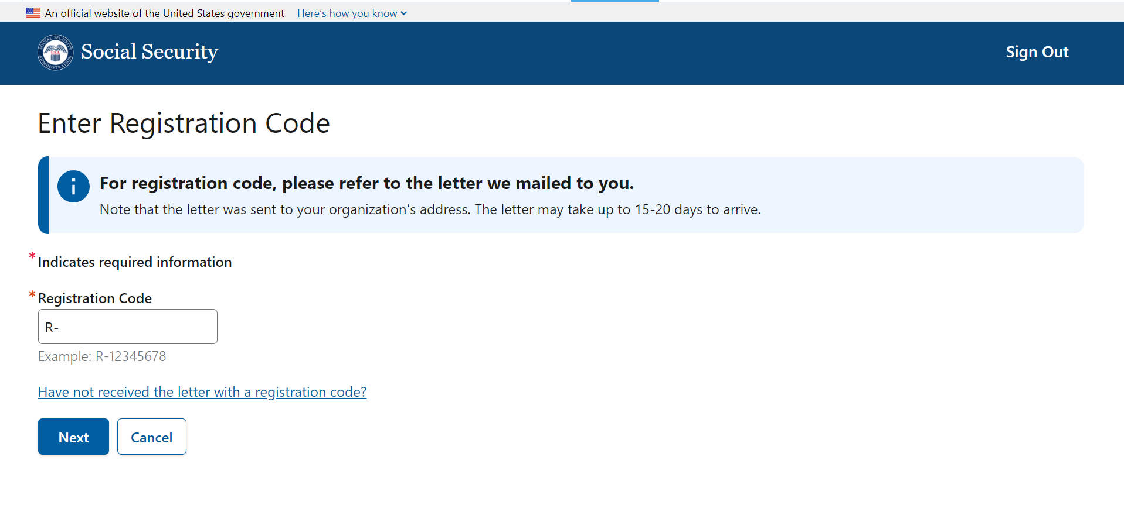
In the event, the user did not receive the registration code they can request a new code after 20 days since the original code was issued. The user will have to confirm the address to ensure there are no changes.

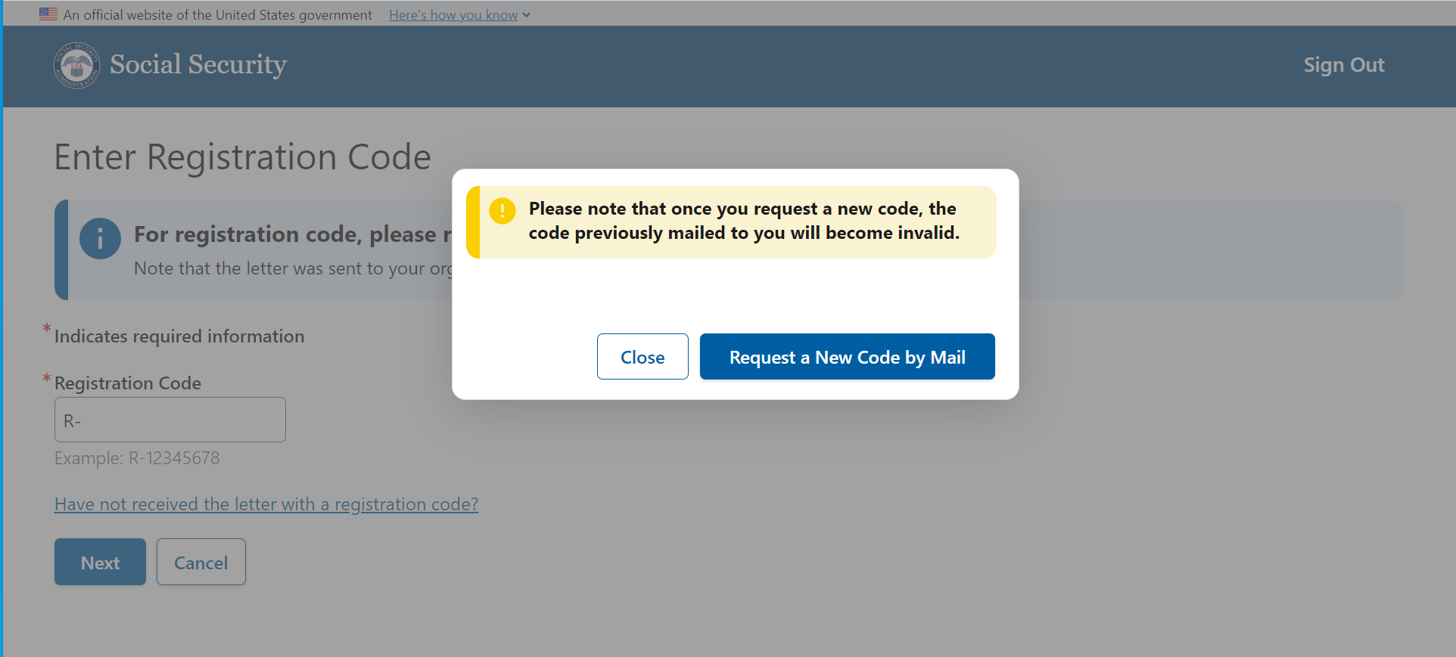

Registration Confirmation
Once the registration code is entered correctly, the system will confirm a successful registration. The user can return to the dashboard.
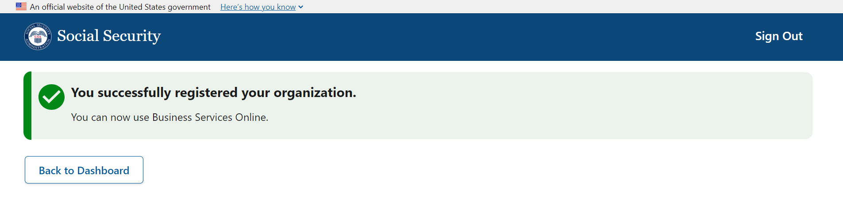

Registered Organizations
The user can view details of the organization they just registered. At this time, they can register another organization if needed.
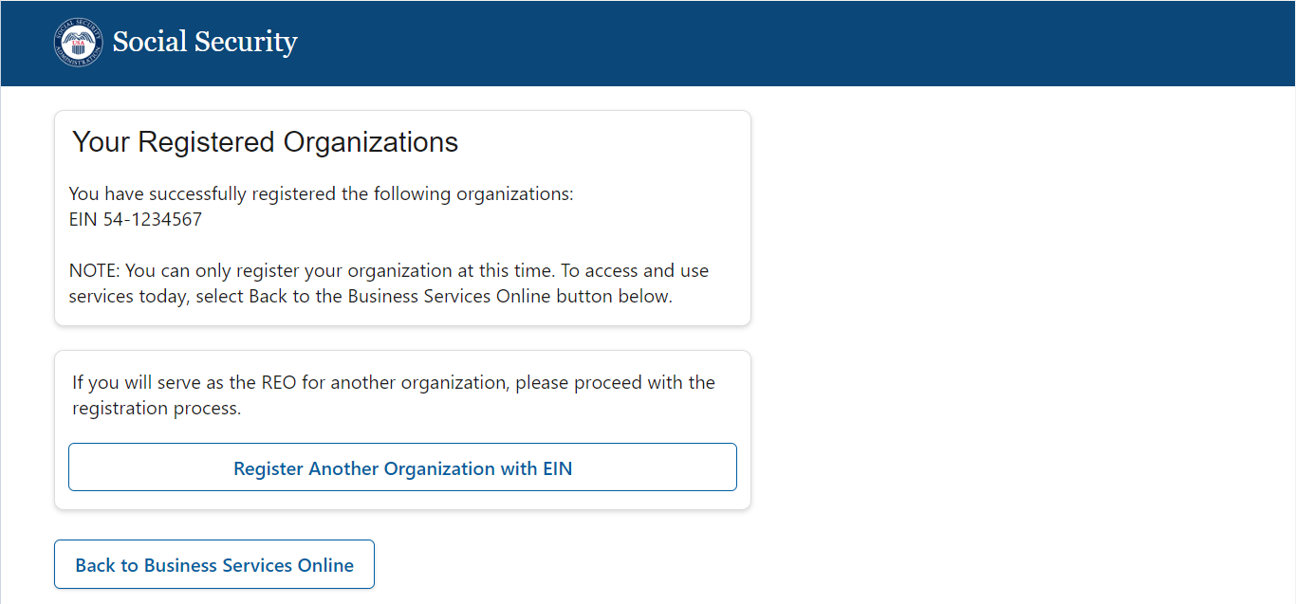

The REO can return to Business Services Online to Business Services Online (ssa.gov).
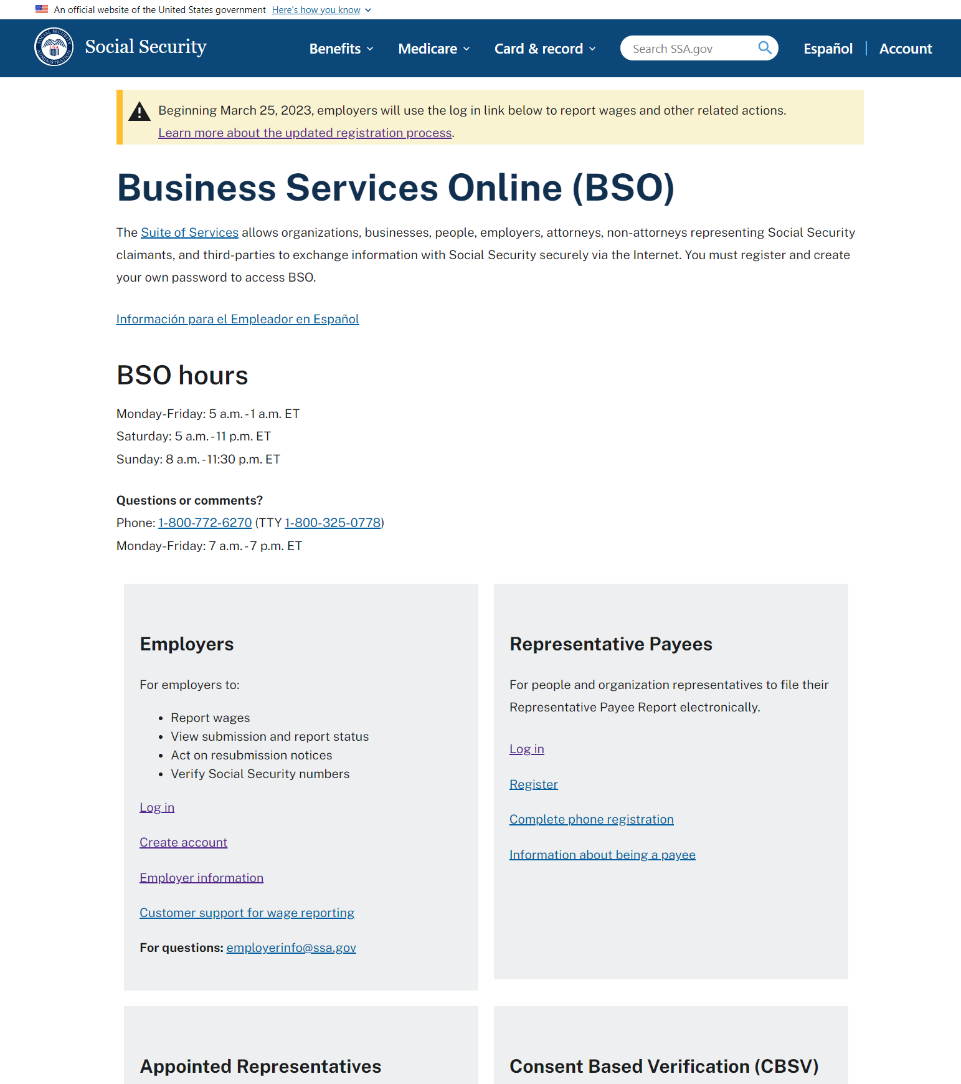

Dashboard Versions
Depending on where the user is in their process or how many organizations they may have to register, there are several versions of the Dashboard.
- New Registration
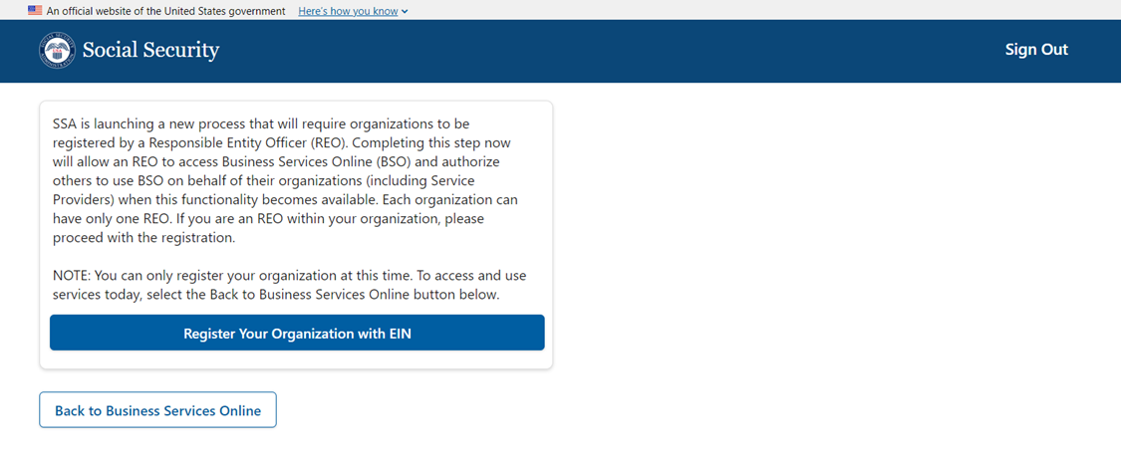

- Pending Registration – Single EIN
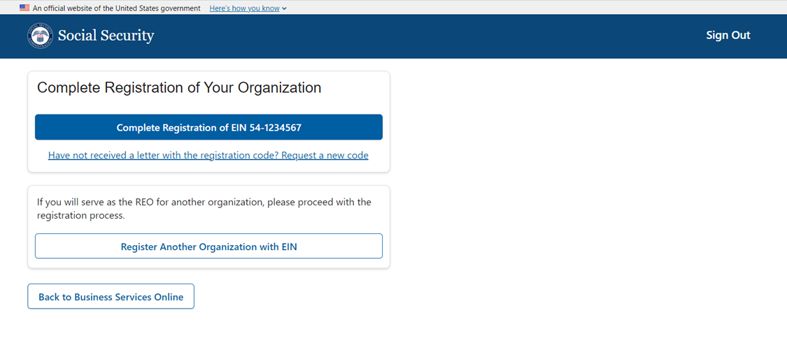

- Pending Registration – Multiple EINs
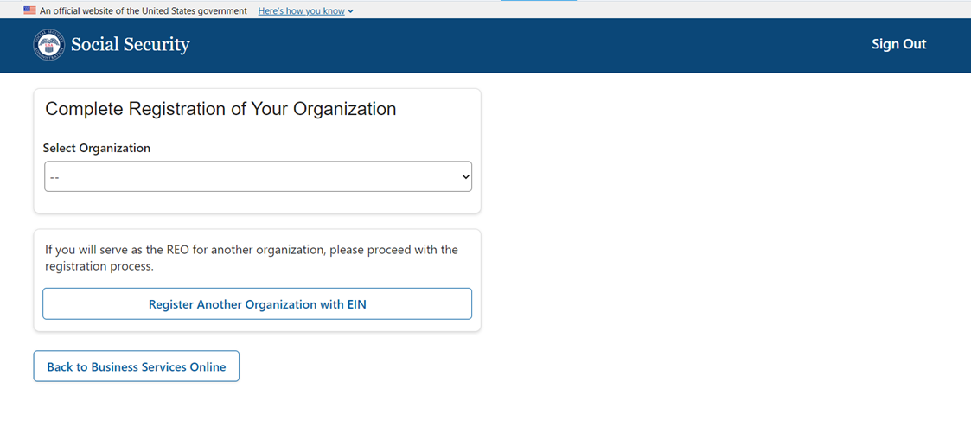
A user can select an EIN and continue to complete their registration.
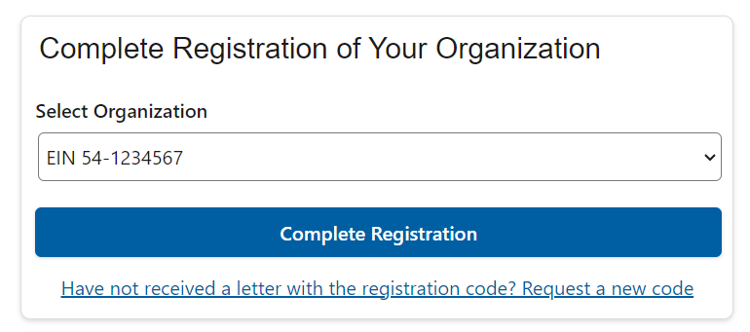

- Completed Registrations – Multiple EINs
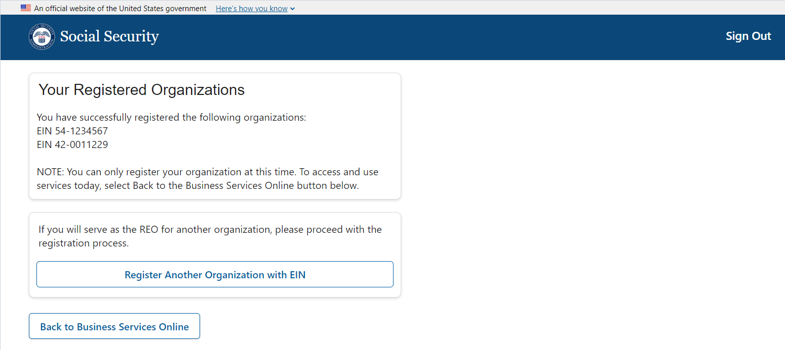

- Single Pending and Single Completed Registrations
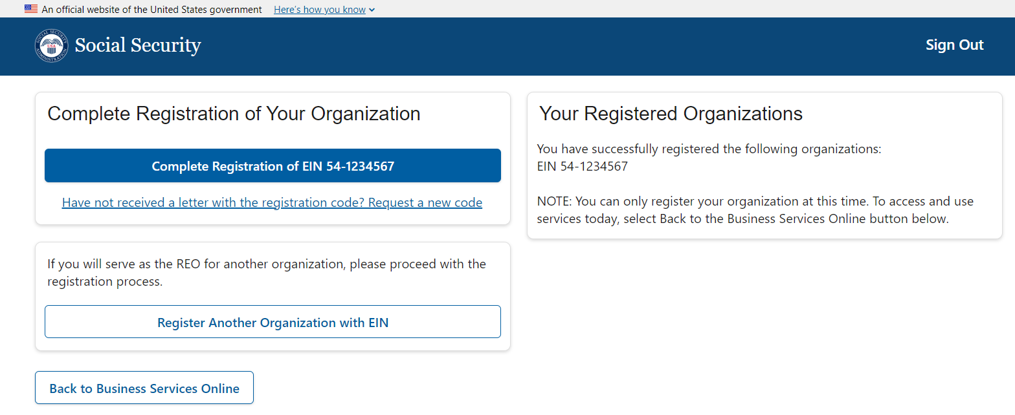

- Single Pending and Multiple Completed Registrations
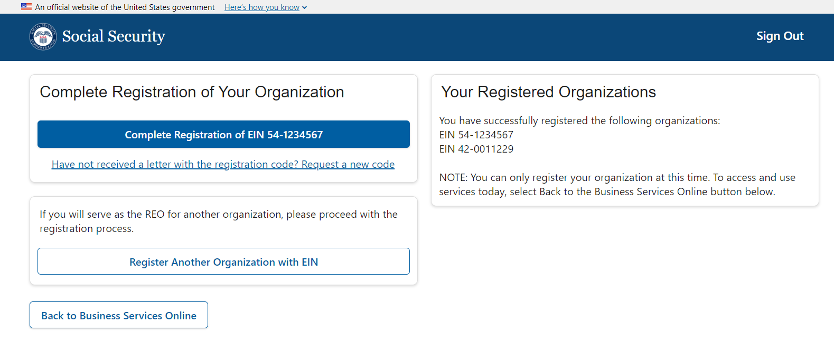

- Single Pending and Single completed Registration.
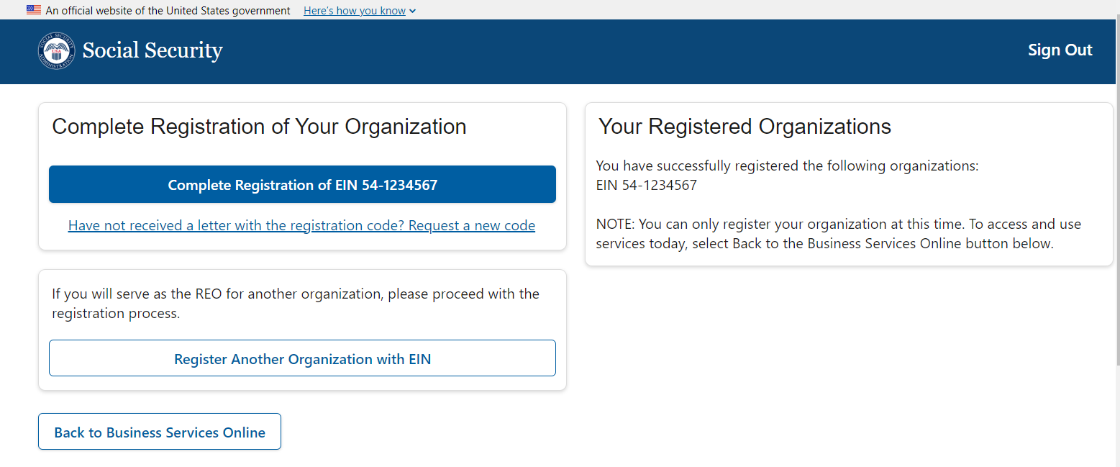

- Multiple pending and Multiple completed Registration
