Instrument 1: Application form

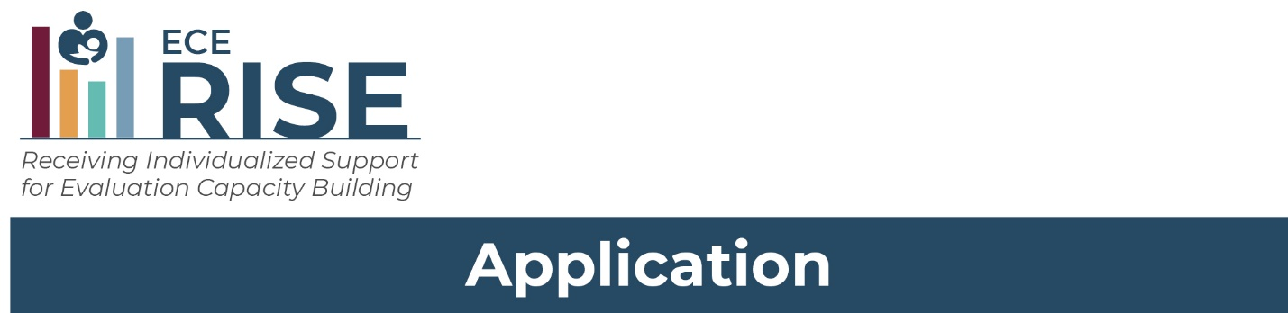
State, Territory, or Tribe:
Name of applicant:
Position or job title of applicant:
Email address of applicant:
Phone number of applicant:

Thank you for your interest in ECE-RISE. There are two steps to the application process:
- Step 1. Complete this application. Answer the questions as best you can. The terms in some of the questions may be less familiar to you, and that is okay. ECE-RISE is designed to help an agency improve its ability to do and use research.
- Step 2. Complete a self-assessment that asks about how your agency currently uses research to inform CCDF policy, management, or practice. The ECE-RISE team will use this assessment to get a complete picture of your agency’s fit for this opportunity. A link to the self-assessment is provided at the end of this application.
The described collection of information is voluntary and will be used to inform selection of agencies to participate in Receiving Individualized Support for Evaluation Capacity Building. Public reporting burden for the described collection of information is estimated to average 30 minutes per response, including the time for reviewing instructions, gathering and maintaining the data needed, and reviewing the collection of information. An agency may not conduct or sponsor, and a person is not required to respond to, a collection of information unless it displays a currently valid OMB control number. The OMB number and expiration date for the described collection are OMB #: 0970-0356, Exp: 02/29/2024. Send comments regarding the burden estimate or any other aspect of this collection of information, including suggestions for reducing this burden to Pia Caronongan at [EMAIL].

Step 1. ECE-RISE Application Form

A. Key questions about policies, programs, or services about CCDF-funded activities
ECE-RISE is offering tailored support for research and evaluation. The ECE-RISE team will support your agency team as you work to answer a question that will help address a problem your agency faces or provide you with more information to improve policies, programs, or services. We’ve included some examples of research questions that your agency may have below.
Examples of questions that CCDF Lead Agencies may have
- How do families learn about and enter into the subsidy system?
- Do families across my state have equitable access to high quality child care?
- Are subsidy reimbursement rates high enough for families to access high quality care?
- How much does it cost to deliver high quality care?
- Is there unmet demand for child care slots for infants and toddlers, children with disabilities, and children whose parents are working nontraditional hours?
- What are the best ways to support the professional development of child care providers?
- How has the COVID-19 pandemic affected the child care choices that families have or make?
- How can CCDF funds be combined with other funding to improve access to high quality care?

1. What is one question about CCDF-funded activities in your state, territory, or tribe that you would like to answer to help you make decisions about policies, program management, or service delivery?
1a. Why do you need the answer to this question? How would knowing the answer to this question help you improve your agency’s policies or practices?
1b. What data or information do you already have access to that you might be able to use to answer this question (for example, market rate survey data or enrollment data)?
1c. What existing data or information might be available from another agency or organization to help answer this question?
1d. What new data or information might you need to help answer this question?
- What is another question you have about a CCDF-funded activity in your state, territory, or tribe that you would like to answer to help you make decisions about policies, program management, or service delivery?
2a. Why do you need the answer to this question? How would knowing the answer to this question help you improve your agency’s policies or practices?
2b. What data or information do you already have access to that you might be able to use to answer this question (for example, market rate survey data or enrollment data)?
2c. What existing data or information might be available from another agency or organization that could help answer this question?
2d. What new data or information might you need to help answer this question?

B. Agency staff and partners

Your agency must identify up to three staff members to work with the ECE-RISE team. Extensive expertise and skills are not required of agency staff as ECE-RISE will be providing tailored support. The agency staff will attend meetings with the ECE-RISE team at least twice a month, work in between meetings to make progress on research and analysis and participate in peer learning community gatherings. Each agency team will need staff for the following roles (in some cases, one staff member may fill multiple roles):
- Coordinator – staff who can help with scheduling and logistics, organizing materials, keeping documentation up to date (approximately 12 hours/month)
- Policy/practice lead – staff with content expertise who can think about policy and practice implications of the research project (approximately 8 hours/month);
- Research lead – staff with research skills who can help carry out the research project, access and manipulate data (approximately 20 hours/month).

The amount of time will vary by role but having up to three members on an agency team will help ensure that the work can be shared but also that each member is involved enough to move the work forward. We also ask about partners outside of your agency but please note that you will still need to identify three staff members within your agency to take the lead and conduct the bulk of the work for ECE-RISE.
- List up to three (3) names of agency staff who would be working with and meeting with the ECE-RISE team to carry out the research project, consult with experts, and collaborate with other CCDF Lead Agencies. More than three staff can participate but for this application we would like to identify those who will lead and spend the most time on the project. Provide names, positions (job titles), and the name of the person’s office, division, or department.
Name | Position and office, division, department | What would their role be?
- Which of the staff members you listed do you expect to coordinate the work of the Agency team and be the primary contact for the ECE-RISE team? (Write the name of lead staff person here)
- What can you do to make sure that these agency staff will have the time and resources to participate? (Write your answer in the space below.)

- What other staff at the agency will advocate for and support the agency’s participation (for example, by ensuring staff time and resources for the project, or reaching out to other agencies for data or information)? How will they support the work? Provide names, positions (job titles), name of the office, division, or department the person works for, and short description of what they will do.
Name | Position and office, division, department | How will they support the work?
- Who are key partners outside your agency that you would want to involve in your ongoing efforts to use and do research? Partners may include researchers, consultants, evaluators, or data analysts in other agencies or states, or stakeholders with an interest in improving how your agency collects and uses information to make decisions about CCDF-funded activities.
(Provide names, positions (job titles), name of office, division, or department, name of state agency or outside entity, and short description of what their role will be.)
Name | Position and office, division, department | State agency or outside entity name | How will they support the work? | Have you worked with them before? If yes, for how long?
C. Agency goals and strengths to build on
- What challenges does your agency face in doing or using research to inform decisions about policies, programs, and practices? (Write your answer in the space below.)
- What would you say is your agency’s biggest asset or strength in terms of interests, knowledge, skills, or abilities related to doing or using research? (Write your answer in the space below.)

Step 2: Self-Assessment
To complete the application process for ECE-RISE, we need some additional information about how your agency currently uses research to inform CCDF policy, management, or practice.
If you completed the Child Care Research and Evaluation Capacity Building Center survey earlier this year, then you do not need to do anything further. If you have not completed the survey or are not sure whether your agency has completed the survey, you can contact the ECE-RISE team at [email] or [phone].

Thank you for completing your application.

You will receive a confirmation email from the ECE-RISE team with next steps.

If you have questions, you can contact the ECE-RISE team at [email] or [1-800-XXXX]

