Appendix A: Interview Outreach

Email/Talking Points for Center Administrators
Hi, [ADMINISTRATOR NAME],
Thank you for participating in the VIQI project this year! My name is [NAME] and I work on the VIQI team. As we close out the VIQI project, we are inviting [center/program] [administrators/directors] to share some final thoughts about how your centers and the families you serve were affected by the pandemic and the hiring market this year. This will help us develop a clearer picture of everything that centers and families have been dealing with.
We could do this at your center, on the phone, or by video conference, and the conversation would take no more than one hour. This is something that you could do before or after work, or during a lunch break - whatever works best for you.
Can we schedule this conversation with you in the next couple of weeks? Here are some times that work on my end: [DATES AND TIMES]. If none of these work for you, please feel free to suggest other times.
[attach study information sheet]

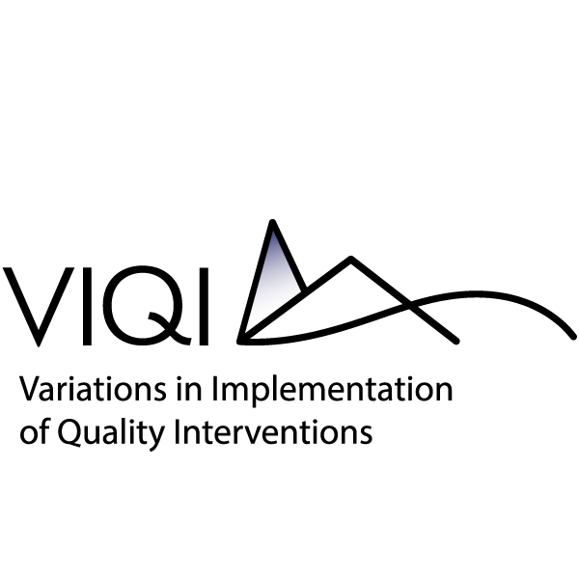
Information about
Administrator Interviews in VIQI

Thank you for your interest in doing an interview as part of the VIQI project! The purpose of the interview is to gather information about your center’s experiences, successes, and challenges from this past year as you participated in the VIQI project. The information you share will help us better understand the larger context in which the VIQI interventions were put in place and how the pandemic may have affected your center and staff.
Is participation voluntary?
Yes. It is your choice whether you take part in this interview or not. You do not have to answer any questions you do not want to answer. You can stop the interview at any time, without penalty.
What are the benefits and risks to me completing these activities?
There are no direct benefits to you, but the information you share will be incredibly valuable in helping us understand your center’s programming and staff members’ experiences and to better inform the early care and education field about what it was like to implement the VIQI interventions.
There is a small risk that your information will be seen outside the study team. However, the study team follows strict rules to protect your information. However, there is a small risk that information you share may be seen outside of the study team, even though we take great care to protect it.
How will my information be protected?
We would like to audio-record our discussion. This is being done because it is difficult for members of the study team to focus on what you are saying and take notes at the same time. The recording will be transcribed and the transcriptions will be deleted at the end of the project. Only researchers on the study team will ever hear the recording or see the transcripts from our discussion. Researchers must agree not to try to identify you or your center. You can indicate if there is something you don’t want to be recorded.
The study team follows strict rules to protect your information. All paper data will be kept locked up, and any information on a computer will be password-protected. At the end of the study, the information collected from you will be de-identified. This process will make it difficult for non-research team members to link any data or information to your name. These de-identified data will be stored in a secure location and will be made available to other researchers under strict security. If the study is extended, only the study team or other researchers who agree to the same strict security requirements described here will have access to your data or information.
Any information collected for the study will be used only for research purposes. No reports will describe you or the centers, classrooms, or teachers you worked with in a way that can be identified. Any information you share with the study team may be combined with other data collected as part of this study. The information collected will not be used to evaluate you or the centers, classrooms, or teachers you worked with. However, if answers that you share would put someone in serious danger, we will have to tell the appropriate agencies to protect the person.
This study has a Certificate of Confidentiality from the U.S. Department of Health and Human Services which says that we cannot be required to share any identifiable information, even under a court order or subpoena. An agency may not conduct or sponsor, and a person is not required to respond to, a collection of information unless it displays a currently valid OMB control number. The OMB control number for this collection is 0970-0356 and it expires 02/29/2024.
This study may be expanded with additional federal or private funding. If this happens, we may contact you to gather more information. At the end of the study, we may create a file of information from the study for other researchers to use in future research studies without additional informed consent from you or a legally authorized representative, but those records will not contain your name or information that could directly identify you.

Questions?
If you have questions about the study or your rights as a study participant, please call or email [NAME] at [CONTACT INFO].

Email/Talking Points for State and Local Early Care and Education Stakeholders
Hi, [NAME],
[PERSONALIZED REMINDER ABOUT VIQI PROJECT/OVERIVEW BASED ON PRIOR COMMUNICATION WITH THIS STAKEHOLDER] As we close out the VIQI project, we are inviting key stakeholders in our VIQI localities to share some thoughts about how state and local contextual factors – for example, local employment and economic conditions, the COVID-19 pandemic, changes to requirements or standards for early care and education centers – may have affected early care and education centers in your [state/city] this past year. This will help us develop a clearer picture of the local context and how it may have influenced the centers participating in the VIQI project this past year.
We could do this on the phone or by video conference, and the conversation would take no more than one hour. This is something that you could do before or after work, or during a lunch break - whatever works best for you.
Can we schedule this conversation with you in the next couple of weeks? Here are some times that work on my end: [DATES AND TIMES]. If none of these work for you, please feel free to suggest other times.
[attach study information sheet]

Information about VIQI State and Local ECE Stakeholders Interviews

Thank you for your interest in doing an interview as part of the VIQI project! As a reminder, the VIQI project aims to examine how different dimensions and levels of quality in early childhood classrooms relate to children’s developmental outcomes. The purpose of these interviews is to gather information about state and local contextual factors that may have affected early care and education centers in your [state/city] during the past year – for example, economic and employment conditions, the COVID-19 pandemic, early care and education policy changes. The information you share will help us better understand the larger context in which the VIQI interventions were put in place and how the pandemic may have affected your center and staff.
Is participation voluntary?
Yes. It is your choice whether you take part in this interview or not. You do not have to answer any questions you do not want to answer. You can stop the interview at any time, without penalty.
What are the benefits and risks to me completing these activities?
There are no direct benefits to you, but the information you share will be incredibly valuable in helping us understand state and local contextual factors that may have influenced early care and education centers during this past year, which can help us interpret findings from the VIQI study.
There is a small risk that your information will be seen outside the study team. However, the study team follows strict rules to protect your information. However, there is a small risk that information you share may be seen outside of the study team, even though we take great care to protect it.
How will my information be protected?
We would like to audio-record our discussion. This is being done because it is difficult for members of the study team to focus on what you are saying and take notes at the same time. The recording will be transcribed, and the transcriptions will be deleted at the end of the project. Only researchers on the study team will ever hear the recording or see the transcripts from our discussion. Researchers must agree not to try to identify you. You can indicate if there is something you don’t want to be recorded.
The study team follows strict rules to protect your information. All paper data will be kept locked up, and any information on a computer will be password-protected. At the end of the study, the information collected from you will be de-identified. This process will make it difficult for non-research team members to link any data or information to your name. These de-identified data will be stored in a secure location and will be made available to other researchers under strict security. If the study is extended, only the study team or other researchers who agree to the same strict security requirements described here will have access to your data or information.
Any information collected for the study will be used only for research purposes. No reports will describe you in a way that can be identified. Any information you share with the study team may be combined with other data collected as part of this study. The information collected will not be used to evaluate you. However, if answers that you share would put someone in serious danger, we will have to tell the appropriate agencies to protect the person.
This study has a Certificate of Confidentiality from the U.S. Department of Health and Human Services which says that we cannot be required to share any identifiable information, even under a court order or subpoena. An agency may not conduct or sponsor, and a person is not required to respond to, a collection of information unless it displays a currently valid OMB control number. The OMB control number for this collection is 0970-0356 and it expires 02/29/2024.
This study may be expanded with additional federal or private funding. If this happens, we may contact you to gather more information. At the end of the study, we may create a file of information from the study for other researchers to use in future research studies without additional informed consent from you or a legally authorized representative, but those records will not contain your name or information that could directly identify you.

Questions?
If you have questions about the study or your rights as a study participant, please call or email [NAME] at [CONTACT INFO].

