Permit Application: Paper application to be phased out by 2017
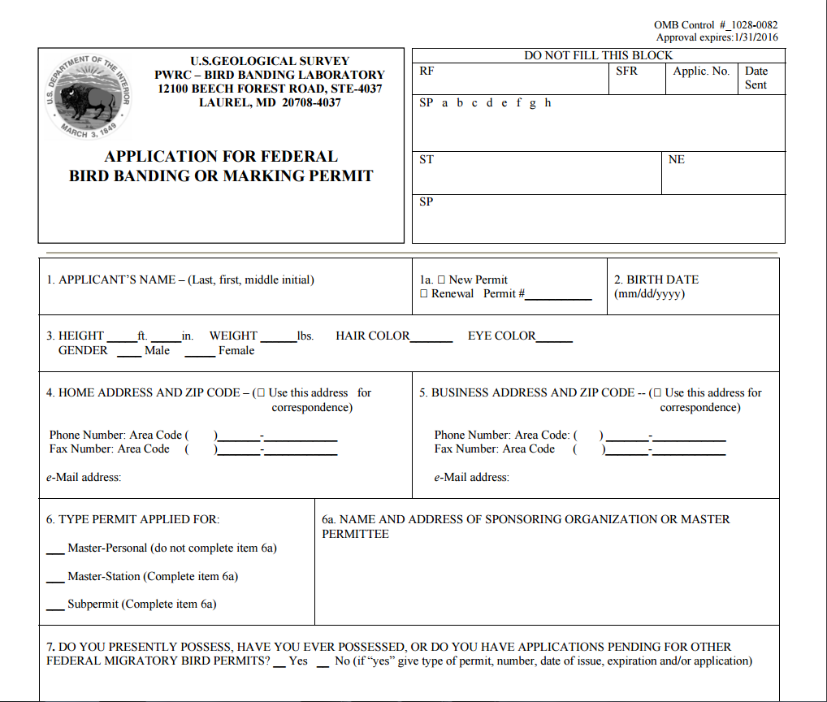

Permit Application: Electronic submission copy
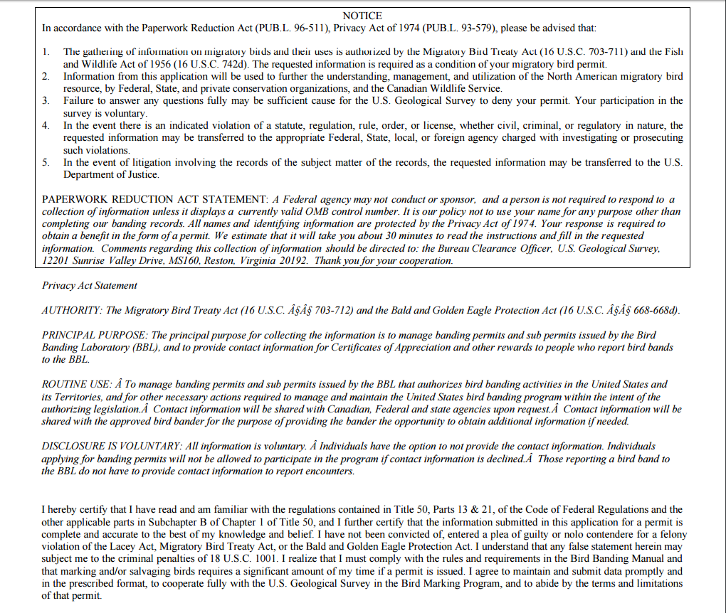

Permit Renewal Form
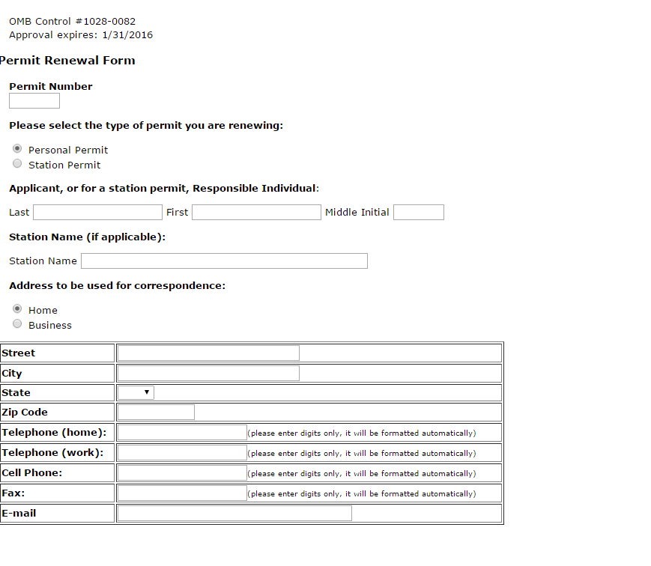
PRA statement is at bottom of the form on next page.

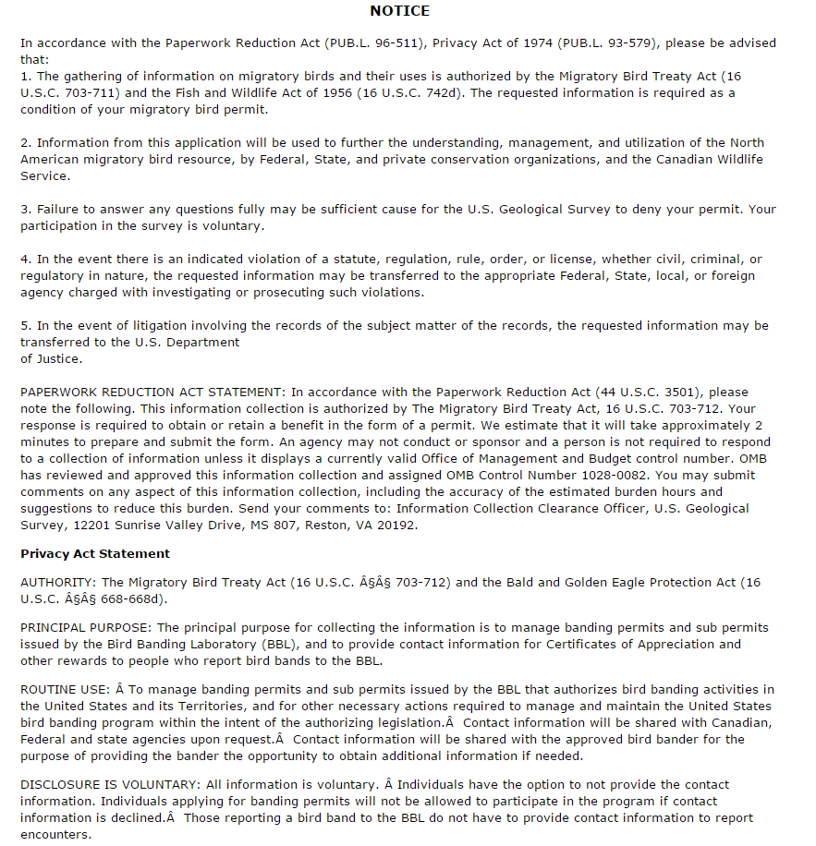

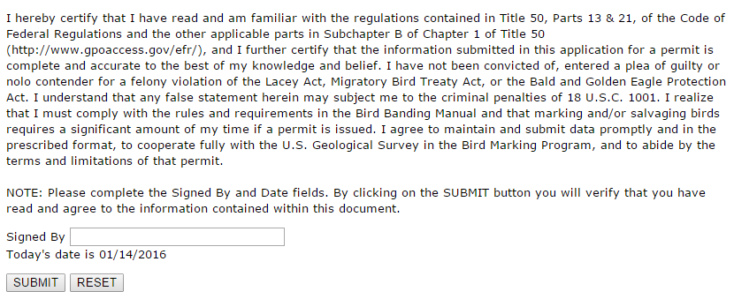

Reportband.gov: Users report recovery of a bird band electronic submission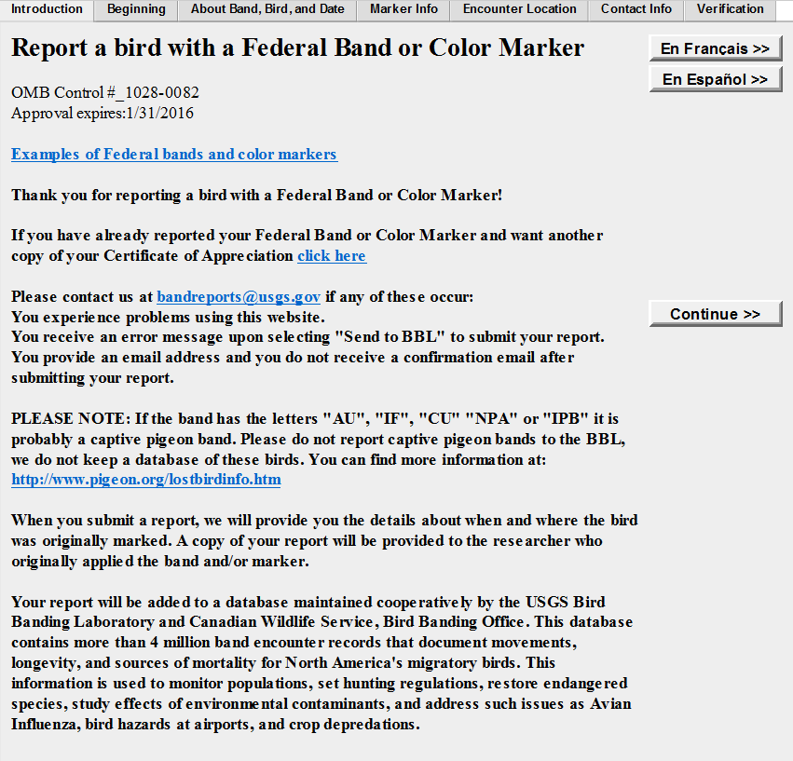

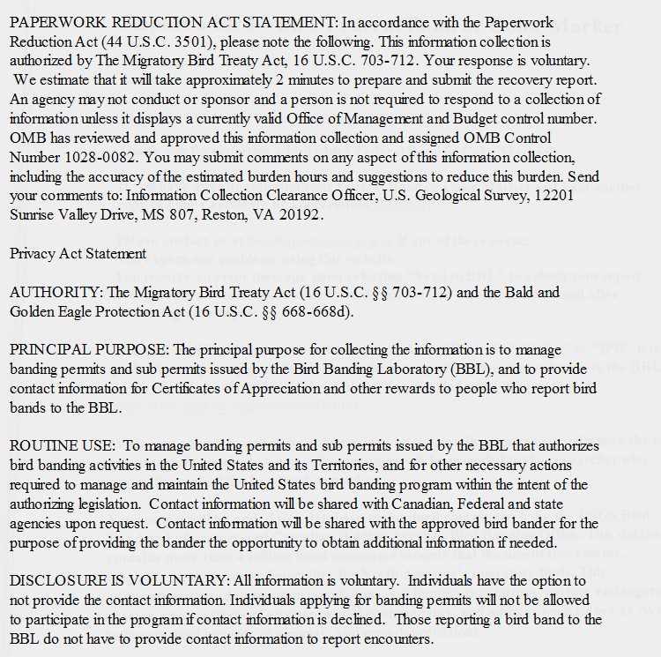

Bandit Software: Batch submission of Bird Banding Data Collection
