ET HANDBOOK NO. 336

18th Edition

UNEMPLOYMENT INSURANCE

STATE QUALITY SERVICE PLAN

PLANNING AND REPORTING GUIDELINES

TABLE OF CONTENTS

INTRODUCTION

A. Background i
B. Relationship/Coordination with Other Plans iii
C. Partnership Principles iii
D. Planning Considerations iv
E. OMB Approval v

CHAPTER I - PLANNING

- INTRODUCTION

- OVERVIEW OF PROCESS

- Schedule I-1
- Annual SQSP UIPL I-1
- Financial Guidelines and Planning Targets I-2
- Performance Measures I-2
- Performance Assessment I-3
- State Plan Preparation I-4
- SQSP Review and Approval I-4

  - CONTENT AND SUBMITTAL OF SQSP

    - Content of the SQSP I-4
    - Submittal of the SQSP I-6
    - Submittal of the SQSP as part of the WIOA Combined Plan I-6

  - STATE PLAN NARRATIVE

A. Description I-7
B. Format and Instructions I-8

  - CORRECTIVE ACTIONS PLANS (CAPs)

A. Description I-8
B. CAP Format Completion I-9

  - UI PROGRAM INTEGRITY ACTION PLAN (IAP)

- Description I-10
- IAP Format Completion I-10

- BUDGET WORKSHEETS AND INSTRUCTIONS

- Worksheet UI-1, UI Staff I-10
- SF 424, Application for Federal Assistance I-11
- Supplemental Budget Requests (SBRs) I-11

VIII. ASSURANCES

- Assurance of Equal Opportunity (EO) I-15
- Assurance of Administrative Requirements and
Allowable Cost Standards I-16
- Assurance of Management Systems, Reporting, and Record Keeping I-20
- Assurance of Program Quality I-20
- Assurance on Use of Unobligated Funds I-20
- Assurance of Prohibition of Lobbying Costs I-21
- Drug-Free Workplace I-21
- Assurance of Contingency Planning I-21
- Assurance of Conformity and Compliance I-22
- Assurance of Automated Information Systems Security I-22
- Assurance of Confidentiality I-23
- Assurance of Disaster Unemployment Assistance I-23
- Assurances for Non-Construction Programs I-23

IX. SQSP CONTENT CHECKLIST

- Formal SQSP Submittal I-23
- Alternate year SQSP Submittal I-24
- SBR Submittal I-25

CHAPTER II - REPORTING

I. INTRODUCTION

II. SUBMITTAL INSTRUCTIONS

A. Use of Computer Printouts in Lieu of Prescribed Forms. II-1
B. Electronic Submittal II-1
C. Due Dates II-1
D. Program Management Systems Document Numbers II-1

III. REPORTS

A. UI-3, Quarterly UI Above-base Report II-2
B. ETA 9130, Financial Status Report II-2
C. SF 270, Request for Advance or Reimbursement II-3

IV. DEFINITIONS

A. Expenditures II-3
B. Funding Period II-3
C. Obligations II-4
D. Unliquidated Obligations II-5
E. Automation Acquisition II-5
F. PMS Document Numbers II-6
G. Time Distribution Definitions II-6

APPENDIX I – UI Performance Measures and UI Programs

A. Core Measures Appendix I - 1
B. Secretary Standards in Regulation Appendix I - 2
C. UI Performs Management Information Measures Appendix I - 3
D. Unemployment Insurance Programs and Other Measures Appendix I - 5

APPENDIX II -- Planning Forms and Formats

A. Snapshot of CAP Form from the SQSP CAP and Quarterly Reporting
Workbook Appendix II - 1
B. UI Program Integrity Action Plan Format Appendix II - 2
C. State Plan Narrative Outline Appendix II - 3
D. SQSP Signature Page Appendix II - 5
E. Worksheet UI-1 Appendix II - 6
F. Instructions for the UI-1 Appendix II - 7
G. Application for Federal Assistance, SF-424 Appendix II - 8
H. Instructions for the SF-424 Appendix II- 11
I Budget Information – Non-Construction Programs, SF-424A Appendix II- 19
J. Instructions for the SF 424A Appendix II- 22
K. Assurances – Non-Construction Programs. SF-424B Appendix II- 37
L. Instructions for the SF-424B Appendix II- 40

APPENDIX III -- Reporting Forms and Formats

A. Worksheet UI-3 Appendix III - 1
B. Instructions for the UI-3 Appendix III - 3
C. US DOL ETA Financial Report, ETA 9130 Appendix III - 8
D. Financial Report Instructions, ETA 9130 Appendix III - 9
E. Request for Advance or Reimbursement, SF-270 Appendix III -20
F. Instructions for the SF-270 Appendix III -22

APPENDIX IV – Information Technology Security Guidelines

A. Contingency Planning Appendix IV- 1
B. Risk Management Appendix IV- 5
C. System Security Planning Appendix IV -11
D. Sample Plan Formats ...…………………………………..…… Appendix IV-18

APPENDIX V – UI Program Integrity Action Plan

A. Background and Instructions Appendix V - 1

ET HANDBOOK NO. 336

18th Edition

INTRODUCTION

This State Quality Service Plan (SQSP) Handbook provides guidelines for the completion and submittal of the State Quality Service Plan (referred to as the SQSP or the State Plan) for the Unemployment Insurance (UI) program, and the reports and data elements to be used for financial reporting of state UI program activities.

A. Background

The SQSP represents an approach to the UI performance management and planning process that allows for an exchange of information between the Federal and state partners to enhance the ability of the program to reflect their joint commitment to performance excellence and client-centered services. The statutory basis for the SQSP is Title III of the Social Security Act -- Section 302 authorizes the Secretary of Labor to provide funds to administer the UI program, and Sections 303(a)(8) and (a)(9) govern the expenditure of those funds. States submit budget worksheets and various assurances annually since funds for UI operations are appropriated each year. The Department of Labor’s (DOL’s) annual budget request for state UI operations contains workload assumptions for which the state must plan in order for the Secretary to carry out the responsibilities under Section 303(a)(1) of the Social Security Act, which requires that each state’s methods of administration insure full payment of unemployment compensation when due. DOL issues financial planning targets based on the budget request. States make plans based on such assumptions and targets via this mechanism.

As part of UI Performs, a comprehensive performance management system for the UI program, the SQSP is the principal vehicle that the state UI programs use to plan, record and manage improvement efforts as they strive for excellence in service. UI Performs was officially announced in August 1995. Unemployment Insurance Program Letter (UIPL) No. 41-95, dated August 24, 1995, outlined a construct for a comprehensive performance management system based on the following:

- a significantly improved data collection infrastructure that provides more management information more frequently;

- performance measures that include National core criterioned measures and a menu of non-criterioned measures for states to use in measuring and improving their program performance;

- a dynamic planning process that is state focused; and

- a goal of continuous improvement with responsibility shared by both state and Federal partners.

UIPL No. 14-05, Changes to UI Performs, and its changes 1, 2, and 3, outline changes to UI Performs as a result of a review of the system. The changes streamlined UI Performs by:

- reducing the number of measures for which performance criteria are set to a few core measures;
- recognizing remaining measures as management information with no set performance criteria; and

- streamlining the SQSP narrative.

The focus of this Handbook is to provide specific guidance regarding the SQSP, which is the implementing document for the performance management system described above. The State Plan is an integral part of UI Performs. It is, therefore, critical to understand the broader context in which the State Plan is developed.

1. The Continuous Improvement Cycle. UI Performs embraces the continuous improvement cycle advocated by quality practitioners which is commonly known as the “Plan-Do-Check-Act” cycle. It also is referred to as a “closed loop” continuous improvement cycle. It incorporates a strategic planning process of identifying priorities; ongoing collection and monitoring of valid data to measure performance; identification of areas of potential improvement; and development of specific action steps to improve performance, followed by use of available data to determine whether the action steps are successful. The cycle continues indefinitely with the opportunity at any point to reassess priorities, performance, and action that can improve performance.

2. The Performance Measurement System. The system includes Core Measures, Secretary’s Standards, Management Information Measures, and UI Programs as listed in Appendix I. The Core Measures and Secretary’s Standards are indicators of how well State Workforce Agencies (SWAs) perform critical activities. Management Information Measures provide additional insight into UI program operations.

3. The Planning Process. UI Performs emphasizes joint responsibility between states and the Employment and Training Administration (ETA) for setting priorities and responding to performance information on an ongoing basis. The relationship between the states and ETA will include the following shared responsibilities:

- continued tracking and analysis of performance data;

- identification of Federal and state priorities;

- development of planning directions;

- negotiation to determine improvement levels; and

- development and implementation of strategies to maintain acceptable performance.

Accomplishing these ongoing responsibilities requires an interactive and consultative process between states and ETA.

4. The State Quality Service Plan. The State Plan is intended to be a dynamic document that states can use as a management tool - much like a business plan - not only to ensure strong program performance, but also to guide key management decisions, such as where to focus resources. It should focus the states’ efforts to ensure well-balanced performance across the range of UI activities. The State Plan also is designed to be flexible to accommodate, among other things, multi-year planning and significant changes in circumstances during the planning cycle. Although it is developed in cooperation with the Federal partner, the State Plan is state-focused. The Federal role in the process is designed to be constructive and supportive.

Operationally, the State Plan also serves as the programmatic plan portion of the grant document through which states receive Federal UI administrative funding. To serve this purpose, states are required to submit budget worksheets and various assurances, as required in the UI grant agreement.

The State Plan is designed to provide the structure for recording the following kinds of information:

- responses Federally-identified priorities;

- performance assessment information;

- short and long term strategies for achieving performance targets;

- corrective action plans (CAPs) for failure to meet core performance criteria; and

- state strategies for evaluating customer satisfaction and gaining customer input to promote performance excellence.

States are required to submit the SQSP electronically and should contact the Regional Office (RO) SQSP Coordinator prior to submittal to coordinate specific details.

B. Relationship/Coordination with Other Plans

The UI program does not stand alone. It is the wage replacement component of an overarching effort to return a worker to suitable work. As such, the SQSP should be developed in concert with other plans which also address the same customer (such as plans under the Wagner-Peyser Act and the Workforce Innovation and Opportunity Act (WIOA)) to ensure a coordinated effort and minimal obstacles for the client in moving from program to program. This coordination will most likely be apparent in the State Plan Narrative portion of the SQSP.

C. Partnership Principles
The three following principles form the basis for carrying out Federal and state responsibilities under UI Performs and the SQSP planning process:

- Basing the federal-state relationship on mutual trust and respect will improve the UI system and its service to the American public;

- Working as equal partners with complementary roles will improve the UI system's quality of service and its integrity; and

- By setting high standards and goals and working together as a team, the system will be strengthened, and the entire nation will benefit.

The following are examples of the actions and attitudes which are consistent with these principles:

- Fostering a win-win relationship; advocating for and supporting one another.
- Sharing credit, celebrating successes;
- Being willing to acknowledge the existence of problems, and focus on fixing them instead of placing blame;
- Mutually accepting responsibility for resolving problems and overcoming deficiencies;
- Where there are differences between partners—
- Trying to resolve disputes equitably and fairly, being willing to compromise to achieve consensus; and
- Seeking early, informal resolution;
- Fostering open, personal communication;
- Clearly defining partner roles, rights and responsibilities;
- Engaging in joint planning and influencing one another's priorities;
- Promoting innovation and creativity;
- Jointly seeking input from customers;
- Sharing information and resources;
- Recognizing the role and importance of other players at the state and national levels;
- Asserting positive and friendly influence on partners to improve performance; and
- Periodically reviewing the principles and roles.

D. Planning Considerations

This section provides information for states to use in developing their SQSPs.

1. State Agency Resource Planning Targets for UI.

    - Financial Guidelines. States will prepare all SQSPs according to financial guidelines transmitted with target funding levels provided by the ROs.
  - Final Allocations. Final allocations may contain increases or decreases from the target funding level, which may require some revisions to submitted or approved State Plans.

2. State Flexibility. States have the flexibility to use the total dollars approved by ETA among the various UI program categories as it deems appropriate. However, for purposes of determining certification of above-base funding for workload above the base, the base staff year levels for claims activities, as allocated by ETA, will be used. Note that this flexibility does not include special allocations which are identified on a case-by-case basis.

3. State Financial Reporting System. ETA does not prescribe the use of any specific accounting and reporting system by the states. States are free to use any accounting system that meets the standards for state grantee financial management systems prescribed by Federal Regulations at 22 CFR 200.302. However, states must be able to report UI financial information in the form and detail described in Chapter II of this Handbook.

E. OMB Approval

OMB No.: 1205-0132 OMB Expiration Date: 02/29/2024 Estimated Average Response Time: 3.41 hours

OMB Burden Statement: Public reporting burden for this collection will vary from state to state, depending on the number of reports required, but will average 3.41 hours per response. These reporting instructions have been approved under the Paperwork reduction Act of 1995. Persons are not required to respond to this collection of information unless it displays a valid OMB control number. Public reporting burden for this collection of information includes the time for reviewing instructions, searching existing data sources, gathering and maintaining the data needed, and completing and reviewing the collection of information. Submission is required to obtain or retain benefits under Section 303(a)(6) of the Social Security Act. Persons responding to this collection have no expectation of confidentiality. Send comments regarding this burden estimate or any other aspect of this collection of information, including suggestions for reducing this burden, to the U.S. Department of Labor, Office of Unemployment Insurance, Room S-4519, 200 Constitution Ave., NW, Washington, DC, 20210, eta-ui-inquiries@dol.gov.

ET HANDBOOK NO. 336

18th Edition

CHAPTER I - PLANNING

- INTRODUCTION

Chapter I of the SQSP Handbook provides guidelines for the completion and submittal of the SQSP for the UI program and instructions for the SBR process for extraordinary funding.

- OVERVIEW OF PROCESS

While the SQSP process is ongoing throughout the year, the Formal (biennial) plan submittal occurs once every two years. Since funds for UI operations are appropriated each year, an Alternate year submittal is required in the off year. Each submittal occurs in conjunction with the funding cycle and utilizes the following process:

- Schedule. The significant activities and dates relating to the submittal and subsequent approval of the SQSP are estimated to be:

Activity | Approximate Date
National Office (NO) issues Annual UIPL | May/June
NO send financial guidelines and planning targets to states  States submit SF 424, 424A (as necessary) | Late June  At RO request or at the time of the SQSP submittal, at the latest
ROs notify states of SQSP approval | Late September
ROs notify NO of approved SQSPs | No later than September 25
Execution of UI Annual Funding Agreement with first funding increment | Early October
States submit UI-1 (UI Staff Hours) | October 1
States electronically submit the required SQSP documents to ROs. | August/September per RO requirement

- Annual SQSP UIPL. Each year, the SQSP submittal will be initiated with the SQSP UIPL. States should carefully review the annual UIPL. This letter will specify the dates relevant to the SQSP process for the approaching fiscal year; summarize National Priorities and Federal Program Emphasis for the year; and identify any special planning requirements in effect for the fiscal year. It also will explain opportunities for increased, targeted funding made available on an annual basis in the President’s budget if such opportunities exist.

- National Priorities and Federal Program Emphasis. The National Priorities and Federal Program Emphasis summarizes the primary areas in which the Federal partner will focus attention and resources for the planning cycle. The DOL Strategic Plan and the annual DOL Performance Budget form the basis for the Federal Program Emphasis. Required by Congress under the Government Performance and Results Act (GPRA), the Federal plans are an integral part of the Federal budget process. They establish program performance goals and outcomes and identify strategies and performance objectives to attain them. Accordingly, states will want to review the current versions of these planning documents before developing their SQSPs. These documents may be found on the DOL webpage, About Us | U.S. Department of Labor (dol.gov).

- Special Planning Requirements. Any special planning considerations or requirements for the planning year will be identified in the SQSP UIPL.

- Financial Guidelines and Planning Targets. Each year the NO provides preliminary allocations, any special financial instructions for the year, and submission deadlines.

- Performance Measures. UI Performs incorporates two types of performance measures (Core and Management Information). States are encouraged to routinely monitor performance data on both Core and Management Information Measures, and to achieve continuous improvement in overall unemployment compensation performance by establishing improvement targets for as many measures as possible.

- Core (Criterioned) Measures. Core Measures are those measures that are considered to be critical indicators of the overall performance of the program. If acceptable levels of performance (ALPs) for them are not met, it signals fundamental impairment in program operations, and triggers corrective action planning. Core Measures are comparable among SWAs and have ALP criteria assigned to them. SWAs are expected to submit CAPs if performance falls below the ALPs. See Appendix I, Performance Measures, for a list of the Core Measures and associated criteria.

- Management Information (Non-Criterioned) Measures. Management Information Measures, like Core Measures, are routinely reported by the state using Federal definitions found in ETA Handbook 401, but, with the exception of the Secretary’s Standards, have no established performance criteria assigned to them. Some Management Information Measures are subsets or components of data included in Core Measures, such as timeliness of Unemployment Compensation for ex-Service Members (UCX) benefit payments, those claiming benefits on an interstate basis, or the individual Tax Performance System (TPS) components of the tax quality measure. These data alert state and Federal managers to performance issues that could result in lower performance on Core Measures and are useful for performance analysis. However, as provided in Federal UI law, the Secretary of Labor retains full authority to address cases of poor performance in a state that does not substantially comply with Federal law requirements.

- Performance Assessment

  - Continuous Assessment. In the SQSP process, both the Federal partner and the state will routinely access performance data to monitor program performance and initiate corrective action when warranted. CAPs are plans developed in response to data showing state performance below the ALPs established for Core Measures and criteria established for other measures and UI programs. Also, if a state’s performance in one or more Management Information Measures is so poor that a state’s substantial compliance with Federal law requirements is in question, DOL may request corrective action. Although performance may be viewed at specific points in time (e.g., monthly, quarterly, annually), each assessment reviews performance over time and focuses not only on performance for the period in question, but also on the trend of performance over the period reviewed (e.g., was performance declining or improving, sustained or erratic).

States that have CAPs in place must submit quarterly status updates to their RO by the date the Region has specified. The status update must include the progress of each CAP milestone or activity scheduled to be completed by the end of the quarter. Quarterly updates are to be recorded using the CAP and Quarterly Reporting Workbook (Appendix II).

  - Annual Assessment. An annual assessment will augment the ongoing continuous improvement process and will form the basis for corrective action planning for the SQSP. This annual assessment will utilize the most recent 12 months of performance data. For data reported monthly or quarterly, the assessment will include the 12 months ending March 31 of each year. For data reported annually, the assessment will be based on data reported for the most recent complete calendar year (or other full 12-month period, per reporting requirements).

ETA will make all relevant data available to the states for SQSP purposes, but states have continuous direct access to the data resident on the state SUN computer system, or through the Office of Unemployment Insurance website at
https://oui.doleta.gov/unemploy/performance1.asp. Subsequent performance data that become available during the plan development period (e.g., April, May, June data) should be utilized to refine plans before final submission and approval.

  - State/Regional Negotiations. Before the SQSP is signed, states and regional administrators must agree on the specific areas for which the state will submit and/or revise CAPs and Narratives in the SQSP. These negotiations encompass performance below the established criteria for Core Measures, Secretary’s Standards, and UI Programs. CAPs are expected to be submitted if performance is unsatisfactory and an effective plan is not already in place.

- State Plan Preparation. States must prepare and transmit an SQSP in accordance with the instructions in this Handbook and in the annual SQSP UIPL. The SQSP, with its CAPs and Narratives, is the state’s formal plan and schedule for improving performance. An acceptable SQSP must have state management approval and must authorize the resources necessary to conduct the actions planned.

- SQSP Review and Approval. ROs shall review SQSPs for completeness, and to ensure that they are in accordance with the instructions and that they reflect negotiated agreements. This review may result in the RO initiating additional discussion or obtaining clarification. A plan that the regional administrator deems unsatisfactory, i.e., failing to meet the requirements identified in this Handbook, shall be returned to the state for revision without approval.

- CONTENT AND SUBMITTAL OF SQSP

- Content of the SQSP. The SQSP process provides a 24-month window for states to adequately plan and implement performance improvement efforts. The process provides for two types of submittals: a Formal (biennial) submittal and an Alternate Year submittal.

Formal SQSP. Every two years, the Formal or Biennial SQSP submittal must contain a complete SQSP package, including: a transmittal letter; the State Plan Narrative, including required Assurance information; CAPs; the IAP; budget worksheets/forms; organizational charts; other required administrative documents as requested; and the SQSP Signature Page.

Alternate Year SQSP. The Alternate Year submittal consists of items included in the state’s request for Federal UI administrative funding, as well as modifications to the Formal SQSP. It must contain at least: a transmittal letter; modifications to the State Plan Narrative, including updated Assurance information; CAPs for new performance deficiencies; required modifications to existing CAPs; the IAP; budget worksheets/forms; updated organizational charts; and the SQSP Signature Page.

Each element/document is described below.

- Transmittal Letter. State administrators must prepare and send a cover letter to the appropriate RO transmitting all the required SQSP documents.

- Budget Worksheets. States must complete required budget forms and plan for administration based on projected allocations received from the Federal partner.

All states must complete Worksheet UI-1 and required SF 424s. States must complete the SF 424A only if they vary the quarterly distribution of base claims activity staff years.

States must submit the Worksheets UI-1 by October 1 of each year separately from the SQSP submittal. States must submit the SF 424 and SF 424A (if necessary) via www.Grants.gov.

Completion instructions and facsimiles of these forms are in Appendix II.

- The State Plan Narrative. The State Plan Narrative is a vital element of the SQSP that provides a vehicle for sharing with the Federal partner state-specific efforts that affect the administration of the UI Program. The State Plan Narrative allows the state to describe in a single narrative: a) state priorities; b) performance assessments; c) coordination with other plans; d) state performance in comparison to the GPRA goals; e) actions planned to correct deficiencies regarding UI programs, UI program reviews, and reporting requirements; and f) results of customer satisfaction surveys (optional). Section IV, State Plan Narrative, provides a detailed description and instructions for the format and content of the Narrative. A sample outline of the State Plan Narrative is contained in Appendix II.

- Corrective Action Plans. CAPs are expected as a part of the SQSP when a state’s annual performance does not meet the criteria, specifically:

  - Performance that did not meet ALPs for Core Measures for the annual measurement period and remains uncorrected prior to the preparation of the SQSP;

  - Performance that did not meet the criteria for Secretary’s Standards for the annual measurement period and remain uncorrected prior to the preparation of the SQSP;

  - UI program deficiencies identified by the NO in the annual SQSP UIPL;

  - UI program integrity; and

  - Failure to meet the requirements for the Assurance of Contingency Planning.

CAPs will not be expected based on Management Information Measures in most circumstances. However, if a state’s performance in one or more Management Information Measures is so poor that a state’s compliance with Federal law requirements is in question, a CAP may be expected.

A sample of the required CAP format is in Appendix II.

- UI Program Integrity Action Plan (IAP). All states are required to complete the IAP, outlining the strategies the state will undertake during the planning period regarding the prevention, reduction, and recovery of UI improper payments. SWAs will use the IAP template in Appendix II to describe planned activities to prevent, detect, reduce, and recover improper UI payments. The description of the plan is in Appendix V.

- Organizational Chart. The state must submit an organizational chart. This organization chart must conform to the requirement for delivery of service through public employment offices, or such other designated providers as the Secretary may authorize; show the state's configuration from the Governor of the state down to the point of Employment Service and UI customer service delivery; and provide sufficient detail to show each organizational unit involved and the title of the unit manager.

- SQSP Signature Page. State administrators must sign and date the SQSP Signature Page located in Appendix II. By signing the Signature Page, the state administrator certifies that the state will comply with all the assurances and activities contained in the SQSP guidelines.

- Submittal of the SQSP. States must submit the SQSP to the RO by the date the Region has specified. The SQSP Content Checklist (Checklist) located at the end of this chapter shows all the documents that comprise the entire SQSP. States should use the Checklist when preparing the SQSP to ensure that those documents appropriate to its plan are submitted, and to minimize the potential for a delay in the approval and funding process. Electronic transmittal of the SQSP is required in a format specified by the RO. States must provide the RO with an original SQSP Signature Page; however, states may submit the Signature Page electronically, if state law permits.

- Submittal of the SQSP as part of the WIOA Combined State Plan. WIOA provides the option for states to include program plans for mandatory one-stop partners and other programs to submit a Combined State Plan. Given that the UI program is a mandatory one-stop partner under WIOA, states have the option of including the UI program as part of the Combined State Plan. However, each state must participate in the UI Performs SQSP process whether or not the state decides to include the UI program as part of its Combined State Plan. The SQSP State Plan Narrative must provide a discussion of the plan coordination with other WIOA Combined Plan programs to ensure a coordinated effort and integrated service delivery.

States that elect to include UI in the Combined State Plan must submit the most recently approved complete SQSP package through the Combined State Plan process via the online WIOA State Plan Portal at https://wioaplans.ed.gov/.

- STATE PLAN NARRATIVE

Of necessity, states engage in a planning process and set priorities for the coming two years. The State Plan Narrative (Narrative) provides a vehicle for sharing the results of that process with the Federal partner. In addition, it provides an opportunity to report on the integration and coordination with other internal and external plans which serve the same client.

- Description. The Narrative consists of a description of major planning elements the state plans to focus on during the 2-year planning cycle. The Narrative should be concise, as a more detailed discussion with RO staff already may have occurred or may occur as a follow-up. However, in order to develop RO and NO support for its objectives, the state needs to provide a minimum amount of information relative to the categories defined in a format that allows for follow-up and tracking.

Below are the components to be included in the Narrative. These components should be addressed in a manner that best describes the state’s direction and plans for two consecutive fiscal years:

- The strategic direction the state has adopted to ensure continuous program improvement, including the basis for the state’s choice of areas to emphasize in the planning cycle, and the actions planned to support performance improvement during the two years;

- Assessment of program performance in prior program years;

- A discussion of the coordination with other plans, including the WIOA Combined Plan;

- Responses to the Secretary of Labor’s areas of program emphasis;

- State performance in comparison to the GPRA goals for the U.S. Department of Labor;

- Actions planned to correct the following types of deficiencies regarding UI programs and reporting requirements including:

  - Program Review Deficiencies. Causes for failures to conduct required program reviews.

- Program Deficiencies. Uncorrected deficiencies identified during program reviews conducted by the state, or ETA.

- Reporting Deficiencies.

- Missing reports: Failure to submit any Federally-required report.

- Late reports: Failure to timely or accurately submit any Federally-required reports. This includes monthly and quarterly reports submitted late more than 50 percent of the time (7 of 12 months for monthly reports; 3 of 4 quarters for quarterly reports); and annual reports submitted late 3 consecutive years.

- Information on the state strategy for evaluating customer satisfaction and including customer input to promote continuous improvement; (optional)

- State’s specific requests for technical assistance from the Federal partner; and

- Information on the state’s approach to maintaining solvency of the state’s unemployment fund.

  - Format and Instructions. A sample of the Narrative outline is in Appendix II. The format is intended to provide states flexibility in conveying the overall direction and emphasis of the Narrative, while providing for electronic transmittal. States are requested to address each area of the outline, including entering N/A (Not Applicable) where appropriate.

- CORRECTIVE ACTIONS PLANS

- Description. CAPs are the state’s formal plan and schedule for improving performance. States are to complete each component of the CAP, including the CAP summary, milestones, and completion dates. CAPs are to be completed and submitted using the format(s) in Appendix II.

States are expected to complete and submit CAPs for the following:

- Performance Deficiencies. Performance that did not meet criteria established for Secretary’s Standards, Core Measures, and UI Programs for the annual measurement period and remains uncorrected prior to the preparation of the SQSP is considered deficient. CAPs for Secretary’s Standards, Core Measures, and UI Programs must be titled as listed in Appendix I.

In many instances, performance deficiencies will have been identified prior to the annual assessment with a CAP already in existence to remedy the problem. Accordingly, the SQSP will not, in many instances, result in the development of a new CAP unless progress on an existing plan is not on target or does not adequately address milestones for the plan cycle. Such CAPs (i.e., adequate, existing CAPs) will be incorporated into the SQSP submission along with revised CAPs and CAPs addressing newly identified deficiencies.

- UI Program Deficiencies. ETA will issue additional guidance to address UI program deficiencies in the annual SQSP UIPL.

- Single Audits. Each state is subject to a Single Audit for the regulations outlined in 2 CFR Part 200, Subpart F. Any unresolved program compliance or performance deficiencies identified by a single audit must be addressed in a CAP. However, if a state is developing a CAP for a performance measure associated with the unresolved program compliance or performance deficiencies from the single audit, the corrective actions for both items may be addressed in a single CAP. Information on the program and audit objectives for the UI program is available as part of the FY 2023 Compliance Supplement at: 2023 Compliance Supplement – 2 CFR Part 200 Appendix XI (whitehouse.gov). (Note: The Compliance Supplement and link is updated annually.)

- Poor Performance on Management Information Measures. If a state’s performance in one or more Management Information Measures is so poor that a state’s substantial compliance with Federal law requirements is in question, corrective action may be required.

  - CAP Format Completion. When developing a CAP for deficient performance, states must complete all data elements in the prescribed formats. Each of the prescribed formats includes the data elements listed below.

  - State.

  - Federal Fiscal Year.

  - Measure/Program Area. Measures are listed in Appendix I.

  - Performance Level. The state must indicate the target performance level they anticipate will result from the completion of the planned corrective actions plan and milestones for each quarter of the planning cycle. The quarterly targets are represented as a percentage reflecting 12-months of cumulative performance data for each quarter ending date.

  - Corrective Action Plan Summary. The summary must address each deficient performance measure as described in ET Handbook 336, Chapter I, in the space provided. It must explain the reason for the deficiency, provide a description of the specific actions/activities planned to improve performance, and a plan for monitoring and assessing accomplishments of planned actions for each CAP.

If the desired improvement will not be accomplished by the end of the two consecutive fiscal years for which the plan is submitted, the state should provide a multi-year plan which must include: (1) an estimate of where performance will be at the end of the 2-year planning cycle; (2) major actions remaining to be taken in subsequent fiscal years; and (3) a projection as to when the performance goal will be achieved.

- Milestones and Completion Dates. The state must list both specific milestones (key corrective action or improvement activities) and the completion date for each milestone in the space provided. Milestones must be established for each element of the state’s CAP and be of sufficient number and frequency to facilitate state and regional plan oversight and assessment during the 2-year cycle. It is anticipated that one or more milestones for each quarter would permit such progress tracking and assessment during the planning cycle through state and regional follow-up schedules.
NOTE. Milestones should be concise and should specify key actions to be accomplished throughout the planning cycle to implement the state's proposals for achieving its corrective action goals. States also may wish to identify performance milestones that reflect the performance level they anticipate will result from completion of planned activities.

- Quarterly Updates. States must provide a quarterly update for each milestone. The update should describe if the milestone was completed as scheduled. If the milestone was not completed as scheduled, states should explain why and provide a new completion date.

An Excel Workbook will be used by states for developing SQSP submissions and for reporting updates to the specific milestones and performance each quarter. The Excel Workbook will be provided to states at the beginning of each SQSP planning cycle. A snapshot of the required format is contained in Appendix II.

- UI Program Integrity Action Plan (IAP).

- Description. IAPs must include root causes of UI improper payments, person(s) accountable for reducing UI improper payments, strategies to address root causes and recovery of improper payments, and a timeline. IAPs should be completed and submitted according to the format in Appendix II.

- IAP Format Completion. When developing an IAP, states must provide all required information as discussed in this Handbook and in the annual SQSP UIPL. A recommended template for the IAP is included in Appendix II of this Handbook.

Instructions for completion on the IAP are in Appendix V.

- BUDGET WORKSHEETS AND INSTRUCTIONS

This section contains instructions states will need to follow to prepare resource requests for administering the UI program during the fiscal year. Budget worksheets are in Appendix II. Only two UI program operation worksheets (UI-1 and SF 424) are required. State agencies must prepare and submit the UI-1 (via Unemployment Insurance Required Reports (UIRR)) for staff hour estimates, and the SF 424 (via grants.gov) for base level planning and supplemental grant requests.

- Worksheet UI-1, UI Staff Hours. A facsimile of Worksheet UI-1 and associated form completion instructions are found in Appendix II. These data are required for the development of annual base planning targets. The UI-1 worksheet is due by submission via the UIRR to the NO (Attn.: Office of Unemployment Insurance, Division of Fiscal and Actuarial Services) by October 1 of each year.

- SF 424, Application for Federal Assistance. The regulation at 22 CFR 200.207 requires the use of forms approved by OMB under the Paperwork Reduction Act of 1995, as amended, for an application for grant funds by state grantees; OMB Standard Form (SF) 424, Application for Federal Assistance is the approved form. ETA requires that states use the SF 424 for submitting applications for UI base grants and SBRs. The SF 424 must be completed according to its instructions.

- Procedures for Submission. States must submit a separate SF 424for each request for base funding and each SBR. A separate SF 424A also may be required as described in sub-paragraph 2.b. below. In addition, states which submit SBRs must provide supporting justification and documentation. SF 424s are due as requested, or with the SQSP at the latest, for base grants and throughout the year as necessary for SBRs.

- Form Completion Instructions. States must follow the standard instructions in completing SFs 424 and 424A; however, states are not required to complete all items on the SF 424 and 424A. A facsimile of these forms and completion instructions are found in Appendix II. The following are specific guidelines for completing SFs 424 and 424A.

a. SF 424. States are not required to complete Items 3, 4, 6, 9, 13, and 14 for base grants and SBRs. States must complete the remaining items. In Item 2, all SBRs are considered to be revisions. In Item 12, the title of the project must refer to either the base grant or SBR title and number. SBRs must be numbered sequentially within the fiscal year, e.g., 00-1, 00-2, etc.

b. SF 424A. States must complete Items 1, 6, and 16 for SBRs. States are not required to complete this form for base grants, unless the number of base claims activity staff years paid by quarter vary; states that do so must show the quarterly distribution in Item 23 (Remarks).

- Supplemental Budget Requests (SBRs). ETA provides supplemental funding related to expenditures due to state law changes enacted after the base allocation is provided. In addition, ETA may on occasion award supplemental funds for specific items not funded in the base allocations. States may submit SBRs for these specific solicitations from ETA.

- Allowable/Unallowable Costs

    - Allowable Costs. States may submit SBRs only for one-time costs that are not a part of base or above-base funding. SBR funds may be used only for the purposes identified in the SBR and/or any modifications to the original agreement approved by the grant officer.

    - Unallowable Costs. SBR funds may not be used for ongoing costs, such as maintenance of software and hardware, or ongoing communications costs. In addition, SBRs may not be used to pay for salary increases, even when these increases are caused by a law change.

- Guidelines for Preparing SBR Supporting Documentation. ETA will evaluate and approve all SBRs on the basis of supporting documentation and the justification provided. Insufficient justification may delay processing and result in partial or total disapproval of the SBR.

  - Supporting Documentation. SBRs may address a variety of projects whose scope cannot be fully anticipated. At a minimum, the SBR supporting documentation must contain the following five elements; however, these guidelines will not perfectly fit every SBR. States should use them as a starting point.

1) Summary. For larger projects, the SBR should contain a summary (1-2 paragraphs) that explains what the funds will accomplish. It should identify major capital expenditures, including hardware, software, and telecommunications equipment; state staff; contract staff; and other purchases. It should also state what the final product or results will be when the funds have been expended.

2) Commitment to Complete Project. ETA cannot assure the availability of future Federal supplemental funds. By applying for these individual projects, the state is agreeing that the projects will be completed with no additional Federal SBR funding. Applicants must agree to continue efforts to complete the SBR project, and to supply any additional funds necessary to complete the project in a timely manner. This assurance is necessary to ensure that projects begun with Federal funds are not abandoned due to a lack of additional Federal funding.

3) Schedule. If the project activities have not been completed, the SBR must include a projected schedule. The schedule should provide the projected dates for significant activities from start to completion.

4) Amount of Funding Requested. The total dollar amount of the SBR must be included. The costs of specific program modules or tasks must also be listed.

5) Description of the Proposed Fund Usage. The SBR must contain a full description of how the funds are to be used and why the proposed expenditures represent the best use of funds for the state. For each specific program module or task, the SBR must include costs for:

(a) Staff. The request must identify both one-time state staff needs, and contract staff needs. Staff needs must include the type of position (e.g., program analysts), the expected number of staff hours, and the projected hourly cost per position.

(1) State Staff. Staff costs are allowable, but all personal services (PS) and personal benefit (PB) expenses and time worked for the project must be appropriately charged to the SBR.

(2) Contractor Staff. For contract staff, the state must supply documentation including the estimated positions and hours, and the anticipated costs. States electing to negotiate with the Information Technology Support Center (ITSC) or other available sources for technical assistance must supply the same information normally requested for all contract staff, including the type of position, the expected staff hours, and the costs.

(b) Non-Personal Services (NPS). States may identify itemized one-time state NPS needs or may calculate staff-related NPS costs by formula. If not itemized in the SBR, staff-related NPS costs (excluding data processing and other needs) must be based on the rates approved for the current year's base allocation.

(1) Hardware, Software, and Telecommunications Equipment. This section must include any hardware, software, and/or telecommunications equipment purchases that are a part of the request. Descriptions must show that the sizing and capabilities of the proposed purchases are appropriate for the state. States that receive SBR funds for specific items, and subsequently determine that other items are more suitable, may substitute those items if they submit an amendment to the SBR documenting the appropriateness of the purchase, and ETA approves the substitution. Substitutions must be in line with the overall goals of the project.

SBRs sometimes include requests for items covered under the definition of automation acquisition in Chapter II. The obligation and expenditure periods for these funds are longer than the periods for regular UI base and above base funds. States must clearly identify automation acquisition items in the SBR.

(2) Travel. The request may include NPS travel costs; however, PS and PB costs for staff while on travel are not allowable.

(3) Other. The request may include one-time costs for other activities, not identified above, and anticipated to be obtained from vendors, such as telephone companies, Internet service providers, and telecommunications providers.

- Additional Required Items for Law Change SBRs. SBRs for law changes must contain the following information:

1) The specific bill number of enactment, and effective date of law change.

2) Relevant provisions as an attachment.

3) Costs per legislative provision and a narrative explaining why costs were or will be incurred for each provision, e.g., implementing tax rate changes; increasing the maximum benefit amount; or creating an alternative base period.

4) If a legislative provision benefits both UI and non-UI activities, the SBR must contain a statement certifying that the request is consistent with the state’s approved cost allocation plan and is only for costs which, under Federal law, may be funded from UI grants.

- Supplementary Items. Some SBRs are for large-scale, complex projects that may be accomplished over a period of years. The following items are not required, but would be helpful in the SBR evaluation process:

- Use of Technology. If applicable, the request should describe how the state will use technology in this project, including the technical appropriateness of the hardware, software, and/or telecommunications equipment for integration with the state's current operating systems.

- Strategic Design. The SBR should include a description of the strategic design of the project as evidence of a well-thought-out analysis of operations.

- Measurable Improvements Expected in UI Operations. The request should identify the areas in which services could be improved through implementation of the proposed project. Measurable improvements may include accomplishing necessary work using fewer steps, doing work more quickly, incorporating work steps which are not currently accomplished, or reducing the amount of error which presently occurs in the work product.

- Supporting Materials. States may attach any additional materials which they believe will enhance the content of the SBR.

- ASSURANCES

The State administrator, by signing the SQSP Signature Page, certifies that the state will comply with the following assurances, and that the state will institute plans or measures to comply with the following requirements. A facsimile of the Signature Page appears in Appendix II. The assurances are identified and explained in Paragraphs A. through K. below.

- Assurance of Equal Opportunity (EO). As a condition to the award of financial assistance from ETA, the state must assure that the operation of its program, and all agreements or arrangements to carry out the programs for which assistance is awarded, will comply with the following laws:

- Section 188 of the Workforce Innovation and Opportunity Act (WIOA);
- Title VI of the Civil Rights Act of 1964, as amended;
- Sections 504 of the Rehabilitation Act of 1973, as amended;
- Age Discrimination Act (ADA) of 1975, as amended; and
- Workforce Innovation and Opportunity Act (WIOA)Title IX of the Education Amendments of 1972, as amended;
- Title II Subpart A of the Americans with Disabilities Act of 1990, as amended; and
    - Equal Pay Act of 1963, as amended.

Further, the state must assure that it will establish and adhere to Methods of Administration that give a reasonable guarantee of compliance with the above equal opportunity and nondiscrimination laws and regulations regarding the program services it provides and in its employment practices. These Methods of Administration must, at a minimum, include the following:

- Designation of an Equal Opportunity Officer. The state must designate a senior-level individual to coordinate its EO responsibilities. The person designated must report to the top official on equal opportunity and nondiscrimination matters and be assigned sufficient staff and resources to ensure the capability to fulfill the agency’s equal opportunity and nondiscrimination obligations.

- Equal Opportunity Notice and Communication. The state must take affirmative steps to prominently display the Equal Opportunity is the Law Notice in all of its facilities and inform applicants/registrants for programs, participants, applicants for employment, and employees:

a. that the state does not discriminate in admission, access, treatment, or employment; and
b. of their right to file a complaint and how to do so.

Other than the Equal Opportunity is the Law Notice, methods of notification of this information may include placement of notices in offices and publication of notices in newsletters, newspapers, or magazines.

  - Assurances. The state must develop and implement procedures for transferring nondiscrimination and EO obligations in sub-contracts and sub-agreements.

  - Universal Access. The state must take appropriate steps to ensure it is that it is providing universal access to its programs. These steps should include reasonable efforts to the various racial and ethnic groups; members of both sexes; individuals with disabilities; individuals address possible disparities in different access based on, possibly among other things, race, ethnicity, sex, disability status, age groups; and individuals with different, and language needs.

  - Compliance with Section 504. The state must take the necessary measures to ensure access to its programs and facilities for persons with disabilities, as well as make certain communication with persons with disabilities is as effective as that with others.

  - Data Collection and Recordkeeping. The state must collect such data and maintain such records in accordance with procedures prescribed by the Director of the U.S. Department of Labor’s Civil Rights Center. These characteristics data (e.g., race, sex, national origin, age, disability) are utilized to determine whether the state and its local office are in compliance with Federal nondiscrimination and equal opportunity statutes and regulations.

  - Monitoring. The state must establish a system for periodically monitoring the delivery of program services for compliance.

  - Discrimination Complaint Procedures. The state must develop and follow procedures for handling complaints of discrimination covering all of the regulations applicable to it as a recipient of Federal financial assistance.

  - Corrective Actions and Sanctions. The state must establish procedures for taking prompt corrective action regarding any noncompliance finding relating to the administration, management, and operation of its programs and activities.

- Assurance of Administrative Requirements and Allowable Cost Standards. The State must comply with administrative requirements and cost principles applicable to grants and cooperative agreements as specified in 2 CFR 200 (Office of Management and Budget’s Uniform Administrative Requirements, Cost Principles, and Audit Requirements for Federal Awards) and 2 CFR part 2900 (U.S. Department of Labor’s Uniform Administrative Requirements, Cost Principles, and Audit Requirements for Federal Awards). The state must assure that state staff will attend mandatory meetings and training sessions or return unused funds.

States that have subawards to organizations covered by audit requirements of 2 CFR 200, Subpart F (Audit Requirements) must (1) ensure that such subrecipients meet the requirements of that circular, as applicable, and (2) resolve audit findings, if any, resulting from such audits, relating to the UI program.

The state also must assure that it will substantially comply with the following specific administrative requirements:

1. Administrative Requirements

a. Program Income. Program income is defined in 2 CFR 200.11 as gross income earned by the non-Federal entity that is directly generated by a grant supported activity or earned as a result of the Federal award during the period of performance. States may deduct costs incidental to the generation of UI program income from gross income to determine net UI program income. UI program income shall be added to the funds committed to the grant by ETA. The program income must be used only as necessary for the proper and efficient administration of the UI program. Any rental income or user fees obtained from real property or equipment acquired with grant funds from prior awards shall be treated as program income under this grant.

b. Budget Changes. Except as specified by terms of the specific grant award, ETA, in accordance with regulations, waives the requirements in 2 CFR 308(f) that states obtain prior written approval for certain types of budget changes.

c. Real Property Acquired with Reed Act Funds. The requirements for real property under ETA-funded grants are TEGL July detailed in regulations and multiple guidance. The OMB regulation in 2 CFR 200.311 governs real property obtained with Federal funds. Training and Employment Guidance Letter (TEGL) No. 3-19, dated July 15, 2019, addresses real property under ETA-funded grants. TEGL No. 3-07, dated August 1, 2007, addresses Transfers of Federal Equity in State Real Property to the States. TEGL No. 7-04, dated October 20, 2004, addresses Issues Related to Real Property used for ETA Program purposes. UIPL No. 39-97, dated September 12, 1997, governs the use of Reed Act funds, which, as explained in section 2.c. below, are funds distributed under specified authorities in Section 903 of the Social Security Act.

d. Equipment Acquired with Reed Act Funds. The requirements for equipment acquired with Reed Act or other non-Federal funds and amortized with UI grants are in UIPL No. 39-97, and UIPL No. 39-97 Changes 1 and 2, and in 22 CFR 200.313.

e. Real Property, Equipment, and Supplies

1) Real property, equipment, and supplies acquired under prior awards are transferred to this award and are subject to the relevant regulations at 22 CFR 200.

2) For computer systems and all associated components which were installed in states for the purpose of Regular Reports, Benefit Accuracy Measurement (BAM), and other UI Activities, the requirements of 22 CFR 200 apply. The NO reserves the right to transfer title and issue disposition instructions in accordance with Federal regulations at 22 CFR 200.313(e). States also will certify an inventory list of system components which will be distributed annually by ETA.

2. Exceptions and Expansions to Cost Principles. The following exceptions or expansions to the cost principles of 2 CFR 200 Subpart E are applicable to states:

- Employee Fringe Benefits. Regarding personnel benefit costs incurred on behalf of state employees who are members of fringe benefit plans which do not meet the requirements of 22 CFR 200.431, the costs of employer contributions or expenses incurred for state fringe benefit plans are allowable, provided that:

- For retirement plans, all covered employees joined the plan before October 1, 1983; the plan is authorized by state law; the plan was previously approved by the Secretary; the plan is insured by a private insurance carrier which is licensed to operate this type of plan in the applicable state; and any dividends or similar credits because of participation in the plan are credited against the next premium falling due under the contract.

- For all state fringe benefit plans other than retirement plans, if the Secretary granted a time extension after October 1, 1983, to the existing approval of such a plan, costs of the plan are allowable until such time as the plan is comparable in cost and benefits to fringe benefit plans available to other similarly employed state employees. At such time as the cost and benefits of an approved fringe benefit plan are equivalent to the cost and benefits of plans available to other similarly employed state employees, the time extension will cease, and the cited requirements of 2 CFR 200 Subpart E will apply.

- For retirement plans and all other fringe benefit plans covered in (1) and (2) of this paragraph, any additional costs resulting from improvements to the plans made after October 1, 1983, are not chargeable to UI grant funds.

- UI Claimant's Court Appeals Costs. To the extent authorized by state law, funds may be expended for reasonable counsel fees and necessary court costs, as fixed by the court, incurred by the claimant on appeals to the courts in the following cases:

- Any court appeal from an administrative or judicial decision favorable in whole or in part for the claimant;

- Any court appeal by a claimant from a decision which reverses a prior decision in his/her favor;

- Any court appeal by a claimant from a decision denying or reducing benefits awarded under a prior administrative or judicial decision;

- Any court appeal as a result of which the claimant is awarded benefits;

- Any court appeal by a claimant from a decision by a tribunal, board of review, or court which was not unanimous;

- Any court appeal by a claimant where the court finds that a reasonable basis exists for the appeal.

- Reed Act Distributions (1956-58, 1998). A state may wish to make payment from the state's UI grant allocations into a state's unemployment fund in the Unemployment Trust Fund for the purpose of reducing charges against Reed Act funds. The use of UI grant allocations to restore Reed Act funds under Section 903(c)(2) of the Social Security Act, 42 U.S.C. 1103(c)(2), is limited to the Reed Act distributions made under Sections 903(a) and (b) of the Social Security Act.

These include the 1956-58 and 1998 Reed Act distributions. The use of UI grant allocations to restore Reed Act funds made under other distributions is not permitted.

In addition, the use of UI grant allocations to restore Reed Act funds is permitted only if the charges against the grant are allowable costs under 2 CFR 200 Subpart E and

- The charges against Reed Act funds were for amounts appropriated, obligated, and expended for the acquisition of automated data processing installations or for the acquisition or major renovation of state-owned buildings, but not land; and

- Regarding each acquisition or improvement of property, the payments are accounted for as credit against equivalent amounts of Reed Act funds previously withdrawn under the respective appropriation.

- Prior Approval of Equipment Purchases. As provided for in 2 CFR 200.313, the requirement that grant recipients obtain prior approval from the Federal grantor agency for all purchases of equipment (as defined in 2 CFR 200.11) is waived and approval authority is delegated to the state administrator.

- Assurance of Management Systems, Reporting, and Record Keeping. The state must assure that:

- Financial systems, including records documenting compliance with Federal statutes, regulations, and the terms and conditions of the Federal award, must be sufficient to permit the preparation of reports required by general and program-specific terms and conditions;; and the tracing of funds to a level of expenditures adequate to establish that such funds have been used according to the Federal statutes, regulations, and the terms and conditions of the Federal award. (2 CFR 200.302).

- The financial management system and the program information system provide federally-required reports and records that are uniform in definition, accessible to authorized Federal and state staff, and verifiable for monitoring, reporting, audit, and evaluation purposes.

- It will submit reports to ETA as required in instructions issued by ETA and in the format ETA prescribes.

- It will retain all financial and programmatic records, supporting documents, and other required records at least three years as specified in 2 CFR 200.334.

- The financial management system provides for methods to ensure compliance with the requirements applicable to procurement and grants as specified in 2 CFR 200.214Suspensio214 (suspension and debarment), and for obtaining the required certifications under 2 CFR 180 regarding debarment, suspension, ineligibility, and voluntary exclusions for lower tier covered transactions.

- Assurance of Program Quality. The state must assure that it will administer the UI program in a manner that ensures proper and efficient administration. "Proper and efficient administration" includes performance measured by ETA through Core measures, Management Information Measures (including Secretary’s Standards), program reviews, and the administration of the UI program requirements.

- Assurance on Use of Unobligated Funds. The state must assure that non-automation funds will be obligated by December 31 of the following fiscal year, and liquidated within 90 days thereafter, or as otherwise specified in annual DOL Appropriation Acts. ETA may extend the liquidation date upon written request. Automation funds must be obligated by end of the 3rd fiscal year, and liquidated within 90 days thereafter, or as otherwise specified in annual DOL Appropriation Acts. ETA may extend the liquidation date upon written request. Failure to substantially comply with this assurance may result in disallowed costs from audits or review findings.

Note. Travel costs for state agency personnel are considered obligated when the travel is actually performed.

- Assurance of Prohibition of Lobbying Costs. The state must assure and certify that, in accordance with the annual DOL Appropriations Acts, no UI grant funds will be used to pay salaries or expenses related to any activity designed to influence legislation or appropriations pending before the Congress of the United States. (2 CFR 200.450)

- Drug-Free Workplace. The state must assure and certify that it will comply with the requirements at this part. (The Drug-Free Workplace Act of 1988, 41 U.S.C. 702 et seq., and 2 CFR 182)

- Assurance of Contingency Planning. The state must establish, effectively implement, and maintain plans for emergency response, backup operations, and post-disaster recovery for the UI systems to ensure the availability of critical information resources and continuity of operations in emergency situations.

The state must assure that, at a minimum, the following formally written and tested procedures of Contingency Planning are in place:

- procedures for sustaining essential business operations while recovering from a significant disruption.
- procedures and capabilities for recovering information technology (IT) system, such as a major application or general support system.
- procedures to facilitate recovery of capabilities at an alternate site.
- procedures and capabilities to sustain an organization’s essential, strategic functions at an alternate site for up to 30 days.
- procedures for recovering business operations immediately following a disaster.
- procedures for disseminating status reports to personnel and the public.
- strategies to detect, respond to, and limit consequences of malicious cyber incident.
- procedures for minimizing loss of life or injury and protecting property damage in response to a physical threat.

The National Institute of Standards and Technology (NIST) provide guidelines for IT Contingency Planning. An overview of these guidelines is provided in Appendix IV. It is recommended that the state follow state or departmental guidelines for business related procedures, such as business continuity, continuity of operations, or business recovery after a disaster.

In the State Plan Narrative, Section H, Assurances, states are expected to provide the dates that their Information Technology (IT) Contingency Plan, System Security Plan, and Risk Assessment were implemented, tested, and reviewed/updated.

If a state does not have an IT Contingency Plan, System Security Plan, and Risk Assessment procedures in place or if these documents are incomplete, then the state is expected to address the actions it plans to take to meet these requirements in a CAP.

- Assurance of Conformity and Compliance. The state must assure that the state law will conform to, and its administrative practice will substantially comply with, all Federal UI law requirements, and that it will adhere to DOL directives.

- Assurance of Automated Information Systems Security. The state must establish and implement an information security program. The state must ensure that it is providing adequate IT security and that it is commensurate to the level of risk associated with the UI program and the UI IT environment. The state must ensure that appropriate safeguards are put in place to protect both tangible and intangible resources and employees.

The state should develop, disseminate, and periodically review/update: (1) formal, documented policies for Risk Assessment and System Security Planning that address purpose, scope, roles, responsibilities, management commitment, coordination among all entities, and compliance; and (2) formal, documented procedures to facilitate the implementation of these policies and associated controls.

The state assures that it has the following Risk Assessment controls for UI systems in place:

- Risk Assessments of the UI systems to assess the risk and magnitude of harm that could result from the unauthorized access, use, disclosure, disruption, modification, or destruction of information and other systems that support the operations and assets of the state.

- Updates to the Risk Assessment at least once every three years or whenever there are significant changes to any of the UI systems, facilities where they reside, or other conditions that may affect the security status of the system.

- Scans for vulnerabilities in the UI systems as deemed necessary or when significant new vulnerabilities potentially affecting the system are identified and reported.

The state assures that it has the following System Security Planning controls for UI systems in place:

- A System Security Plan for the UI systems that provides an overview of the security requirements for the systems and a description of the security controls in place or planned for meeting those requirements. The plan should be approved by the officials designated by the state.

- An annual review of the system security plan for the UI systems. Revisions to the plan should address system/organizational changes or problems identified during plan implementation and/or security control assessments.

- A set of rules that describes users’ responsibilities and expected behavior with regard to UI information and information system usage. A signed acknowledgement (Rules of Behavior) from users indicating that they have read, understood, and agreed to abide by a set of Rules of Behavior, before authorizing access to the information system and its resident information.

An overview of Risk Management and System Security Planning for an information system is provided in Appendix IV.

- Assurance of Confidentiality. The state will keep confidential any business information, as defined at 20 CFR Part 603618.100, and any successor provision(s), it obtains or receives in the course of administering the Trade Adjustment Assistance for Workers (TAA), Alternative Trade Adjustment Assistance (ATAA), and Reemployment Trade Adjustment Assistance (RTAA) programs under this Agreement. The state also shall adhere as applicable to the requirements in 20 CFR Part 603. The state shall not disclose such information to any person, organization, or other entity except as authorized by applicable state and Federal laws.

- Assurance of Disaster Unemployment Assistance (DUA). The state must assure that it will conduct annual training for its DUA staff and developing and maintain a standard operating procedures manual.

- Assurances for Non-Construction Programs. The state must agree to Non-Construction Program assurances as detailed in Standard Form 424B, as applicable.

- SQSP CONTENT CHECKLIST

The SQSP Content Checklist shows all the documents which comprise the entire SQSP listed by submittal and in order of assembly. Each state must ensure that those documents appropriate to its plan are submitted to minimize the potential for a delay in the approval and funding process.

- Formal SQSP Submittal (Biennial submittal)

AUGUST/SEPTEMBER SUBMITTAL (Main)

- Transmittal Letter

- The State Plan Narrative
A. Overview
B. Federal Emphasis (GPRA goals), if required
C. Program Review Deficiencies
D. Program Deficiencies
E. Reporting Requirements
F. Customer Service Surveys (optional)
G. Other
H. Assurances

- Corrective Action Plans

- Deficient Core Performance
- Deficient Secretary’s Standards
- UI Program Deficiencies
- BAM Requirement Deficiencies
- Organization
- Authority
3) Written Procedures
4) Forms
- Sample Selection
- Investigation Procedures
7) Case Completion Timeliness
- TPS Requirement Deficiencies
- Poor Performance of Management Information Measures
- Single Audits

- UI Program Integrity Action Plan

- Budget Worksheets/Forms
SF 424, SF 424 (A) - Application for Federal Assistance (as necessary)

- Organization Chart

- Signature Page

OCTOBER SUBMITTAL

UI-1 - UI Staff Hours

B. Alternate year SQSP

AUGUST/SEPTEMBER SUBMITTAL (Main)

- Transmittal Letter

- State Plan Narrative with required updates

- CAPs:
- New CAPs for:
  - On-site reviews that identify a need for corrective action
  - New performance deficiencies identified during the most recent performance year.
  - Other performance deficiencies identified in the annual SQSP UIPL.

- Modifications to existing CAPs for:
  - Missed milestones
  - Other

- UI Program Integrity Action Plan

5. Budget Worksheets/Forms
SF 424, SF 424 (A) - Application for Federal Assistance (as necessary)

6. Organization Chart

7. Signature Page

OCTOBER SUBMITTAL
UI-1 - UI Staff Hours

- SBR SUBMITTAL (Only when solicited by DOL)

1. Transmittal Letter
2. Budget Worksheets/Forms
SF 424 and SF 424 (A) - Application For Federal Assistance
3. Supporting Documentation
Summary
Commitment to Complete Project
Schedule
Description of Proposed Fund Usage
Amount of Funding Requested
Expenditures
4. Additional SBR Documentation (Law Change SBRs only)
Bill Number and Effective Date
Relevant Provisions
Costs & Narrative by Legislative Provision
UI only Statement
5. Optional Supplementary Items (Large-scale, Complex Projects)
Technical Approach
Strategic Design
Measurable Improvements Expected
Supporting Materials

ET HANDBOOK NO. 336

18th Edition

CHAPTER II - REPORTING

- INTRODUCTION

Chapter II of the SQSP Handbook provides guidelines for the reports and data elements to be used for financial reporting of state UI program activities.

- SUBMITTAL INSTRUCTIONS

- Use of Prescribed Forms. States may submit financial report information on the ETA 9130, SF 270, and SF 424.

- Electronic Submittal. States submit the UI-3 and the UI-1 worksheet through UIRR. This ensures that the reported data are consistent. UIRR makes output reports available for review and correction before electronic transmission to the NO. In addition, electronic submittal is available for the ETA 9130 via the Enterprise Business Support System.

States submit the SF 424s via www.Grants.gov. All other required standard forms must be submitted to the appropriate ETA regional office (RO); however, SBR information is submitted directly to the NO. The NO electronically receives UIRR and ETA 9130 reports, which the ROs also may access.

- Due Dates. The UI-3 worksheet is due within 30 days after the end of the reporting quarter. The ETA 9130 is due 45 days after the end of the reporting quarter. The request form, SF 270, is a voluntary report.

- Program Management Systems (PMS) Document Numbers. The following is an example of a list of PMS Document Numbers that the NO will use to issue obligational authority and that states will use for the ETA 9130 and when drawing cash. Additional line items may be necessary depending on the funding being directed to the state agency. Definitions of program categories on the UI-3 are provided in Section IV, Paragraph H, Time Distribution Definitions.

PROGRAM | PMS DOCUMENT NO.
UI State Administration | UIxxxxxxx
UI National Activities | UIxxxxxxx
Disaster Unemployment Assistance (DUA) Administration | UIxxxxxxx
Disaster Unemployment Assistance (DUA) Benefits | UIxxxxxxx

NOTE. ETA code numbers are assigned to each separate DUA disaster when funds are provided to the states.

- REPORTS

Facsimiles of the forms and completion instructions can be found in Appendix III. Additionally, standard forms may be downloaded from https://www.grants.gov/web/grants/forms/sf-424-family.html and the ETA 9130 form and instructions may be downloaded from https://www.doleta.gov/grants/financial_reporting.cfm#ETA-9130_Forms_and_Instructions.

  - UI-3, Quarterly UI Above-base Report

- Purpose. This report provides information to ETA on the number of staff years worked and paid for various UI program categories and provides the basis for determining above-base entitlements.

- Reporting Instructions. States are required to report the number of quarterly staff years worked and paid and the number of year-to-date staff years paid. ETA does not prescribe the type of time distribution reporting system used by states to generate the required data. However, the system used must be capable of providing data in the required detail, and the data must fairly and accurately represent the utilization of staff years. Data must be traceable to supporting documentation, e.g., time distribution and cost reports. States using sampling, allocation, and estimating techniques to spread actual hours to the UI programs must have documentation describing the techniques and procedures being used.

- Report Completion Instructions. States are to enter only data which cannot be obtained elsewhere in UIRR or calculated from existing data.

- ETA 9130, Financial Status Report. This report is an ETA form prescribed for use by 2 CFR 2 CFR 200.328 and 2 CFR 2900.14. A separate ETA 9130 is submitted each quarter for each fiscal year of funds (including the current fiscal year), until such time as all unliquidated obligations (resources on order) have been liquidated and a final ETA 9130 is submitted. States submit a final ETA 9130 when all financial activity has ceased and the unobligated balance is zero, and the following equation is satisfied: obligational authority = accrued expenditures = cash received.

ETA is requiring states to report administrative expenditures on the accrued expenditure basis each quarter using the ETA-9130 financial reports (2 CFR 2900.14). The ETA 9130 submitted for TAA, ATAA, RTAA, and DUA (if funds are issued to state) payments must report them on the cash basis, i.e., actual cash benefits paid during the reporting period.

ETA 9130s are to be submitted for each line item for which the state agency has been issued obligation authority. This may include, but is not limited to, the following:

- Unemployment Insurance State Administration. All UI administrative funds are to be included on the ETA 9130, including funds for TAA ATAA, and RTAA (depending on when the petition was filed) benefits administration, but excluding UI National Activities and cooperative agreements. UI program income and associated costs also must be reported on the ETA 9130. On line 12 (Remarks), enter accrued expenditures (quarter) and obligations (year-to-date) separately according to staff costs and NPS costs. Expenditures/obligations must reflect charges against only current year funds. Charges against prior year funds (including carry-over funds) are to be reflected on the separate ETA 9130 for that year.

- UI National Activities. (Separate for each year)

- DUA Benefits and Administration (Separate for each year)

- TAA Benefits. (Separate for each year)

- ATAA Benefits. (Separate for each year)

- RTAA Benefits

- SF 270, Request for Advance or Reimbursement. This report is a government-wide standard form prescribed for use by OMB Circular No. A-102, and by DOL regulation at 29 CFR 97.41(d). This is a voluntary report which states may use to request above-base advances.

- DEFINITIONS

  - Expenditures. For accrued expenditures, this term is defined in 2 CFR 200.1 as charges incurred by the grantee during a given period requiring the provision of funds for (1) goods and other property received; (2) services performed by employees, contractors, subrecipients and other payees; and (3) programs for which no current services or performance are required such as annuities, insurance claims, or other benefit payments.

The term "Outlays" on the ETA 9130 has the same meaning as accrued expenditures under the accrual basis of reporting.

  - Funding Period. Non-automation funds must be obligated by December 31 of the following fiscal year, and liquidated within 90 days thereafter, or as required otherwise by annual DOL Appropriation Acts. ETA may extend the liquidation date upon written request. Automation funds must be obligated by the end of the 3rd fiscal year, and liquidated within 90 days thereafter, or as required otherwise by annual DOL Appropriation Acts. ETA may extend the liquidation date on written request. The annual SQSP UIPL will specify the specific funding period for the plan period and any special provisions contained in the appropriation language.

  - Obligations. Obligations are the sum of outlays and unliquidated obligations (resources on order).

Guidelines for establishing obligations in the UI program are listed below:

- Obligations must be intended to meet a bona fide need of the funding period in which the need arises, or to replace stock used in the funding period. To comply with this guideline, purchase orders, requisitions, and contracts recorded as obligations must be firm, complete, and must request prompt delivery of materials or services. Do not include in the amounts reported as obligations administrative reservations, such as reservations for contemplated procurements in the form of requisitions within the state, invitations for bids, or any other similar arrangements.

- Where an obligation is definite, but the precise amount is not known, it may be estimated.

- States must obligate allocations for regular operations of the UI program -- whether base or above-base funded -- as specified in paragraph IV.B. above.

- Generally, obligations should be supported by a valid purchase order or other binding agreement, in writing, between the parties, for goods to be delivered or services to be performed. Purchase orders are to be included only to the extent that their issuance, together with previous or subsequent action by the other party, constitutes an offer and acceptance that has become a binding agreement. Such orders (and requisitions) may not be regarded as issued as long as they remain within the control of the issuing agency.

- If the state issues purchase orders directly to a vendor, obligations must be recorded and reported on the basis of the purchase orders.

- For purchases placed with another state agency which are required by state law or regulation, an exception is made to the requirement for supporting a transaction by a valid purchase order or binding agreement in writing. Where the state law or regulations mandatorily require the state agency to procure the specific materials, requisitions of state agencies may be treated as purchase orders, and obligations must be recorded and reported on the basis of the requisitions issued to the central procurement agency.

- When procurement from a central procurement agency is optional, obligations may be recorded on the basis of requisitions issued by the state, provided (a) there is documentary evidence (such as a store stock catalog) that the items are normally stocked, and (b) the requisition is for a bona fide need of the funding period in which the need arises, or it is for replacement of stock used in the funding year. When items or services are ordered through a central procurement agency with delivery to the state direct from the vendor, obligations must be recorded on the basis of purchase orders issued by the central agency.

- Unliquidated Financial Obligations. This term on the ETA 9130, for reports prepared on an accrued expenditure basis, is defined in 2 CFR 200.11 as “financial obligations incurred by the non-Federal entity for which an expenditure has not been recorded.” The term "unliquidated obligations” has the same meaning as "resources on order” had in the past. States must report valid unliquidated obligations on the ETA 9130 for the UI program.

States should periodically review unliquidated obligation amounts to determine their validity. Obligations must not be carried on the state agency's books unless the agency is reasonably certain that payment of the obligation will be required at a later date.

Regulations at 2 CFR 200.344(b) require that states must liquidate all financial obligations incurred under the Federal award no later than 120 calendar days after the end date of the period of performance as specified in the terms and conditions of the Federal award unless extended by the Federal agency at the request of the grantee. Thus, states must obtain written approval from ETA to retain unliquidated non-automation acquisition obligations beyond 6 months after the end of the fiscal year or automation acquisition obligations beyond two years and 90 days after the end of the fiscal year. State requests for extension of the deadline for expending funds must be in writing and executed prior to the regular deadlines for fund expenditure.

- Automation Acquisition. Automation acquisition refers to obtaining computers and their peripheral and auxiliary equipment and associated software. Automation data processing services are those services necessary to support the acquisition of such equipment. The term does not include maintenance and other costs relating to current operations and services.

Given the fast pace of technological developments, the list of products covered under the meaning of automation equipment will change with time; therefore, no definitive list can be provided. The following are examples of products and services to illustrate what is meant by automation acquisition items, but is not intended to be a comprehensive list:

  - Hardware. Central processing units; front-end processing units; minicomputers; microcomputers and related peripheral equipment, such as data storage devices, document scanners, data entry equipment, terminal controllers, and data terminal equipment; computer-based word processing systems other than memory typewriters; equipment and systems for computer networks; equipment and systems for communications, which includes voice, radio, images, optical, data, and video; related items such as switchboards, PBX units, multiplexers, FAX, modems, digital computer service units, channel service units, channel extenders, protocol converters, VSAT, satellite, encryption and voice response units.

- Software. Programs and routines used to employ and control the capabilities of automated and communication systems such as operating systems, compilers, assemblers, utilities, library routines, maintenance routines, applications, converters, conversion routines, knowledge-based systems, artificial intelligence systems, decision support systems, executive information systems, security and encryption, and networking programs.

- Services. One-time costs for staff, service bureaus, or contract services directly related to the initial acquisition of automation systems, including those relating to feasibility studies, systems design, application software security and system development; and the transportation, installation, training, and maintenance of such items which directly relate to the initial acquisition.

- PMS Document Numbers. Because some states have moved to accounting systems other than the Cost Accounting System (CAS), ETA established uniform accounting codes for use by all states in reporting back to ETA. While the uniform codes are based on the current CAS fund ledger code structure, non-CAS users may establish whatever account/code classification system they wish to use in their accounting systems. However, the ETA 9130s submitted to ETA must contain the PMS Document Number(s) issued under the UI Annual Funding Agreement, and they must be used in identifying cash drawdowns by program through the Department of Health and Human Service’s Payment Management System.

- Time Distribution Definitions. The definitions of the UI program categories contained in the UI base allocations and Quarterly Financial Report (UI-3) are a combination of UI functions previously defined in ET Handbook No. 362 (State Accounting Manual), Volume II, Chapter IV. The following reflects the program categories used on the UI-3 worksheet and the CAS time distribution functions and codes:

UI-3

Associated Time Distribution Functional Activity Codes (under Project
Code 210 unless otherwise stated)

Claims Activities

Initial Claims (200)
Weeks Claimed (Includes ERP) (200)
Nonmonetary Determinations (230)
Multi-claimant Services (238)
Appeals (240)

Employer Activities

Wage Records (260)
Tax (Includes Tax Travel) (300)

UI PERFORMS

UI Performs (Function 461 and/or Project Code 213)

UI Support/AS&T

Benefits/Appeals Travel (235)
Benefit Payment Control (270)
UI Support (400)
Internal Security (459)
Interstate Activities (460)
AS&T (100, 120, 150)

TAA and ATAA Benefit Administration (Project Code 219)

Use only Claims Activities codes 200, 230, 238, and 240 (see above) under
Project Code 219)

Other

Reserved for special categories

ET HANDBOOK NO. 336

18th Edition

APPENDIX I

UI PERFORMANCE MEASURES

and

UI PROGRAMS

UI Performance Measures and UI Programs

Core Measures | Acceptable Levels of Performance
Benefits Measures
First Payment Promptness: % of all 1st payments within 14/21 days after the compensable week (excludes workshare, DUA, retroactive payments) | 87
Nonmonetary Determination Time Lapse:  % of Separations and Nonseparations within 21 days of Detection Date | 80 (combined score)
Nonmonetary Determination Quality- Nonseparations: % of Nonseparation Determinations with Quality Scores equal to or greater than 95 points | 75
Nonmonetary Determination Quality- Separations: % of Separation Determinations with Quality Scores equal to or greater than 95 points | 75
Overpayment Measure
Detection of Overpayments: % of detectable/recoverable overpayments established for recovery | ≥50 and ≤95% of detectable/recoverable overpayments are established for recovery
UI Overpayment Recovery Measure | 68%
Appeals Measures
Average Age of Pending Lower Authority Appeals: | 30 Days
Average Age of Pending Higher Authority Appeals: | 40 Days
Lower Authority Appeals Quality: % of Lower Authority Appeals with Quality Scores at least 85% of potential points | 80
Tax Measures
New Employer Status Determinations Time Lapse: % of New Status Determinations within 90 days of Quarter End Date | 70
Tax Quality (Part A): assessment of the accuracy and completeness of the tax program | No more than 3 tax functions failing TPS in a year
Tax Quality (Part B): assessment of the accuracy and completeness of the tax program | The same tax function cannot fail for 3 consecutive years
Effective Audit Measure | Score >=7; and exceed all 4 factors
Integrity Measure
Improper Payments Measure | < 10%

Secretary Standards in Regulation | Criteria
First Payment Promptness (Regulation): % of 1st Payments within 14/21 days: IntraState UI, full weeks | 87
First Payment Promptness (Regulation): % of 1st Payments within 35 days: IntraState UI, full weeks | 93
First Payment Promptness (Regulation): % of 1st Payments within 14/21 days: InterState UI, full weeks | 70
First Payment Promptness (Regulation): % of 1st Payments within 35 days: InterState UI, full weeks | 78
Lower Authority Appeals (Regulation): % decided within 30 days of filing | 60
Lower Authority Appeals (Regulation): % decided within 45 days of filing | 80

UI Performs Management Information Measures

Secretary’s Standards
      - First Payments Intrastate full weeks, within 14/21 days
      - First Payments Intrastate full weeks, within 35 days
      - First Payments Interstate full weeks, within 14/21 days
      - First Payments Interstate full weeks, within 35 days
      - Lower Authority Appeals Timeliness – 30 Days
      - Lower Authority Appeals Timeliness – 45 Days

Tax Measures
- New Status Determination Timeliness (within 180 days of Quarter Ending Date)
- Successor Status Determination Timeliness (within 90 days of Quarter Ending Date)
- Successor Status Determination Timeliness (within 180 days of Quarter Ending Date)
- Contributory Employer Report Filing Timeliness
- Reimbursing Employer Report Filing Timeliness
- Secured Delinquent Contributory Reports Timeliness
- Secured Delinquent Reimbursing Reports Timeliness
- Resolved Delinquent Contributory Reports Timeliness
- Resolved Delinquent Reimbursing Reports Timeliness
- Contributory Employer Payments Timeliness
- Reimbursing Employer Payments Timeliness
- Percent of Contributory Employer Tax Due Declared Uncollectible
- Percent of Reimbursing Employer Receivables Due Declared Uncollectible
- Percent of Contributory Employer Accounts Receivable At End of Report Period to Tax Due
- Percent of Reimbursing Employer Accounts Receivable At End of Report Period to Tax Due
- Percent of Change in Total Wages Resulting from Audit
- Percent of Contributory Employers Audited
- Percent of Total Wages Audited (Annualized)
- Accuracy of New Status Determination
- Accuracy of Successor Determination
- Accuracy of Status Inactivations
- Timeliness of Cashiering
- Accurate Identification and Resolution of Report Delinquency
- Accurate Identification and Resolution of Accounts Receivable
- Audits to Meet ESM Requirements
- Accuracy of Contribution Report Processing
- Accuracy of Debits and Billings of Contributory Employers
- Accuracy of Debits and Billings of Reimbursing Employers
- Accuracy of Credits and Refunds
- Accuracy of Benefit Charging
- Accuracy of Experience Rating

Cash Management Measures
- Average Days on Deposit
- Timeliness of transfer from clearing account to Trust Fund

Benefits Measures
Timeliness of Payments and Nonmonetary Determinations

- First Payments Intrastate full weeks
- First Payments Interstate full weeks
- First Payments Intrastate, all weeks
      - First Payments Interstate, all weeks
      - First Payments, partial weeks
      - First Payments, UCFE
      - First Payments, UCX
      - First Payments, workshare
      - Continued Weeks Payment, all weeks
- Continued Weeks Payment, partial weeks
- Continued Weeks Payments, workshare
- Intrastate Separation Determinations
- Intrastate Nonseparation Determinations
- Interstate Separation Determinations
- Interstate Nonseparation Determinations

Combined Wage Claims Timeliness Measures
- Combined Wage Claim Wage Transfer
- Combined Wage Claim Billing
- Combined Wage Claim Reimbursements

Benefits Accuracy Measures
- Paid Claim Accuracy
- Denied Claim Accuracy
- Operational Overpayment Rates

Benefit Payment Control Measures
- Fraud Overpayment Recovery Rate
- Nonfraud Overpayment Recovery Rate

Appeals Measures

Appeals Timeliness Measures and Case Aging Measures
- Lower Authority Appeals Timeliness
- Higher Authority Appeals Timeliness
- Lower Authority Appeals, Case Aging
- Higher Authority Appeals, Case Aging

Appeals Quality Measure

1. Lower Authority Appeals Quality - Due Process

Macroeconomic Stabilization Measures

- Recipiency Rates
- Exhaustion Rates

Unemployment Insurance Programs and Other Measures

1. Unemployment Compensation for Federal Employees (UCFE)
2. Unemployment Compensation for ex-Service Members (UCX)
3. Benefit Payment Control (BPC)
4. Internal Security (IS)
5. UI Automation Support Account (UIASA)
6. State Audits
7. Benefit Accuracy Measurement (BAM)
8. National Directory of New Hires (NDNH)
9. Tax Performance System (TPS)
10. Data Validation (DV)
11. Benefits, Timeliness, and Quality (BTQ)
12. Reporting Delinquencies
13. UI Program Integrity

HANDBOOK NO. 336

18th Edition

APPENDIX II

PLANNING FORMS AND FORMATS

State Quality Service Plan (SQSP)
Integrity Action Plan (IAP)
State Name – Fiscal Year (FY) 20XX

Accountable Agency Official(s)
List the person or persons accountable for ensuring integrity in the state’s unemployment insurance (UI) program.

Name:
Title:
Email:
Phone:

- IAP Topic #1

- IAP Topic #2

- IAP Topic #3

- IAP Topic #4

- IAP Topic #5

- IAP Topic #6

- IAP Topic #7

- IAP Topic #8

STATE PLAN NARRATIVE OUTLINE

STATE PLAN NARRATIVE
(State Name – Fiscal Years xxxx and xxxx)

Overview

State priorities and the strategic direction the state has adopted to ensure continuous improvement.

Assessment of past performance and expected future performance. Includes, at state discretion, a discussion of external factors that may have performance implications.

Coordination with other plans, including WIOA.

Federal emphasis (GPRA goals), if required

State performance compared to the GPRA goals.

Actions planned to achieve GPRA goals and targets.

C. Program Review Deficiencies

Causes for failures to conduct required reviews/activities, e.g., Benefit Payment Control, Internal Security, Benefit Accuracy Measure, and Tax Performance System.

Plans to conduct the reviews as required.

D. Program Deficiencies

Plans to correct deficiencies identified through required program reviews, e.g., deficiencies identified during an internal security review.

E. Reporting Deficiencies

Actions planned to correct reporting deficiencies. Reporting deficiencies are defined as missing reports, reports submitted late more than 50 percent of the time (7 of 12 months for monthly reports; 3 of 4 quarters for quarterly reports), and annual reports submitted late 3 consecutive years.

F. Customer Service Surveys (optional)

G. Other (e.g., approach to maintaining solvency, requests for technical assistance)

H. Assurances:

- Assurance of Equal Opportunity (EO).
- Assurance of Administrative Requirements and Allowable Cost Standards.
- Assurance of Management Systems, Reporting, and Recordkeeping.
- Assurance of Program Quality.
- Assurance on Use of Unobligated Funds.
- Assurance of Prohibition of Lobbying Costs (29 CFR Part 93).
- Drug-Free Workplace (29 CFR Part 98).
- Assurance of Contingency Planning.
Provide the most recent dates for the following:
  - Information Technology (IT) Contingency Plan Implemented: __________
  - IT Contingency Plan Reviewed/Updated1: __________
  - IT Contingency Plan Tested: __________
- Assurance of Conformity and Compliance.
- Assurance of Automated Information Systems Security.
Provide the most recent dates for the following:
  - Risk Assessment Conducted: __________
  - System Security Plan Reviewed/Updated: __________
- Assurance of Confidentiality
- Assurance of Disaster Unemployment Assistance
- Conducted Annual DUA Training for DUA Staff ☐ Yes ☐ No
Provide the date of the training: __________
- Developed and/or Maintain Standard Operating
Procedures for use during a major disaster declaration ☐ Yes ☐ No
- Assurance for Non-Construction Programs

Public reporting burden for this collection of information is estimated to average 4 hours per response, including time for reviewing instructions, searching existing data sources, gathering and maintaining the data needed, and completing and reviewing the collection of information. Send comments regarding this burden estimate or any other aspect of this collection of information, including suggestions for reducing this burden, to the U.S. Department of Labor, Office of Unemployment Insurance, Room S-4231, 200 Constitution Ave., NW, Washington, DC, 20210, eta-ui-inquiries@dol.gov.

U.S. Department of Labor
SQSP SIGNATURE PAGE

OMB Control No.: 1205-0132 Expiration Date: 02/29/2024
U.S. DEPARTMENT OF LABOR Employment and Training Administration | FEDERAL FISCAL YEAR | STATE
UNEMPLOYMENT INSURANCE
STATE QUALITY SERVICE PLAN
SIGNATURE PAGE
This Unemployment Insurance State Quality Service Plan (SQSP) is entered into between the Department of Labor, Employment and Training Administration, and

_______________________________________________________
(NAME OF STATE AGENCY)

The Unemployment Insurance SQSP is part of the State's overall operating plan, and, during this Federal fiscal year, the State agency will adhere to and carry out the standards set forth in Federal UI Law as interpreted by the DOL and adhere to the Federal requirements related to the use of granted funds.

All work performed under this agreement will be in accordance with the assurances and descriptions of activities as identified in the SQSP Handbook and will be subject to its terms.

TYPED NAME AND TITLE | SIGNATURE | DATE
Jane Doe  _______________________________  STATE ADMINISTRATOR (print name) | Jane Doe | September 25, 20xx
_______________________________
DOL – REGIONAL OFFICE APPROVING OFFICIAL (print name)
_______________________________
DOL – NATIONAL OFFICE APPROVING OFFICIAL (print name)
(if required)

WORKSHEET UI-1

U.S. DEPARTMENT OF LABOR Exp. Date 02/29/2024
Employment and Training Administration OMB Control No. 1205-0132
WORKSHEET UI-1 | UI STAFF HOURS
State | Fiscal Year |  |  | Date
Annual Hours Per Staff Year and Quarterly Distribution
Hours Per Staff Year | Annual | First | Second | Third | Fourth
a. Hours Worked
b. Hours Paid
Comments

ETA 8623A

INSTRUCTIONS FOR THE UI-1
OMB No.: 1205-0132 OMB Expiration Date: 02/29/2024 Estimated Average Response time: 1 hour
OMB Burden Statement: These reporting instructions have been approved under the Paperwork reduction Act of 1995. Persons are not required to respond to this collection of information unless it displays a valid OMB control number. Public reporting burden for this collection of information includes the time for reviewing instructions, searching existing data sources, gathering and maintaining the data needed, and completing and reviewing the collection of information. Submission is required to obtain or retain benefits under SSA 303(a)(6). Persons responding to this collection have no expectation of confidentiality. Send comments regarding this burden estimate or any other aspect of this collection of information, including suggestions for reducing this burden, to the U.S. Department of Labor, Office of Unemployment Insurance, Room S-4519, 200 Constitution Ave., NW, Washington, DC, 20210, eta-ui-inquiries@dol.gov.
Please type or print legibly. The following general instructions explain how to use the form itself.
Item Entry
- Enter the annual staff year hours worked and distribution by quarter.
The annual hours for this item must equal the annual hours worked from the planning targets.
- Enter the annual staff year hours paid and distribution by quarter.
The annual hours for this item must equal the annual hours for the number of standard hours.

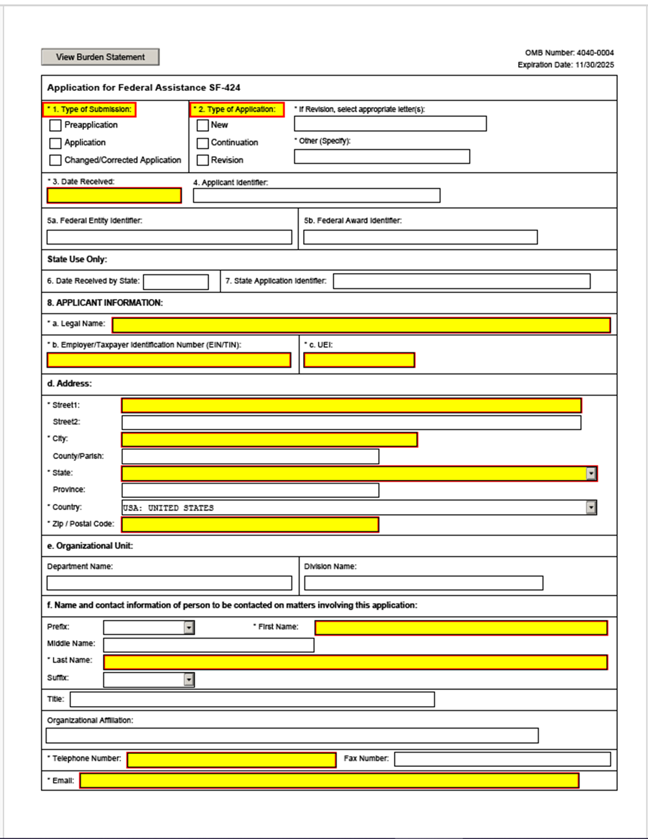
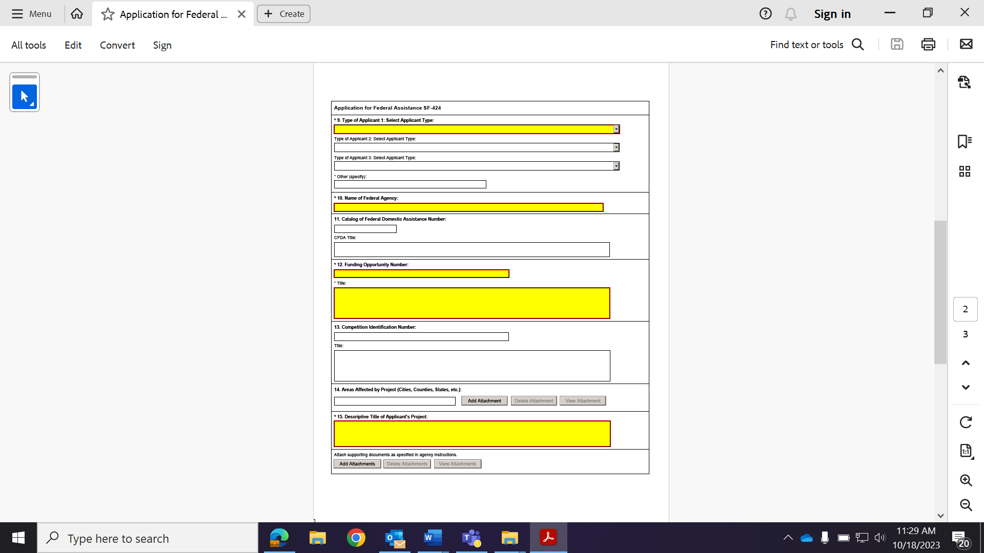
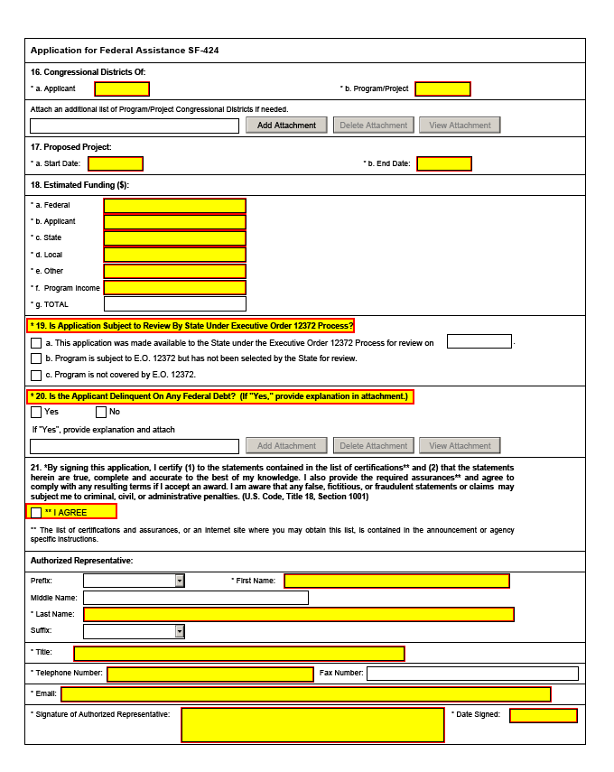
Grants.gov Form Instructions
Form Identifiers | Information
Agency Owner | Grants.gov
Form Name | Application for Federal Assistance (SF-424) V4.0
OMB Number | 4040-0004
OMB Expiration Date | 11/30/2025
Form Field Instructions
Field  Number | Field Name | Required or  Optional | Information
1. | Type of Submission: | Required | Select one type of submission in accordance with agency instructions.  - Pre-application  - Application  - Changed/Corrected Application - Check if this submission is to change or correct a previously submitted application. Unless requested by the agency, applicants may not use this form to submit changes after the closing date.

Field  Number | Field Name | Required or  Optional | Information
2. | Type of Application | Required | Select one type of application in accordance with agency instructions.  - New - An application that is being submitted to an agency for the first time.  - Continuation - An extension for an additional funding/budget period for a project with a projected completion date. This can include renewals.  - Revision - Any change in the federal government's financial obligation or contingent liability from an existing obligation. If a revision, enter the appropriate letter(s). More than one may be selected.  A: Increase Award  B: Decrease Award  C: Increase Duration  D: Decrease Duration  E: Other (specify)  AC: Increase Award, Increase Duration  AD: Increase Award, Decrease  Duration  BC: Decrease Award, Increase  Duration  BD: Decrease Award, Decrease  Duration
3. | Date Received: | Required | Enter date if form is submitted through other means as instructed by the Federal agency. The date received is completed electronically if submitted via Grants.gov.
4. | Applicant Identifier: |  | Enter the entity identifier assigned by the Federal agency, if any, or the applicant’s control number if applicable.
5a. | Federal Entity Identifier: |  | Enter the number assigned to your organization by the federal agency, if any.

Field  Number | Field Name | Required or  Optional | Information
5b. | Federal Award  Identifier: |  | For new applications, leave blank. For a continuation or revision to an existing award, enter the previously assigned federal award identifier number. If a changed/corrected application, enter the federal identifier in accordance with agency instructions.
6. | Date Received by State: |  | Leave this field blank. This date will be assigned by the state, if applicable
7. | State Application Identifier: |  | Leave this field blank. This identifier will be assigned by the state, if applicable.
8. | Applicant Information: |  | Enter the following in accordance with agency instructions.
 | a. Legal Name: | Required | Enter the legal name of the applicant that will undertake the assistance activity. This is the organization that has registered with the System for Award Management (SAM). Information on registering with SAM may be obtained by visiting SAM.gov.
 | b. Employer/Taxpayer Number (EIN/TIN): | Required | Enter the employer or taxpayer identification number (EIN or TIN) as assigned by the Internal Revenue Service. If your organization is not in the US, enter 44-4444444.
 | c. UEI: | Required | Enter the organization’s UEI received from SAM. The UEI is a unique 12-character organization identifier. Information on registering with System for Award  Management (SAM.gov) may be obtained by visiting the Grants.gov website.
 | d. Address: | Required | Enter address: Street 1 (required); City (required); County/Parish, State (required if country is US); Province; Country (required); 9-digit ZIP/Postal Code (required if country is US). If +4 does not exist for the address, enter “0000”.
 | e. Organizational Unit |  | Enter the name of the primary organizational  unit, department, or division that will undertake the assistance activity.

Field  Number | Field Name | Required or  Optional | Information
 | f. Name and contact information of person to be contacted on matters involving this application | Required | Enter the first and last name (required); prefix, middle name, suffix, and title. Enter organizational affiliation if affiliated with an organization other than that in 7.a. Telephone number and email (required); fax number.

Field  Number | Field Name | Required or  Optional | Information
9. | Type of Applicant:  Select Applicant Type | Required | Select a minimum of one applicant type or select up to three applicant types in accordance with agency instructions. If “Other” is selected, then specify Other Type of Applicant in text box.  A: State Government  B: County Government  C: City or Township Government  D: Special District Government  E: Regional Organization  F: U.S. Territory or Possession  G: Independent School District  H: Public/State Controlled Institution of  Higher Education  I: Indian/Native American Tribal  Government (Federally Recognized)  J: Indian/Native American Tribal  Government (Other than Federally  Recognized)  K: Indian/Native American Tribally  Designated Organization  L: Public/Indian Housing Authority  M: Nonprofit with 501C3 IRS Status (Other than Institution of Higher Education)  N: Nonprofit without 501C3 IRS Status  (Other than Institution of Higher  Education)  O: Private Institution of Higher Education  P: Individual  Q: For-Profit Organization (Other than  Small Business)  R: Small Business  S: Hispanic-serving Institution  T: Historically Black Colleges and  Universities (HBCUs)  U: Tribally Controlled Colleges and  Universities (TCCUs)  V: Alaska Native and Native Hawaiian  Serving Institutions  W: Non-domestic (non-US) Entity  X: Other (specify)
10. | Name of Federal Agency: | Required | Enter the name of the federal agency from which assistance is being requested with this application. This information is pre-populated if submitting through Grants.gov.

Field  Number | Field Name | Required or  Optional | Information
11. | Catalog Of Federal  Domestic Assistance  Number/Title | Required | Enter the Catalog of Federal Domestic Assistance number and title of the program under which assistance is requested, as found in the program announcement, if applicable. This information is pre-populated if using Grants.gov.
12. | Funding Opportunity Number/Title | Required | Enter the Funding Opportunity Number and  title of the opportunity under which assistance is requested as found in the program announcement. This information is pre-populated if using Grants.gov.
13. | Competition  Identification  Number/Title: |  | Enter the competition identification number and title of the competition under which assistance is requested, if applicable. These fields are pre-populated by Grants.gov if provided by the federal agency.
14. | Areas Affected By Project: |  | This data element is intended for use only by programs for which the area(s) affected are likely to be different from the place(s) of performance reported on the SF-424 Project/Performance Site Location(s) Form. Add attachment to enter additional areas, if needed.
15. | Descriptive Title of Applicant’s Project: | Required | Enter a brief descriptive title of the project. Supporting documents may be attached if specified in agency instructions.

Field  Number | Field Name | Required or  Optional | Information
16. | Congressional Districts | Required | 16a. Enter the applicant’s congressional district. 16b. Enter the primary district affected by the program or project. Enter in the following format: 2 character state abbreviation – 3 characters district number,  e.g., CA-005 for California 5th district, CA-012 for California 12th district, NC-103 for North Carolina’s 103rd district. If all congressional districts in a state are affected, enter “all” for the district number, e.g., MD-all for all congressional districts in Maryland. If nationwide, i.e., all districts within all states are affected, enter US-all. If the program/project is outside the US, enter 00.000. This optional data element is intended for use only by programs for which the area(s) affected are likely to be different than place(s) of performance reported on the SF-424 Project/Performance Site Location(s) form. Attach an additional list of program/project congressional districts, if needed.
17. | Proposed Project Start and End Dates: | Required | Enter the proposed start date and end date of the project.
18. | Estimated Funding: | Required | Enter the amount requested, or to be contributed during the first funding/budget period by each contributor. Value of in-kind contributions should be included on appropriate lines, as applicable.
19. | Is Application Subject to  Review by State Under  Executive Order | Required | Applicants should contact the State Single  Point of Contact (SPOC) for Federal Executive Order 12372 to determine whether the application is subject to the State intergovernmental review process. Select the appropriate box. If “A.” is selected, enter the date the application was submitted to the State.
Field  Number | Field Name | Required or  Optional | Information
20. | Is the Applicant  Delinquent on any Federal Debt? | Required | Select the appropriate box. This question applies to the applicant organization, not the person who signs as the authorized representative. Categories of federal debt include; but may not be limited to: delinquent audit disallowances, loans, and taxes. If yes, include an explanation in an attachment.
21. | Authorized  Representative: | Required | To be signed and dated by the authorized representative of the applicant organization. Enter the first and last name (required); prefix, middle name, and suffix. Enter title, telephone number, fax number, and email. Fax number is not required. A copy of the governing body’s authorization for you to sign this application as the official representative must be on file in the applicant’s office. (Certain federal agencies may require that this authorization be submitted as part of the application.) If the application is submitted via Grants.gov, the signature of the authorized representative and the date signed are completed upon submission.

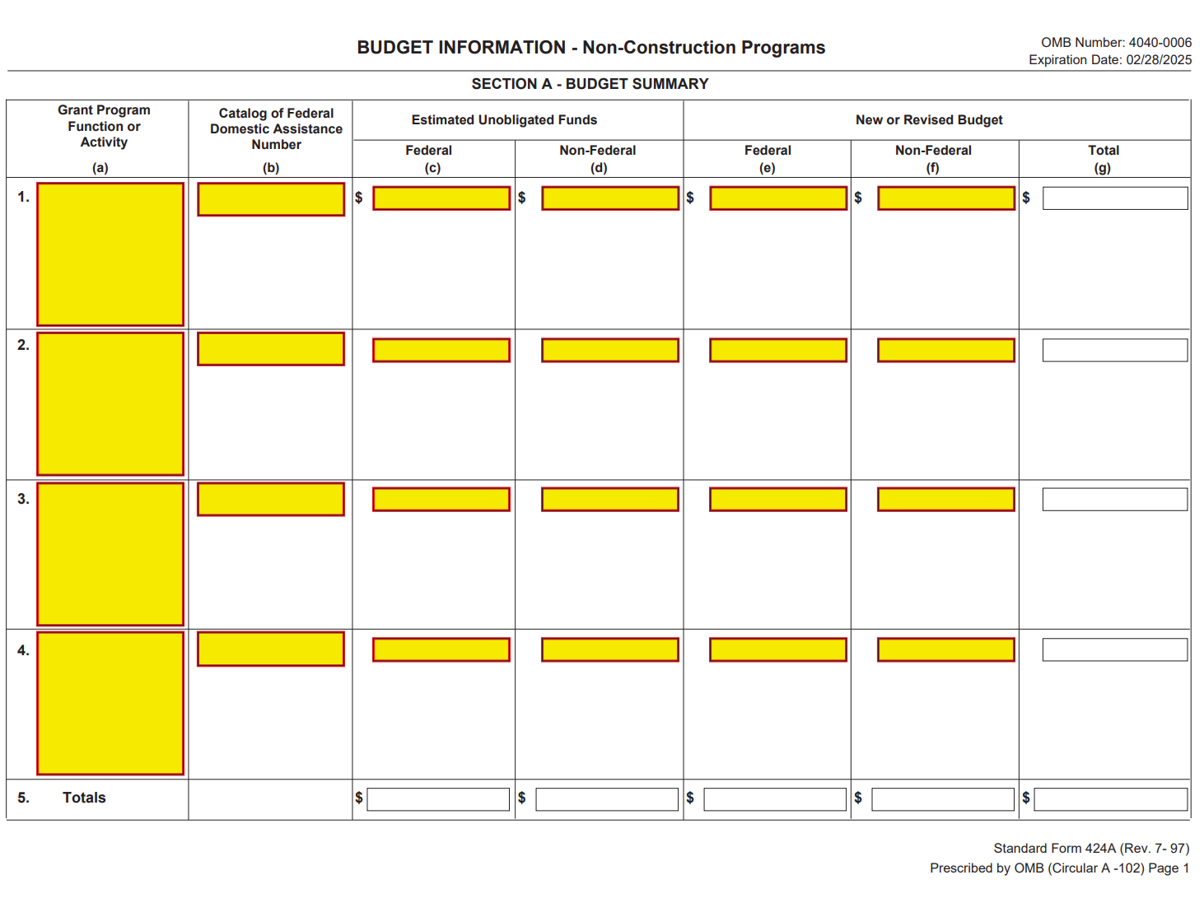
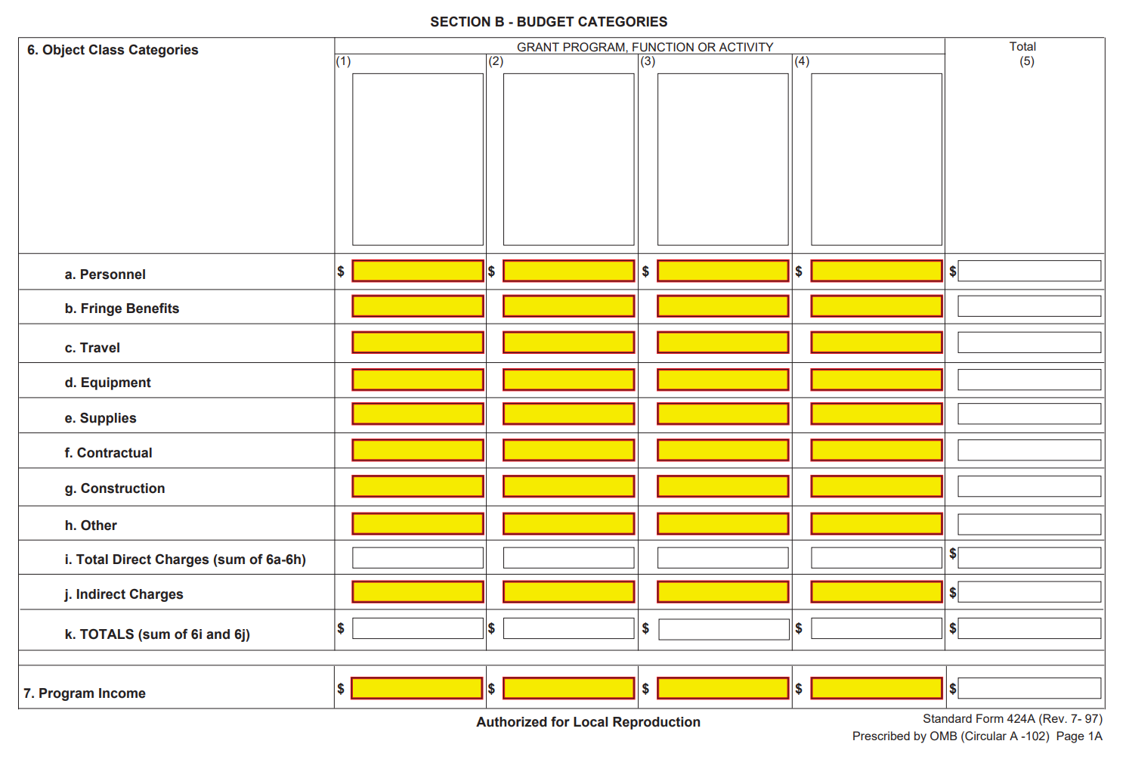
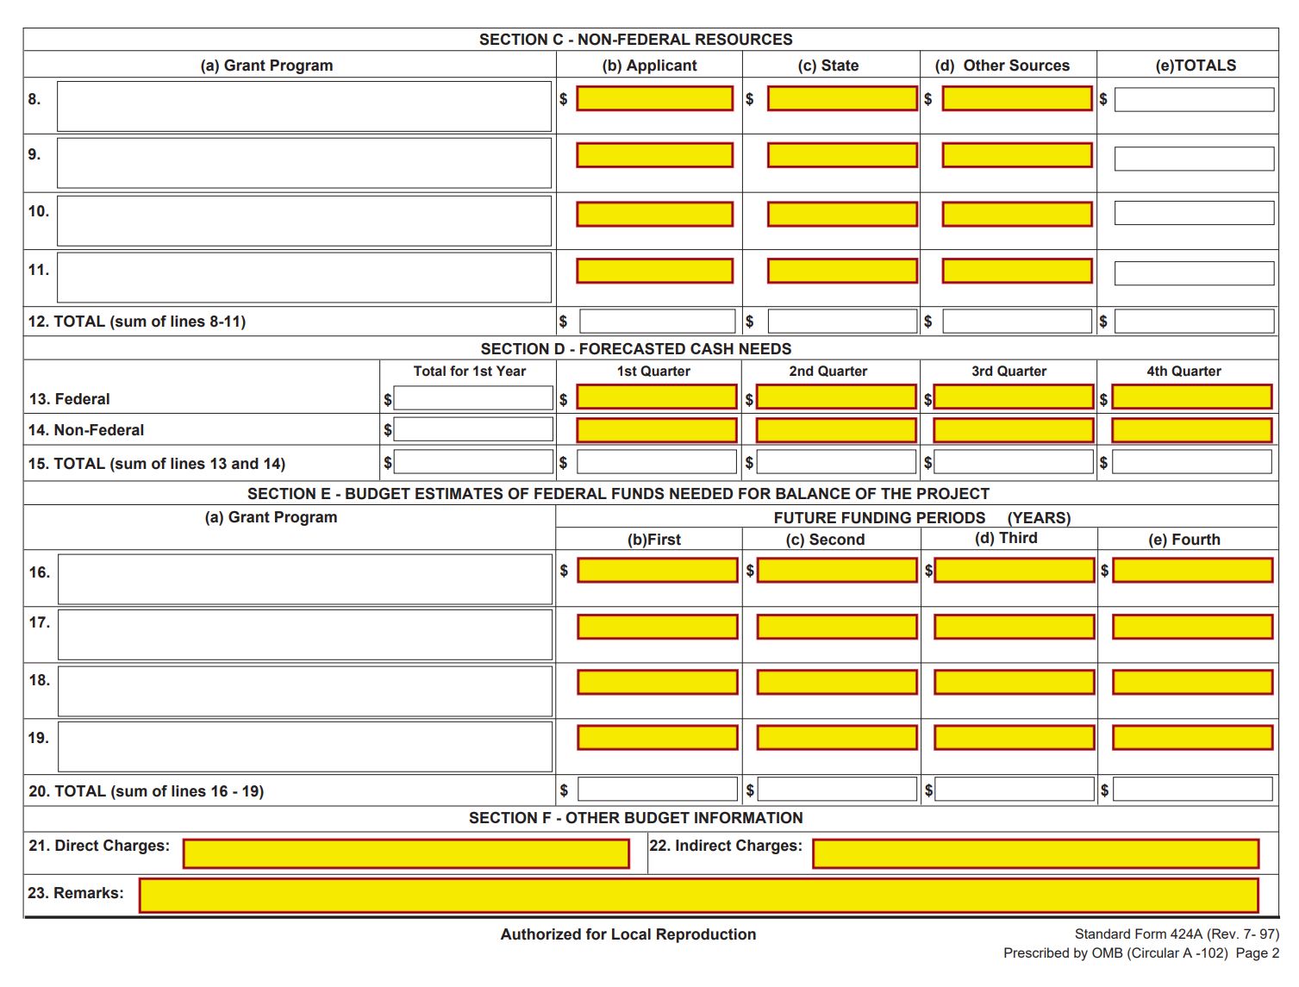

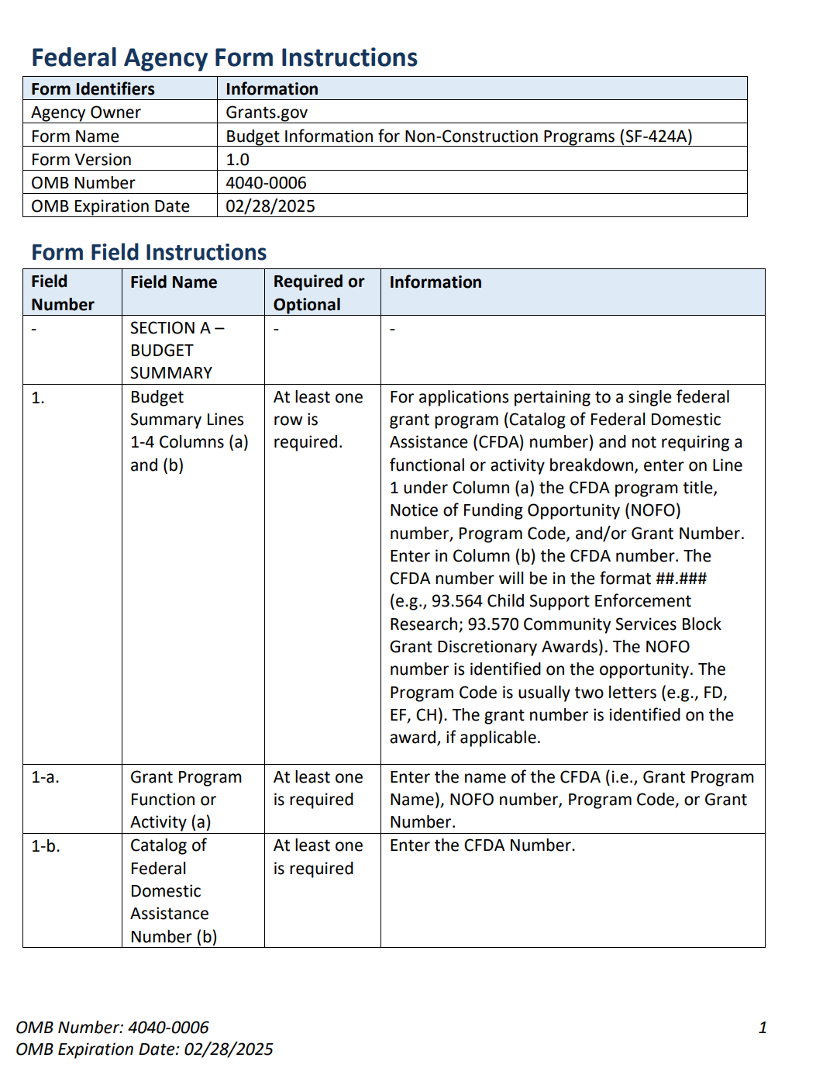

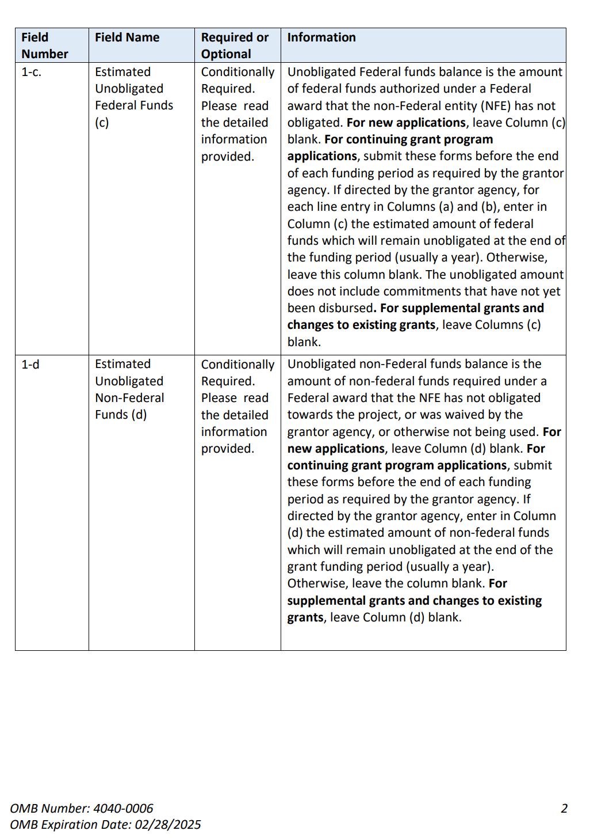
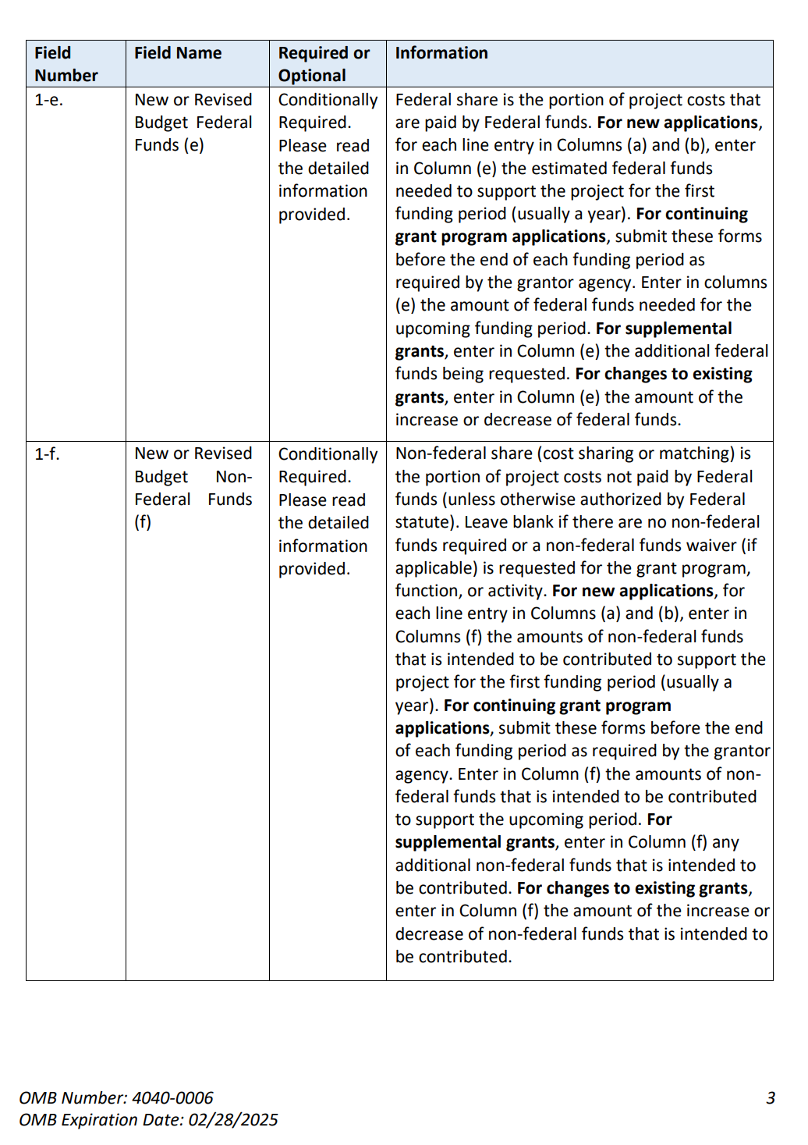

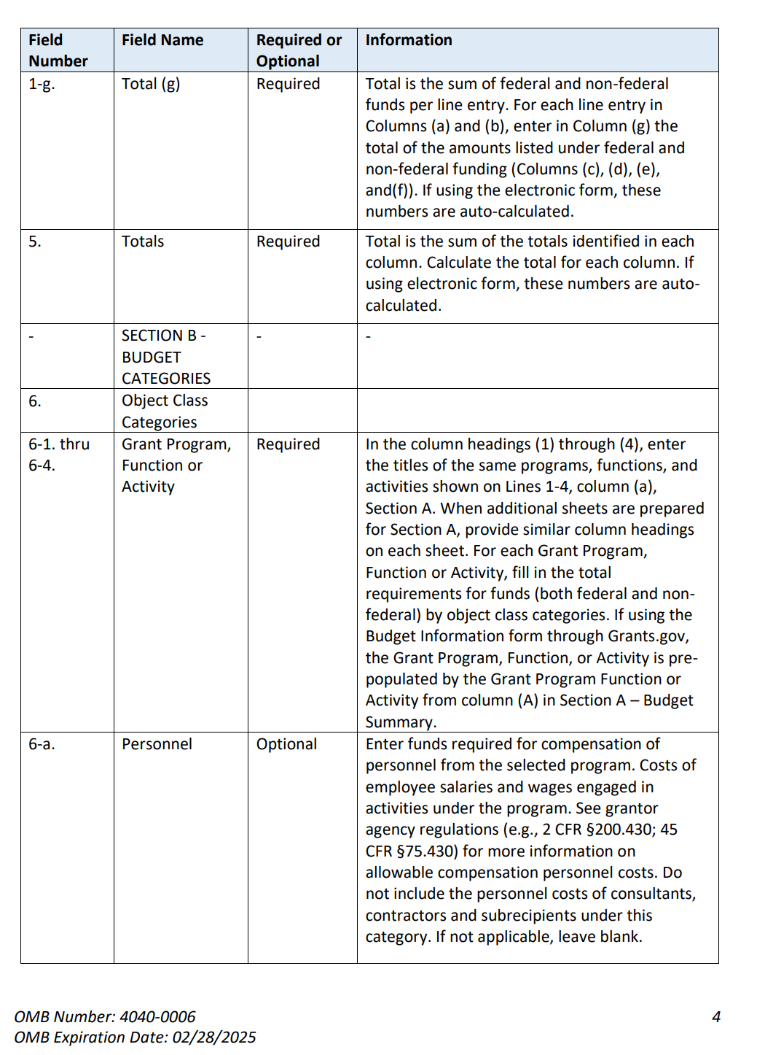

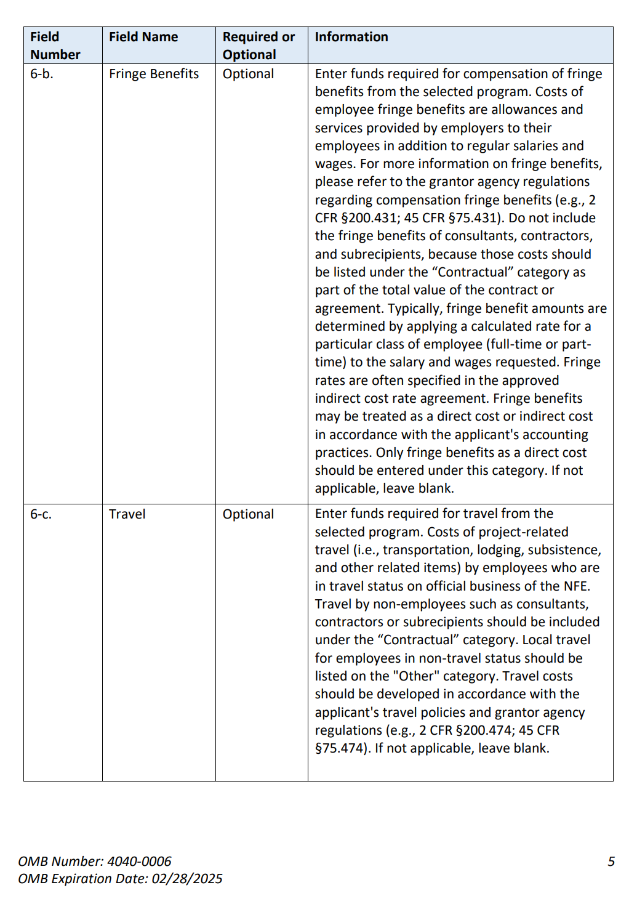
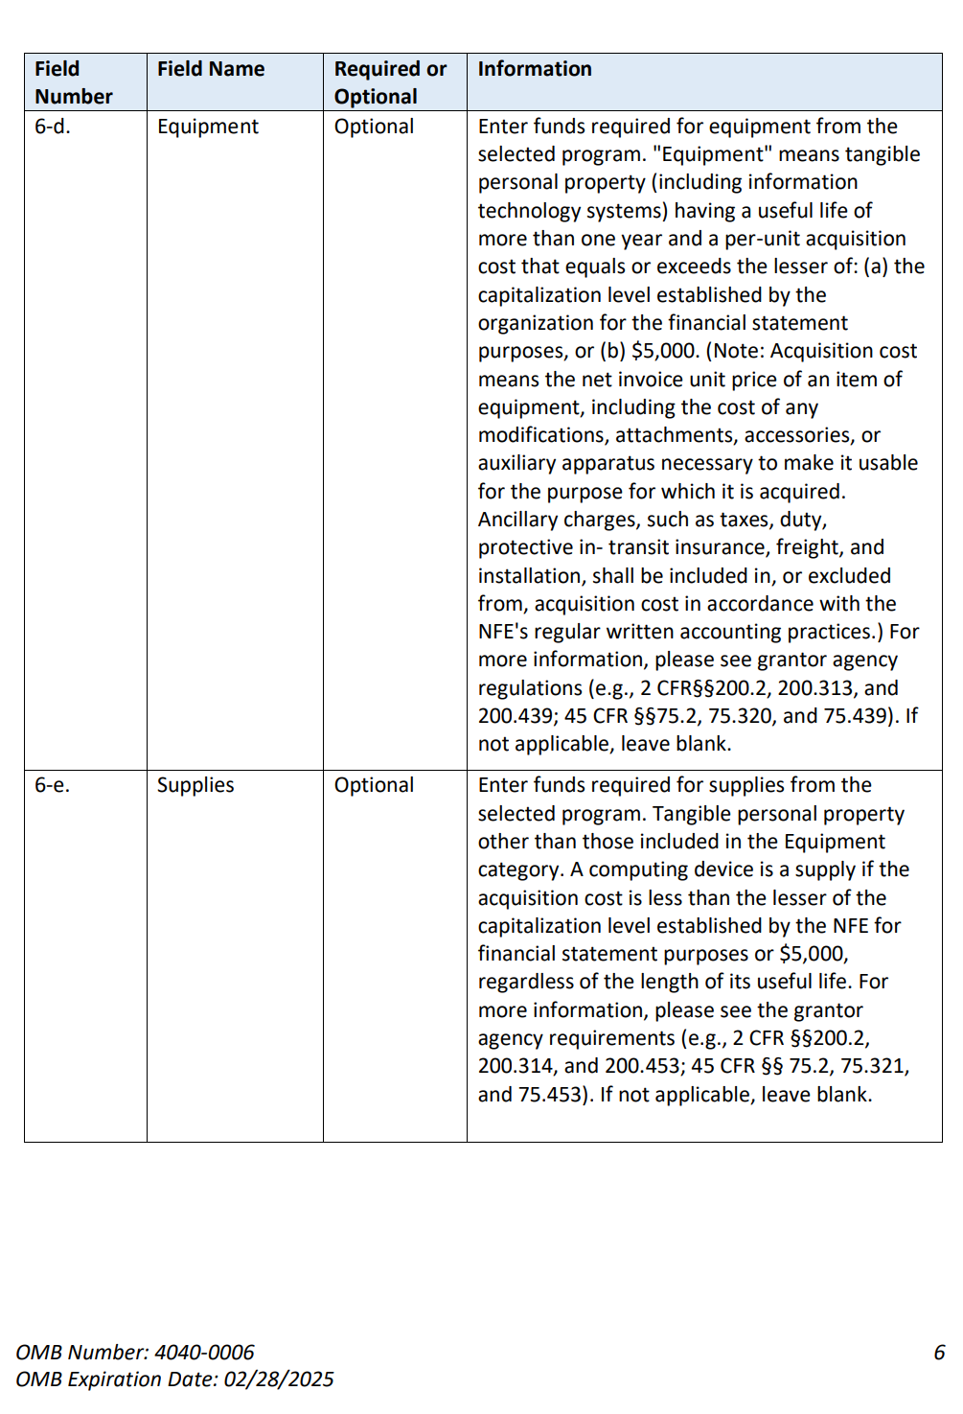

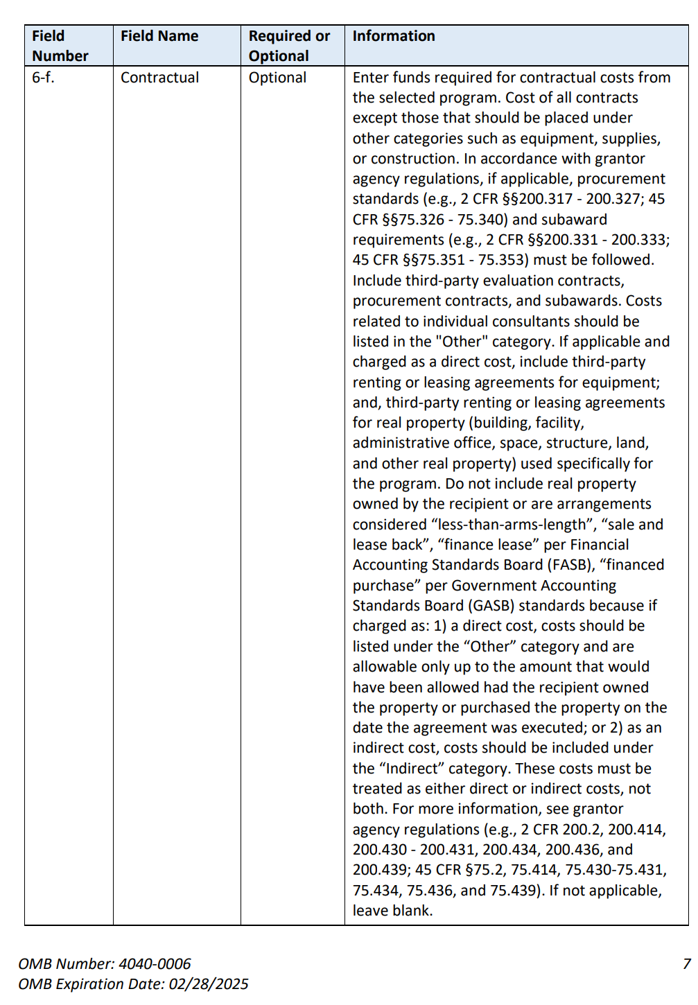

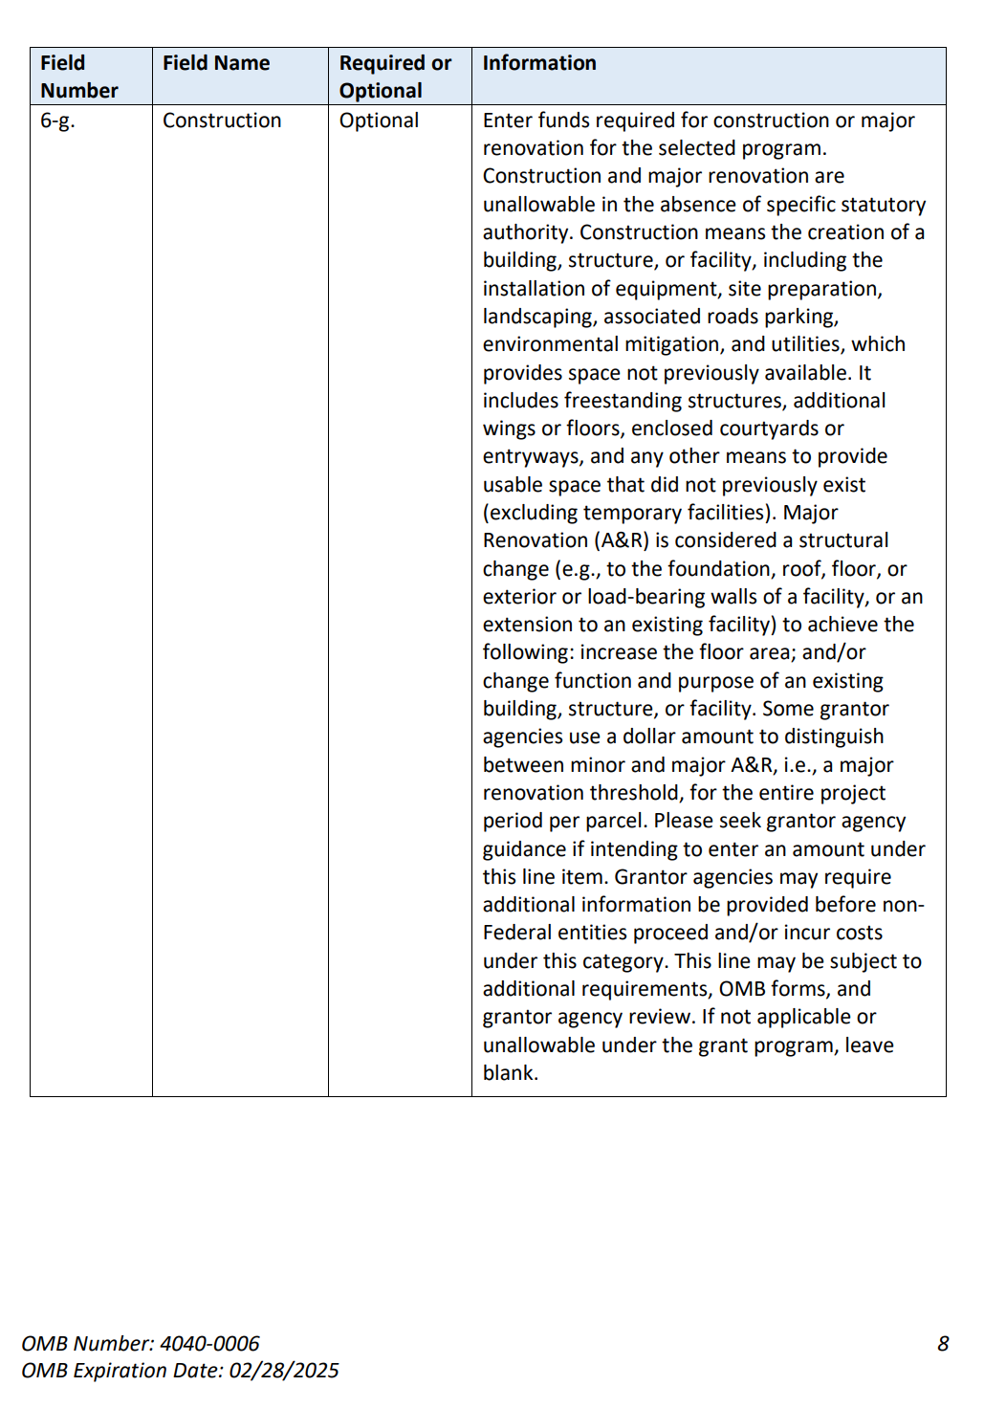

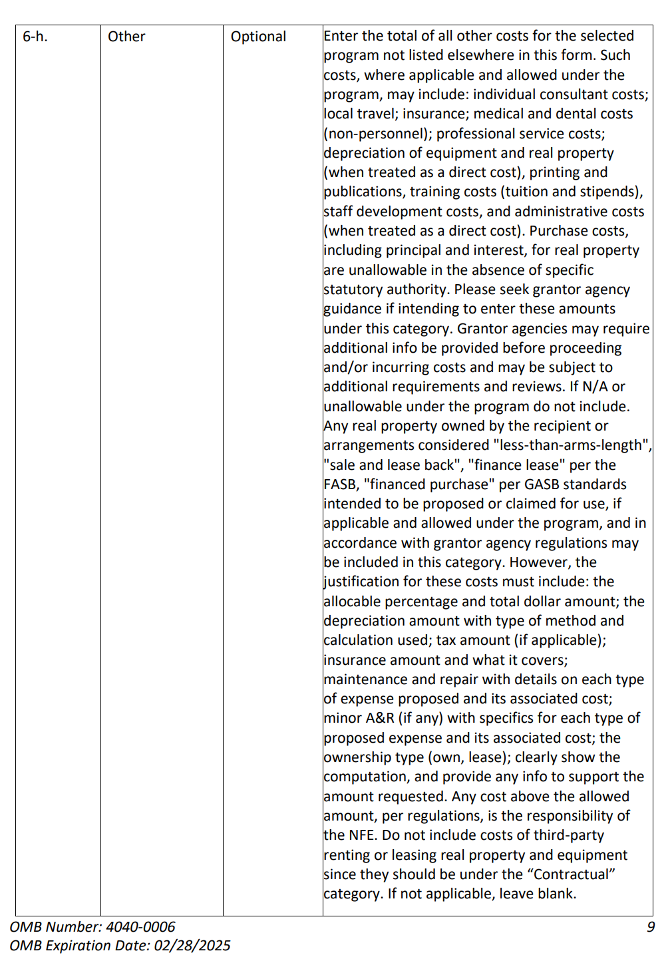

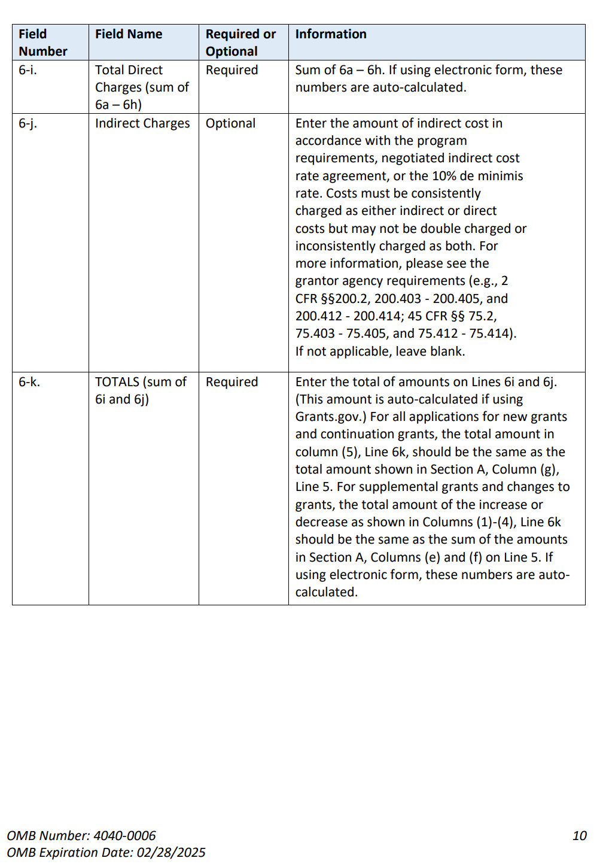
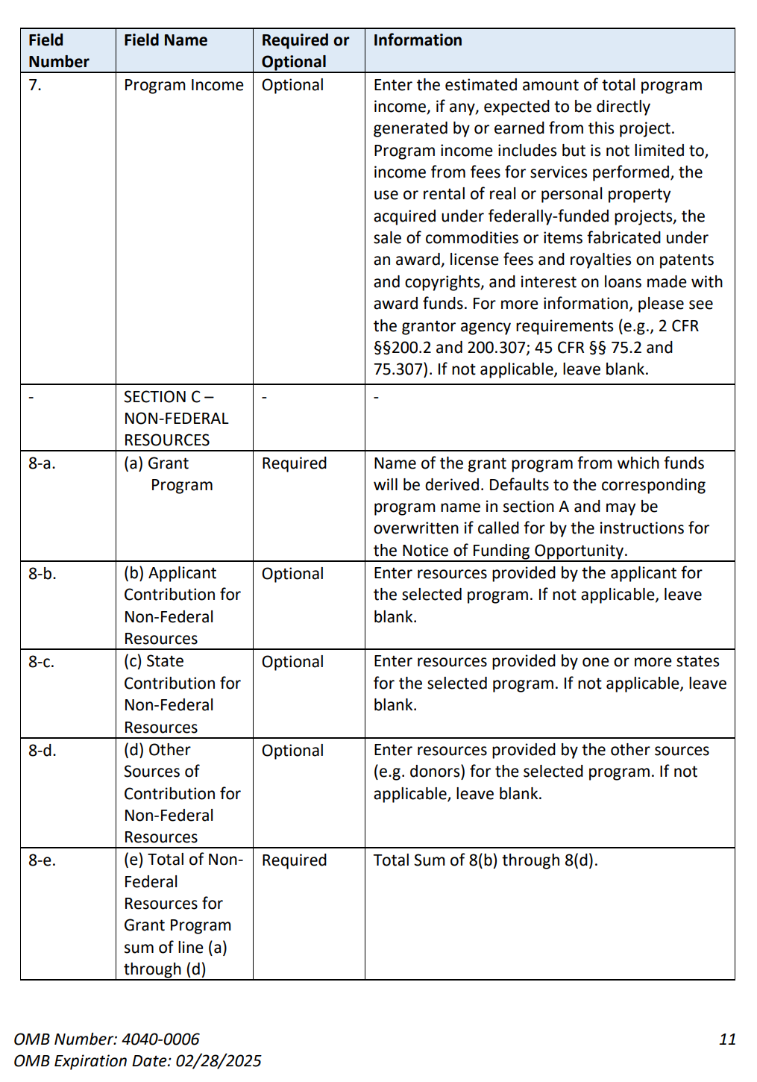

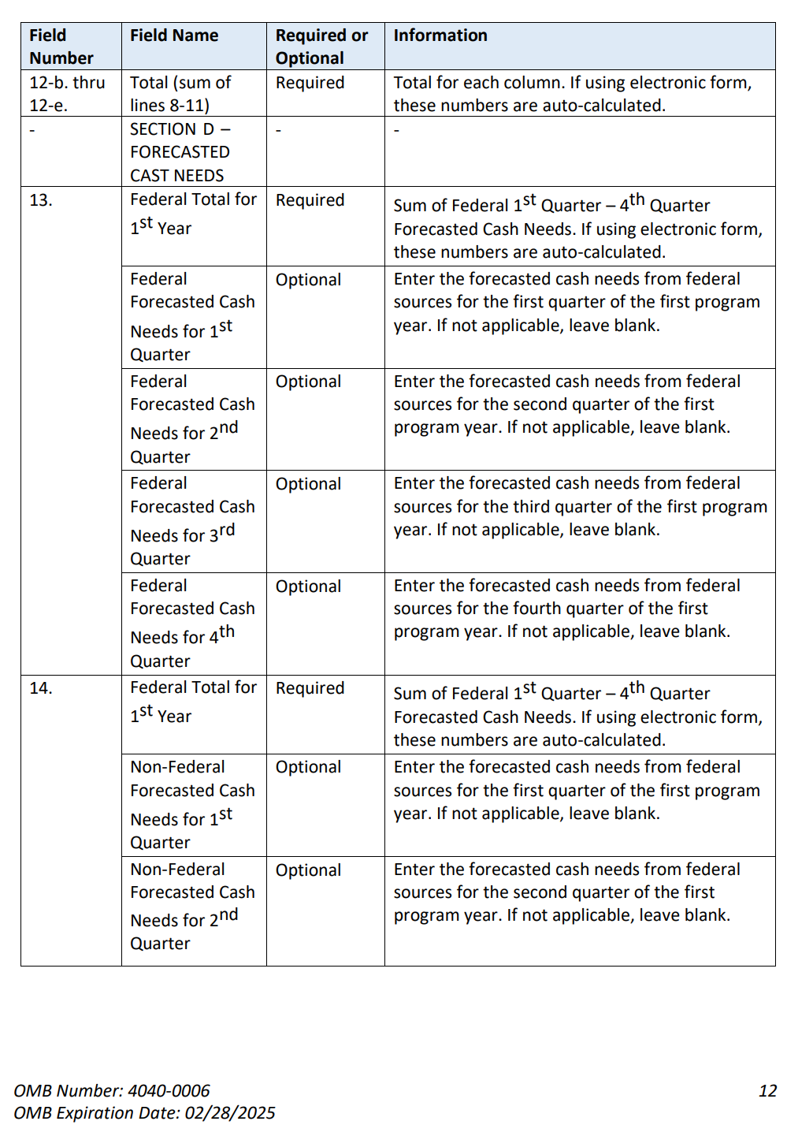

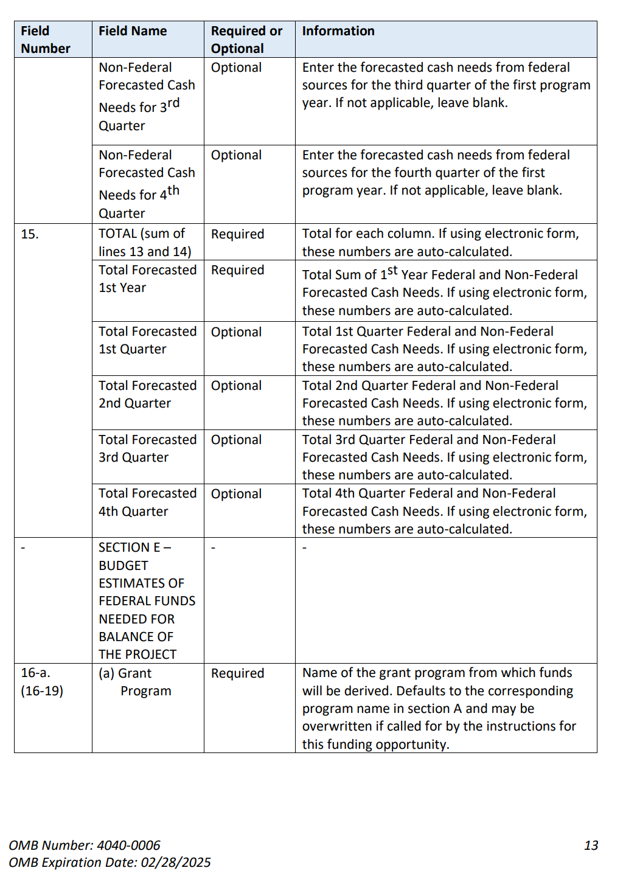

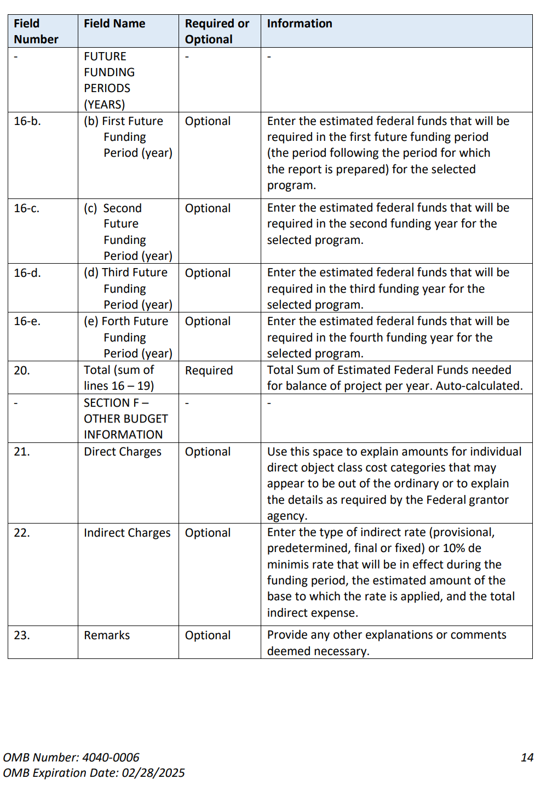
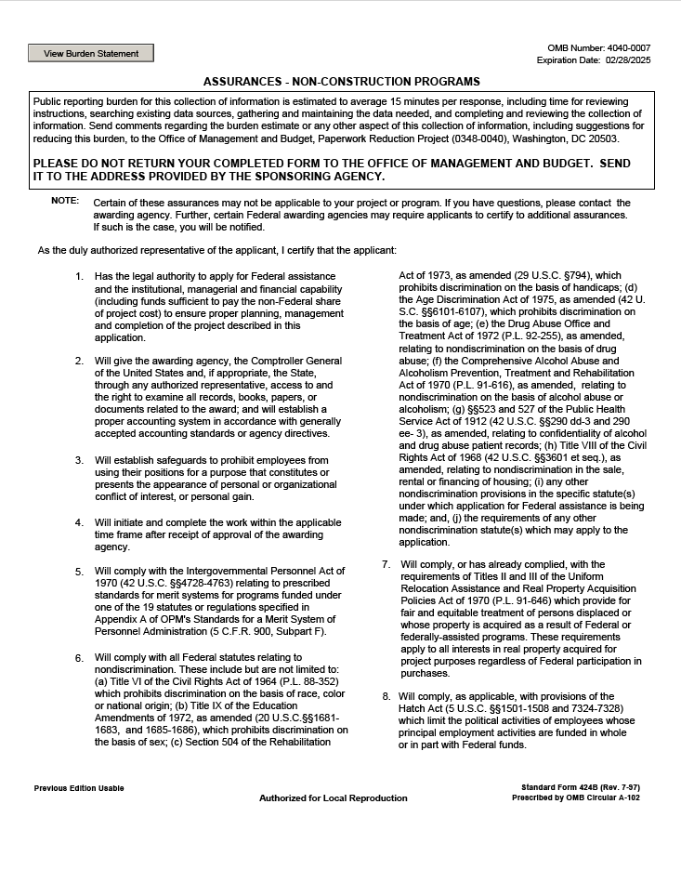
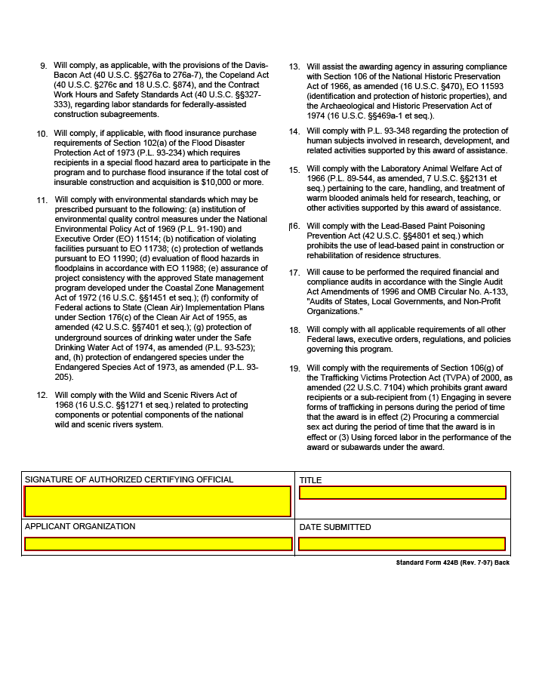

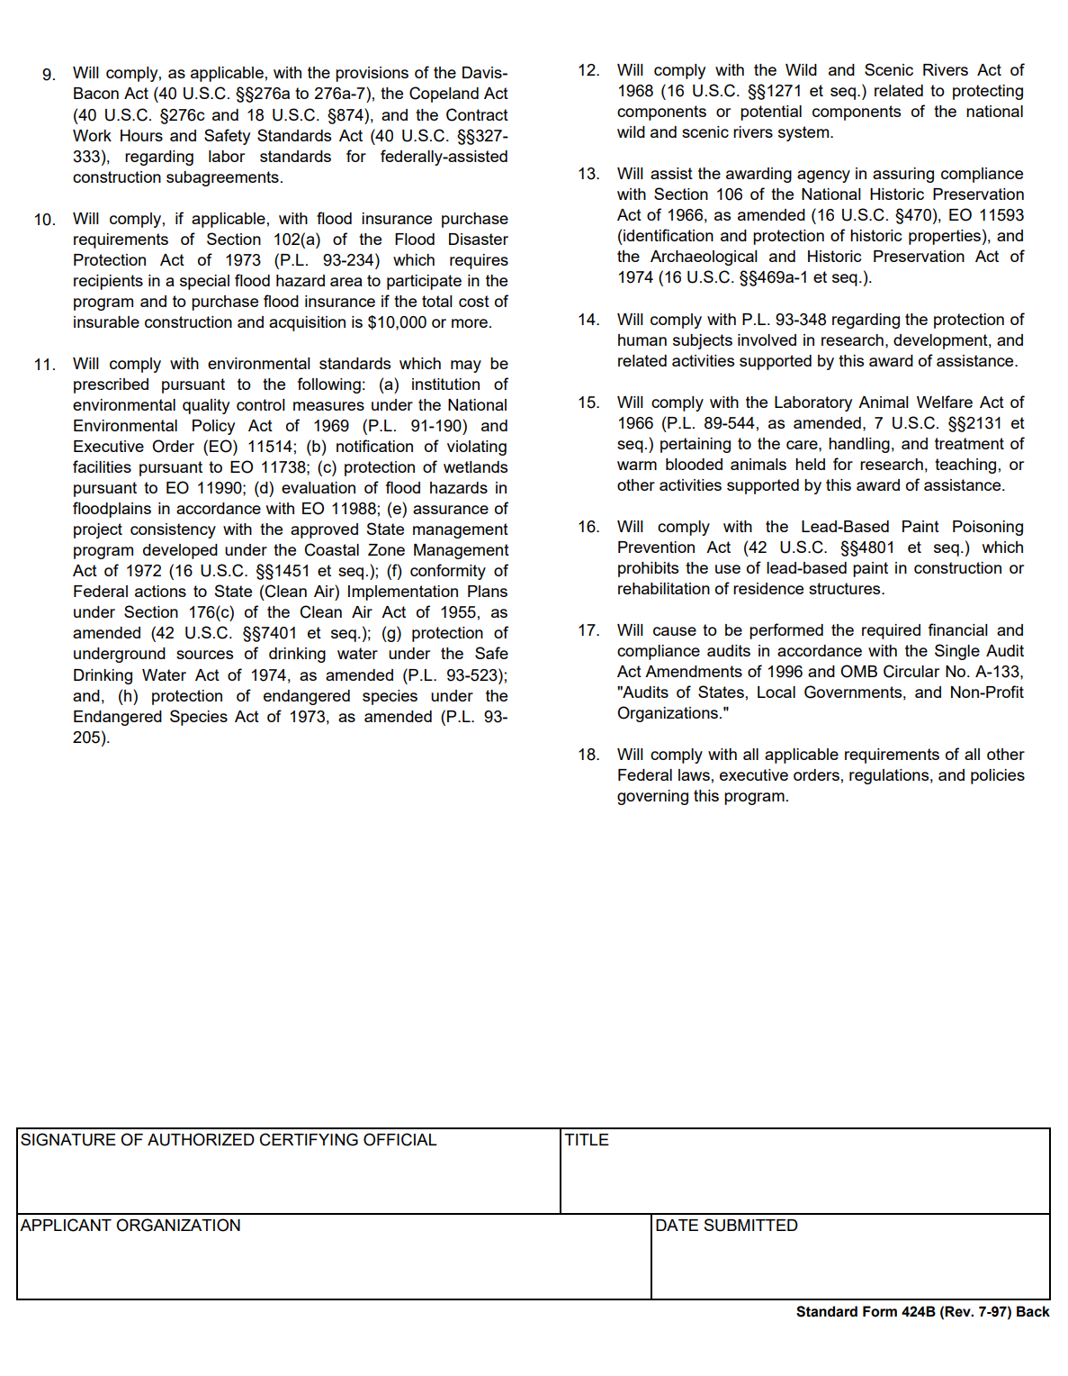

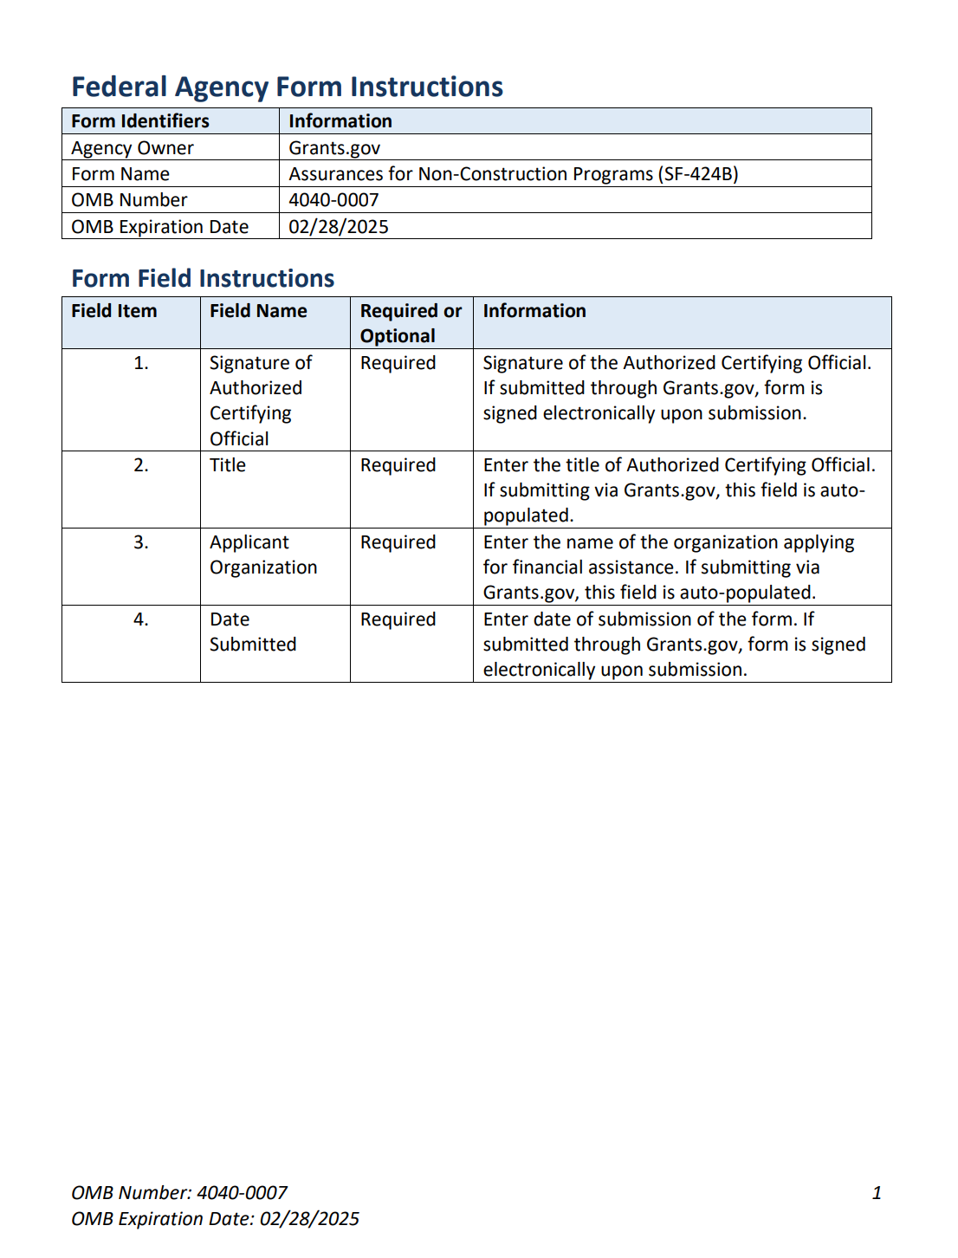

ET HANDBOOK NO. 336

18th Edition

APPENDIX III

REPORTING FORMS AND FORMATS

WORKSHEET UI-3

U.S. DEPARTMENT OF LABOR Exp. Date 02/29/2024
Employment and Training Administration OMB Approval #1205-0132

WORKSHEET UI-3 | QUARTERLY UI ABOVE-BASE EARNINGS REPORT
State |  | Fiscal Year | Quarter

Section A: Program Staff Year Usage
 | Quarter |  | Year-to-Date
Program Category | (a) SY Worked | (b) SY Paid | (c) SY Paid
1. Claims Activities
2. Employer Activities
3. UI PERFORMS
4. Support/AS&T
5. Trade Claims Activities
6. Other
7. Total Staff Years

Section B: Regular Above-Base Entitlement Certification
Standard Hours: Quarterly Year-to-Date Yearly
Claims Activity | (a) Workload | (b) MPU | (c)
1. Initial Claims (Regular, EB, and STC)
2. Initial Claims (Third Tier)
3. Weeks Claimed (Regular, EB, and STC)
4. Weeks Claimed (Third Tier)
5. Nonmonetary Deter. (Regular, EB, and STC)
6. Nonmonetary Deter. (Third Tier)
7. Appeals (Regular, EB, and STC)
8. Appeals (Third Tier)
9. Interstate Appeals Taken (IB-101)
10. Interstate Agent Referrals
11. Multiclaimant Services
12. Monetary Redeterminations
13. SAVE
14. Total Staff Years Worked/Earned = Sum of Lines 1 through 13
15. Entitlement Staff Years Worked = Line 14 - Base SY Worked ( )
16. Entitlement Staff Years Paid = Line 15 x Experienced Leave ( )
17. PS/PB Entitlement $ = Line 16 x Regular Above-Base PS/PB Rate ($ )
18. Support Entitlement $ = Line 17 x Above-Base Support Percentage ( %)
19. Other $ (Specify)
20. Total Dollar Costs = Line 17 + Line 18 + Line 19
21. Advance
22. Net Dollar Entitlement = Line 20 - Line 21
CERTIFICATION: I certify to the best of my knowledge and belief that information provided herein is accurate and complete and was obtained from agency accounting records.
Signature Title Date
U.S. DEPARTMENT OF LABOR Exp. Date 02/29/2024
Employment and Training Administration OMB Approval #1205-0132

WORKSHEET UI-3 (Continued) | QUARTERLY UI ABOVE-BASE REPORT
State |  | Fiscal Year | Quarter

Section C: Trade ABOVE-BASE Entitlement Certification
Standard Hours: Quarterly Year-to-Date Yearly
Claims Activity | (a) Workload | (b) MPU | (c)
1. Initial Claims
2. Weeks Claimed
3. Nonmonetary Determinations
4. Appeals
5. Trade Redeterminations
6. Other Staff Years (Specify)
7. Total Staff Years Worked = Sum of Lines 1 through 6
8. Staff Years Paid = Line 7 x Experienced Leave ( )
9. PS/PB Entitlement $ = Line 8 x Trade PS, Regular Above-Base PB Rate ($ )
10. Support Entitlement $ = Line 9 x Trade Support Percentage ( %)
11. Other $ (Specify)
12. Total Trade Dollar Costs = Line 9 + Line 10 + Line 11

Section D: Additional Benefits Above-Base Entitlement Certification
Standard Hours: Quarterly Year-to-Date Yearly
Claims Activity | (a) Workload | (b) MPU | (c)
1. Initial Claims
2. Weeks Claimed
3. Nonmonetary Determinations
4. Appeals
5. Monetary Redeterminations
6. Other Staff Years (Specify)
7. Total Staff Years Worked = Sum of Lines 1 through 6
8. Staff Years Paid = Line 7 x Regular Above-Base Experienced Leave ( )
9. PS/PB Entitlement $ = Line 8 x Regular Above-Base PS/PB Rate ($ )
10. Support Entitlement $ = Line 9 x Regular Above-Base Support Percentage ( %)
11. Other $ (Specify)
12. Total AB Dollar Costs = Line 9 + Line 10 + Line 11

ETA 2208A

INSTRUCTIONS FOR THE UI-3

OMB No.: 1205-0132 OMB Expiration Date: 02/29/2024 Estimated Average Response time: 120 minutes

OMB Burden Statement: these reporting instructions have been approved under the Paperwork reduction Act of 1995. Persons are not required to respond to this collection of information unless it displays a valid OMB control number. Public reporting burden for this collection of information includes the time for reviewing instructions, searching existing data sources, gathering and maintaining the data needed, and completing and reviewing the collection of information. Submission is required to obtain or retain benefits under SSA 303(a)(6). Persons responding to this collection have no expectation of confidentiality. Send comments regarding this burden estimate or any other aspect of this collection of information, including suggestions for reducing this burden, to the U.S. Department of Labor, Office of Unemployment Insurance, Room S-4519, 200 Constitution Ave., NW, Washington, DC, 20210, eta-ui-inquiries@dol.gov.

Please type or print legibly. The following general instructions explain how to use the form itself.

General Instructions

This form is designed so that application can be made for funds from one or more grant programs (Regular UI, Trade, and Additional Benefits). The SAVE program is included on Section B of the UI-3 in order to reimburse ongoing operational costs related to the SAVE program.

The electronic version of this form appears slightly different on the computer screen than the one included in these instructions, which is provided for display only. States should submit their reports electronically. There is minimal data entry necessary in the current UI-3s. Workloads, MPUs, Staff Years Worked/Earned and Experienced Leave Rates are all automatically entered. In addition, the electronic version has a "Comments" section to explain entries in the "Other Staff Years" or "Other $" lines but does not have a block for certification by a State official. States are urged to use the comment section for explanations of “Other” lines. The comments section is heavily relied upon during the review of the report.

Note: Throughout the UI-3 reports, listed as Sections A, B, C, and D in these instructions, States should enter zero (0) in any cell that must be manually entered but has no data (no activity) for the particular quarter being reported on.

Minutes Per Unit. Minutes per unit (MPU) for each of the four broadband activities in Lines 1 through 8 in Section B and Lines 1 through 4 in Sections C and D are allocated in the annual base budget and the Above-Base funding process. These budgeted MPU values vary for each State from year to year; however, static MPU values have been established for the following functions:

IB Agent Appeals (Line 9, Section B) 20.0
Interstate Referrals (Line 10, Section B) 15.0
Redeterminations (Line 12, Section B and Line 5, Section C and D) (promulgated in the Unemployment Insurance Program Letter (UIPL) for the allocations)
SAVE (Line 13, Section B) 6.5

Position Computation. Generally, staff years earned are computed by multiplying workload by minutes per unit and dividing by the minutes available in the relevant period. This computation yields the number of staff required in the budget period to accomplish the workload. For a calendar quarter, the formulae are expressed as follows:

(Workload x MPU)/(60 x Quarter Hours Paid) = Staff Years Worked/Earned.
Staff Years Worked/Earned x Experienced Leave Factor = Staff Years Paid/Earned.

Experienced Leave Factor. The experienced leave factor is calculated by dividing the quarterly staff years paid/used by the quarterly staff years worked/used for that program activity. Regular UI and Trade Above-Base have different experienced leave factors.

Personal Services/Personnel Benefits (PS/PB) Rate. Attachment II to the UIPL for the yearly allocations contains the approved annual Regular UI Above-Base PS/PB rates. These are expressed as annual rates and must be converted to a quarterly equivalent for use on the UI-3. A staff hour conversion factor should be used by determining the number of staff hours in the quarter as a ratio of staff hours in the year and applying this ratio to the annual rate. For the Trade program, states may use the average experienced personal services rate of staff working in Trade claims activities. Trade personnel benefits will be funded at the same rate as the Regular Above-Base program.

Support. The support percentage may vary from one year to another and from one program to another. Therefore, the total support percentage will be promulgated in the UIPL for the yearly allocations.

Section A. Program Staff Year Usage

Lines 1-7, Columns (a) through (c)

Complete this section for current quarter and fiscal year-to-date. This section lists the UI categories to be reported. For each of Lines 1-7 in Section A, enter quarterly staff years worked in Column (a), quarterly staff years paid in Column (b), and year-to-date staff years paid in Column (c). These lines should reflect total staff years. No adjustment should be made for staff years financed with prior year carry-forward funds.

Line 1 - Enter staff years for claims activities including initial claims, weeks claimed, eligibility reviews, nonmonetary determinations, appeals, and multi-claimant services.

Line 2 - Enter staff years for employer activities including wage records, tax, and tax travel.

Line 3 - Enter staff years for UI PERFORMS activities, less UI PERFORMS AS&T.

Line 4 - Enter staff years for support activities for the UI and Trade programs including benefits and appeals travel, benefit payment control, UI support, internal security, interstate, automation grants staff, and administrative staff and technical services (AS&T), including UI PERFORMS and Trade AS&T. (Note: Some accounting reports that states use to populate the UI-3 do not show AS&T staff years worked in these programs. The SWA should estimate the AS&T staff years worked by analyzing the percentage of AS&T staff years paid charged to these programs.)

Line 5 - Enter staff years for claims activities under the Trade Adjustment Assistance (TAA) provisions of the Trade Act of 1974, as amended.

Line 6 - Enter staff years for special funded activities not included in the above lines (e.g., SAVE), and for activities funded with national activities funds (excluding cooperative agreements).

Line 7 - Enter the sum of the staff years in Lines 1 through 6, for each column.

Section B. Regular Above-Base Entitlement Certification

Lines 1-13, Column (a)

Total workload in Section B will include data from the Regular UI, Extended Benefits (EB), and Short-Time Compensation (STC) programs, and, if enacted, third tier programs (e.g., FSB, FSC, EUC, and TEUC). The following table shows the source of data for total workloads:

Line 1 - Data will automatically be entered from the ETA 5159 Regular, EB, and STC reports: the sum of lines 101, 102, and 103 for columns 2, 3, 5, and 7 of the Regular and EB reports, and the sum of columns 2 and 3 for line 101 of the STC report.

Line 2 - Data will automatically be entered from the ETA 5159 (Third Tier): the sum of lines 101, 102, and 103 for columns 2, 3, 4, and 7.

Line 3 - Data will automatically be entered from the ETA 5159 Regular, EB, and STC reports: the sum of lines 201, 202, and 203 for columns 10 and 13 of the Regular and EB reports, and the workload in line 201, column 9 of the STC report.

Line 4 - Data will automatically be entered from the ETA 5159 (Third Tier) report: the sum of lines 201, 202, and 203 for columns 10 and 13.

Line 5 - Data will automatically be entered from the ETA 207 Regular and EB reports: the sum of lines 101, 103, and 105 for column 1.

Line 6 - Data will automatically be entered from the ETA 207 (Third Tier) report: the sum of lines 101, 103, and 105 for column 1.

Line 7 - Data will automatically be entered from the ETA 5130 Regular and EB reports: the sum of columns 1 through 6 in line 100.

Line 8 - Data will automatically be entered from the ETA 5130 (Third Tier) report: the sum of columns 1 through 6 in line 100.

Line 9 - States should enter IB Agent Appeals: the sum of IB-101s sent to liable States.

Line 10- Data will automatically be entered from the ETA 5159 Regular and EB reports: the difference between the sum of column 4 and the sum of column 5.

Line 11 - States should enter the number of multi-claimant appeals (not appellants). Line 11 is automatically subtracted from line 7 before Staff Years Worked/Earned are calculated on line 7.

Line 12 - States should enter the number of monetary redeterminations. (Reserved for future use.)

Line 13 - Data will automatically be entered from line 1 of the ETA 9016.

* OMB Approval Numbers: ETA 5159: #1205-0010, expires 04/30/2022; ETA 207: #1205-0150, expires 05/31/2020; ETA 5130: #1205-0172, expires 05/31/2020; ETA 9016: #1205-0268, expires 02/28/2021

Lines 1-10 and Lines 12-13, Column (b)

The appropriate MPU values will be entered automatically. If another MPU value is necessary for Line 12, the defaulted MPU value can be overwritten.

Lines 1-10 and Lines 12-13, Column (c)

Staff years worked/earned will be calculated automatically using the formula in the General Instructions.

Line 11, Column (c)

States should enter the number of staff years worked/used for processing multi-claimant non-monetary determinations and appeals for activities such as labor dispute determinations for individual claimants or retroactive payments resulting from an appeal decision. The quarter-to-date multi-claimant staff years used (extracted from the cost distribution report) should be entered in column (c), line 11, Section B. Note: the computer software automatically subtracts the workload count in column (a), line 11 from the workload count (column a) in lines 7 before Staff Years Worked/Earned are computed in column (c), line 7.

Line 14- The Total Staff Years Worked/Earned will be automatically calculated from Lines 1 through 13, column (c).

Line 15- Entitlement Staff Years Worked will automatically be calculated by subtracting Base Staff Years Worked for the given quarter from Staff Years Worked/Earned (Line 14). Base Staff Years Worked will automatically be calculated and entered in the parentheses on line 15. Base Staff Years Worked will be calculated by dividing the Hours per Staff Years Paid by the Hours per Staff Year Worked for the appropriate quarter from the UI-1 to determine the budgeted leave factor; the number of Claims Activity Staff Years Paid will be divided by the budgeted leave factor for that quarter. States which have noted the breakout of quarterly hours in the remarks section of their SF 424-A (See instructions in the yearly UIPL providing Resource Planning Targets and Guidelines; and the UIPL used to promulgate the Resource Allocations) may override the defaulted Base Staff Years Worked entered by the system with their own calculated Base Staff Years Worked.

Line 16- Entitlement Staff Years Paid will automatically be calculated by the system by multiplying the experienced leave factor by the data in Line 15, Column (c). The experienced leave factor will automatically be calculated by dividing the quarterly staff years paid by the staff years worked for claims activities as reported in Line 1, Section A. The experienced leave factor will automatically be entered in the parentheses on Line 16. If part-time or temporary staff do not earn leave, the staff year entitlement in Line 16 will be equal to the entitlement in Line 15.

Line 17- States should enter the Regular UI Above-Base quarterly PS/PB rate, which will automatically be multiplied by the data in Line 16.

Line 18- States should enter the Regular UI Above-Base Support percentage, which will automatically be multiplied by the data in Line 17.

Line 19- States should enter costs relating to special cases and note these in the comments section. States should also enter other costs relating to the SAVE program - such as computer access charges and equipment, and phone leasing charges. The General Services Administration bills states that use the Immigration and Naturalization Service's (INS) computer database to verify claimants' immigration status. In addition, some States must lease phone Lines and equipment in order to use the INS database. These costs are fully reimbursed; however, states that are approved to use the INTERNET system to obtain access to the INS database may not claim leased Line and equipment costs. States should specify all such costs in the "Comments" section.

Line 20- Total dollar costs, the sum of lines 17, 18, and 19 will automatically be calculated and entered on line 20.

Line 21- States should enter the amount of the advance received at the beginning of the quarter for quarterly Above-Base claims operations.

Line 22- The net dollar entitlement, Line 22, will automatically be calculated by subtracting the data in line 21 from the data in Line 20 and entered here.

Section C. Trade Above-Base Entitlement Certification

Lines 1-5,

Column (a) - States should enter total workload data which will include data from the Regular Trade program. Its source is State data.

Column (b) - Trade broadband MPU values, which will automatically be entered, are identical to the Regular broadband MPU values, except for Trade weeks claimed, which excludes the weighted MPU value for the Eligibility Review Program (ERP) from the Regular weeks claimed MPU value. The Trade Redeterminations MPU value is promulgated in the yearly field memorandum for the allocations.

Column (c) - Staff Years Worked/Earned will automatically be calculated by the system using the formula in the General Instructions.

Line 6 - States should enter other staff years, such as Trade Benefit Travel staff years worked/used.

Line 7 - The sum of lines 1 through 6 in Column (c) will automatically be calculated and entered here.

Line 8 - The system will use the same formula to calculate Staff Years Paid as for Section B, but will calculate the experienced leave factor by using Section A, Line 5. If necessary, this defaulted value can be overwritten.

Line 9 - States should enter the combined Trade PS and Above-Base PB rate. The system will multiply this rate by the entry in Line 8.

Line 10- States should enter the Trade Above-Base Support percentage. The system will use this data and multiply it by the entry in Line 9.

Line 11- States should enter other costs relating to Trade Administration in Line 11. Notices in local newspapers for special worker notifications are fully reimbursed. States should specify all such costs in the "Comments" section.

Line 12- The system will automatically enter the sum of Lines 9, 10, and 11 here.

Section D. Additional Benefits (AB) Above-Base Entitlement Certification

Note: Reporting of AB data is not required for statistical purposes, but is necessary in order to calculate the proper entitlement.

Lines 1-5,

Column (a) - States should enter the total broadband AB program workload. Its source is State data.

Column (b) - AB broadband MPU values that will automatically be entered are identical to the Regular broadband MPU values. The AB Redeterminations MPU value, which should be manually entered, is promulgated in the yearly field memorandum for the allocations.

Column (c) - Staff Years Worked/Earned will automatically be calculated by the system using the formula in the General Instructions.

Line 6 - (Reserved for future use.)

Line 7 - The sum of Lines 1 through 6 in Column (c) will automatically be calculated and entered here.

Line 8 - Staff Years Paid will automatically be calculated by the system by multiplying the same experienced leave factor as for Section B by the data in Line 7.

Line 9 - States should enter the Regular UI Above-Base quarterly PS/PB rate in the parentheses on line 9. The system will multiply this rate by the data in Line 8.

Line 10- States should enter the Regular UI Above-Base Support percentage in the parentheses on line 10. The system will use this figure and multiply it by the entry in Line 9.

Line 11- (Reserved for future use.)

Line 12- The system will automatically enter the sum of Lines 9, 10 and 11 here.

Employment Service and Unemployment Insurance Programs

U.S. DOL ETA FINANCIAL REPORT
(Follow instructions on the back.)
1. Federal Agency and Organizational Element to Which Report is Submitted |  |  |  |  | 2. Federal Grant or Other Identifying Number Assigned by DOL |  |  | OMB Approval No. 1205-0461  Expires 1/31/2025
3. Recipient Organization (Name and complete address including Zip code)
4a. Unique Entity Identifier |  | 4b. EIN |  | 5. Recipient Account Number or Identifying Number |  |  | 6. Final Report □ Yes □ No | 7. Basis of Reporting  □ Accrual
8. Project/Grant Period From: (MM/DD/YYYY) |  |  |  | To: (MM/DD/YYYY) |  |  | 9. Reporting Period End Date (MM/DD/YYYY)
10. Transactions |  |  |  |  |  |  | Cumulative
Federal Cash:
a. Cash Receipts
b. Cash Disbursements
c. Cash on Hand (line a minus b) |  |  |  |  |  |  | $ -
Federal Expenditures and Unobligated Balance:
d. Total Federal Funds Authorized
e. Federal Share of Expenditures
f. Total Administrative Expenditures
g. Federal Share of Unliquidated Obligations
h. Total Federal Obligations (sum of lines e and g) |  |  |  |  |  |  | $ -
i. Unobligated Balance of Federal Funds (line d minus h) |  |  |  |  |  |  | $ -
Recipient Share:
j. Total Recipient Share Required
k. Recipient Share of Expenditures
l. Remaining Recipient Share to Be Provided (line j minus k) |  |  |  |  |  |  | $ -
Program Income:
m. Total Program Income Earned
n. Program Income Expended in Accordance with the Addition Method
o. Unexpended Program Income (line m minus line n) |  |  |  |  |  |  | $ -
11. Additional Expenditure Data Required
a. Other Federal Funds Expended
b. Real Property Proceeds Expended
12. Remarks: (Attach any explanations deemed necessary or information required by Federal sponsoring agency in compliance with governing legislation.)
13. Indirect Expenditures
a. Type of Rate | b. Rate | c. Rate Approval Date | d. Period From  (MM/DD/YYYY) |  | Period To  (MM/DD/YYYY) | e. Base | f. Amount Charged | g. Federal Share
h. Totals: |  |  |  |  |  | $ - | $ - | $ -
14. Certification: By signing this report, I certify to the best of my knowledge and belief that the report is true, complete, and accurate, and the expenditures, disbursements and cash receipts are for the purposes and objectives set forth in the terms and conditions of the Federal award. I am aware that any false, fictitious, or fraudulent information, or the omission of any material fact, may subject me to criminal, civil or administrative penalties for fraud, false statements, false claims or otherwise. (U.S. Code Title 18, Section 1001 and Title 31, Sections 3729–3730 and 3801–3812).
a. Typed or Printed Name and Title of Authorized Certifying Official |  |  |  |  |  |  | c. Telephone (Area code, number, and extension)
 |  |  |  |  |  |  | d. Email Address
b. Signature of Authorized Certifying Official |  |  |  |  |  |  | e. Date Report Submitted (MM/DD/YYYY)
 |  |  |  |  |  |  | 15. Agency Use Only:
Prescribed by OMB Uniform Guidance 2 CFR 200.
Persons are not required to respond to this collection of information unless it displays a currently valid OMB number. Public reporting burden for this collection of information, which is required to obtain or retain benefits (2 CFR 200.327 and WIOA Section 185(e)(2)), is estimated to average 45 minutes per response, including time for reviewing instructions, searching existing data sources, gathering and maintaining the data needed, and completing and reviewing the collection of information. The reason for the collection of information is general program oversight, evaluation and performance assessment. Send comments regarding the burden estimate or any other aspect of this collection of information, including suggestions for reducing this burden, to ETA Office of Management and Administrative Services, Rm N-4653, U.S. Department of Labor, Washington DC 20210, eta-ui-inquiries@dol.gov.
ETA-9130 (I)


U.S. Department of Labor Employment and Training Administration
Financial Report Instructions
ETA-9130 (I) – Employment Services & Unemployment Insurance
There are different variations of form ETA-9130, each pertaining to a specific program/funding stream.
The instructions for the various ETA-9130 forms are not identical.
Please ensure that you are using the correct ETA-9130 form and instructions.

Report Submission

Beginning with the March 31, 2023, quarterly reporting period, grant recipients will submit their ETA-9130 financial reports in the Payment Management System (PMS). Recipients primary and secondary contacts must have access to PMS to submit and certify financial reports. Please refer to Training and Employment Notice No.16-22 for additional guidance at https://www.dol.gov/agencies/eta/advisories/ten-16-22

PMS Access – ETA grant recipient must have an account.

- If you organization has an active grant with ETA, a PMS account that is used to draw down grant funds already exists. Please log in to PMS and update your account permissions to request access to the ETA-9130 financial reporting forms.
- Grant Recipients that do not have access to PMS should submit a new User Access request to PMS.
- Detailed instructions on how to request access as a new user and to update user permissions are available at:
https://pms.psc.gov/grant-recipients/user-access.html

PMS Self-Service Web Portal is available to grant recipients if additional assistance is needed:

- PMS Helpdesk – https://pms.psc.gov/support/help-desk.html. T
- Online service tickets – https://gditshared.servicenowservices.com/hhs_pms

PMS Representative – ETA grant recipients can find their PMS Representative/PMS Liaison Accountant at: https://pms.psc.gov/findpms-liaison-accountant.html

Reporting Requirements

- Submission of the ETA-9130 is required on a quarterly basis. Reporting quarter end dates shall correspond to the following calendar quarter end dates: March 31, June 30, September 30, and December 31. A final quarter ETA-9130 is required at the completion of the quarter, encompassing the grant award end date, or at the completion of the quarter in which all funds have been expended, whichever comes first. The final quarter ETA-9130 must be indicated by selecting “YES” in Item 6, Final Report.

- Quarterly reports, including the final quarter report, are required to be submitted no later than 45 calendar days after the end of each specified reporting period. The reporting due dates are: May 15, August 15, November 15, and February 15. The deadlines for ETA-9130 submissions do not change, even in instances when the reporting due date falls on a weekend or holiday. The e-reporting system is available 24 hours a day, 7 days a week, and reports can be submitted in advance of the due date. However, technical support is available only during normal business hours (EST), Monday through Friday.

- All financial data is required to be reported cumulative from grant inception, through the end of each reporting period. Expenditure data is required to be reported on an accrual basis.

- A separate ETA-9130 is required for each program and each fund source (subaccount) awarded to a grant recipient.

- All sections of the report must be completed unless otherwise noted in the grant agreement.

For more information regarding DOL/ETA grants and financial reporting, please visit http://www.doleta.gov/grants/. Additional assistance may be provided through your Federal Project Officer.

Please ensure that the certifying official information contained in Items 14a -14d is correct. Any outdated information will delay transmission of the grant’s closeout package and relevant information affecting the grant.

Line Item Number | Reporting/Line Item | Instructions
Cover Information
1 | Federal Agency and Organizational  Element to Which Report is Submitted | “U.S. Department of Labor Employment & Training Administration.”  PRE-ENTERED
2 | Federal Grant or Other Identifying Number Assigned by DOL | Grant number assigned for the award by DOL/ETA and contained on the grant award document. Also called Federal Award Identification Number (FAIN) under the Uniform Guidance (2 CFR 200). PRE-ENTERED
3 | Recipient Organization | Name and complete address of recipient organization.  PRE-ENTERED
4a | Unique Entity Identifier | Recipient organization’s Unique Entity Identifier, currently known as the Data Universal Numbering System (DUNS) number or Central Contractor Registry extended DUNS number until such time a Unique Entity Identifier (UEI) is determined.  PRE-ENTERED
4b | EIN | Recipient organization’s Employer Identification Number (EIN). Also known as the Federal Employer Identification Number (FEIN), or the Federal Tax Identification Number, the EIN is a unique nine-digit number assigned by the Internal Revenue Service (IRS) to business entities operating in the United States for the purpose of identification.  PRE-ENTERED
5 | Recipient Account Number or Identifying Number | Enter the account number or any other identifying number assigned by the recipient to the grant award. This number is strictly for the recipient’s use and is not required by DOL/ETA.
6 | Final Report (Yes/No) | Select appropriate box. Check “Yes” only if this is the final quarter report for subject grant subaccount. For grants with multiple subaccounts, each subaccount may be indicated “final” at the time all funds in that subaccount are expended. However, the grant closeout will not occur until after the grant end date
7 | Basis of Reporting (Accrual) | ACCRUAL has been pre-entered on all ETA-9130 reports.  DOL/ETA regulations require that all recipients report expenditures and program income on an accrual basis. For accrual basis reporting, accrued expenditures are recorded when a requirement to pay is established.  NOTE: Uniform Guidance, 2 CFR 2900.14: “In addition to the guidance set forth in 2 CFR 200.327, for Federal awards from the Department of Labor, the DOL awarding agency will prescribe whether the report will be on a cash or an accrual basis. If the DOL awarding agency requires reporting on an accrual basis and the recipient’s accounting system is not on the accrual basis, the recipient will not be required to convert its accounting system, but must develop and report such accrual information through best estimates based on an analysis of the documentation on hand.”
8 | Project/Grant Period, From: (MM/DD/YYYY) | The beginning date of the grant award as defined in the grant award document.  PRE-ENTERED
8 | Project/Grant Period, To: (MM/DD/YYYY) | The ending date of the grant award as defined in the grant award document, and the final date for which any accrued expenditures can be incurred under the subject grant award.  PRE-ENTERED
9 | Reporting Period End Date: (MM/DD/YYYY) | The last date of the quarter for which cumulative data is provided on the subject ETA-  9130. (Required reporting quarter end dates are contained in the “Reporting  Requirements” in the first section of these instructions.)  PRE-ENTERED

Line Item Number | Reporting/Line Item | Instructions
10 | Transactions  Enter cumulative amounts in the Cumulative Column for each line item requiring data entry, as of the reporting period end date. NOTE: If any line item does NOT require data entry for a particular grant/program, a ZERO must be entered.  Line items which will be automatically calculated are grayed out, and no data entry will be permitted by the reporting entity.  Cumulative data for the current reporting quarter will become the Previous Period Column in the following quarter. This Period data will be automatically calculated. Use Section 12, Remarks, to provide any information deemed necessary to support/explain data provided in this section.
Federal Cash
10a | Cash Receipts | This amount will be PRE-ENTERED to agree with DOL cumulative quarter-end drawdown records associated with this grant and the specific subaccount identified in Item 2. This is equal to the cumulative drawdowns posted in the Payment Management System (PMS) through the end of the reporting period end date.  NOTE: For grant recipients operating on a reimbursement basis, this amount will NOT reflect cash utilized from other fund sources of the recipient organization to pay for subject grant activities, until such funds are drawn down under the subaccount specifically associated with this grant as identified in Item 2.
10b | Cash Disbursements | Enter the cumulative amount of cash disbursed from the cash receipts identified on 10a, as of the reporting period end date. The cash disbursements reported must be all or a portion of the cash receipts reflected on Item 10a.  This entry should reflect the sum of actual cash disbursements for direct charges for goods and services, the amount of cash paid out for indirect expenses, and the amount of cash advance payments and payments made to subrecipients and subcontractors.  NOTE: Line 10e (Federal Share of Expenditures) will typically be greater than Line 10b due to the inclusion of accruals, for which payment has not been made. If allowable advances made to subrecipients, cause Line 10b to exceed Line 10e, a valid explanation should be provided in Section 12, Remarks.  If the cumulative entry for this line item is less than the previous period cumulative amount, a valid explanation should be provided in Section 12, Remarks.
10c | Cash on Hand  (line 10a minus line 10b) | This is an automatic calculation, which is Line 10a (Cash Receipts) minus Line 10b (Cash Disbursements).  The cash on hand amount should represent immediate cash needs. An explanation for the excess cash on hand amount should be provided in Section 12, Remarks.  NOTE: In accordance with Department of Treasury regulations, federal cash must be drawn solely to accommodate immediate needs.
Federal Expenditures and Unobligated Balance:
10d | Total Federal Funds Authorized | This amount is pre-entered for all grants, except WIA or WIOA formula-funded. This entry should agree with the grant award amount specified in the official grant award document for this subaccount, as identified in Item 2. (Discrepancies must be identified by recipient and corrected, as necessary, by the Grant Officer.)
10e | Federal Share of Expenditures | Enter the cumulative amount of accrued expenditures for allowable costs associated with the funds authorized on Line10d (Total Federal Funds Authorized).  DOL/ETA requires reporting on an accrual basis. If the recipient’s accounting system is not on an accrual basis, the recipient will not be required to convert its accounting system, but must develop and report such accrual information through best estimates based on an analysis of the documentation on hand (2 CFR 2900.14).

Line Item Number | Reporting/Line Item | Instructions
Expenditures for reports prepared on an accrual basis are the sum of: actual cash disbursements specified in Line 10b for direct charges for goods and services; the amount of indirect expenses incurred; net increase or decrease in the amounts owed by the nonFederal entity for goods and property received; and services performed by employees, contractors, subrecipients, and other payees, and programs for which no current services or performance are required such as annuities, insurance claims, or other benefit payments, minus any rebates, refunds, or other credits.

Unless cash advances have been made to subrecipients or there is a reduction for rebates, refunds, or other credits, this entry will usually be greater than Line 10b (Cash Disbursements) because accruals (goods and services received but not yet paid for) must be included on this line item. Non-Federal entities must liquidate existing cash advances before requesting additional advances (2 CFR 2900.7). In addition, recipients operating on a reimbursement basis must report all accrued expenditures (including cash disbursements for allowable grant activities) in the quarter in which they occur.

NOTE: If the cumulative entry for this line item is less than the previous period cumulative amount, a valid explanation should be provided in Section 12, Remarks.
10f | Total Administrative Expenditures | Enter a zero for this line item. Administrative costs are NOT required to be broken out of total Federal Share of Expenditures reported on line 10e, for ES and UI grants.
10g | Federal Share of Unliquidated Obligations | Enter any obligations incurred, for which an accrued expenditure has not yet been recorded, as of the reporting period end date.  Unliquidated obligations should include amounts which will become due to subrecipients and contractors. On the final report, this line item should be zero.  The OMB Uniform Guidance defines “Obligation” in 2 CFR 200.71 as follows: “When used in connection with a non-Federal entity’s utilization of funds under a Federal award, obligations means orders placed for property and services, contracts and subawards made, and similar transactions during a given period that require payment by the nonFederal entity during the same or a future period.” Please refer to 2 CFR 200 and 2 CFR 2900 for additional guidance.  NOTE: For DOL/ETA grants, the only liquidation that can occur during closeout is the liquidation of accrued expenditures (NOT obligations) for goods and/or services received during the grant period.  Do not include any amount on Line 10g that has been reported on Line 10e (Federal Share of Expenditures) or 10f (Total Administrative Expenditures). Do not include any amount on Line 10g for a future commitment of funds/encumbrances (e.g., entire lease, budgeted salary costs) for which an obligation has not yet been incurred.
10h | Total Federal Obligations (sum of lines 10e and 10g) | This is an automatic calculation, which is the sum of Lines 10e (Federal Share of Expenditures) and 10g (Federal Share of Unliquidated Obligations).
10i | Unobligated Balance of Federal  Funds  (line 10d minus line 10h) | This is an automatic calculation, which is Line 10d (Total Federal Funds Authorized) minus Line Item 10h (Total Federal Obligations).
Recipient Share:
10j | Total Recipient Share Required | Enter the total match requirement, if applicable. A match requirement will be listed in the grant award document and on the SF-424a, Section A, Column F “Non-Federal.”  If there is no match requirement, a ZERO must be entered.
10k | Recipient Share of Expenditures | Enter any non-Federal funds expended, by recipient organization, for the purposes or activities of subject grant. Expenditures identified on this line item must be allowable costs which could otherwise have been paid for out of subject grant funds. These expenditures should include both match and other non-Federal leveraged resources. The value of allowable non-Federal in-kind match contributions should also be included.

Line Item Number | Reporting/Line Item | Instructions
This entry may (and often will) exceed the required match entered on Line 10j (Total Recipient Share Required).

NOTE: Non-Federal funds expended for the purposes or activities of the subject grant, which are allowable under the OMB Uniform Guidance (2 CFR 200 and 2 CFR 2900), but which are not completely allowable under the subject grant (due to a program specific restriction), should not be reported on this line item, but should be included in the quarterly progress report. Other federal funds expended for the purpose and benefit of this grant should be included in line item 11a (Other Federal Funds Expended).
10l | Remaining Recipient Share to Be  Provided  (line 10j minus line10k) | This is an automatic calculation, which is Line 10j (Total Recipient Share Required) minus  Line 10k (Recipient Share of Expenditures). When the match requirement identified on Line 10j has been met, or if Line 10j is zero, the value on Line 10l will automatically be set to zero.
Program Income:
10m | Total Program Income Earned | Enter the total amount of program income earned as the result of allowable grant activity. The addition method for recording and reporting program income is required for all ETA programs/grants. For additional reference, program income is defined in the applicable program regulations and in 2 CFR 200.80 and 2 CFR 200.307.  Either gross or net program income may be reported. If gross program income is reported, the costs for generating the income should be included on Line 10e (Federal Share of Expenditures). If net program income is reported, the costs for generating the income are subtracted from the total income earned before entering the net amount on 10m.  If no program income is earned, a ZERO must be entered.
10n | Program Income Expended in  Accordance with the Addition Method | Enter the cumulative amount of accrued expenditures incurred against the program income earned on Line 10m (Total Program Income Earned).  NOTE: Program income is to be expended during the same grant period in which it is earned and must be disbursed before requesting new cash advance payments (2 CFR 200.305 (b)(5)).
10o | Unexpended Program Income (line 10m minus line 10n) | This is an automatic calculation, which is Line10m (Total Program Income Earned) minus 10n (Program Income Expended in Accordance with the Addition Method).
11 | Additional Expenditure Data Required
11a | Other Federal Funds Expended | Enter any other Federal funds expended, by the recipient organization and any subrecipient organizations for the same purposes or activities of the subject grant. Expenditures included must be allowable costs which could otherwise have been paid for out of subject grant funds.  Other Federal funds expended by any non-subrecipient partner organizations for the benefit of this grant program should be included in the quarterly progress report.  This entry should include expenditures of all Federally funded leveraged resources, whether or not such expenditures are the result of a leveraging requirement.
11b | Real Property Proceeds Expended | Enter expenditure of funds resulting from the sale of real property purchased with DOL/ETA ES or UI funds. Further guidance on this requirement can be found in Training and Employment Guidance Letter No. 3-07, Transfer of Federal Equity in State Real Property to the States, dated August 1, 2007.  NOTE: This amount should not be included in the amount reported on Line 10e (Federal Share of Expenditures).
12 | Remarks  Enter any explanations deemed necessary by the recipient or information required by DOL/ETA. (This section supports transactions entered on lines identified in Sections 10, 11, and 13, as applicable.)
Line Item Number | Reporting/Line Item | Instructions
NOTE: In this Remarks section, grantees are required to continue to break out the total expenditures reported on Line 10e (Federal Share of Expenditures): by 7(a) – 90% and 7(b) – 10% expenditures, per the Wagner-Peyser Act of 1933, as amended by the
Workforce Innovation and Opportunity Act (WIOA).
13 | Indirect Expenditures  Complete this information only for indirect expenses incurred by the non-federal entity receiving direct awards from DOL and using an indirect cost rate. State recipients using a Statewide Cost Allocation Plan (SWCAP) and/or subrecipients will not report indirect expenditures.  Indirect cost expenditures are only required to be reported on the Final Report. Recipients must enter information on lines 13a – 13h at the end of the project/grant period.
13a | Type of Rate | State whether indirect cost rate(s) is Provisional, Predetermined, Final, Fixed, Fixed with Carry-Forward, DeMinimis, or other.
13b | Rate | Enter the indirect cost rate(s) in effect during the reporting period.
13c | Rate Approval Date | Enter the date on which the indirect cost rate was approved.
13d | Period From | Enter the date on which the approved indirect cost rate became effective.  NOTE: The indirect cost rate period must apply to the Project/Grant Period in line 8 above.
13d | Period To | Enter the last date (ending date) on which the approved indirect cost rate was (or is going to be) effective.  NOTE: The indirect cost rate period must apply to the Project/Grant Period in line 8 above.
13e | Base | Enter the amount of the distribution base against which the rate(s) was applied, such as modified total direct costs (MTDC). Distribution bases are described in 2 CFR Part 200 and the Federal Acquisition Regulations (FAR). MTDC is defined at 2 CFR Part 200.68.
13f | Amount Charged | Enter the amount of indirect costs charged during the time period specified. Multiply 13b (Rate) x 13e (Base).
13g | Federal Share | Enter the Federal share of the amount in 13f (Amount Charged).
13h | Totals | Enter the totals for 13e (Base), 13f (Amount Charged), and 13g (Federal Share) respectively.
14a-b | Certification  The authorized official certifies accuracy of reported data by entering assigned PIN.  “By signing this report, I certify to the best of my knowledge and belief that the report is true, complete, and accurate, and the expenditures, disbursements and cash receipts are for the purposes and objectives set forth in the terms and conditions of the Federal award. I am aware that any false, fictitious, or fraudulent information, or the omission of any material fact, may subject me to criminal, civil or administrative penalties for fraud, false statements, false claims or otherwise. (U.S. Code Title 18, Section 1001 and Title 31, Sections 3729–3730 and 3801–3812).”
14c | Telephone (Area Code, Number and Extension) | The telephone number of the certifying official is automatically displayed. If the information contained in this field is outdated or incorrect, please contact your Federal Project Officer  (FPO) and Grant Officer to inform him/her of the error and the need to request a change.
14d | Email Address | The email address of the certifying individual is automatically displayed. If the information contained in this field is outdated or incorrect, please contact your Federal Project Officer  (FPO) and Grant Officer to inform him/her of the error and the need to request a change.
14e | Date Report Submitted (MM/DD/YYYY) | The date the ETA-9130 is certified/submitted to DOL/ETA is automatically displayed.
15 | Agency Use Only | This section is reserved for DOL/ETA use.

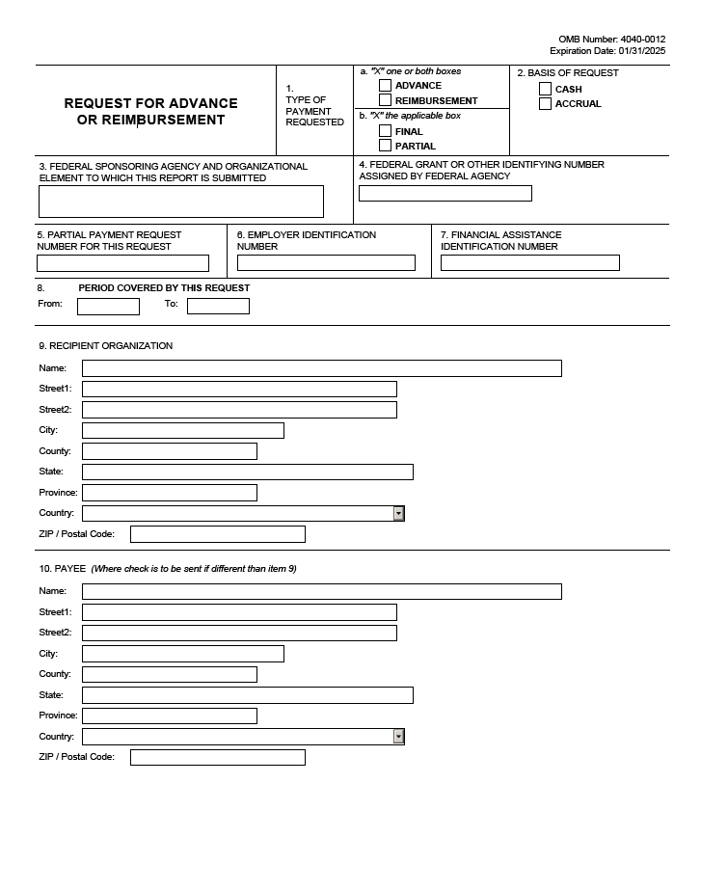
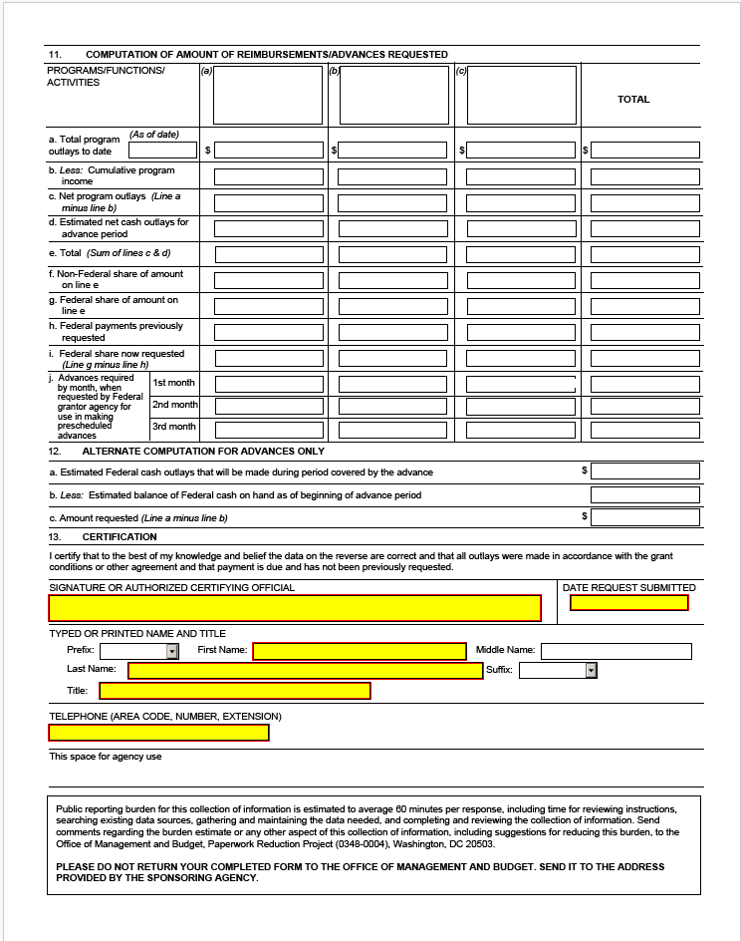
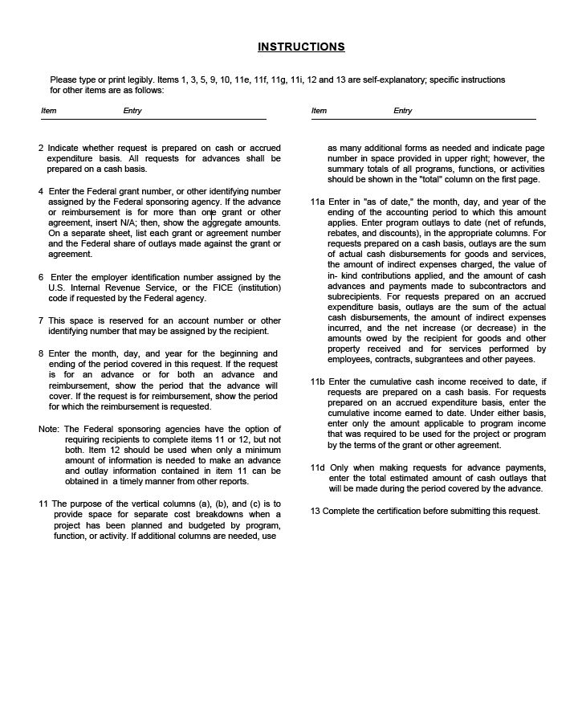

ET HANDBOOK NO. 336

18th Edition

APPENDIX IV

INFORMATION TECHNOLOGY SECURITY GUIDELINES

INFORMATION TECHNOLOGY (IT) CONTINGENCY PLANNING

Contingency planning for information systems is a required process for developing general support systems (GSS) and major applications (MA) with appropriate backup methods and procedures for implementing data recovery and reconstitution against IT risks. Risks to information systems may be natural, technological, or human in nature.

Contingency planning refers to interim measures to recover IT services following an emergency or system disruption. Interim measures may include the relocation of IT systems and operations to an alternate site, the recovery of IT functions using alternate equipment, or the performance of IT functions using manual methods.

The capability to recover and reconstitute data should be integral to the information system design concept during the Initiation phase of Software Development Life Cycle of a system. Recovery strategies should be built into the architecture of the system during the Development phase. The contingency processes should be tested and maintained during the Implementation phase; contingency plans should be exercised and maintained during the Operations/Maintenance phase.

NIST SP 800-34, Contingency Planning Guide for Information Technology Systems, details a seven-step methodology for developing an IT contingency process and plan. These seven steps are summarized below:

Step 1: Develop Contingency Planning Policy Statement

A formal department or agency policy provides the authority and guidance necessary to develop an effective contingency plan. The statement should define the agency’s overall contingency objectives; identify leadership, roles and responsibilities, resource requirements, test, training, and exercise schedules; and develop maintenance schedules and determine the minimum required backup frequency.

Step 2: Conduct Business Impact Analysis

A business impact analysis (BIA) is a critical step to understanding the information systems components, interdependencies, and potential downtime impacts. The BIA helps to identify and prioritize critical IT systems and components. Contingency plan strategy and procedures should be designed in consideration of the results of the BIA.

A BIA is conducted by identifying the system’s critical resources. Each critical resource is then further examined to determine how long functionality of the resource could be withheld from the information system before an unacceptable impact is experienced. The impact may be something that materializes over time or may be tracked across related resources and dependent systems (e.g., cascading domino effect). The time identified is called a maximum allowable outage (MAO). Based on the potential impacts, the amount of time the information system can be without the critical resource then provides a recourse recovery priority around which an organization can plan recovery activities. The balancing point between the MAO and the cost to recover establishes the information system’s recovery time objective (RTO). Recovery strategies must be created to meet the RTO. The strategy must also address recovering information system critical components within a priority, as established by their individual RTOs.

Step 3: Identify Preventive Controls

In some cases, implementing preventive controls might mitigate outage impacts identified by the BIA. Preventive controls are measures that detect, deter, and/or reduce impacts to the system. When cost-effective, preventing an impact is desired over implementing recovery strategies (and therefore risking data loss and impact to the organization). Preventive measures are specific to individual components and the environment in which the components operate. Common controls include:

- Uninterruptible power supply (UPS);
- Fire suppression systems;
- Gasoline or diesel-powered generators;
- Air conditioning systems with excess capacity to permit failure of certain components;
- Heat-resistant and waterproof containers for backup media and vital non-electronic records; and
- Frequent, scheduled data backups.

Step 4: Develop Recovery Strategies

When a disruption occurs despite the preventive measures implemented, a recovery strategy must be in place to recover and restore data and system operations within the RTO period. The recovery strategy is designed from a combination of methods, which together address the full spectrum of information system risks. The most cost-effective option, based on potential impact, should be selected and integrated into the information system architecture and operating procedures.

System data must be backed up regularly; therefore, all IT contingency plans should include a method and frequency for conducting data backups based on system criticality. Data that is backed up may need to be stored offsite and rotated frequently, depending upon the criticality of the system.

Major disruptions to system operations may require restoration activities to be implemented at an alternate site. The type of alternate site selected must be based on RTO requirements and budget limitations. Equipment for recovering and/or replacing the information system must be provided as part of the recovery strategy. Cost, delivery time, and compatibility factors must also be considered when determining how to provide the necessary equipment. Agencies must also plan for an alternate site that, at a minimum, provides workspace for all contingency plan personnel, equipment, and the appropriate IT infrastructure necessary to execute IT contingency plan and system recovery activities.

The recovery strategy requires personnel to implement the procedures and test operability. Generally, a member of the organization’s senior leadership is selected to activate the plan and lead overall recovery operations. Appropriate teams of personnel (at least two people to ensure there is a primary and alternate available to execute procedures) are identified to be responsible for specific aspects of the plan. Personnel should be chosen to staff the teams based on their normal responsibilities, system knowledge, and availability to recover the system on an on-call basis. A line of succession should be defined to ensure that someone could assume the role of senior leadership if the plan leader is unable to respond.

Step 5: Develop IT Contingency Plan

Procedures for executing the recovery strategy are outlined in the IT contingency plan. The plan must be written in a format that will provide the users (recovery team leadership and members) the context in which the plan is to be implemented and the direct procedures, based on role, to execute.

The NIST SP 800-34 presents a sample format for developing an IT contingency plan. The format defines three main phases that govern the actions to be taken following a system disruption. The Notification/Activation phase describes the process of notifying recovery personnel and performing a damage assessment. The Recovery phase discusses a suggested course of action for recovery teams and personnel to restore IT operations at an alternate site or using contingency capabilities. The final phase, Reconstitution, outlines actions that can be taken to return the system to normal operating conditions. Additionally, the format contains the Supporting Information and Appendices components, which provide supplemental information necessary to understand the context in which the plan is to be used and gives additional information that, may be necessary to execute procedures (e.g., emergency contact information and the BIA).

Step 6: Plan Testing, Training, and Exercises

Personnel selected to execute the IT contingency plan must be trained to perform the procedures, the plan must be exercised, and the system strategy must be tested.

Plan testing should include:

• System recovery on an alternate platform from backup media | • System performance using alternate equipment
• Coordination among recovery teams | • Restoration of normal operations
• Internal and external connectivity | • Notification procedures

Personnel training should include:

• Purpose of the plan | • Security requirements
• Cross-team coordination and communication | • Team-specific processes
• Reporting procedures | • Individual responsibilities

Plan exercises should be designed to examine, individually and then collectively, various components of the entire plan. Exercises may be conducted in a classroom setting: discussing specific components of the plan and/or impact issues; or they may be functional exercises: simulating the recovery using actual replacement equipment, data, and alternate sites.

Step 7: Plan Maintenance

The IT contingency plan must always be maintained in a ready state for use immediately upon notification. At least, annual reviews of the plan must be conducted to ensure that key personnel and vendor information, system components and dependencies, the recovery strategy, vital records, and operational requirements are up to date. While some changes may be obvious (e.g., personnel turnover or vendor changes), others will require analysis. The BIA should be reviewed periodically and updated with new information to identify new contingency requirements and priorities. Changes made to the plan are noted in a record of changes, dated, and signed or initialed by the person making the change. The revised plan, or plan sections are circulated to those with plan responsibilities. Because of the impact that plan changes may have on interdependent business processes or information systems, the changes must be clearly communicated and properly annotated in the beginning of the document.
Risk Management

An effective risk management process is an important component of a successful information security program. The principal goal of an organization’s risk management process is to protect the organization and its ability to perform its mission, not just its information assets. Risk Management is an essential management function of the organization that is tightly woven into the system development life cycle (SDLC). Because risk cannot be eliminated entirely, the risk management process allows information security program managers to balance the operational and economic costs of protective measures and achieve gains in mission capability. By employing practices and procedures designed to foster informed decision-making, agencies help protect their information systems and the data that support their own mission.

NIST SP 800-30, Guide for Conducting Risk Assessments, provides for the development of an effective risk management program.

Risk management is an aggregation of three processes:

- Risk Assessment,
- Risk Mitigation, and
- Evaluation and Assessment.

These three processes are summarized below:

Risk Assessment

The goal of the risk assessment process is to identify and assess the risks to a given environment. The depth of the risk assessment performed can vary greatly and is determined by the criticality and sensitivity of the system, as applied to confidentiality, integrity, and availability. To meet the goal of the risk assessment, a process is divided into following steps:

Step 1: System Characterization

Characterizing an information system establishes the scope of the risk assessment effort, delineates the operational authorization boundaries, and provides information. This step begins with the identification of the information system boundaries, resources, and information.

When characterizing the system, the mission criticality and sensitivity are described in sufficient terms to form a basis for the scope of the risk assessment. Various techniques, such as questionnaires, interviews, documentation reviews, and automated scanning tools, can be used to collect the information needed to characterize the system completely. At a minimum, the system characterization describes the following individual system components:

- Hardware;
- Software;
- External interfaces to other systems;
- Data; and
- People.

In addition to the component descriptions, the system characterization describes other factors with the potential to affect the security of the system, such as:

- System functional requirements;
- Organizational security policy and architecture;
- System network topology;
- Information flows throughout the system;
- Management, operational, and technical security controls implemented or planned to be implemented for the system; and
- Physical and environmental security mechanisms.

Step 2: Threat Identification

Threat identification consists of identifying threat sources with the potential to exploit weaknesses in the system. The threat statement must be tailored to the individual organization and its processing environment (e.g., end-user computing habits), which is accomplished by performing a threat evaluation, using the system characterization as the basis, for the potential to cause harm to the system.

There are common threat sources that typically apply, regardless of the system, and should be evaluated. These common threats can be categorized into three areas:

- Natural threats (e.g., floods, earthquakes, tornadoes, landslides, avalanches, electrical storms),
- Human threats (intentional or unintentional), and
- Environmental threats (e.g., power failure).

In general, information on natural threats (e.g., floods, earthquakes, storms) should be readily available, as known threats have been identified by many government and private sector organizations. Intrusion detection tools also are becoming more prevalent, and government and industry organizations continually collect data on security events, thereby improving the ability to assess threats realistically.

Step 3: Vulnerability Identification

Vulnerability is defined as “a flaw or weakness in system security procedures, design, implementation, or internal controls that could be exercised (accidentally triggered or intentionally exploited) and result in a security breach or a violation of the system’s security policy”. Vulnerabilities can be identified using a combination of a number of techniques and sources. Reviews of such sources as previous risk assessments, audit reports, vulnerability lists, and security advisories can be used to begin the process of vulnerability identification. System security testing, using methods such as automated vulnerability scanning tools; security, test, and evaluation; and penetration testing can be used to augment the vulnerability source reviews and identify vulnerabilities that may not have been previously identified in other sources.

In addition, developing a security requirements checklist based on the security requirements specified for the system during the conceptual, design, and implementation phases of the SDLC can be used to provide a 360-degree inspection of the system. The checklist developed must ensure the inclusion of appropriate questions in the areas of management, operational and technical security controls. The results of the checklist can be used as input for evaluating compliance and noncompliance, which in turn identifies system, process, and procedural weaknesses that represent potential vulnerabilities.

Step 4: Risk Analysis

The risk analysis is a determination (or estimation) of risk to the system, an analysis that requires the consideration of closely interwoven factors, such as the security controls in place for the system under review, the likelihood that those controls will be either insufficient or ineffective protection of the system, and the impact of that failure. The following four steps—control analysis, likelihood determination, impact analysis, and risk determination—are, in a practical sense, performed simultaneously or nearly simultaneously because they are so tightly linked to each other.

1. Control Analysis

As previously discussed, the analysis of controls in place to protect the system can be accomplished using a checklist or questionnaire, which is based on the security requirements for the system. The checklist also provides guidance on testing security controls. The results are used to strengthen the determination of the likelihood that a specific threat might successfully exploit a particular vulnerability.

2. Likelihood Determination

Likelihood determination considers a threat source’s motivation and capability to exploit vulnerability, the nature of the vulnerability, the existence of security controls, and the effectiveness of mitigating security controls. Likelihood ratings are described in the qualitative terms of high, moderate, and low, and are used to describe how likely a successful exploitation of a vulnerability is by a given threat. For example, if a threat is highly motivated and sufficiently capable, and controls implemented to protect the vulnerability are ineffective, then it is highly likely that the attack would be successful. In this scenario, the appropriate likelihood rating would be high. The likelihood ratings of moderate and low are similarly defined to successively lesser degrees.

3. Impact Analysis

The third factor used in determining the level of risk to a system is impact. A proper overall impact analysis considers the following factors: impact to the systems, data, and the organization’s mission. Additionally, this analysis should also consider the criticality and sensitivity of the system and its data for the three security domains of confidentiality, integrity, and availability. Tools such as mission-impact reports, asset criticality assessment reports, and business impact analyses results in a rating describing the estimated impact to the system and organization should a threat successfully exploit vulnerability. While impact can be described using either a quantitative or qualitative approach, in the context of information technology (IT) systems and data, impact is generally described in qualitative terms. As with the ratings used to describe likelihood, impact levels are described using the terms of high, moderate, and low. NIST SP 800-30 provides definitions for the impact ratings of low, medium, and high.

4. Risk Determination

Once the ratings for likelihood and impact have been determined through appropriate analyses, the level of risk to the system and the organization can be derived by multiplying the ratings assigned for threat likelihood (e.g., probability) and threat impact. NIST SP 800-30 provides how to calculate an overall risk rating using inputs from the threat likelihood and impact categories.

Step 5: Control Recommendations

The goal of the control recommendations is to reduce the level of risk to the information system and its data to a level the organization deems acceptable. These recommendations are essential input for the risk mitigation process, during which the recommended procedural and technical security controls are evaluated, prioritized, and implemented. This step is designed to help agencies identify and select controls appropriate to the organization’s operations and mission that could mitigate or eliminate the risks identified in the preceding steps. The following factors should be considered in recommending controls and alternative solutions to minimize or eliminate identified risks:

Effectiveness of recommended options (e.g., system compatibility):

- Legislation and regulation;
- Organizational policy;
- Operational impact; and
- Safety and reliability.

Step 6: Results Documentation

The risk assessment report is the mechanism used to report the results formally of all risk assessment activities. The intended function of this report is to describe and document the risk posture of the system while it is operating in its stated environment (as described in the system characterization) and to provide organization managers with sufficient information so that they can make sound, risk-based decisions, such as resources that must be allocated to the risk mitigation phase. Lastly, the agency should ensure that the results of the risk assessment are appropriately reflected in the system’s Plan of Action and Milestones (POA&M) and System Security Plan.

At a minimum, the risk assessment report should describe the following:

- Scope of the assessment based on the system characterization;
- Methodology used to conduct the risk assessment;
- Individual observations resulting from conducting the risk assessment; and
- Estimation of the overall risk posture of the system.

The risk assessment process is usually repeated at least every three years. However, risk assessments should be conducted and integrated into the SDLC for information systems.

Risk Mitigation

The second phase of the risk management process is risk mitigation. Because it is impractical, if not impossible, to eliminate all risk from a system, risk mitigation strives to prioritize, evaluate, and implement the appropriate risk-reducing controls recommended from the risk assessment process. Managers may use several options to reduce the risk to a system. These options are risk assumption; risk avoidance; risk limitation; risk planning, research, and acknowledgement; and risk transference.

A straightforward strategy can be used to determine whether risk mitigation actions are necessary. Working from each risk identified and analyzed in the first process—risk assessment—managers must then decide whether the risk is acceptable or unacceptable and, subsequently, whether to implement additional controls or not to mitigate unacceptable risks. Once the decision has been made on which risks are to be addressed in the risk mitigation process, a seven-step approach is used to guide the selection of security controls:

1. Prioritize actions;
2. Evaluate recommended control options;
3. Conduct cost-benefit analyses;
4. Select controls;
5. Assign responsibility;
6. Develop a safeguard implementation plan; and
7. Implement selected control(s).

The process of selecting controls to mitigate identified risks to an acceptable level is based on the security categorization of the system. For new systems, once the security controls for the system have been identified and refined and an initial risk assessment conducted, the selected controls must be implemented. For legacy systems, the security controls that are selected are verified.

Organizations can leverage controls used among multiple systems by designating them as common controls where implementation, assessment, and monitoring is conducted at an organizational level or by areas of specific expertise (e.g., human resources, physical security, building management). The system owner must understand who is responsible for implementing these controls and identify the risk that this extension of trust will generate.

Because it is impracticable to eliminate all risk, it is important to note that even after the controls have been selected and implemented, some degree of residual risk will remain. The remaining residual risk should be analyzed to ensure that it is at an acceptable level. After the appropriate controls have been put in place for the identified risks, the authorizing official should sign a statement accepting any residual risk. Either the official should authorize the operation of the new information system or request continued processing of the existing information system. If the residual risk has not been reduced to an acceptable level, the risk management cycle must be repeated to identify a way of lowering the residual risk to an acceptable level.

Evaluation and Assessment

The third and final phase in the risk management process is evaluation and assessment. The art of risk management in today’s dynamic and constantly changing IT environments must be ongoing and continuously evolving. Systems are upgraded and expanded, components are improved, and architectures are constantly evolving.

The evaluation and assessment of security controls’ effectiveness must be performed. The results are used to provide an Authorizing Official with the essential information needed to make a credible, risk-based decision on whether to authorize the operation of the information system. The reuse of assessment data will not only save valuable resources, but also provide the most up-to-date risk information for the authorizing official.

Many of the risk management activities are conducted during a snapshot in time—a static representation of a dynamic environment. All the changes that occur to systems during normal, daily operations have the potential to affect the security of the system adversely in some fashion, and it is the goal of the risk management evaluation and assessment process to ensure that the system continues to operate in a safe and secure manner. This goal can be partially reached by implementing a strong configuration management program. In addition to monitoring the security of an information system on a continuous basis, agencies must track findings from the security control assessment to ensure they are addressed appropriately and do not continue to pose or introduce new risks to the system.
System Security Planning

The objective of system security planning is to improve the protection of information system resources. The protection of a system must be documented in a system security plan. The purpose of the system security plan is to provide an overview of the security requirements of the system and describe the controls in place or planned for meeting those requirements. The system security plan also delineates responsibilities and expected behavior of all individuals who access the system. It should reflect input from various managers with responsibilities concerning the system.

NIST SP 800-18 Guide for Developing Security Plans for Federal Information Systems, provides basic information on how to prepare a system security plan in accordance with applicable federal requirements, and it is easily adaptable to a variety of organizational structures.

Program managers, system owners, and security personnel in the organization must understand the system security planning process. In addition, users of the information system and those responsible for defining system requirements should also be familiar with the system security planning process, as the system security plan is an important deliverable in the SDLC process. Those responsible for implementing and managing information systems must participate in addressing security controls to be applied to their systems.

Applications

All information systems must be covered by a system security plan. Systems can be labeled as a major application (MA) or general support system (GSS). MA is defined as an application that requires special attention to security due to the risk and magnitude of harm resulting from the loss, misuse, or unauthorized access to or modification of the information in the application. GSS is defined as an interconnected set of information resources under the same direct management control that shares common functionality. It normally includes hardware, software, information, data, applications, communications, and people. A minor application is an application, other than major application, that requires attention to security due to the risk and magnitude of harm resulting from the loss, misuse, or unauthorized access to or modification of the information in the application. Minor applications are typically included as part of a GSS.

Security Planning Roles and Responsibilities

Agencies should develop policy on the system security planning process. System security plans are living documents that require periodic review, modification, and POA&M for implementing security controls. Procedures should be in place outlining who reviews the plans, keeps the plan current, and follows up on planned security controls.

The roles and responsibilities in this section are specific to information system security planning.

Chief Information Officer

The chief information officer (CIO) is the agency official responsible for developing and maintaining an agency-wide information security program and has the following system security planning responsibilities:

Designating a Senior Agency Information Security Officer (SAISO) who shall carry out the CIO's responsibilities for system security planning such as:

- Developing and maintaining information security policies, procedures, and control techniques to address system security planning;
- Managing the identification, implementation, and assessment of common security controls;
- Ensuring that personnel with significant responsibilities for system security plans are trained;
- Assisting senior agency officials with their responsibilities for system security plans; and
- Identifying and developing common security controls for the agency.

Information System Owner

The information system owner is the agency official responsible for the overall procurement, development, integration, modification, and operation and maintenance of the information system. The information system owner has the following responsibilities related to system security plans:

- Developing the system security plan in coordination with information owners, the system administrator, the information system security officer (ISSO), the SAISO, and functional "end users";
- Maintaining the system security plan and ensuring that the system is deployed and operated according to the agreed-upon security requirements; and
- Ensuring that system users and support personnel receive the requisite security training (e.g., instruction in rules of behavior) and assisting in the identification, implementation, and assessment of the common security controls.

Information Owner

The information owner is the agency official with statutory or operational authority for specified information and is responsible for establishing the controls for information generation, collection, processing, dissemination, and disposal. The information owner has the following responsibilities related to system security plans:
- Establishing the rules for the appropriate use and protection of the subject data/information (rules of behavior);
- Providing input to information system owners on the security requirements and security controls for the information systems where the information resides;
- Deciding who has access to the information system and determining what types of privileges or access rights; and
- Assisting in identifying and assessing the common security controls where the information resides.

Senior Agency Information Security Officer

The SAISO is the agency official responsible for serving as the CIO’s primary liaison to the agency’s information system owners and ISSOs. The SAISO has the following responsibilities related to system security plans:

- Carrying out the CIO’s responsibilities for system security planning;
- Coordinating the development, review, and acceptance of system security plans with information system owners, ISSOs, and the authorizing official;
- Coordinating the identification, implementation, and assessment of the common security controls; and
- Possessing professional qualifications, including training and experience, required to develop and review system security plans.

Information System Security Officer

The ISSO is the agency official assigned responsibility by the SAISO, authorizing official, management official, or information system owner for ensuring that the appropriate operational security posture is maintained for an information system or program. The ISSO has the following responsibilities related to system security plans:

- Assisting the SAISO in identifying, implementing, and assessing the common security controls; and
- Actively supporting the development and maintenance of the system security plan, to include coordinating system changes with the information system owner and assessing the security impact of those changes.

Rules of Behavior

The rules of behavior should clearly delineate responsibilities and expected behavior of all individuals with access to the system. The rules should state the consequences of inconsistent behavior or noncompliance and be made available to every user prior to receiving authorization for system access. It is required that the rules contain a signature page for each user to acknowledge receipt, indicating that they have read, understand, and agree to abide by the rules of behavior. Electronic signatures are acceptable for use in acknowledging the rules of behavior.

Following lists the examples of what should be covered in typical rules of behavior:

- Delineate responsibilities, expected use of system, and behavior of all users
- Describe appropriate limits on interconnections
- Define service provisions and restoration priorities
- Be clear on consequences of behavior not consistent with rules

It covers the following topics:

- Work at home
- Dial-in access
- Connection to the Internet
- Use of copyrighted work
- Unofficial use of government equipment
- Assignment and limitations of system privileges and individual accountability
- Password usage
- Searching databases and divulging information

Agencies can incorporate, by reference, the agency body of policies and procedures governing information security and other applicable policies in the text of the rules of behavior.

System Security Plan Approval

Organizational policy should clearly define who is responsible for system security plan approval and procedures developed for plan submission, including any special memorandum language or other documentation required by the agency.

System Boundary Analysis and Security Controls

Before the system security plan is developed, the information system as well as the information itself should be categorized based on impact analysis. NIST issued Federal Information Processing Standards (FIPS) 199, Standards for Security Categorization of Federal Information and Information Systems to develop standards for categorizing information and information systems. Refer to FIPS Publication 199 for more information on system categorization. Then a determination can be made as to which systems in the inventory can be logically grouped into GSSs or MAs. The FIPS 199 impact levels should be considered when the system boundaries are drawn and when selecting the initial set of security controls (e.g., control baseline). The baseline security controls can then be tailored based on an assessment of risk and local conditions, including organization-specific security requirements, specific threat information, cost-benefit analyses, the availability of compensating controls, or special circumstances. Common security controls, which is one of the tailoring considerations, must be identified prior to system security plan preparation to identify those controls covered at the agency level that are not system-specific. These common security controls can then be incorporated into the system security plan by reference.

Security Controls

FIPS 200, Minimum Security Requirements for Federal Information and Information Systems provides seventeen minimum-security requirements for the information systems. The requirements represent a broad-based, balanced information security program that addresses the management, operational, and technical aspects of protecting the confidentiality, integrity, and availability of the information and information systems. An agency should meet the minimum-security requirements in this standard by applying security controls selected in accordance with NIST SP 800-53, Recommended Security Control for Federal Information Systems and the designated impact levels of the information systems. An agency has the flexibility to tailor the security control baseline in accordance with the terms and conditions set forth in the standard. Tailoring activities include:

(1) the application of scoping guidance,
(2) the specification of compensating controls, and
(3) the specification of agency-defined parameters in the security controls, where allowed. The system security plan should document all tailoring activities.

Scoping Guidance

Scoping guidance provides an agency with specific terms and conditions on the applicability and implementation of individual security controls in the security control baselines defined in NIST SP 800-53. System security plans should clearly identify which security controls used scoping guidance. In addition, system security plans should include a description of the type of considerations that were made.

Compensating Controls

Compensating security controls are the management, operational, or technical controls used by an agency in lieu of prescribed controls in the low, moderate, or high security control baselines, which provide equivalent or comparable protection for an information system. Compensating security controls for an information system should be used by an agency only under the following conditions:

(1) The agency selects the compensating controls from the security control catalog in NIST SP 800-53;
(2) The agency provides a full and complete rationale and justification for how the compensating controls provide an equivalent security capability or level of protection for the information system; and
(3) The agency assesses and formally accepts the risk associated with using the compensating controls in the information system.

Common Security Controls

An agency-wide view of the information security program facilitates the identification of common security controls that can be applied to one or more agency information systems. Common security controls can apply to all agency information systems; a group of information systems at a specific site; or common information systems, subsystems, or applications (i.e., common hardware, software, and/or firmware) deployed at multiple operational sites. Common security controls are typically identified during a collaborative agency-wide process that involves the CIO, SAISO, authorizing officials, information system owners, and ISSOs.

For efficiency in developing system security plans, common security controls should be documented once and then inserted or imported into each system security plan for the information systems within the agency.

Security Control Selection

An agency should meet the minimum-security requirements in FIPS 199 by selecting the appropriate security controls and assurance requirements as described in NIST SP 800-53. The process of selecting the appropriate security controls and assurance requirements for agency information systems to achieve adequate security is a multifaceted, risk-based activity involving management and operational personnel within the agency. Subsequent to the security categorization process, an agency must select an appropriate set of security controls for their information systems that satisfy the minimum-security requirements set forth in FIPS 200. The selected set of security controls must be one of three security control baselines from NIST SP 800-53 (see Table below) that are associated with the designated impact levels of the agency information systems as determined during the security categorization process.

FIPS 199 Categorization

Potential Impact

Security Objective | Low | Moderate | High
Confidentiality  Preserving authorized restrictions on information access and disclosure, including means for protecting personal privacy and proprietary information.  [44 U.S.C., SEC. 3542] | The unauthorized disclosure of information could be expected to have a limited adverse effect on organizational operations, organizational assets, or individuals. | The unauthorized disclosure of information could be expected to have a serious adverse effect on organizational operations, organizational assets, or individuals. | The unauthorized disclosure of information could be expected to have a severe or catastrophic adverse effect on organizational operations, organizational assets, or individuals.
Integrity  Guarding against improper information modification or destruction and includes ensuring information non-repudiation and authenticity.  [44 U.S.C., SEC. 3542] | The unauthorized modification or destruction of information could be expected to have a limited adverse effect on organizational operations, organizational assets, or individuals. | The unauthorized modification or destruction of information could be expected to have a serious adverse effect on organizational operations, organizational assets, or individuals. | The unauthorized modification or destruction of information could be expected to have a severe or catastrophic adverse effect on organizational operations, organizational assets, or individuals.
Availability  Ensuring timely and reliable access to and use of information.  [44 U.S.C., SEC. 3542] | The disruption of access to or use of information or an information system could be expected to have a limited adverse effect on organizational operations, organizational assets, or individuals. | The disruption of access to or use of information or an information system could be expected to have a serious adverse effect on organizational operations, organizational assets, or individuals. | The disruption of access to or use of information or an information system could be expected to have a severe or catastrophic adverse effect on organizational operations, organizational assets, or individuals.

Completion and Approval Dates
The completion date of the system security plan should be provided. The completion date should be updated whenever the plan is periodically reviewed and updated. The system security plan should also contain the date the authorizing official or the designated approving authority approves the plan.

Ongoing System Security Plan Maintenance

Once the information system security plan is approved, it is important to periodically assess the plan; review any change in system status, functionality, design, etc.; and ensure that the plan continues to reflect the correct information about the system. This documentation and its accuracy are imperative for system recertification and reaccreditation activity. All plans should be reviewed and updated, if appropriate, at least annually. Some items to include in the review are:

- Change in information system owner;
- Change in information security representative;
- Major change in system architecture;
- Change in system status;
- Additions/deletions of system interconnections;
- Change in system scope; and
- Change in authorizing official.

SAMPLE PLAN FORMATS
SAMPLE IT CONTINGENCY PLAN FORMAT

This sample format provides a template for preparing an information technology (IT) contingency plan. The template is intended to be used as a guide, and the Contingency Planning Coordinator should modify the format as necessary to meet the system’s contingency requirements and comply with internal policies. Where practical, the guide provides instructions for completing specific sections. Text is added in certain sections; however, this information is intended only to suggest the type of information that may be found in that section. The text is not comprehensive and should be modified to meet specific agency and system considerations. The IT contingency plan should be marked with the appropriate security label, such as Official Use Only.
- IT CONTINGENCY PLAN

- 1. INTRODUCTION

- 1.1 PURPOSE

This {system name} Contingency Plan establishes procedures to recover the {system name} following a disruption. The following objectives have been established for this plan:

- Maximize the effectiveness of contingency operations through an established plan that consists of the following phases:
- Notification/Activation phase to detect and assess damage and to activate the plan
- Recovery phase to restore temporary IT operations and recover damage done to the original system
- Reconstitution phase to restore IT system-processing capabilities to normal operations.
- Identify the activities, resources, and procedures needed to carry out {system name} processing requirements during prolonged interruptions to normal operations.
- Assign responsibilities to designated {Organization name} personnel and provide guidance for recovering {system name} during prolonged periods of interruption to normal operations.
- Ensure coordination with other {Organization name} staff who will participate in the contingency planning strategies. Ensure coordination with external points of contact and vendors who will participate in the contingency planning strategies.

- 1.2 APPLICABILITY

The {system name} Contingency Plan applies to the functions, operations, and resources necessary to restore and resume {Organization name}’s {system name} operations as it is installed at primary location name, City, State. The {system name} Contingency Plan applies to {Organization name} and all other persons associated with {system name} as identified under Section 2.3, Responsibilities.
The {system name} Contingency Plan is supported by plan name, which provides the purpose of plan. Procedures outlined in this plan are coordinated with and support the plan name, which provides purpose of plan.

- 1.3 SCOPE
- 1.3.1 Planning Principles

Various scenarios were considered to form a basis for the plan, and multiple assumptions were made. The applicability of the plan is predicated on two key principles:

- The {Organization name}’s facility in City, State, is inaccessible; therefore, {Organization name} is unable to perform {system name} processing for the Department.

- A valid contract exists with the alternate site that designates that site in City, State, as the {Organization name}’s alternate operating facility.
- {Organization name} will use the alternate site building and IT resources to recover {system name} functionality during an emergency that prevents access to the original facility.
- The designated computer system at the alternate site has been configured to begin processing {system name} information.
- The alternate site will be used to continue {system name} recovery and processing throughout the period of disruption, until the return to normal operations.

- 1.3.2 Assumptions

Based on these principles, the following assumptions were used when developing the IT Contingency Plan:

- The {system name} is inoperable at the {Organization name} computer center and cannot be recovered within 48 hours.
- Key {system name} personnel have been identified and trained in their emergency response and recovery roles; they are available to activate the {system name} Contingency Plan.
- Preventive controls (e.g., generators, environmental controls, waterproof tarps, sprinkler systems, fire extinguishers, and fire department assistance) are operational at the time of the disaster.
- Computer center equipment, including components supporting {system name}, are connected to an uninterruptible power supply (UPS) that provides 45 minutes to 1 hour of electricity during a power failure.
- {system name} hardware and software at the {Organization name} original site are unavailable for at least 48 hours.
- Current backups of the application software and data are intact and available at the offsite storage facility.
- The equipment, connections, and capabilities required to operate {system name} are available at the alternate site in City, State.
- Service agreements are maintained with {system name} hardware, software, and communications providers to support the emergency system recovery.

The {system name} Contingency Plan does not apply to the following situations:

- Overall recovery and continuity of business operations. The Business Resumption Plan (BRP) and Continuity of Operations Plan (COOP) are appended to the plan.

- Emergency evacuation of personnel. The Occupant Evacuation Plan (OEP) is appended to the plan.
- Any additional constraints should be added to this list.

- 1.4 REFERENCES/REQUIREMENTS

This {system name} Contingency Plan complies with the {Organization name}’s IT contingency planning policy as follows:
The organization shall develop a contingency planning capability to meet the needs of critical supporting operations in the event of a disruption extending beyond 72 hours. The procedures for execution of such a capability shall be documented in a formal contingency plan and shall be reviewed at least annually and updated as necessary. Personnel responsible for target systems shall be trained to execute contingency procedures. The plan, recovery capabilities, and personnel shall be tested to identify weaknesses of the capability at least annually.

The {system name} Contingency Plan also complies with the following federal and departmental policies:

- The Computer Security Act of 1987
- OMB Circular A-130, Management of Federal Information Resources, Appendix III, November 2000.
- Federal Preparedness Circular (FPC) 65, Federal Executive Branch Continuity of Operations, July 1999
- Presidential Decision Directive (PDD) 67, Enduring Constitutional Government and Continuity of Government Operations, October 1998
- PDD 63, Critical Infrastructure Protection, May 1998
- Federal Emergency Management Agency (FEMA), The Federal Response Plan (FRP), April 1999
- Defense Authorization Act (Public Law 106-398), Title X, Subtitle G, “Government Information Security Reform,” October 30, 2000
- Any other applicable federal policies should be added
- Any other applicable departmental policies should be added.

1.5 RECORD OF CHANGES

Modifications made to this plan since the last printing are as follows:

Record of Changes
Page No. | Change Comment | Date of Change | Signature

- 2. CONCEPT OF OPERATIONS

2.1 SYSTEM DESCRIPTION AND ARCHITECTURE

Provide a general description of system architecture and functionality. Indicate the operating environment, physical location, general location of users, and partnerships with external organizations/systems. Include information regarding any other technical considerations that are important for recovery purposes, such as backup procedures. Provide a diagram of the architecture, including security controls and telecommunications connections.

2.2 LINE OF SUCCESSION

The {organization name} sets forth an order of succession, in coordination with the order set forth by the department to ensure that decision-making authority for the {system name} Contingency Plan is uninterrupted. The Chief Information Officer (CIO), {organization name} is responsible for ensuring the safety of personnel and the execution of procedures documented within this {system name} Contingency Plan. If the CIO is unable to function as the overall authority or chooses to delegate this responsibility to a successor, the Deputy CIO shall function as that authority. Continue description of succession as applicable.

- 2.3 RESPONSIBILITIES

The following teams have been developed and trained to respond to a contingency event affecting the IT system.

The Contingency Plan establishes several teams assigned to participate in recovering {system name} operations. The {team name} is responsible for recovery of the {system name} computer environment and all applications. Members of the team name include personnel who are also responsible for the daily operations and maintenance of {system name}. The team leader title directs the {team name}.

Continue to describe each team, their responsibilities, leadership, and coordination with other applicable teams during a recovery operation.

The relationships of the team leaders involved in system recovery and their member teams are illustrated in Figure XX below.

(Insert hierarchical diagram of recovery teams. Show team names and leaders; do not include actual names of personnel.)

Describe each team separately, highlighting overall recovery goals and specific responsibilities. Do not detail the procedures that will be used to execute these responsibilities. These procedures will be itemized in the appropriate phase sections.

3. NOTIFICATION AND ACTIVATION PHASE

This phase addresses the initial actions taken to detect and assess damage inflicted by a disruption to {system name}. Based on the assessment of the event, the plan may be activated by the Contingency Planning Coordinator.

In an emergency, the {Organization name}’s top priority is to preserve the health and safety of its staff before proceeding to the Notification and Activation procedures.

Contact information for key personnel is located in Personnel Contact list appendix. The notification sequence is listed below:

- The first responder is to notify the Contingency Planning Coordinator. All known information must be relayed to the Contingency Planning Coordinator.
- The systems manager is to contact the Damage Assessment Team Leader and inform them of the event. The Contingency Planning Coordinator is to instruct the Team Leader to begin assessment procedures.
- The Damage Assessment Team Leader is to notify team members and direct them to complete the assessment procedures outlined below to determine the extent of damage and estimated recovery time. If damage assessment cannot be performed locally because of unsafe conditions, the Damage Assessment Team is to follow the outline below.

Damage Assessment Procedures:

(Detailed procedures should be outlined to include activities to determine the cause of the disruption; potential for additional disruption or damage; affected physical area and status of physical infrastructure; status of IT equipment functionality and inventory, including items that will need to be replaced; and estimated time to repair services to normal operations.)
- Upon notification from the Contingency Planning Coordinator, the Damage Assessment Team Leader is to …
- The Damage Assessment Team is to ….

Alternate Assessment Procedures:

- Upon notification from the Contingency Planning Coordinator, the Damage Assessment Team Leader is to …
- The Damage Assessment Team is to ….
- − When damage assessment has been completed, the Damage Assessment Team Leader is to notify the Contingency Planning Coordinator of the results.
- − The Contingency Planning Coordinator is to evaluate the results and determine whether the contingency plan is to be activated and if relocation is required.
- − Based on assessment results, the Contingency Planning Coordinator is to notify assessment results to civil emergency personnel (e.g., police, fire) as appropriate.

The Contingency Plan is to be activated if one or more of the following criteria are met:
- 1. {System name} will be unavailable for more than 48 hours
- 2. Facility is damaged and will be unavailable for more than 24 hours
- 3. Other criteria, as appropriate.

- If the plan is to be activated, the Contingency Planning Coordinator is to notify all Team Leaders and inform them of the details of the event and if relocation is required.
- Upon notification from the Contingency Planning Coordinator, Team Leaders are to notify their respective teams. Team members are to be informed of all applicable information and prepared to respond and relocate if necessary.
- The Contingency Planning Coordinator is to notify the off-site storage facility that a contingency event has been declared and to ship the necessary materials (as determined by damage assessment) to the alternate site.
- The Contingency Planning Coordinator is to notify the Alternate site that a contingency event has been declared and to prepare the facility for the Organization’s arrival.
- The Contingency Planning Coordinator is to notify remaining personnel (via notification procedures) on the general status of the incident.

- 4. RECOVERY OPERATIONS

This section provides procedures for recovering the application at the alternate site, whereas other efforts are directed to repair damage to the original system and capabilities.
The following procedures are for recovering the {system name} at the alternate site. Procedures are outlined per team required. Each procedure should be executed in the sequence it is presented to maintain efficient operations.

Recovery Goal. State the first recovery objective as determined by the Business Impact Assessment (BIA). For each team responsible for executing a function to meet this objective, state the team names and list their respective procedures.

- {team name}
− Team Recovery Procedures
- {team name}
− Team Recovery Procedures
- {team name}
− Team Recovery Procedures

Recovery Goal. State the second recovery objective as determined by the BIA. For each team responsible for executing a function to meet this objective, state the team names and list their respective procedures.

- {team name}
− Team Recovery Procedures
- {team name}
− Team Recovery Procedures
- {team name}
− Team Recovery Procedures

Recovery Goal. State the remaining recovery objectives (as determined by the BIA). For each team responsible for executing a function to meet this objective, state the team names and list their respective procedures.

- 5. RETURN TO NORMAL OPERATIONS

This section discusses activities necessary for restoring {system name} operations at the {Organization name}’s original or new site. When the computer center at the original or new site has been restored, {system name} operations at the alternate site must be transitioned back. The goal is to provide a seamless transition of operations from the alternate site to the computer center.

Original or New Site Restoration

Procedures should be outlined, per necessary team, to restore or replace the original site so that normal operations may be transferred. IT equipment and telecommunications connections should be tested.

- {team name}
− Team Resumption Procedures
- {team name}
− Team Resumption Procedures

- 5.1 CONCURRENT PROCESSING

Procedures should be outlined, per necessary team, to operate the system in coordination with the system at the original or new site. These procedures should include testing the original or new system until it is functioning properly and the contingency system is shut down gracefully.

- {team name}
− Team Resumption Procedures
- {team name}
− Team Resumption Procedures

- 5.2 PLAN DEACTIVATION

Procedures should be outlined, per necessary team, to clean the alternate site of any equipment or other materials belonging to the organization, with a focus on handling sensitive information. Materials, equipment, and backup media should be properly packaged, labeled, and shipped to the appropriate location(s). Team members should be instructed to return to the original or new site.
- {team name}
− Team Testing Procedures
- {team name}
− Team Testing Procedures

- 6. PLAN APPENDICES

The appendices included should be based on system and plan requirements.
- Personnel Contact List
- Vendor Contact List
- Equipment and Specifications
- Service Level Agreements and Memorandums of Understanding
- IT Standard Operating Procedures
- Business Impact Analysis
- Related Contingency Plans
- Emergency Management Plan
- Occupant Evacuation Plan
- Continuity of Operations Plan.

Sample Information System Security Plan Template

The following sample has been provided ONLY as one example. Agencies may be using other formats and choose to update those to reflect any existing omissions based on this guidance. This is not a mandatory format; it is recognized that numerous agencies and information security service providers may have developed and implemented various approaches for information system security plan development and presentation to suit their own needs for flexibility. The template instructions, which are separate from the template, will assist the user when completing the sections of the plan.

Information System Security Plan

1. Information System Name/Title:
2. Information System Categorization:

 | LOW |  | MODERATE |  | HIGH

3. Information System Owner:
4. Authorizing Official:
5. Other Designated Contacts:
6. Assignment of Security Responsibility:
7. Information System Operational Status:

 | Operational |  | Under Development |  | Major Modification

8. Information System Type:

 | Major Application |  | General Support System

9. General System Description/Purpose

10. System Environment

11. System Interconnections/Information Sharing

System  Name | Organization | Type | Agreement  (ISA/MOU/MOA) | Date | FIPS 199 Category | C&A  Status | Auth.  Official

12. Related Laws/Regulations/Policies

13. Minimum Security Controls

CONTROL FAMILY | DESCRIPTION | class
Access Control (AC) |  | Technical
Awareness and Training (AT) |  | Operational
Audit and Accountability (AU) |  | Technical
Certification, Accreditation, and Security Assessments (CA) |  | Management
Configuration Management (CM) |  | Operational
Contingency Planning (CP) |  | Operational
Identification and Authentication (IA) |  | Technical
Incident Response (IR) |  | Operational
Maintenance (MA) |  | Operational
Media Protection (MP) |  | Operational
Physical & Environmental Protection (PE) |  | Operational
Planning (PL) |  | Management
Personnel Security (PS) |  | Operational
Risk Assessment (RA) |  | Management
System and Services Acquisition (SA) |  | Management
System and Communications Protection (SC) |  | Technical
System and Information Integrity (SI) |  | Operational

14. Information System Security Plan Completion Date: _____________________

15. Information System Security Plan Approval Date: _______________________
Template Instructions

1. Information System Name/Title
- Unique identifier and name given to the system.

2. Information System Categorization
- Identify the appropriate FIPS 199 categorization.

3. Information System Owner
- Name, title, agency, address, email address, and phone number of person who owns the system.

4. Authorizing Official
- Name, title, agency, address, email address, and phone number of the senior management official designated as the authorizing official.

5. Other Designated Contacts
- List other key personnel, if applicable; include their title, address, email address, and phone number.

6. Assignment of Security Responsibility
- Name, title, address, email address, and phone number of person who is responsible for the security of the system.

7. Information System Operational Status
- Indicate the operational status of the system. If more than one status is selected, list which part of the system is covered under each status.

8. Information System Type
- Indicate if the system is a major application or a general support system.

9. General System Description/Purpose
- Describe the function or purpose of the system and the information processes.

10. System Environment
- Provide a general description of the technical system. Include the primary hardware, software, and communications equipment.

11. System Interconnections/Information Sharing
- List interconnected systems and system identifiers (if appropriate), provide the system, name, organization, system type (major application or general support system), indicate if there is an ISA/MOU/MOA on file, date of agreement to interconnect, FIPS 199 category, C&A status, and the name of the authorizing official.

12. Related Laws/Regulations/Policies
- List any laws or regulations that establish specific requirements for the confidentiality, integrity, or availability of the data in the system.

13. Minimum Security Controls
- Provide a thorough description of how the minimum controls in the applicable baseline are being implemented or planned to be implemented. The controls should be described by control family and indicate whether it is a system control, hybrid control, common control, scoping guidance is applied, or a compensating control is being used.

14. Information System Security Plan Completion Date
- Enter the completion date of the plan.

15. Information System Security Plan Approval Date
- Enter the date the system security plan was approved and indicate if the approval documentation is attached or on file.

HANDBOOK NO. 336

18th Edition

APPENDIX V

UI PROGRAM INTEGRITY ACTION PLAN

Unemployment Insurance (UI) Integrity Action Plan

Background

On March 2, 2020, the Payment Integrity Information Act of 2019 (PIIA) (Pub.L. 116-117), codified in 31 U.S.C. 3351 et seq., repealed and replaced the Improper Payments Information Act of 2002, and the subsequent statutory amendments (the Improper Payments Elimination and Recovery Act of 2010 (IPERA) and the Improper Payments Elimination and Recovery Improvement Act of 2012 (IPERIA). PIIA requires Federal agencies and entities receiving Federal funding to ensure that their managers and accountable officers (including the agency head), programs, and, where applicable, states and localities, are held accountable for 1) establishing and maintaining sufficient internal controls, including an appropriate control environment, that effectively prevents improper payments from being made; and 2) for promptly detecting and recovering improper payments that are made.

To implement the requirements of PIIA, the Department is requiring states to report their planned activities to prevent, detect, reduce, and recover improper UI payments in the Unemployment Insurance Integrity Action Plan (IAP). A recommended template for the plan has been developed and is included in Appendix II of this handbook. The IAP should provide:

- Strategies and associated actions the state is taking to combat fraud; verify identities; prevent, detect, and recover improper payments, including fraudulent overpayments; and reduce the improper payment rate;
- Timeline, expected targets and measures; and
- Type and source of resource(s) dedicated to accomplish the IAP, which includes identifying which tools, solutions, and service providers are used in the state’s fraud management operations.

The U.S. Department of Labor (Department) provides assists the states in planning by providing each state with state-specific Benefit Accuracy Measurement (BAM) improper payment estimates, and data regarding the top root causes of improper payments. The Department also provides additional topics to be addressed in the IAP as part of the annual SQSP additional planning guidance.

IAP Specifics

The IAP must identify the state agency official(s) accountable for fraud mitigation activities and reducing improper payments, summarize the state’s fraud risk assessment of whether it has the internal controls, human capital, and information technology systems and other infrastructure needed to combat fraud and reduce improper payments to minimal cost-effective levels, and identify any statutory or regulatory barriers which may limit the agency’s corrective actions in mitigating fraud and reducing improper payments. Additionally, the plan must discuss the state’s root causes of improper payments and present the state’s strategies to address these causes.

- Strategies to address Root Causes and Recovery of Improper Payments and Fraudulent Overpayments. The state must use the BAM improper payment estimates provided by the Department, to describe their strategies to prevent, detect, and/or reduce each improper payment root cause. Additionally, the strategies must include actions to improve the recovery of these improper payments and fraudulent overpayments.

To determine the root causes for improper payments, each state needs to conduct an analysis of improper payments by reviewing:
    - Cause and responsible party,
    - Cause and prior actions by the agency, employer and claimant, and
    - Cause and BAM error detection points.

Other analysis may include state staffing issues, technology tools used, comprehensive UI fraud risk assessments, etc.

    - Prevention. Prevention activities are by definition proactive. These are actions performed before payment issuance to assure that the payment is accurate when made. An effective prevention strategy can reduce the potential for fraud and/or agency errors that result in overpaid benefits. Examples of prevention activities include, but are not limited to:

      - Use of required and recommended cross-matches as outlined in Unemployment Insurance Program Letter (UIPL) No. 23-20;

      - Use of data mining and data analysis to detect suspicious activity associated with initial claims;

      - Use of predictive analysis to identify claims at high risk for fraud and overpayments;

      - Identity verification processes and procedures;

      - Expanding the methods for communicating Benefit Rights and Responsibility Information),,, reviewing information layout and reading level, and testing claimant understanding;

      - Using behavioral insights to develop strategies, revise messaging, and make changes to program design to improve customer experience, prevent improper payments, and achieve program outcomes. Training and Employment Notice (TEN) No. 15-21, announced the UI Integrity Center's Behavioral Insights Toolkit, which provides state UI agencies information to assist in applying behavioral insights to address program compliance challenges and improve UI program integrity;

      - Training employers and claimants on separation information requirements;

      - Implementing the State Information Data Exchange System (SIDES) designed to improve the quality and timeliness of separation information;

      - Reviewing state law, rules and regulations, business processes, and goals that are concerned with employment service (ES) registration and aligning these elements to eliminate overpayments. Several business models exist which may help to eliminate ES Registration errors. Two of the most successful are outlined below:

        - Claimant responsible for ES registration – State stops payment if the claimant is not registered within 14 days of the initial claim. Weeks claimed or additional claims automatically maintain registration as active.

        - Agency responsible for ES registration – State collects enough information during the initial claims process to register the claimant for services. This information is transmitted to ES and the system shows an active registration.

      - Improving the continued claims process (Interactive Voice Response (IVR) and online) design and flow logic to better detect changes in employment status between weekly certifications. To prevent benefit year earnings reporting errors, states should ensure the IVR or online process clearly focuses first on employment status and then earnings in its series of questions asked -- for example, “Did you work during the week of mm/dd/yyyy?, How many hours did you work? How much do you earn per hour?;

      - Focusing on the claimant’s return to work date and earnings verification. If a claimant does not report work or hours after the return-to-work date, create a call-in reporting requirement when the claimant has claimed a week after the return-to-work date and has not reported earnings;

      - Staff evaluation and training (such as an Expanded Benefit Timeliness and Quality adjudication evaluation program and issue training); and

      - Assuring standardized fact-finding questions are used and completed for each issue type.

    - Detection. Detection activities occur after payment. These are actions that the state controls and usually involves cross-match/data analysis activities. Examples of detection activities include, but are not limited to:

      - National Directory of New Hire (NDNH) Cross-matching – implement the recommended operating procedures for NDNH cross-matching as outlined in UIPL Nos. 19-11 and 13-19, and TEN No. 05-20. Check cross-match time parameters and agency filters, and use mandatory call-ins if a week is claimed and no earnings are reported;

      - Wage Record Cross-matching – check the index calculation to ensure that it reflects current earnings disregard standards, run the wage record cross-match for nine consecutive weeks after the end of a quarter to distribute workload and detect issues as soon as information is available;

      - Implementation of SIDES to improve the quality and timeliness of separation and benefit year earnings information and to receive employer reported information in electronic format so earnings comparisons can be completed electronically instead of manually;

      - Use of required and recommended cross-matches as outlined in UIPL No 23-20;

      - Use of data mining and data analysis to detect suspicious activity associated with initial and continued claims; and

      - Use of predictive analysis to identify claims at high risk for fraud and overpayments.

    - Mitigation/Reduction. Mitigation/Reduction activities are those actions which reduce the amount overpaid or the number of weeks overpaid. Examples of mitigation/reduction activities include, but are not limited to:

      - Redesign of Benefit Payment Control (BPC) workflow to reduce administrative activities;

      - Using call-in and/or automated “required to report” notices (mail, IVR, email, and online) to raise BPC earnings issues quickly;

      - Use of weighting strategies to prioritize detection workload; and

      - Automating certain overpayment establishment decisions, where the business process only requires earning adjustment notices.

    - Recovery. Recovery activities are those actions that improve the recovery of overpayments, including fraudulent overpayments. UIPL No. 33-99 provides the Overpayment Recovery Technical Assistance Guide. Examples of recovery activities include, but are not limited to:

      - Implementation of the required and recommended overpayment recovery activities outlined in UIPL No. 23-20;

      - Redesign of the BPC overpayment recovery workflow process; and

      - Streamline administrative activities and/or automation of skip tracing and collection notices to claimants.

- Targets and Timeline. When designing strategies to mitigate fraud risks and address improper payments, agencies must set targets for future improper payment levels and a timeline when the proposed strategies will be completed and within which the expected targets will be reached. We encourage states to develop realistic multi-year initiatives.

- Resource Allocation. The IAP must include a description of the type of resources such as human capital, IT and other tools, solutions, processes and procedures that will be used to combat fraud and prevent, detect, reduce and recover improper payments, including fraudulent overpayments. States are expected to identify which service provider(s) tools and solutions are used in the state’s fraud management operations

OMB Control No.: 1205-0132 OMB Expiration Date: 02/29/2024 Estimated Average Response time: 3 hours
OMB Burden Statement: These reporting instructions have been approved under the Paperwork reduction Act of 1995. Persons are not required to respond to this collection of information unless it displays a valid OMB control number. Public reporting burden for this collection of information includes the time for reviewing instructions, searching existing data sources, gathering and maintaining the data needed, and completing and reviewing the collection of information. Submission is required to obtain or retain benefits under SSA 303(a)(6). Persons responding to this collection have no expectation of confidentiality. Send comments regarding this burden estimate or any other aspect of this collection of information, including suggestions for reducing this burden, to the U.S. Department of Labor, Office of Unemployment Insurance, Room S-4231, 200 Constitution Ave., NW, Washington, DC, 20210, eta-ui-inquiries@dol.gov.

The criteria for measures of Secretary’s Standards are currently in regulation and will remain in effect until the regulation is replaced.
The criteria for measures of Secretary’s Standards are currently in regulation and will remain in effect unless and until the regulation is superseded.
At a minimum, an IT Contingency Plan must be reviewed and/or updated annually.
⁴ At a minimum, an IT Contingency Plan must be reviewed and/or updated annually.
⁵ IT Contingency Plan must be tested annually.
1 The information in this appendix is attributed to National Institute of Standards and Technology (NIST) Special Publications (SP) and Federal Information Processing Standards (FIPS). These publications can be found on the NIST website, http://csrc.nist.gov/publications/PubsSPs.html, and http://csrc.nist.gov/publications/PubsFIPS.html, respectively. The key NIST documents are listed below: NIST SP 800-18, Guide for Developing Security Plans for Federal Information Systems; NIST SP 800-30, Guide for Conducting Risk Assessments; NIST SP 800-34, Contingency Planning Guide for Information Technology Systems; NIST SP 800-53, Security and Privacy Controls for Federal Information Systems and Organizations; NIST SP 800-100, Information Security Handbook: A Guide for Managers; FIPS Pub 199, Standards for Security Categorization of Federal Information and Information Systems; FIPS Pub 200, Minimum Security Requirements for Federal Information and Information Systems;

