ESSER Y3 Form: Proposed Changes
- Collect Maintenance of Equity separately, at a later date (August 15)
- Remove 2.2ba (direct SEA expenditures in prior reporting period)
- Revise 2.1b (total expenditures in prior reporting period) from:
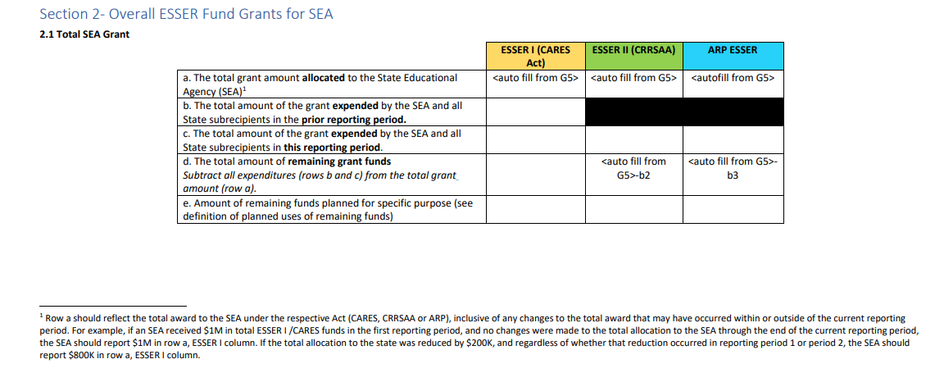
to collect expenditures in prior reporting periods (plural), for CARES, CRRSA and ARP ESSER.
- Revise 2.4b, 2.4d – Total ESSER I SEA Reserve Expenditures in Prior Reporting Periods
- Revise 2.5b, 2.5d to include collection on prior year expenditures of CRRSA funds
- Revise 2.6b, 2.6f to include collection on prior year expenditures of ARP ESSER funds
- Revise 3.b3 to Total ESSER I Expenditures in Prior Reporting Periods (plural)
- Revise 3.b4 and 3.b5 to include collection on prior year expenditures of CRRSA, ARP funds respectively

