2024 Teaching and Learning International Survey
(TALIS 2024) Main Study Recruitment and Field Test

OMB# 1850-0888 v.12 (No changes since v.8)

June 2022

APPENDIX A-1: FIELD TEST RECRUITMENT MATERIALS

TALIS 2024 Field Test State Letter 2
TALIS 2024 Field Test School District Letter 3
TALIS 2024 Field Test School Letter 4
TALIS 2024 Field Test Study Brochure 5
TALIS 2024 Field Test Study Brochure Timeline of Activities 7
TALIS 2024 Field Test School FAQ 8
TALIS 2024 Field Test Teacher FAQ 10
TALIS 2024 Field Test Teacher Brochure – Public and Private Schools 12
TALIS 2024 Field Test Teacher Invite Email – Core TALIS Questionnaire 14
TALIS 2024 Field Test Teacher Invite Email – TKS Questionnaire 15
TALIS 2024 Field Test Summary of Activities for School Coordinators 16
TALIS 2024 Field Test School Letter – Private Schools 17
TALIS 2024 Field Test Study Brochure – Private Schools 18
TALIS 2024 Field Test School FAQ – Private Schools 20
TALIS 2024 Field Test Teacher FAQ – Private Schools 22
TALIS 2024 Field Test Teacher Invite Email – Core TALIS Questionnaire – Private Schools 24
TALIS 2024 Field Test Teacher Invite Email – TKS Questionnaire – Private Schools 25
TALIS 2024 Field Test E-Filing Instructions 26
TALIS 2024 Field Test School Coordinator Communication 34
TALIS 2024 Field Test Respondent Reminders 40
TALIS 2024 School Coordinator Handbook 56
TALIS 2024 MyTALIS.us Website 71
TALIS 2018 School Coordinator WebEx Presentation (will be updated for TALIS 2024) 82
TALIS 2024 Field Test Generic District Application 92

TALIS 2024 Field Test State Letter
[Date]
[Title] [Name First] [Name Last]
[Title/Department]
[State]
[Address 1]
[City], [State] [Zip code]

Dear [Title] [Name Last]:

The United States is participating in an important international study in 2024: TALIS – the Teaching and Learning International Survey of principals and teachers at grades 7, 8, and 9. TALIS provides comparative information about teaching and the teaching profession around the world. This study is coordinated by the Organization for Economic Cooperation and Development (OECD), and 53 countries, including the United States, have committed to participate in TALIS 2024. Some schools in your state have been randomly selected to participate in the TALIS 2024 field test this coming February, and I am writing to ask your agency to support the participation of those schools.

TALIS is the first and only international survey that focuses on teachers, teaching, and learning environments in middle schools and lower secondary schools. It fills important information gaps in the international comparisons of education systems and offers an opportunity for teachers and school principals to have a say in education analysis and policy development in key policy areas. TALIS allows countries to compare themselves with other countries facing similar challenges, and to learn from other policy approaches. This year, the United States will field test an additional module as part of TALIS called the Teacher Knowledge Survey (TKS). This survey will gather information about teachers’ pedagogical decisions in the classroom. The purpose of the field test is to try out new questions to ensure they accurately measure the topics and policy concerns that TALIS is designed to examine and that they successfully capture the views of U.S. teachers.

TALIS is described in more detail in the enclosed materials. The study is conducted in the United States by the National Center for Education Statistics (NCES) in the U.S. Department of Education and is administered by Westat in Rockville, Maryland. The U.S. Office of Management and Budget has approved the data collection under OMB# 1850-0888. For information on the confidentiality of the data collected, please see the enclosed FAQ. While participation in this study is voluntary, we ask your agency to support participation by schools in your state so that the results for the United States are complete and accurate.

Within the next few weeks, a representative of Westat will contact sampled school districts and schools to discuss participating in the field test. We are in contact with your state assessment director and NAEP State Coordinator to try to ensure that we are not conflicting with other state efforts and that districts and schools understand how TALIS fits in with other data collections conducted by NCES. We also coordinate the administration of TALIS with NAEP and other NCES activities. In the meantime, if you have any questions, please do not hesitate to call 1-855-545-1163 or send an email to TALISHELP@westat.com. You may also get more information about this study by contacting Mary Coleman at NCES at 202-245-8382 or Mary.Coleman@ed.gov or by visiting the TALIS website at https://nces.ed.gov/surveys/talis.

Thank you for your time and support.
Sincerely,

Peggy Carr, Ph.D.
Commissioner
cc: [State assessment coordinator name]
Enclosures

The National Center for Education Statistics (NCES) is authorized to conduct the Teaching and Learning International Survey (TALIS) by the Education Sciences Reform Act of 2002 (ESRA 2002, 20 U.S.C. §9543). The data are being collected for NCES by Westat, a U.S.-based research organization. All of the information you provide may be used only for statistical purposes and may not be disclosed, or used, in identifiable form for any other purpose except as required by law (20 U.S.C. §9573 and 6 U.S.C. §151).

TALIS 2024 Field Test School District Letter
[Date]

[Title] [Name First] [Name Last], [Title/Department]
[School District]
[Address 1]
[City], [State] [Zip code]

Dear [Title] [Name Last]:

The United States is participating in an important international study in 2024: TALIS – the Teaching and Learning International Survey of principals and teachers at grades 7, 8, and 9. TALIS provides comparative information about teaching and the teaching profession around the world. This study is coordinated by the Organization for Economic Cooperation and Development (OECD), and 53 countries, including the United States, have committed to participate in TALIS 2024. Some schools in your district have been randomly selected to participate in the TALIS 2024 field test this coming February, and I am writing to ask your agency to support the participation of those schools.

TALIS is the first and only international survey that focuses on teachers, teaching, and learning environments in middle schools and lower secondary schools. It fills important information gaps in the international comparisons of education systems and offers an opportunity for teachers and school principals to have a say in education analysis and policy development in key policy areas. TALIS allows countries to compare themselves with other countries facing similar challenges, and to learn from other policy approaches. This year, the United States will field test an additional module as part of TALIS called the Teacher Knowledge Survey (TKS). This survey will gather additional information about teachers’ pedagogical decisions in the classroom. The purpose of the field test is to try out new questions to ensure they accurately measure the topics and policy concerns that TALIS is designed to examine and that they successfully capture the views of U.S. teachers.

Participating schools will receive $200, and each school’s TALIS school coordinator (school staff person designated to liaise with TALIS staff) will receive $200 as a thank you for their time and effort. Selected teachers will receive $25 for completing the TALIS teacher questionnaire.

TALIS is described in more detail in the enclosed materials. The study is conducted in the United States by the National Center for Education Statistics (NCES) in the U.S. Department of Education and is administered by Westat in Rockville, Maryland. The U.S. Office of Management and Budget has approved the data collection under OMB# 1850-0888. For information on the confidentiality of the data collected, please see the enclosed FAQ. While participation in this study is voluntary, we ask your agency to support participation by schools in your district so that the United States has a representative sample of schools across the country.

Within the next few days, a representative of Westat will contact the following school or schools in your district that have been selected for the field test: [LIST SAMPLED SCHOOLS HERE…].

If you have any questions, please do not hesitate to call 1-855-545-1163 or send an email to TALISHELP@westat.com. You may also get more information about this study by contacting Mary Coleman at NCES at 202-245-8382 or Mary.Coleman@ed.gov or by visiting the TALIS website at https://nces.ed.gov/surveys/talis.

Thank you for your time and support.
Sincerely,

Peggy Carr, Ph.D.
Commissioner
Enclosures

The National Center for Education Statistics (NCES) is authorized to conduct the Teaching and Learning International Survey (TALIS) by the Education Sciences Reform Act of 2002 (ESRA 2002, 20 U.S.C. §9543). The data are being collected for NCES by Westat, a U.S.-based research organization. All of the information you provide may be used only for statistical purposes and may not be disclosed, or used, in identifiable form for any other purpose except as required by law (20 U.S.C. §9573 and 6 U.S.C. §151).

TALIS 2024 Field Test School Letter

[Date]
[Title] [Name First] [Name Last], [Title/Department]
[School District]
[Address 1]
[City], [State] [Zip code]

Dear [Title] [Name Last]:

The United States is participating in an important international study in 2024: TALIS – the Teaching and Learning International Survey of principals and teachers at grades 7, 8, and 9. TALIS provides comparative information about teaching and the teaching profession around the world. This study is coordinated by the Organization for Economic Cooperation and Development (OECD), and 53 countries, including the United States, have committed to participate in TALIS 2024. Your school is one of only 40 across the United States that has been randomly selected to participate in the TALIS 2024 field test this coming February.

TALIS is the first and only international survey that focuses on teachers, teaching, and learning environments in middle schools and lower secondary schools. It fills important information gaps in the international comparisons of education systems and offers an opportunity for teachers and school principals to have a say in education analysis and policy development in key policy areas. TALIS allows countries to compare themselves with other countries facing similar challenges, and to learn from other policy approaches. This year, the United States will field test an additional module as part of TALIS called the Teacher Knowledge Survey (TKS). This survey will gather additional information about teachers’ pedagogical decisions in the classroom. The purpose of the field test is to try out new questions to ensure they accurately measure the topics and policy concerns that TALIS is designed to examine and that they successfully capture the views of U.S. teachers.

Participating schools will receive $200, and each school’s TALIS school coordinator (school staff person designated to liaise with TALIS staff) will receive $200 as a thank you for their time and effort. Selected teachers will receive $25 for completing the TALIS teacher questionnaire.

TALIS is described in more detail in the enclosed materials. The study is conducted in the United States by the National Center for Education Statistics (NCES) in the U.S. Department of Education and is administered by Westat in Rockville, Maryland. The U.S. Office of Management and Budget has approved the data collection under OMB# 1850-0888. For information on the confidentiality of the data collected, please see the enclosed FAQ. I hope you will participate in this voluntary study because it is important that the United States has a nationally representative sample of schools and teachers.

Within the next few days, a representative of Westat will contact you to discuss your participation. If you have any questions, please do not hesitate to call 1-855-545-1163 or send an email to TALISHELP@westat.com. You may also get more information about this study by contacting Mary Coleman at NCES at 202-245-8382 or Mary.Coleman@ed.gov or by visiting the TALIS website at https://nces.ed.gov/surveys/talis.

Your participation in the field test for TALIS 2024 is vital. Thank you for your time and for supporting this important international study.

Sincerely,

Peggy Carr, Ph.D.
Commissioner
Enclosures

The National Center for Education Statistics (NCES) is authorized to conduct the Teaching and Learning International Survey (TALIS) by the Education Sciences Reform Act of 2002 (ESRA 2002, 20 U.S.C. §9543). The data are being collected for NCES by Westat, a U.S.-based research organization. All of the information you provide may be used only for statistical purposes and may not be disclosed, or used, in identifiable form for any other purpose except as required by law (20 U.S.C. §9573 and 6 U.S.C. §151).
TALIS 2024 Field Test Study Brochure

What is TALIS?
The Teaching and Learning International Survey (TALIS) is a survey about teachers, teaching, and learning environments. First conducted in 2008, its main objective is to provide international indicators that will help countries develop well-informed education policy. TALIS offers teachers and principals the opportunity to provide their perspectives on education in the United States. TALIS 2024 will be conducted in spring 2024.

Why is TALIS important?
TALIS is an effort by the United States and other countries to better understand the successes and challenges faced by teachers and school leaders. TALIS fills gaps in our knowledge of teacher and principal working conditions, an area that has been underrepresented in international studies of education. TALIS aims to inform policymakers and educators around the world about shared concerns and promising educational approaches.

What will schools and teachers be asked to do?
TALIS 2024 includes the core TALIS teacher and principal questionnaires that are similar to those used in prior rounds of TALIS, plus a new Teacher Knowledge Survey (TKS). Teachers will complete either the core TALIS or the TKS instrument. The questionnaires are designed to take approximately 45 minutes for principals to complete and approximately 60 minutes for teachers to complete. Questionnaires cover the following topics:
- teacher and principal background and characteristics;
- school leadership and climate, including support for diversity;
- teachers’ instructional approaches and pedagogical practices;
- teacher and principal professional development; and
- teacher appraisal and feedback.

What is TKS?
TKS is a new survey included in TALIS 2024 that investigates the different pedagogical decisions teachers make in the classroom. The main objective of TKS is to gather information to improve the quality of teaching for better student learning by focusing on the following questions:
- How can we improve the selection and retention of teachers?
- How can we improve teacher learning for more effective teaching?
- How can we improve pedagogy for more effective learning?

How will the study be coordinated?
Data collection for this study will be carried out by staff from Westat, under contract with the U.S. Department of Education. Principals are asked to designate a School Coordinator who will liaise with TALIS staff and provide a list of 7th, 8th, and 9th grade teachers; distribute materials to the principal and selected teachers; and encourage the completion of surveys by the deadline. School Coordinators will likely spend an average of 240 minutes on the liaison tasks.

Who will be surveyed?
TALIS focuses on the middle and lower secondary levels: grades 7, 8, and 9 in the United States. Principals and teachers at U.S. schools have been randomly selected to participate.

What is the purpose of the TALIS Field Test in 2023?
TALIS conducts a field test (a small-scale, trial run of the study) in every participating country to see if any of the survey questions are biased because of national, social, or cultural differences. Statistical analyses of principal and teacher responses are also conducted to check for evidence of differences in response across countries that could indicate a linguistic or conceptual translation problem. Survey questions that are found to be problematic are dropped from the survey or treated differently in the analysis. In February 2023, the United States will participate in the TALIS 2024 field test.

What will happen with the collected data?
Data from the field trial will be used to ensure that the surveys accurately measure the topics they are designed to measure and that the views of teachers and school administrators in the U.S. are appropriately represented. After the main study, TALIS data will be used to describe the conditions of teaching and schooling across countries and to develop comparative education indicators. The data provided by principals and teachers may be used only for statistical purposes and may not be disclosed or used in identifiable form for any other purpose except as required by law (20 U.S.C., § 9573 and 6 U.S.C. §151). Reports of the findings from TALIS will not identify participating districts, schools, or individual staff. Individual responses will be combined to produce summary statistics and reports.

Examples of key findings from TALIS 2018
- Most teachers (90 percent) were satisfied with their job, and most (91 percent) did not regret becoming a teacher.
- Acute stress at work was associated with teachers’ job satisfaction and their intention to continue teaching: 18 percent of teachers reported experiencing a lot of stress in their work, and 49 percent reported that having too much administrative work was one of the main sources of stress.
- Teachers who reported that their school provided staff with opportunities to actively participate in school decisions and support their professional development were more likely to say that they were satisfied with the conditions of their employment (apart from salaries).
- In terms of salaries, 39 percent of teachers and 47 percent of principals were satisfied with the pay they received.

SOURCE: OECD. (2020). TALIS 2018 Results (Volume II): Teachers and School Leaders as Valued Professionals. Paris: Author.

TALIS 2024 Participants

TALIS 2024: 53 countries and economies
OECD countries |  |  | Non-Member economies
Australia  Austria  Belgium (Fl., Fr.)  Canada (Alberta)  Chile  Colombia  Costa Rica  Czech Republic  Denmark  Estonia  Finland | France  Hungary  Iceland  Israel  Italy  Japan  Korea  Latvia  Lithuania  Mexico  Netherlands | New Zealand  Norway  Poland  Portugal  Slovak Republic  Slovenia  Spain  Sweden  Turkey  United States | Albania  Azerbaijan  Bahrain  Brazil  Bulgaria  China (Shanghai)  Croatia  Kazakhstan  Kosovo  Montenegro  Morocco | North Macedonia  Romania  Russian Federation  Saudi Arabia  Serbia  Singapore  South Africa  United Arab Emirates  Uzbekistan  Vietnam

For more information
TALIS is sponsored by the Organization for Economic Cooperation and Development (OECD) and managed in the United States by the National Center for Education Statistics (NCES), part of the U.S. Department of Education.

To learn more about TALIS, visit https://nces.ed.gov/surveys/talis and https://www.oecd.org/talis. For questions about TALIS, contact the TALIS Information Hotline at 1-855-545-1163 or email TALISHELP@westat.com.

The National Center for Education Statistics (NCES) is authorized to conduct the Teaching and Learning International Survey (TALIS) by the Education Sciences Reform Act of 2002 (ESRA 2002, 20 U.S.C. §9543). The data are being collected for NCES by Westat, a U.S.-based research organization. All of the information you provide may be used only for statistical purposes and may not be disclosed, or used, in identifiable form for any other purpose except as required by law (20 U.S.C. §9573 and 6 U.S.C. §151). The U.S. Office of Management and Budget has approved this data collection under OMB #1850-0888.

TALIS 2024 Field Test Study Brochure Timeline of Activities

 | Nov–Dec 2022 | January 2023 Pre-survey Contact | February 2023 | Benefits
Principal | - Identify a school coordinator. |  | - Complete an online School Questionnaire on the characteristics of the school. | - Represent other similar U.S. schools.  - Receive U.S. national report with TALIS 2024 results.  - Schools will receive $200 for participating.
Teachers |  |  | - Complete an online Teacher Questionnaire on education and teaching experience. | - Teachers will receive $25 for completing the teacher questionnaire.
School  Coordinator | - Provide a list of eligible teachers to TALIS staff. | - Provide a list of eligible teachers to TALIS staff.  - Notify selected teachers and inform them about the benefits of participating. | - Coordinate the principal’s completion of the school questionnaire.  - Coordinate the teachers’ completion of the teacher questionnaire. | - Receive $200 for time and effort in coordinating the survey.
TALIS Staff | - Provide school with materials explaining TALIS and its importance.  - Work with the school coordinator to construct a list of eligible teachers.  - Protect data collected from the school and teachers. | - Call the school coordinator to discuss survey and teacher participation.  - Select a random sample of eligible teachers to participate.  - Provide online access information for the teacher and school questionnaires to the school coordinator. | - Meet with school coordinator after the assessment.  - Help with any technical issues or other coordination that is required.
Find Out More | https://nces.ed.gov/surveys/talis

TALIS 2024 Field Test School FAQ

Teaching and Learning International Survey
FREQUENTLY ASKED QUESTIONS
Information for Schools

What is TALIS?
TALIS is an international survey of teaching and learning environments. It asks teachers and principals questions about their backgrounds, work environments, professional development, and beliefs and attitudes about teaching. TALIS is unique because it is the only comparative international education study that collects data from nationally representative samples of teachers and their school principals.

TALIS’ main objective is to provide accurate and relevant international indicators on teachers and teaching towards the goal of helping countries review current conditions and develop informed education policy. TALIS offers an opportunity for teachers and school principals to provide their perspectives on the state of education in their own countries, allowing for a global view of teachers and the education systems in which they work. TALIS is being conducted in grades 7, 8, and 9 in the United States.

Why was my school selected for participation?
Schools with varying demographics and in different locales were randomly selected so that the U.S. sample is representative of the overall U.S. school population, both public and private. The random selection process is important for ensuring that a country’s sample accurately reflects its schools and therefore can be compared fairly with samples of schools from other countries.

What will schools and teachers be asked to do?
TALIS 2024 includes the core TALIS teacher and principal questionnaires that are similar to those used in prior rounds of TALIS, plus a new Teacher Knowledge Survey (TKS). Teachers will complete either the core TALIS or the TKS instrument. Questionnaires cover the following topics:
- teacher and principal background and characteristics;
- school leadership and climate, including support for diversity;
- teachers’ instructional approaches and pedagogical practices;
- teacher and principal professional development; and
- teacher appraisal and feedback.

What is TKS?
TKS is a new survey included in TALIS 2024 that investigates the different pedagogical decisions teachers make in the classroom. The main objective of TKS is to gather information to improve the quality of teaching for better student learning by focusing on the following questions:
- How can we improve the selection and retention of teachers?
- How can we improve teacher learning for more effective teaching?
- How can we improve pedagogy for more effective learning?

How long do the questionnaires take to complete?
The principal and teacher questionnaires are designed to be completed within 45 minutes and 60 minutes, respectively, including the time it may take to read instructions and gather the needed information.

Will all teachers in the school be asked to participate?
It depends on the number of teachers in the school. The study requires a random sample of up to 35 teachers who teach at least one class/course to 7th, 8th, or 9th graders in each school, regardless of subject matter. In schools with 35 or fewer eligible teachers, all teachers who teach at target grades will be asked to participate.

What is the field test for?
Field tests are a critical part of the development of survey questions for international studies like TALIS. Field tests (small-scale, trial runs of a survey) allow survey developers to try out new questions to determine their performance when administered to principals and teachers around the world. The results of the U.S. field test will help developers to eliminate wording or topics in the survey questions that do not perform well or show what they are intended to measure.

Who conducts the study?
The study will be undertaken by trained staff from Westat under contract to the National Center for Education Statistics (NCES) in the U.S. Department of Education. NCES is authorized to conduct this study by the Education Sciences Reform Act of 2002 (20 U.S. Code, Section 9543). The U.S. Office of Management and Budget has approved this data collection under OMB# 1850-0888.

When will the field test be conducted?
The field test will be conducted in February 2023. Both the principal and selected teachers will receive instructions on how to complete the questionnaires. To make responding easier, the questionnaires will be available online, although a paper-based version will also be available.

What will happen with the collected data?
The data from the questionnaires will be used to document the conditions of teaching and schooling that may be related to student learning and to develop comparative education indicators geared toward informing policy discussions about teachers and teaching. The data provided by schools and staff may be used only for statistical purposes and may not be disclosed, or used, in identifiable form for any other purpose except as required by law (20 U.S.C. §9573 and 6 U.S.C. §151). Reports of the findings from TALIS will not identify participating districts, schools, or individual staff. Individual responses will be combined with those from other participants to produce summary statistics and reports.

Is participation required by federal law?
No. School and teacher participation is voluntary. However, we hope you will participate in this study so that the principal and teachers like those in your school are accurately and fairly represented.

How will the study be coordinated in my school?
Schools are asked to designate a School Coordinator to distribute materials and gather information. The School Coordinator will be the main contact at the school through whom Westat will communicate. There is no need for contractor staff to visit the school. The School Coordinator is asked to complete a sampling form listing eligible teachers of 7th, 8th, or 9th graders, distribute information materials to the selected teachers, provide the principal and teachers with the questionnaires or login/password information for the online surveys, and to encourage the completion of the surveys by the agreed upon deadline. School Coordinators will likely spend an average of 240 minutes on the liaison tasks. The School Coordinator can be a teacher or any school staff member (e.g., office administrator).

TALIS 2024 Field Test Teacher FAQ

Teaching and Learning International Survey
FREQUENTLY ASKED QUESTIONS
Information for Teachers

What is TALIS?
TALIS is an international survey of teaching and learning environments. It asks teachers and principals questions about their backgrounds, work environments, professional development, and beliefs and attitudes about teaching. TALIS is unique because it is the only comparative international education study that collects data from nationally representative samples of teachers and their school principals.

TALIS’ main objective is to provide accurate and relevant international indicators on teachers and teaching towards the goal of helping countries review current conditions and develop informed education policy. TALIS offers an opportunity for teachers and school principals to provide their perspectives on the state of education in their own countries, allowing for a global view of teachers and the education systems in which they work. TALIS is being conducted in grades 7, 8, and 9 in the United States.

What role do teachers have in TALIS?
Teachers are the main source of information for TALIS. TALIS gives you an opportunity to provide information that is critical to understanding the conditions and activities of teaching in your school as well as to voice your perspectives on teaching and learning at your school.

TALIS 2024 includes the core TALIS teacher questionnaire that is similar to what was used in prior rounds of TALIS, plus a new Teacher Knowledge Survey (TKS). Teachers will complete either the core TALIS or the TKS instrument. Questionnaires cover the following topics:
- teacher background and characteristics;
- teachers’ instructional approaches and pedagogical practices;
- teacher professional development; and
- teacher appraisal and feedback.

What is TKS?
TKS is a new survey included in TALIS 2024 that investigates the different pedagogical decisions teachers make in the classroom. The main objective of TKS is to gather information to improve the quality of teaching for better student learning by focusing on the following questions:
- How can we improve the selection and retention of teachers?
- How can we improve teacher learning for more effective teaching?
- How can we improve pedagogy for more effective learning?

How was I selected to complete a questionnaire?
The TALIS school coordinator in your school (the person designated by your school principal to communicate with TALIS staff) provided a list of all teachers who teach any students in grades 7, 8, or 9. You are one of up to 35 teachers from your school who were selected to participate. Your participation in TALIS is vital to assure that your views are represented.

How long will it take to complete the questionnaire?
The teacher questionnaire will take approximately 60 minutes to complete online.

How can I access the questionnaire?
To access the questionnaire (https://portal.mytalisusa.com/TeacherQuestionnaire), you will need to have an internet connection, a suitable internet browser (see the list below), and your login credentials. You will be emailed a unique hyperlink that you can click on to access the questionnaire directly. The TALIS staff are ready to work with you to make access and completion of the teacher questionnaire as easy and efficient as possible.

The following browsers are supported by TALIS and can be downloaded for free if you do not already have them installed on the computer:

• Firefox: Version [X] and above
• Microsoft Edge: Version [X] and above
• Google Chrome: Version [X] and above
• Safari (Mac version): Version [X] and above

What will be done with the information you collect from me?
Your responses to the questionnaire will be combined with those from other participating teachers across the United States to produce summary statistics and reports. Data from the field trial are collected to ensure the surveys accurately measure the topics they are designed to measure and that the views of teachers and school administrators are appropriately represented. By law, data provided by schools and staff may be used only for statistical purposes and may not be disclosed, or used, in identifiable form for any other purpose except as required by law [20 U.S.C. §9573 and 6 U.S.C. §151]. Reports of the findings will not identify participating districts, students, or individual staff. For a recent example of how TALIS data are reported, please visit https://nces.ed.gov/surveys/talis/talis2018/.

Where can I go for help or technical support?
If you have any questions or experience any difficulties, please contact the TALIS U.S. home office at
1-855-545-1163 or email TALISHELP@westat.com.

For more information on TALIS, including results from previous data collections, please visit the TALIS website at https://nces.ed.gov/surveys/talis.

TALIS 2024 Field Test Teacher Brochure – Public and Private Schools

Front Page
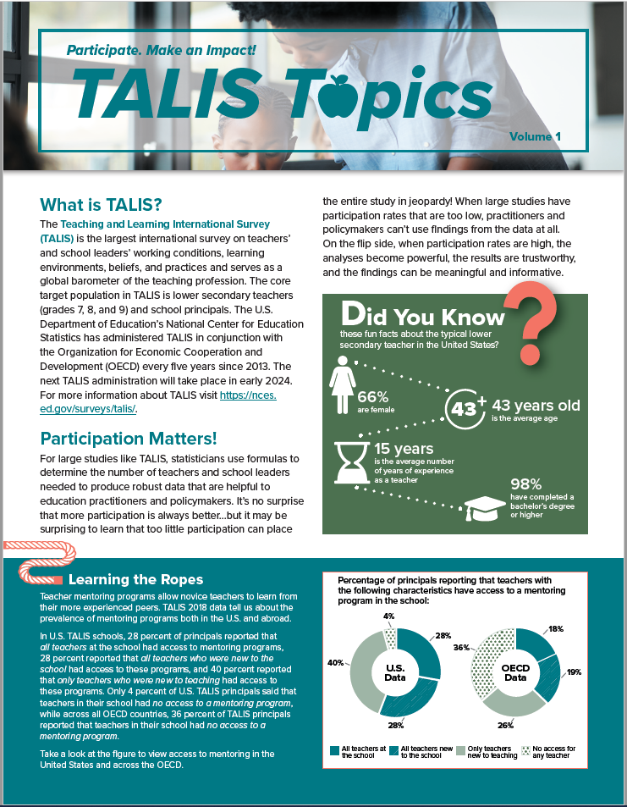
Back Page
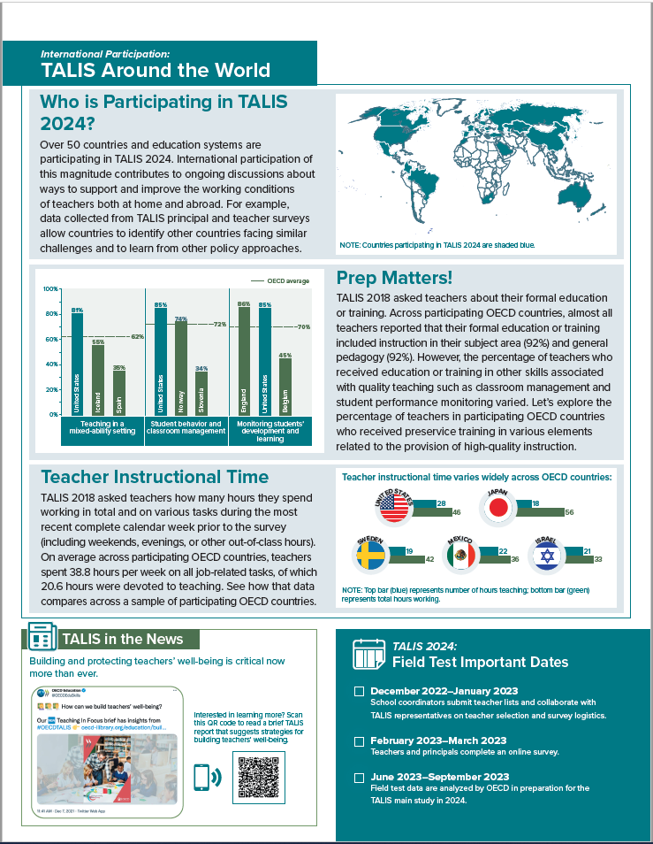

TALIS 2024 Field Test Teacher Invite Email – Core TALIS Questionnaire

[Month, Day,] 2023

Dear [Teacher Name]:

The United States is participating in an important international study in 2024: TALIS – the Teaching and Learning International Survey of principals and teachers at grades 7, 8, and 9. TALIS provides comparative information about teaching and the teaching profession around the world, with 53 countries participating in 2024.

Your school is one of 40 schools across the United States that are taking part in the TALIS field test, and you’ve been selected to participate by completing an online teacher questionnaire about your background and teaching experience, teaching practices, and the learning environment at your school.

The questionnaire takes about 60 minutes to complete. This information, combined with responses from school principals, helps to provide a more complete understanding of the teaching profession and the contexts for learning. Reports of the TALIS findings will not identify participating districts, students, or individual staff.

You will receive $25 as a thank you for completing the questionnaire, if allowed by your school’s policy. Use the provided link and unique account information below to complete your questionnaire.
Link: https://portal.mytalisusa.com/TeacherQuestionnaire
Username: [username]
Password: [password]
TALIS is conducted in the United States by the National Center for Education Statistics (NCES) in the U.S. Department of Education. The data collection is carried out by Westat in Rockville, Maryland, on behalf of NCES. The U.S. Office of Management and Budget has approved the data collection under OMB# 1850-0888. For more detailed information, please see the attached FAQ.
If you have any questions, please do not hesitate to call 1-855-545-1163 or send an email to TALISHELP@westat.com.
You may also get more information about this study by visiting the TALIS website at https://nces.ed.gov/surveys/talis.
Thank you for your time and for supporting this important international study.
Sincerely,
The TALIS USA Team
The National Center for Education Statistics (NCES) is authorized to conduct the Teaching and Learning International Survey (TALIS) by the Education Sciences Reform Act of 2002 (ESRA 2002, 20 U.S.C. §9543). The data are being collected for NCES by Westat, a U.S.-based research organization. All of the information you provide may be used only for statistical purposes and may not be disclosed, or used, in identifiable form for any other purpose except as required by law (20 U.S.C. §9573 and 6 U.S.C. §151).

TALIS 2024 Field Test Teacher Invite Email – TKS Questionnaire

[Month, Day,] 2023

Dear [Teacher Name]:

The United States is participating in an important international study in 2024: TALIS – the Teaching and Learning International Survey of principals and teachers of students in grades 7, 8, and 9. TALIS provides comparative information about teaching and the teaching profession around the world, with 53 countries participating in 2024. The United States will participate in the Teacher Knowledge Survey (TKS), a new TALIS module.

Your school is one of 40 schools across the United States that are taking part in the TKS field test, and you’ve been selected to participate by completing an online teacher questionnaire about your background, teaching experience, instructional approaches, and pedagogical decisions.

The questionnaire takes about 60 minutes to complete. This information, combined with responses from school principals, helps to provide a more complete understanding of the teaching profession and the contexts for learning. Reports of the TALIS and TKS findings will not identify participating districts, students, or individual staff.

You will receive $25 as a thank you for completing the questionnaire, if allowed by your school’s policy. Use the provided link and unique account information below to complete your questionnaire.
Link: https://portal.mytalisusa.com/TeacherQuestionnaire
Username: [username]
Password: [password]
TALIS is conducted in the United States by the National Center for Education Statistics (NCES) in the U.S. Department of Education. The data collection is carried out by Westat in Rockville, Maryland, on behalf of NCES. The U.S. Office of Management and Budget has approved the data collection under OMB# 1850-0888. For more detailed information, please see the attached FAQ.
If you have any questions, please do not hesitate to call 1-855-545-1163 or send an email to TALISHELP@westat.com.
You may also get more information about this study by visiting the TALIS website at https://nces.ed.gov/surveys/talis.
Thank you for your time and for supporting this important international study.
Sincerely,
The TALIS USA Team
The National Center for Education Statistics (NCES) is authorized to conduct the Teaching and Learning International Survey (TALIS) by the Education Sciences Reform Act of 2002 (ESRA 2002, 20 U.S.C. §9543). The data are being collected for NCES by Westat, a U.S.-based research organization. All of the information you provide may be used only for statistical purposes and may not be disclosed, or used, in identifiable form for any other purpose except as required by law (20 U.S.C. §9573 and 6 U.S.C. §151).

TALIS 2024 Field Test Summary of Activities for School Coordinators

Summary of TALIS Activities for School Coordinators

What will be asked of the School Coordinator?

Upon the school’s agreement to participate, TALIS staff will work with the School Coordinator to:

Provide a list of eligible teachers at grades 7, 8, and 9 (depending on the grades included in the school). The School Coordinator will receive instructions for preparing and submitting the teacher listing form. The teacher listing form will be used to randomly select teachers for participation in the study.
Distribute informational materials to the school principal and selected teachers, encouraging their participation in the study.
Distribute the principal and teacher questionnaires. The School Coordinator will be mailed the principal and teacher questionnaires and asked to distribute them to the school principal and selected teachers. Since the questionnaires will also be made available online, TALIS staff will work with the School Coordinator to determine the need for paper-based versions of the survey instruments.
Encourage the participation of the school principal and selected teachers in the study. To thank everyone for their time and effort, the school will receive $200.00 upon completion of the principal questionnaire, and each teacher will receive $25.00 upon completion of their questionnaire.
As a thank you for his/her time and effort, the School Coordinator will receive $200 upon successful completion of the study in the school.

Please feel free to contact TALIS with any questions via e-mail at TALISHELP@westat.com or by
calling 1-855-545-1163.

TALIS 2024 Field Test School Letter – Private Schools
[Date]
[Title] [Name First] [Name Last], [Title/Department]
[School District]
[Address 1]
[City], [State] [Zip code]

Dear [Title] [Name Last]:

The United States is participating in an important international study in 2024: TALIS – the Teaching and Learning International Survey of principals and teachers at grades 7, 8, and 9. TALIS provides comparative information about teaching and the teaching profession around the world. This study is coordinated by the Organization for Economic Cooperation and Development (OECD), and 53 countries, including the United States, have committed to participate in TALIS 2024. Your school is one of only 40 across the United States that has been randomly selected to participate in the TALIS 2024 field test this coming February.

TALIS is the first and only international survey that focuses on teachers, teaching, and learning environments in middle schools and lower secondary schools. It fills important information gaps in the international comparisons of education systems and offers an opportunity for teachers and school principals to have a say in education analysis and policy development in key policy areas. TALIS allows countries to compare themselves with other education systems facing similar challenges, and to learn from other policy approaches. This year, the United States will field test a new module as part of TALIS called the Teacher Knowledge Survey (TKS). This survey will gather additional information about teachers’ pedagogical decisions in the classroom. The purpose of the field test is to try out new questions to ensure they accurately measure the topics and policy concerns that TALIS is designed to examine and that they successfully capture the views of U.S. teachers.

I’m writing to ask that you encourage the teachers in your school to participate in TALIS, as every teacher who completes the survey plays an important role in representing other teachers and schools that are similar. It’s vital that teachers in every kind of education system—including private schools—participate in TALIS to ensure the U.S. sample is an accurate reflection of what teaching and learning looks like across the country. This information provides unique insight on the conditions of and activities relating to teaching in your school. But bigger than that, by taking part in TALIS, they will be contributing to a global, collaborative conversation about how factors like learning environments, professional development, school leadership, and job satisfaction impact teaching practice around the world.

Participating schools will receive $200, and each school’s TALIS school coordinator (school staff person designated to liaise with TALIS staff) will receive $200 as a thank you for their time and effort. Selected teachers will receive $25 for completing the TALIS teacher questionnaire.

TALIS is described in more detail in the enclosed materials. The study is conducted in the United States by the National Center for Education Statistics (NCES) in the U.S. Department of Education and is administered by Westat, a firm headquartered in Rockville, Maryland. The U.S. Office of Management and Budget has approved the data collection under OMB# 1850-0888. For information on the confidentiality of the data collected, please see the enclosed FAQ. I hope you will participate in this voluntary study because it is important that the United States has a nationally representative sample of schools and teachers.

Within the next few days, a representative of Westat will contact you to discuss your participation. If you have any questions, please do not hesitate to call 1-855-545-1163 or send an email to TALISHELP@westat.com. You may also get more information about this study by contacting Mary Coleman at NCES at 202-245-8382 or Mary.Coleman@ed.gov or by visiting the TALIS website at https://nces.ed.gov/surveys/talis.

Your participation in the field test for TALIS 2024 is vital. Thank you for your time and for supporting this important international study.

Sincerely,

Peggy Carr, Ph.D.
Commissioner
Enclosures

The National Center for Education Statistics (NCES) is authorized to conduct the Teaching and Learning International Survey (TALIS) by the Education Sciences Reform Act of 2002 (ESRA 2002, 20 U.S.C. §9543). The data are being collected for NCES by Westat, a U.S.-based research organization. All of the information you provide may be used only for statistical purposes and may not be disclosed, or used, in identifiable form for any other purpose except as required by law (20 U.S.C. §9573 and 6 U.S.C. §151).
TALIS 2024 Field Test Study Brochure – Private Schools

What is TALIS?
The Teaching and Learning International Survey (TALIS) is a survey about teachers, teaching, and learning environments. First conducted in 2008, its main objective is to provide international indicators that will help countries develop well-informed education policy. TALIS offers teachers and principals the opportunity to provide their perspectives on education in the United States. TALIS 2024 will be conducted in the spring of 2024.

Why is TALIS important?
TALIS is an effort by the United States and other countries to better understand the successes and challenges faced by teachers and school leaders. TALIS fills gaps in our knowledge of teacher and principal working conditions, an area that has been underrepresented in international studies of education. TALIS aims to inform policymakers and educators around the world about shared concerns and promising educational approaches.

Why should private schools participate?
It’s vital that teachers in every kind of education system, including private and parochial schools, participate in TALIS to ensure the U.S. sample is an accurate reflection of what teaching and learning looks like across the country. The perspectives and opinions of educators in private school environments provide unique and valuable insight on key factors like professional development opportunities, school leadership, mechanisms for feedback, and job satisfaction that are essential to the larger, global conversation about teaching practice and educational progress.

What will schools and teachers be asked to do?
TALIS 2024 includes the core TALIS teacher and principal questionnaires that are similar to those used in prior rounds of TALIS, plus a new Teacher Knowledge Survey (TKS). Teachers will complete either the core TALIS or the TKS instrument. The questionnaires are designed to take approximately 45 minutes for principals to complete and approximately 60 minutes for teachers to complete. Questionnaires cover the following topics:
- teacher and principal background and characteristics;
- school leadership and climate, including support for diversity;
- teachers’ instructional approaches and pedagogical practices;
- teacher and principal professional development; and
- teacher appraisal and feedback.

What is TKS?
TKS is a new survey included in TALIS 2024 that investigates the different pedagogical decisions teachers make in the classroom. The main objective of TKS is to gather information to improve the quality of teaching for better student learning by focusing on the following questions:
- How can we improve the selection and retention of teachers?
- How can we improve teacher learning for more effective teaching?
- How can we improve pedagogy for more effective learning?

How will the study be coordinated?
Data collection for this study will be carried out by staff from Westat, under contract with the U.S. Department of Education. Principals are asked to designate a School Coordinator who will liaise with TALIS staff and provide a list of 7th, 8th, and 9th grade teachers; distribute materials to the principal and selected teachers; and encourage the completion of surveys by the deadline. School Coordinators will likely spend an average of 240 minutes on the liaison tasks.

Who will be surveyed?
TALIS focuses on the middle and lower secondary levels: grades 7, 8, and 9 in the United States. Principals and teachers at U.S. schools have been randomly selected to participate.

What is the purpose of the TALIS Field Test in 2023?
TALIS conducts a field test (a small-scale, trial run of the study) in every participating country to see if any of the survey questions are biased because of national, social, or cultural differences. Statistical analyses of principal and teacher responses are also conducted to check for evidence of differences in response across countries that could indicate a linguistic or conceptual translation problem. Survey questions that are found to be problematic are dropped from the survey or treated differently in the analysis. In February 2023, the United States will participate in the TALIS 2024 field test.

What will happen with the collected data?
Data from the field trial will be used to ensure that the surveys accurately measure the topics they are designed to measure and that the views of teachers and school administrators in the U.S. are appropriately represented. After the main study, TALIS data will be used to describe the conditions of teaching and schooling across countries and to develop comparative education indicators. The data provided by principals and teachers may be used only for statistical purposes and may not be disclosed or used in identifiable form for any other purpose except as required by law (20 U.S.C., § 9573 and 6 U.S.C. §151). Reports of the findings from TALIS will not identify participating districts, schools, or individual staff. Individual responses will be combined to produce summary statistics and reports.

Examples of key findings from TALIS 2018
- Most teachers (90 percent) were satisfied with their job, and most (91 percent) did not regret becoming a teacher.
- Acute stress at work was associated with teachers’ job satisfaction and their intention to continue teaching: 18 percent of teachers reported experiencing a lot of stress in their work, and 49 percent reported that having too much administrative work was one of the main sources of stress.
- Teachers who reported that their school provided staff with opportunities to actively participate in school decisions and support their professional development were more likely to say that they were satisfied with the conditions of their employment (apart from salaries).
- In terms of salaries, 39 percent of teachers and 47 percent of principals were satisfied with the pay they received.

SOURCE: OECD. (2020). TALIS 2018 Results (Volume II): Teachers and School Leaders as Valued Professionals. Paris: Author.

TALIS 2024: Participants

TALIS 2024: 53 countries and economies
OECD countries |  |  | Non-Member economies
Australia  Austria  Belgium (Fl., Fr.)  Canada (Alberta)  Chile  Colombia  Costa Rica  Czech Republic  Denmark  Estonia  Finland | France  Hungary  Iceland  Israel  Italy  Japan  Korea  Latvia  Lithuania  Mexico  Netherlands | New Zealand  Norway  Poland  Portugal  Slovak Republic  Slovenia  Spain  Sweden  Turkey  United States | Albania  Azerbaijan  Bahrain  Brazil  Bulgaria  China (Shanghai)  Croatia  Kazakhstan  Kosovo  Montenegro  Morocco | North Macedonia  Romania  Russian Federation  Saudi Arabia  Serbia  Singapore  South Africa  United Arab Emirates  Uzbekistan  Vietnam

For more information
TALIS is sponsored by the Organization for Economic Cooperation and Development (OECD) and managed in the United States by the National Center for Education Statistics (NCES), part of the U.S. Department of Education.

To learn more about TALIS, visit https://nces.ed.gov/surveys/talis and https://www.oecd.org/talis. For questions about TALIS, contact the TALIS Information Hotline at 1-855-545-1163 or email TALISHELP@westat.com.

The National Center for Education Statistics (NCES) is authorized to conduct the Teaching and Learning International Survey (TALIS) by the Education Sciences Reform Act of 2002 (ESRA 2002, 20 U.S.C. §9543). The data are being collected for NCES by Westat, a U.S.-based research organization. All of the information you provide may be used only for statistical purposes and may not be disclosed, or used, in identifiable form for any other purpose except as required by law (20 U.S.C. §9573 and 6 U.S.C. §151). The U.S. Office of Management and Budget has approved this data collection under OMB #1850-0888.
TALIS 2024 Field Test School FAQ – Private Schools

Teaching and Learning International Survey
FREQUENTLY ASKED QUESTIONS
Information for Schools

What is TALIS?
TALIS is an international survey of teaching and learning environments. It asks teachers and principals questions about their backgrounds, work environments, professional development, and beliefs and attitudes about teaching. TALIS is unique because it is the only comparative international education study that collects data from nationally representative samples of teachers and their school principals.

TALIS’ main objective is to provide accurate and relevant international indicators on teachers and teaching towards the goal of helping countries review current conditions and develop informed education policy. TALIS offers an opportunity for teachers and school principals to provide their perspectives on the state of education in their own countries, allowing for a global view of teachers and the education systems in which they work. TALIS is being conducted in grades 7, 8, and 9 in the United States.

Why was my school selected for participation?
Schools with varying demographics and in different locales were randomly selected so that the U.S. sample is representative of the overall U.S. school population, both public and private. The random selection process is important for ensuring that a country’s sample accurately reflects its schools and therefore can be compared fairly with samples of schools from other countries.

Why is it important for my school to take part?
Every teacher who completes the TALIS survey plays an important role in representing other teachers and schools that are similar. The perspectives and opinions of educators in private schools provide unique and valuable insight that, when combined with contributions from public school teachers, paints a more comprehensive picture of what teaching and learning looks like in different classrooms and school environments across the United States.

What will schools and teachers be asked to do?
TALIS 2024 includes the core TALIS teacher and principal questionnaires that are similar to those used in prior rounds of TALIS, plus a new Teacher Knowledge Survey (TKS). Teachers will complete either the core TALIS or the TKS instrument. Questionnaires cover the following topics:
- teacher and principal background and characteristics;
- school leadership and climate, including support for diversity;
- teachers’ instructional approaches and pedagogical practices;
- teacher and principal professional development; and
- teacher appraisal and feedback.

What is TKS?
TKS is a new survey included in TALIS 2024 that investigates the different pedagogical decisions teachers make in the classroom. The main objective of TKS is to gather information to improve the quality of teaching for better student learning by focusing on the following questions:
- How can we improve the selection and retention of teachers?
- How can we improve teacher learning for more effective teaching?
- How can we improve pedagogy for more effective learning?

How long do the questionnaires take to complete?
The principal and teacher questionnaires are designed to be completed within 45 minutes and 60 minutes, respectively, including the time it may take to read instructions and gather the needed information.

Will all teachers in the school be asked to participate?
It depends on the number of teachers in the school. The study requires a random sample of up to 35 teachers who teach at least one class/course to 7th, 8th, or 9th graders in each school, regardless of subject matter. In schools with 35 or fewer eligible teachers, all teachers who teach at target grades will be asked to participate.

What is the field test for?
Field tests are a critical part of the development of survey questions for international studies like TALIS. Field tests (small-scale, trial runs of a survey) allow survey developers to try out new questions to determine their performance when administered to principals and teachers around the world. The results of the U.S. field test will help developers to eliminate wording or topics in the survey questions that do not perform well or show what they are intended to measure.

Who conducts the study?
The study will be undertaken by trained staff from Westat under contract to the National Center for Education Statistics (NCES) in the U.S. Department of Education. NCES is authorized to conduct this study by the Education Sciences Reform Act of 2002 (ESRA 2002, 20 U.S.C. §9543). The U.S. Office of Management and Budget has approved this data collection under OMB# 1850-0888.

When will the field test be conducted?
The field test will be conducted in February 2023. Both the principal and selected teachers will receive instructions on how to complete the questionnaires. To make responding easier, the questionnaires will be available online, although a paper-based version will also be available.

What will happen with the collected data?
The data from the questionnaires will be used to document the conditions of teaching and schooling that may be related to student learning and to develop comparative education indicators geared toward informing policy discussions about teachers and teaching. The data provided by school staff may be used only for statistical purposes and may not be disclosed, or used, in identifiable form for any other purpose except as required by law (20 U.S.C. §9573 and 6 U.S.C. §151). Reports of the findings from TALIS will not identify participating districts, schools, students, or individual staff. Individual responses will be combined with those from other participants to produce summary statistics and reports.

Is participation required by federal law?
No. School and teacher participation is voluntary. However, we hope you will participate in this study so that the principal and teachers like those in your school are accurately and fairly represented.

How will the study be coordinated in my school?
Schools are asked to designate a School Coordinator to distribute materials and gather information. The School Coordinator will be the main contact at the school through whom Westat will communicate. There is no need for contractor staff to visit the school. The School Coordinator is asked to complete a sampling form listing eligible teachers of 7th, 8th, or 9th graders, distribute information materials to the selected teachers, provide the principal and teachers with the questionnaires or login/password information for the online surveys, and to encourage the completion of the surveys by the agreed upon deadline. School Coordinators will likely spend an average of 240 minutes on the liaison tasks. The School Coordinator can be a teacher or any school staff member (e.g., office administrator).

TALIS 2024 Field Test Teacher FAQ – Private Schools

Teaching and Learning International Survey
FREQUENTLY ASKED QUESTIONS
Information for Teachers

What is TALIS?
TALIS is an international survey of teaching and learning environments. It asks teachers and principals questions about their backgrounds, work environments, professional development, and beliefs and attitudes about teaching. TALIS is unique because it is the only comparative international education study that collects data from nationally representative samples of teachers and their school principals.

TALIS’ main objective is to provide accurate and relevant international indicators on teachers and teaching towards the goal of helping countries review current conditions and develop informed education policy. TALIS offers an opportunity for teachers and school principals to provide their perspectives on the state of education in their own countries, allowing for a global view of teachers and the education systems in which they work. TALIS is being conducted in grades 7, 8, and 9 in the United States.

What role do teachers have in TALIS?
Teachers are the main source of information for TALIS. TALIS gives you an opportunity to provide information that is critical to understanding the conditions and activities of teaching in your school as well as to voice your perspectives on teaching and learning at your school.

TALIS 2024 includes the core TALIS teacher questionnaire that is similar to what was used in prior rounds of TALIS, plus a new Teacher Knowledge Survey (TKS). Teachers will complete either the core TALIS or the TKS instrument. Questionnaires cover the following topics:
- teacher background and characteristics;
- teachers’ instructional approaches and pedagogical practices;
- teacher professional development; and
- teacher appraisal and feedback.

What is TKS?
TKS is a new survey included in TALIS 2024 that investigates the different pedagogical decisions teachers make in the classroom. The main objective of TKS is to gather information to improve the quality of teaching for better student learning by focusing on the following questions:
- How can we improve the selection and retention of teachers?
- How can we improve teacher learning for more effective teaching?
- How can we improve pedagogy for more effective learning?

How was I selected to take the TALIS teacher questionnaire?
The TALIS school coordinator in your school (the person designated by your school principal to communicate with TALIS staff) provided a list of all teachers who teach any students in grades 7, 8, or 9. You are one of up to 35 teachers from your school who were selected to participate. Your participation in TALIS is vital to assure that your views are represented.

How long will it take to complete the questionnaire?
The teacher questionnaire will take approximately 60 minutes to complete online.

How can I access the questionnaire?
To access the questionnaire (https://portal.mytalisusa.com/TeacherQuestionnaire), you will need to have an internet connection, a suitable internet browser (see the list below), and your login credentials. You will be emailed a unique hyperlink that you can click on to access the questionnaire directly. The TALIS staff are ready to work with you to make access and completion of the teacher questionnaire as easy and efficient as possible.

The following browsers are supported by TALIS and can be downloaded for free if you do not already have them installed on the computer:
• Firefox: Version [X] and above
• Microsoft Edge: Version [X] and above
• Google Chrome: Version [X] and above
• Safari (Mac version): Version [X] and above

What will be done with the information you collect from me?
Your responses to the questionnaire will be combined with those from other participating teachers across the United States to produce summary statistics and reports. Data from the field trial are collected to ensure the surveys accurately measure the topics they are designed to measure and that the views of teachers and school administrators are appropriately represented. By law, data provided by schools and staff may be used only for statistical purposes and may not be disclosed, or used, in identifiable form for any other purpose except as required by law [20 U.S.C. §9573 and 6 U.S.C. §151]. Reports of the findings will not identify participating districts, students, or individual staff. For a recent example of how TALIS data are reported, please visit https://nces.ed.gov/surveys/talis/talis2018/.

Where can I go for help or technical support?
If you have any questions or experience any difficulties, please contact the TALIS U.S. home office at
1-855-545-1163 or email TALISHELP@westat.com.

For more information on TALIS, including results from previous data collections, please visit the TALIS website at https://nces.ed.gov/surveys/talis.

TALIS 2024 Field Test Teacher Invite Email – Core TALIS Questionnaire – Private Schools

[Month, Day,] 2023

Dear [Teacher Name]:

The United States is participating in an important international study in 2024: TALIS – the Teaching and Learning International Survey of principals and teachers at grades 7, 8, and 9. TALIS provides comparative information about teaching and the teaching profession around the world, with 53 countries participating in 2024.

Your school is one of 40 schools across the United States that are taking part in the TALIS field test, and you’ve been selected to participate by completing an online teacher questionnaire about your background and teaching experience, teaching practices, and the learning environment at your school.

The questionnaire takes about 60 minutes to complete. This information, combined with responses from school principals, helps to provide a more complete understanding of the teaching profession and the contexts for learning. Reports of the TALIS findings will not identify participating districts, students, or individual staff.

You will receive $25 as a thank you for completing the questionnaire, if allowed by your school’s policy. Use the provided link and unique account information below to complete your questionnaire.

Link: https://portal.mytalisusa.com/TeacherQuestionnaire
Username: [username]
Password: [password]

Though your participation in TALIS is voluntary, every teacher who completes the survey plays an important role in representing other teachers and schools that are similar. It’s vital that teachers in every kind of education system—including private and parochial schools—participate in TALIS to ensure the U.S. sample is an accurate reflection of what teaching and learning looks like across the country. The information you provide combined with responses from other teachers and principals provides unique insight on the conditions of and activities relating to teaching in your school. But bigger than that, by taking part in TALIS, you have the opportunity to share your perspective and contribute to a global conversation about how factors like learning environments, professional development, school leadership, and job satisfaction impact teaching practice around the world. Your participation is valuable and appreciated.

TALIS is conducted in the United States by the National Center for Education Statistics (NCES) in the U.S. Department of Education. The data collection is carried out by Westat in Rockville, Maryland, on behalf of NCES. The U.S. Office of Management and Budget has approved the data collection under OMB# 1850-0888. For more detailed information, please see the attached FAQ.

If you have any questions, please do not hesitate to call 1-855-545-1163 or send an email to TALISHELP@westat.com.

You may also get more information about this study by visiting the TALIS website at https://nces.ed.gov/surveys/talis.

Thank you for your time and for supporting this important international study.

Sincerely,

The TALIS USA Team

The National Center for Education Statistics (NCES) is authorized to conduct the Teaching and Learning International Survey (TALIS) by the Education Sciences Reform Act of 2002 (ESRA 2002, 20 U.S.C. §9543). The data are being collected for NCES by Westat, a U.S.-based research organization. All of the information you provide may be used only for statistical purposes and may not be disclosed, or used, in identifiable form for any other purpose except as required by law (20 U.S.C. §9573 and 6 U.S.C. §151).

TALIS 2024 Field Test Teacher Invite Email – TKS Questionnaire – Private Schools

[Month, Day,] 2023

Dear [Teacher Name]:

The United States is participating in an important international study in 2024: TALIS – the Teaching and Learning International Survey of principals and teachers of students in grades 7, 8, and 9. TALIS provides comparative information about teaching and the teaching profession around the world, with 53 countries participating in 2024. The United States will participate in the Teacher Knowledge Survey (TKS), a new TALIS module.

Your school is one of 40 schools across the United States that are taking part in the TALIS field test, and you’ve been selected to participate by completing an online teacher questionnaire about your background, teaching experience, instructional approaches, and pedagogical decisions.

The questionnaire takes about 60 minutes to complete. This information, combined with responses from school principals, helps to provide a more complete understanding of the teaching profession and the contexts for learning. Reports of the TALIS findings will not identify participating districts, students, or individual staff.

You will receive $25 as a thank you for completing the questionnaire, if allowed by your school’s policy. Use the provided link and unique account information below to complete your questionnaire.

Link: https://portal.mytalisusa.com/TeacherQuestionnaire
Username: [username]
Password: [password]

Though your participation in TALIS is voluntary, every teacher who completes the survey plays an important role in representing other teachers and schools that are similar. It’s vital that teachers in every kind of education system—including private and parochial schools—participate in TALIS to ensure the U.S. sample is an accurate reflection of what teaching and learning looks like across the country. The information you provide combined with responses from other teachers and principals provides unique insight on the conditions of and activities relating to teaching in your school. But bigger than that, by taking part in TALIS, you have the opportunity to share your perspective and contribute to a global conversation about how factors like learning environments, professional development, school leadership, and job satisfaction impact teaching practice around the world. Your participation is valuable and appreciated.

TALIS is conducted in the United States by the National Center for Education Statistics (NCES) in the U.S. Department of Education. The data collection is carried out by Westat in Rockville, Maryland, on behalf of NCES. The U.S. Office of Management and Budget has approved the data collection under OMB# 1850-0888. For more detailed information, please see the attached FAQ.

If you have any questions, please do not hesitate to call 1-855-545-1163 or send an email to TALISHELP@westat.com.

You may also get more information about this study by visiting the TALIS website at https://nces.ed.gov/surveys/talis.

Thank you for your time and for supporting this important international study.

Sincerely,

The TALIS USA Team

The National Center for Education Statistics (NCES) is authorized to conduct the Teaching and Learning International Survey (TALIS) by the Education Sciences Reform Act of 2002 (ESRA 2002, 20 U.S.C. §9543). The data are being collected for NCES by Westat, a U.S.-based research organization. All of the information you provide may be used only for statistical purposes and may not be disclosed, or used, in identifiable form for any other purpose except as required by law (20 U.S.C. §9573 and 6 U.S.C. §151).

TALIS 2024 Field Test E-Filing Instructions

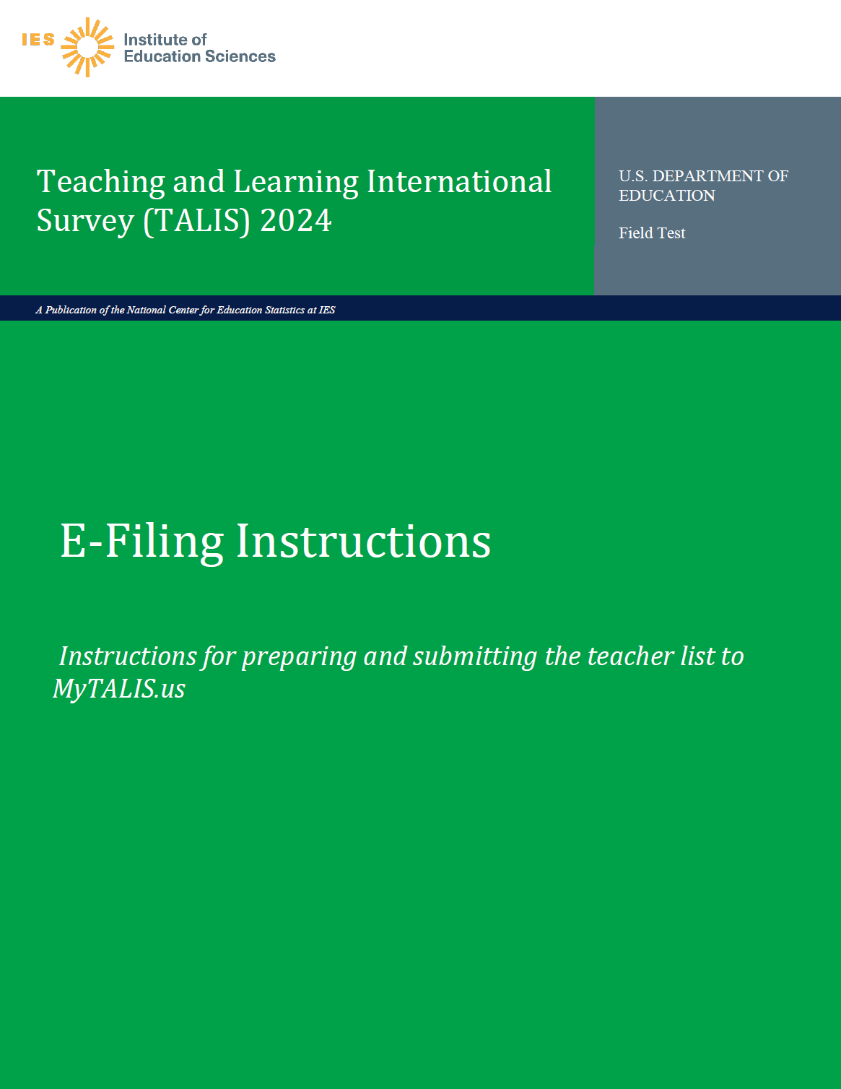

Preparing the TALIS Electronic Teacher File (E-File)

Step 1: Identify ALL teachers eligible to teach students in grade 7, 8, or 9.

Criteria for TALIS teacher eligibility are:
    - All teachers who are eligible to teach grade 7, 8, or 9 students.
    - Teacher-aides, assistants, and other school staff are not eligible.

TALIS needs accurate information about all teachers at your school who teach students in grades 7, 8, or 9. In addition to teacher name and email, TALIS needs you to identify which domain each teacher primarily teaches to students in grades 7, 8, or 9.

Step 2: List each of the eligible teachers.

Use the electronic listing form template provided on the MyTALIS.us website (www.MyTALIS.us).

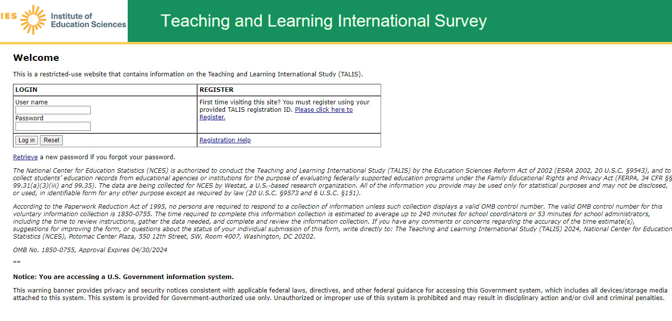

Text for 2024 field test (to replace text in the above image):

The National Center for Education Statistics (NCES) is authorized to conduct the Teaching and Learning International Survey (TALIS) by the Education Sciences Reform Act of 2002 (ESRA 2002, 20 U.S.C. §9543). The data are being collected for NCES by Westat, a U.S.-based research organization. All of the information you provide may be used only for statistical purposes and may not be disclosed, or used, in identifiable form for any other purpose except as required by law (20 U.S.C. §9573 and 6 U.S.C. §151).
According to the Paperwork Reduction Act of 1995, no persons are required to respond to a collection of information unless such collection displays a valid OMB control number. The valid OMB control number for this voluntary information collection is 1850-0888. The time required to complete this information collection and participate in study activities is estimated to average 240 minutes per school coordinator, including the time to review instructions, gather the data needed, and complete and review the information collection. If you have any comments or concerns regarding the accuracy of the time estimate(s), suggestions for improving the form, or questions about the status of your individual submission of this form, write directly to: Teaching and Learning International Survey (TALIS), National Center for Education Statistics (NCES), Potomac Center Plaza, 550 12th Street, SW, 4th floor, Washington, DC 20202.
OMB No. 1850-0888, Approval Expires xx/xx/20xx

Notice: You are accessing a U.S. Government information system.
This warning banner provides privacy and security notices consistent with applicable federal laws, directives, and other federal guidance for accessing this Government system, which includes all devices/storage media attached to this system. This system is provided for Government-authorized use only. Unauthorized or improper use of this system is prohibited and may result in disciplinary action and/or civil and criminal penalties.

List teachers in your school who are eligible for TALIS along with their other necessary information.
    - Teacher first name
    - Teacher middle name (not required)
    - Teacher last name
    - Email address (this is needed to deliver their log in credentials electronically)
    - Main domain (1 – Language, 2 – Social Sciences, 3 – Math & Science, 4 – Other)

Exhibit 1. Example Teacher Listing Form
Teacher First Name | Teacher Middle Name | Teacher Last Name | Teacher email | Main Domain
John |  | Simpson | JohnSimpson@nomail.com | 1
Carol |  | White | CarolWhite@nomail.com | 1
Jamie |  | Smith | JamieSmith@nomail.com | 1
Loretta |  | Alexander | LorettaAlexander@nomail.com | 2
Cindy |  | Tasker | CindyTasker@nomail.com | 2
Bethel |  | Lane | BethelLane@nomail.com | 2
Lin |  | Jing | LinJing@nomail.com | 3
Jarrod |  | McElroy | JarrodMcElroy@nomail.com | 3
Meghan |  | Taferishi | MeghanTaferishi@nomail.com | 4
Tisha |  | Campbell | TishaCampbell@nomail.com | 3
Tonya |  | Jackson | TonyaJackson@nomail.com | 4
Monique |  | Smith | MoniqueSmith@nomail.com | 3
Geoffery |  | Johnson | GeofferyJohnson@nomail.com | 4
John |  | Candy | JohnCandy@nomail.com | 2
Grady |  | White | GradyWhite@nomail.com | 2

Submitting the TALIS Electronic Teacher File (E-File)

Step 1: Upload file. After you have created and saved your teacher E-File, proceed to www.MyTALIS.us. Once you have logged in, click the “Submit Teacher List” link on the left side of the page (box 1 in exhibit 2) underneath the “Submit Teacher Link.” Then click the “Browse” button to locate your file (box 2 in exhibit 2). Once you’ve located the file and clicked ok, click “Upload” (box 3 in exhibit 2).

Exhibit 2. Submit Teacher List - Initial Screen

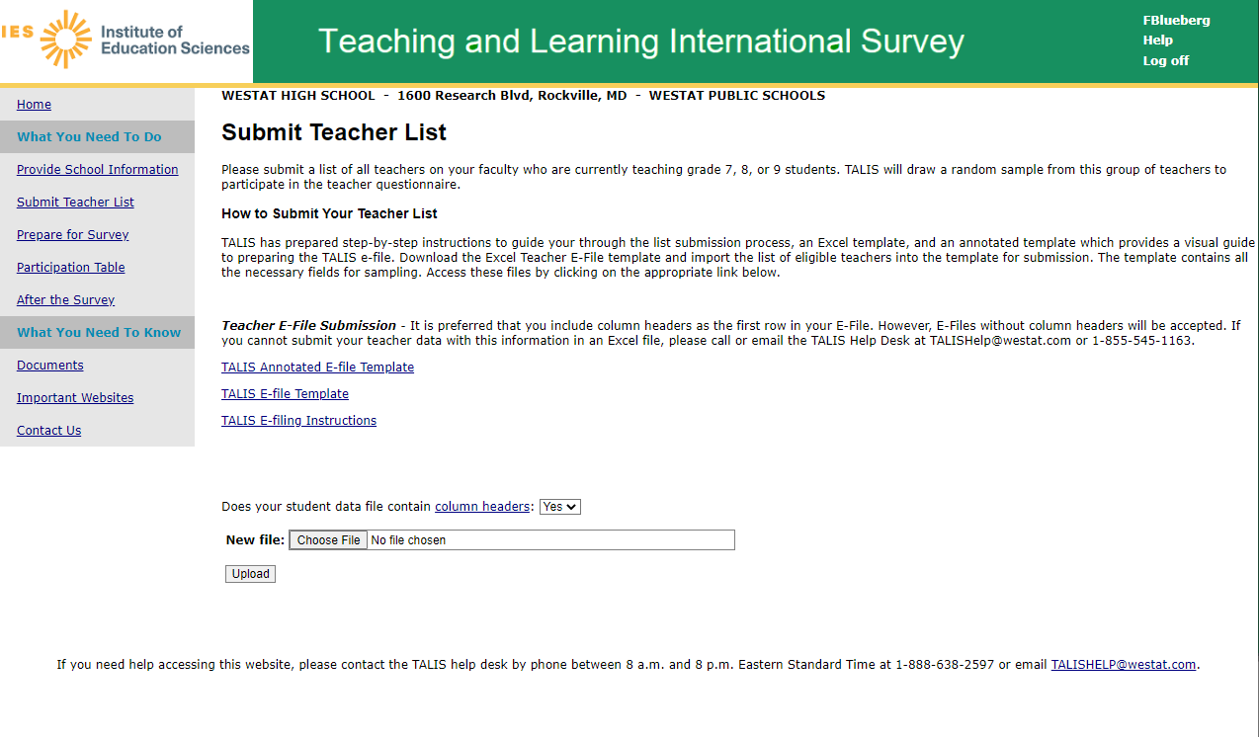
2
3
1

Step 2: Map Columns. The column headings in your file are shown in rows on the left side of the page. In each row, for each heading on the left, click on the down arrow next to the words in the table that read "Column Contains..." on the right. If there is no appropriate description in the drop-down list for your column heading, select N/A.

Exhibit 3. Submit Teacher List - Identify Your Columns
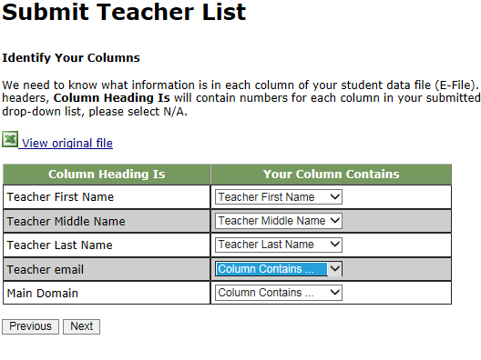

Step 3: Match Values to TALIS Codes. The next step is matching the values on your file to TALIS codes. The values in your column will again be displayed on the left. Select the corresponding TALIS code from the drop-down list (see exhibit 4). If there is no appropriate description in the drop-down list for your column heading, select N/A. When you are finished matching your values to TALIS codes, click next.
Exhibit 4. Submit Teacher List - Match Your Values to TALIS Codes (Domain Mapping)

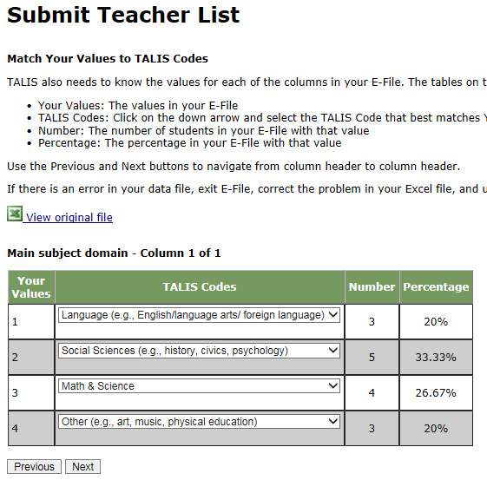

Step 4: Verify your E-file. The final step is to verify that the information is correct and submit your file. Check that the distribution of teachers by main subject domain match the total number of teachers you submitted. Indicate whether this information is correct and click “Submit.” If the information is incorrect click “Incorrect” and then click on the “Submit Teacher List” link on the left side of the screen. This will save your progress and exit the current e-file. You can access this file again or upload a new corrected file and start over by using the same file upload process described in Step 1.

Exhibit 5. Submit Teacher List - Verify Your E-file

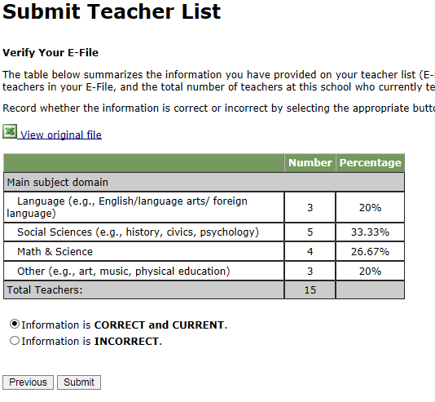

Online Teacher Data Checks. After you click “Submit”, a number of online data validation checks are performed by our programs. These checks include checking the number of listed teachers against statistical estimates, checking for valid emails, and checking for any missing data. If the data fail these online checks, you will be presented with a screen that describes the issue, the location of the row(s) in your file that contains the errant data, and you will need to correct the file and upload a new version. Exhibit 6 (below) provides an example of a file with missing data. Notice that the affected row is provided for each instance where the check failed. This is designed to help you efficiently locate and ameliorate any issues. Exhibit 7 provides an example of a file where an invalid email was provided.

Exhibit 6. Online Data Check - Missing Data

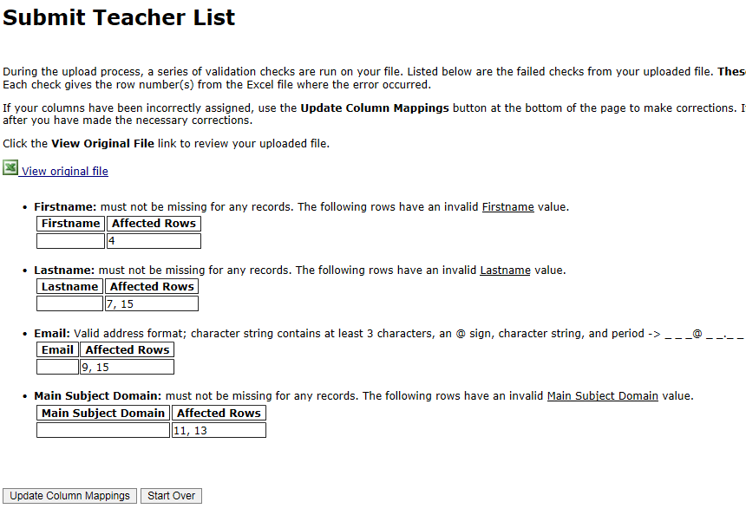

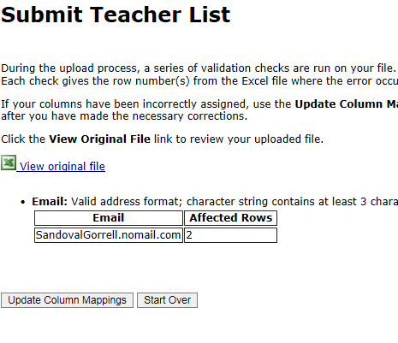
Exhibit 7. Online Data Check - Invalid Email

If at any time you realize that every eligible teacher was not listed or needs to be corrected, you can exit e-filing, correct the file, and upload a new one by clicking on the “Submit Teacher List” link and uploading a new file. If you have any questions or would like to talk with someone about e-filing, please reach out to the TALIS help desk by phone between 8 a.m. and 8 p.m. Eastern Standard Time at 1-855-545-1163 or email TALISHelp@westat.com.

TALIS 2024 Field Test School Coordinator Communication

1. Email to register on MyTALIS

Dear <title> <last name>:
Thank you again for participating in the TALIS 2024 field test taking place in February 2023. To keep you informed of new information about TALIS as well as steps for preparing for the study, we have developed a website for school coordinators called MyTALIS (https://www.myTALIS.us). This is a secure site with content tailored to each individual school.
Below is your Registration ID. You will use this the first time you visit MyTALIS to create your own username and password.
MyTALIS REGISTRATION ID: <Registration ID>
The registration ID supports multiple users, though each user will need to provide their own registration information (e.g., name, email, phone, address).
If you need technical assistance at any time, please do not hesitate to contact the TALIS help desk at 1-800-545-1163 or email TALISHelp@westat.com.
We look forward to working with you.
Sincerely,
The U.S. TALIS Team

The National Center for Education Statistics (NCES) is authorized to conduct the Teaching and Learning International Survey (TALIS) by the Education Sciences Reform Act of 2002 (ESRA 2002, 20 U.S.C. §9543). The data are being collected for NCES by Westat, a U.S.-based research organization. All of the information you provide may be used only for statistical purposes and may not be disclosed, or used, in identifiable form for any other purpose except as required by law (20 U.S.C. §9573 and 6 U.S.C. §151).

2. Cover letter to School Coordinator accompanying School Coordinator Handbook

Hello!

Thank you for agreeing to serve as the TALIS School Coordinator for your school during the TALIS 2024 field test. Enclosed is a TALIS School Coordinator Handbook describing your role and the tasks you are asked to complete during the survey.

Please review the handbook and familiarize yourself with the survey procedures and your role. We will hold a short informational WebEx on [date]. You will be contacted through a separate email regarding the details of the WebEx.

If you have not already registered on the MyTALIS.us study website, please do so. If you need your registration credentials, call the TALIS Help Desk at help desk at 1-855-545-1163 or email TALISHelp@westat.com.

Thank you again!

The TALIS USA Team

The National Center for Education Statistics (NCES) is authorized to conduct the Teaching and Learning International Survey (TALIS) by the Education Sciences Reform Act of 2002 (ESRA 2002, 20 U.S.C. §9543). The data are being collected for NCES by Westat, a U.S.-based research organization. All of the information you provide may be used only for statistical purposes and may not be disclosed, or used, in identifiable form for any other purpose except as required by law (20 U.S.C. §9573 and 6 U.S.C. §151).

3. E-file instructions email to School Coordinator

Dear School Coordinator,

Thank you for your time and effort working on the TALIS 2024 field test!

We are pleased to announce that www.mytalis.us is now ready to receive teacher electronic listing files (e-files).

The instructions for preparing and submitting your school’s teacher listing file are attached to this email. The TALIS E-filing Instructions can also be accessed online from the website. Along with the instructions, we’ve prepared a formatted Excel template to make preparing the e-file more convenient.

If you have yet to register on www.mytalis.us, please let us know so we can send you the registration ID for your school.

Reach out to the TALIS help desk by phone between 8 a.m. and 8 p.m. Eastern Standard Time at 1-855-545-1163 or email TALISHelp@westat.com.

Thanks again for your support.

All the best,

The TALIS USA Team

The National Center for Education Statistics (NCES) is authorized to conduct the Teaching and Learning International Survey (TALIS) by the Education Sciences Reform Act of 2002 (ESRA 2002, 20 U.S.C. §9543). The data are being collected for NCES by Westat, a U.S.-based research organization. All of the information you provide may be used only for statistical purposes and may not be disclosed, or used, in identifiable form for any other purpose except as required by law (20 U.S.C. §9573 and 6 U.S.C. §151).

4. TALIS E-file reminder email to School Coordinator
Subject: TALIS E-File Reminder
Attachment: TALIS E-Filing Instructions

Dear School Coordinator:
Welcome and thank you for your efforts as the school coordinator for the Teaching and Learning International Survey (TALIS) 2024 field test at your school!
We are nearing the deadline for your teacher list to be submitted for sampling (insert date, 2023). Please upload your school’s list as soon as possible so that sampled teachers can be notified about the survey.
Detailed instructions for submitting your lists to TALIS are included in the enclosed document titled TALIS E-Filing Instructions.
If you have any questions about the instructions, please contact the TALIS Help Desk at 1-855-545-1163 or send an email to TALISHELP@westat.com. The e-filing instructions are also posted on the MyTALIS.us study website (www.mytalis.us).

Sincerely,
The TALIS USA Team

The National Center for Education Statistics (NCES), within the U.S. Department of Education, conducts the Teaching and Learning International Survey (TALIS) in the United States as authorized by the Education Sciences Reform Act of 2002 (ESRA 2002, 20 U.S.C. §9543). All of the information you provide may be used only for statistical purposes and may not be disclosed, or used, in identifiable form for any other purpose except as required by law (20 U.S.C. §9573 and 6 U.S.C. §151).
5. Email to School Coordinator when teacher samples are complete and Teacher Tracking Form/School Logon Forms/Teacher Logon Invitations have been posted to MyTALIS.us

Subject: TALIS Teacher Sampling Complete

Hello!

We have processed the list of teachers from your school and selected a sample of teachers for the Teacher Questionnaire. The following materials are now available on www.mytalis.us:
- Teacher Tracking Form
- Principal Questionnaire Invitation
- Teacher Core TALIS Questionnaire Invitation
- Teacher TKS Questionnaire Invitation

To access the files:

1. Log into www.mytalis.us with your username/password.
2. Click the Documents link in the “What you Need to Know” section.
3. Click on the link in the upper center of the page under "Download Your School's materials here:"

To open the files, use the password [insert password]

Please review and update the Teacher Tracking Form following the steps provided in chapter 3, section 3.3 of your School Coordinator Handbook. Please distribute the Principal and Teacher Questionnaire invitations, update the Teacher Tracking Form, and return the tracking form to Westat as described in section 3.5 of the School Coordinator Handbook.

Your TALIS Representative will contact you to make sure you have received the materials you need. He or she can assist you in answering any questions you may have.

If you have any questions in the meantime, please feel free to call the TALIS Help Desk at 1-855-545-1163, or send an email to TALISHELP@westat.com

Thank you again!

The TALIS USA Team

The National Center for Education Statistics (NCES) is authorized to conduct the Teaching and Learning International Survey (TALIS) by the Education Sciences Reform Act of 2002 (ESRA 2002, 20 U.S.C. §9543). The data are being collected for NCES by Westat, a U.S.-based research organization. All of the information you provide may be used only for statistical purposes and may not be disclosed, or used, in identifiable form for any other purpose except as required by law (20 U.S.C. §9573 and 6 U.S.C. §151).

6. Cover letter to hard copy materials package sent to School Coordinator when survey is ready to launch.

Hello!

Enclosed please find the necessary materials for the launch of the TALIS survey. The following materials are included:
- Principal invitation
- Teacher invitations
- Return envelope
- Red security envelope
- Teacher Tracking Form

Please review the School Coordinator Handbook and familiarize yourself with the survey procedures and your role. If you missed the informational WebEx on <insert date>, you can access a recording of the presentation and the slides on the Documents page of MyTALIS.us.

If you have not already registered on MyTALIS.us study website, please do so. If you need your registration credentials, or have other questions, call the TALIS Help Desk at 1-800-545-1163, or send an email to TALISHELP@westat.com.

Thank you again!

The TALIS USA Team

The National Center for Education Statistics (NCES) is authorized to conduct the Teaching and Learning International Survey (TALIS) by the Education Sciences Reform Act of 2002 (ESRA 2002, 20 U.S.C. §9543). The data are being collected for NCES by Westat, a U.S.-based research organization. All of the information you provide may be used only for statistical purposes and may not be disclosed, or used, in identifiable form for any other purpose except as required by law (20 U.S.C. §9573 and 6 U.S.C. §151).

TALIS 2024 Field Test Respondent Reminders
TALIS 2024 Field Test Teacher Questionnaire Invitation
Dear «NAME»:

Your school is one of 40 schools across the United States taking part in the Teaching and Learning International Study (TALIS) 2024 field test. Conducted every 5 years since 2008, TALIS is an international survey of principals and teachers at grades 7, 8, and 9 and provides comparative information about teaching and the teaching profession around the world, with 53 countries participating in 2024.

You’ve been selected to participate by completing a TALIS online teacher questionnaire. The questionnaire takes about 60 minutes. If you have any questions about how you were selected for this survey, please contact your TALIS school coordinator, «SCFNAME» «SCLNAME».

You will receive $25 as a thank you for completing the questionnaire, if allowed by your school’s policy.
Use the provided link and unique account information below to complete your questionnaire.

https://portal.mytalis.us
User ID: «IDTEACH»
Password: «T_CHKSUM»

Your participation is valuable and appreciated. The information you contribute combined with responses from other teachers and principals provides accurate and reliable data to teachers, principals, and policy makers around the world.

TALIS is conducted in the United States by the National Center for Education Statistics (NCES) in the U.S. Department of Education and is administered by Westat, a firm headquartered in Rockville, Maryland. The U.S. Office of Management and Budget has approved this data collection under OMB #1850-0888.

To get more information about this study visit the TALIS website at https://nces.ed.gov/surveys/talis.

If you need assistance accessing the survey, reach out to the TALIS help desk by phone between 8 a.m. and 8 p.m. Eastern Standard Time at 1-800-545-1163 or email TALISHelp@westat.com.

Sincerely,

The TALIS USA Team

The National Center for Education Statistics (NCES) is authorized to conduct the Teaching and Learning International Survey (TALIS) by the Education Sciences Reform Act of 2002 (ESRA 2002, 20 U.S.C. §9543). The data are being collected for NCES by Westat, a U.S.-based research organization. All of the information you provide may be used only for statistical purposes and may not be disclosed, or used, in identifiable form for any other purpose except as required by law (20 U.S.C. §9573 and 6 U.S.C. §151).

TALIS 2024 Field Test Principal Questionnaire Invitation
Dear «principal»:

Your school is one of 40 schools across the United States taking part in the Teaching and Learning International Study (TALIS) 2024 field test. Conducted every 5 years since 2008, TALIS is an international survey of principals and teachers at grades 7, 8, and 9 and provides comparative information about teaching and the teaching profession around the world, with 53 countries participating in 2024.

Each principal is asked to complete the TALIS online principal questionnaire about their school. The questionnaire takes about 45 minutes and can be completed in a single session or multiple sessions over time.

Use the provided link and unique account information below to complete your questionnaire.

https://portal.mytalis.us
User ID: «IDSCHOOL»
Password: «SCH_CHKSUM»

The information you contribute combined with responses from teachers and principals provides accurate and reliable data to teachers, principals, and policy makers around the world. Your participation is valuable and appreciated.

TALIS is conducted in the United States by the National Center for Education Statistics (NCES) in the U.S. Department of Education and is administered by Westat, a firm headquartered in Rockville, Maryland. The U.S. Office of Management and Budget has approved this data collection under OMB #1850-0888.

To get more information about this study visit the TALIS website at https://nces.ed.gov/surveys/talis.

If you need assistance accessing the survey, reach out to the TALIS help desk by phone between 8 a.m. and 8 p.m. Eastern Standard Time at 1-800-545-1163 or email TALISHelp@westat.com.

Sincerely,

The TALIS USA Team

The National Center for Education Statistics (NCES) is authorized to conduct the Teaching and Learning International Survey (TALIS) by the Education Sciences Reform Act of 2002 (ESRA 2002, 20 U.S.C. §9543). The data are being collected for NCES by Westat, a U.S.-based research organization. All of the information you provide may be used only for statistical purposes and may not be disclosed, or used, in identifiable form for any other purpose except as required by law (20 U.S.C. §9573 and 6 U.S.C. §151).

TALIS 2024 Field Test Teacher Questionnaire Hard-Copy Invitation
(Image from TALIS 2018)
Front Side
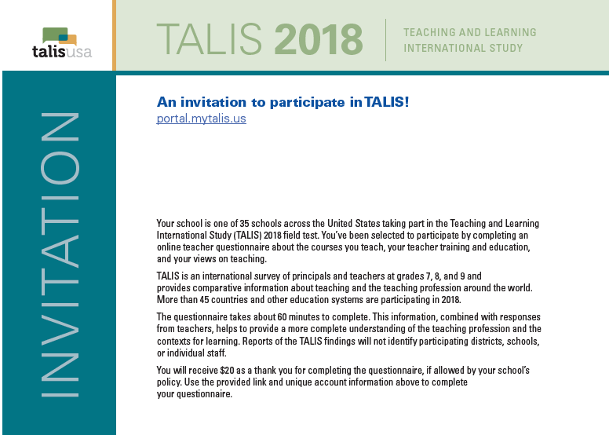

Text for 2024 field test (to replace text from the 2018 field test in the above image):

Your school is one of 40 schools across the United States taking part in the Teaching and Learning International Study (TALIS) 2024 field test. You’ve been selected to participate by completing an online teacher questionnaire.

TALIS is an international survey of principals and teachers at grades 7, 8, and 9 and provides comparative information about teaching and the teaching profession around the world, with 53 countries participating in 2024.

The questionnaire takes about 60 minutes to complete. This information, combined with responses from other teachers, helps to provide a more complete understanding of the teaching profession and the contexts for learning. Reports of the TALIS findings will not identify participating districts, schools, or individual staff.

You will receive $25 as a thank you for completing the questionnaire, if allowed by your school’s policy. Use the provided link and unique account information above to complete your questionnaire.

TALIS 2024 Field Test Teacher Questionnaire Hard-Copy Invitation
(Image from TALIS 2018)
Back Side
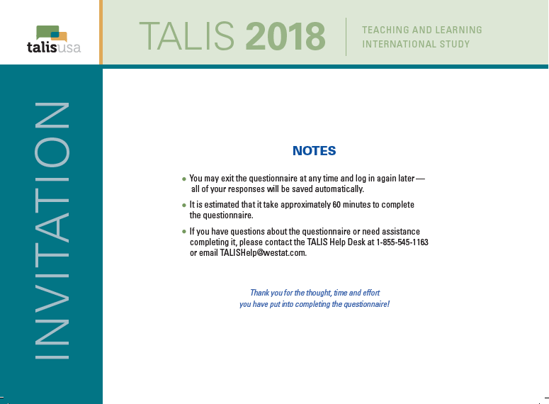

Text for 2024 field test (to replace text from the 2018 field test in the above image):

NOTES
● It is estimated that it takes approximately 60 minutes to complete this questionnaire.
● If you have questions about this survey or need assistance completing it, please contact the TALIS Help Desk at 1-800-545-1163 or email TALISHelp@westat.com.
Thank you for the thought, time, and effort you have put into completing this questionnaire!

The National Center for Education Statistics (NCES) is authorized to conduct the Teaching and Learning International Survey (TALIS) by the Education Sciences Reform Act of 2002 (ESRA 2002, 20 U.S.C. §9543). The data are being collected for NCES by Westat, a U.S.-based research organization. All of the information you provide may be used only for statistical purposes and may not be disclosed, or used, in identifiable form for any other purpose except as required by law (20 U.S.C. §9573 and 6 U.S.C. §151).
TALIS 2024 Field Test Principal Questionnaire Hard-Copy Invitation
(Image from TALIS 2018)
Front Side
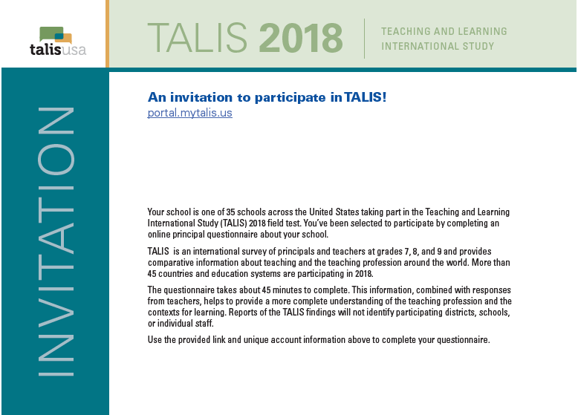

Text for 2024 field test (to replace text from the 2018 field test in the above image):

Your school is one of 40 schools across the United States taking part in the Teaching and Learning International Study (TALIS) 2024 field test. You’ve been selected to participate by completing an online principal questionnaire about your school.

TALIS is an international survey of principals and teachers at grades 7, 8, and 9 and provides comparative information about teaching and the teaching profession around the world, with 53 countries participating in 2024.

The questionnaire takes about 45 minutes to complete. This information, combined with responses from other principals and teachers, helps to provide a more complete understanding of the teaching profession and the contexts for learning. Reports of the TALIS findings will not identify participating districts, schools, or individual staff.

Use the provided link and unique account information above to complete your questionnaire.

TALIS 2024 Field Test Principal Questionnaire Hard-Copy Invitation
(Image from TALIS 2018)
Back Side
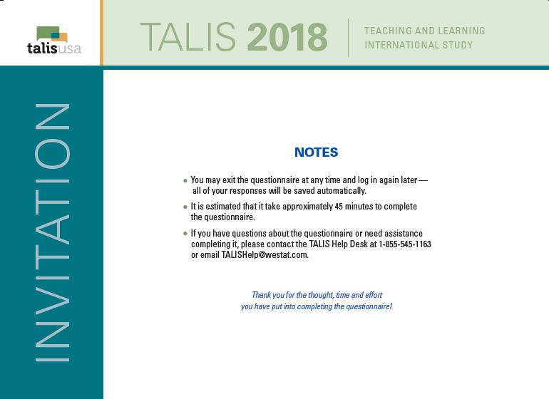

Text for 2024 field test (to replace text from the 2018 field test in the above image):

NOTES
● You may exit the questionnaire at any time and log in again later—all of your responses will be saved automatically.
● It is estimated that it takes approximately 45 minutes to complete this questionnaire.
● If you have questions about this survey or need assistance completing it, please contact the TALIS Help Desk at 1-800-545-1163 or email TALISHelp@westat.com.
Thank you for the thought, time, and effort you have put into completing this questionnaire!

The National Center for Education Statistics (NCES) is authorized to conduct the Teaching and Learning International Survey (TALIS) by the Education Sciences Reform Act of 2002 (ESRA 2002, 20 U.S.C. §9543). The data are being collected for NCES by Westat, a U.S.-based research organization. All of the information you provide may be used only for statistical purposes and may not be disclosed, or used, in identifiable form for any other purpose except as required by law (20 U.S.C. §9573 and 6 U.S.C. §151).

TALIS 2024 Field Test Teacher Questionnaire Login Pages
(Image from TALIS 2018)
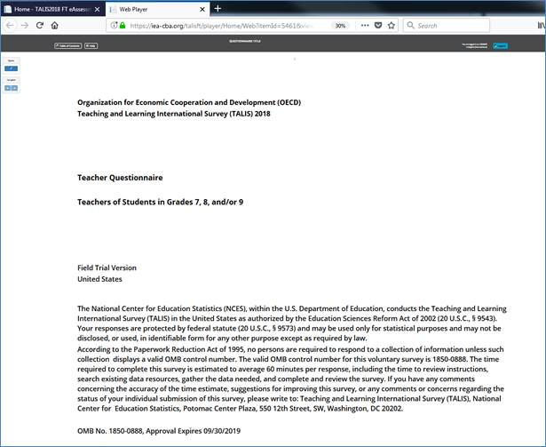
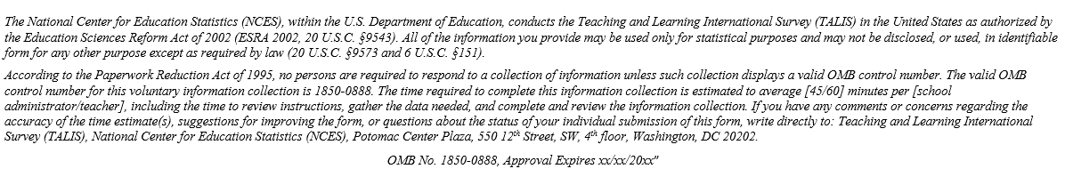
Text for 2024 field test (to replace text from the 2018 field test in the above image):

The National Center for Education Statistics (NCES) is authorized to conduct the Teaching and Learning International Survey (TALIS) by the Education Sciences Reform Act of 2002 (ESRA 2002, 20 U.S.C. §9543). The data are being collected for NCES by Westat, a U.S.-based research organization. All of the information you provide may be used only for statistical purposes and may not be disclosed, or used, in identifiable form for any other purpose except as required by law (20 U.S.C. §9573 and 6 U.S.C. §151).
According to the Paperwork Reduction Act of 1995, no persons are required to respond to a collection of information unless such collection displays a valid OMB control number. The valid OMB control number for this voluntary information collection is 1850-0888. The time required to complete this information collection is estimated to average up to 60 minutes per teacher, including the time to review instructions, gather the data needed, and complete and review the information collection. If you have any comments or concerns regarding the accuracy of the time estimate(s), suggestions for improving the form, or questions about the status of your individual submission of this form, write directly to: Teaching and Learning International Survey (TALIS), National Center for Education Statistics (NCES), Potomac Center Plaza, 550 12th Street, SW, 4th floor, Washington, DC 20202. OMB No. 1850-0888, Approval Expires MM/DD/2025.
TALIS 2024 Field Test Principal Questionnaire Login Pages
(Image from TALIS 2018)

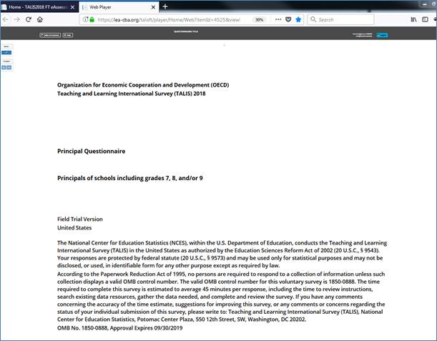
Text for 2024 field test (to replace text from the 2018 field test in the above image):

The National Center for Education Statistics (NCES) is authorized to conduct the Teaching and Learning International Survey (TALIS) by the Education Sciences Reform Act of 2002 (ESRA 2002, 20 U.S.C. §9543). The data are being collected for NCES by Westat, a U.S.-based research organization. All of the information you provide may be used only for statistical purposes and may not be disclosed, or used, in identifiable form for any other purpose except as required by law (20 U.S.C. §9573 and 6 U.S.C. §151).
According to the Paperwork Reduction Act of 1995, no persons are required to respond to a collection of information unless such collection displays a valid OMB control number. The valid OMB control number for this voluntary information collection is 1850-0888. The time required to complete this information collection is estimated to average up to 45 minutes per school administrator, including the time to review instructions, gather the data needed, and complete and review the information collection. If you have any comments or concerns regarding the accuracy of the time estimate(s), suggestions for improving the form, or questions about the status of your individual submission of this form, write directly to: Teaching and Learning International Survey (TALIS), National Center for Education Statistics (NCES), Potomac Center Plaza, 550 12th Street, SW, 4th floor, Washington, DC 20202. OMB No. 1850-0888, Approval Expires MM/DD/2025.
TALIS 2024 Field Test Teacher Reminder 1

Dear «NAME»:

Thanks to you and your school for participating in the Teaching and Learning International Survey (TALIS) 2024 field test. This email is a reminder that you have been selected to represent your school’s teacher body in TALIS by completing an online teacher questionnaire.

Please know that your participation is important and valued. If you have any questions about how you were selected for this survey, please contact your TALIS school coordinator, «SCFNAME» «SCLNAME».

You will receive $25 as a thank you for completing this questionnaire, if allowed by your school’s policy.
Use the provided link and unique account information below to complete your questionnaire.

https://portal.mytalis.us
User ID: «IDTEACH»
Password: «T_CHKSUM»

TALIS is conducted in the United States by the National Center for Education Statistics (NCES) in the U.S. Department of Education and is administered by Westat, a firm headquartered in Rockville, Maryland. The U.S. Office of Management and Budget has approved the data collection under OMB #1850-0888.

To get more information about this study visit the TALIS website at https://nces.ed.gov/surveys/talis.

If you need assistance accessing the survey, reach out to the TALIS help desk by phone between 8 a.m. and 8 p.m. Eastern Standard Time at 1-800-545-1163 or email TALISHelp@westat.com.

Sincerely,

The TALIS USA Team

The National Center for Education Statistics (NCES) is authorized to conduct the Teaching and Learning International Survey (TALIS) by the Education Sciences Reform Act of 2002 (ESRA 2002, 20 U.S.C. §9543). The data are being collected for NCES by Westat, a U.S.-based research organization. All of the information you provide may be used only for statistical purposes and may not be disclosed, or used, in identifiable form for any other purpose except as required by law (20 U.S.C. §9573 and 6 U.S.C. §151).

TALIS 2024 Field Test Principal Reminder 1

Dear «NAME»:

The Teaching and Learning International Survey (TALIS) data collection period ends <DATE>. This email is a reminder to login and complete the online principal questionnaire at your earliest convenience.

Please know that your participation is important and valued. This week your school’s TALIS School Coordinator will receive a hard-copy questionnaire with a pre-paid return envelope for you to complete, in case you’ve had difficulties completing the questionnaire online or prefer to complete it on paper.

You can still complete the survey online! Use the information below to access the website and get started:

https://portal.mytalis.us
User ID: <IDSCHOOL>
Password: <SCH_CHKSUM>

TALIS is conducted in the United States by the National Center for Education Statistics (NCES) in the U.S. Department of Education and is administered by Westat, a firm headquartered in Rockville, Maryland. The U.S. Office of Management and Budget has approved the data collection under OMB #1850-0888.

To get more information about this study visit the TALIS website at https://nces.ed.gov/surveys/talis.

If you need assistance accessing the survey, reach out to the TALIS help desk by phone between 8 a.m. and 8 p.m. Eastern Standard Time at 1-800-545-1163 or email TALISHelp@westat.com.

Sincerely,

The TALIS USA Team

The National Center for Education Statistics (NCES) is authorized to conduct the Teaching and Learning International Survey (TALIS) by the Education Sciences Reform Act of 2002 (ESRA 2002, 20 U.S.C. §9543). The data are being collected for NCES by Westat, a U.S.-based research organization. All of the information you provide may be used only for statistical purposes and may not be disclosed, or used, in identifiable form for any other purpose except as required by law (20 U.S.C. §9573 and 6 U.S.C. §151).

TALIS 2024 Field Test Teacher Reminder 2

Dear «NAME»:

The Teacher and Learning International Survey (TALIS) data collection period ends <DATE>.

Remember to complete your TALIS questionnaire by this Friday night, or let your TALIS school coordinator, «SCFNAME» «SCLNAME», know that you don’t want to participate so we stop sending you reminder messages.
To complete the questionnaire online, use the provided link and unique account information below:

https://portal.mytalis.us
User ID: <IDTEACH>
Password: <T_CHKSUM>

If you log in and complete any portion of the questionnaire you are eligible to receive the $25 incentive, if allowed by your school, even if you can’t find time to complete it all before Friday night.

This week your TALIS School Coordinator received a shipment of hard-copy questionnaires with pre-paid return envelopes, in case you’ve had difficulties completing the questionnaire online or prefer to complete it on paper. If you plan to complete on paper, please reply to this email and let us know so we stop sending email messages to you.

TALIS is conducted in the United States by the National Center for Education Statistics (NCES) in the U.S. Department of Education and is administered by Westat, a firm headquartered in Rockville, Maryland. The U.S. Office of Management and Budget has approved the data collection under OMB #1850-0888.

To get more information about this study visit the TALIS website at https://nces.ed.gov/surveys/talis.

If you need assistance accessing the survey, reach out to the TALIS help desk by phone between 8 a.m. and 8 p.m. Eastern Standard Time at 1-800-545-1163 or email TALISHelp@westat.com.

Sincerely,

The TALIS USA Team

The National Center for Education Statistics (NCES) is authorized to conduct the Teaching and Learning International Survey (TALIS) by the Education Sciences Reform Act of 2002 (ESRA 2002, 20 U.S.C. §9543). The data are being collected for NCES by Westat, a U.S.-based research organization. All of the information you provide may be used only for statistical purposes and may not be disclosed, or used, in identifiable form for any other purpose except as required by law (20 U.S.C. §9573 and 6 U.S.C. §151).

TALIS 2024 Field Test Principal Reminder 2

Dear «NAME»:

Thanks to you and your colleagues for participating in the Teaching and Learning International Survey (TALIS) 2024! In the next few weeks your school will receive its $200.00 incentive check as a thank you for your participation if allowed by school policy.

This is a reminder to complete your TALIS principal questionnaire by this Friday night. The data collection period ends <DATE>.

To complete the questionnaire online, use the provided link and unique account information below:

https://portal.mytalis.us
User ID: <IDSCHOOL>
Password: <SCH_CHKSUM>

TALIS is conducted in the United States by the National Center for Education Statistics (NCES) in the U.S. Department of Education and is administered by Westat, a firm headquartered in Rockville, Maryland. The U.S. Office of Management and Budget has approved the data collection under OMB #1850-0888.

To get more information about this study visit the TALIS website at https://nces.ed.gov/surveys/talis.

If you need assistance accessing the survey, reach out to the TALIS help desk by phone between 8 a.m. and 8 p.m. Eastern Standard Time at 1-800-545-1163 or email TALISHelp@westat.com.

Sincerely,

The TALIS USA Team

The National Center for Education Statistics (NCES) is authorized to conduct the Teaching and Learning International Survey (TALIS) by the Education Sciences Reform Act of 2002 (ESRA 2002, 20 U.S.C. §9543). The data are being collected for NCES by Westat, a U.S.-based research organization. All of the information you provide may be used only for statistical purposes and may not be disclosed, or used, in identifiable form for any other purpose except as required by law (20 U.S.C. §9573 and 6 U.S.C. §151).

TALIS 2024 Field Test Teacher Last-Day Reminder

Dear «NAME»:

The Teacher and Learning International Survey (TALIS) data collection period ends today.

Remember to complete your TALIS questionnaire by tonight, or let your TALIS school coordinator, «SCFNAME» «SCLNAME», know that you don’t want to participate so we can assign proper close-out codes.
To complete the questionnaire online, use the provided link and unique account information below:

https://portal.mytalis.us
User ID: <IDTEACH>
Password: <T_CHKSUM>

If you log in and complete any portion of the questionnaire you are eligible to receive the $25 incentive, if allowed by your school, even if you can’t find time to complete it all before tonight.

This week your TALIS School Coordinator received a shipment of hard-copy questionnaires with pre-paid return envelopes, in case you’ve had difficulties completing the questionnaire online or prefer to complete it on paper. If you plan to complete on paper, please reply to this email and let us know so we can make sure we have the proper participation code assigned for you. You can still send them today!

To get more information about this study visit the TALIS website at https://nces.ed.gov/surveys/talis.

If you need assistance accessing the survey, reach out to the TALIS help desk by phone between 8 a.m. and 8 p.m. Eastern Standard Time at 1-800-545-1163 or email TALISHelp@westat.com.

Sincerely,

The TALIS USA Team

The National Center for Education Statistics (NCES) is authorized to conduct the Teaching and Learning International Survey (TALIS) by the Education Sciences Reform Act of 2002 (ESRA 2002, 20 U.S.C. §9543). The data are being collected for NCES by Westat, a U.S.-based research organization. All of the information you provide may be used only for statistical purposes and may not be disclosed, or used, in identifiable form for any other purpose except as required by law (20 U.S.C. §9573 and 6 U.S.C. §151).

TALIS 2024 Field Test Principal Last-Day Reminder

Dear «NAME»:

The Teacher and Learning International Survey (TALIS) data collection period ends today.

Remember to complete your TALIS questionnaire by tonight, or let your TALIS school coordinator, «SCFNAME» «SCLNAME», know that you don’t want to participate so we can assign proper close-out codes.
To complete the questionnaire online, use the provided link and unique account information below:

https://portal.mytalis.us
User ID: <IDSCHOOL>
Password: <SCH_CHKSUM>

If you log in and complete any portion of the questionnaire your data will contribute to the national database.

This week your TALIS School Coordinator received a hard-copy questionnaire with a pre-paid return envelope, in case you’ve had difficulties completing the questionnaire online or prefer to complete it on paper. If you plan to complete on paper, please reply to this email and let us know so we can make sure we have the proper participation code assigned for you. You can still send them today!

To get more information about this study visit the TALIS website at https://nces.ed.gov/surveys/talis.

If you need assistance accessing the survey, reach out to the TALIS help desk by phone between 8 a.m. and 8 p.m. Eastern Standard Time at 1-800-545-1163 or email TALISHelp@westat.com.

Sincerely,

The TALIS USA Team

The National Center for Education Statistics (NCES) is authorized to conduct the Teaching and Learning International Survey (TALIS) by the Education Sciences Reform Act of 2002 (ESRA 2002, 20 U.S.C. §9543). The data are being collected for NCES by Westat, a U.S.-based research organization. All of the information you provide may be used only for statistical purposes and may not be disclosed, or used, in identifiable form for any other purpose except as required by law (20 U.S.C. §9573 and 6 U.S.C. §151).

TALIS 2024 Field Test Teacher Deadline Extension Email

Subject: TALIS online survey extended till <insert date>!
Dear «NAME»:

As you may know, the TALIS survey was scheduled to end on <previous end date>. However, we are making every effort to include all the sampled teachers, so it is being extended until <Insert date>. The TALIS team is really counting on you!

Without your contribution the study could be in jeopardy. Teachers like you are busy people, and we recognize that. If you could find time to complete the survey it would go a long way toward helping the study be successful.

Click the link below, enter your login information (also below), and complete Part A:

https://portal.mytalis.us
User ID: «IDTEACH»
Password: «T_CHKSUM»

Don’t let this to opportunity to provide valuable contributions to research that shapes education policy for future generations pass you by. The survey is now scheduled to close <Insert date>.

Go online and complete the questionnaire as soon as possible. Thank you for your time.

Sincerely,

The U.S. TALIS Team

The National Center for Education Statistics (NCES) is authorized to conduct the Teaching and Learning International Survey (TALIS) by the Education Sciences Reform Act of 2002 (ESRA 2002, 20 U.S.C. §9543). The data are being collected for NCES by Westat, a U.S.-based research organization. All of the information you provide may be used only for statistical purposes and may not be disclosed, or used, in identifiable form for any other purpose except as required by law (20 U.S.C. §9573 and 6 U.S.C. §151).

TALIS 2024 Field Test Principal Deadline Extension Email

Dear «NAME»:

As you may know the TALIS survey was scheduled to end on <previous end date>. However, we are making every effort to include all of the principals from participating schools, so the deadline is being extended until <Insert date>. The TALIS team is really counting on you!

If you could find time to complete the survey it would go a long way toward helping the study be successful.

Click the link below, enter your login information (also below), to complete the survey:

https://portal.mytalis.us
User ID: «IDSCHOOL»
Password: «SCH_CHKSUM»

Don’t let this to opportunity to provide valuable contributions to research that shapes education policy for future generations pass you by. The survey is now scheduled to close <Insert date>.

Go online and complete the questionnaire as soon as possible. Thank you for your time.

Sincerely,

The U.S. TALIS Team

The National Center for Education Statistics (NCES) is authorized to conduct the Teaching and Learning International Survey (TALIS) by the Education Sciences Reform Act of 2002 (ESRA 2002, 20 U.S.C. §9543). The data are being collected for NCES by Westat, a U.S.-based research organization. All of the information you provide may be used only for statistical purposes and may not be disclosed, or used, in identifiable form for any other purpose except as required by law (20 U.S.C. §9573 and 6 U.S.C. §151).

TALIS 2024 School Coordinator Handbook

The following pages show the School Coordinator Handbook for school coordinators. The School Coordinator Handbook for TALIS 2024 is not yet active because it is adapted from an international source version that has not yet been released to participating countries. In the pages that follow, we have updated the handbook used in TALIS 2018 based on what we expect will be changes for TALIS 2024. An updated version of the handbook (including TALIS 2024 screen images) will be provided in a package update in fall 2022.


Organization for Economic Cooperation and Development (OECD)
 | Teaching and Learning International Survey (TALIS) 2024
 | School Coordinator Handbook
United States: Grades 7, 8, and 9
January 2018
 | Consortium
 | International Association for the Evaluation of Educational Achievement (IEA)  (Amsterdam, The Netherlands and Hamburg, Germany)
 | Statistics Canada  (Ottawa, Canada)
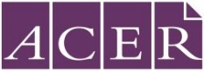 | Australian Council for Educational Research (ACER) (Melbourne, Australia)

The National Center for Education Statistics (NCES), within the U.S. Department of Education, conducts the Teaching and Learning International Survey (TALIS) in the United States as authorized by the Education Sciences Reform Act of 2002 (ESRA 2002, 20 U.S.C. §9543). All of the information you provide may be used only for statistical purposes and may not be disclosed, or used, in identifiable form for any other purpose except as required by law (20 U.S.C. §9573 and 6 U.S.C. §151).
According to the Paperwork Reduction Act of 1995, no persons are required to respond to a collection of information unless such collection displays a valid OMB control number. The valid OMB control number for this voluntary information collection is 1850-0888. The time required to complete this information collection and participate in study activities is estimated to average 240 minutes per school coordinator, including the time to review instructions, gather the data needed, and complete and review the information collection. If you have any comments or concerns regarding the accuracy of the time estimate(s), suggestions for improving the form, or questions about the status of your individual submission of this form, write directly to: Teaching and Learning International Survey (TALIS), National Center for Education Statistics (NCES), Potomac Center Plaza, 550 12th Street, SW, 4th floor, Washington, DC 20202. OMB No. 1850-0888, Approval Expires xx/xx/xxxx.
- Introduction
Thank you for agreeing to be a school coordinator during the Teaching and Learning International Survey (TALIS) 2018. Your work as a school coordinator will contribute to the U.S. efforts to obtain accurate and useful information about the work of teachers and principals. We appreciate your willingness to help. Your efforts and support contribute to the TALIS objective of improving the quality of schooling in the United States.
  - Overview of the survey and study background
The Teaching and Learning International Survey (TALIS) is the first international OECD survey to focus on the learning environment and the working conditions of teachers in schools. TALIS was first administered in 2008 with 24 countries and other education systems. The second cycle of the survey was conducted in 2013 with 34 education systems. The United States first participated in TALIS in 2013 and again in 2018 and is one of more than 53 countries and other education systems participating in 2024.
TALIS aims to fill key international and national data gaps in understanding of teachers, teaching, and the impact that teachers can have on student learning. It provides an opportunity for teachers and school principals to give their input into education analysis and policy development in key policy areas. Cross-country analyses from TALIS provide opportunities to identify other countries facing similar challenges and to learn from other policy approaches.
Your school is participating in the TALIS in winter-spring 2023. In the United States, TALIS will collect data from schools and teachers who teach students in grades 7, 8 and 9. The survey will launch on February 15, 2023 and run through March 17, 2023.
Please note that this survey is in no way an attempt to evaluate the performance of individual schools, teachers, or principals No individual results will be produced. Analyses will only report aggregate country or system level results. The data we will ask you to collect will enable us to draw a picture of the working conditions of teachers and principals in the participating schools while respecting the confidentiality rights and identity of the respondents.
To find out more about TALIS, visit the U.S. TALIS site at https://nces.ed.gov/surveys/talis/ or the international OECD site at www.oecd.org/talis.

If you have any questions or concerns, please contact us:
TALIS Help Desk
Phone: 1-800-545-1163
FAX: 240-314-2334
Email: TALISHELP@westat.com

  - Your Role as School Coordinator
As a school coordinator you act as the liaison between your school and the TALIS Home Office. You help to facilitate the survey to teachers in your school. In order to assist you, a TALIS representative, assigned to your school, will contact you at various points during the field period to make sure you have what you need and that any questions you have are answered. Exhibit 1.1 provides a summary of the key activities for the School Coordinator.
Please be aware that School Coordinators have to treat all survey information, especially personally identifying information and responses, as confidential at all times.
Administering TALIS involves three components:
- Principal Questionnaire to be completed by the school principal. If your school does not have a principal but, for example, a school management team, the Principal Questionnaire should be filled in by the highest ranking person of this team. If in doubt please contact the TALIS Help Desk and identify the best person to complete the questionnaire.
- Core Teacher Questionnaire to be completed by up to 20 randomly sampled teachers in your school.
- TKS Questionnaire to be completed by up to 15 randomly sampled teachers in your school.
As School Coordinator for TALIS, we ask you to assist us in the identification and sampling of teachers, and to ensure the correct distribution and collection of all survey materials. In this role, you are responsible for overseeing the survey administration in your school. It is essential that you carefully follow the procedures described in this handbook to ensure that the correct teachers are identified for sampling and that the survey is administered similarly in all participating countries. Failure to do so might invalidate the results of the study.
As a thank you for your help with facilitating TALIS in your school, you will receive $200 if allowed by your school’s policy.

Exhibit 1.1. Key Activities for TALIS School Coordinators
Step | Activity | Handbook Section | Schedule | Completed
1 | Receive E-filing instructions from TALIS Home Office. Prepare Teacher Listing Form and submit it via MyTALIS.us. | 2.1 | 4 weeks prior to start of the survey
2 | Download and print the Teacher Tracking Form from MyTALIS.us. Receive hardcopy of the principal invitation, and teacher invitations, and storage envelope via FedEx. Check if the number of teacher invitations matches the number of teachers listed on the form. | 2.3 | 1 to 2 weeks prior to the start of the survey
3 | Distribute the principal invitations and the teacher invitations according to the Teacher Tracking Form. | 2.3 | Shortly before the start of the survey
4 | TALIS ADMINISTRATION |  | February 15- March 17, 2023
5 | Record teacher participation information on the Participation Table on MyTALIS.us. | 3.3 - 3.4 | During the survey administration period
6 | Return the completed paper versions of the questionnaire to the TALIS Home Office at Westat. | 3.5 | At the end of the survey administration period
7 | Securely store the Teacher Tracking Form for a period of at least six months. | 3.5 | At the end of the survey administration period
8 | Complete school debriefing call with TALIS Representative | 4 | At the end of the survey administration period
- Preliminary Tasks
  - Preparing the teacher list
You should have received a separate set of E-filing instructions detailing how to prepare the teacher list and should be preparing that list if it has not already been submitted. If you have questions regarding the preparation of the list, please contact the TALIS Help Desk.
  - Prepare for the survey
As the school coordinator you are the liaison for TALIS in your school.
Please visit the “Prepare for Survey” link on MyTALIS.us for information about preparing your school for TALIS. Here you will find tips for engaging staff, enlisting teacher support and motivating teachers. Exhibit 2.1 shows the page and its location.
Exhibit 2.1. Prepare for Survey page on MyTALIS.us
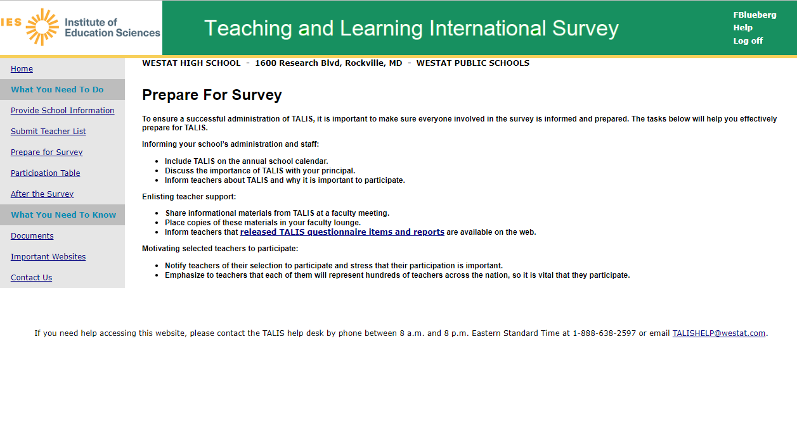

  - Checking the materials on arrival
After the teacher list is submitted and the TALIS Home Office selects a sample of teachers, you will receive a FedEx package containing:
- Principal Questionnaire Invitation – provides the principal/designee with the information needed to access the online Principal Questionnaire.
- Teacher Questionnaire Invitations (in general 35) – provide the selected teachers with the information needed to access the online Teacher Questionnaires.
- Red storage envelope
- FedEx return envelope
In addition, the Teacher Tracking Form and electronic versions of the principal and teacher invitations will be posted electronically to MyTALIS.us in a zip file.
When the materials are available, you will be notified via email with instructions and a password for the zip file. To download, go to the “Documents” link. See Exhibit 2.2 below to showing where to find the link on MyTALIS.us.
You should download and print a copy of the tracking form and keep it securely stored in the storage envelope when not in use. The electronic versions of the invitations are provided for you as a backup should the hard copy invitations get misplaced or damaged. They are provided for your convenience should you need them.
Your TALIS representative will contact you prior to the start of data collection to ensure that you have all the materials and to answer any questions.

Exhibit 2.2. Documents page on MyTALIS.us
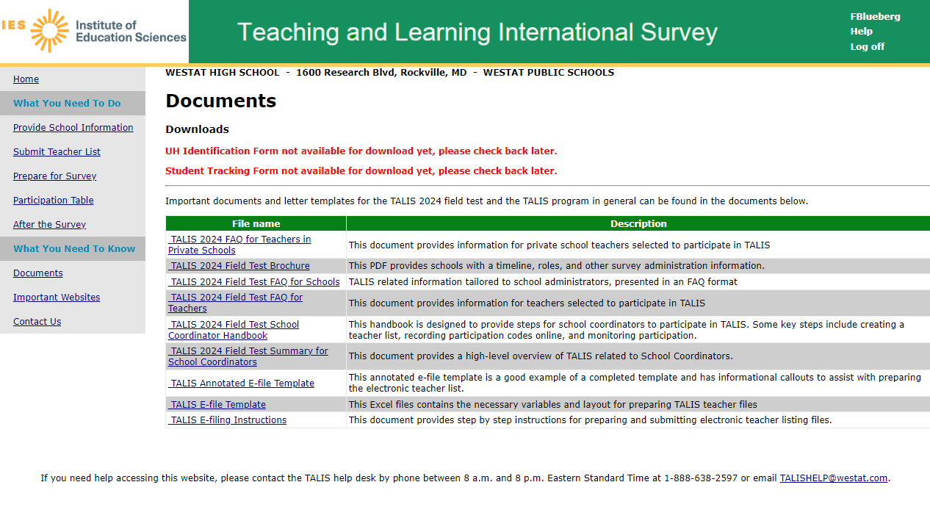
Distribute the principal and teacher questionnaire invitations to the principal/designee and the teachers listed on the Teacher Tracking Form.
Please notify the TALIS Help Desk if you have difficulty accessing or receiving this information. Examples of the principal and teacher questionnaire invitations are shown in exhibit 2.3 and 2.4 below.
Important! Under no circumstances may a sampled teacher be replaced with any other teacher who was not selected to participate in TALIS.
Exhibit 2.3. Principal Questionnaire Invitation
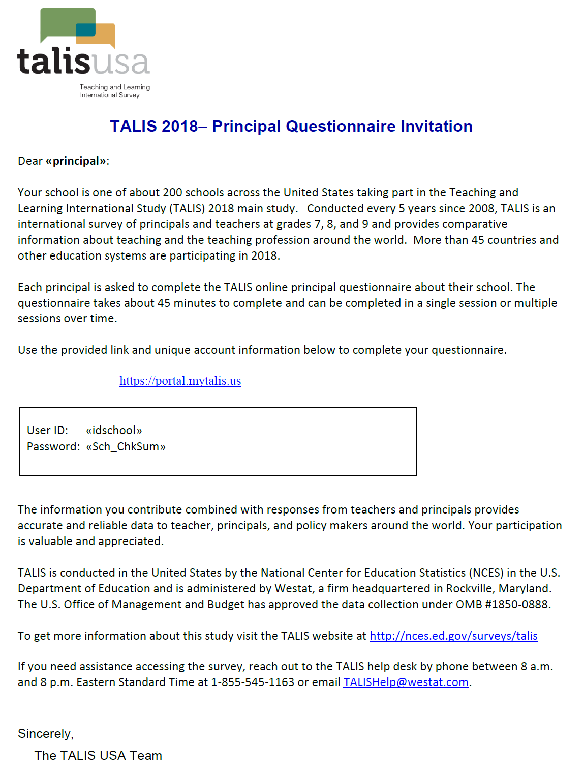
Exhibit 2.4. Teacher Questionnaire Invitation
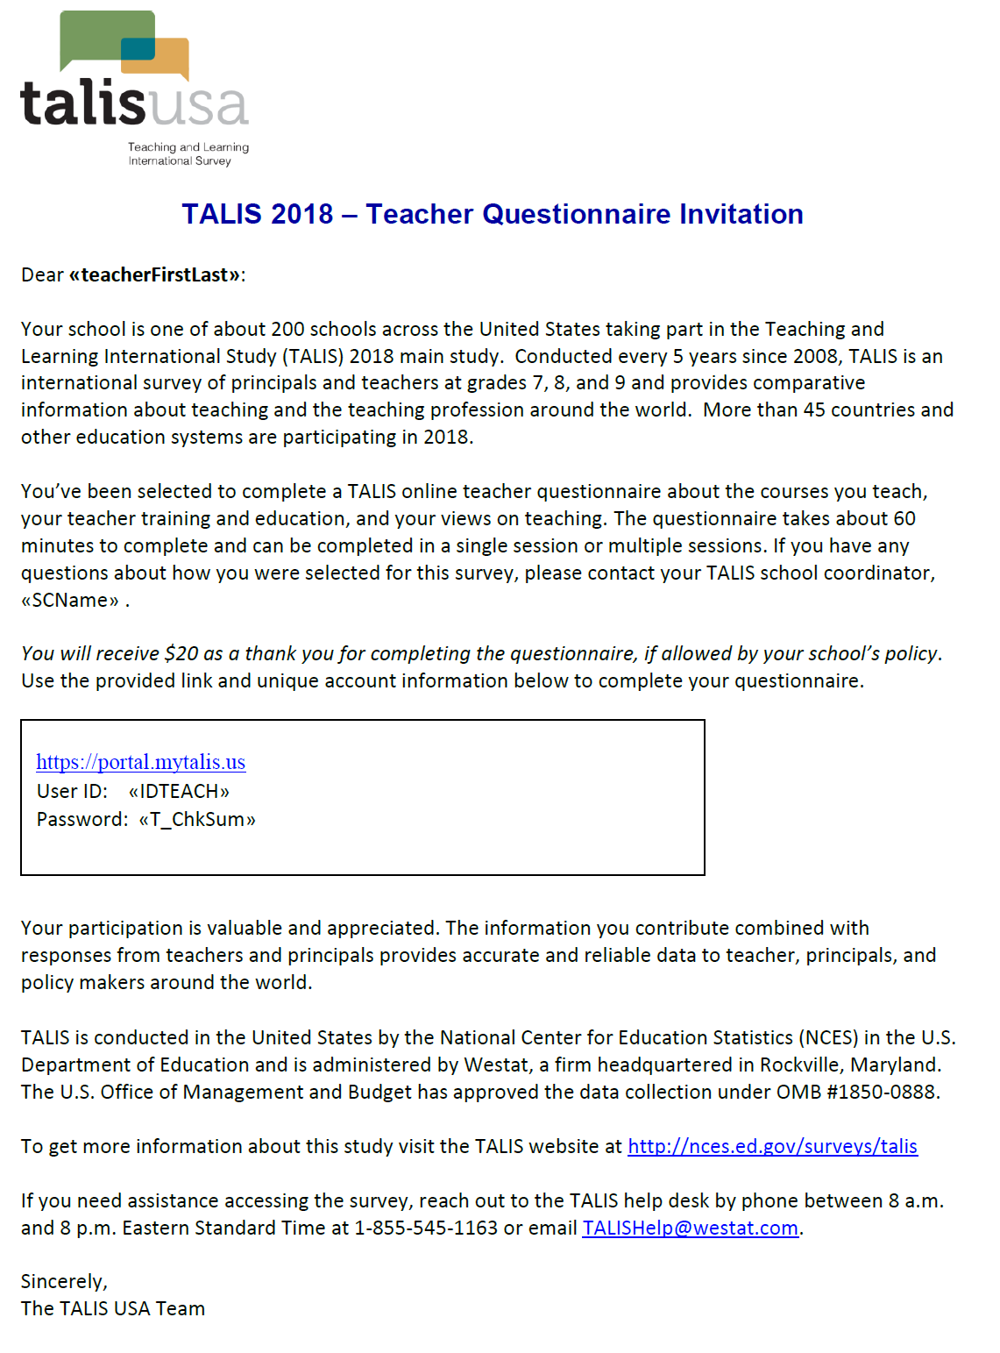
- Administering the Questionnaires
  - Overview
Monitoring participation and completion of the TALIS questionnaires is one of the main tasks for you as school coordinator. This requires close cooperation between you and your TALIS representative.

TALIS WEEK!
Schools and teachers participating in TALIS in the United States are encouraged to complete their questionnaires during the week of February 15 – February 17!
The field period for TALIS is February 15 – March 17, 2023.
It is important that you adhere to the timeline so that your school’s data can be used for international analysis.

  - Accessing the online principal and teacher questionnaires
Our ultimate goal is to achieve a participation rate of 100 percent. This will ensure that the information from the United States is comparable at the international level. It is not permitted to use printouts of the online questionnaires under any circumstances!
The web pages for the online questionnaires have been designed to work with minimum browser requirements. The online questionnaires do not require JavaScript to work and ‘cookies’ will not be used.
Please advise teachers and the principal that school and respondent identities are never included in any reports. All of the provided information may be used only for statistical purposes and may not be disclosed, or used, in identifiable form for any other purpose except as required by law (20 U.S.C. §9573 and 6 U.S.C. §151). Responses are saved as people go from question to question. They may leave the questionnaire at any time and log in again later (for example, on the next day).
On average, the Principal Questionnaire will take about 45 minutes to complete. The Teacher Questionnaire should take approximately 60 minutes to complete, on average.

  - Monitoring participation and questionnaire completion
You will need to monitor and code the participation of teachers during the survey. To do this you will use the “Participation Table” on MyTALIS.us. The Participation Table provides questionnaire status by teacher ID as listed on the Teacher Tracking Form. It also provides information on incentive status.
All teachers will begin with a status of “Not Started.” As teachers complete the questionnaires online change in completion status will be reflected in the table as either “Started” or “Finished.” You should check the Participation Table daily during the data collection period and update participation. Throughout the survey period, periodic email reminders will be sent from the TALIS Home Office to the teachers whose questionnaires are not finished. You should also follow-up with these teachers and encourage them to complete their questionnaire.
You will need to enter the participation status of each teacher on the Participation Table and on your copy of the Teacher Tracking Form. Record the following codes in TTF Participation Code column:
- Use “1” for “Returned - paper”
- Use “2” for “Returned - online”
- Use “3” for “Not Returned”
- Use “4” for “left school permanently”, i.e. if the teacher left the school after being listed but before the administration of the survey started.
- Use “5” for “Exclusion” if a teacher has been listed but does not teach students in grades 7, 8, or 9; if the teacher is also the principal; or he/she is in a position that was not to be according to E-file instructions.
- Use “6” for “Refused” if the teacher refuses to participate in TALIS.
In the Participation Table, set the participation codes by selecting the relevant code from a drop down list. Exhibit 3.1 shows an example of the Participation Table list. You should also record these codes in the column 5 of the Teacher Tracking Form. See Appendix A for an example of the tracking form.
Exhibit 3.1. Participation Table on MyTALIS.us
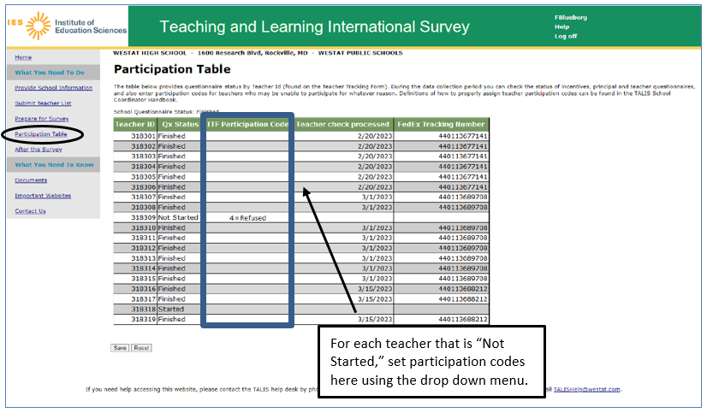
The TALIS Home Office will send email reminders to teachers with statuses of “Not Started” or “Started” and participation code of “3”. Please also prompt teachers that have not completed the survey to do so before April 27.
On March 6, two weeks before the end of the survey, you will receive a FedEx package with paper versions of the questionnaire for those teachers that have yet to complete the questionnaire. Each questionnaire will have a label with the Teacher ID and an accompanying postage paid return envelope. Please distribute the paper questionnaires to the correct teachers and ask that they complete the questionnaire – either with the paper copy or online – before March 17. If teachers are electing to use paper, you will need to confirm that they have returned the questionnaire to the TALIS Home Office and set their participation code to 1 – Returned (paper).
  - Completing the Teacher Tracking Form
Check the Teacher Tracking Form and ensure that all teachers have a participation code and that these are complete and accurate. The participation code for each teacher on the tracking form should match the code that was set in the Participation Table. Ensure that any corrections to the main subject domain in column 3 are clearly indicated.
  - Returning materials to the TALIS Home Office

Return the Teacher Tracking Form

Once the Teacher Tracking Form is complete, make a copy of the form. Store the original version in the red storage envelope that came with your materials.
Using the copy of the Teacher Tracking Form, separate the form along the dashed line between two teacher ID fields (the column 2’s). Place the portion with the teacher name and teacher ID (columns 1 and 2) in the storage envelope along with the original form.
Store this envelope securely until June 2024, at which time these materials should be destroyed.
Send the copy of the completed Teacher Tracking Form without teacher names to the TALIS Home Office using the FedEx return envelope provided with your materials.

Return paper questionnaires

As mentioned, you should update the teacher participation online in the Participation Table on MyTALIS.us. If the principal or any teachers completed the questionnaire on paper they should return the questionnaire to the TALIS Home Office using the return envelope they received with the paper version. However, if any completed paper questionnaires were given to you, please return them to the TALIS Home Office.

- Quality Control during the Main Study
Quality control takes place at numerous stages in the course of questionnaire preparation and also during data processing. This is one of the reasons why it is important that you adhere to all of the above described procedures at all times.
Your TALIS representative will conduct a final call with you at the end of the administration period to complete a short School Coordinator debriefing that will gather information about your experience in administering the survey in your school. The debriefing interview will be done over the phone. The Home Office will work to ensure that the implementation of the survey in schools has been undertaken according to the TALIS Technical Standards, such as checking that the anonymity and confidentiality of respondents has been respected and that the Teacher Listing Form and the Teacher Tracking Form have been filled in correctly and stored securely.

Your help with TALIS is very important to its success in ensuring that data collected in the United States is of the highest quality.

The U.S. TALIS and International Project Team appreciate your time and effort.

Thank you!

APPENDIX A: Example of a teacher tracking form
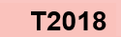
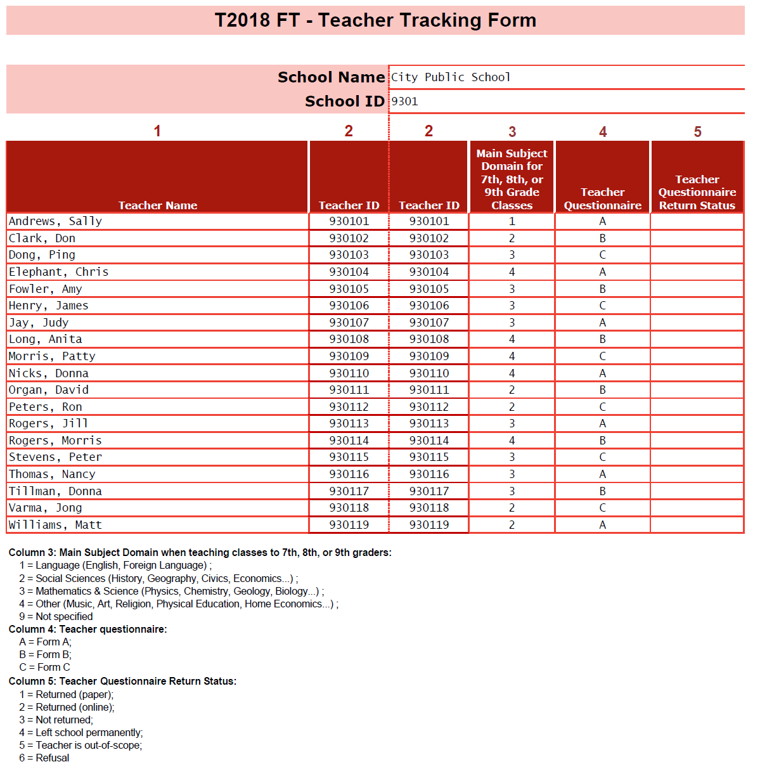

APPENDIX B: Explanation of Teaching Domains

1 = Language includes:
- Reading and writing (and literature) in the mother tongue, reading and writing (and literature) in the language of instruction, reading and writing in the tongue of the country (region) as a second language (for non-natives), language studies, public speaking, literature
- Modern and Foreign languages
- Ancient Greek and/or Latin
2 = Social Sciences includes:
- Social studies, community studies, contemporary studies, economics, environmental studies, geography, history, humanities, legal studies, studies of the own country, social sciences, ethical thinking, philosophy
3 = Mathematics & Science includes:
- Mathematics, mathematics with statistics, geometry, algebra etc.
- Physics, physical science, chemistry, biology, human biology, environmental science, agriculture/horticulture/forestry, astronomy
4 = Other includes:
- Orientation in technology, including information technology, computer studies, construction/surveying, electronics, graphics and design, keyboard skills, word processing, workshop technology / design technology
- Arts, music, visual arts, practical art, drama, performance music, photography, drawing, creative handicraft, creative needlework
- Physical education, gymnastics, dance, health
- Religion, history of religions, religion culture, ethics

TALIS 2024 MyTALIS.us Website

The following pages show the web content of MyTALIS.us for schools and school coordinators. MyTALIS.us is described in Part B of the main study package. The systems for TALIS 2024 are not yet active, but in the pages that follow, we have updated the content used in TALIS 2018 based on what we expect will be changes for TALIS 2024. Updated screenshots and, if necessary, any updated text will be provided in a change request in fall 2022.

MyTALIS.us – Login
Text for 2024 field test (to replace text in the above image):

The National Center for Education Statistics (NCES) is authorized to conduct the Teaching and Learning International Survey (TALIS) by the Education Sciences Reform Act of 2002 (ESRA 2002, 20 U.S.C. §9543). The data are being collected for NCES by Westat, a U.S.-based research organization. All of the information you provide may be used only for statistical purposes and may not be disclosed, or used, in identifiable form for any other purpose except as required by law (20 U.S.C. §9573 and 6 U.S.C. §151).
According to the Paperwork Reduction Act of 1995, no persons are required to respond to a collection of information unless such collection displays a valid OMB control number. The valid OMB control number for this voluntary information collection is 1850-0888. The time required to complete this information collection and participate in study activities is estimated to average 240 minutes per school coordinator, including the time to review instructions, gather the data needed, and complete and review the information collection. If you have any comments or concerns regarding the accuracy of the time estimate(s), suggestions for improving the form, or questions about the status of your individual submission of this form, write directly to: Teaching and Learning International Survey (TALIS), National Center for Education Statistics (NCES), Potomac Center Plaza, 550 12th Street, SW, 4th floor, Washington, DC 20202.
OMB No. 1850-0888, Approval Expires xx/xx/20xx

Notice: You are accessing a U.S. Government information system.
This warning banner provides privacy and security notices consistent with applicable federal laws, directives, and other federal guidance for accessing this Government system, which includes all devices/storage media attached to this system. This system is provided for Government-authorized use only. Unauthorized or improper use of this system is prohibited and may result in disciplinary action and/or civil and criminal penalties.

MyTALIS.us – Home
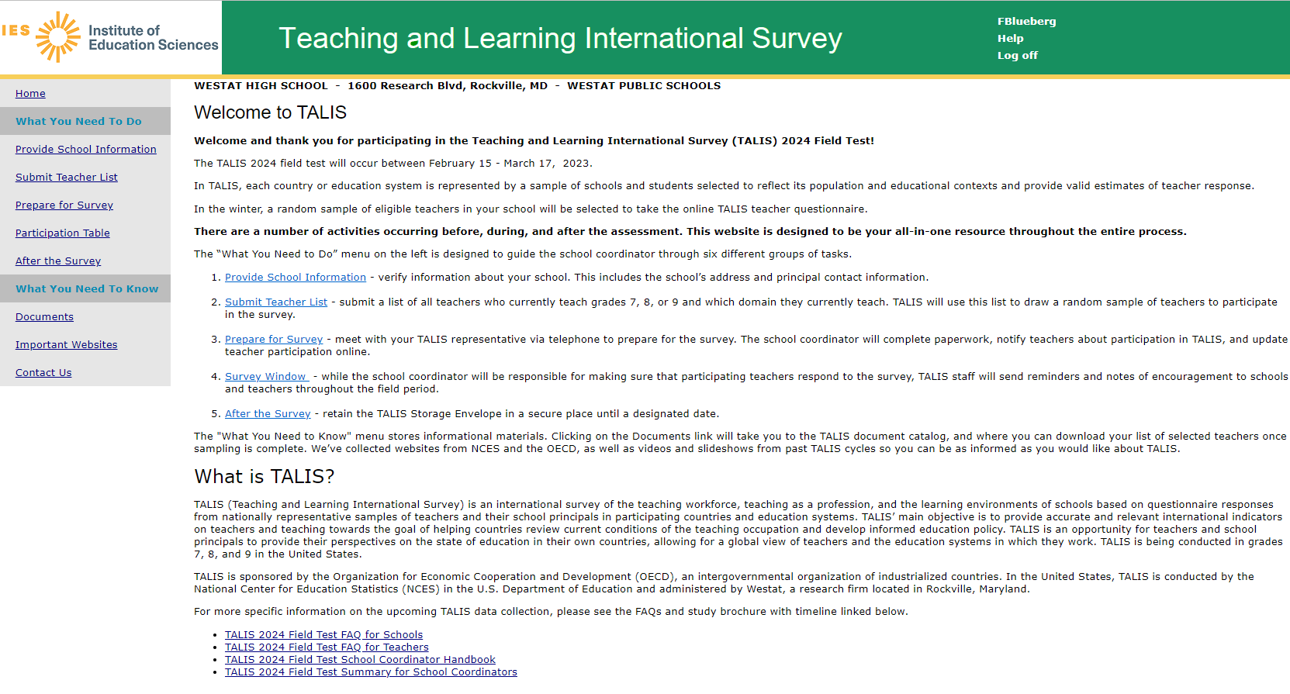
This screen is the Welcome page for the MyTALIS.us site. It provides overview information about the survey and navigation to specific areas of the site.
Welcome Screen text:
Welcome to TALIS
Welcome and thank you for participating in the Teaching and Learning International Survey (TALIS) 2024 Field Test!
The TALIS 2024 field test will occur between February 15 - March 17, 2023.
In TALIS, each country or education system is represented by a sample of schools and students selected to reflect its population and educational contexts and provide valid estimates of teacher response.
In the winter, a random sample of eligible teachers in your school will be selected to take the online TALIS teacher questionnaire.
There are a number of activities occurring before, during, and after the assessment. This website is designed to be your all-in-one resource throughout the entire process.
The “What You Need to Do” menu on the left is designed to guide the school coordinator through six different groups of tasks.
- Provide School Information - verify information about your school. This includes the school’s address and principal contact information.
- Submit Teacher List - submit a list of all teachers who currently teach grades 7, 8, or 9 and which domain they currently teach. TALIS will use this list to draw a random sample of teachers to participate in the survey.
- Prepare for Survey - meet with your TALIS representative via telephone to prepare for the survey. The school coordinator will complete paperwork, notify teachers about participation in TALIS, and update teacher participation online.
- Survey Window - while the school coordinator will be responsible for making sure that participating teachers respond to the survey, TALIS staff will send reminders and notes of encouragement to schools and teachers throughout the field period.
- After the Survey - retain the TALIS Storage Envelope in a secure place until a designated date.
The "What You Need to Know" menu stores informational materials. Clicking on the Documents link will take you to the TALIS document catalog, and where you can download your list of selected teachers once sampling is complete. We’ve collected websites from NCES and the OECD, as well as videos and slideshows from past TALIS cycles so you can be as informed as you would like about TALIS.
What is TALIS?
TALIS (Teaching and Learning International Survey) is an international survey of the teaching workforce, teaching as a profession, and the learning environments of schools based on questionnaire responses from nationally representative samples of teachers and their school principals in participating countries and education systems. TALIS’ main objective is to provide accurate and relevant international indicators on teachers and teaching towards the goal of helping countries review current conditions of the teaching occupation and develop informed education policy. TALIS is an opportunity for teachers and school principals to provide their perspectives on the state of education in their own countries, allowing for a global view of teachers and the education systems in which they work. TALIS is being conducted in grades 7, 8, and 9 in the United States.
TALIS is sponsored by the Organization for Economic Cooperation and Development (OECD), an intergovernmental organization of industrialized countries. In the United States, TALIS is conducted by the National Center for Education Statistics (NCES) in the U.S. Department of Education and administered by Westat, a research firm located in Rockville, Maryland.
For more specific information on the upcoming TALIS data collection, please see the FAQs and study brochure with timeline linked below.
- TALIS 2024 Field Test FAQ for Schools
- TALIS 2024 Field Test FAQ for Teachers
- TALIS 2024 Field Test School Coordinator Handbook
- TALIS 2024 Field Test Summary for School Coordinators

MyTALIS.us – Provide School Information
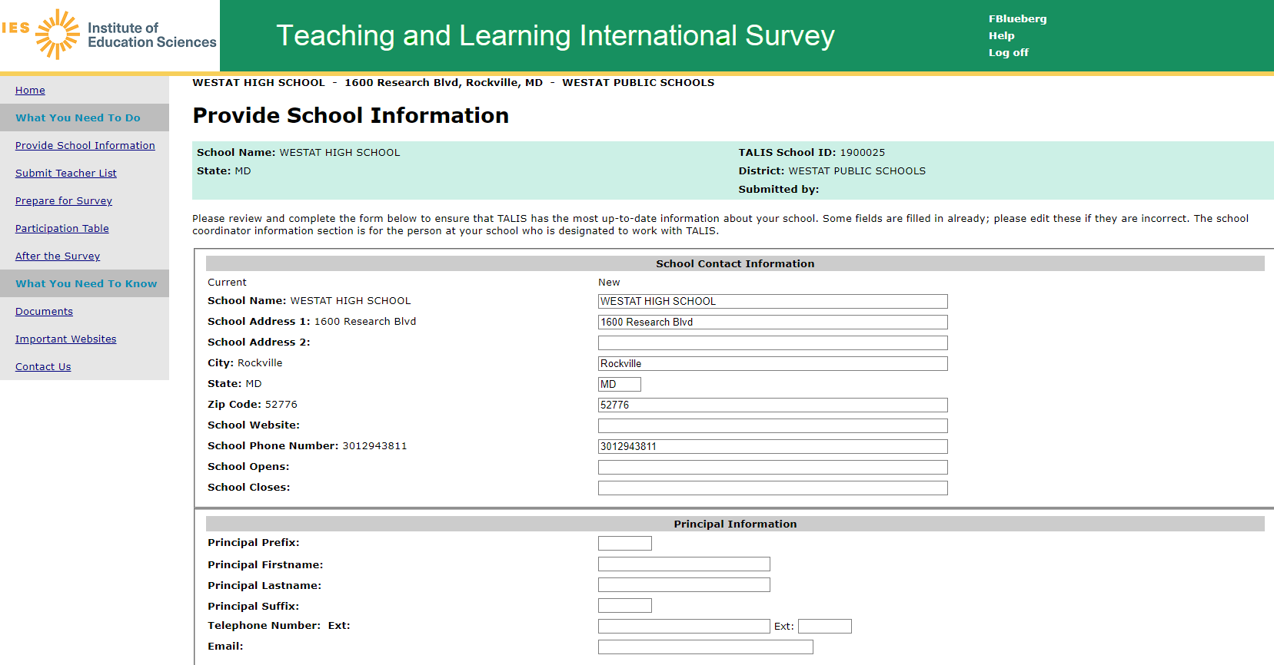
This screen provides information about the school. This information is already populated first from the sampling information and then updated by the NAEP State Coordinators or TALIS Recruiters.
Provide School Information screen text:
Please review and complete the form below to ensure that TALIS has the most up-to-date information about your school. Some fields are filled in already; please edit these if they are incorrect. The school coordinator information section is for the person at your school who is designated to work with TALIS.

MyTALIS.us – Submit Teacher List
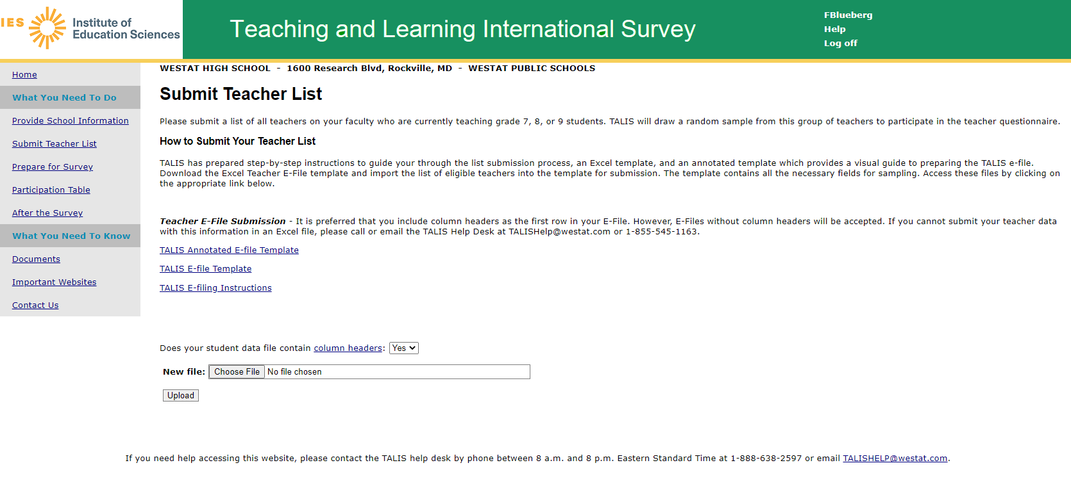
This screen provides the E-file instructions and template and is where the school coordinator will securely upload the completed teacher list.
Submit Teacher List screen text:
Submit Teacher List
Please submit a list of all teachers on your faculty who are currently teaching grade 7, 8, or 9 students. TALIS will draw a random sample from this group of teachers to participate in the teacher questionnaire.
How to Submit Your Teacher List
TALIS has prepared step-by-step instructions to guide your through the list submission process, an Excel template, and an annotated template which provides a visual guide to preparing the TALIS e-file. Download the Excel Teacher E-File template and import the list of eligible teachers into the template for submission. The template contains all the necessary fields for sampling. Access these files by clicking on the appropriate link below.
Teacher E-File Submission - It is preferred that you include column headers as the first row in your E-File. However, E-Files without column headers will be accepted. If you cannot submit your teacher data with this information in an Excel file, please call or email the TALIS Help Desk at TALISHelp@westat.com or 1-855-545-1163.
TALIS Annotated E-file Template
TALIS E-file Template
TALIS E-filing Instructions
MyTALIS.us – Prepare for Survey
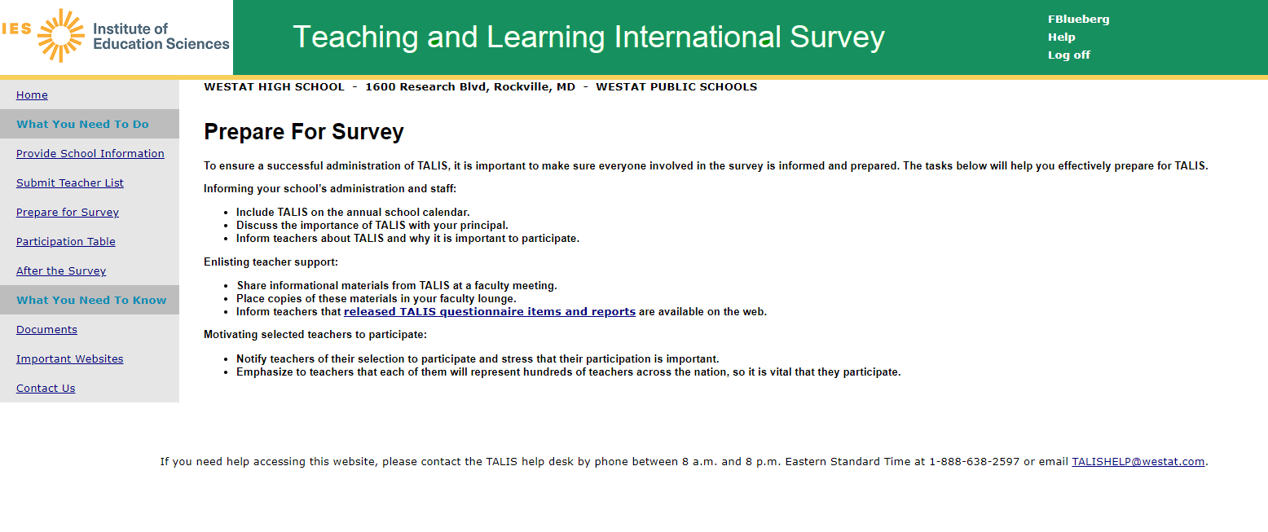
This screen provides information and suggestions for preparing for the survey including discussing the survey with school staff, providing materials, and notifying teachers of their selection to participate.
Prepare for Survey screen text:
Prepare For Survey

To ensure a successful administration of TALIS, it is important to make sure everyone involved in the survey is informed and prepared. The tasks below will help you effectively prepare for TALIS.

Informing your school’s administration and staff:
- Include TALIS on the annual school calendar.
- Discuss the importance of TALIS with your principal.
- Inform teachers about TALIS and why it is important to participate.

Enlisting teacher support:
- Share informational materials from TALIS at a faculty meeting.
- Place copies of these materials in your faculty lounge.
- Inform teachers that released TALIS questionnaire items and reports are available on the web.

Motivating selected teachers to participate:
- Notify teachers of their selection to participate and stress that their participation is important.
- Emphasize to teachers that each of them will represent hundreds of teachers across the nation, so it is vital that they participate.

MyTALIS.us – Participation table
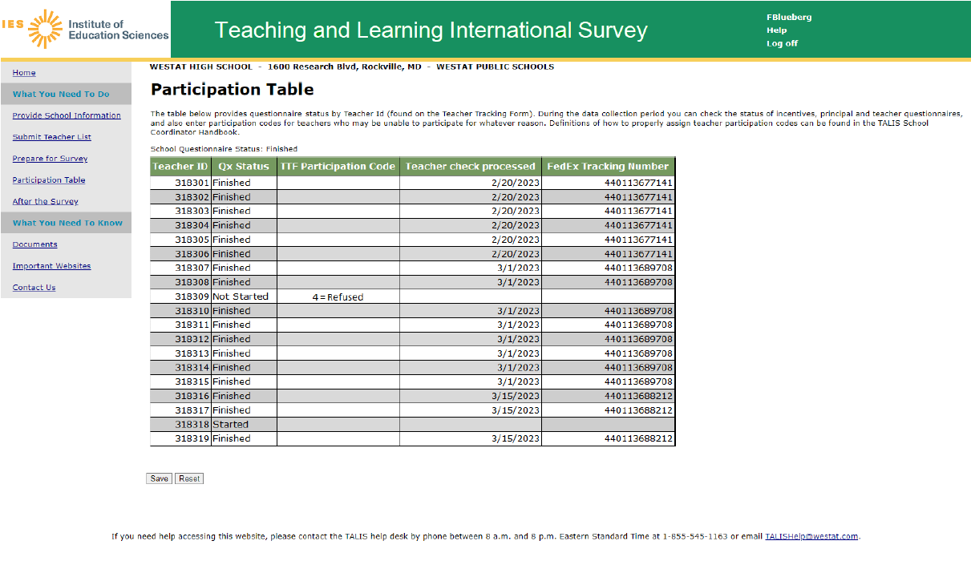
This screen provides the Participation table showing the status of each questionnaire by teacher id. The school coordinator updates the participation codes for the teachers throughout the survey administration period.
Participation Table screen text:
Participation Table
The table below provides questionnaire status by Teacher Id (found on the Teacher Tracking Form). During the data collection period you can check the status of incentives, principal and teacher questionnaires, and also enter participation codes for teachers who may be unable to participate for whatever reason. Definitions of how to properly assign teacher participation codes can be found in the TALIS School Coordinator Handbook.

MyTALIS.us – After the Survey
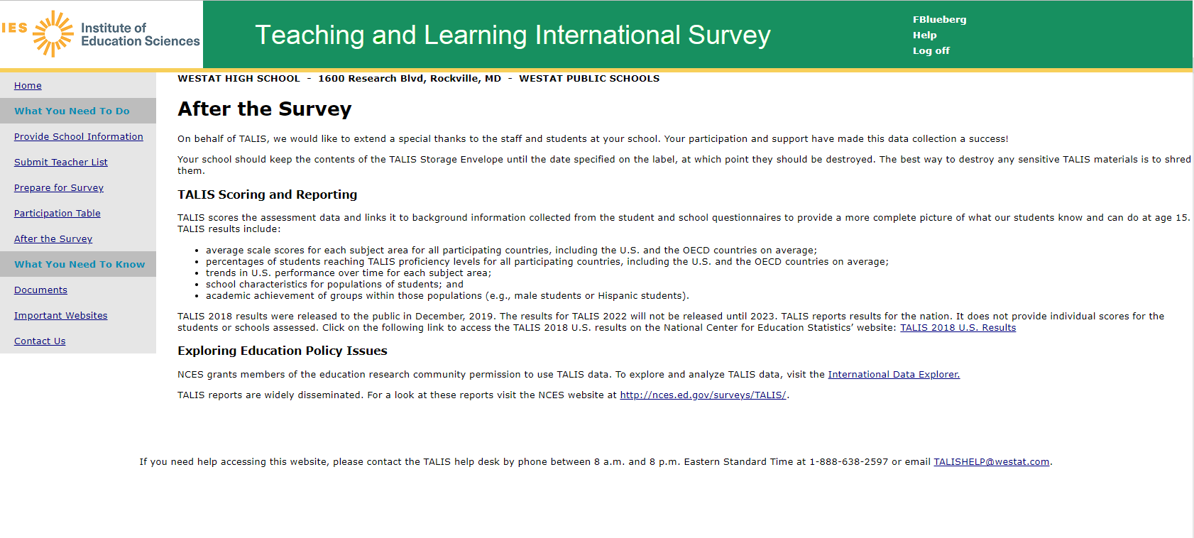
This screen provides information about storing teacher tracking forms and distributing incentives.
After the Survey screen text:
After the Survey
On behalf of TALIS, we would like to extend a special thanks to the staff and students at your school. Your participation and support have made this data collection a success!
Your school should keep the contents of the TALIS Storage Envelope until the date specified on the label, at which point they should be destroyed. The best way to destroy any sensitive TALIS materials is to shred them.
TALIS Scoring and Reporting
TALIS scores the assessment data and links it to background information collected from the student and school questionnaires to provide a more complete picture of what our students know and can do at age 15. TALIS results include:
- average scale scores for each subject area for all participating countries, including the U.S. and the OECD countries on average;
- percentages of students reaching TALIS proficiency levels for all participating countries, including the U.S. and the OECD countries on average;
- trends in U.S. performance over time for each subject area;
- school characteristics for populations of students; and
- academic achievement of groups within those populations (e.g., male students or Hispanic students).
TALIS 2018 results were released to the public in December 2019. The results for TALIS 2024 will not be released until 2025. TALIS reports results for the nation. It does not provide individual scores for the students or schools assessed. Click on the following link to access the TALIS 2018 U.S. results on the National Center for Education Statistics’ website: TALIS 2018 U.S. Results
Exploring Education Policy Issues
NCES grants members of the education research community permission to use TALIS data. To explore and analyze TALIS data, visit the International Data Explorer.
TALIS reports are widely disseminated. For a look at these reports visit the NCES website at http://nces.ed.gov/surveys/TALIS/.
MyTALIS.us – Documents
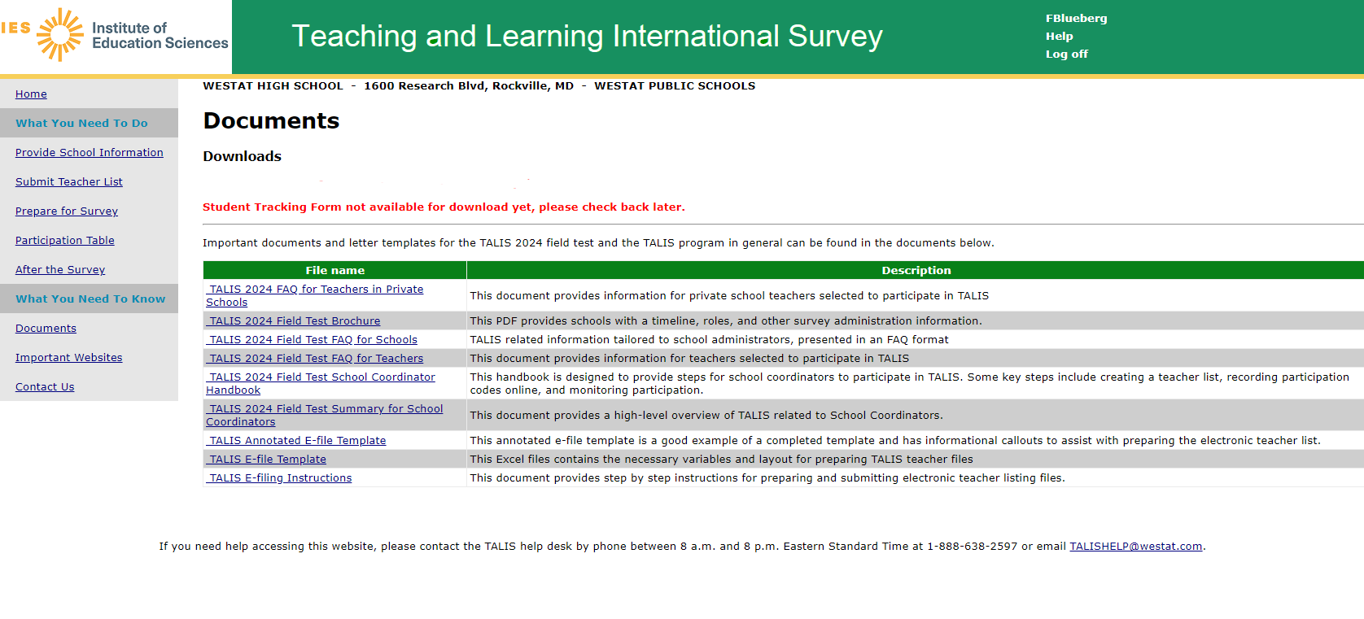
Documents screen text:
Important documents and letter templates for the TALIS 2024 field test and the TALIS program in general can be found in the documents below.

MyTALIS.us – Important Websites
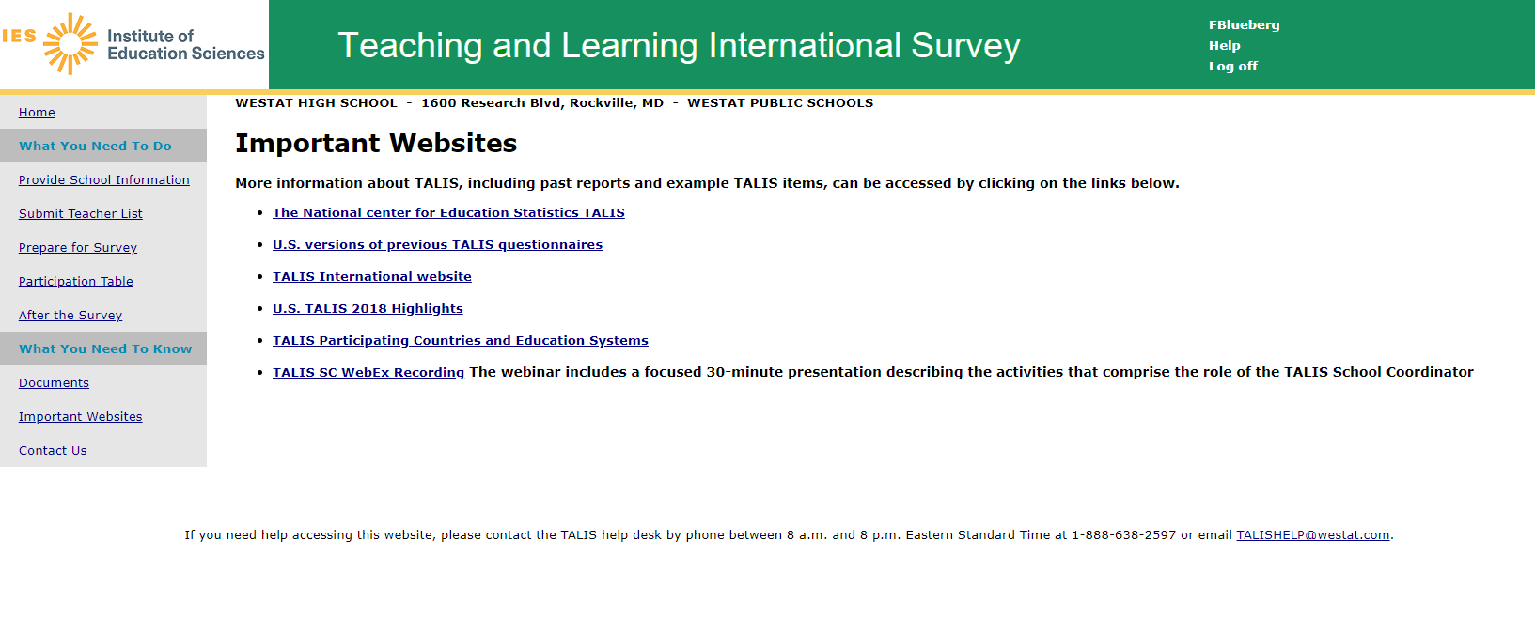
Important Websites screen text:
Important Websites

More information about TALIS, including past reports and example TALIS items, can be accessed by clicking on the links below.
- The National center for Education Statistics TALIS
- U.S. versions of previous TALIS questionnaires
- TALIS International website
- U.S. TALIS 2018 Highlights
- TALIS Participating Countries and Education Systems
- TALIS SC WebEx Recording The webinar includes a focused 30-minute presentation describing the activities that comprise the role of the TALIS School Coordinator

MyTALIS.us – Contact Us
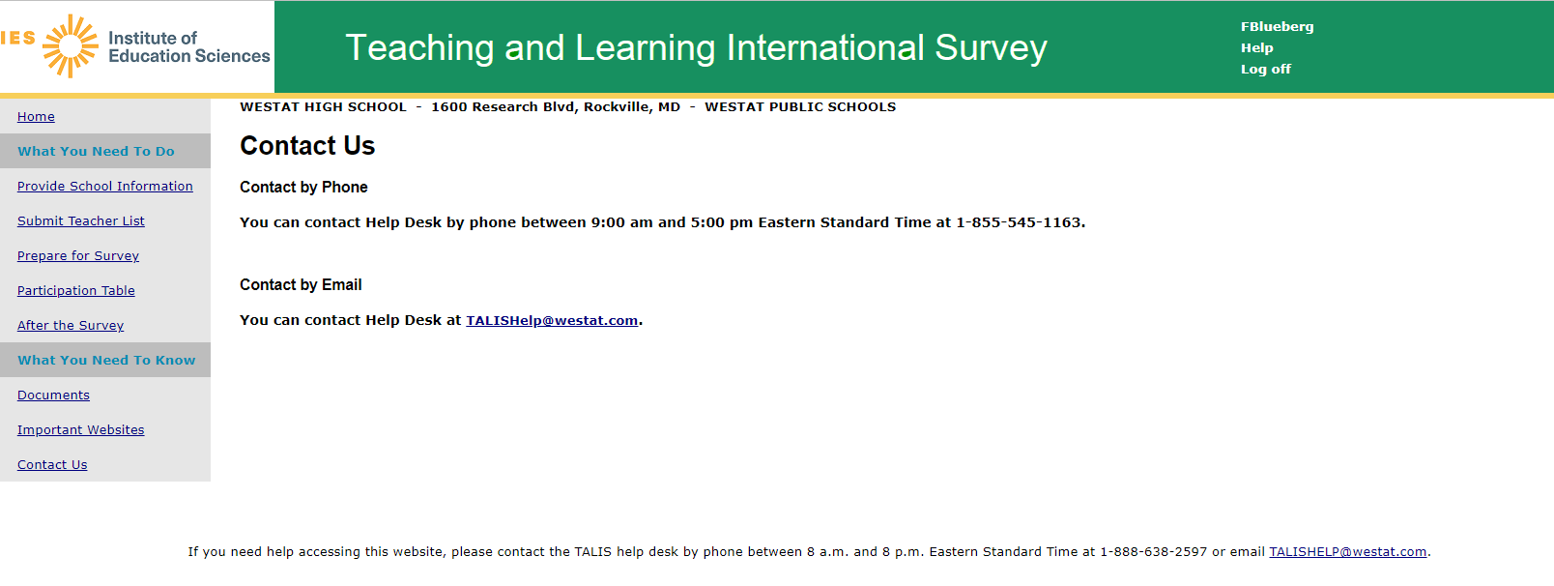

Contact Us screen text:

Contact Us

Contact by Phone

You can contact Help Desk by phone between 9:00 am and 5:00 pm Eastern Standard Time at 1-855-545-1163.

Contact by Email

You can contact Help Desk at TALISHelp@westat.com.

TALIS 2018 School Coordinator WebEx Presentation (will be updated for TALIS 2024)

The following pages show slides for an informational School Coordinator Webinar describing the activities that comprise the role of the TALIS School Coordinator. The webinar is presented shortly before teacher sampling begins within schools. The School Coordinator Webinar for TALIS 2024 is not yet updated because it is adapted from international materials and operational processes that have not yet been released to participating countries. We expect changes to the webinar materials will be minimal and will include references the current round of TALIS and updates to the specifics of the study, such as number of teachers to be sampled and timelines. An updated version of the webinar slides will be provided in an updated package in fall 2022.

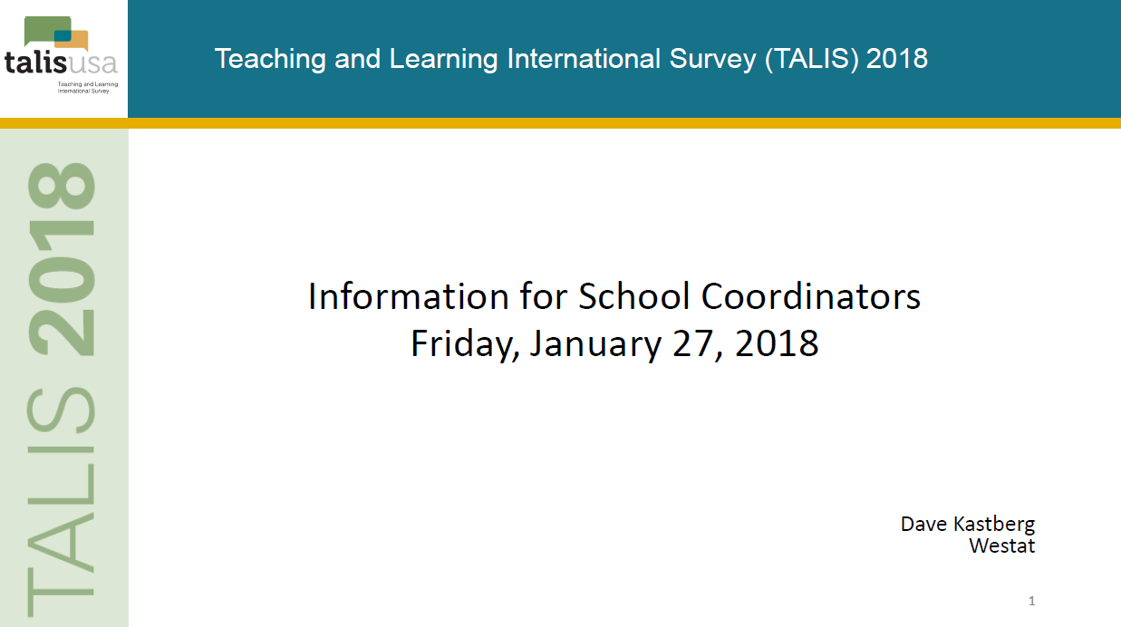

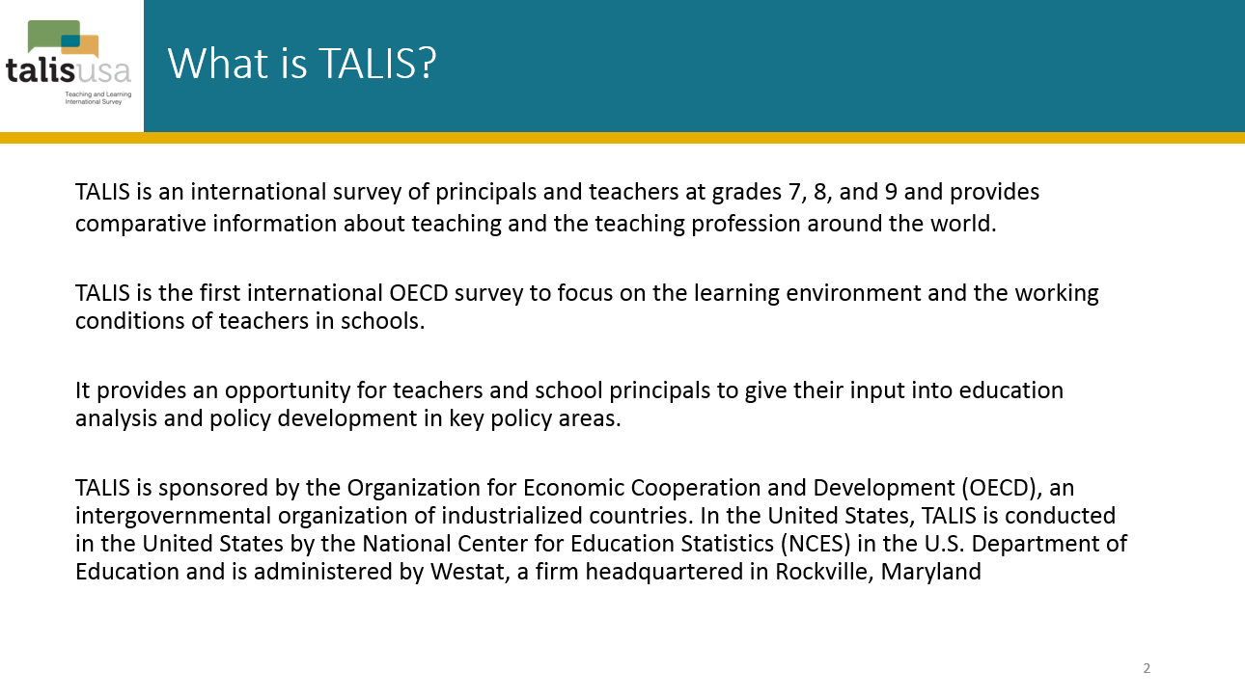

The last sentence in the slide above will read:
In the United States, TALIS is conducted by the National Center for Education Statistics (NCES) in the U.S. Department of Education and is administered by Westat, a firm headquartered in Rockville, Maryland.
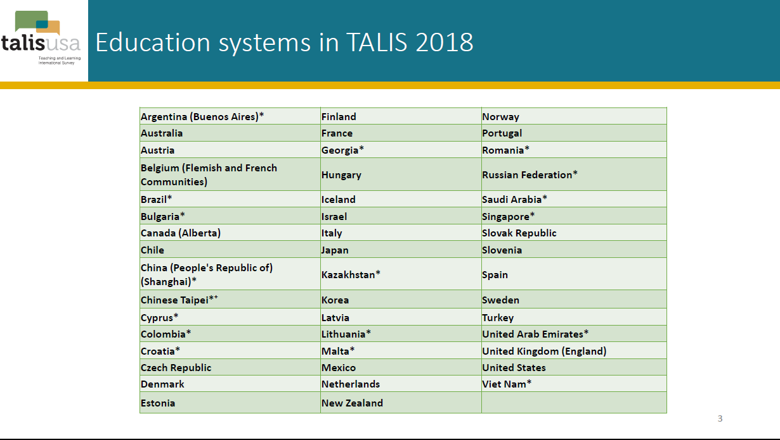

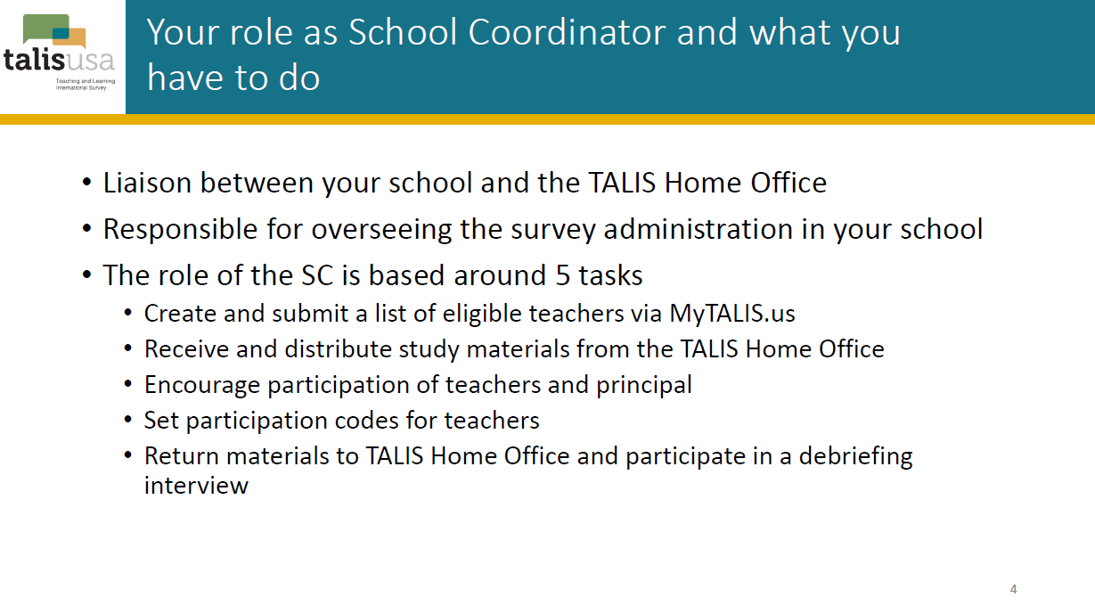

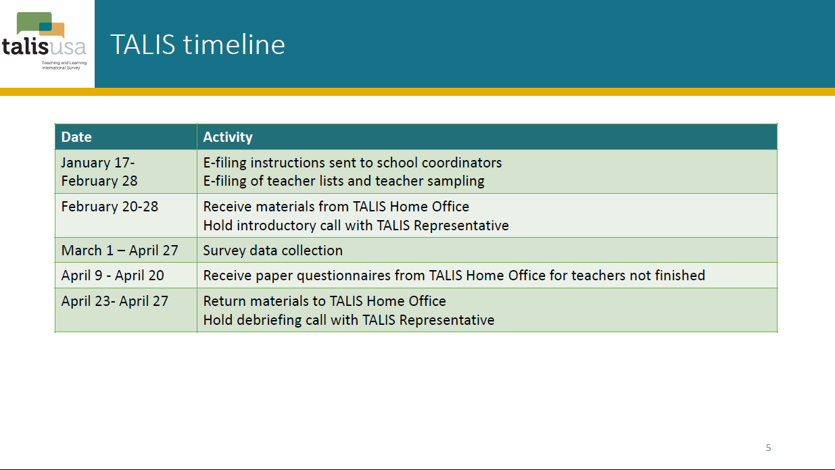

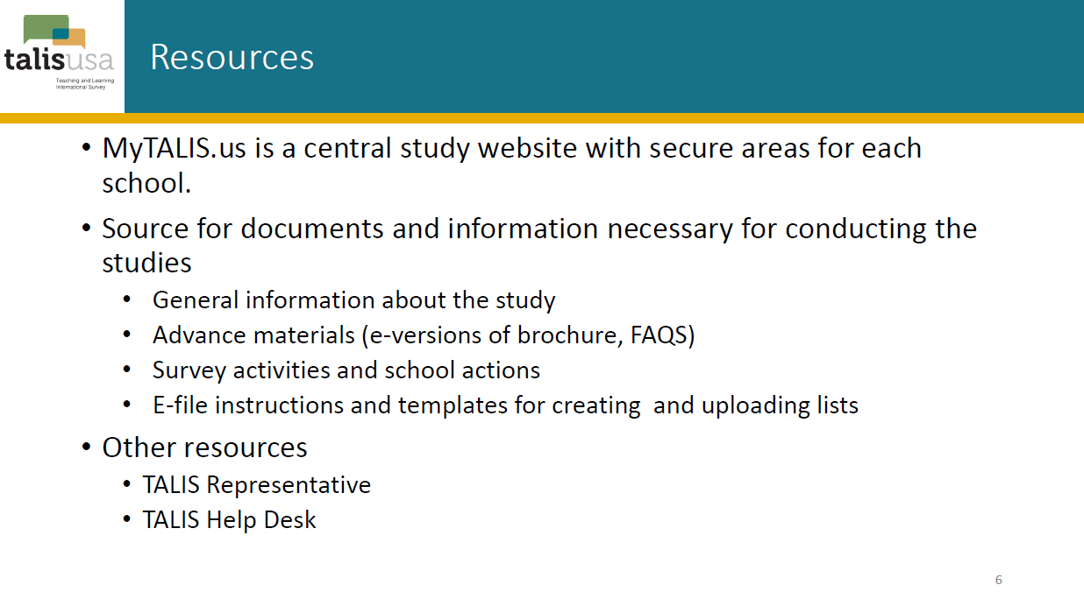

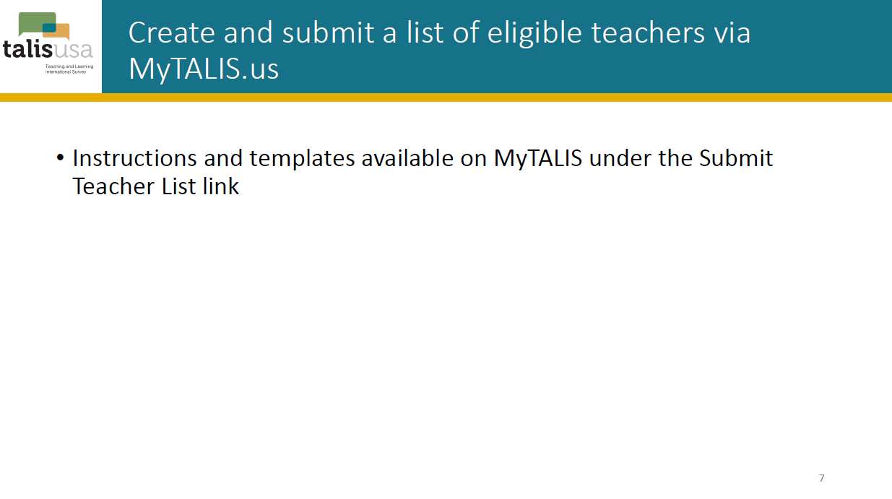

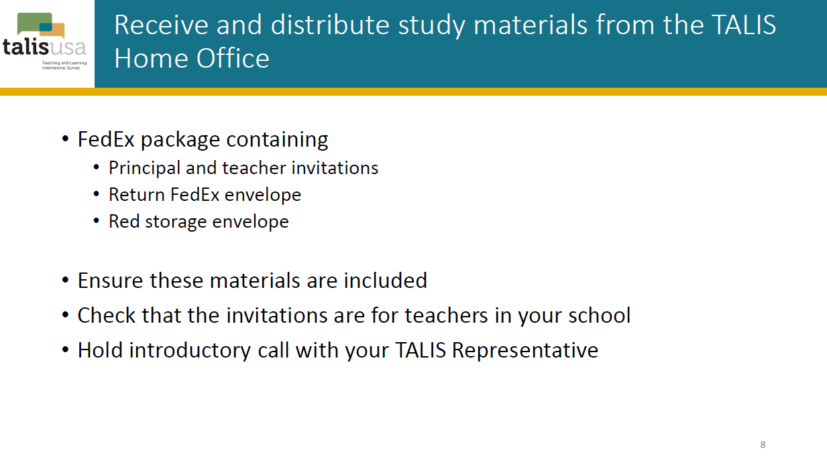

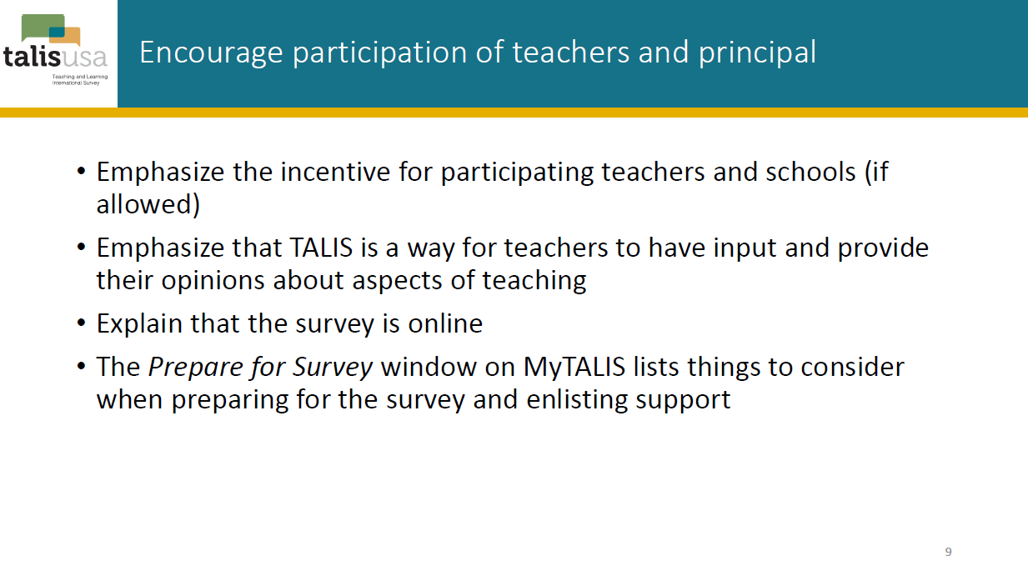

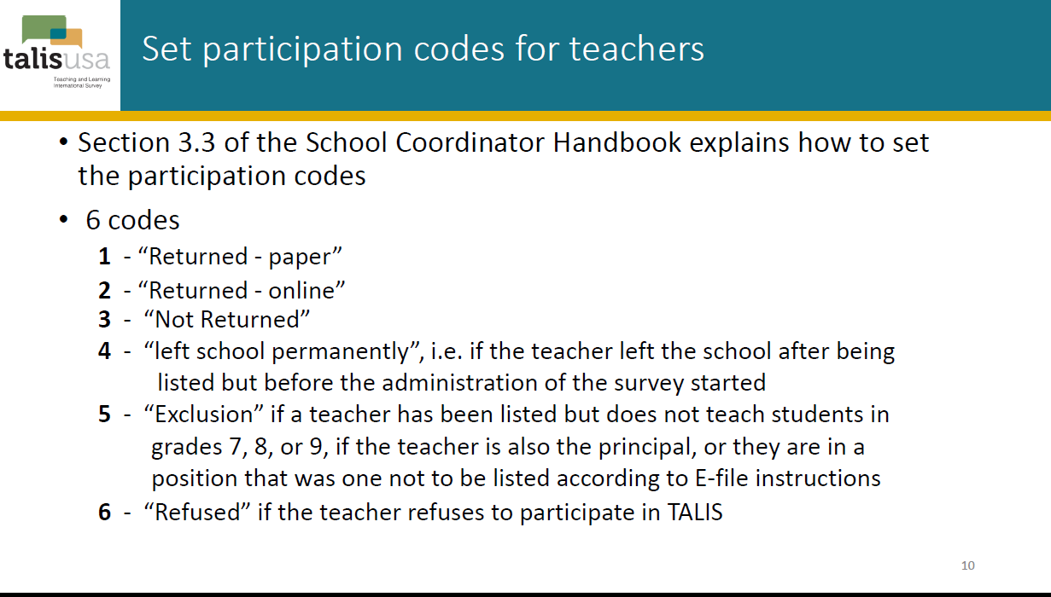

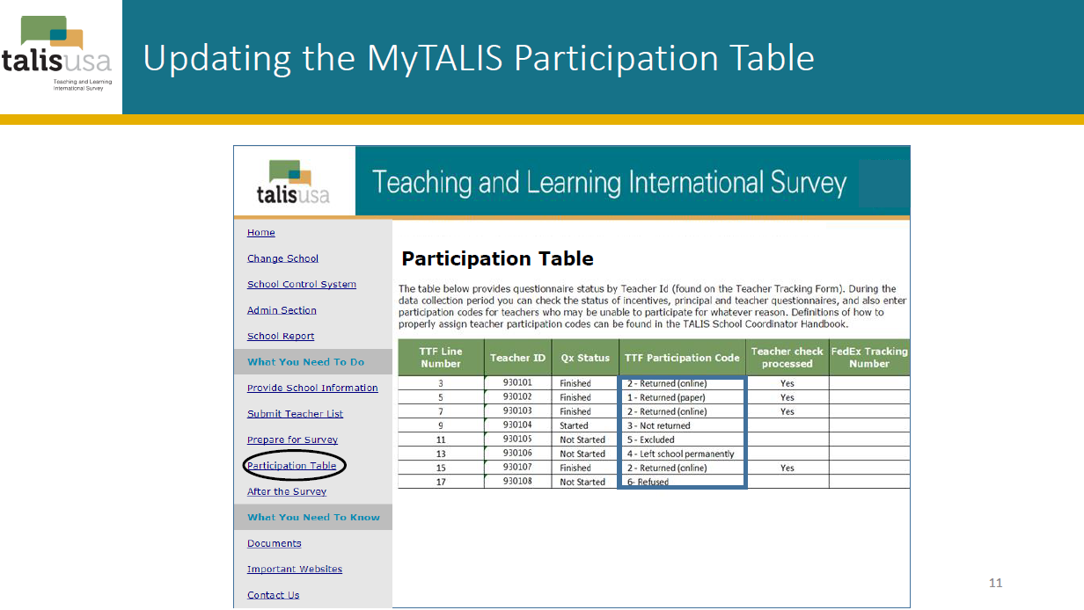

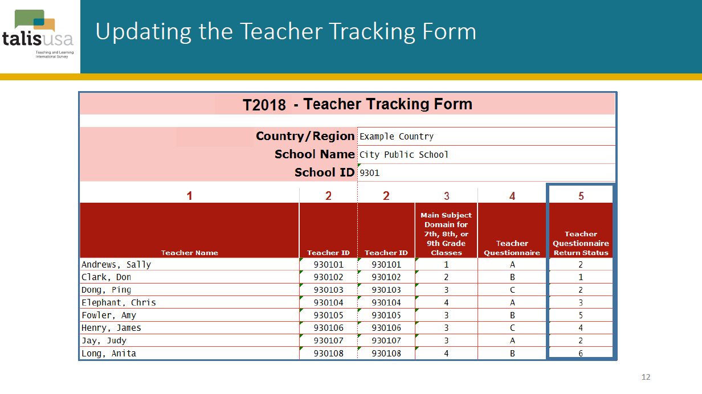

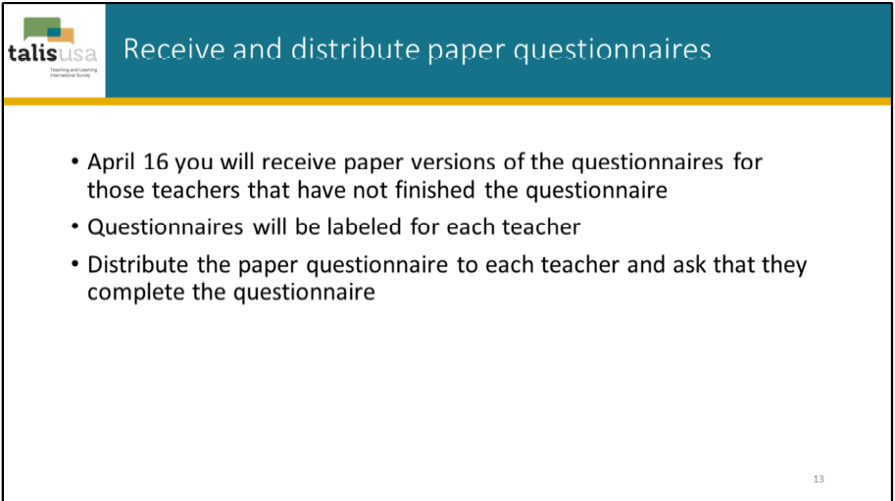

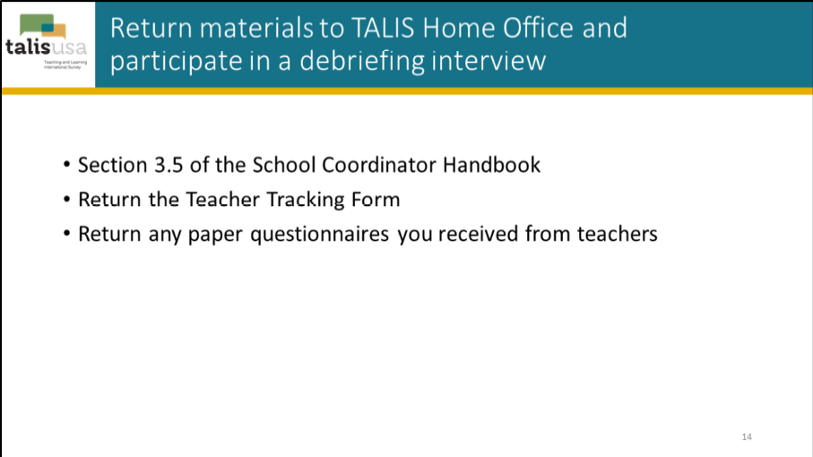

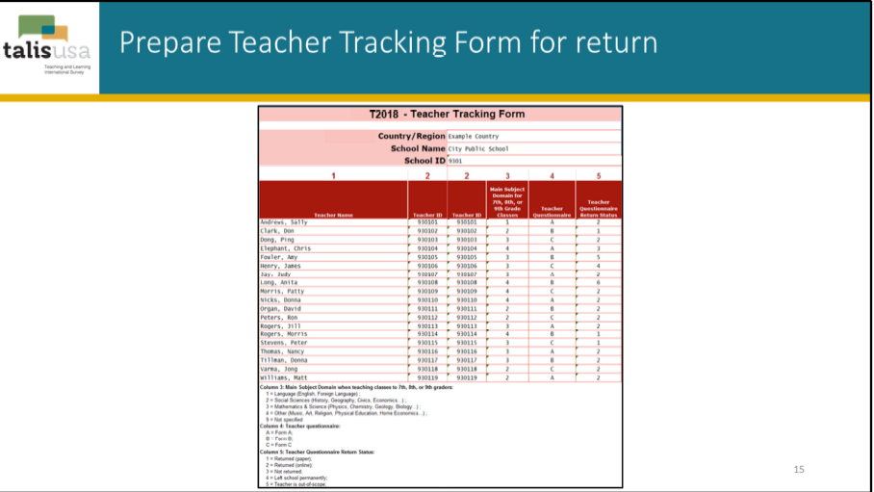

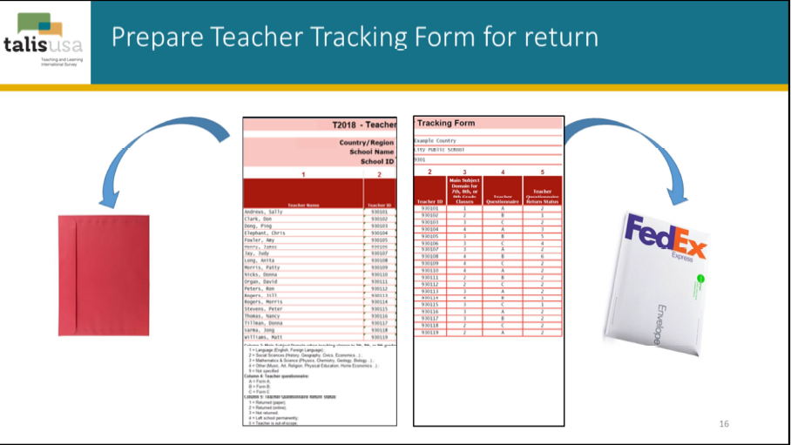

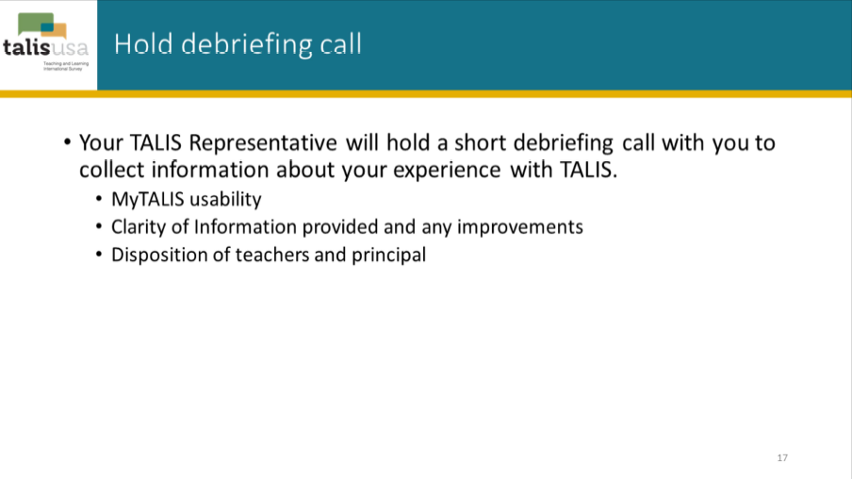

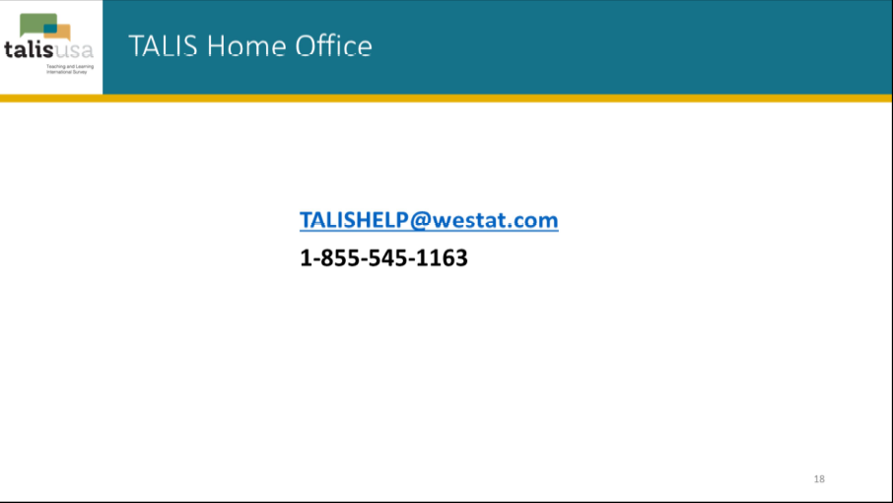

TALIS 2024 Field Test Generic District Application

CONTACT
Applicant: Dave Kastberg
Title: TALIS Study Director
Affiliation: Westat
Address: 1500 Research Blvd
Rockville, MD 20850
Phone: (301) 294-3811
E-mail: davidkastberg@westat.com

TALIS Research Application Contact:
David Kastberg, TALIS Study Director, Westat
1-301-294-3811
davidkastberg@westat.com

TITLE
Teaching and Learning International Survey (TALIS) 2024 Field Test
Anticipated Start Date: February 2023
Anticipated End Date: March 2023

PURPOSE OF THE STUDY

The Teaching and Learning International Survey (TALIS) is survey of teachers and principals focusing on the working conditions of teachers and the teaching and learning practices in schools. TALIS 2024 is focused on teachers’ professional environment, teaching conditions, and their impact on school and teacher effectiveness. TALIS 2024 will address teacher training and professional development, teacher appraisal, school climate, school leadership, instructional approaches, pedagogical practices, and teaching experience with and support for teaching diverse populations.

TALIS 2024 is sponsored by the Organization for Economic Cooperation and Development (OECD). The OECD is an international organization that works to build better policies, with one of the focal areas of interest in education and the education workforce. Therefore, TALIS is a survey that is fielded internationally. That is, 53 countries in 2024 are participating in TALIS. Each administration of TALIS is a collaborative effort by the participating countries, guided by their governments on the basis of shared policy driven interests.

In the U.S., TALIS 2024 is conducted by the U.S. Department of Education’s National Center for Education Statistics (NCES). The United States will administer TALIS for the third time in 2024, having participated in 2013 and 2018. TALIS 2024 will be administered across February and March of 2024.

Within the U.S., the TALIS 2024 administration will focus on middle school and junior high school (grades 7 through 9, lower secondary education). The administration of TALIS 2024 will include both classroom teachers in lower secondary education school programs as well as the principals of their schools.

In February and March of 2023, the TALIS 2024 field test will be administered. The purpose of the field test is to test the survey instruments and study procedures in preparation for the full-scale administration in 2024.

SIGNIFICANCE OF THE STUDY AND BENEFITS OF PARTICIPATION

Participating in TALIS 2024 will allow the U.S. to continue to compare with and learn from other countries working to improve their education systems using a variety of approaches. Reponses from school principals and teachers cover subjects such as professional development they have received; their teaching beliefs and practices; the review of teacher work and the feedback and recognition they received about their work; and various other school leadership, management, and workplace issues.
HYPOTHESES AND MEASUREMENT

As part of a continuing cycle of international education studies, the U.S., through NCES, is currently and in the coming years participating in several international assessments and surveys. TALIS 2024, sponsored by OECD, is one of these studies. TALIS 2024 is part of the larger international program that NCES has actively participated in through collaboration with and representation at the OECD. Through this active participation, NCES has sought to strengthen the quality, consistency, and timeliness of international data. To continue this effort, the U.S. must participate with well-organized and well-executed data gathering activities within the nation’s boundaries. These efforts allow NCES to build a comprehensive data network that reports on the status of education in the U.S. and informs decision-making at the national, state, and local levels.
TALIS 2024 focuses the following themes motivated by current theory and research. The results of TALIS 2024 will inform education policy and spur further investigation into differences within and between countries. Alternate sources for these data at a national level do not exist. Every participating country must implement two background questionnaires for TALIS 2024: a principal questionnaire and a Core teacher questionnaire. These questionnaires focus on the working conditions of teachers and the teaching and learning practices in schools:
Teachers’ instructional practices and beliefs: teaching practices and beliefs with a focus on classroom management, teachers’ views on resources of effective teaching, teachers’ openness to adopting innovative teaching practices, and their views on school conditions and incentives to foster innovation.
School leadership: the profile of school leadership and management styles (including indicators on the roles and functions of school leaders) and distributed/team leadership.
Teachers’ professional practices: teaching practices, cooperation among teaching staff, teaching special education needs students, the pedagogical use of technology (while ensuring there is no overlap with other studies), and student assessment practices.
Teacher education and initial preparation: duration of education, content of formal education or training, pedagogical content knowledge, general pedagogical knowledge, and practical experience.
Teacher feedback and development: in-service professional development (types of activities, participation rates, intensity of participation, mentoring, and induction programs), the needs and demands for in-service professional development, barriers preventing participation in in-service professional development, the perceived impact of in-service professional development, forms of professional development that impact teaching and other aspects of professional practice, connections between teacher feedback and development, feedback as a feature of effective professional development, and feedback supporting innovation in teaching practice.
School climate: disciplinary climate, teacher-student relations, teachers’ working time, and parent-teacher and parent-school relations.
Job satisfaction: overall job satisfaction, teacher perception of the value of the teaching profession, teachers’ views on the factors that would increase their job satisfaction, and perception of the value of the profession.
Teacher self-efficacy: the extent to which teachers feel capable of performing general teaching practices and specific instruction to foster 21st century skills, the relations between self-efficacy, job satisfaction, and further relevant teacher outcomes, individual differences in self-efficacy with respect to teachers’ age, education, gender, and school environment.
Diversity: policies and practices surrounding the recognition of diversity and supports for inclusion at the school and in the classroom.
Educational use of technology: teachers’ education and professional learning in the use of technology, teaching and professional practices, occupational perceptions, teacher attitudes toward and beliefs about technology, and school leadership and resources.
Social and emotional learning: student task performance, emotional regulation, collaboration, open-mindedness, engaging with others, and motivational aspects of learning.
In addition, TALIS 2024 includes a teacher questionnaire focused on teacher knowledge, including the below themes:
Teaching methods and lesson planning: productively utilizing instructional time through use of various teaching methods, knowing when and how to apply each method to promote students’ conceptual understanding of learning tasks, and structuring learning objectives, lessons, curricular units, and assessment.
Classroom management: maximizing instructional time through awareness of all classroom activity, handling multiple classroom events concurrently, pacing lessons appropriately to maintain momentum, providing clear directions, and maintaining student attention.
Learning and development: fostering individual learning through knowledge of various cognitive learning processes, including learning strategies, impact of prior knowledge, memory and information processing, causal attributions, effects and quality characteristics of praise, and opportunities for increasing student engagement.
Affective-motivational dispositions: knowledge of motivational learning processes and strategies to motivate a single student or whole group.
Evaluation and diagnosis procedures: knowledge of different forms and purposes of formative and summative classroom assessments, how various frames of reference impact student motivation, and quality of assessment.
Data and research literacy: knowledge of interpreting, evaluating, and using research and data to inform the teaching and learning process.
QUESTIONNAIRES
Copies of the draft TALIS 2024 questionnaires for public schools are enclosed.
The school, principal, and teacher questionnaire modules are described below. Additional information about TALIS is available at https://nces.ed.gov/surveys/talis/.
Every participating country must implement two questionnaires for TALIS 2024: a principal questionnaire and a Core teacher questionnaire. In addition to the principal and Core teacher questionnaires, the US is participating in the Teacher Knowledge Survey (TKS). Themes captured in the teacher and principal questionnaires are presented above, within Hypotheses and Measurement.
METHODOLOGY AND SAMPLING
On behalf of NCES, Activate Research Inc. and Westat are the data collection contractors for TALIS 2024 data. TALIS 2024 is a self-administered survey that is offered to respondents through an online survey. The survey does not require the use of any school personnel to administer it, other than the direct time it takes for the respondent to complete the questionnaire. The survey does not involve students. There is no use of classroom time required for the completion of these questionnaires.
Sampled schools are asked to assign a school coordinator to serve as a central point of contact for TALIS 2024. The school coordinator provides assistance arranging for the study within each school and prepares a list of all eligible teachers in the school to be used in the selection of a sample of teachers within the school.
For the field test, the U.S. plans to select a sample of 40 schools in ten states: Connecticut, Delaware, Iowa, Idaho, Louisiana, Michigan, Oklahoma, Rhode Island, Utah, and West Virginia. The U.S. will sample approximately 1,400 teachers within these schools. Sampling for TALIS 2024 begins by selecting schools and then including the principal and a sample of approximately 35 teachers within each selected school, with approximately 20 teachers sampled for the Core TALIS and 15 sampled for the TKS.
DATA COLLECTION
TALIS 2024 will administer online questionnaires to principals and a sample of teachers within each participating school. Each participant will receive an electronic invitation, over email, to participate in TALIS 2024. Within this e-mail there will be a URL and access information for completing the questionnaire. In addition to the e-mail invitation, hard copy invitations will also be sent to the school coordinator with instructions for the school coordinator to distribute these to the sampled teachers. In the rare instance that e-mail is not an option, hard copy invitations will be the primary mode of survey invitation.
One week after the opening of the online questionnaires and on a weekly basis thereafter, TALIS 2024 study staff will send reminder emails to respondents who have not started or completed their questionnaires. During the final week of the assessment window the TALIS 2024 study staff will make follow-up contacts with the school coordinators requesting them to encourage teachers and principals to complete their questionnaires prior to the end of the field period.

The planned data collection schedule is outlined below.
TALIS 2024 Field Test Planned Timetable | Approximate Schedule
Invitation to complete the survey | February 2023
Weekly reminders | February through March 2023
Final week of study window, follow-up with school coordinators with a request to follow-up with principals and teachers | March 2023

RESPONSE BURDEN
TALIS 2024 relies on the voluntary participation of the principal, teachers, and school personnel. Every effort is made to create questionnaires that collect in-depth data without putting an undue burden on the respondent. The estimated average response time for each questionnaire in the TALIS 2024 is shown below.
TALIS 2024 respondent | Estimated average response time per respondent
Principal questionnaire | 45 minutes
Teacher questionnaires (Core and TKS) | 60 minutes

TALIS 2024 does not require student or parent participation, and no classroom time is required for completion of the questionnaires. All participation is voluntary. There are no penalties for not participating in the study. When completing the questionnaires, respondents can skip any question they do not want to answer.
Each participating school has a designated school coordinator to support the conduct of the study. The estimate for the school coordinators support is generously estimated to be 240 minutes, spread across creating and submitting the list of teachers; receiving and distributing the hard copy invitations; and encouraging participation of the teachers and the principal.
ANALYSIS AND RELEASE OF INFORMATION
For the TALIS 2024 field test there will be no published report of the findings. For the main study, an analysis of the U.S. and international data will be conducted to report on the U.S. national results in relation to the international results. Based on proposed analyses of the international data set by the IC, and the need for NCES to report results from the perspective of a U.S. constituency, a statistical analysis of the U.S. national data set as compared to the international data set will be conducted. Analysis of data will include examinations of the survey instruments of U.S. teachers and school principals in relation to their international counterparts. All reports and publications will be coordinated with the release of information from the international organizing body.

BENEFIT TO YOUR SCHOOL DISTRICT
TALIS 2024 offers the opportunity for teachers and principals to provide input into education analysis and policy development. Cross-country analysis of these data allows countries to identify other countries facing similar challenges and to learn from other policy approaches. School principals and teachers will provide information about issues such as the professional development they have received; their teaching beliefs and practices; the review of teachers’ work and the feedback and recognition they receive about their work; and various other school leadership, management, and workplace issues.

TALIS 2024 is part of the OECD’s Education Indicators Project (INES), helping to create a system of indicators for cross-national comparisons in education. INES achieves its purpose by collecting and analyzing a set of key indicators for international comparison; providing an international forum for the exchange of methods and practices of developing and using education indicators for national policymakers; and contributing to evaluation methodology and developing more valid, reliable, and comprehensive indicators for use in policymaking. TALIS 2024 has been designed to increase the international information available to OECD countries on teachers, teaching, and the impact that teachers can have on student learning. The overall objective of TALIS 2024 is to provide international indicators and policy-relevant analysis on teachers and teaching to help countries develop and review policies that create the conditions for effective schooling.

All districts ultimately benefit when good data help legislators and administrators make good decisions. The ability of NCES to provide this important information is contingent upon the voluntary participation of sampled schools, principals, and teachers; participation of these schools and staff is dependent upon their districts’ approval. Because your district and its schools and staff represent themselves and many others like them, your and your schools’ participation is crucial for producing high quality information. By participating in this this survey, you will ensure that information about your district’s schools, principals, and teachers is included in those important decisions.
CONFIDENTIALITY
Data security and confidentiality protection procedures have been put in place for TALIS 2024 to ensure that the contractor and its subcontractors comply with all privacy requirements, including:
- The statement of work of this contract;
- Family Educational Rights and Privacy Act (FERPA) of 1974 (20 U.S.C. §1232(g));
- Privacy Act of 1974 (5 U.S.C. §552a);
- Privacy Act Regulations (34 CFR Part 5b);
- Computer Security Act of 1987;
- U.S.A. Patriot Act of 2001 (P.L. 107-56);
- Education Sciences Reform Act of 2002 (ESRA 2002, 20 U.S.C. §9573);
- Cybersecurity Enhancement Act of 2015 (6 U.S.C. §151);
- Foundations of Evidence-Based Policymaking Act of 2018, Title III, Part B, Confidential Information Protection;
- The U.S. Department of Education General Handbook for Information Technology Security General Support Systems and Major Applications Inventory Procedures (March 2005);
- The U.S. Department of Education Incident Handling Procedures (February 2009);
- The U.S. Department of Education, ACS Directive OM: 5-101, Contractor Employee Personnel Security Screenings;
- NCES Statistical Standards; and
- All new legislation that impacts the data collected through the contract for this study.
Furthermore, the companies conducting TALIS 2024, Activate Research Inc. and Westat, comply with the U.S. Department of Education’s IT security policy requirements as set forth in the Handbook for Information Assurance Security Policy and related procedures and guidance, as well as IT security requirements in the Federal Information Security Modernization Act (FISMA), Federal Information Processing Standards (FIPS) publications, Office of Management and Budget (OMB) Circulars, and the National Institute of Standards and Technology (NIST) standards and guidance. All data products and publications will also adhere to the revised NCES Statistical Standards, as described at the website: https://nces.ed.gov/statprog/2012/.
By law (20 U.S.C. §9573), a violation of the confidentiality restrictions is a felony, punishable by imprisonment of up to 5 years and/or a fine of up to $250,000. TALIS procedures for maintaining confidentiality include notarized nondisclosure affidavits obtained from all personnel who will have access to individual identifiers; personnel training regarding the meaning of confidentiality; controlled and protected access to computer files; built-in safeguards concerning status monitoring and receipt control systems; and a secure, staffed, in-house computing facility. TALIS follows detailed guidelines for securing sensitive project data, including, but not limited to physical/environment protections, building access controls, system access controls, system login restrictions, user identification and authorization procedures, encryption, and project file storage/archiving/destruction.

Additionally, the companies conducting TALIS 2024, Activate Research Inc. and Westat, take security measures to protect the web data collection applications from unauthorized access. The U.S. Department of Education has established a policy regarding the personnel security screening requirements for all contractor employees and their subcontractors. Activate Research Inc. and Westat comply with these personnel security screening requirements throughout the life of the contract, including several requirements that Activate Research Inc. and Westat must meet for each employee working on the contract for 30 days or more. Among these requirements are that each person working on the contract must be assigned a position risk level. The risk levels are high, moderate, and low based upon the level of harm that a person in the position can cause to the Department’s interests. Each person working on the contract must complete the requirements for a “Contractor Security Screening.” Depending on the risk level assigned to each person’s position, a follow-up background investigation by the Department will occur.

The laws pertaining to the use of personally identifiable information are clearly communicated in correspondence with states, districts, school administrators, and teachers. The following language will be included in respondent contact materials and on data collection instruments:
The National Center for Education Statistics (NCES) is authorized to conduct the Teaching and Learning International Survey (TALIS) by the Education Sciences Reform Act of 2002 (ESRA 2002, 20 U.S.C. §9543). The data are being collected for NCES by Westat, a U.S.-based research organization. All of the information you provide may be used only for statistical purposes and may not be disclosed, or used, in identifiable form for any other purpose except as required by law (20 U.S.C. §9573 and 6 U.S.C. §151).

Login pages and the front cover of each data collection instrument, including questionnaires, also include the following statement:

According to the Paperwork Reduction Act of 1995, no persons are required to respond to a collection of information unless such collection displays a valid OMB control number. The valid OMB control number for this voluntary information collection is 1850-0888. The time required to complete this information collection is estimated to average up to [45/60] minutes per [teacher/school administrator], including the time to review instructions, gather the data needed, and complete and review the information collection. If you have any comments or concerns regarding the accuracy of the time estimate(s), suggestions for improving the form, or questions about the status of your individual submission of this form, write directly to: Teaching and Learning International Survey (TALIS), National Center for Education Statistics (NCES), Potomac Center Plaza, 550 12th Street, SW, 4th floor, Washington, DC 20202.
OMB No. 1850-0888, Approval Expires MM/DD/2025

Data collected during the TALIS 2024 field test will not be released to the public or researchers other than the OECD as described above. Activate Research Inc. and Westat will conduct a thorough disclosure risk analysis of the TALIS 2024 main study data when preparing the data files for use by researchers, in compliance with ESRA (20 U.S.C. §9573). Schools with high disclosure risk will be identified and, to ensure that individuals may not be identified from the data files, a variety of masking strategies will be used. The U.S. Department of Education’s National Center for Education Statistics (NCES) Disclosure Review Board (DRB) carefully reviews all datasets prior to release to ensure that disclosure risks have been properly addressed. The TALIS 2024 data will be reviewed and approved by the DRB prior to any public release, as has been the protocol for all previous rounds of TALIS.

INSTITUTIONAL REVIEW BOARD (IRB) OR HUMAN SUBJECTS REVIEW
Under the federal policy for the protection of human subjects, TALIS 2024 is exempt from IRB review because it utilizes survey procedures and is conducted in established or commonly accepted educational settings, involving normal educational practices. There is no potential for harm to human subjects.

The U.S. Department of Education has adopted a common set of regulations known as the Federal Policy for the Protection of Human Subjects or "Common Rule." The design of these regulations is based on established, internationally recognized ethical principles. The specific regulation is Title 34, Code of Federal Regulations, Part 97, Protection of Human Subjects, which includes Subpart A, Basic Policy, and Subpart D, Additional Protections for Children. These regulations classify as exempt certain categories of research. Research that is nonexempt is covered by the regulations. Research activities in which the only involvement of human subjects will be in one or more of the following categories are exempt [34 CFR 97.101(b)(2)]:
Research involving the use of educational tests (cognitive, diagnostic, aptitude, achievement), survey procedures, interview procedures or observation of public behavior, unless the information identifies the subjects and disclosure could reasonably place the subjects at risk of criminal or civil liability or be damaging to the subjects' financial standing, employability, or reputation. Subpart D amends this exemption, in part: If the subjects are children, research involving interview or survey procedures and research involving observations of public behavior in which the researcher(s) participate in the activities being observed are not exempt. However, research involving the use of educational tests and research involving observations of public behavior in which the researcher(s) do not participate in the activities being observed are exempt.
For more information, please see http://www2.ed.gov/policy/fund/guid/humansub/overview.html.
INFORMED CONSENT
The nature of this self-administered, cross-sectional survey is not considered intrusive, and has been ruled to be exempt under the protection of human subjects’ provisions in federal research. There are no individual student data (such as test scores or Social Security numbers) associated with any of the data acquired in this data collection. Since no data are collected about individual students, it is not necessary to obtain active, informed consent from students’ parents/guardians.
Participation in the TALIS 2024 is completely voluntary, and individual survey items can be left blank, at the discretion of each respondent. A respondent gives implied consent to participate by completing the TALIS 2024 questionnaire.

