Uniform Relocation Assistance and Real Property Acquisition for Federal and Federally Assisted Programs
Final Rule Regulatory Impact Analysis
Docket FHWA-2018-0039

July 19, 2023

Prepared for:
Federal Highway Administration
Office of Real Estate Services
Washington, DC

Notice

This document is disseminated under the sponsorship of the U.S. Department of Transportation in the interest of information exchange. The United States Government assumes no liability for the contents or use thereof.

The U.S. Government does not endorse products or manufacturers. Trade or manufacturers’ names appear herein solely because they are considered essential to the objective of this report.

REPORT DOCUMENTATION PAGE |  |  |  | Form Approved  OMB No. 0704-0188
Public reporting burden for this collection of information is estimated to average 1 hour per response, including the time for reviewing instructions, searching existing data sources, gathering and maintaining the data needed, and completing and reviewing this collection of information. Send comments regarding this burden estimate or any other aspect of this collection of information, including suggestions for reducing this burden to Department of Defense, Washington Headquarters Services, Directorate for Information Operations and Reports (0704-0188), 1215 Jefferson Davis Highway, Suite 1204, Arlington, VA 22202-4302. Respondents should be aware that notwithstanding any other provision of law, no person shall be subject to any penalty for failing to comply with a collection of information if it does not display a currently valid OMB control number. PLEASE DO NOT RETURN YOUR FORM TO THE ABOVE ADDRESS.
1. AGENCY USE ONLY (Leave blank) |  | 2. REPORT DATE  July 19, 2023 |  | 3. REPORT TYPE AND DATES COVERED
4. TITLE AND SUBTITLE  Uniform Relocation Assistance and Real Property Acquisition for Federal and federally assisted Programs: Final Rule Regulatory Impact Analysis |  |  |  |  | 5a. FUNDING NUMBERS  693JJ319N300029
6. AUTHOR(S)  Catherine Taylor; Sarah Plotnick; Faisal Ajam; Emily Futcher; Carson Poe; Melissa Corder; Arnold Feldman |  |  |  |  | 5b. CONTRACT NUMBER  N/A
7. PERFORMING ORGANIZATION NAME(S) AND ADDRESS(ES)  U.S. Department of Transportation Volpe National Transportation Systems Center  55 Broadway, Kendall Square  Cambridge, MA 02142 |  |  |  |  | 8. PERFORMING ORGANIZATION REPORT NUMBER
9. SPONSORING/MONITORING AGENCY NAME(S) AND ADDRESS(ES)  U.S. Department of Transportation, Federal Highway Administration  Office of Real Estate Services  1200 New Jersey Ave, SE  Washington, DC 20590 |  |  |  |  | 10. SPONSORING/MONITORING  AGENCY REPORT NUMBER
11. SUPPLEMENTARY NOTES

12a. DISTRIBUTION/AVAILABILITY STATEMENT |  |  |  |  | 12b. DISTRIBUTION CODE
13. ABSTRACT (Maximum 200 words)
This regulatory impact analysis estimates the costs and benefits associated with the final rule for the Uniform Relocation Assistance and Real Property Acquisition Policies Act of 1970.
14. SUBJECT TERMS |  |  |  |  |  | 15. NUMBER OF PAGES  79
 |  |  |  |  |  | 16. PRICE CODE
17. SECURITY CLASSIFICATION  OF REPORT | 18. SECURITY CLASSIFICATION  OF THIS PAGE |  | 19. SECURITY CLASSIFICATION  OF ABSTRACT |  |  | 20. LIMITATION OF ABSTRACT
Standard Form 298 (Rev. 2-89)
Prescribed by ANSI Std. 239-18

Contents
List of Figures 7
List of Tables 7
Abbreviations and Acronyms 8
Executive Summary 9
1. Background 12
1.1 Summary of Proposed and Final Rule 12
1.2 Legislative History 13
1.3 Program Responsibilities and Expenditure Areas 14
1.4 Need for Regulatory Action 14
1.4.1 MAP-21 Mandates 15
1.4.2 Interagency Coordination 16
1.4.3 Practitioner Input and Research 17
1.5 Notice of Proposed Rulemaking 18
1.6 Affected Entities 19
1.7 Assumptions and Methodology for Cost-Benefit Analysis 21
2. Residential Displacements 22
2.1 Background 22
2.2 Data 22
2.3 Revising Maximum Replacement Housing Payment (RHP) and Rental Replacement Housing Payment (RRHP) 23
2.3.1 Administrative Cost Savings 24
2.3.2 Transfers (Increased Program Expenditures) 27
2.4 Homeowner 90 Day Eligibility 27
2.4.1 Administrative Cost Savings 27
2.4.2 Transfers (Increased Program Expenditures) 29
2.5 Reverse Mortgages 30
2.5.1 Benefits 30
2.5.2 Transfers (Increased Program Expenditures) 31
2.5.3 Costs 31
2.6 Rental Application and Credit Check Fees 32
2.6.1 Benefits 32
2.6.2 Transfers (Increased Program Expenditures) 33
2.7 Residential Self-Moves 34
2.7.1 Administrative Cost Savings 34
2.7.2 Transfer (Increased Program Expenditures) 35
3. Non-residential Displacements 36
3.1 Background 36
3.2 Data 37
3.3 Reimbursement for Updating Other Media 38
3.3.1 Benefits 38
3.3.2 Transfers (Increased Program Expenditures) 39
3.4 Search Expenses 39
3.4.1 Benefits 39
3.4.2 Transfers (Increased Program Expenditures) 40
3.5 Re-establishment expenses 43
3.5.1 Benefits 43
3.5.2 Transfers (Increased Program Expenditures) 44
3.6 Fixed Payment In-Lieu-of Moving Expenses 47
3.6.1 Benefits 47
3.6.2 Transfers (Increased Program Expenditures) 48
3.7 Move Cost Finding 51
3.7.1 Administrative Cost Savings 51
3.7.2 Transfer (Increased Program Expenditures) 51
4. Program Administration 52
4.1 Appraisal Waiver Valuations 52
4.1.1 Benefits 52
4.1.2 Transfer (Increased Program Expenditures) 52
4.2 First and Second Tier Waiver Valuations 52
4.2.1 Benefits 53
4.2.2 Transfer (Increased Program Expenditures) 53
4.3 Third Tier of Waiver Valuations 53
4.3.1 Benefits 53
4.3.2 Transfer (Increased Program Expenditures) 53
4.4 Use of Single Agents 53
4.4.1 Benefits 54
4.4.2 Transfer (Increased Program Expenditures) 54
4.5 Inspection of Comparable Replacement Dwellings 54
4.5.1 Benefits 55
4.5.2 Transfer (Increased Program Expenditures) 55
4.6 Other Clarifications and Streamlining 55
4.6.1 Benefits 57
4.6.2 Costs 57
4.7 Legal Status Verification 57
4.7.1 Benefits 58
4.7.2 Transfers (Increased Program Expenditures) 58
4.8 Revising Program Materials 58
4.8.1 Benefits 58
4.8.2 Costs 58
4.9 Federal Agency Reporting Requirement 59
4.9.1 Benefits 60
4.9.2 Costs 60
5. Summary 61
6. Appendix 65

List of Figures
Figure 1. Residential Relocations (FHWA) 23
Figure 2. Last Resort Housing as a Percent of All Residential Displacements (FHWA) 25
Figure 3. Non-Residential Displacements (FHWA) 37
Figure 4. Non-Residential In-Lieu-Of Payments (FHWA) 38

List of Tables
Table 1. Federal Agencies Potentially Subject to the Uniform Act 20
Table 2. Benefits from Increasing Maximum Amounts for Replacement Housing Assistance (FHWA) 27
Table 3. Administrative Cost Savings from Changing Homeowner Eligibility from 180 days to 90 days (FHWA) 28
Table 4. Transfers (Increased Program Expenditure) from Changing Homeowner Eligibility from 180 days to 90 days (FHWA) 30
Table 5. Administrative Costs of Reverse Mortgages (All Agencies) 32
Table 6. Transfers (Increased Program Expenditures) from Reimbursing Rental Application and Credit Check Fees 34
Table 7. Non-Residential Maximum Payments 37
Table 8. Change in Search Expense Reimbursement for Non-residential Relocations (FHWA) 43
Table 9. Change in Re-establishment Expense for Non-residential Relocations (FHWA) 47
Table 10. Change in Fixed Payments In-Lieu-of Moving Costs for Non-residential Relocations (FHWA) 51
Table 11. Costs to Update Program Materials (All Agencies) 59
Table 12. Costs for Annual Reporting (All Agencies) 61

Abbreviations and Acronyms

BRARS | Business Relocation Assistance Retrospective Study
CFR | Code of Federal Regulations
DOD | U.S. Department of Defense
DOE | U.S. Department of Energy
DOI | U.S. Department of the Interior
DOJ | U.S. Department of Justice
DOT | U.S. Department of Transportation
DSS | Decent, Safe, and Sanitary
EPA | U.S. Environmental Protection Agency
FAA | Federal Aviation Administration
FEMA | Federal Emergency Management Agency
FHWA | Federal Highway Administration
FRA | Federal Railroad Administration
FTA | Federal Transit Administration
GAO | U.S. Government Accountability Office
GSA | General Services Administration
HHS | U.S. Department of Health and Human Services
HUD | U.S. Department of Housing and Urban Development
MAP-21 | Moving Ahead for Progress in the 21st Century
NASA | National Aeronautics and Space Administration
RHP | Replacement Housing Payment—Owners
RRHP | Rental Replacement Housing Payment—Tenants
RUS | Rural Utilities Service
TVA | Tennessee Valley Authority
Uniform Act | Uniform Relocation Assistance and Real Property Acquisition Policies Act of 1970
USACE | U.S. Army Corp of Engineers
USDA | U.S. Department of Agriculture
VA | U.S. Department of Veterans Affairs

Executive Summary

The Uniform Relocation Assistance and Real Property Acquisition Policies Act of 1970 (Uniform Act) provides important protections and assistance for people affected by federally funded projects. Congress passed the law to safeguard people whose real property is acquired or who move from their homes, businesses, nonprofit organizations, or farms as a result of projects receiving Federal funds. The Moving Ahead for Progress in the 21st Century Act (MAP-21) modified the statutory payment levels for which displaced persons may be eligible under the Uniform Act’s implementing regulations, necessitating the current rule. In addition, the Federal Highway Administration (FHWA) is making changes to wording and section organization to better reflect the Federal experience implementing Uniform Act programs since the last comprehensive rulemaking for 49 CFR 24, which occurred in 2005. At the Federal level, 14 departments and 5 independent Agencies are subject to the Uniform Act, and their input was reflected in the Notice of Proposed Rulemaking (NPRM). Subsequent to the NPRM, FHWA responded to additional input from those Federal Agencies, recipients, and other members of the public. The final rule reflects that input.
This regulatory evaluation is largely similar to the regulatory evaluation of the NPRM. However, it has been revised to reflect changes in the final rule compared to the NPRM and to update the analysis given that roughly 3 years have passed since the analysis conducted for the NPRM. No public comments were received related to the Regulatory Impact Analysis (RIA) for the NPRM.
The costs of the final rule over 10 years for all Uniform Act Agencies are estimated to be $2.2 million when discounted at 7 percent and $2.4 million when discounted at 3 percent. The annualized costs are estimated to be $311,000 per year when discounted at 7 percent and $283,000 per year when discounted at 3 percent. The larger impact of this final rule is in the form of transfers from the displacing Agencies to property owners whose real estate is acquired for Federal projects. Transfers over the 10-year analysis period resulting from this rule are estimated to be $169.5 million when discounted at 7 percent and $214.6 million when discounted at 3 percent or roughly $24.1 million per year when annualized at 7 percent or $25.2 million per year when annualized at 3 percent. This rule can therefore be thought of as predominantly a transfer rule, as the estimated social costs are significantly smaller than those transfers from the displacing Agencies to those compensated. The FHWA was the only Agency that provided data upon which to base estimates of the transfers. Therefore, the magnitude of the change in transfers for all Federal Agencies may be somewhat larger than is reported here.
The bulk of the estimated costs are related to updating program materials to reflect the changes in the final rule. In addition, some smaller recipient and Federal Agency administrative cost savings have been estimated. Again, FHWA was the only Agency that had a detailed data set available for its Uniform Act Program, and therefore only the administrative cost savings to FHWA have been estimated here. Based on communications with other Uniform Act Agencies, FHWA analysts believe that FHWA has the largest Uniform Act Program; however, other Agencies have sizable programs as well. Therefore, the total cost savings across all Agencies will likely be larger.
The benefits of the final rule primarily relate to improved equity and fairness to entities that are displaced from their properties or that move as a result of projects receiving Federal funds. For example, the final rule raises the statutory maximums for payments to displaced entities to assist with the re-establishment of the business, farm, or nonprofit organization. There is strong evidence that entities experience re-establishment costs well above the current maximum amount. Raising the maximum payment levels would compensate those entities more fairly and equitably for the negative impacts they experience as a result of a Federal or federally assisted project. However, the fairness and equity benefits of the final rule cannot be quantified or monetized. The higher level of payments may also contribute to more entities being able to successfully re-establish after displacement.
The final rule contains changes, such as a requirement for annual reporting, that can be expected to improve transparency, and, therefore, oversight of the program. Again, that benefit is not quantified or monetized.
The table below offers a summary of the costs and benefits of the final rule over the 10-year analysis period. Given that the benefits of the rule related to equity and fairness have not been quantified, it would be misleading to report a calculation of net benefits for this final rule. Nonetheless, the benefits related to equity and fairness are believed to be sufficient to justify the cost of the final rule.
Summary of Costs and Benefits for Analysis Period 2023-2032
Item | Discounted 7% | Discounted 3% | Annualized 7% | Annualized 3%
Costs
Reverse Mortgages | $29,046 | $36,647 | $4,136 | $4,296
Revising Program Materials | $2,216,271 | $2,451,123 | $315,547 | $287,346
Federal Agency Reporting Requirement | $184,582 | $232,883 | $26,280 | $27,301
Cost Savings
Revising Max. RHP/RRHP (FHWA Only) | ($235,772) | ($300,627) | ($33,569) | ($35,243)
Homeowner 90 Day Eligibility (FHWA Only) | ($7,286) | ($9,193) | ($1,037) | ($1,078)
Appraisal Waivers | Not Quantified | Not Quantified | Not Quantified | Not Quantified
Third Tier of Waiver Valuations | Not Quantified | Not Quantified | Not Quantified | Not Quantified
Use of Single Agents | Not Quantified | Not Quantified | Not Quantified | Not Quantified
Inspection of Comparable Housing | Not Quantified | Not Quantified | Not Quantified | Not Quantified
Other Clarity & Streamlining Changes | Not Quantified | Not Quantified | Not Quantified | Not Quantified
Total Costs* | $2,186,841 | $2,410,833 | $311,357 | $282,623
Benefits
Equity & Fairness | Not Quantified | Not Quantified | Not Quantified | Not Quantified
Program Oversight | Not Quantified | Not Quantified | Not Quantified | Not Quantified
*Totals may not match sums due to rounding

Transfers to Displaced Persons for Analysis Period 2023—2032 (FHWA)
Item | Discounted 7% | Discounted 3% | Annualized 7% | Annualized 3%
Residential
Revising Max. RHP/RRHP | $0 | $0 | $0 | $0
Homeowner 90-day Eligibility | $1,770,513 | $2,231,474 | $252,081 | $261,597
Reverse Mortgages | Not Quantified | Not Quantified | Not Quantified | Not Quantified
Rental Application and Credit Check Fees | $2,239,669 | $2,825,733 | $318,879 | $331,262
Nonresidential displaced persons
Reimbursement for Updating Other Media | Not Quantified | Not Quantified | Not Quantified | Not Quantified
Search Expenses | $8,072,686 | $10,257,668 | $1,149,369 | $1,202,512
Re-Establishment Expenses | $125,461,485 | $158,817,606 | $17,862,893 | $18,618,268
Fixed Payments In-Lieu-Of Moving Expenses | $31,997,535 | $40,514,920 | $4,555,729 | $4,749,585
Total* | $169,541,889 | $214,647,402 | $24,138,951 | $25,163,224
*Totals may not match sums due to rounding

Background
The Uniform Act provides important protections and assistance for people affected by federally funded projects. Congress passed the law to safeguard people whose real property is acquired or who move from their homes, businesses, nonprofit organizations, or farms as a result of projects receiving Federal funds. The Uniform Act ensures that these persons are treated fairly and equitably and receive just compensation for and assistance in moving from their properties.

Summary of Proposed and Final Rule
The changes in this rule are necessitated in part by the MAP-21. The MAP-21 increased the maximum statutory payment levels for which certain displaced persons may be eligible under the Uniform Act’s implementing regulations at Title 49 Code of Federal Regulations (CFR) part 24 (49 CFR part 24). Specifically, it:
- amended the statutory maximum for replacement housing payments for displaced homeowners and displaced tenants;
- amended the maximum statutory payment amount for non-residential re-establishment expenses;
- amended the maximum fixed payment amount for non-residential displacements; and
- reduced the length of occupancy requirement for displaced homeowners to be eligible for replacement housing payments from 180 days to 90 days.

The FHWA used the rulemaking opportunity provided by MAP-21 to review input on Uniform Act implementation issues that it has collected over recent years. Accordingly, in the NPRM FHWA proposed to make changes to wording and section organization to better reflect the Federal experience implementing Uniform Act Programs, since the last comprehensive rulemaking for 49 CFR 24 in 2005. The NPRM contained the MAP-21 changes and the following proposed changes:
- addressed how Agencies should handle reverse mortgages also called home equity conversion mortgages (HECM);
- provided reimbursement for updating other media for non-residential displacements;
- increased the maximum amount of reimbursement for non-residential search expenses;
- provided administrative streamlining changes related to:
  - facilitating use of appraisal waivers,
  - introduction of a third tier of waiver valuations,
  - expansion of the use of the single agent concept,
  - increased flexibility for inspection of comparable housing, and
  - other clarifications and streamlining efforts;
- addressed how to conduct legal status verification;
- how to adjust certain monetary limits and benefits payments for inflation and other factors;
- introduced new Federal Agency reporting requirements.

In general, the proposed changes from the NPRM are included in the final rule. However, in response to comments received to the NPRM, the final rule makes the following adjustments to the NPRM:
- allows costs related rental applications and credit checks to be reimbursed;
- includes new flexibilities related to how an Agency can pay displaced persons for self-moves;
- provides an option for Agencies to develop an estimate of move costs, i.e. a “move cost finding”, of up to $5,000 for uncomplicated non-residential moves;
- increases the threshold for tier 1 and tier 2 waiver valuations;
- modifies the requirements regarding the implementation of the tier 3 waiver valuation;
- allows the thresholds for appraisal waivers and tiers of waiver valuations and for conflict of interest, 49 CFR 24.102(n), to be adjusted in the future;
- allows the maximum amount of reimbursement for non-residential search expenses to be adjusted in the future; and
- provides additional clarifications and streamlining measures related to section 24.101 Voluntary Acquisitions.

Legislative History
When the Uniform Act was enacted January 1971, Federal Agencies that administered programs requiring real property acquisition individually implemented their own regulations. In March 1978, the U.S. Government Accountability Office (GAO) issued a Report to Congress beginning a movement within the government that led to the 1985 publication of a model “Common Rule,” with the U.S. Department of Transportation (DOT) serving as the Lead Agency. At that time, all affected Federal Agencies issued their own rules based on the model. In 1987, Congress passed The Surface Transportation and Uniform Relocation Assistance Act of 1987, amending the Uniform Act and confirming DOT as Lead Agency, which U.S. DOT delegated to FHWA. Two years later, FHWA issued a Final Unified Rule, and the other Federal Agencies rescinded their own rules and provided cross references in their policies to the governmentwide regulation at 49 CFR 24 that has since implemented the Uniform Act.
FHWA’s primary responsibilities as Lead Agency are to:
- Develop, publish, issue, and update the regulations necessary to carry out the Uniform Act.
- Provide Uniform Act leadership, advisory assistance, and training materials for all affected Federal Agencies.
- Monitor implementation and enforcement of the Uniform Act in coordination with other Federal Agencies.

Acting as Lead Agency, FHWA is now proposing to amend 49 CFR 24. This activity would affect the land acquisition and displacement activities of all Federal Agencies subject to the Uniform Act (See Section 1.5).

Program Responsibilities and Expenditure Areas
The Uniform Act provides for compensation to owners whose property is acquired for Federal or federally assisted projects to ensure their fair and consistent treatment, as well as to persons displaced as a direct result of Federal or federally assisted projects, so that they will not suffer disproportionate adverse effects as a result of projects designed for the benefit of the public as a whole. Agencies conducting a program or project under the Uniform Act must carry out their legal responsibilities to affected property owners and displaced persons. These responsibilities include:
For Real Property Acquisition
- Appraise the property to be acquired before negotiations.
- Invite the property owner to accompany the appraiser during the property inspection.
- Provide the owner with a written offer of just compensation and summary of what is being acquired.
- Pay for the property before taking possession.
- Reimburse expenses resulting from the transfer of title such as recording fees, prepaid real estate taxes, or other expenses.
For Residential Displacements
- Provide relocation assistance advisory services to displaced tenants and owner occupants.
- Provide a minimum of 90-days advance written notice of the earliest date an occupant may be required to vacate a property being acquired.
- Reimbursement of moving and related expenses.
- Identify comparable replacement housing that is decent, safe, and sanitary (DSS), and provide payment for the added cost of renting or purchasing the comparable replacement housing.
For Non-residential Displacements
- Provide relocation assistance advisory services.
- Provide a minimum of 90-days advance written notice of the earliest date an occupant may be required to vacate a property being acquired.
- Reimburse for moving, re-establishment, and related expenses as applicable.

Need for Regulatory Action
Since publication of the last Uniform Act Final Rule in 2005, FHWA has undertaken a comprehensive effort to identify potential opportunities for improving Uniform Act implementation. The FHWA initiatives have included research on the need for regulatory and statutory change to the Uniform Act; co-sponsorship of national symposiums on Uniform Act implementation issues; implementation of pilot projects designed to determine the effect of changes in certain Uniform Act requirements and procedures and an examination of the experiences of several State departments of transportation (State DOTs) in providing payments required by State law which supplemented Uniform Act benefits. These activities confirmed that there are a number of improvements to implementation that could be made which would clarify existing requirements, reduce administrative burdens recipients and Federal Agencies, and improve the government’s service to individuals and businesses affected by Federal or federally assisted projects and programs. The mandated changes in MAP-21 presented an occasion to formally address these, and a practical impetus for FHWA to partner with the other Agencies subject to the Uniform Act to again take a broad look at the Uniform Act to discuss their ideas on how implementation might be improved. The FHWA also used the rulemaking opportunity to review input on Uniform Act implementation issues that it has been collecting and compiling over recent years. Each of these sources of final changes to 49 CFR 24 are discussed below.

MAP-21 Mandates
Section 1521 of MAP-21 included increases in certain relocation assistance benefit levels for displaced persons; the authority to develop a regulatory mechanism to consider and implement future adjustments to those benefit levels; and a requirement for an annual report on governmentwide real property acquisitions subject to the Uniform Act. Specifically, MAP-21:
- Amended the maximum statutory benefit for replacement housing payments (RHP) for displaced homeowners from $22,500 to $31,000.
- Amended the maximum statutory benefit for rental replacement housing payment (RRHP) for displaced tenants from $5,250 to $7,200.
- Reduced the length of occupancy requirement for homeowners to be eligible for replacement housing payments from 180 days to 90 days before the initiation of negotiations.
- Amended the maximum statutory benefit for reimbursement of business re-establishment expenses from $10,000 to $25,000.
- Amended the maximum amount for the fixed “in-lieu-of moving costs” payment for non-residential displacements from $20,000 to $40,000.
- Allows that if the head of the Lead Agency determines that the cost of living, inflation, or other factors indicate the relocation assistance benefits should be adjusted to meet the policy objectives of the Uniform Act, that the head of the Lead Agency may adjust certain benefit levels.

This final rule includes increases in certain benefits by roughly 33 percent to account for inflation and other factors since 2012. This was determined by using the most current Consumer Price Index for All Urban Consumers (CPI-U) available, June 2023, compared to the end of year CPI for 2012 (305.1 / 229.6 = 1.33). Specifically, the final rule:

- Amends the maximum statutory benefit for RHPs for displaced homeowners to $41,200.
- Amends the maximum statutory benefit for RRHPs for displaced tenants to $9,570.
- Amends the maximum statutory benefit for reimbursement of business re-establishment expenses to $33,200.
- Amends the maximum amount for the fixed “in-lieu-of moving costs” payment for non-residential displacements to $53,200.

The MAP-21 also required that Federal Agencies that are subject to the Uniform Act, and have programs or projects requiring the acquisition of real property, or causing a displacement from real property to provide FHWA, as Lead Agency, with an annual summary report describing its Uniform Act activities. The previous requirement was that Agencies provide a report (49 CFR 24.9I) not more than every 3 years. The FHWA invited all the affected Federal Agencies to discuss the new reporting requirement. A working group consisting of a cross-section of affected Federal Agencies collectively developed language for 49 CFR 24 and a proposed template for the detailed annual report. The FHWA believes that the NPRM provides Agencies with a streamlined reporting format that balances the need to provide Agencies with appropriate time to develop the necessary reporting systems from which details can be extracted, with the need to compile the information into a meaningful report. Understanding that it may be unworkable for an Agency to complete a detailed report in the first year or during the course of successive years, the group agreed that an interim narrative report option where the Agency summarizes its Uniform Act stewardship and oversight efforts and detailed its progress toward being able to provide a detailed annual report would be appropriate.

Interagency Coordination
The FHWA actively engaged other Agencies to identify other potential regulatory improvements. Immediately after MAP-21 was enacted, FHWA began outreach to the other Federal Agencies subject to Uniform Act requirements.
First, FHWA assembled a working group of approximately 25 Federal Agency representatives to discuss the regulatory amendments that MAP-21 required and other clarifications or modifications that might streamline implementation for practitioners and recipients. From November 2012 to April 2013, FHWA conducted a series of 10 conference calls with the working group. Together, the group reviewed 84 sections of 49 CFR 24 to discuss suggestions on how provisions of the regulation should be updated, clarified, or improved, as well as rationales for each revision. Contributions from working group members were based on their experiences implementing the rule and feedback they had received from their stakeholders. The FHWA considered the group’s recommendations for each of the regulation’s subparts and then convened a second Federal working group to discuss a vetted list of proposed changes. The second group met via 7 conference calls between April and June 2013 to review the list of proposed changes, ultimately identifying approximately 50 items it believed should be advanced in a rulemaking.
In October 2017, FHWA reconvened the Federal interagency working group representatives in a series of 10 meetings between November 8, 2017, and February 6, 2018, to again review the draft NPRM.
Between February and March of 2020, FHWA held NPRM listening sessions. The FHWA held two internal listening sessions, and four were held for the public to include State DOTs, local public agencies, the American Association of State Highway Transportation Organization, the International Right of Way Association and other Federal Agency funding recipients.

Practitioner Input and Research
The FHWA has collected input and recommendations on Uniform Act implementation in the years since the last rulemaking. Field-level suggestions for improvement have come from direct practitioner comments and views expressed to FHWA and research projects that the Agency has funded.

Practitioner Input
Practitioners periodically contact FHWA to express confusion over certain sections of the regulation. They do so via communication with FHWA Division Offices or FHWA program office responsible for the Uniform Act; conversations at national conferences and symposiums co-sponsored by FHWA; feedback on FHWA pilot projects; and research designed to determine the effect of making changes to various Uniform Act requirements and procedures.

Research
The FHWA has used information from several recent research studies to further assess the adequacy of the current benefit levels. Several of the studies and their outcomes are discussed below.
- Business Relocation Assistance Retrospective Study (BRARS)

A 2006 GAO report found evidence that displaced business owner interviewees considered Uniform Act benefits available to business to be inadequate. From 2010 to 2012, FHWA commissioned a study of the actual costs businesses incur as a result of having to relocate for a public transportation project. The primary focus of the research was to determine the costs that a business incurs that would be reimbursable if re-establishment expense payments were not limited to the existing Federal statutory maximum amount of $10,000. The FHWA had heard anecdotal evidence for many years that the payments were not adequate to re-establish a business. The study also investigated a fixed payment (payment in-lieu-of the re-establishment and other move cost benefits) a business may be eligible to receive, if not for the statutory maximum payment of $20,000.
- A Study of Reverse Mortgages in Relocation Assistance

The FHWA commissioned a research effort focused on establishing a fair and effective method of calculating benefit payments available under the Uniform Act, when displacing persons with a reverse mortgage, also referred to as HECM. A reverse mortgage is a valid lien and is secured by the residence. However, unlike typical mortgages used to finance the dwelling, reverse mortgages allow the owner to withdraw some of the equity in their homes while still residing in them and to remain in the dwelling until either the owner passes away or decides to move from the dwelling. The research concluded that displacing owners whose property is encumbered with a HECM presents a number of challenges that do not fit neatly within the parameters of the Uniform Act or its implementing regulations. It recommended that when dealing with displacements involving homeowners with a HECM, each situation must be approached on a case-by-case basis, depending on the individual circumstances presented. Based on these report findings and FHWA’s programmatic experience, FHWA agrees that the Uniform Act, its implementing regulations, and current guidance do not adequately support determinations of benefits to be provided for displaced persons with a reverse mortgage. The final rule includes a new section, 24.401(e), that specifies how practitioners should calculate benefits for displaced homeowners who have reverse mortgages.
- Electronic Notices and Offers

Currently, 49 CFR 24 requires that Agencies personally deliver or send notices to property owners or occupants by certified or registered first-class mail, return receipt requested. The FHWA sponsored a research project to evaluate the feasibility of using electronic methods to deliver notices and offers without jeopardizing an owner’s or a tenant’s rights under the Uniform Act. The research included interviews with State DOT personnel regarding their experience with electronic notices and the convening of a working group to identify the challenges that must be addressed when using an electronic delivery or signature verification system for federally funded projects. Findings suggested that, although personal contact and delivery is the preferred approach, the flexibility to use electronic delivery and signature verification would offer streamlining opportunities at various points throughout the right of way acquisition process. The research team recommended that FHWA:
- Update the Uniform Act regulations to permit Agencies the flexibility to implement electronic delivery/signature verification systems for notices and offers and to allow methods of mail delivery other than the U.S. Postal Service.
- Implement minimum safeguards or a certification process that allows the use of electronic notices or signatures consistent with existing State and Federal laws.

Notice of Proposed Rulemaking
The FHWA published the NPRM in December 2019. Subsequent to the NPRM, FHWA responded to additional input from those Federal Agencies, recipients, and other members of the public. The final rule reflects that input and incorporates the following changes:
- The final rule adds reimbursement of costs for rental replacement dwelling application fees and credit reports.
- The final rule adds flexibility on how payments for self-moves (both residential and non-residential) can be calculated.
- The final rule adds additional flexibility on when waiver valuations can be used.
- The final rule has added flexibility on when certain limits and benefit payments can be adjusted for inflation and other factors. The proposed rule had proposed that such adjustments occur only after 5 years.
- The final rule clarifies which payment limits can be adjusted in the future for inflation and other factors.
This regulatory evaluation is largely similar to the regulatory evaluation of the NPRM. However, it has been revised to reflect changes in the final rule compared to the NPRM (as summarized above) and to update the analysis given that roughly 3 years have passed since the analysis conducted for the NPRM. No public comments were received related to the RIA for the NPRM.

Affected Entities
All acquiring Agencies meeting the definition set out in Section 24.2(a)(i) are required to comply with the Uniform Act and the implementing regulation, 49 CFR Part 24. The FHWA identified the 14 departments and 5 independent Agencies listed in Table 1 as being potentially subject to the Uniform Act. Of these, seven departments and three independent Agencies were found to not have active programs. Some active departments have multiple sub-agencies, or modes in the case of DOT, that administer separate Uniform Act Programs. Based on outreach to other Agencies conducted as part of this rulemaking, FHWA analysts believe that FHWA has the largest Uniform Act Program. However, other Agencies have sizable programs as well. Table 1 provides a list of the Uniform Act Agencies and their active status.
As part of the interagency coordination to develop this rulemaking in 2013, some Agencies provided data on the size of their respective programs, which is presented in Table A13, Appendix A of this report. However, since that effort represented the first time that this data had been assembled, the figures may not have been complete. More recently, Agencies have begun to report on their Uniform Act activities in compliance with MAP-21 and in anticipation of this rulemaking. The more current information is also presented in Table A13 of Appendix A of this report. Again, due to the still developing nature of Agency reports the figures may not be complete. Some of the Agencies have provided a narrative report rather than a numeric report.
In this analysis, the costs of the final rule are estimated for all Federal Agencies that are subject to the Uniform Act. However, due to data limitations, the benefits (where quantifiable) are estimated only for FHWA. The magnitude of transfers is also estimated only for FHWA due to data limitations. The MAP-21 requirement (further clarified in this final rule) for annual summary reports of Uniform Act activity from Federal Agencies is expected to alleviate these types of data issues going forward.
Table 1. Federal Agencies Potentially Subject to the Uniform Act
Department | Status
Department of Agriculture (USDA)
Rural Utilities Service (RUS) | Not Active
U.S. Forest Service (FS) | Active
Department of Commerce | Not Active
Department of Defense (DOD)
U.S. Army Corp of Engineers (USACE) | Active
U.S. Navy | Active
Department of Education | Not Active
Department of Energy (DOE)
Bonneville Power Administration (BPA) | Active
Southwestern Power Administration (SWPA) | Active
Western Area Power Administration (WAPA) | Active
Department of Health and Human Services (HHS) | Not Active
Department of Housing and Urban Development (HUD) | Active
Department of Homeland Security (DHS)
U.S. Coast Guard | Not Active
FEMA | Active
Department of Interior (DOI)
Bureau of Reclamation (USBR) | Active
Bureau of Land Management (BLM) | Active
Fish and Wildlife Service (FWS) | Active
National Park Service (NPS) | Active
Department of Justice (DOJ) | Not Active
Department of Labor | Not Active
Department of State | Not Active
Department of Transportation (DOT)
Federal Highway Administration (FHWA) | Active
Federal Railroad Administration (FRA) | Active
Federal Transit Administration (FTA) | Active
Federal Aviation Administration (FAA) | Active
Department of Veterans Affairs (VA) | Not Active
Independent Agencies
Environmental Protection Agency (EPA) | Active
General Services Administration (GSA) | Active
National Aeronautics and Space Administration (NASA) | Not Active
United States Postal Service (USPS) | Not Active
Tennessee Valley Authority (TVA) | Not Active

Assumptions and Methodology for Cost-Benefit Analysis
The key elements used in framing this analysis are as follows:
- Discount Rates: 7 percent and 3 percent
- Period of Analysis: 10 years from 20–3 - 2032
- Monetary values expressed in 2021 dollars unless otherwise specified
- Discounting calculations use 2021 as the base year
- Expected inflation rate over analysis period: 2.3 percent

Section 24.11 of the final rule allows the Lead Agency to adjust the maximum payment amounts for certain limits and benefits payments listed in Section 24.11(a) when it determines that, due to the effects of the cost of living, inflation, or other factors, those limits and benefits payments should be adjusted to meet the policy objectives of the Uniform Act. While the rule is flexible, allowing such adjustments to occur when necessary, this analysis explores a scenario with adjustments approximately every 2-3 years through the analysis period (2025, 2028 and 2031). The first adjustment after the final rule becomes effective makes an inflation adjustment assuming the base is June 2023, which set the payment levels for this final rule.

Residential Displacements

Background
Displaced persons (both homeowners and tenants) are provided with relocation benefits and other assistance under the Uniform Act. All actual, necessary, and reasonable moving expenses are reimbursed. In addition, displaced homeowner and tenant occupants may be eligible for RHP or RRHP as applicable, to assist with purchasing or renting a comparable replacement dwelling.
Although MAP-21 changes to Uniform Act benefit levels were effective on October 12, 2014, there has been no corresponding update of the published rule. Under the current published version of the rule, the maximum RHP amount for 90-day homeowner to purchase a replacement dwelling is $22,500, and the final rule revises that amount to $41,200. For 90-day tenant occupants, the current maximum RRHP is $5,250, and the final rule revises that amount to $9,570. Under the current rule, homeowner occupants who have resided at the location for fewer than 180 days but more than 90 days are considered as 90-day tenant occupants and are eligible for the RRHP. Under the final rule, such homeowners would be documented as eligible for an RHP instead.

Data
The FHWA is the only Agency to provide historical data for Uniform Act activity. For that reason, this analysis focuses only on FHWA data. Figure 1 shows historical FHWA data on the number of residential displacements for the previous 9 years (2013 to 2021). During that time FHWA provided Federal-aid funding to State DOTs that carried out an overall cumulative average of 1,488 residential relocations per year. Thus, this analysis assumes that on average 1,488 residential relocations will occur each year of the analysis period.

Figure 1. Residential Relocations (FHWA)

Revising Maximum Replacement Housing Payment (RHP) and Rental Replacement Housing Payment (RRHP)
As required by MAP-21, Section 24.401 and Section 24.502 of the final rule raises the maximum amount for the RHP for homeowners (including mobile home owners) from $22,500 to $31,000, while Section 24.402 and Section 24.503 of the final rule raises the amount of rental assistance payment or down payment assistance for tenants (including renters of mobile homes) from $5,250 to $7,200. The FHWA further adjusted the maximum amount by roughly 33 percent to account for inflation since 2012. This final rule raises the maximum amount for the RHP for homeowners to $41,200 and the rental assistance payment or down payment assistance for tenants to $9,570. Both payment amounts are increased by roughly 83 percent. The final rule allows for the maximum amount to be adjusted to account for cost of living, inflation, or other factors, which include unusual or historic escalation in property values, rental costs, or costs for other services necessary to relocate. These indicators and others will be considered in determining whether relocation assistance benefits should be adjusted to meet the policy objectives of the Uniform Act.

Administrative Cost Savings
As will be discussed more fully below, the increases in RHP and RRHP are not expected to change program expenditures but instead will reduce certain recipient and Federal Agency administrative burdens. The reduced administrative burden is one benefit of the rule change.
To explain why this change is not expected to increase program expenditures, consider the fact that a federally funded public project cannot proceed until a person displaced from his/her dwelling has been provided relocation assistance, which ensures that a comparable dwelling is available. Housing replacement by a Federal Agency as a “Last Resort” (last resort housing provisions) in 42 U.S.C. 4626(b) provides that “No person shall be required to move from his or her dwelling on account of any program or project… unless…..comparable replacement housing is available….” Should comparable housing not be available within the statutory limits allowed for a tenant or homeowner, the last resort housing provisions of 42 U.S.C. 4626(a) require Agencies, on a case-by-case basis, to provide eligibilities and payments that exceed the statutory maximums to ensure that comparable replacement housing is available to displaced homeowner and tenant occupants.
The MAP-21 increase in statutory limits will reduce the incidence of having to utilize the last resort housing provisions of 42 U.S.C. 4626 and reduce the recipient and Federal Agency administrative burdens and costs that are associated with these payments. However, the total program expenditures will not change, since the current rule already requires that sufficient payment is provided to obtain replacement housing.
The last resort housing provisions were intended to ensure that Agencies have a mechanism for dealing with unique circumstances or extraordinary needs of displaced homeowner and tenant occupants. However, the nearly 20-year-old existing statutory limits result in the last resort housing provisions of 42 U.S.C. 4626 being frequently utilized. Thus, the effect of increasing the statutory limits will be to reduce the frequency and necessity of utilizing the last resort housing provisions. The use of last resort housing provisions creates additional administrative burdens for a displacing Agency, including the need for case-by-case documentation and justification by the Agency. Reduction in use of the last resort provisions and the administrative burdens associated with them will ensure that displacing Agencies provide needed benefits and assistance to displaced homeowner and tenant occupants in as timely a manner as possible.
The FHWA data shows that over the period 1991 to 2013 the percent of last resort housing residential relocations has been increasing at a rate of 0.8 percentage points per year (see Figure 2). The FHWA used this time period to understand baseline trends before the MAP-21 changes in maximum payment levels were adopted in practice. OMB Circular A-4 recommends agencies use a pre-statutory baseline for regulatory analysis.

Figure 2. Last Resort Housing as a Percent of All Residential Displacements (FHWA)
In 2009, FHWA contacted a number of entities to determine what displacing Agency administrative effort and costs are specifically associated with last resort claims. The majority of those contacted were able to provide an estimate of the amount of administrative time typically spent on developing both a written justification for use of last resort housing payments and the administrative effort expended to review and approve the payment claim. Analysis of the information provided indicates that on average a last resort housing claim requires approximately an additional 1.5 hours of displacing Agency administrative time for review and approval.
The average hourly wage for managers in State government for 2021 is $47.69. To account for the cost of employer provided benefits, we multiply the wage rate by a factor of 1.56 to arrive at $74 savings for each hour administrative time saved due to the final rule.
To estimate the cost savings related to reduced displacing Agency administrative time needed for use of last resort housing payments due to the final rule, we estimated the change in the number of residential relocations using last resort housing payments due to the final rule each year during the analysis period. We then multiplied that number by 1.5 hours of administrative time reduction, and then multiply by $74 per hour (the cost savings related to one hour in administrative work.)
Table A7 of Appendix A of this report shows the calculations related to this estimation process. It is assumed that on average 1,488 residential relocations will occur each year of the analysis period. Under the current rule, we expect that the percent of residential relocations using last resort housing payments will continue to grow at 0.8 percentage points per year as shown in Figure 2. Following that trend, the percent using last resort would reach about 51 percent by 2023. However, as a result of the higher statutory limits in the final rule, we expect that the percent of relocations using the last resort housing payment would decrease. While there is uncertainty regarding the magnitude of the expected drop, an estimate can be made by comparing the real value of the RHP maximum (in constant 2021 dollars) to the percentage of last resort payments that would be predicted for that level of the RHP maximum. The final rule’s RHP maximum of $41,200 is roughly $36,174 in 2021 dollars ($41,200 * 0.878) (see column [d] of Table A15 in Appendix). In 1999, the RHP maximum of $22,500 in nominal dollars reaches a similar amount in 2021 dollars ($36,608) and the regression model suggests that roughly 32 percent of residential relocations used last resort during that year (see column [d] and [e] of Table A7). Therefore, we estimate that the percent using last resort housing payment in 2023 would drop from 51 percent in the baseline to 32 percent under the final rule. We assume that the percent of households receiving a last resort housing payment would then continue to grow at 0.8 percentage points per year until the amounts are adjusted for inflation or other factors.
The final rule is flexible, allowing such adjustments to occur when necessary, but this analysis explores a scenario with adjustments roughly every 2-3 years in the analysis period (2025, 2028 and 2031). As shown in Table A15, an analyst seeking to update the amounts in 2025 would calculate the factor by dividing the most recent CPI (for an adjustment in 2025, this analysis approximates using the CPI from 2024) by the CPI from June 2023. To estimate what the CPI would be in 2024, we use the most recent CPI available to us which is 305.1 for June 2023 and adjust for one and a half more years of expected inflation, whiIe the Presidents FY 23 Budget puts at 2.3 percent per year. As shown in Table A15, the resulting factor is 1.03 (305.1/ 315.7). Therefore, we assume that an adjustment made in 2025 would result an adjustment of 3 percent such that the RHP for homeowners would rise to $42,436 and the RRHP would rise to $9,857. Expressed in 2021 dollars, those amounts are $36,410 and $8,457 respectively. At that time, we expect that the percent of households receiving last resort housing payments drop to the predicted level 1999 levels when a similar level of payment (in real terms) was in place (see Table A7). That percentage is roughly 32 percent. The subsequent inflation adjustments will remain minor if they are done fairly regularly to keep up with inflation and each subsequent inflation adjustment will move the percent of households receiving last resort payments back to its 1999 level.
These calculations suggest that between 286 and 381 fewer households would receive last resort housing payments per year resulting in between 429 and 571 fewer hours spent in administering the program. When valued at $74 per hour, summed over the 10 year analysis period and discounted at 7 percent, this provision of the final rule provides roughly $236,000 of administrative cost savings. The estimated cost savings of raising the RHP in the final rule are shown in Table 2.
Table 2. Benefits from Increasing Maximum Amounts for Replacement Housing Assistance (FHWA)
Year | Administrative Cost Savings (2021 $) | Discounted 7% | Discounted 3%
2023 | $31,712 | $27,699 | $29,892
2024 | $31,712 | $25,887 | $29,021
2025 | $34,355 | $26,209 | $30,524
2026 | $34,355 | $24,495 | $29,635
2027 | $34,355 | $22,892 | $28,772
2028 | $38,319 | $23,863 | $31,157
2029 | $38,319 | $22,302 | $30,249
2030 | $38,319 | $20,843 | $29,368
2031 | $42,283 | $21,495 | $31,463
2032 | $42,283 | $20,088 | $30,546
Total* | $366,012 | $235,772 | $300,627
*Totals may not match sums due to rounding

Transfers (Increased Program Expenditures)
The use of the last resort housing provision has resulted in displaced homeowners and tenants receiving RHPs at amounts comparable to or exceeding the amounts in the final rule. Therefore, the statutory increases will not result in an increase of RHP eligibilities, payments, or reimbursements to displaced homeowners or tenants.

Homeowner 90 Day Eligibility
The final rule (Section 24.2(a)) widens the pool of homeowners eligible for an RHP by reducing the amount of time that a person must have owned and occupied the dwelling from 180 days to 90 days in order to be eligible. The final rule does not change the eligibility requirement for tenants; tenants who have resided at the location for 90 days or more are already eligible for a rental assistance payment under the current rule. Under the current rule, homeowners who have resided at the location for fewer than 180 days but more than 90 days are considered as 90-day tenants and are eligible for a replacement assistance payment.

Administrative Cost Savings
Reduced displacing Agencies administrative burden is a positive impact of this rule change. Under the final rule, the group of homeowners who have resided at the displacement location for between 90 and 179 days would be eligible for replacement assistance payment up to a maximum amount of $41,200. Previously this group was eligible for a rental assistance payment of up to $5,250. By reducing the length of occupancy requirements for this subset of homeowners, an entire section of regulatory requirements focused on this specific calculation has been eliminated. The total program expenditures for RHPs for these homeowners is consequently expected to increase, but the final rule will reduce the administrative burden involved in determining payment amounts for this subset of homeowners.
It is assumed that on average 1,488 residential relocations will occur each year of the analysis period. The FHWA data indicates that over the period 1991 to 2003 on average 54 percent of residential relocations involve homeowners (rather than tenants). Therefore, we assume that there are 804 residential relocations of homeowners each year of the analysis period. Data from the 2013 American Housing Survey (most recent year for which data is available) shows that 5.28 percent of homeowners (this does not include tenants) had lived at their residence for less than 1 year. Assuming a uniform distribution of when homeowners moved into their residence (90 days / 365 days = ¼ or one quarter of the year), approximately 1.3 percent (5.28/4) had lived at their residence between 90 and 179 days. Given this, we assume that approximately 10 homeowner relocations will be impacted by the change in eligibility from 180 days to 90 days. We expect that by simplifying the calculations that pertain to this group there will be an administrative cost savings of 1.5 hours per instance for displacing Agencies. Thus, we estimate the total cost savings, valued at $74 per hour, would be approximately $11,100 over the analysis period (see Table 3).
Table A8 in Appendix A of this report provides the details of this calculation.
Table 3. Administrative Cost Savings from Changing Homeowner Eligibility from 180 days to 90 days (FHWA)
Year | Administrative Cost Savings  (2021 $) | Discounted 7% | Discounted 3%
2023 | $1,110 | $970 | $1,046
2024 | $1,110 | $906 | $1,016
2025 | $1,110 | $847 | $986
2026 | $1,110 | $791 | $957
2027 | $1,110 | $740 | $930
2028 | $1,110 | $691 | $903
2029 | $1,110 | $646 | $876
2030 | $1,110 | $604 | $851
2031 | $1,110 | $564 | $826
2032 | $1,110 | $527 | $802
Total* | $11,100 | $7,286 | $9,193
*Totals may not match sums due to rounding

Transfers (Increased Program Expenditures)
This subset of displaced homeowners may receive some additional RHP as a result of this change. At most, program expenditures might increase by $31,630 per instance (the new maximum of $41,200 minus the old maximum of $9,570, if they were to remain only eligible for a rental assistance payment). However, we note that since they bought their home within 6 months of the displacement, the housing market in their area is likely not significantly different from the time they bought their home and the payment received for their property is likely to be sufficient to obtain comparable replacement housing with little additional program expenditure required.
In 2013, 1.3 percent of homeowners had lived at their residence between 90 and 179 days. Applying this 1.3 percent to the annual estimate of 804 residential relocations of homeowners each year suggests that 10 relocations per year may now be subject to the higher maximum payments and result in additional program expenditures of up to $31,630 per instance (in nominal dollars) or $27,771 (in 2021 dollars) in the first year of the analysis period.
In order to bring those estimates forward through the analysis, we must account for the fact that prices are changing over that period due to inflation. The final rule is flexible, allowing such adjustments to occur when necessary, but this analysis explores a scenario with adjustments roughly every 2-3 years in the analysis period (2025, 2028 and 2031). As shown in Table A15, an analyst seeking to update the amounts in 2025 would calculate the factor by dividing the most recent CPI (in 2025, the most recent CPI would be approximated from 2024) by the CPI from June 2023. To estimate what the CPI would be in 2024, we use the most recent CPI available to us which is 305.1 for June 2023 and adjust for one and a half more years of expected inflation, while the Presidents FY 23 Budget puts at 2.3 percent per year. As shown in Table A15, the resulting factor is 1.03 (315.7/ 305.1). Therefore, we assume that an adjustment made in 2025 would result an adjustment of 3 percent such that the RHP for homeowners would rise to $42,436 and the RRHP would rise to $9,857. Expressed in 2021 dollars, those amounts are $36,410 and $8,457 respectively.
Based on these calculations the difference in additional program expenditures (in 2021 dollars), between the current rule and the final rule would range between $26,000 and $27,800 in each year of the analysis period. These calculations are shown in Table A9 of Appendix A of this report.

Table 4. Transfers (Increased Program Expenditure) from Changing Homeowner Eligibility from 180 days to 90 days (FHWA)
Year | Total Difference in Program Expenditures  (2021 $) | Discounted 7% | Discounted 3%
2023 | $277,711 | $242,564 | $261,770
2024 | $271,385 | $221,531 | $248,356
2025 | $273,338 | $208,528 | $242,857
2026 | $267,148 | $190,473 | $230,444
2027 | $261,284 | $174,104 | $218,821
2028 | $273,302 | $170,199 | $222,220
2029 | $267,028 | $155,412 | $210,794
2030 | $261,101 | $142,022 | $200,112
2031 | $273,036 | $138,798 | $203,164
2032 | $267,068 | $126,882 | $192,936
Total* | $2,692,401 | $1,770,513 | $2,231,474
*Totals may not match sums due to rounding

Reverse Mortgages
A reverse mortgage, also known as a HECM is the Federal Housing Administration's Mortgage Program that enables seniors to withdraw some of the equity in their homes while still residing in them. Currently, the regulations do not address reverse mortgages and each instance is handled on a case-specific basis. The final rule adds a definition of reverse mortgage, identifying a reverse mortgage as a valid lien and describing common terms and conditions of the reverse mortgage. To supplement the definition, the final rule at Section 24.401(e) allows certain reverse mortgage expenses to be an eligible for reimbursement as a Mortgage Interest Differential Payment, and offers a new section to 49 CFR Appendix A at Section 24.401(e) with examples of types of reverse mortgages and benefit options. The goal of the change is to enable those homeowner occupants who have reverse mortgages 180-days prior to the initiation of negotiations to be made whole by providing them with reimbursement to purchase a replacement reverse mortgage when purchasing replacement housing.

Benefits
Reverse mortgages allow older homeowners to draw down the equity of their home to provide income for daily living expenses, while at the same time remaining in their home. The final rule specifies that displaced homeowners who currently have the financial benefits and security of reverse mortgages, should be provided with a similar reverse mortgage after the relocation. Therefore, the benefit of the final rule is that the group of displaced homeowners who have a reverse mortgage retain the benefits of that reverse mortgage after the relocation. Currently, displacements on properties with reverse mortgages are relatively rare occurrences, but they may become more common in the future.

Transfers (Increased Program Expenditures)
Obtaining new replacement reverse mortgages will likely require additional program expenditures but the magnitude of the increased program expenditures is unknown. At this time FHWA has only anecdotal experience with pricing replacement reverse mortgages. Reverse mortgages are complicated financial instruments and the calculations involved in pricing reverse mortgages are unique to each individual case and involve the age of the homeowner, the amount of remaining equity in the home, etc. Therefore, it is difficult to estimate the additional costs of obtaining replacement reverse mortgages.

Costs
Due to their complexity, there is expected to be an increase in recipient and Federal Agency administrative time required to facilitate reverse mortgages for displaced homeowners.
Based on FHWA 2013-2021 statistical data shown in Figure 1. Residential Relocations (FHWA), it is assumed that for FHWA, on average, 1,488 residential relocations will occur each year of the analysis period. The FHWA data indicates that over the period 1991 to 2003, on average, 54 percent of residential relocations involve homeowner occupants (rather than tenant occupants). Therefore, we assume there are 804 residential relocations of homeowners each year of the analysis period.
According to data from the 2021 American Housing Survey, approximately 1.8 percent of homeowners held a reverse mortgage in 2021. In the absence of information on expectations of future growth and/or contraction of the reverse mortgage market, we assume that the percent of homeowners holding reverse mortgages stays constant at 1.8 percent. We therefore assume that 14.5 (0.018*804) FHWA residential displacements would be encumbered by reverse mortgages each year of the analysis period. We use current information on the size of FHWA’s program relative to all Federal activity, as shown in Table A13.c of Appendix A and find that roughly 99 percent of all the known Uniform Act residential displacements in 2020 are attributed to FHWA (806 out of 815). Thus, we factor the FHWA estimate by 1.01 resulting in a governmentwide estimated total of 15 reverse mortgages.
We estimate that program specialists would spend 5 hours per parcel facilitating a replacement reverse mortgage. The average hourly salary for this type of State government worker is $37.94. By multiplying the hourly wage by 1.56 to account for the cost of employer-provided benefits, hourly costs become $59. These calculations are shown in Table A12 of Appendix A of this report and are summarized in Table 5 below.
Table 5. Administrative Costs of Reverse Mortgages (All Agencies)
Year | Reverse Mortgage Administrative Costs (2021$) | Discounted 7% | Discounted 3%
2023 | $4,425 | $3,865 | $4,171
2024 | $4,425 | $3,612 | $4,050
2025 | $4,425 | $3,376 | $3,932
2026 | $4,425 | $3,155 | $3,817
2027 | $4,425 | $2,949 | $3,706
2028 | $4,425 | $2,756 | $3,598
2029 | $4,425 | $2,575 | $3,493
2030 | $4,425 | $2,407 | $3,391
2031 | $4,425 | $2,249 | $3,293
2032 | $4,425 | $2,102 | $3,197
Total* | $44,250 | $29,046 | $36,647
*Totals may not match sums due to rounding

Rental Application and Credit Check Fees
In Section 24.301(g)(7), the final rule will add a new provision for reimbursement of costs for rental replacement dwelling application fees and credit reports for both residential and non-residential relocations. The additional benefit payment was proposed via a comment to the December 2019 publication of the NPRM for 49 CFR part 24 in the Federal Register. The comment brought to FHWA’s attention that residential tenant occupants may not be afforded reimbursement for rental application fees and costs for required inquiries into a displaced tenant’s application and credit history for the purpose of renting a replacement dwelling allowable under Section 4.301(g)(7). The FHWA determined that providing the eligibility as a moving related expense will provide displaced tenant occupants assurance of receiving reimbursement for this incidental expense, and will clarify the requirements for Agency implementation and utilization. The FHWA has included this expense with a capped amount of $1,000 (although in individual circumstances the cap can be raised by applying for a waiver for reasonable and necessary costs). Revisions in Section 24.11 will allow this cost cap to be increased in the future for inflation or other factors.

Benefits
The benefits of this rule change relate to increased equity and fairness. The rule change will help to ensure that displaced persons shall not suffer disproportionate injuries as a result of programs and projects designed for the benefit of the public as a whole, and to minimize the hardship of displacement on such persons for programs or projects undertaken by a Federal Agency or with Federal financial assistance.

Transfers (Increased Program Expenditures)
The FHWA anticipates that this rule change will result in increased program expenditures. The FHWA data indicates that the largest annual total of non-residential re-establishment claims processed between 1991 and 2003 was 750. For that same period, the largest total for residential tenants was 1,146, including last resort rental assistance payments and excluding 357 rental assistance payments used as down payments on the purchase of a replacement dwelling (the latter group, since they are purchasing a home, would not experience costs related to rental applications or credit checks). Since 10 percent of States prohibit fees being charged by landlords for rental applications and credit history, this estimate of increased program expenditures assumes that 90 percent of the rental replacement housing claims would incur this category of costs. The total number of expected displacements that may incur program costs associated with rental applications and credit checks is then 1,706.
While the maximum amount allowed for this category of reimbursement is $1,000, the actual average cost incurred is likely to be lower. The typical fee is roughly $50. Prospective tenants may need to apply to multiple properties, therefore this analysis assumes each displacement would involve four applications for a reimbursement of the $200 ($50 * 4) per displacement and a total across all displacements of $341,200 per year. These calculations are presented in Table A14 in Appendix A of this report and summarized in Table 6, below.

Table 6. Transfers (Increased Program Expenditures) from Reimbursing Rental Application and Credit Check Fees
Year | Total Difference in Program Expenditures  (2021 $) | Discounted 7% | Discounted 3%
2023 | $341,200 | $298,017 | $321,614
2024 | $341,200 | $278,521 | $312,246
2025 | $341,200 | $260,300 | $303,152
2026 | $341,200 | $243,271 | $294,322
2027 | $341,200 | $227,356 | $285,750
2028 | $341,200 | $212,482 | $277,427
2029 | $341,200 | $198,582 | $269,346
2030 | $341,200 | $185,590 | $261,501
2031 | $341,200 | $173,449 | $253,885
2032 | $341,200 | $162,102 | $246,490
Total* | $3,412,000 | $2,239,669 | $2,825,733
*Totals may not match sums due to rounding

Residential Self-Moves
In response to comments to the NPRM, FHWA revised the final rule related to payment for self-moves. The changes are found at Section 24.301(b)(2)(ii-iv) and Section 24.301(c)(2)(ii-iv). Subparagraph (ii) adds criteria needed to determine and document self-move reimbursement eligibility. Subparagraph (iii) adds new flexibility to allow use of a move cost estimate prepared by qualified Agency staff and subparagraph (iv) adds new flexibility to base residential self-move cost reimbursement eligibility on the lower of two commercial moving cost bids. Previously the self-move cost reimbursement was made based on a fixed schedule periodically published by FHWA or by documenting actual receipted expenses related to the self-move such as equipment rental and labor.

Administrative Cost Savings
The flexibility to use a cost estimate prepared by qualified Agency staff is a benefit because its use will result in cost savings through reduced administrative burdens and paperwork for Agencies subject to the Uniform Act for low cost, uncomplicated personal property only moves as opposed to obtaining a commercial bid. These cost savings are not quantifiable as their use will be voluntary on the part of the Agencies, and a method for tracking the actual instances where this moving cost payment method will be used has not been established.
The flexibility to use the lower of two commercial bids is a benefit to Agencies subject to the Uniform Act and to the displaced person because it will provide a streamlining of the claim process for a self-move, since receipts will not be required as in the case of an actual cost self-move, resulting in reduced administrative burdens and paperwork. These cost savings are not quantifiable as their use will be voluntary on the part of the Agencies and displaced persons, and a method for tracking their actual use has not been established.

Transfer (Increased Program Expenditures)
This change is not expected to change the amount of program expenditures to displaced persons.

Non-residential Displacements

Background
The Uniform Act allows for two options for relocation assistance benefits to non-residential displacements. The first option allows for reimbursement of actual approved expenses related to search, re-establishment, and moving expenses. Under the current rule, the maximum reimbursable amount of search related expenses is $2,500. The final rule changes the maximum amount to $5,000. Non-residential displaced persons need to provide documentation related to those expenses in order to receive the reimbursement payment. However, the final rule also allows for a single payment of $1,000 with minimal or no documentation, as the total reimbursement payment for searching expenses should the displaced person select this option.
Moving expense payments are generally based on the lower of two estimates from a commercial moving service or a self-move based on actual receipts and an hourly pay rate. Documentation and verification of the move is required to receive this payment.
In addition to Agency approved moving costs, relocation assistance for non-residential displacements also allows for reimbursement of re-establishment expenses up to a maximum of $10,000; MAP-21 required an increase in the maximum amount to $25,000. The final rule increases the maximum amount to $33,200 to account for recent inflation. Eligible re-establishment expenses include such things as modification to the replacement property to accommodate the business operation and advertisement of the replacement location.
An alternative for non-residential displacements involves a fixed “in-lieu-of,” moving costs payment. Instead of submitting documentation related to relocation expenses (search, re-establishment, and moving), a non-residential displaced person can opt to receive a payment equal to its average annual net earnings over the last 2 years. The maximum amount for the in-lieu-of payment is $20,000 under the current rule. The final rule raises the maximum amount to $53,200 to account for recent inflation. The non-residential displaced person may choose only one option, either the reimbursement of moving costs, search expenses, and re-establishment expense payments or the in-lieu-of moving costs payment.
The final rule at Section 24.11 allows for the maximum amounts related to reimbursement for re-establishment expenses and the in-lieu-of moving costs payment to be adjusted for inflation or other factors. Table 7 provides a summary of these payment amounts.
Table 7. Non-Residential Maximum Payments
Payment Type | Current Maximum | Maximum Under Final Rule
Reimbursement Option
Search Expenses | $2,500 | $5,000; or $1,000 with little or no documentation
Re-establishment Expenses | $10,000 | $33,200*
Moving Expenses | None | None
In-lieu-of Option
Payment Amount | $20,000 | $53,200*
*Can be adjusted for inflation or other factors.

Data
The FHWA is the only Agency that had and could provide a significant amount of historical data for Uniform Act relocation activity. For that reason, this analysis focuses only on FHWA data. Figure 3. Non-Residential Displacements (FHWA) shows historical FHWA data on a number of non-residential displacements for the previous 9 years (2013 to 2021). During that time FHWA provided Federal-aid funding to State DOTs that carried out an average of 1,388 non-residential relocations per year. Thus, this analysis assumes that on average 1,388 non-residential relocations will occur each year of the analysis period.

Figure 3. Non-Residential Displacements (FHWA)
The FHWA data from 1991 to 2003 (see Figure 4) shows that during that time period approximately 14 percent of non-residential displacements received the in-lieu-of payment rather than the reimbursement payment. There is no discernable trend in that percentage during that period. It is possible that raising the maximum amount of the in-lieu-of payment will cause more displaced businesses to choose that option. However, there is insufficient information upon which to make an estimate of that impact. Therefore, we assume that 14 percent of business displacements will elect to receive the in-lieu-of payment during the analysis period both with and without the final rule.

Figure 4. Non-Residential In-Lieu-Of Payments (FHWA)

Reimbursement for Updating Other Media
Section 24.301(g) allows non-residential displaced persons to be reimbursed for certain eligible actual moving expenses, including re-lettering of signs and replacing stationary. The final rule adds making updates to other media that are made obsolete as a result of the move to the list of eligible moving expenses. The FHWA intends in part for this change to cover the cost of making changes to Websites, DVDs, CDs, or other types of media that have been introduced since the implementing regulations of the Uniform Act were first written.

Benefits
The benefits of the rule change will be increased fairness and equity. There may also be more non-residential displaced persons that would re-establish successfully because of the reduced costs of moving. Under the new rule, non-residential displaced persons can be reimbursed for expenses that they either currently absorb or perhaps choose not to incur.

Transfers (Increased Program Expenditures)
The new payment is a reimbursement, and thus the resulting increase in payments is not a social cost, but rather a transfer. There is not sufficient information upon which to estimate the magnitude of the increase in program expenditures due to the final rule.

Search Expenses
The current rule allows for reimbursement to non-residential displaced persons for reasonable expenses related to searching for a replacement location. The final rule at Section 24.301(g)(18) increases the maximum amount of reimbursement from $2,500 to $5,000, an increase of $2,500. The final rule at Section 24.301(g)(18)(ii) allows for non-residential displaced persons to be provided a one-time payment of $1,000 for search expenses as an alternative to the reimbursements provided for in Section 24.301(g)(18)(i) with little or no documentation. The change to Section 24.301(g)(18)(i) will allow these search expenses to include attorney’s fees related to negotiating the purchase of a replacement site. In response to comments received to the NPRM, the final rule at Section 24.11 allows for this amount to be adjusted for inflation or other factors in the future.

Benefits
Expenses for searching for a replacement location may be incurred when a non-residential displaced person will be displaced. The purpose of the change to the maximum searching expense reimbursement amount is to more closely align with current searching costs for travel which may include: professional fees paid to a real estate agent or broker; time in searching for and locating a suitable replacement location; and time in negotiating a lease or purchase or obtaining necessary permits. Typically, a claim for reimbursement of these expenses is supported by an itemized accounting of dates, times and activities as this is a reimbursement of incurred expenses. The FHWA’s 2010 Business Relocation Assistance Retrospective Study (BRARS) reported that businesses incur searching expenses that routinely exceed the current regulatory limit of $2,500; in the 2006 to 2010 timeframe, 61 percent of businesses that claim actual expenses (rather than the in-lieu-of payment) claim a search expense and of those, 71 percent claimed the maximum amount. This finding strongly suggests that currently businesses are not being fully compensated for the search costs they incur due to the displacement. The benefit of the final rule is to more fairly and equitably compensate displaced non-residential displaced persons for the search costs they incur due to Federal or federally assisted projects. This may also allow more non-residential displaced persons to re-establish successfully because it will allow them to utilize their resources for other expenses. Under the new rule, non-residential displaced persons can be reimbursed for more of the expenses that they either currently absorb or perhaps choose not to incur.
In addition, the new provision at Section 24.301(g)(18)(ii) provides Federal Agencies with the option to make a onetime alternative search expense payment of up to $1,000 with little or no documentation for their programs. This change is expected to result in administrative savings since requiring documentation for all searching expenses can be administratively burdensome to both the Agency and the non-residential displaced persons. However, due to lack of information about how many non-residential displaced persons might choose the $1,000 payment, this benefit is not quantified.

Transfers (Increased Program Expenditures)
Because the payment is a reimbursement, the resulting increase in payments is not a social cost, but rather a transfer.
To estimate the magnitude of the transfer to the non-residential displaced persons, we first estimated the average payment amount under the existing rule and then the average payment amount under the new maximum. The difference of those two amounts was calculated, and then multiplied by the estimated total number of non-residential displaced persons that are expected to claim the reimbursement. The information used as the basis of the estimation is from the BRARS, which includes an in-depth investigation of 244 business relocations that occurred between 2006 and 2010.
Table A1 in Appendix A of this report presents the calculations used to estimate the representative payments for each year of the analysis period under both the current rule and the final rule. The BRARS finds that of the businesses that claimed reimbursement for search expenses, 71 percent claimed the maximum amount of $2,500; the remaining 29 percent claimed some amount between $0 and $2,500. Based on the observation that the majority of businesses incur search costs greater than $2,500 we expect the distribution of payments to be skewed toward the upper end of the range. We therefore assume the latter group receives $2,000 on average. Thus, the typical reimbursement is estimated to be $2,355 (0.71*$2,500 + 0.29* $2,000) in (approximately) 2008 dollars.
To estimate the representative reimbursement under the final rule, we assume that the percentage of those that claim some amount less than $2,500 remains the same as under the current rule. State DOTs stop collecting data related to search expenses once the non-residential displaced person reaches the current limit, therefore it is difficult to know the distribution of search expenses incurred beyond the current maximum level of reimbursement. However, the business owners interviewed for the BRARS did provide the following information: two (2) business owners stated they spent “more than $2,500”; two (2) said they spent “much more than $2,500”; one (1) owner said he spent $5,000; two (2) stated they spent $10,000; and one (1) indicated he spent over $11,000 (page 34). Based on this anecdotal information, one might expect that five out of eight non-residential displaced persons that exceed the current maximum of $2,500 will claim the new maximum amount of $5,000. That is, 62.5 percent (five out of eight) of the 71 percent claiming the maximum benefit, or 44.4 percent, will receive the full $5,000. The remaining 26.6 percent of non-residential displaced persons would claim some amount between $2,500 and $5,000. Based on the observation that more businesses incur costs greater than $5,000 than incur costs less than $2,500 we expect the distribution of payments to be skewed toward the upper end of the range and use $4,000 as representative amount for this group. Thus, if the final rule were in place during the period 2006 to 2010 when the BRARS was conducted, the estimated typical reimbursement would have been $3,864 (0.29*$2,000 + 0.266*$4,000 + 0.444*$5,000) in 2008 dollars.
In order to bring those estimates forward through the analysis, we must account for the fact that prices are changing over that period due to inflation.
To account for the impact of inflation on the regulatory maximum search expense payments, we assume that percentage of non-residential displacements that receive the maximum amount increases by 0.8 percentage points each year. The 0.8 percentage point estimate is taken from the analysis of the growth in the percent of household relocations that exceed the maximums for RHPs and thus receive a last resort housing payment. To illustrate, we assume that 71 percent of non-residential displaced persons receive the $2,500 maximum under the current rule in 2008. In 2009, we assume that 71.8 percent do (0.71 + .008). The remainder would receive an amount less than the $2,500 maximum, which we assume will continue to be $2,000. In estimating the representative payments made under the current rule, that pattern continues throughout the analysis period. The percent of businesses receiving the maximum payment is expected to be 83.0 percent in 2023, first year of the analysis period and 90.2 percent in the last year of the analysis.
The process for estimating the representative search payment under the final rule is very similar except that the 0.8 annual percentage point growth in non-residential displaced persons receiving the maximum payment applies to the estimate of non-residential displaced persons that receive the $5,000 maximum for search expenses rather than the $2,500 maximum. As explained above, we estimated that 44.4 percent would receive the $5,000 maximum in 2008. Therefore, in 2009 we assume that 45.2 percent (0.444 + .008) would receive the maximum payment.
By 2023, the first year of the analysis period, we expect that 56.4 percent of non-residential displaced persons will receive the maximum amount under the final rule compared to 83.0 percent under the current rule. The percent receiving some amount less than the current $2,500 follows the same pattern as was estimated for the future under the current rule, and the percent receiving some amount between $2,500 and $5,000 is the remainder (we assume the representative amount this group receives is $4,000).
The final rule allows for that maximum payment amount to be changed in the future due to inflation or other factors. The final rule is flexible, allowing such adjustments to occur when necessary, but this analysis explores a scenario with adjustments roughly every 2-3 years in the analysis period (2025, 2028 and 2031). An analyst seeking to update the amounts in 2025 would calculate the factor by dividing the most recent CPI (in 2025, the most recent CPI would be approximated from 2024) by the CPI from June 2023. To estimate the CPI what the CPI would be in 2024, we use the most recent CPI available to us which is 305.1 for June 2023 and adjust for one and a half more years of expected inflation, which the Presidents FY 23 Budget puts at 2.3 percent per year. As shown in Table A15, the resulting factor is 1.03 (315.7/ 305.1). Therefore, we assume that an adjustment made in 2025 would result an adjustment of 3 percent such that the maximum search expense would rise from $5,000 to $5,150 in nominal dollars or $4,419 when expressed in 2021 dollars. At that time, we expect that the percent of non-residential displacements receiving the maximum amount would drop to the predicted level for 2022, when a similar level of payment (in real terms) was in place. That percentage is 55.6 percent, a drop from the 57.2 percent expected in 2024 before the inflation adjustment. The subsequent inflation adjustments will remain minor if they are done fairly regularly to keep up with inflation and each subsequent inflation adjustment will move the percent of households receiving last resort payments back to its 2022 level.
The pattern for the percent receiving some amount less than the current $2,500 follows the same pattern as was estimated for the future under the current rule, and the percent receiving some amount between $2,500 and $5,000 is the remainder (we assume the representative amount this group receives is $4,000 in 2023 and it is grown using the same inflation rate as is used for the maximum payment amount).
Based on these calculations the difference in typical search cost reimbursement payments (in 2021 dollars), between the current rule and the final rule would range between $1,600 and $2,000 in each year of the analysis period. These calculations are shown in Table A1 of Appendix A of this report.
The calculations used to estimate the total change in program expenses related to search expenses to displaced businesses are shown in Table A2 of Appendix A of this report. There are expected to be 1,388 non-residential displacements each year of the analysis period, and 86 percent of the non-residential displaced persons (1,194) are expected to choose the move cost reimbursement option rather than the in-lieu-of payment. Of those 1,194 non-residential displacements, 61 percent are expected to claim search expenses (728). The total change in program expenditures related to the final rule is then the number of non-residential displaced persons claiming the search payment multiplied by the difference in average reimbursements for search expenses due to the final rule. The total change in payments related to search expenses are shown in Table 8 below.
Note that the inclusion of time and fees spent for determining the adequacy of a potential replacement property, or for attorney’s fees when negotiating a lease or purchase of a replacement location may increase the percent of displaced business that claim the maximum amount or increase the amount that is claimed by displaced businesses who claim less than the maximum amount. However, the magnitude of the change in program expenditures related to inclusion of attorney’s fees cannot be estimated with the available information. It is likely to be small in the number of instances, however, as the relocations that are complicated enough to require use of an attorney likely exceed the $2,500 ceiling based on the categories of expenses that are already eligible.
Table 8. Change in Search Expense Reimbursement for Non-residential Relocations (FHWA)
Year | Total Difference in Program Expenditures (nominal) | Total Difference in Program Expenditures (2021 $) | Discounted 7% | Discounted 3%
2023 | $1,316,770 | $1,156,124 | $1,009,804 | $1,089,758
2024 | $1,331,330 | $1,142,281 | $932,442 | $1,045,349
2025 | $1,414,462 | $1,186,734 | $905,353 | $1,054,398
2026 | $1,429,896 | $1,172,515 | $835,987 | $1,011,421
2027 | $1,445,329 | $1,159,154 | $772,393 | $970,773
2028 | $1,654,892 | $1,297,436 | $807,978 | $1,054,934
2029 | $1,672,428 | $1,281,080 | $745,600 | $1,011,296
2030 | $1,689,964 | $1,265,783 | $688,502 | $970,118
2031 | $1,920,454 | $1,405,772 | $714,623 | $1,046,027
2032 | $1,940,238 | $1,389,210 | $660,004 | $1,003,595
Total* | $15,815,764 | $12,456,089 | $8,072,686 | $10,257,668
*Totals may not match sums due to rounding

Re-establishment expenses
The current rule at Section 24.304 allows certain non-residential displaced persons to receive a payment not to exceed $10,000 for actual expenses incurred when relocating and re-establishing at the replacement site. Eligible re-establishment expenses may include the addition of facilities such as bathrooms, handicapped accessibility features, room partitions, built-in display cases or similar items if required by Federal, State or local codes, ordinances, or simply considered reasonable and necessary for the operation of the business. The final rule raises the maximum reimbursement for re-establishment from its pre-MAP-21 limit of $10,000 for eligible expenses to an inflation adjusted amount of $33,200, a difference of $23,200. The final rule allows for the maximum amount to be adjusted in the future for inflation or other factors.

Benefits
The goal of increasing the limit for reimbursement of re-establishment expenses to $33,200 is to more fairly reimburse re-establishment costs. The BRARS finds that during the 2006 to 2010 timeframe 70 percent of businesses that claim a re-establishment payment claim the maximum amount which strongly suggests that currently non-residential displaced persons are not being compensated for the costs they incur due to the displacement. The benefit of the final rule is to more fairly and equitably compensate non-residential displaced persons and to also facilitate their successful relocation and re-establishment. Under the new rule, non-residential displaced persons will be reimbursed for more of the expenses that they either currently absorb or perhaps choose not to incur.

Transfers (Increased Program Expenditures)
Because the payment of re-establishment expenses is a reimbursement, the resulting increase in payments is not a social cost, but rather a transfer.
The BRARS finds that 13 States have already enacted legislation that increases the limit of this payment above the Uniform Act current pre-MAP-21 maximum of $10,000, and that 10 of those States have either set the limit close to or higher than the new final rule maximum, or have imposed no maximum at all (pages 11-14). We therefore expect that the final rule will have no impact on non-residential displaced persons in those 10 States. These 10 States (Maryland, Minnesota, New Hampshire, North Dakota, Oklahoma, South Carolina, Utah, Washington, Wisconsin, and Wyoming) comprise 8 percent of the total non-residential displacements in 52 States and territories. Thus, the final rule is expected to impact only 92 percent of all non-residential displacements.
The BRARS also finds that overall 70 percent of businesses that claim a re-establishment payment claim the maximum amount. This is the average of the 75 percent of businesses that claim the maximum in States using the Uniform Act maximum, and 65 percent of businesses in States that have increased their respective maximums to levels higher than that of the Uniform Act (page 29).
Based on this information, we estimate the average re-establishment payment under the current rule, and what it would be under the final rule in a manner similar to that used to estimate the search expense payments. To estimate the magnitude of the transfer to non-residential displaced persons, we first estimate the average payment amount under the existing rule and then we estimate the average payment amount under the new maximum. Next, we calculate the difference of those two amounts and multiply the difference by the estimated total number of non-residential displaced persons that are in States with maximum levels that are impacted by the final rule and that are expected to claim re-establishment expenses.
Table A3 in Appendix A of this report presents the calculations used to estimate the representative payments for each year of the analysis period under both the current rule and the final rule. Under the current rule, the BRARS found that in 2008, 75 percent of displaced businesses claimed the current maximum amount of $10,000 — meaning that 25 percent claimed some amount less than $10,000. Based on the observation that the majority of businesses experience costs greater than $10,000 we expect the distribution of payments to be skewed toward the upper end of the range. We therefore use $7,500 as the representative amount receive by the second group. Thus, the representative reimbursement for re-establishment expenses under the current rule is estimated to be $9,375 (0.25*$7,500 + 0.75*$10,000) in 2008 dollars.
To estimate the representative reimbursement under the final rule, we assume that the percent that claim some amount less than $10,000 in 2008 would have remained the same at 25 percent. The BRARS found that in States with reimbursement levels close to or higher than the new $33,200 maximum, 65 percent of displaced businesses claimed the higher maximum. Therefore, we assume that 65 percent of non-residential displaced persons will still claim the higher maximum amount. We assume the remaining 10 percent of non-residential displaced persons would claim some amount between $10,000 and $33,200. Based on the observation that most businesses experience costs greater than $33,200 we expect the distribution of payments to be skewed toward the upper end of the range. We therefore use $25,000 as the representative amount received by this group. Thus, the representative reimbursement for re-establishment expenses under the current rule is expected to be $25,995 (0.25*$7,500 + 0.10*$25,000 + 0.65*$33,200) in 2008 dollars.
In order to bring those estimates forward to the 2023 through 2032 analysis period, we must account for the fact that prices are changing over that period due to inflation.
To account for the impact of inflation on the statutory maximum payments, we assume that the percentage of non-residential displaced persons that receive the maximum amount increases by 0.8 percentage points each year. The 0.8 percentage point estimate is taken from the analysis of the growth in the percent of household relocations that exceed the maximums for replacement housing payment and thus receive a last resort housing payment. To illustrate, we assume that 75 percent of non-residential displaced persons receive the $10,000 maximum under the current rule in 2008. In 2009, we assume that 75.8 percent do (0.75 +0.008). The remainder would receive an amount less than the $10,000 maximum, which we assume will continue to be $7,500. In estimating the typical payment under the current rule, that pattern continues throughout the analysis period. The percent of businesses receiving the maximum payment is expected to be 87.0 percent in 2023, the first year of the analysis period and 94.2 percent in 2032, the last year of the analysis period.
The process for estimating the representative re-establishment payment under the final rule is very similar except that the 0.8 annual percentage point growth in non-residential displaced persons receiving the maximum payment applies to the estimate of non-residential displaced persons that receive the $33,200 maximum rather than the $10,000 maximum. As explained above, we estimated that 65 percent would receive the $33,200 maximum in 2008. Therefore, in 2009 we assume that 65.8 percent (0.65 +0.008) would receive the maximum payment. By 2023, the first year of the analysis period, we expect that 77.0 percent of non-residential displaced persons will receive the maximum amount. The percent of non-residential displaced persons receiving the maximum is assumed to continue to increase by 0.8 percentage points each year until 2025 at which point this analysis assumes that the amounts will be adjusted for inflation.
This analysis explores a scenario with adjustments roughly every 2-3 years of the analysis period (2025, 2028 and 2031). An analyst seeking to update the amounts in 2025 would calculate the factor by dividing the most recent CPI (in 2025, the most recent CPI is approximated from 2024) by the CPI from June 2023. To estimate the CPI what the CPI would be in 2024, we use the most recent CPI available to us which is 305.1 June 2023 and adjust for one and a half more years of expected inflation, which The Presidents FY23 Budget puts at 2.3 percent per year. As shown in Table A15, the resulting factor is 1.03 (315.7/ 305.1). Therefore, we assume that an adjustment made in 2025 would result an adjustment of 3 percent such that the maximum search expense would rise to $34,196 in nominal dollars or $29,340 when expressed in 2021 dollars. At that time, we expect that the percent of non-residential displacements receiving the maximum amount would drop to the predicted level for 2022, when a similar level of payment (in real terms) was in place. That percentage is roughly 76.2 percent, a drop from the 77.8 percent expected in 2024 before the inflation adjustment. The subsequent inflation adjustments will remain minor if they are done fairly regularly to keep up with inflation and each subsequent inflation adjustment will move the percent of households receiving last resort payments back to its 2022 level.
The pattern for the percent receiving some amount less than the current $10,000 follows the same pattern as was estimated for the future under the current rule, and the percent receiving some amount between $10,000 and the maximum amount is the remainder. We assume that this group receives $25,000 when the rule first becomes effective. In subsequent years it is grown at the same inflation rate as is used to determine the maximum payment amounts.
The results of these calculations are shown in Table A3 of Appendix A of this report. The difference in typical re-establishment payment between the current rule and the final rule ranges from roughly $16,600 and $18,700 in 2021 dollars over the course of the analysis period.
The calculations used to estimate the total change in program expenses related to re-establishment expenses to non-residential displaced persons are shown in Table A4 of Appendix A of this report. There are expected to be 1,388 non-residential displacements each year of the analysis period, and 86 percent of the non-residential displaced persons (1,194) are expected to choose the reimbursement option rather than the fixed in-lieu-of payment. Of those 1,194 non-residential displacements, 92 percent (1,101) are expected to be impacted by the change to the maximum re-establishment reimbursement contained in the final rule. The remaining 8 percent would not be impacted because some States have maximum amounts that are higher than the new maximum. The total change in program expenditure related to the final rule is then the number of non-residential displaced persons impacted by increases in maximum re-establishment expense payments multiplied by the difference in typical reimbursements due to the final rule. The total change in payments related to re-establishment expenses are shown in
Table 9 below.

Table 9. Change in Re-establishment Expense for Non-residential Relocations (FHWA)
Year | Total Difference in Program Expenditures (nominal) | Total Difference in Program Expenditures (2021 $) |  | Discounted 7% | Discounted 3%
2023 | $21,319,764 | $18,718,753 | $16,349,684 |  | $17,644,220
2024 | $21,524,110 | $18,467,686 | $15,075,133 |  | $16,900,549
2025 | $22,449,778 | $18,835,363 | $14,369,409 |  | $16,734,976
2026 | $22,662,896 | $18,583,575 | $13,249,832 |  | $16,030,355
2027 | $22,876,014 | $18,346,563 | $12,225,090 |  | $15,364,958
2028 | $25,168,179 | $19,731,852 | $12,288,006 |  | $16,043,801
2029 | $25,402,383 | $19,458,226 | $11,324,865 |  | $15,360,503
2030 | $25,636,588 | $19,201,805 | $10,444,509 |  | $14,716,584
2031 | $28,145,770 | $20,602,704 | $10,473,370 |  | $15,330,347
2032 | $28,402,532 | $20,336,213 | $9,661,588 |  | $14,691,313
Total* | $243,588,014 | $192,282,740 | $125,461,485 |  | $158,817,606
*Totals may not match sums due to rounding

Fixed Payment In-Lieu-of Moving Expenses
Rather than submitting documentation for reimbursement of actual expenses related to search, moving, and re-establishment expenses, certain non-residential displaced persons can choose a one-time fixed payment of moving expenses “in-lieu-of” these benefits. The payment amount is the average annual net earnings during the 2 years prior to the displacement, up to the pre-MAP-21 baseline maximum amount of $20,000. The final rule increases this amount to $53,200, a difference of $33,200. As mentioned above, approximately 14 percent of non-residential displacements chose the in-lieu-of payment rather than reimbursements.

Benefits
Although the in-lieu-of payment is not strictly a reimbursement, its goal is to compensate non-residential displaced persons for their relocation expenses while at the same time imposing a minimum amount of paperwork for an Agency and displaced person’s administrative burden. It provides an alternative method of receiving reimbursement for costs associated with a move. Some non-residential displaced persons may choose the in-lieu-of payment because they do not yet know where they will relocate, and the payment will allow them access to funds prior to actually incurring expenses. Therefore, the benefit of this option relates to reduced administrative burden on the part of the Agency and of the non-residential displaced persons.
In relation to this final rule, it is possible that changing the maximum amount of the fixed payment may increase the number of non-residential displaced persons choosing this option, and therefore reduce the administrative costs of the program for both Agencies and displaced persons. However, no data exists upon which to estimate the magnitude of that potential impact. More broadly, increasing the maximum payment associated with the fixed payment will serve to achieve the equity and fairness goals of the Uniform Act by providing a higher level of compensation to non-residential displaced persons. As discussed in preceding sections of this document, there is significant evidence that under the current rules, businesses often incur costs above the amounts of payments allowed. Increasing the amount of the fixed payment may also result in more non-residential displaced persons successfully relocating.

Transfers (Increased Program Expenditures)
Because the in-lieu-of payment is compensating non-residential displaced persons for costs incurred due to a displacement, even though the payment is not structured as a reimbursement, this analysis categorizes the increase in payments related to this payment option as a transfer rather than a social cost.
The BRARS finds that 5 States have enacted legislation that increases the limit of this payment above the Uniform Act pre-MAP-21 maximum of $20,000, and above the $53,200 maximum level set in the final rule (pages 11-14). We therefore expect that the final rule will have no impact on non-residential displaced persons in those 5 States. In 2021, these 5 States (Maine, Maryland, Pennsylvania, Utah and Virginia) comprised 5 percent of the total non-residential displacements in 52 States and territories. Thus, the final rule is estimated to impact 95 percent of all non-residential displacements.
The BRARS also finds that in those States where the maximum level is set by the Uniform Act, 78 percent of non-residential displacements had 2-year average annual net earnings equal to or greater than $25,000. In States that authorized payment in excess of $20,000, 76 percent of non-residential displacements reviewed had 2-year average annual net earnings equal to or greater than the maximum amount allowed (page 24).
Based on this information, we estimate the representative in-lieu-of payment under the current rule and what it would be under the final rule in a manner similar to that used to estimate the search expense payments and re-establishment expense payments. To estimate the magnitude of the transfer to the non-residential displaced persons, we first estimate the representative payment amount under the existing rule, and then we estimate the representative payment amount under the new maximum. We then calculate the difference between those two amounts and multiply the difference by the estimated total number of non-residential displacements that are in States with maximum levels that would be impacted by the final rule and that are expected to choose the in-lieu-of payment.
Table A5 in Appendix A of this report presents the calculations used to estimate the representative payments for each year of the analysis period under both the current rule and the final rule. Under the current rule, the BRARS finds that of those who opt for the in-lieu-of payment 78 percent of businesses claim the current maximum amount of $20,000, meaning that 22 percent claim some amount less than $20,000. Based on the observation that the majority of non-residential displaced persons have average annual net earnings greater than $20,000, we expect the distribution of payments to be skewed toward the upper end of the range. We therefore assume that the second group typically receives approximately $15,000. Thus, the representative in-lieu-of payment under the current rule is estimated to be $18,900 (0.22*15,000 + 0.78*$20,000) in 2008 dollars.
To estimate the representative in-lieu-of payment under the final rule, we assume that the percentage that claim some amount less than $20,000 remains the same as under the current rule. The BRARS found that in States with fixed-payment options close to or higher than the new $53,200 maximum, 76 percent of displaced businesses received the maximum amount. Therefore, we assume that 76 percent of non-residential displaced persons will still receive the higher maximum amount. We assume the remaining 2 percent of non-residential displaced persons would claim some amount between $20,000 and $53,200. Based on the observation that most non-residential displaced persons have average annual net earnings greater than $53,200, we expect the distribution of payments to be skewed toward the upper end of the range. We therefore assume that this group typically would receive $35,000. Thus, the representative in-lieu-of payment under the current rule is expected to be $44,432 (0.22*$15,000 + 0.02*$35,000 + 0.76*$53,200) in 2008 dollars.
To bring those estimates forward to the 2023 through 2032 analysis period, we must account for the fact that prices are changing over that period due to inflation.
To account for the impact of inflation on the statutory maximum payments, we assume that the percent of non-residential displaced persons that receive the maximum amount increases by 0.8 percent points each year (until it reaches 100 percent). The 0.8 percentage point estimate is taken from the analysis of the growth in the percent of household relocations that receive a last resort housing payment. To illustrate, we assume that 78 percent of non-residential displaced persons choosing the in-lieu-of payment receive the $20,000 maximum under the current rule. In 2009, we assume that 78.8 percent do (0.78 + 0.008). The remainder would receive an amount less than the $20,000 maximum, which we assume will continue to be $15,000. In estimating the representative payment amount under the current rule, that pattern continues throughout the analysis period. The percent of non-residential displaced persons receiving the maximum payment is expected to be 90.0 percent in 2023, the first year of the analysis period. and 97.2 percent in 2032, the last year of the analysis period.
The process for estimating the representative in-lieu-of payment under the final rule is very similar except that the 0.8 percentage point growth in non-residential displaced persons receiving the maximum payment applies to the estimate of non-residential displaced persons that receive the $53,200 maximum rather than the $20,000 maximum. As explained above, we estimated that 76 percent would receive the $53,200 maximum in 2008. Therefore in 2009 we assume that 76.8 percent (0.76 + 0.008) would receive the maximum payment. By 2023, the first year of the analysis period, we expect that 88.0 percent of non-residential displaced persons will receive the maximum amount.
The percent of non-residential displaced persons receiving the maximum is assumed to continue to increase by 0.8 percentage points each year until 2025 at which point this analysis assumes that the amounts will be adjusted for inflation.
This analysis explores a scenario with adjustments roughly every 2-3 years of the analysis period (2025, 2028 and 2031). An analyst seeking to update the amounts in 2025 would calculate the factor by dividing the most recent CPI (in 2025, the most recent CPI would be approximated from 2024) by the CPI from June 2023. To estimate the CPI what the CPI would be in 2024, we use the most recent CPI available to us which is 305.1 for June 2023 and adjust for one and a half more years of expected inflation, which the Presidents FY 23 Budget puts at 2.3 percent per year. As shown in Table A15, the resulting factor is 1.03 (315.7/ 305.1). Therefore, we assume that an adjustment made in 2025 would result an adjustment of 3 percent such that the maximum in-lieu-of payment would rise to $54,769 in nominal dollars or $47,015 when expressed in 2021 dollars. At that time, we expect that the percent of non-residential displacements receiving maximum amount would drop to the predicted level for 2022, when a similar level of payment (in real terms) was in place. That percentage is roughly 87.2 percent, a drop from the 88.8 percent expected in 2024 before the inflation adjustment. The subsequent inflation adjustments will remain minor if they are done fairly regularly to keep up with inflation and each subsequent inflation adjustment will move the percent of households receiving last resort payments back to its 2022 level.
The pattern for the percent receiving some amount less than the current $20,000 follows the same pattern as was estimated for the future under the current rule, and the percent receiving some amount between $20,000 and the maximum amount is the remainder. We assume that this group receives $35,000 when the rule first becomes effective. In subsequent years it is grown at the same inflation rate as is used to determine the maximum payment amounts.
The results of these calculations are shown in Table A5 of Appendix A of this report. The difference in typical in-lieu-of payments between the current rule and the final rule ranges from roughly $21,600 to $25,200 in 2021 dollars over the course of the analysis period.
The calculations used to estimate the total change in program expenses related to in-lieu-of payments to non-residential displaced persons are shown in Table A6 of Appendix A of this report. There are expected to be 1,388 non-residential displacements each year of the analysis period and 14 percent of the non-residential displaced persons (194) are expected to choose fixed payments. Of those 194 non-residential displacements, 95 percent (184) are expected to be impacted by the change to the maximum fixed payment contained in the final rule. The remaining 5 percent would not be impacted because some States have maximum amounts that are close to or higher than the new maximum. The total change in program expenditures related to the final rule is then the number of non-residential displaced persons impacted by the increase in the maximum in-lieu-of payment multiplied by the difference in representative payments due to the final rule. The total change in payments related to non-residential displacement fixed payments is shown in Table 10.

Table 10. Change in Fixed Payments In-Lieu-of Moving Costs for Non-residential Relocations (FHWA)
Year | Total Difference in Program Expenditures (nominal) | Total Difference in Program Expenditures (2021 $) | Discounted 7% | Discounted 3%
2023 | $5,430,944 | $4,768,369 | $4,164,878 | $4,494,645
2024 | $5,479,814 | $4,701,681 | $3,837,972 | $4,302,704
2025 | $5,712,889 | $4,793,114 | $3,656,644 | $4,258,620
2026 | $5,764,109 | $4,726,569 | $3,369,979 | $4,077,180
2027 | $5,815,329 | $4,663,894 | $3,107,749 | $3,905,938
2028 | $6,430,821 | $5,041,764 | $3,139,757 | $4,099,415
2029 | $6,487,687 | $4,969,569 | $2,892,334 | $3,923,023
2030 | $6,544,554 | $4,901,871 | $2,666,293 | $3,756,876
2031 | $7,217,027 | $5,282,864 | $2,685,540 | $3,930,947
2032 | $7,279,934 | $5,212,433 | $2,476,389 | $3,765,572
Total* | $62,163,109 | $49,062,126 | $31,997,535 | $40,514,920
*Totals may not match sums due to rounding

Move Cost Finding
In response to comments to the NPRM, FHWA revised the final rule related to payment for moving expenses for non-residential displacements. The final rule at section 24.301(d)(2)(iii) adds a self-move option which may be used for uncomplicated non-residential moves which may cost no more than $5,000. Section 24.11 allows this amount to be adjusted in the future for inflation.

Administrative Cost Savings
The flexibility is a benefit because its use will result in cost savings through reduced administrative burdens and paperwork for Agencies subject to the Uniform Act for low cost, uncomplicated non-residential moves as opposed to processing submitted receipts or obtaining commercial bids. These cost savings are not quantifiable as their use will be voluntary on the part of the Agencies and displaced persons, and a method for tracking the actual instances where this moving cost payment method will be used has not been established.

Transfer (Increased Program Expenditures)
This change is not expected to change the amount of program expenditures to displaced persons.

Program Administration

Appraisal Waiver Valuations
Changes for Section 24.102(c)(2)(ii)(A)(1) Appraisal waiver thereof, and invitation to owner are intended allow an appraiser to accept and perform waiver valuations while remaining compliant with the provisions of the State appraisal licensing enforcement Agencies. Currently, in some States, when a State-certified or licensed appraiser estimates a value, they may be obligated under the licensing requirements of their State to perform an appraisal even if the client requests something less than an appraisal. Some States have laws that interpret waiver valuations as appraisals, and those States only permit appraisers to perform appraisals, which effectively nullifies the benefits of the waiver valuation. Performing appraisals rather than waiver valuations in situations where the valuation problem is not complex can cause unnecessary delay and adds unnecessary cost to an acquisition. The change will specify that waiver valuations are not appraisals under the rule. This change is intended to encourage those States to take advantage of the streamlining efficiencies offered by the existing waiver valuation and avoid the increased time and increased cost associated with providing complex appraisals.

Benefits
According to FHWA program office staff, a simple appraisal for property values up to $50,000 would generally cost between $1,000 and $2,000 whereas a waiver valuation would cost roughly $600, for a savings of approximately $400 to $1,400 per instance. This does not include the cost savings enjoyed by forgoing the appraisal review process, which generally cost between $1,000 to $1,500 per instance for the review of simplistic valuations. However, the number of instances that would change from a simple appraisal to a waiver valuation cannot be estimated with the available information. As a consequence, the cost savings from this rule change have not been quantified.

Transfer (Increased Program Expenditures)
This change is not expected to change the amount of program expenditures to displaced persons.

First and Second Tier Waiver Valuations
Changes to Section 24.102(c)(2)(ii)(C) increase the waiver valuation thresholds from $10,000 to $15,000 for the first tier, and $25,000 to $35,000 for the second tier to address comments received to the NPRM requesting additional waiver valuation flexibility. Section 24.102(n)(3) makes corresponding changes to relevant conflict of interest provisions. Section 24.11 of the final rule allows these dollar amounts to be adjusted in the future to account for inflation.

Benefits
Similar to the changes for appraisal waiver valuations, this change is expected to provide administrative cost savings. However, the cost difference among the three tiers of valuations is not known. In addition, the number of instances that would change valuation tiers is not known. As a consequence, the cost savings from this change have not been quantified.

Transfer (Increased Program Expenditures)
This change is not expected to change the amount of program expenditures to displaced persons.

Third Tier of Waiver Valuations
The NPRM proposed the addition of Section 24.102(c)(2)(ii)(D) to create a third tier of waiver valuations that would extend the potential use of waiver valuations to parcels of up to $50,000 in value. Currently, the ceiling for waiver valuations is $25,000 for the Tier 2 Waiver Valuation. The final rule confirms the creation of the third tier of waiver valuations for parcels with values between $35,000 and $50,000 with some modifications in implementation compared to the NPRM. Section 24.11 of the final rule allows for this threshold dollar amount will be adjusted in the future to account for inflation.

Benefits
This change is expected to result in cost savings related to the cost difference between appraisals and waiver valuations which is roughly $800 to $5,600 per instance. However, the number of instances that would change from a complete appraisal to a waiver valuation being performed cannot be estimated with the available information. As a consequence, the cost savings from this change have not been quantified.

Transfer (Increased Program Expenditures)
This change is not expected to change the amount of program expenditures to displaced persons.

Use of Single Agents
Changes for Section 24.102(n)(3) Conflict of Interest create a two-tiered approach for allowing a single agent to both value property and perform negotiations on a property.
The current regulation allows single agents who valued properties to also perform negotiations on properties that were valued at less than $10,000. The FHWA has conducted reviews that provided no indication that the use of the single agent created a problem to administer or led to property owners receiving offers that were less than the Agency’s best estimate of just compensation. The FHWA’s experience is that the $10,000 limit has been managed effectively and property owners’ rights and protections have not been diminished by this process.
In the NPRM, FHWA proposed to raise the limit to $25,000 with a two-tiered approach for the single agent concept applying it to align with current waiver valuation thresholds up to the $10,000 amount and acquisitions estimated to be greater than $10,000 but less than $25,000 requiring an appraisal and review of the appraisal, if the valuation preparer is also acting as the negotiator. In response to comments to the NPRM, the final rule adopts the proposal but with higher threshold levels to match the increase in waiver valuation thresholds in Section 24.102(c)(2)(ii)(C). The single agent concept can be applied for waiver valuations up to the $15,000 amount. Acquisitions estimated to be greater than $15,000 but less than $35,000 require an appraisal and review of the appraisal if the valuation preparer is also acting as the negotiator. Section 24.11 allows these threshold levels to be adjusted in the future for inflation.

Benefits
The change is expected to provide some minor displacing Agency administrative cost savings related to flexibility in the use of agents who perform valuations and negotiations. Work that previously had to be performed by two different agents can now be performed by a single agent, allowing managers at Agencies more flexibility in making assignments to allocate agents in a more efficient way. This cost savings has not been quantified.

Transfer (Increased Program Expenditures)
This change is not expected to change the amount of program expenditures to displaced persons.

Inspection of Comparable Replacement Dwellings
Section 24.205(c)(2)(ii) Relocation Planning, Advisory Services, and Coordination, requires that the Agency provide each person to be displaced with an offer of at least one comparable replacement dwelling for their relocation. Section 24.403(a)(1) Additional rules governing replacement housing payments, states that, if available, the Agency is to consider at least three comparable replacement dwellings and compute the differential payment on the dwelling that is most representative of being equal to or better than the displacement dwelling. Before relocation, dwellings used as comparable replacement dwellings for determining the replacement housing differential payment should be determined to meet comparable replacement dwelling standards by the Agency for the Uniform Act requirement of offering at least one comparable replacement dwelling to the displaced person to have been met. The change to Section 24.205(c)(2)(ii)(C), would allow Agencies to utilize dwellings for this purpose when inspection of the comparable replacement dwelling was not possible, as long as the Agency discloses in writing that the dwelling has not been inspected. If chosen as the replacement dwelling by the person being displaced, purchase or rental of the property must be conditioned upon it being inspected and found to meet comparable replacement dwelling standards prior to the displaced person committing to the purchase or rental as with any other dwelling the displaced person may choose. In practice, it may be impossible to schedule a full inspection of comparable housing unit, but the Agency could conduct an in-person exterior visual inspection and provide other information from property listings such as interior pictures, pricing, etc. This change still ensures the Agency has determined that the dwelling offered to the displaced person meets the requirements of a comparable replacement dwelling as defined.

Benefits
The change could facilitate the completion of replacement housing differential payment determinations and enable the Agency to make an offer to the displaced person in the rare instance where it is not possible for the Agency to determine if the selected dwelling meets the comparable replacement dwelling standards and requirements as defined in Section 24.2(a). If the comparable dwelling is chosen as the replacement dwelling by the displaced person, the Agency is required to take the necessary steps to ensure the dwelling’s condition meets comparable replacement dwelling standards and requirements prior to commitment for purchase or rental by the displaced person. There is a minor cost associated with including an additional text in a letter to a person being displaced that the comparable housing was not fully inspected. The cost of inserting this additional text is expected to be de minimums compared to the total cost of assembling the information and distributing the information about the dwellings to persons being displaced. Further, the number of instances where access to dwellings for a comparable replacement determination is not possible to be rare, so the number of instances where this text would be required cannot be estimated with the available information. This change is expected to provide net benefits, though the benefits have not been quantified.

Transfer (Increased Program Expenditures)
This change is not expected to change the amount of program expenditures to displaced persons.

Other Clarifications and Streamlining
In large part, the amendments to the Uniform Act regulations that FHWA proposes are intended to clarify existing requirements, and to streamline processes involved with providing service to residential and non-residential displaced persons affected by Federal or federally assisted projects. The FHWA believes the changes will better meet modern needs, while reducing the paperwork, and Federal aid recipient or Federal Agency administrative burdens on Agencies subject to the Uniform Act.
For example, FHWA is proposing to make additions, modifications, and minor corrections to several definitions and acronyms to better explain sections that have generated questions among Uniform Act Agencies in the past. One such clarification is at Appendix A for Section 24.305(e) where a more detailed discussion about calculating a benefit, and if necessary, prorating the average annual net earnings of a business or farm operation is given; this particular proposal includes sample calculations for businesses with less than 1 year in operation, more than 1 year but not 2 full years in operation, and seasonally operated businesses.
Another example clarification relates to the Section 24.2(a) definition of “Decent, safe, and sanitary dwellings,” referred to as DSS. The Uniform Act requires that displaced persons must have a comparable replacement dwelling made available to them, of which, meeting the standards of being DSS is a part. The FHWA has revised the definition of DSS to clarify that the standards in Section 24.2(a)(8) are minimum standards and the most stringent of either the DSS requirements, local housing and occupancy codes, or displacing Agency regulation or policy must be used by displacing Agencies.
Changes to Section 24.301(g)(4) clarify that if an Agency determines that storage is an actual, reasonable, and necessary expense in conjunction with this schedule, payment may be paid in accordance with Section 24.301(g)(4) for a period not to exceed 12 months.
The creation of new Section 24.202(a) Persons required to move temporarily in Subpart C--General Relocation Requirements presents content currently provided in Appendix A. This addition clarifies the payments a person required to move temporarily is eligible for. Related to this new section, two new definitions are added to Section 24.2(a). The definition for Persons required to move temporarily has been added to the definition of displaced persons and the definition of Occupants of a temporary, daily, or emergency shelter has been added to the definition of Persons not displaced. This new content provides direction for addressing temporary relocation of persons not displaced or persons occupying a shelter.
The final rule regulatory changes are also expected to streamline the relocation process. Notable instances of these streamlining provisions are discussed individually below.
The insertion of new paragraph (a) under Section 24.302 Fixed Payment for Moving Expenses – Residential Moves acts to clarify that if a displaced person chooses to receive a fixed payment for moving expenses as an alternative to a payment for actual, reasonable, moving expenses, and also requires storage for up to 12 months, only a single fixed payment for the move into storage in accordance with the Fixed Residential Moving Cost Schedule, and the necessary storage costs for up to 12 months will be eligible for payment. The expenses for the move out of storage to the replacement dwelling would not be an eligible expense. Using storage in combination with a fixed payment for moving expenses is expected to be rare, since usually someone would require two moves when using storage, one move into storage and one move out of storage. Thus, it is unlikely that someone would choose to use a fixed payment, and instead be reimbursed for their actual moving expenses, which would include the expenses for moving into and out of storage.
Changes for Section 24.5 Manner of notices will allow Uniform Act Agencies to use digital means to provide notices should a property owner or displaced person opt to receive notices electronically. The current regulation requires that Agencies personally serve or send notices to property owners or displaced persons by certified or registered first-class mail, return receipt requested. The FHWA believes that delivery of notices by digital or electronic means can provide Agencies and property owners or displaced persons with an optional communications method that can streamline the acquisition and negotiation process, while not reducing any benefits or protections to property owners or displaced persons.
Changes to 24.301(g)(18) Searching for a replacement location in the final rule will streamline this benefit’s payment process for non-residential relocations. The FHWA believes that in some instances, requiring documentation for all searching expenses can be administratively burdensome to both the displacing Agency and the non-residential displaced person. The new provision at Section 24.301(g)(18)(ii) will provide Federal and State agencies with the option to make a onetime alternative payment of up to $1,000 with little or no documentation for search expenses incurred while securing a replacement location. The FHWA believes there would be savings in a displacing Agency’s administrative costs associated with reviewing expenses that non-residential displaced persons submit, and cost savings to the displaced persons who will not need to maintain records and provide receipts and records of the expenses incurred. This cost savings cannot be quantified with available information.
In response to comments to the NPRM, the final rule revises Section 24.101 Voluntary Acquisitions. In that section (b)(2) and (b)(3) were removed and (b)(1) was reorganized to clarify the requirements and qualifications for determining when a voluntary acquisition may be advanced for all Federal and federally assisted programs and projects desiring to use voluntary acquisition

Benefits
The benefits of the clarifying and streamlining changes are reduced administrative burdens and expedited project delivery schedules for acquiring Agencies. Agencies subject to the Uniform Act will be able to more easily implement the regulations. It is expected that the likelihood of miscalculating a benefit amount will be reduced due to the new calculation examples. There will also be reduced acquiring Agency administrative costs associated with communicating with landowners and displaced persons, and documenting expenses associated with acquisitions and relocations. However, these benefits cannot be quantified, as there is no data suggesting how much time is currently allocated to all of the various acquiring Agency administrative tasks associated with implementing the regulation and/or successfully completing an acquisition and relocation.

Costs
The costs associated with the clarifications and streamlining changes are tied to the costs that Uniform Act Agencies will incur when updating their policies and procedures manuals. (See Section 4.8.2 for a full accounting of these expected costs).

Legal Status Verification
Under the current rule when an Agency has reason to believe that the certification of a person who has self-certified that he or she is an alien lawfully present in the United States is invalid, the displacing Agency is required to obtain verification of the alien's status from the local Bureau of Citizenship and Immigration Service Office. US Customs and Border Protection has changed the process for verification of legal status of aliens lawfully present for benefit-providing Agencies. The new process is called “SAVE” and can be performed using other electronic or paper-based means. The final rule revises instructions for verification of legal status to require the use of the SAVE process when an Agency has reason to believe that the certification provided is invalid.

Benefits
The benefit of the change is to provide Agencies with accurate information on how to verify legal status of individuals who will receive assistance under the Uniform Act.

Transfers (Increased Program Expenditures)
Because the SAVE program already exists, there is expected to be only minimal costs associated with running a few additional queries regarding legal status of individuals involved in Uniform Act activities. However, SAVE charges a fee based on the number and type of transactions, presumably to defray the fixed-costs of providing the service. If an Agency’s account does not make any transactions in a given month then SAVE does not charge that account. However, if an Agency’s account makes any transaction in a given month, SAVE automatically charges a minimum monthly service transaction fee of $25 in addition to $0.50 per verification. The FHWA has no information on which to estimate the total expected payments related to SAVE fees.

Revising Program Materials
Due to changes in MAP-21 and the final rule, most Federal Agencies and recipients will likely need or elect to revise their program guidance materials, such as right-of-way manuals or Uniform Act training materials.

Benefits
The benefits of the revised materials will be the effective implementation of the final rule.

Costs
The cost of revising program materials is expected to be experienced by all 19 Federal Agencies that have active Uniform Act Programs. The FHWA expects that all 52 States and Territories, as recipients, will need to update their program manuals. The FAA and FTA stated that they each have roughly 50 recipients that are large enough to have their own manuals. The remaining Federal Agencies likely disseminate one package of information related to the Uniform Act, and it is unlikely that the recipients have their own materials. We estimate that roughly 225 labor hours per Agency will be required for the initial revision the program materials. This analysis explores a scenario with adjustments to the maximum payments roughly every 2-3 years of the analysis period (2025, 2028 and 2031). For each adjustment, the program materials will need to be updated again. We estimate that the update will require 15 labor hours per Agency. The average hourly salary for these types of State government workers is $37.94. By multiplying the hourly wage by 1.56 to account for the cost of employer-provided benefits, hourly costs become $59. The calculations associated with estimating the cost of revising program materials based on these assumptions are shown in Table A10 of Appendix A of this report and are summarized in Table 11 below.

Table 11. Costs to Update Program Materials (All Agencies)
Year | Program Material Update Costs (2021$) | Discounted 7% | Discounted 3%
2023 | $2,216,925 | $1,936,348 | $2,089,664
2024 | $0 | $0 | $0
2025 | $147,795 | $112,752 | $131,314
2026 | $0 | $0 | $0
2027 | $0 | $0 | $0
2028 | $147,795 | $92,039 | $120,171
2029 | $0 | $0 | $0
2030 | $0 | $0 | $0
2031 | $147,795 | $75,131 | $109,973
2032 | $0 | $0 | $0
Total* | $2,660,310 | $2,216,271 | $2,451,123
*Totals may not match sums due to rounding

Federal Agency Reporting Requirement
The MAP-21 requires that each Federal Agency subject to the Uniform Act submit an annual report describing activities conducted by the Agency. Prior to MAP-21 the requirement was that Agencies provide a report (outlined in Appendix B to 49 CFR 24) not more than every 3 years, which is assumed to be included as the reporting baseline in this analysis. The FHWA convened a working group to discuss and provide input on the proposed annual report template. The report requests a narrative on the overarching program and related activities as well as specific program metrics, including the number of acquisitions, relocations, condemnations, total dollars spent, and use of housing of last resort.
The FHWA realizes that not all Agencies subject to this reporting requirement currently have the ability to collect all information requested on the reporting form. However, FHWA envisions that the Federal Agencies may provide an interim version of this report that includes only a narrative section focusing on their respective efforts to improve and enhance delivery of Uniform Act benefits and services. Narrative report information would include information on training offered, reviews conducted, or technical assistance provided to recipients.

Benefits
The FHWA believes that the report will provide a good indicator of program health and scope. The information the report collects will facilitate FHWA’s ability to carry out its primary responsibilities as Lead Agency to the Uniform Act. The Lead Agency can also use this data as part of the process of analyzing the need to increase benefits.

Costs
Under the final rule, all Federal Agencies with active Uniform Act Programs will be required to report annually to FHWA. There are 14 departments and 5 independent Agencies that are subject to the Uniform Act. We assume that the reporting will require 30 labor hours of Federal staff time on average. The hourly salary for a Federal worker preparing the report is estimated to be $47.35, based on the 2021 General Schedule (GS) Level 12, Step 5 for Washington, DC. Multiplying this hourly rate by 1.56 to account for the cost of employer provided benefits results the hourly costs of $74. This is the reporting cost under the final rule. However, the baseline conditions prior to MAP-21 also had a reporting requirement, although the report was only required every 3 years. Thus the net cost of the final rule is the cost of the final rule minus the baseline costs. Table A11 of Appendix A of this report shows the details of those calculations which are summarized in Table 12. below.

Table 12. Costs for Annual Reporting (All Agencies)
Year | Annual Reporting Costs (2021 $) | Discounted 7% | Discounted 3%
2023 | $28,120 | $24,561 | $26,506
2024 | $28,120 | $22,954 | $25,734
2025 | $28,120 | $21,453 | $24,984
2026 | $28,120 | $20,049 | $24,257
2027 | $28,120 | $18,738 | $23,550
2028 | $28,120 | $17,512 | $22,864
2029 | $28,120 | $16,366 | $22,198
2030 | $28,120 | $15,295 | $21,552
2031 | $28,120 | $14,295 | $20,924
2032 | $28,120 | $13,360 | $20,314
Total* | $281,200 | $184,582 | $232,883
*Totals may not match sums due to rounding

Summary
The Uniform Relocation Assistance and Real Property Acquisition Policies Act of 1970 (Uniform Act) provides important protections and assistance for people affected by federally funded projects. Congress passed the law to safeguard people whose real property is acquired or who move from their homes, businesses, nonprofit organizations, or farms as a result of projects receiving Federal funds. The Moving Ahead for Progress in the 21st Century Act (MAP-21) modified the statutory payment levels for which displaced persons may be eligible under the Uniform Act’s implementing regulations, necessitating the current rulemaking. In addition, the Federal Highway Administration made changes to wording and section organization to better reflect the Federal experience implementing Uniform Act Programs since the last comprehensive rulemaking for 49 CFR 24, which occurred in 2005. At the Federal level, 14 departments and 5 independent Agencies are subject to the Uniform Act, and their input is reflected in the final rule.
The costs of the final rule for all Uniform Act Agencies are estimated to be $2.2 million when discounted at 7 percent and $2.4 million when discounted at 3 percent. The 10-year annualized costs are estimated to be: $311,000 per year when discounted at 7 percent and $283,000 per year when discounted at 3 percent. The larger impact of this rule is in the form of transfers from the government to property owners whose real estate is acquired for Federal projects. The estimated amount of transfers over the 10-year analysis period resulting from this rule are $169.5 million when discounted at 7 percent and $214.6 million when discounted at 3 percent or roughly $24.1 million per year when annualized at 7 percent or $25.2 million per year when annualized at 3 percent. This rule can therefore be thought of as predominantly a transfer rule, as the estimated costs are significantly smaller than the estimated transfers. The FHWA was the only Agency that provided data upon which to base estimates of the transfers. Therefore, the magnitude of the change in transfers for all Federal Agencies may be larger than is reported here.
The bulk of the estimated costs are related to updating program materials to reflect the changes in the final rule. In addition, some minor recipient and Federal Agency administrative cost savings have been estimated. Again, FHWA was the only Agency that had a detailed data set available for its Uniform Act Program, and therefore only the administrative cost savings to FHWA have been estimated here. Based on communications with other Uniform Act Agencies, FHWA analysts believe that FHWA has the largest Uniform Act Program; however, other Agencies have sizable programs as well. Therefore, the total cost savings across all Agencies will likely be larger.
The benefits of the final rule primarily relate to improved equity and fairness to entities that are displaced from their properties or that move as a result of projects receiving Federal funds. For example, the final rule raises the statutory maximums for payments to displaced entities to assist with the re-establishment of the business, farm, or nonprofit organization. There is strong evidence that entities experience re-establishment costs well above the current maximum amount. Raising the maximum payment levels will compensate those entities more fairly and equitably for the negative impacts they experience as a result of a Federal or federally assisted project. However, the fairness and equity benefits of the final rule cannot be quantified or monetized. The higher level of payments may also contribute to more entities being able to successfully re-establish after displacement.
The final rule contains changes, such as a requirement for annual reporting, that can be expected to improve transparency, and, therefore, oversight of the program. Again, that benefit cannot be quantified or monetized.
The table below offers a summary of the costs and benefits of the final rule over the 10-year analysis period. Given that the benefits of the rule related to equity and fairness have not been quantified, it would be misleading to report a calculation of net benefits for this final rule. Nonetheless, the benefits related to equity and fairness are believed to be sufficient to justify the cost of the rule.
Summary of Costs and Benefits for Analysis Period 2023-2032
Item | Discounted 7% | Discounted 3% | Annualized 7% | Annualized 3%
Costs
Reverse Mortgages | $29,046 | $36,647 | $4,136 | $4,296
Revising Program Materials | $2,216,271 | $2,451,123 | $315,547 | $287,346
Federal Agency Reporting Requirement | $184,582 | $232,883 | $26,280 | $27,301
Cost Savings
Revising Max. RHP/RAP (FHWA Only) | ($235,772) | ($300,627) | ($33,569) | ($35,243)
Homeowner 90 Day Eligibility (FHWA Only) | ($7,286) | ($9,193) | ($1,037) | ($1,078)
Appraisal Waivers | Not Quantified | Not Quantified | Not Quantified | Not Quantified
Third Tier of Waiver Valuations | Not Quantified | Not Quantified | Not Quantified | Not Quantified
Use of Single Agents | Not Quantified | Not Quantified | Not Quantified | Not Quantified
Inspection of Comparable Housing | Not Quantified | Not Quantified | Not Quantified | Not Quantified
Other Clarity & Streamlining Changes | Not Quantified | Not Quantified | Not Quantified | Not Quantified
Total Costs* | $2,186,841 | $2,410,833 | $311,357 | $282,623
Benefits
Equity & Fairness | Not Quantified | Not Quantified | Not Quantified | Not Quantified
Program Oversight | Not Quantified | Not Quantified | Not Quantified | Not Quantified

Transfers to Displaced Persons for Analysis Period 2023—2032 (FHWA)
Item | Discounted 7% | Discounted 3% | Annualized 7% | Annualized 3%
Residential displaced persons
Revising Max. RHP/RAP | $0 | $0 | $0 | $0
Homeowner 90-day Eligibility | $1,770,513 | $2,231,474 | $252,081 | $261,597
Reverse Mortgages | Not Quantified | Not Quantified | Not Quantified | Not Quantified
Rental Application and Credit Check Fees | $2,239,669 | $2,825,733 | $318,879 | $331,262
Non-residential displaced persons
Reimbursement for Updating Other Media | Not Quantified | Not Quantified | Not Quantified | Not Quantified
Search Expenses | $8,072,686 | $10,257,668 | $1,149,369 | $1,202,512
Re-Establishment Expenses | $125,461,485 | $158,817,606 | $17,862,893 | $18,618,268
Fixed Payments In-Lieu-Of Moving Expenses | $31,997,535 | $40,514,920 | $4,555,729 | $4,749,585
Total | $169,541,889 | $214,647,402 | $24,138,951 | $25,163,224
*Totals may not match sums due to rounding

Appendix

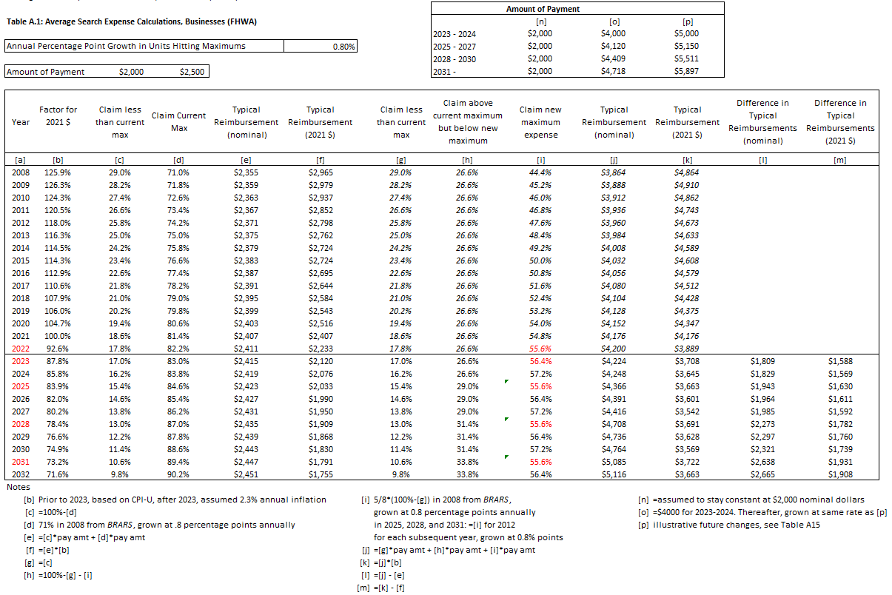
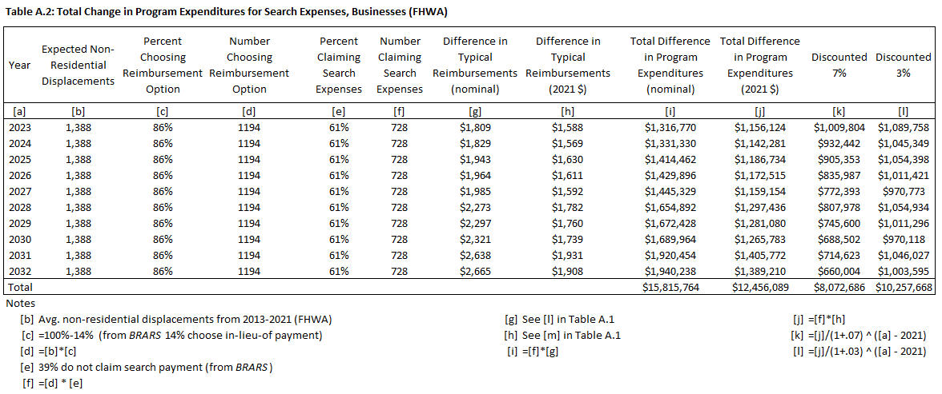

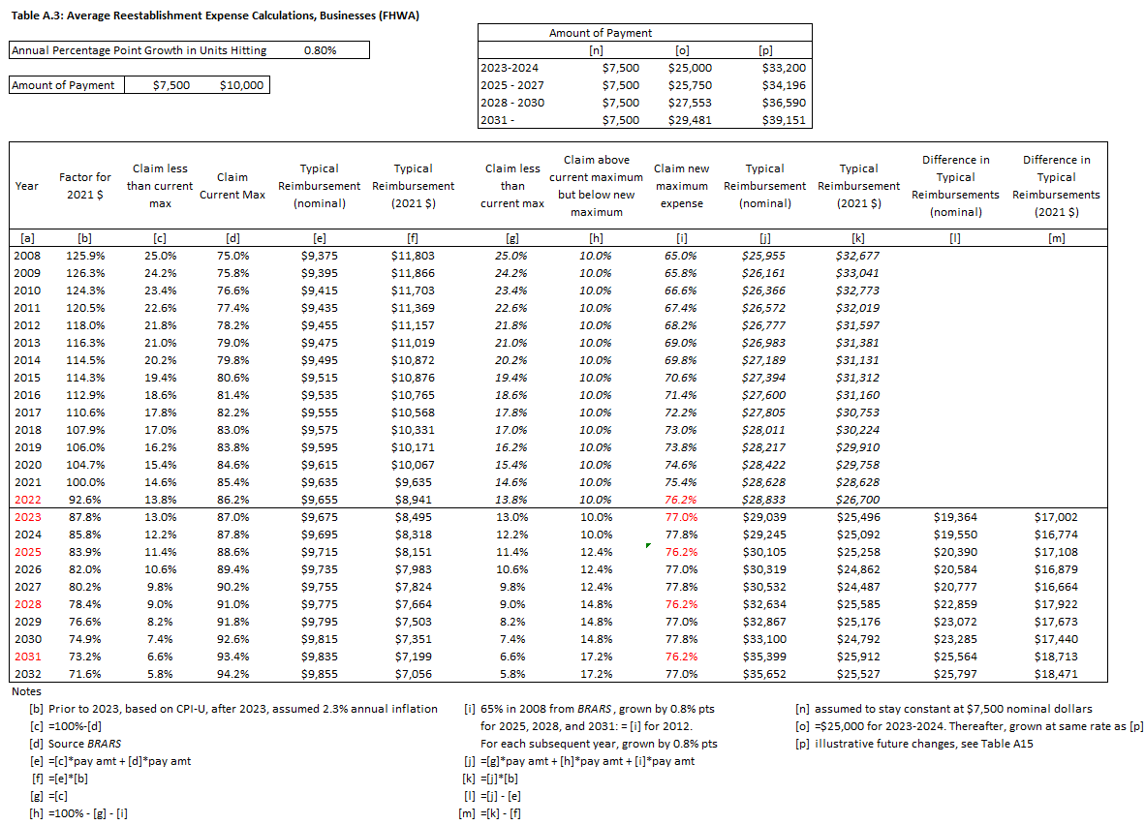

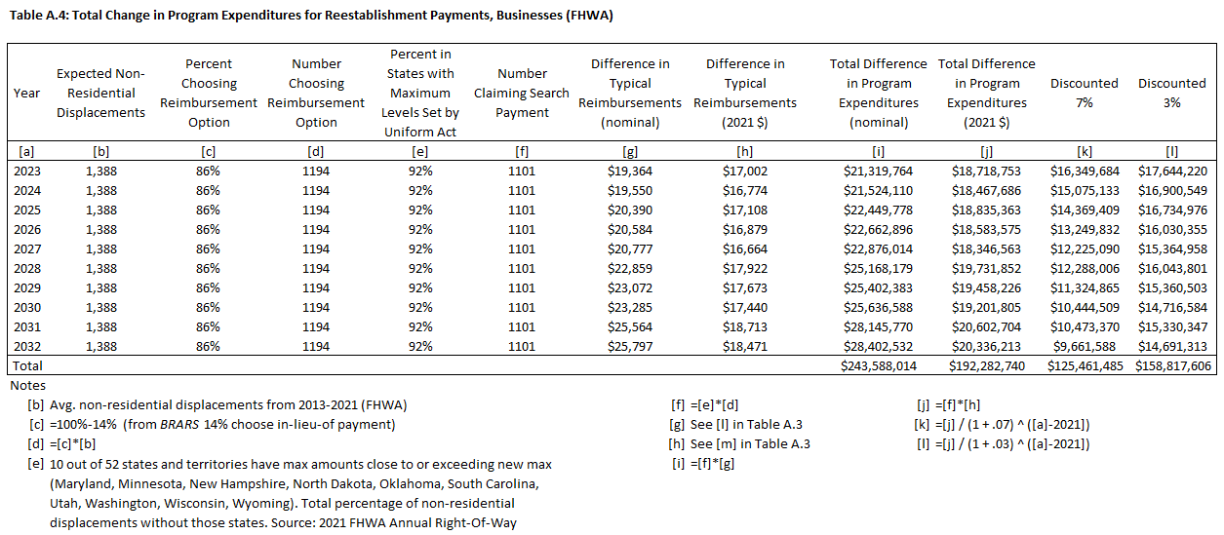

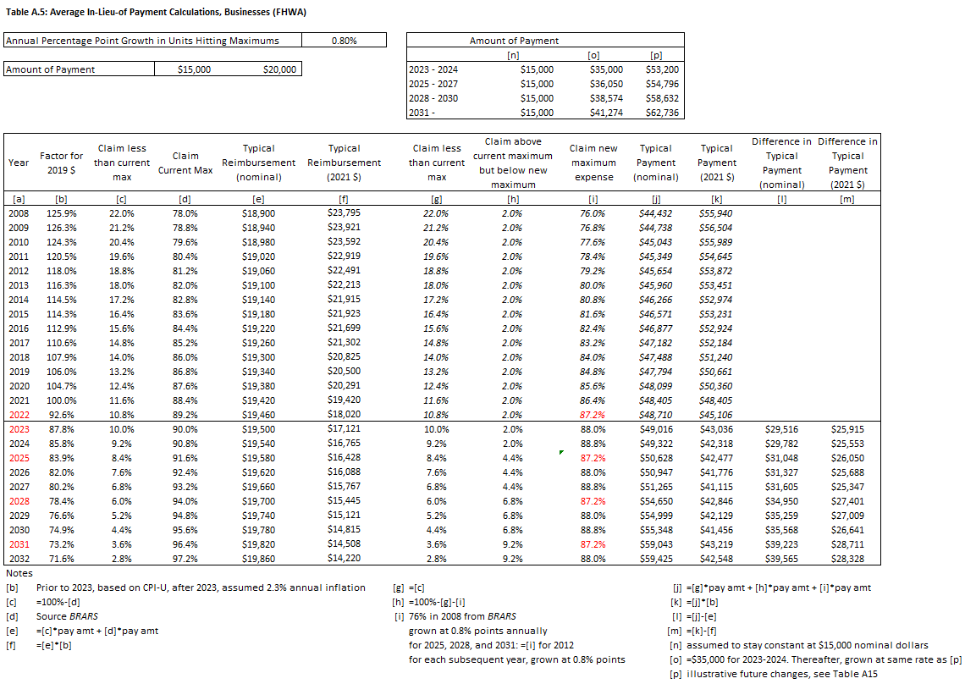

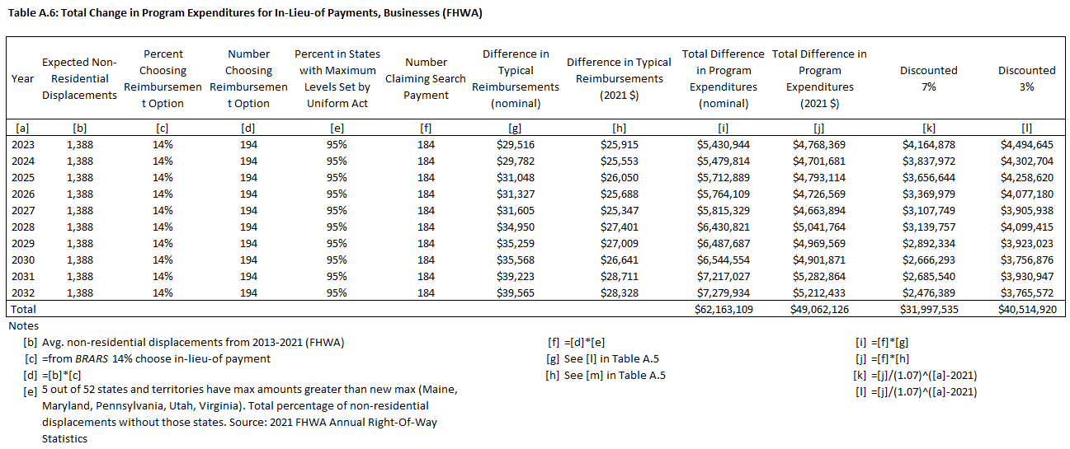

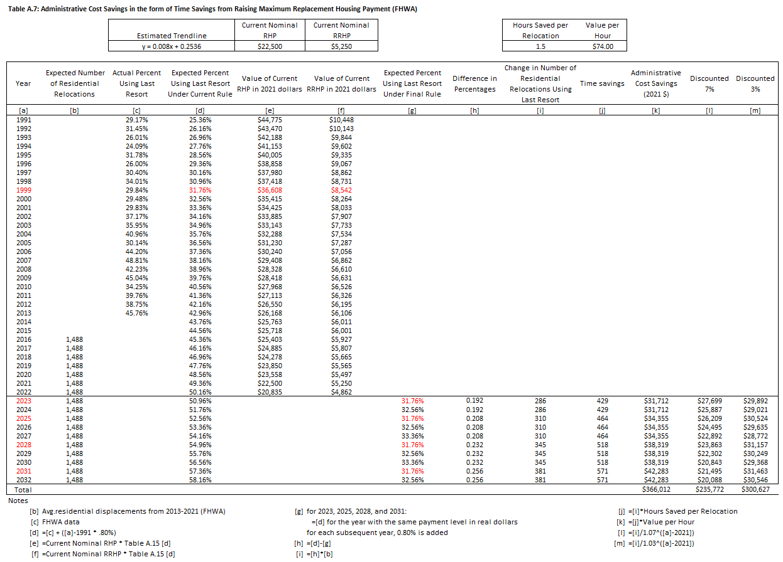

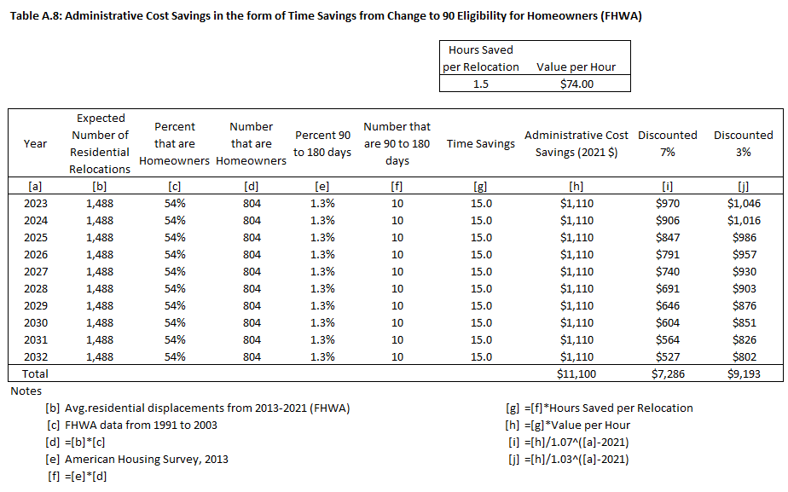

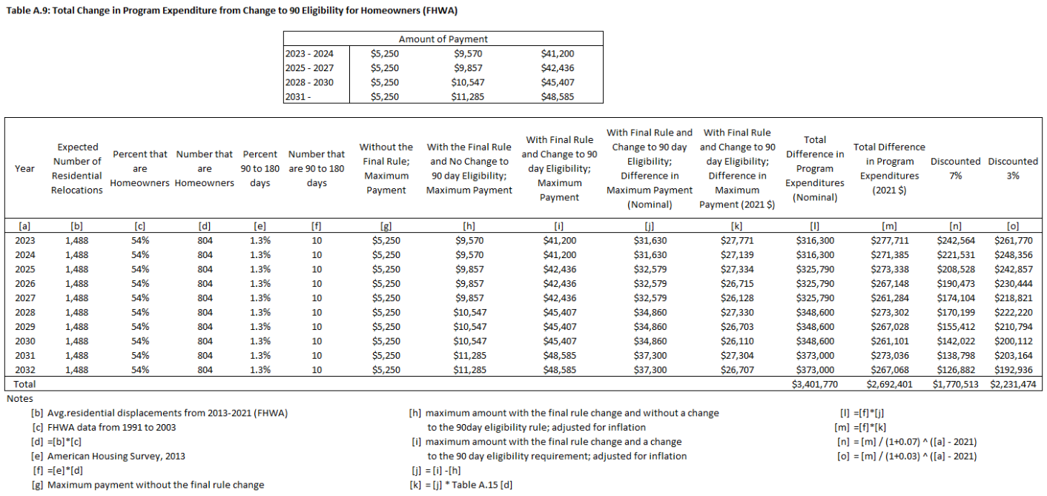

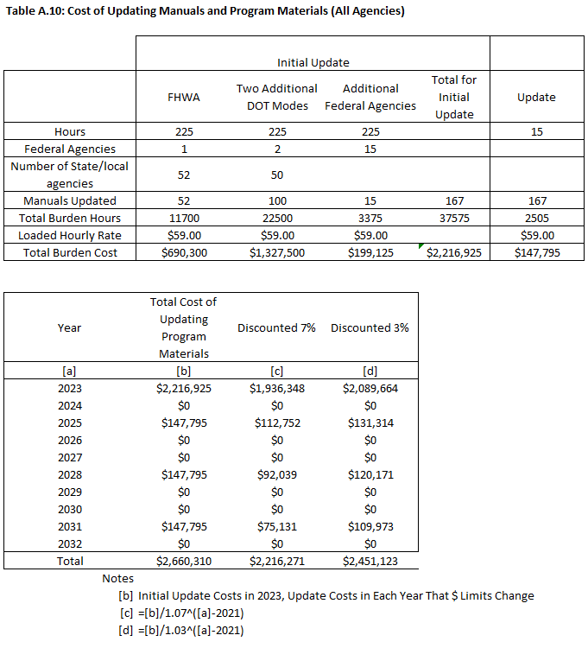
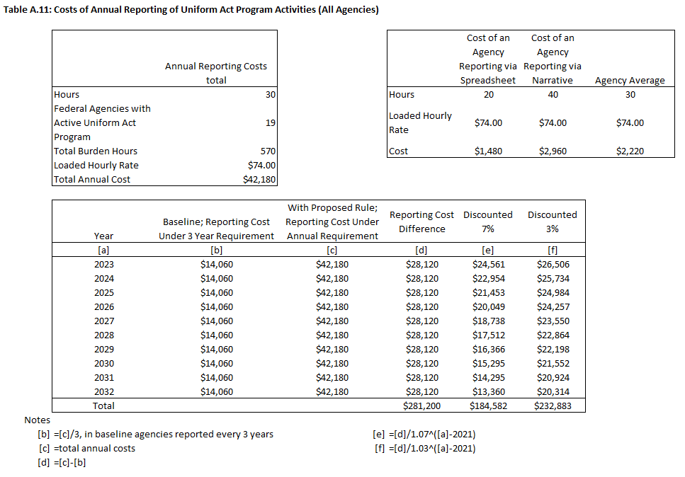
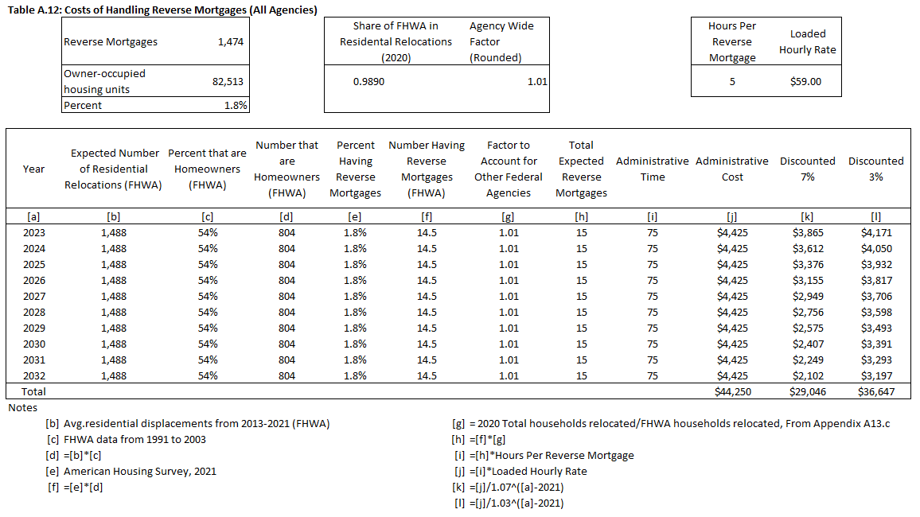

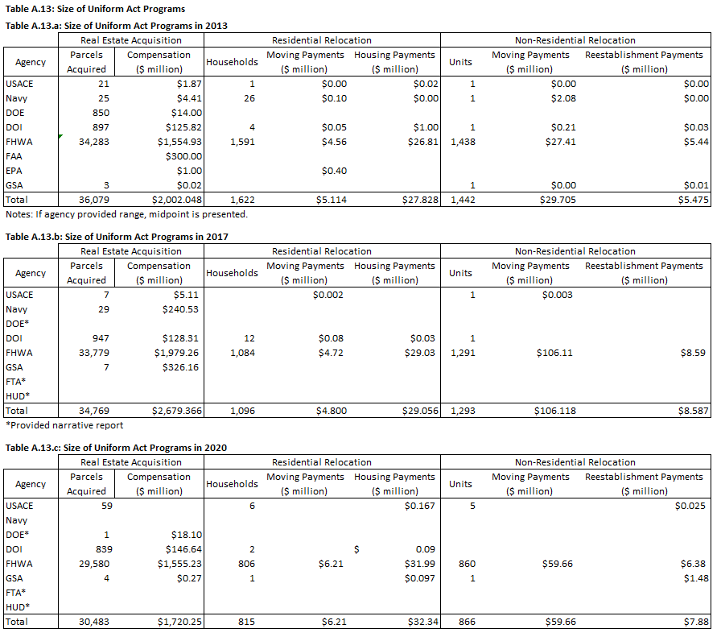
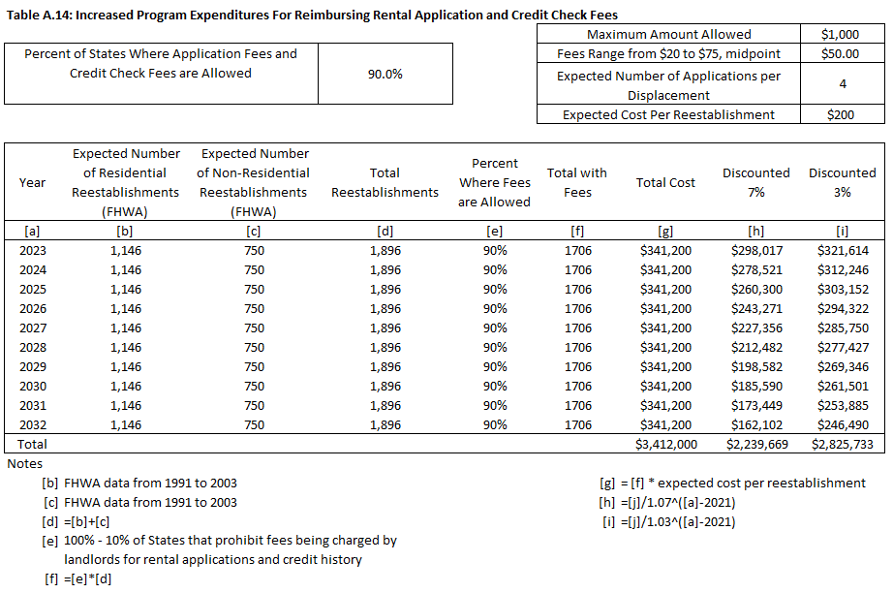

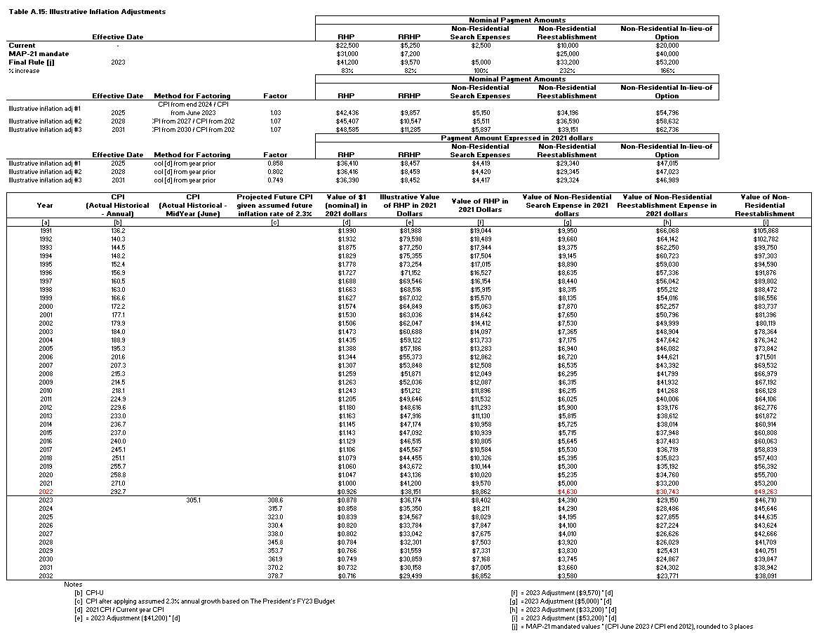

U.S. Department of Transportation
John A. Volpe National Transportation Systems Center
55 Broadway
Cambridge, MA 02142-1093

617-494-2000
www.volpe.dot.gov

Recipient is the direct recipient of Federal program funds, is not a Federal Agency and is accountable to the Federal funding Agency for the use of the funds and for compliance with applicable Federal requirements.
These estimates are an upper bound estimate, based on the maximum amount that program expenditures could increase based on the proposed changes in maximum reimbursement amounts.
There may be additional increases in search expense due to the proposed inclusion of attorney’s fees as a category of reimbursement.
As defined in MAP-21, the new Uniform Act payment levels became effective 2 years after the date of enactment of MAP-21. This date was October 1, 2014.
All acquiring Agencies meeting the definition set out in Section (§) 24.2(a)(1)(i) are required to comply with the Uniform Act and the implementing regulation, 49 CFR 24.
GAO, 2006. Eminent Domain: Information about its Uses and Effect on Communities and Property Owners Is Limited (GAO-07-78). www.gao.gov/products/GAO-07-28
Notices and Offers by Electronic Methods: Process Streamlining FHWA-HEP-16-008; https://www.fhwa.dot.gov/real_estate/publications/e_methods/index.cfm
Office of Management and Budget, OMB Circular No. A-4, New Guidelines for the Conduct of Regulatory Analysis, Mar. 2, 2004.
See Table S-9 Economic Assumptions. Office of Management and Budget, Budget of the U.S Government Fiscal Year 2023. https://www.whitehouse.gov/wp-content/uploads/2022/03/ap_2_assumptions_fy2023.pdf
Data accessed at https://www.fhwa.dot.gov/real_estate/uniform_act/stats/index.cfm. Data from the earlier period (2004 to 2012) is substantially incomplete because not all states reported data during that period. The data from prior to 2004 is more complete but is not illustrative of current conditions.
Although FHWA data for the period 2004 through 2012 is not complete in terms of total relocation activity, it is sufficient as a source for calculating percentage relocations that require a last resort payment.
BLS Occupational Employment Statistics, May 2021, Occupation Code 11-000, NAICS 999200. https://www.bls.gov/oes/2021/may/naics4_999200.htm#11-0000
BLS Employer Costs for Employee Compensation, Historical Listing, Table 5 State and Local Government, Management, Professional, and Related Occupations. For this group, roughly 64 percent of employee compensation is wages and the remainder is the cost of benefits which suggests that one should factor wages by 1.56 (100%/64%) to estimate the total cost of compensation.
Because both the RHP and RRHP payment levels are increased by roughly 83 percent in the final rule, this method will produce the same result for both payment types. We focus on RHP in this discussion for simplicity.
https://www.whitehouse.gov/wp-content/uploads/2022/03/ap_2_assumptions_fy2023.pdf
U.S. Census Bureau, American Housing Survey. 2013 National – Household Demographics accessed at https://www.census.gov/programs-surveys/ahs/data.2013.html
https://www.whitehouse.gov/wp-content/uploads/2022/03/ap_2_assumptions_fy2023.pdf
1,474,000/82,513,000 = 1.8%. American Housing Survey, 2021, Mortgage Characteristics. https://www.census.gov/programs-surveys/ahs/data/interactive/ahstablecreator.html
BLS Occupational Employment Statistics, May 2021, Occupation Code 11-9141, NAICS 999200. https://www.bls.gov/oes/2021/may/naics4_999200.htm#11-0000
This item is presented here, in Section 2 “Residential Displacements,” since the majority of such displacements are residential.
Data on non-residential re-establishment claims and residential re-establishment claims were provided by FHWA
Zillow link: https://www.zillow.com/rental-manager/resources/rental-application-form/
Non-residential displacements include displacements of businesses, farms, and non-profit organizations. The term “displaced business” is also used in this document to refer to a business, farm, or non-profit organization that has been displaced under the Uniform Act.
Data accessed at https://www.fhwa.dot.gov/real_estate/uniform_act/stats/index.cfm. Data from the earlier period (2004 to 2012) is substantially incomplete because not all States reported data during that period. The data from prior to 2004 is more complete but is not illustrative of current conditions.
https://www.fhwa.dot.gov/real_estate/publications/business_relocation_assistance/index.cfm
https://www.whitehouse.gov/wp-content/uploads/2022/03/ap_2_assumptions_fy2023.pdf
FHWA Non-Residential Displacements. Annual Right-of-Way Statistics. https://www.fhwa.dot.gov/real_estate/uniform_act/stats/index.cfm
https://www.whitehouse.gov/wp-content/uploads/2022/03/ap_2_assumptions_fy2023.pdf
FHWA Non-Residential Displacements. Annual Right-of-Way Statistics. https://www.fhwa.dot.gov/real_estate/uniform_act/stats/index.cfm
https://www.whitehouse.gov/wp-content/uploads/2022/03/ap_2_assumptions_fy2023.pdf
BLS Occupational Employment Statistics, May 2021, Occupation Code 11-9141, NAICS 999200. https://www.bls.gov/oes/2021/may/naics4_999200.htm#11-0000
This assumed 30-hour estimate is based on the information that currently half of Agencies use the narrative format while the other half use the spreadsheet format and an assumption that the narrative format would require 20 hours of labor hours while the spreadsheet format would require 40 hours of labor.
https://www.opm.gov/policy-data-oversight/pay-leave/salaries-wages/salary-tables/21Tables/html/DCB_h.aspx. Note that Washington, DC, locality pay is likely higher than most other locations, is therefore a conservative estimate.
See 49 CFR 24.9(c)
These estimates are an upper bound estimate, based on the maximum amount that program expenditures could increase based on the final rule’s changes in maximum reimbursement amounts.
There may be additional increases in search expense due to the final rule’s inclusion of attorney’s fees as a category of reimbursement.

