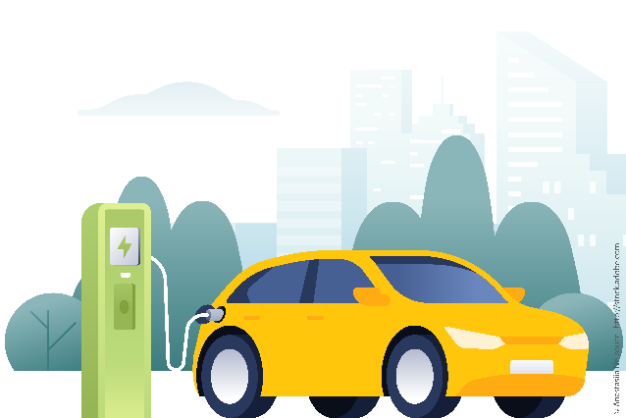  Electric Vehicle Use and Inventory Survey (eVIUS)  Survey of battery electric and plug-in hybrid electric vehicles  For more information on eVIUS, visit www.bts.gov/eVIUS. | You have been selected to participate in the first ever Electric Vehicle Inventory and Use Survey (eVIUS).  The survey will be conducted by the U.S. Department of Transportation’s (DOT) Bureau of Transportation Statistics (BTS) in partnership with the U.S. DOT Federal Highway Administration (FHWA) and the U.S. Department of Energy (DOE) to better understand the characteristics and uses of electric vehicles on our nation’s roads, as well as charging patterns and preferences.  You are among a national sample of battery electric and plug-in hybrid electric vehicle owners who are invited to participate in this voluntary survey. The data generated from eVIUS will be used to inform public policy and investment decisions related to electric vehicles and charging infrastructure.
Survey Sponsors: Bureau of Transportation Statistics, Federal Highway Administration, and the U.S. Department of Energy | X, Y all proudly support the EVIUS
Postcard 5 x 7 (Side 1)

Postcard 5 x 7 (Side 2)
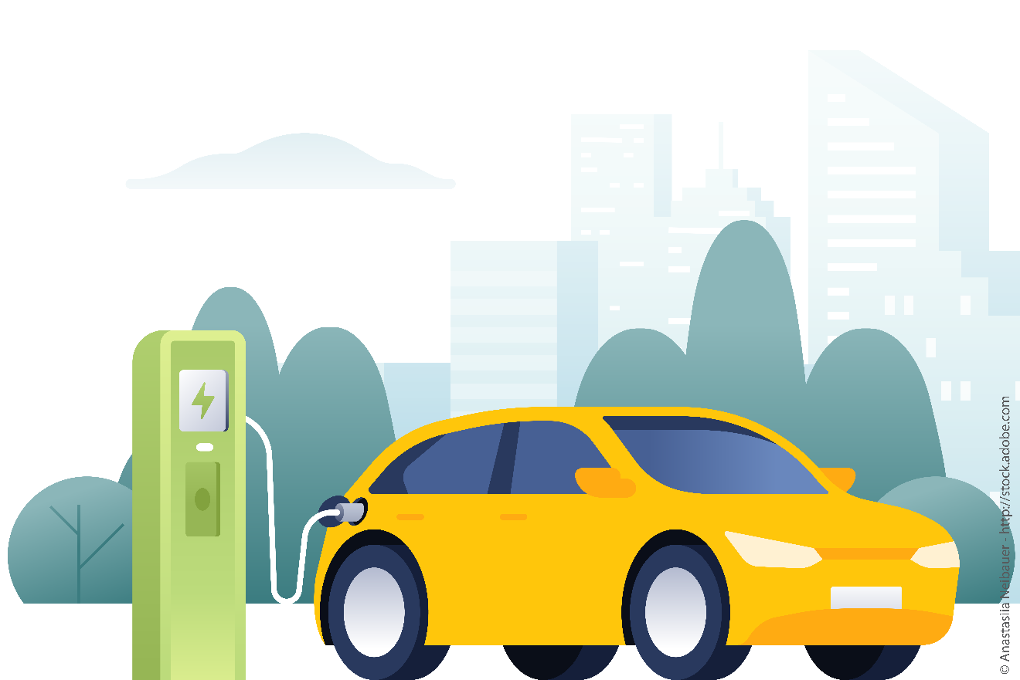  More information about the Electric Vehicle Inventory and Use Survey (eVIUS) | BTS Return Address  Stamp
What information will eVIUS collect?
The eVIUS will ask you to provide information about your registered electric vehicle such as: the type of vehicle ownership (e.g., personal vs. business), type of vehicle use, weekly and annual mileage, and charging behaviors.
How long will the survey take?
We estimate that the eVIUS will take an average of 15 minutes to complete.
Will my data be shared?
Any data you provide would be kept strictly confidential and only used to produce aggregate statistics.
What are the next steps?
You will receive a letter in the next couple of weeks providing detailed information about the online survey, along with your survey link.

For more information visit www.bts.gov/eVIUS or email us at eVIUS-help@dot.gov.

TO:

_______________________________________________

_______________________________________________

_______________________________________________




